discovery-server - application.yml
Configuration for the Eureka service registry that other services register with and look each other up through.
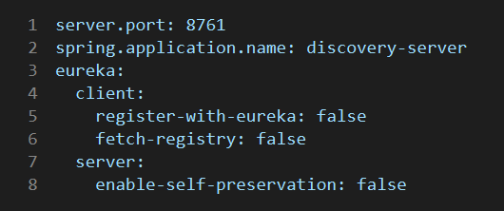

Explanation
- server.port: 8761 - the standard Eureka port (matches the default EUREKA_URL).
- spring.application.name: discovery-server - service name.
- eureka.client.register-with-eureka: false and fetch-registry: false - the server does not register with or read from itself (standalone mode).
- eureka.server.enable-self-preservation: false - expired instances are removed promptly instead of being kept during network issues; convenient for local dev, risky in production.

