order-query-service - application.yml
Configuration for the order query service (read model for orders, served via the gateway's /api/query and mobile routes).
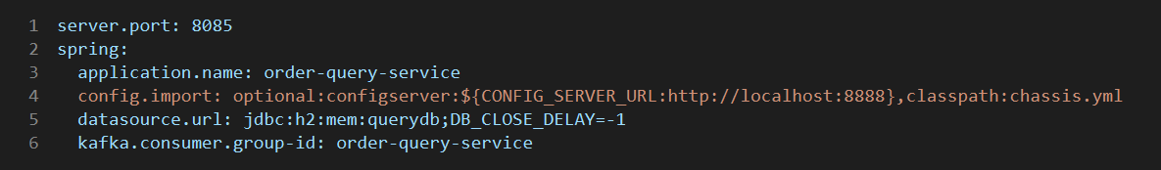

Explanation
- server.port: 8085 - the HTTP port this service listens on.
- spring.application.name: order-query-service - the name used for Eureka registration, logging and tracing.
- spring.config.import - loads config from the Config Server (CONFIG_SERVER_URL, default http://localhost:8888; optional so the service still starts without it) and the shared classpath:chassis.yml defaults (JPA, Kafka, Eureka, tracing, logging).
- spring.datasource.url - an in-memory H2 database named querydb; data is lost on restart.
- spring.kafka.consumer.group-id: order-query-service - the Kafka consumer group, so this service gets its own copy of each message.

