Smart Fan - BLE

Design Document

1. Splash Screen

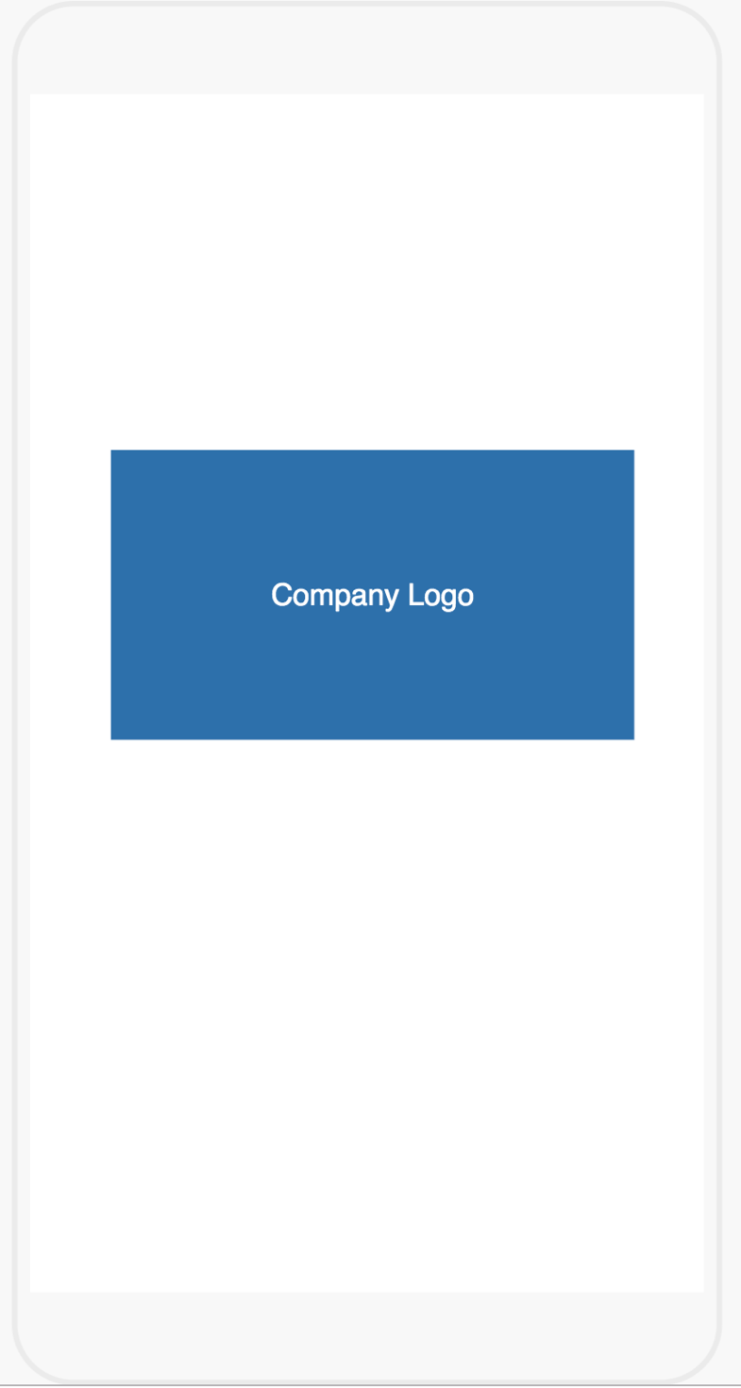

1. Device Scanning screen

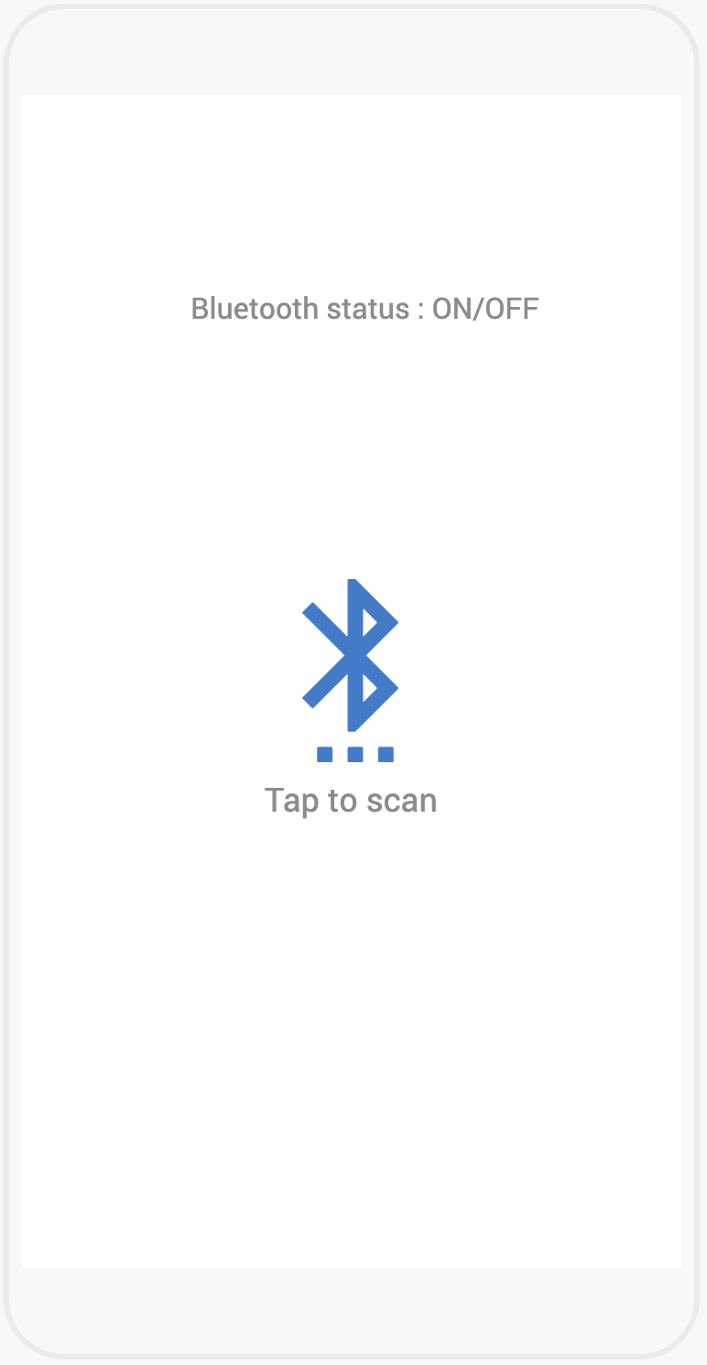

Icon : Center X and Center Y

Y: 8 from bottom of the Bluetooth icon

Font: Roboto Regular

Size: 16

Color: #8C8C8C (R: 140, G:140, B:140)

Y: 100

Font: Roboto Regular

Size: 16

Color: #8C8C8C (R: 140, G:140, B:140)

Width: 100

Color: #317ACE (R: 49, G:122, B:206)

Height: 100

1. Device list screen

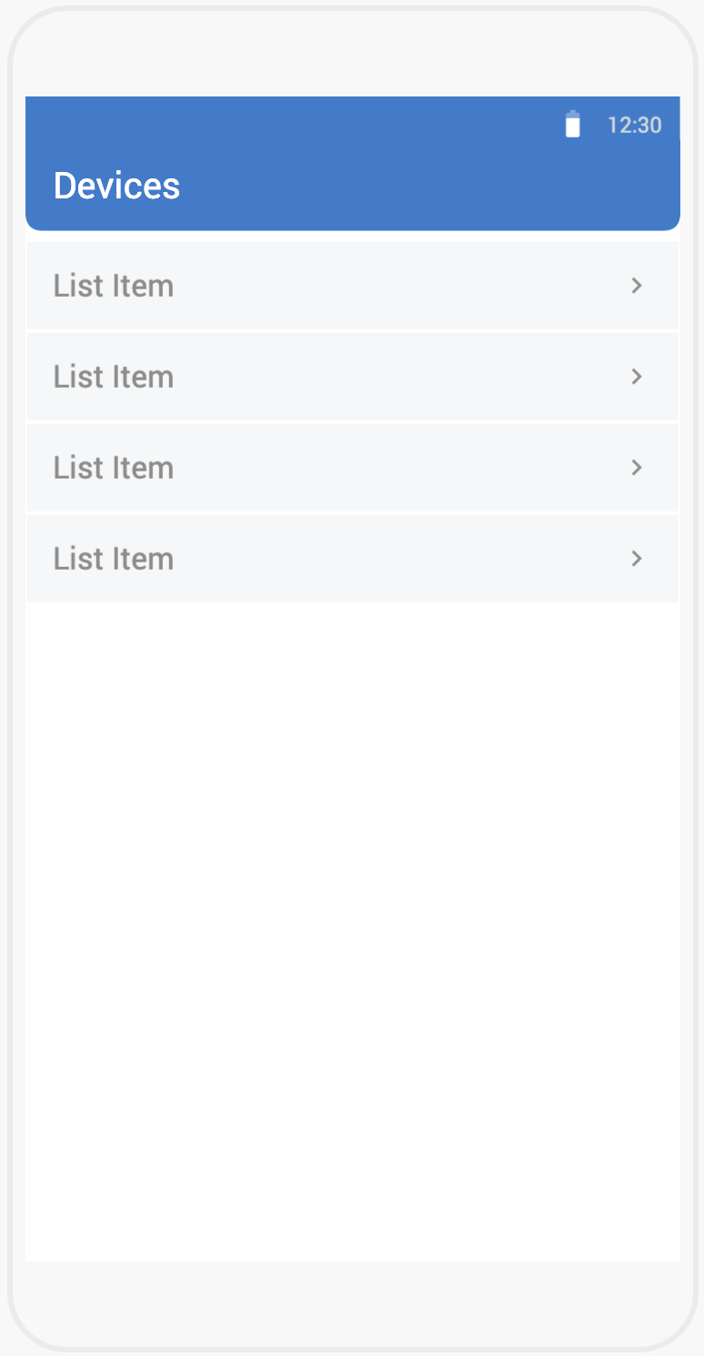

BG: #CFD8DC (R:207, G:216, B:220), Opacity: 20%

Label: Font: Roboto Regular, Size: 17, Color: # 8C8C8C (R:140, G:140, B:140)

Icon: Size: 18x18, Color: # 8C8C8C (R:140, G:140, B:140)

Font: Roboto Regular, Size: 20, Color: #FFFFFF

Total height: 80

BG: #317ACE (R:49, G:122, B:206)

Bottom left & right corner radius: 10

1. Fan controller screen

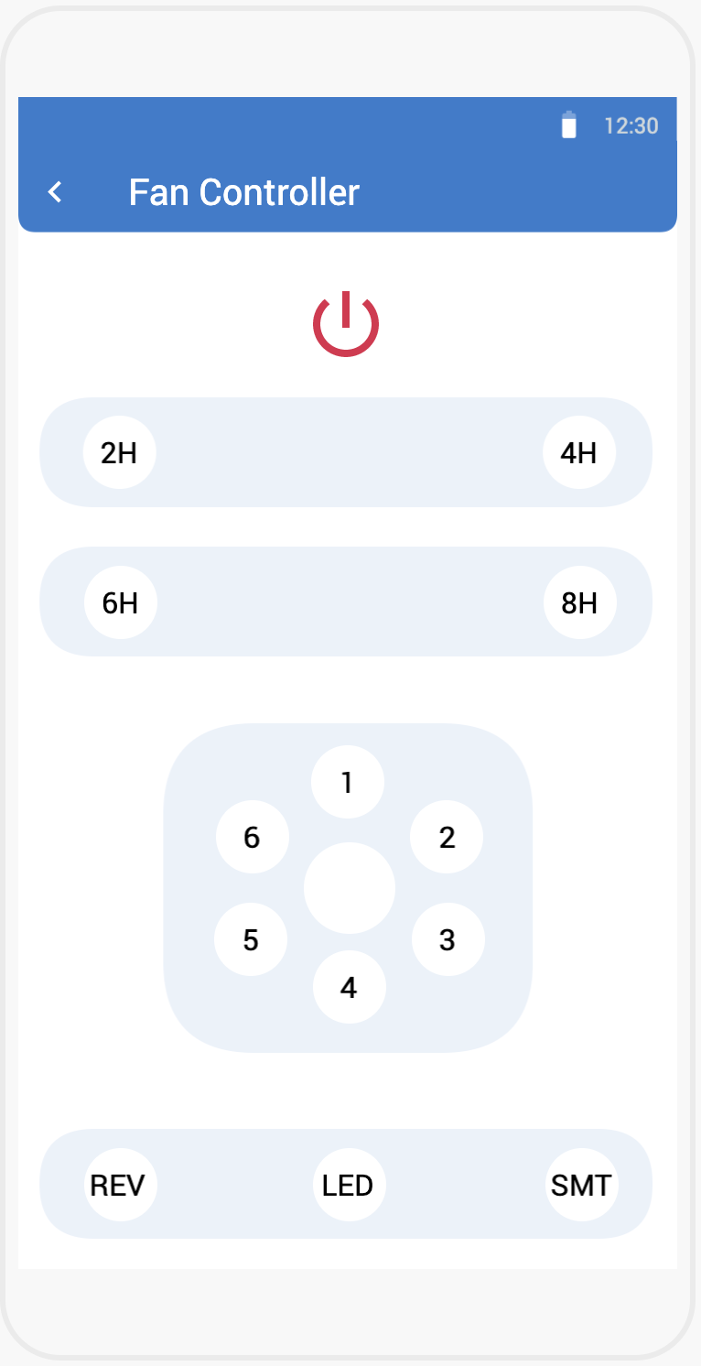

Button: Size: 60 x 60, BG Color: OFF- #FFFFFF. ON-#5BA63E (R:91, G:166, B:62), Corner radius: 30 (width/2)

Button: Size: 48 x 48, Left-Space: 16, Right-Space: 16 (for right side icons), BG Color: OFF- #FFFFFF. ON-#5BA63E (R:91, G:166, B:62), Corner radius: 24 (width/2)

Button Text: Font: Roborto Regular, Size: 16, Color: #000000

Size: 48x48, Y: 100, Color: OFF- #E0274D (R:224, G:39, B:77). ON- #5BA63E (R:91, G:166, B:62)

Left & Right Space: 65, Height: 180, BG: #317ACE (R:49, G:122, B:206), Opacity: 10%

Left & Right Space: 12, Height: 60, BG: #317ACE (R:49, G:122, B:206), Opacity: 10%

Left-Spacing: 60, Font: Refer screen 3

Icon: Size: 24 x 24, Left-Space: 8, Color: #FFFFFF

1. Registration screen

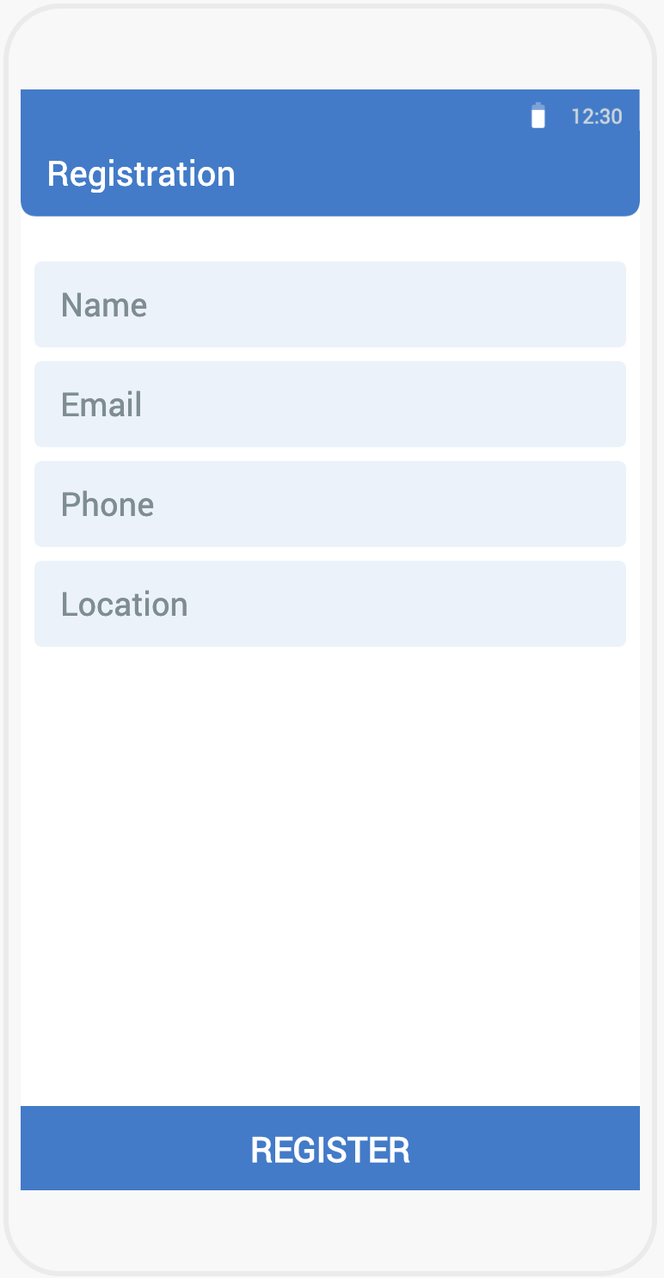

Button: Height: 50, BG: #317ACE (R:49, G:122, B:206). Text: Font: Roberto Regular, size: 20, color: #FFFFFF

1st Text Field Y: 100

Space between each text field: 8

Text Field: Height: 50, Left & Right space: 8 BG: #317ACE (R:49, G:122, B:206) Opacity: 10%, Text font: Roboto Regular, size: 19, color: #7B8D93 (R:123, G:141, B:147)

1. Verification screen

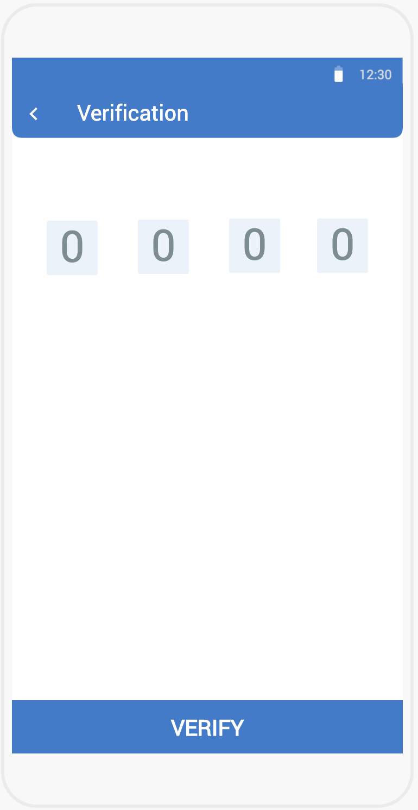

Text field: Y: 150, Height, Width: 50 x 50, BG: #317ACE (R:49, G:122, B:206) Opacity: 10%, Text Font: Roboto Regular, size: 40, color: #7B8D93 (R:123, G:141, B:147). First text field X: 32, last button right space: 32. Equal space between each button

Button: Height: 50, BG: #317ACE (R:49, G:122, B:206). Text: Font: Roberto Regular, size: 20, color: #FFFFFF