Smart Fan - BLE

Functional Requirements

This document specifies deliverables and functional requirements for the Smart Fan App

# Revision History

|  |  |  |
| --- | --- | --- |
| Date | Version | Description of Revision |
| 24/08/2019 | 01.00 | Initial document creation |
|  |  |  |
|  |  |  |
|  |  |  |
|  |  |  |
|  |  |  |
|  |  |  |
|  |  |  |

Contents

Revision History 1

Date 1

Version 1

Description of Revision 1

Specification Details 2

Section 1: Splash screen 2

Section 2: Registration Screen 3

Section 3: Verification 4

Section 4: Bluetooth status screen 5

Section 5: Device list screen 6

Section 6: Fan controller screen 7

# Specification Details

## Section 1: Splash screen

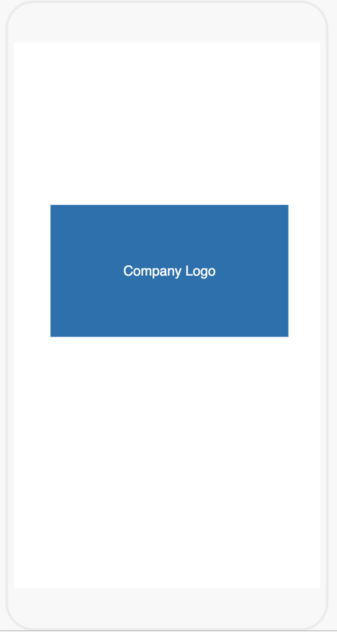

1. displays logo and title as specified by client
   1. displays immediately upon start of the app
      1. remains visible until app is fully loaded, at which time it is:
      2. replaced by registration screen (see Section 2) if user is not registered already otherwise, replaced by Bluetooth status screen (section 4)

## Section 2: Registration Screen

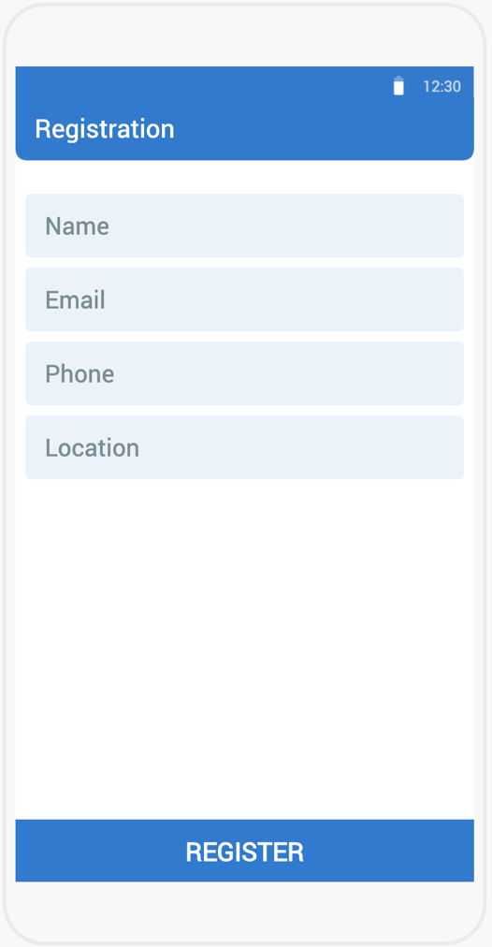

2. Navigates from splash screen if user is not registered

2.1. All fields are mandatory

2.2. Basic validation to be done for all the fields

2.3. Email and Phone specific validation to be done

2.4. When the user taps REGISTER:

2.4.1. Store all the values locally and generate 4-digit random code (store locally for verification) and send SMS to the phone number provided in the phone field.

2.4.2. Once the SMS is sent, navigate the user to the verification screen (section 3)

## Section 3: Verification

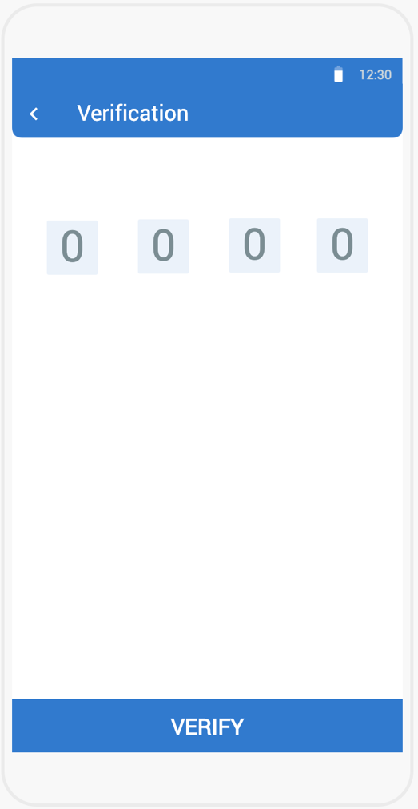

1. Navigates from registration screen (section 2)
   1. Enter the password the user received through SMS
   2. Basic validation to be done
   3. Once the user taps VERIFY, validate the randomly generated code that is store locally and the values entered in the text fields. If it is matching, then send the registration details to cfappreceive@gmail.com", from: "cfappsend@gmail.com", subject: "New User Registered", body: "Hello, New user registered. \n Name: Username \n Email: Email \n Phone: Phone \n Location: Location \n Date: Date \n Client: Android App
   4. Navigate the user to the Bluetooth status screen (section 4)

## Section 4: Bluetooth status screen

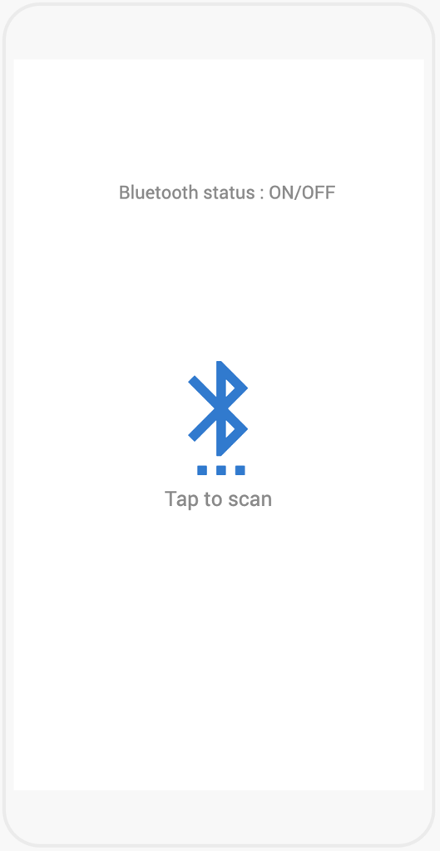

1. Navigates either from section 1 or 3

4.1. Show the device Bluetooth status in the status label

4.2. When the user taps on Bluetooth button/icon, either display error message (if device is not supported/Bluetooth is off) or navigate the user to section 5

## Section 5: Device list screen

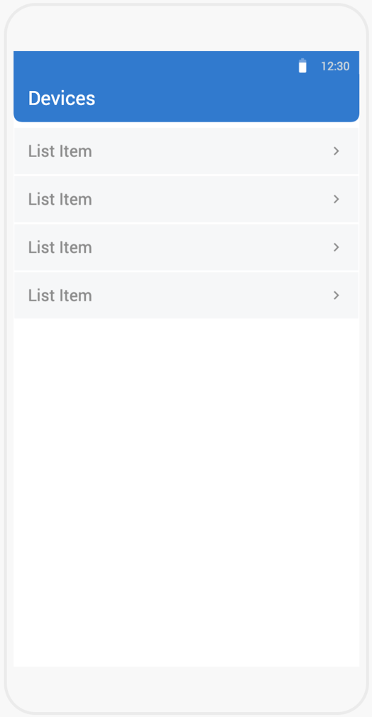

1. Navigates from section 5
   1. Lists the scanned/available nearby Bluetooth devices
   2. When the user taps any of the device from the list, pair the device and navigate to section 6

## Section 6: Fan controller screen

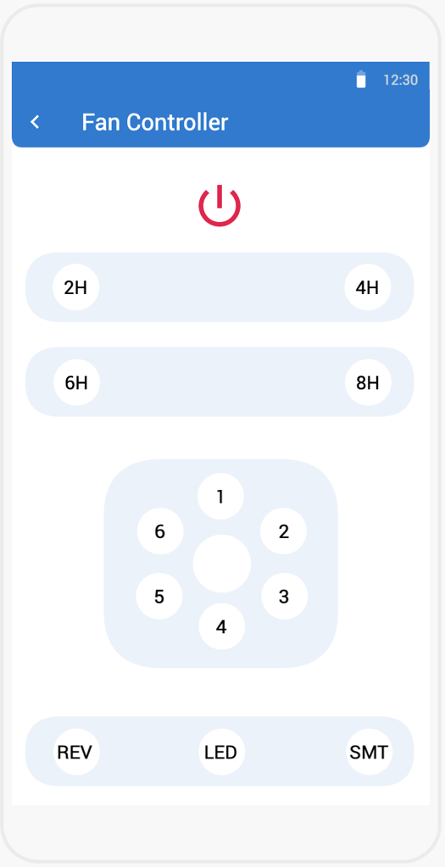

1. Navigates from section 5
   1. In any point while in this screen if the device Bluetooth is tuned OFF:
      1. Prompt error message “Device Bluetooth is tuned off. Please turn it ON from the phone settings”
      2. Once the user turns ON, pair the device again
      3. If it is not turned ON for 2 minutes interval, pop message “Phone Bluetooth is still OFF” and navigate the user to section 4
   2. In any point while in this screen if the Bluetooth device is not responding/turned off/pair status is not paired:
      1. Try to repair for 3 times each 10 second showing reconnecting message. If it fails to repair, navigate the user to section 5
   3. If it successfully pairs, then user can control the fan. Below are the commands;

Fan Controller Commands:

Note: All the commands will work only if is paired to Bluetooth device

*SaTbMcRdLeVffIggRhhh*

Power ON/OFF button

0.Power OFF (Disable all buttons except Speed buttons)

1. Power ON (Enable all buttons)

S – Speed, a (0…7)

1. Power Off
2. Power ON and Speed is 1
3. Speed 2
4. Speed 3
5. Speed 4
6. Speed 5
7. Speed 6
8. Turbo (Center button)

T – Timer, b (0,2,4,6,8)

0.Timer off, 2. 2H, 4.4H, 6. 6H, 8. 8H

M – Smart, c (0 and 1)

0.Smart OFF (enable All Speed buttons) 1. Smart ON (disable All speed buttons)

R – Reverse, d (0 and 1)

0.Reverse OFF 1. Reverse ON

I – Indicator, gg (20,30,50 and 60) – Pop message

20. Over current 30. Over voltage 50. Motor failure 60. Over temperature