
DEPARTMENT OF COMPUTER SCIENCE AND ENGINEERING
PLANT DISEASE DETECTION

Under the Guidance of
R.Sreenivasulu
B.Pranathi
R200356

AGENDA
- Abstract
- Introduction
- Motivation
- Workflow
- System Architecture
- Modules
- Module-1: Image Upload & Preprocessing
- Module-2: CNN Disease Prediction
- Module-3: Grad-CAM Visualization
- Results & Discussion
- Conclusion & Future Enhancements

ABSTRACT
- The project introduces an automated system for detecting plant diseases using Convolutional Neural Networks (CNNs).
- Users can upload leaf images, which are processed by a trained model to predict the disease class with high accuracy.
- Grad-CAM visualizations are used to highlight the specific regions influencing the model’s decision.
- The system is implemented through a Django web interface, ensuring ease of use and accessibility.
- Prediction history and visualization features help users track and analyze previously uploaded images.
- The model demonstrates strong performance in distinguishing healthy leaves from various disease categories

INTRODUCTION
- Plant diseases pose serious challenges to global crop productivity and agricultural sustainability.
- Manual identification of diseases is slow, expertise-dependent, and impractical for large-scale monitoring.
- Deep learning, especially CNNs, offers powerful capabilities for analyzing leaf patterns and identifying diseases automatically.
- This project focuses on creating an intelligent system that leverages image processing and machine learning for plant health monitoring.
- The integrated Django platform allows users to interact with the model through simple image uploads and easy result visualization.

MOTIVATION
- Plant diseases cause major crop losses every year, affecting farmers’ income and overall food production.
- Many farmers lack access to agricultural experts who can diagnose diseases accurately and on time.
- Manual disease detection is slow, inconsistent, and not feasible for large-scale farms.
- Early and automated detection can significantly reduce damage and improve crop health.
- Recent advancements in Deep Learning make image-based disease identification fast, accurate, and reliable.
- A simple, affordable, and technology-driven solution can help bridge the gap between farmers and expert-level diagnosis.

WORKFLOW
- The user uploads a plant leaf image through the Django web interface.
- The system preprocesses the image by resizing, normalizing, and converting it into a model-ready format.
- The trained CNN model analyzes the image and predicts the corresponding disease class.
- Grad-CAM generates a heatmap to highlight the regions that influenced the prediction.
- The result page displays the predicted disease, confidence score, and heatmap visualization.
- The prediction details are stored in the user’s history for future reference and analysis.

SYSTEM ARCHITECTURE

1. Frontend Layer
Designed using HTML, CSS, and JavaScript, the frontend provides an intuitive interface where users can upload leaf images and view prediction results along with heatmaps.

2. Backend Layer (Django Framework)
The Django backend manages routing, user requests, authentication, and interaction between the web interface and the machine learning model.

3. Image Processing Component
Uploaded images are resized, normalized, and transformed into tensors to match the input requirements of the CNN model.

4. CNN Model Layer
A trained Convolutional Neural Network performs feature extraction and classifies the uploaded leaf image into the appropriate disease category.

5. Grad-CAM Visualization Layer
Grad-CAM is used to generate heatmaps that highlight which parts of the leaf contributed most to the model’s prediction, enhancing interpretability.

6. Database Layer
Stores user details, uploaded images, prediction results, and history to support easy tracking and retrieval within the application.

MODULES
Module 1: Image Upload & Preprocessing
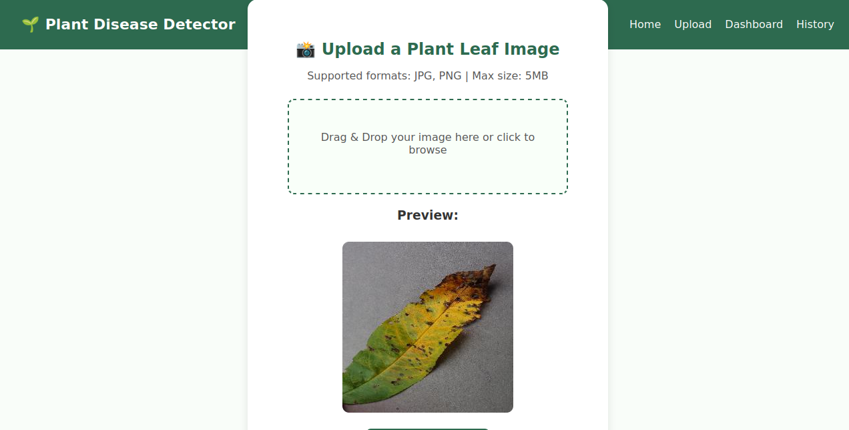
This module manages the user interaction with the system. Users upload leaf images through a clean Django interface. Once uploaded, the system automatically preprocesses the image—resizing it to the required dimensions, normalizing pixel values, and converting it into a tensor suitable for CNN input.
Module 2 : Disease Detection using ResNet 9

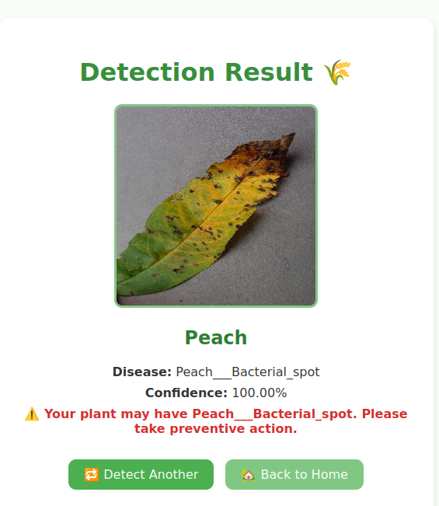
When a new image is uploaded, it undergoes preprocessing steps such as resizing,normalization, and tensor conversion. The CNN model extracts deep visual features — like spots, discolorations, and texture variations — to classify the image into one of the predefined categories.
Module-3: Grad-CAM Visualization

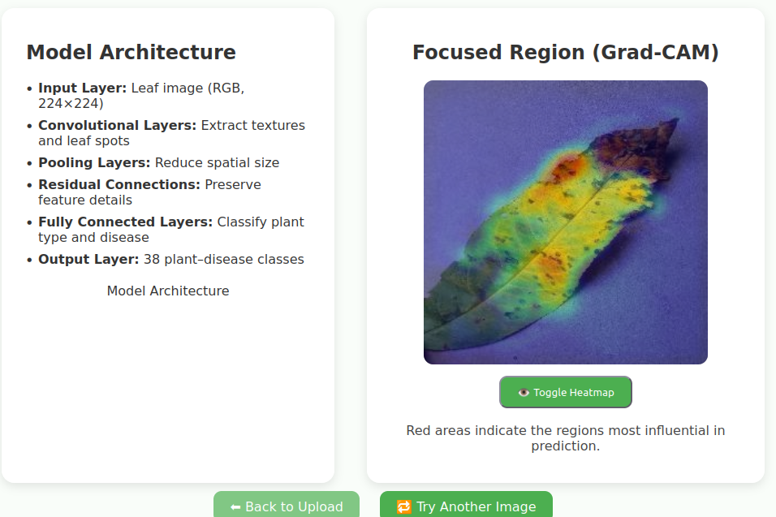
After the model predicts the class, Grad-CAM extracts gradients from the final convolutional layer and generates a heatmap overlay on the original image. The red and yellow areas in the heatmap represent the regions the model focused on while identifying the disease

Results and Discussion:
The Plant Disease Detection System using CNN and Django
demonstrates how deep learning can support agriculture by automating
plant disease identification from leaf images. With an integrated CNN
model, the system enables users to upload images, view predictions with
confidence scores, and analyze affected regions using Grad-CAM. It
effectively identifies diseases across multiple crops such as tomato,
apple, grape, corn, and potato.
This project contributes to digital agriculture by providing a
practical and intelligent tool that assists early disease detection, helping
farmers improve crop health and productivity

Conclusion and Future Enhancements:
The plant disease detection system demonstrates the effectiveness of deep learning in addressing real agricultural challenges by accurately identifying diseases across 14 plant diseases and 38 leaf categories.Using a ResNet – based PyTorch model trained on 70000 images,the system achieves strong accuracy and reliable predictions while reducing the need for expert diagnosis. Overall the project successfully delivers a fast,scalable and user friendly solution that supports early disease identification and promote better crop health management.
Future improvements include expanding the dataset with more plant species and conditions,devoloping a mobile app for field level diagnosis,and enabling with treatment recommendations,multi disease detection,and explainable AI features like heatmaps.


