PRADEEPKUMAR S
SIMATS ENGINEERING
ASSESSMENT TOOL 1: Agent Design Assessment
COURSE NAME: ARTIFICIAL INTELLIGENCE AND EXPERT SYSTEMS
COURSE OUTCOME COVERED
COURSE CODE: MLA01
CO1: Apply search algorithms and heuristic techniques to solve state-space search and optimization problems. (BTL 3)
Assessment Tool Weightage: 55 %
Total Marks: 50 Time: 60 Mins No. of Questions: 1
Annexure A
Agent Design Assessment
Code of Conduct:
I ___PRADEEPKUMAR_________________ (Name / Reg No) certify that this submission is my original work and that I have adhered to the guidelines specified for this assessment. I understand that any violation of academic integrity rules will result in disciplinary action.
Signature of the student:

Question | Problem  Understanding & AI Concept Identification | Dialogflow Agent Design &  Implementation | Problem  Formulation &  Conversation Flow Design | Application of AI Techniques & Reasoning | Testing,  Evaluation & Documentation | Total
Weightage | 20% | 30% | 20% | 20% | 10% | 100%
Q1

Signature of the Faculty Total Marks Awarded
Scenario
A university wants to develop an AI-based Student Support Assistant to provide instant responses to student queries related to course registration, timetable, examination schedules, attendance details, and campus services.
As an AI developer, design and implement a conversational agent using Dialogflow that can understand user requests, process intents, and provide appropriate responses.
Q. No. | Criteria to be evaluated | BL | Marks
1 | Problem Analysis and Agent Design: Analyze the student support problem and explain how Artificial Intelligence can solve the problem. Design the conversational agent by defining its objective, users, environment, inputs, outputs, and expected performance measures. | BL3 | 10
Problem Analysis: In our university the students have many doubts about course registration, timetable, exam schedule, attendance and campus services. For every small doubt they have to go to the office or ask the staff again and again. The staff are not free all the time, so the students have to stand in queue or wait for a reply. This wastes the time of both students and staff, and sometimes students even miss important dates like the last date of registration.
How AI can solve the problem: An AI chatbot can answer the students at any time (24 x 7) and it can talk to many students at the same time. It uses Natural Language Processing (NLP) to understand what the student typed, finds the intent (what the student really wants) and gives the correct reply within a few seconds. Because of this the students get quick help and the work of the office staff becomes less. Dialogflow is a good tool for this because it already has NLP inside it and it is easy to create intents and responses.
Design of the Conversational Agent:
Component | Description
Objective | To give quick and correct answers to the student queries about course registration, timetable, exam schedule, attendance and campus services without waiting for the staff.
Users | University students are the main users. New students, parents and office staff can also use it.
Environment | A chat window on the university website or mobile app. The agent runs on Dialogflow in the cloud and talks with the user in text. The environment is partially observable (the agent does not know what the student wants until he types it) and it keeps changing because every student asks different things.
Inputs | Text messages typed by the student like "show my timetable", and details like course name, date, register number and service name.
Outputs | Text replies with the required information, questions asking for the missing details, and a fallback message when the query is not understood.
Performance Measures | Intent detection accuracy, response time (less than 2 seconds), correct and useful answers, proper handling of unknown queries, student satisfaction, and fewer queries going to the office staff.

2 | Dialogflow Agent Development: Create a Dialogflow agent by designing appropriate Intents, Entities, Training Phrases, Responses, and Contexts. Explain how the agent perceives user queries and generates responses. Provide screenshots of the implementation. | BL5 | 10
I created a Dialogflow ES agent named StudentSupportAssistant. The agent has the following intents, entities and contexts.
Intents, Training Phrases and Responses:
Intent | Training Phrases | Response
Default Welcome Intent | hi, hello, hey, good morning | Hello! I am the Student Support Assistant. I can help you with course registration, timetable, exam schedule, attendance and campus services. What do you want to know?
Course_Registration | I want to register for a course, how do I register for @course_name, enroll me in @course_name, course registration | Okay, to register for $course_name please log in to the student portal, go to Academics > Course Registration, select the course and click Submit.
Course_Registration - lastdate | what is the last date, till when can I register, when does registration close, deadline | The last date for course registration is 30th of this month. For late registration you need permission from the HOD.
Timetable_Query | show my timetable, do I have class @sys.date, what is the timetable for @sys.date, class schedule | Your timetable is available in the student portal under Academics > Timetable. The first class starts at 9:00 AM.
Exam_Schedule | when is the exam, show exam timetable, when does the semester exam start, exam date | The exam timetable is available in the student portal under Examination > Exam Schedule. Please carry your hall ticket to the exam hall.
Attendance_Details | what is my attendance, check my attendance, attendance percentage, am I short of attendance | You need at least 75% attendance to write the semester exam. Please check your attendance in the student portal under Academics > Attendance.
Campus_Services | where is the library, @campus_service timings, tell me about hostel, is the canteen open | You can find the details of $campus_service in the Campus Services section of the student portal. The office is open from 9 AM to 5 PM.
Default Fallback Intent | No training phrases (used when nothing matches) | Sorry, I didn't get that. You can ask me about course registration, timetable, exam schedule, attendance or campus services.

Entities: I made two custom entities. @course_name has the values Artificial Intelligence, Machine Learning, Data Structures, DBMS, Python Programming and Computer Networks, with synonyms like AI, ML and DS. @campus_service has the values Library, Hostel, Canteen, Transport, WiFi and Sports Complex, with synonyms like bus, mess and internet. I also used the system entity @sys.date in the timetable intent so that words like "tomorrow" are understood. The parameters course_name and campus_service are marked as required, so if the student does not give them the agent asks a question like "Which course do you want to register for?".
Contexts: When the student asks about course registration, the Course_Registration intent sets an output context called course_registration-followup with lifespan 2. The follow-up intent Course_Registration - lastdate has the same context as input context. So if the student asks "what is the last date" after the registration question, the agent knows it is about course registration and does not mix it with the exam dates.
How the agent perceives the user query and generates the response:
1. The student types a message in the chat window.
2. Dialogflow uses NLP and machine learning to compare the message with the training phrases of all the intents. It does not need an exact match, so similar sentences also work.
3. It selects the intent with the highest confidence score. If the score is below the classification threshold (0.3 by default), the Default Fallback Intent is used.
4. It picks the entities from the message (like Machine Learning) and stores them as parameters. If a required parameter is missing, the agent asks the prompt question.
5. It checks the active contexts to decide whether a follow-up intent should be matched.
6. Finally it sends the response text with the parameter values filled in and the chat window shows it to the student.
Implementation Screenshots:
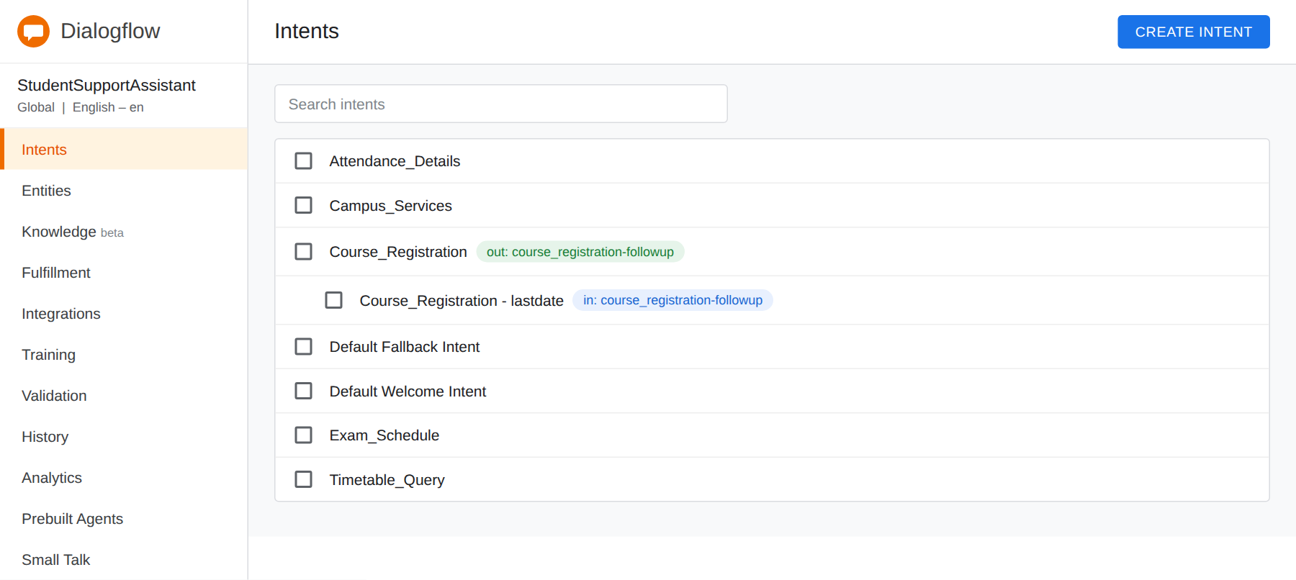
Screenshot 1: Intents created in the StudentSupportAssistant agent
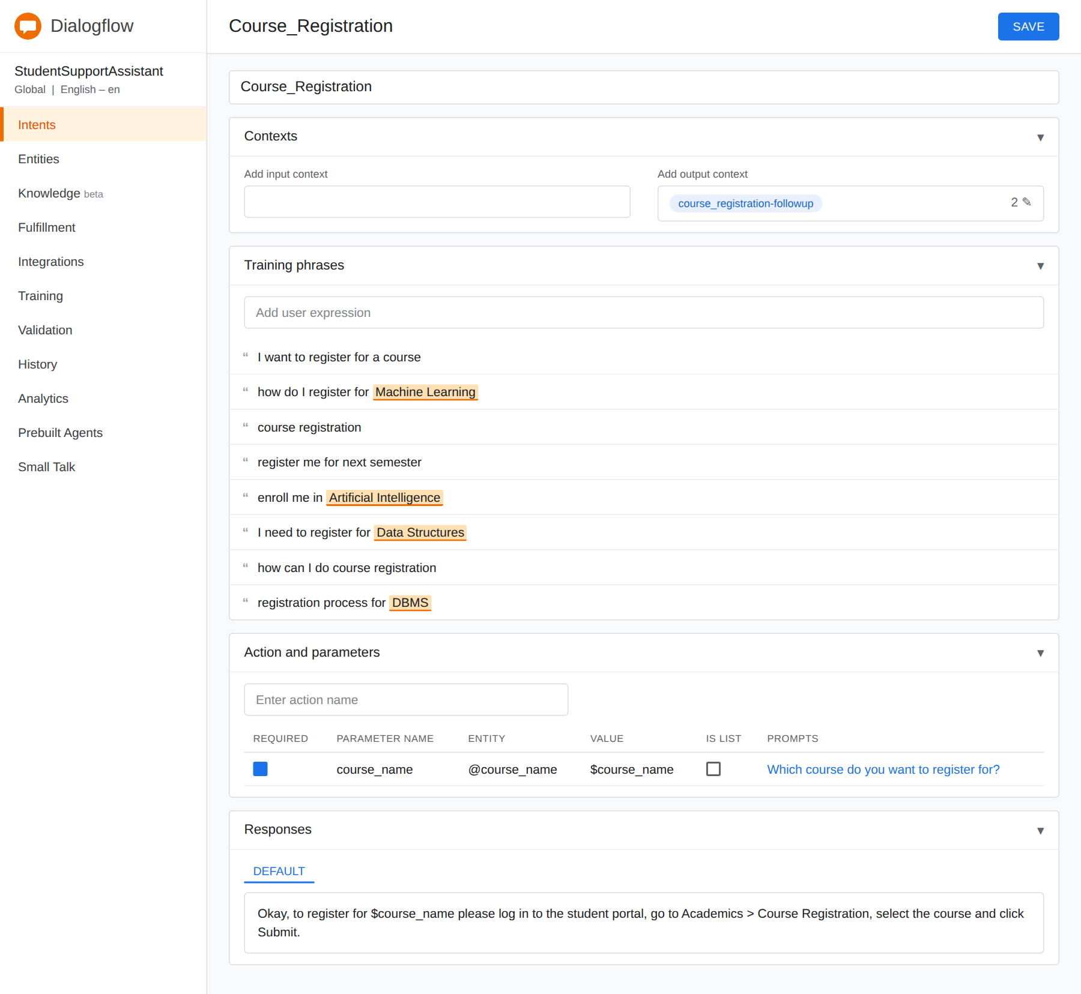
Screenshot 2: Course_Registration intent with context, training phrases, parameter and response
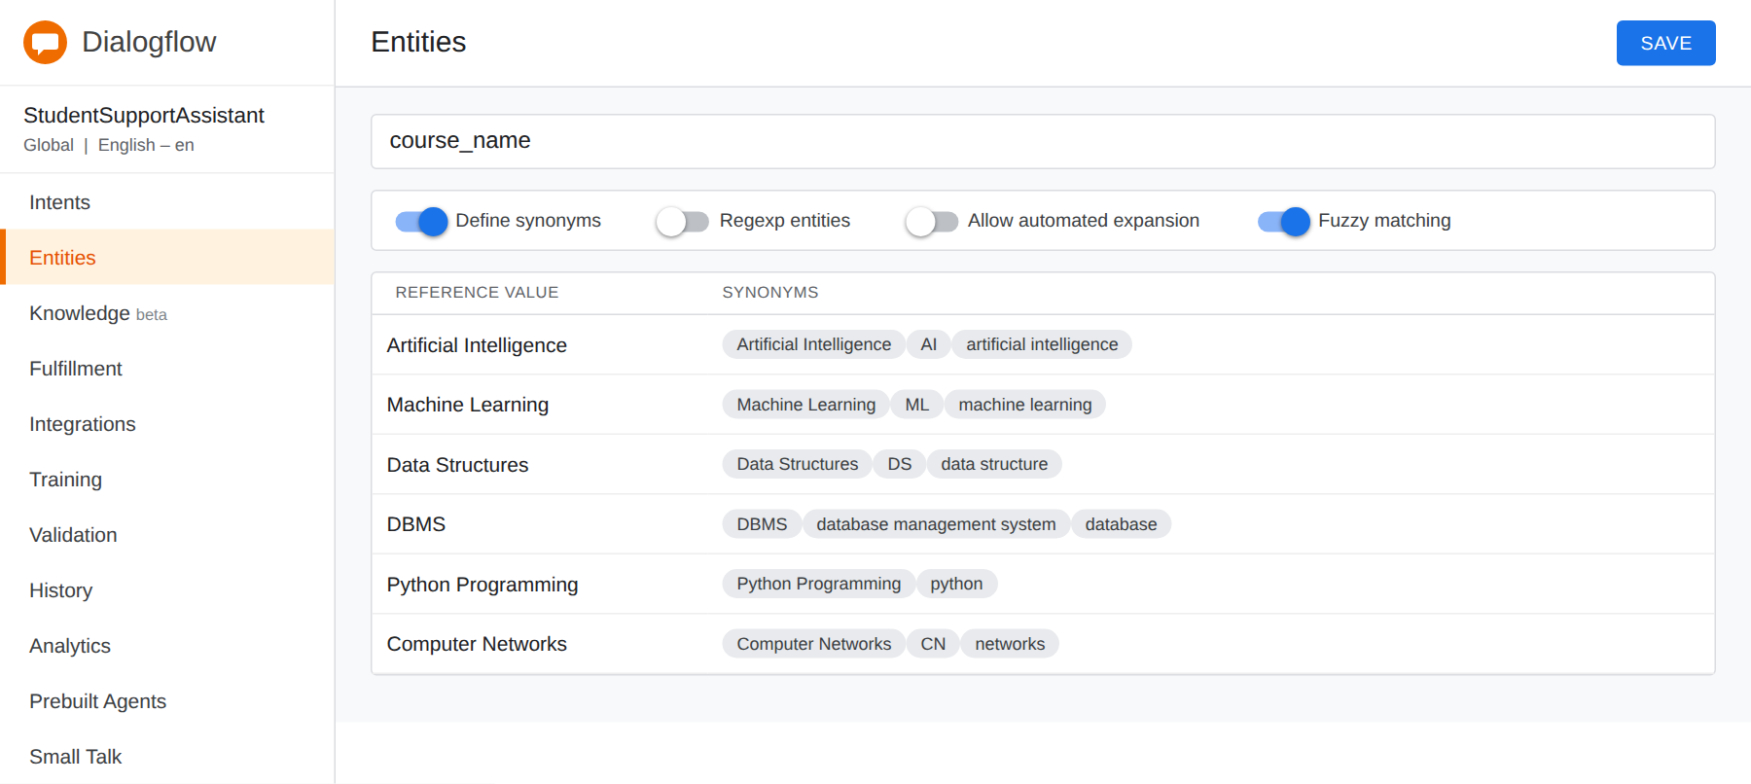
Screenshot 3: Entity @course_name with synonyms
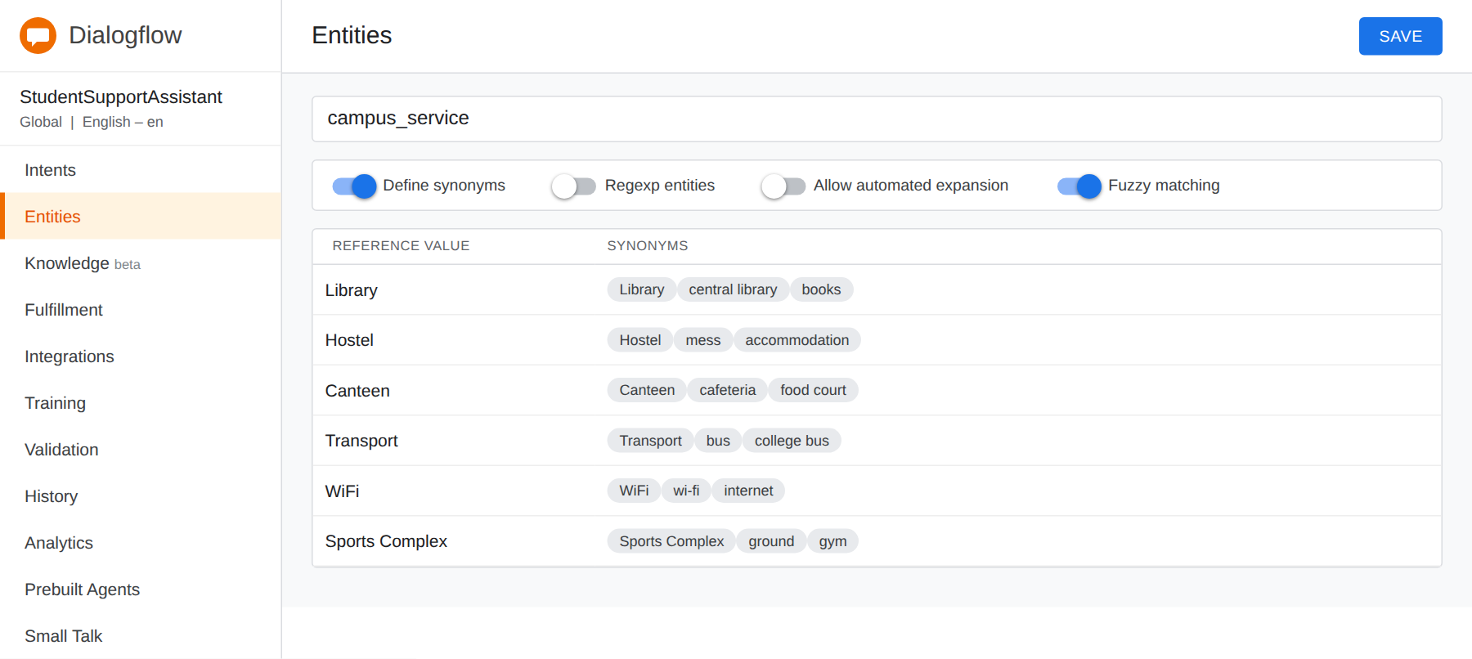
Screenshot 4: Entity @campus_service with synonyms
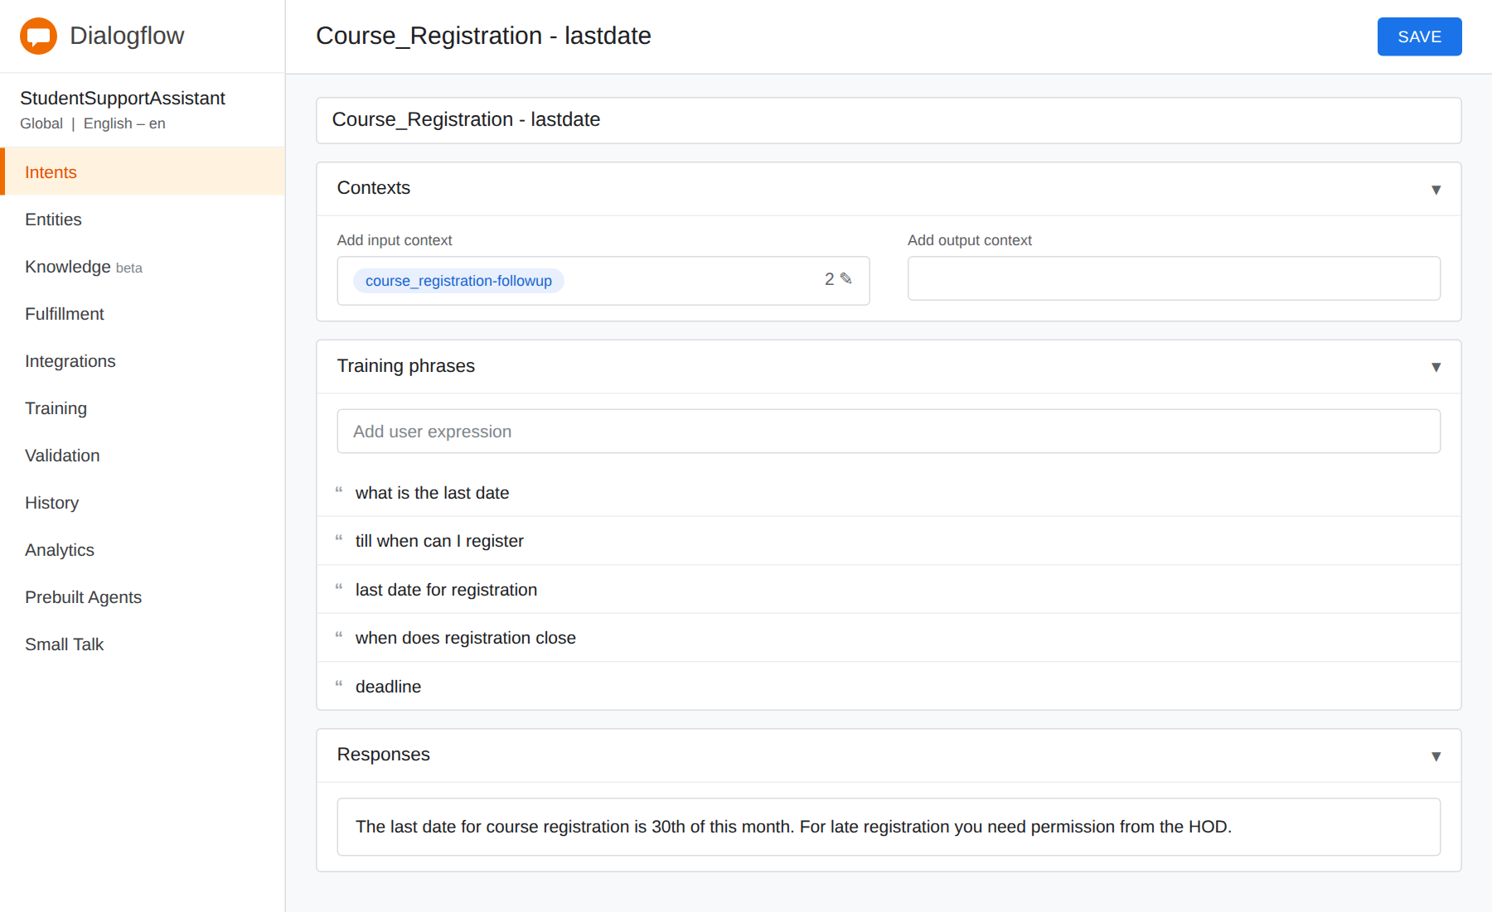
Screenshot 5: Follow-up intent Course_Registration - lastdate with input context
3 | Problem Formulation and Decision Flow: Represent the chatbot interaction as a problem-solving process by defining the initial state, user goal, possible actions, state transitions, and goal completion conditions. Draw the conversation flow diagram. | BL6 | 10
Initial State: The student opens the chat window. The agent has not got any query yet, so no intent is selected, no parameters are collected and no context is active. The bot only shows the welcome message.
User Goal: The student wants to get the correct information (course registration help, timetable, exam schedule, attendance or campus service details) quickly and with less number of messages.
Possible Actions: Greet the user, detect the intent from the query, ask for the missing details (slot filling), use the context for follow-up questions, give the answer, ask the user to rephrase when the query is not understood, ask if the user needs anything else, and end the chat.
State Transitions:
Current State | Event / Action | Next State
Start | Student opens the chat | Welcome
Welcome | Bot greets and student types a query | Intent Detection
Intent Detection | Query matches an intent | Intent Matched (Registration, Timetable, Exam, Attendance or Campus)
Intent Detection | No intent matches (low confidence) | Fallback
Fallback | Bot asks the student to rephrase | Intent Detection
Intent Matched | Required details are missing | Slot Filling (ask course, day, register no. or service)
Slot Filling | Student gives the details | Response
Intent Matched | All details are already given | Response
Response | Student asks another question | Intent Detection
Response | Student says no or thanks | Goal Reached

Goal Completion Conditions: The conversation is complete when (1) the correct intent is identified, (2) all the required parameters are collected, (3) the agent gives the correct response, and (4) the student does not need anything more (says thanks or bye). Every bot message is counted as 1 step cost, so we want to reach the goal in the minimum number of steps.
Conversation Flow Diagram:
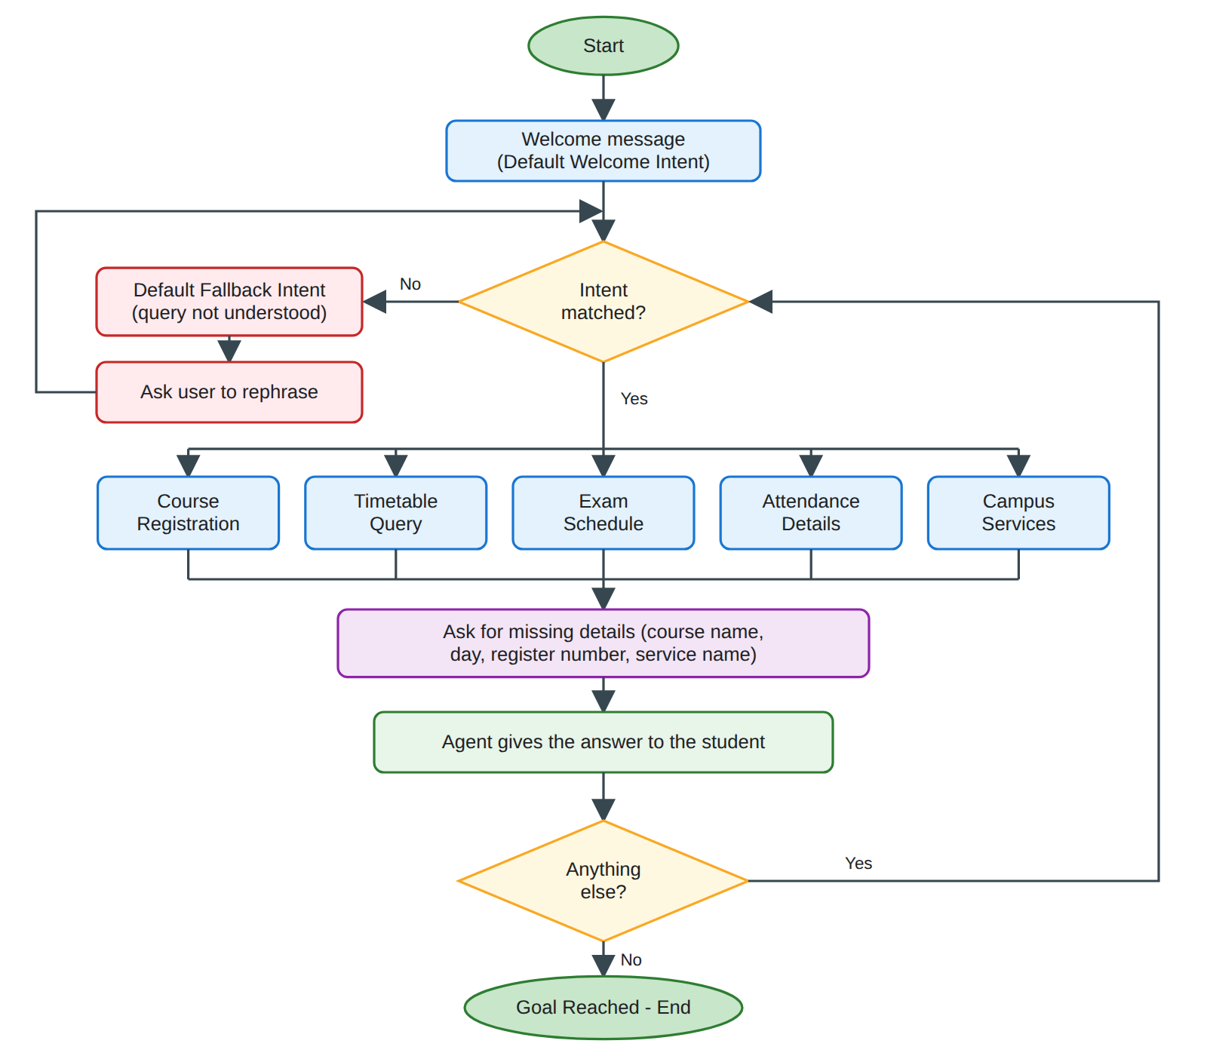
Conversation flow diagram of the Student Support Assistant
4 | Search Strategy Application: Analyze how search techniques used in AI problem solving can support conversational agents. Apply a suitable search approach (such as Breadth First Search or heuristic-based search) to model intent selection or dialogue navigation and justify your choice. | BL5 | 10
Analysis: In AI problem solving, search is used to find a path from the start state to the goal state. A conversation can also be seen as a search problem. Every dialogue state (greeting, intent detection, asking a detail, showing the answer) is a node, every bot action or user input is an edge, and the goal is the state where the student question is answered. So search techniques can help the agent to select the right intent and to move through the dialogue in the least number of steps. Uninformed search like BFS finds the shortest path, and heuristic search can use a score (like intent confidence or number of missing details) to choose the best next state.
Search approach used: Breadth First Search (BFS). I used BFS on the dialogue graph of the chatbot. It starts from the Start node, visits all the nodes of one level and then goes to the next level using a queue. A visited set is used so that the Fallback > Ask Rephrase > Detect Intent loop does not run forever.
Justification: I chose BFS because the dialogue graph is small and every step has the same cost, so BFS always gives the path with the minimum number of steps and the student gets the answer with fewer messages. BFS is also complete (it finds the goal if it exists) and it is simple to code. DFS can go deep into one branch or get stuck in a loop and it does not give the shortest path. Heuristic search like A* is better for big graphs, but here we do not have a good heuristic value for each state and the graph is small, so it is not needed.
Code:
from collections import deque

graph = {
"Start": ["Welcome"],
"Welcome": ["Detect Intent"],
"Detect Intent": [
"Registration", "Timetable", "Exam",
"Attendance", "Campus", "Fallback"
],
"Registration": ["Ask Course"],
"Ask Course": ["Ask Semester"],
"Ask Semester": ["Confirm Reg"],
"Confirm Reg": ["Goal"],
"Timetable": ["Ask Day"],
"Ask Day": ["Show Timetable"],
"Show Timetable": ["Goal"],
"Exam": ["Ask Subject"],
"Ask Subject": ["Show Exam Date"],
"Show Exam Date": ["Goal"],
"Attendance": ["Ask Reg No"],
"Ask Reg No": ["Show Attendance"],
"Show Attendance": ["Goal"],
"Campus": ["Ask Service"],
"Ask Service": ["Show Info"],
"Show Info": ["Goal"],
"Fallback": ["Ask Rephrase"],
"Ask Rephrase": ["Detect Intent"],
"Goal": []
}

targets = {
"Registration": "Confirm Reg",
"Timetable": "Show Timetable",
"Exam": "Show Exam Date",
"Attendance": "Show Attendance",
"Campus": "Show Info",
"Fallback": "Ask Rephrase"
}

keywords = {
"register": "Registration",
"enroll": "Registration",
"timetable": "Timetable",
"class": "Timetable",
"exam": "Exam",
"attendance": "Attendance",
"library": "Campus",
"hostel": "Campus",
"canteen": "Campus"
}

def find_intent(text):
text = text.lower()
for word, intent in keywords.items():
if word in text:
return intent
return "Fallback"

def bfs(start, goal):
queue = deque([[start]])
visited = {start}
explored = 0
while queue:
path = queue.popleft()
node = path[-1]
explored += 1
if node == goal:
return path, explored
for nxt in graph[node]:
if nxt not in visited:
visited.add(nxt)
queue.append(path + [nxt])
return None, explored

queries = [
"I want to register for a course",
"show my timetable",
"when is the exam",
"what is my attendance",
"where is the library",
"tell me a joke"
]

for q in queries:
intent = find_intent(q)
path, explored = bfs("Start", targets[intent])
print("Query :", q)
print("Intent :", intent)
print("Path :", " > ".join(path))
print("Steps :", len(path) - 1, "| Nodes explored:", explored)
print()

path, explored = bfs("Start", "Goal")
print("Shortest path to goal:", " > ".join(path))

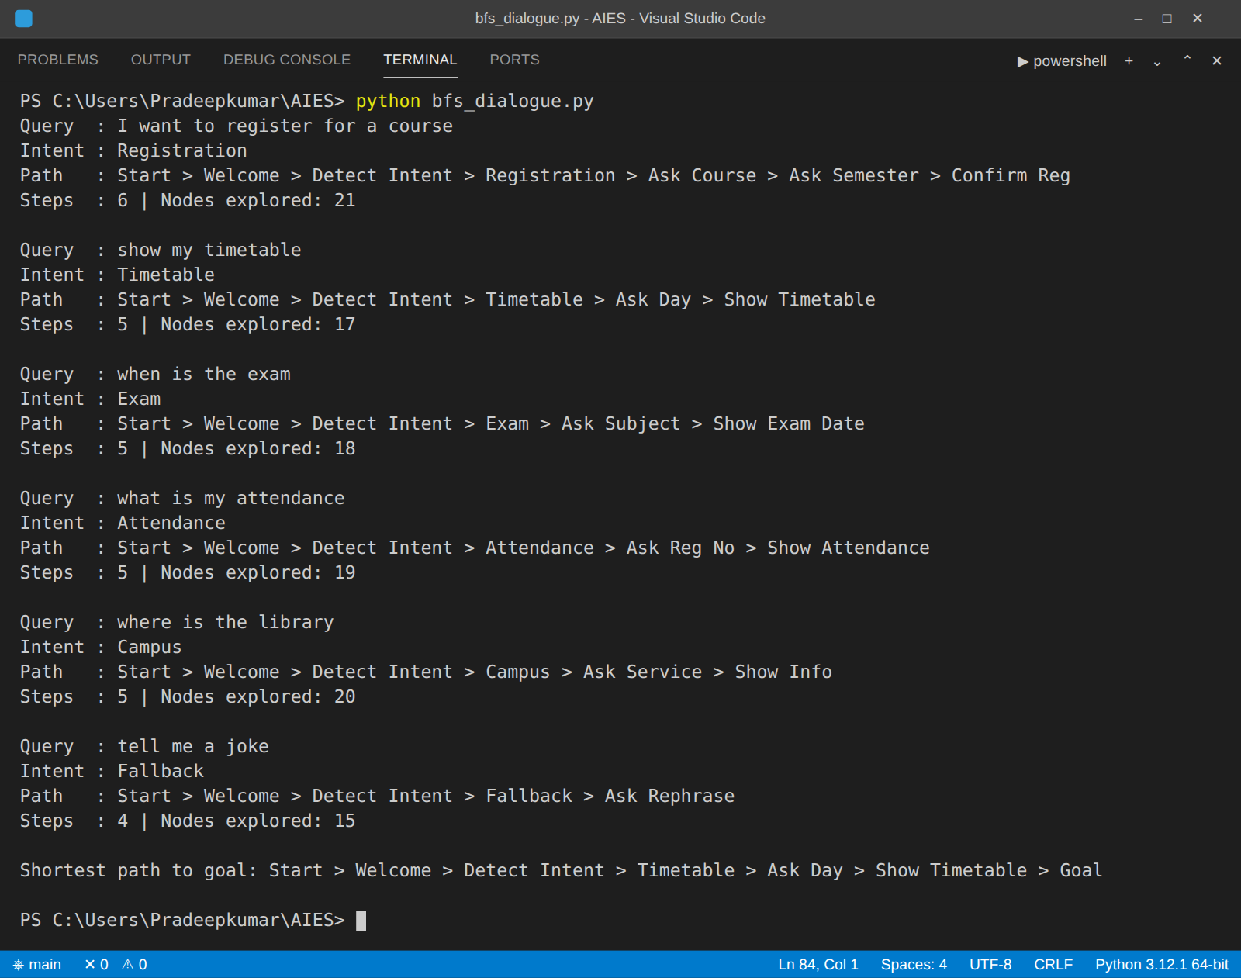
Output of bfs_dialogue.py in the VS Code terminal
5 | Testing and Evaluation: Test the Dialogflow agent with different user queries. Evaluate accuracy, response quality, handling of unknown queries, and suggest improvements. | BL6 | 10
Testing: I tested the agent in the Try it now panel of Dialogflow using different types of queries. The test results are given below.
No. | User Query | Expected Intent | Detected Intent | Result
1 | hi | Default Welcome Intent | Default Welcome Intent | Pass
2 | i want to register for machine learning | Course_Registration | Course_Registration | Pass
3 | show my timetable for tomorrow | Timetable_Query | Timetable_Query | Pass
4 | when is the AI exam | Exam_Schedule | Exam_Schedule | Pass
5 | what is my attendance percentage | Attendance_Details | Attendance_Details | Pass
6 | where is the library | Campus_Services | Campus_Services | Pass
7 | what is the last date (after registration question) | Course_Registration - lastdate | Course_Registration - lastdate | Pass
8 | is the hostel mess open now | Campus_Services | Campus_Services | Pass
9 | tell me a joke | Default Fallback Intent | Default Fallback Intent | Pass
10 | can u tell my marks | Default Fallback Intent | Default Fallback Intent | Pass
11 | do i have class on monday morning | Timetable_Query | Default Fallback Intent | Fail
12 | exam hall ticket attendance rule | Exam_Schedule | Attendance_Details | Fail

Test Screenshots:
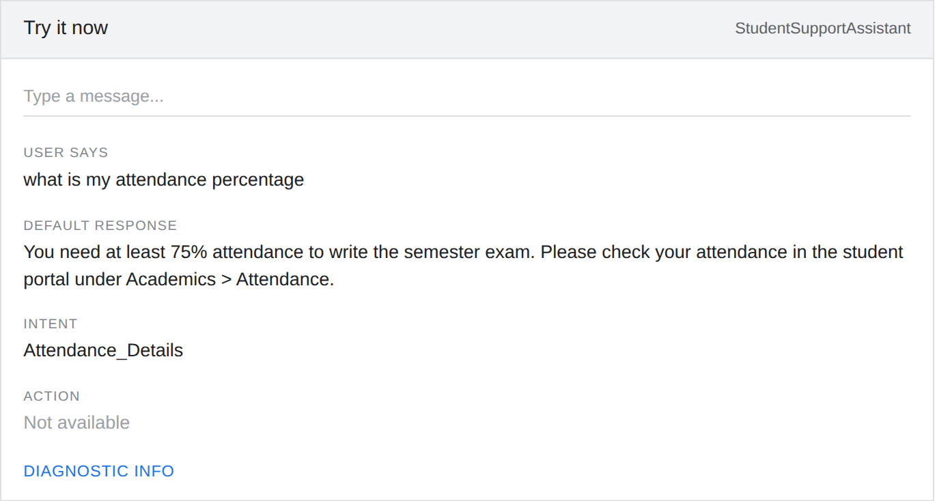
Screenshot 1: Query "what is my attendance percentage" detected as Attendance_Details
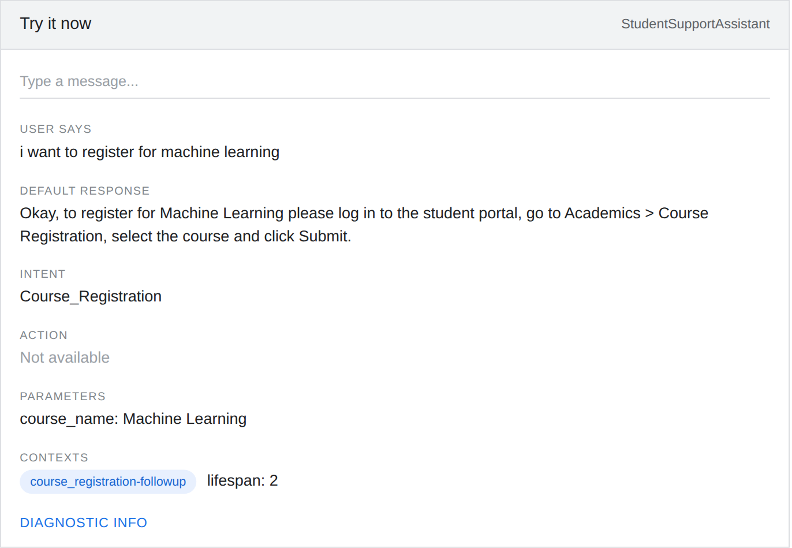
Screenshot 2: Query "i want to register for machine learning" with parameter and context
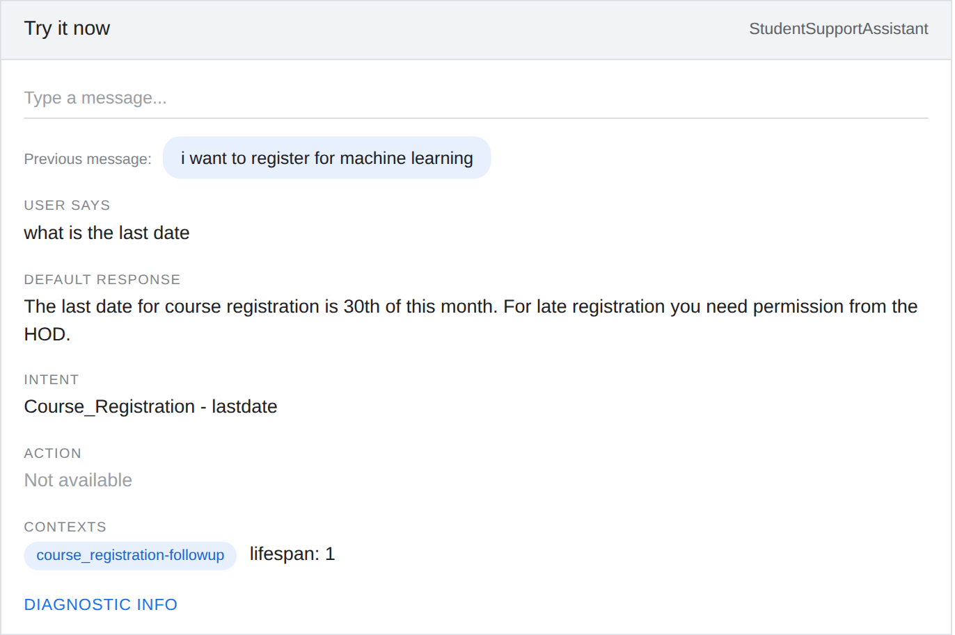
Screenshot 3: Follow-up query "what is the last date" using the context
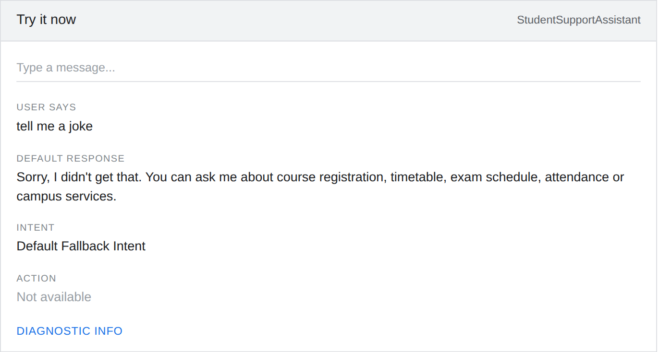
Screenshot 4: Unknown query "tell me a joke" handled by the Default Fallback Intent
Accuracy: Out of 12 test queries, 10 were detected correctly. So the accuracy = 10 / 12 x 100 = 83.3%.
Response Quality: The responses were short, clear and matched the question. The follow-up question also worked properly because of the context. But the answers are only fixed text because the agent is not connected to the real university database, so it cannot show the real attendance or timetable of a student.
Handling of Unknown Queries: For the unrelated queries like "tell me a joke" and "can u tell my marks" the Default Fallback Intent worked and showed the help message. But the same message comes every time and it does not help for the marks query. Two queries failed. "do i have class on monday morning" went to the fallback because the training phrases did not have this type of sentence, and "exam hall ticket attendance rule" got confused between Exam_Schedule and Attendance_Details because there are two topics in one sentence.
Suggested Improvements:
1. Add more training phrases (at least 15 to 20 for each intent) with different sentence styles.
2. Connect the agent to the university database using webhook fulfillment so that it gives the real timetable, exam dates and attendance.
3. Add new intents like marks/results and fee payment.
4. Use different fallback responses and add suggestion chips (buttons) like Timetable, Exam and Attendance.
5. Add a day entity and handle two topics in one query.
6. Check the History and Training tabs regularly to find wrong matches and fix them.

Evaluation Rubrics
Criteria | Weightage (%) | Excellent (Full Marks) | Good | Average | Poor
Problem  Understanding &AI Concept Identification | 20% | 10 – Clearly analyzes the student support problem, defines AI application, agent objective, users, environment, inputs, outputs, and  performance measures with proper justification. | 7.5 – Identifies  most components of the agent design with minor  omissions. | 5 – Provides  basic problem analysis with  limited  explanation of agent  components. | 0–2.5 –  Incomplete  understanding of problem and agent design.
Dialogflow Agent Design &Implementation | 30% | 10 – Successfully creates a functional Dialogflow agent with appropriate intents, entities, training phrases, responses, contexts, and explains interaction flow with screenshots. | 7.5 – Develops  major Dialogflow components with minor  configuration  errors. | 5 – Creates basic intents and  responses with limited  entity/context utilization. | 0–2.5 –  Incomplete or incorrect  Dialogflow  implementation.
Problem  Formulation &Conversation  Flow Design | 20% | 10 – Clearly represents  chatbot interaction using initial state, goal state, actions, state transitions, goal  conditions, and a  well-designed conversation flow diagram. | 7.5 – Provides a structured flow with minor  missing details. | 5 – Provides  basic flow  representation with limited  explanation. | 0–2.5 – Poor or missing  problem  formulation anddecision flow.
Application of AI Techniques &Reasoning | 20% | 10 – Correctly analyzes and applies suitable search  strategies (BFS/heuristic search) for intent selection or dialogue navigation with strong justification. | 7.5 – Applies  appropriate search strategy with  reasonable  explanation. | 5 – Provides  basic  understanding of search strategy application. | 0–2.5 – Unable to relate search concepts with conversational agent.
Testing,  Evaluation &Documentation | 10% | 10 – Performs comprehensive testing using multiple user queries, evaluates accuracy, response quality, unknown query handling, and suggests meaningful improvements. | 7.5 – Performs  adequate testing and provides  evaluation with minor gaps. | 5 – Conducts  limited testing with basic  observations. | 0–2.5 –  Insufficient  testing and  evaluation.

