PRADEEPkUMAR(192425016)
SIMATS ENGINEERING
ASSESSMENT TOOL 2

COURSE NAME: CSA16 COURSE CODE: Data Warehousing and Data Mining

COURSE OUTCOME COVERED

CO1: Design data warehouse architectures with appropriate dimensional models for effective decision support systems. BL1,BL2
Assessment Tool Weightage: 30%

QUESTIONS: 5 Total Marks:25

Concept Mapping
Annexure A

Criteria | Concept Identification (2.5) | Linkages (2.5) | Organization (2) | Integration of Literature (2) | Clarity (1) | Total(10)
Weightage | 25% | 25% | 20% | 20% | 10% | 100%
Q1
Q2
Q3
Q4
Q5

Code of Conduct:

I ____pradeepKumar________________ (Name / Reg No) certify that this submission is my original work and that I have adhered to the guidelines specified for this assessment.
I understand that any violation of academic integrity rules will result in disciplinary action.

Signature of the student:

RUBRICS FOR CALCULATION:

Concept Mapping
Criteria | Weightage | Level 4 (Exemplary) | Level 3 (Proficient) | Level 2 (Developing) | Level 1 (Beginning)
Concept Identification | 25% | Identifies all key concepts from literature accurately and comprehensively | Identifies most key concepts with minor omissions | Identifies limited concepts; some are irrelevant or missing | Fails to identify essential concepts
Linkages | 25% | Establishes clear, meaningful, and accurate relationships between concepts | Shows correct relationships with minor gaps | Relationships are weak, unclear, or partially incorrect | No meaningful relationships established
Organization | 20% | Concepts are well-structured hierarchically with logical flow and grouping | Mostly organized with minor structural issues | Some organization but lacks clear hierarchy | No logical organization or structure
Integration of Literature | 20% | Integrates multiple studies effectively to show connections and comparisons | Shows some integration of literature | Limited integration; mostly isolated concepts | No integration of literature evidence
Clarity | 10% | Concept map is clear, neat, visually structured, and easy to interpret | Generally clear with minor readability issues | Clarity is reduced; difficult to interpret in parts | Poorly presented and hard to understand

Annexure A

Concept Map 1: Decision Support Systems (DSS)

Task Description:
Construct a concept map that explains how a Decision Support System (DSS) supports organizational decision-making.

🎯 What your map must show:
- Core components: Data, Model, User Interface
- Types of DSS
- Flow: Data → Analysis → Decision
- Role in business decision-making
- Real-world example linkage

Concept Map 2: Operational Systems vs DSS

Task Description:
Develop a comparative concept map that clearly distinguishes Operational Systems (OLTP) and Decision Support Systems (OLAP).

What your map must show:
- Definitions of OLTP and DSS
- Differences (data type, purpose, users, processing)
- Similarities and interactions
- Real-time vs historical data
- Example systems (banking vs analytics)

Concept Map 3: Architecture of Data Warehouse

Task Description:
Create a hierarchical concept map illustrating the architecture of a Data Warehouse.

What your map must show:
- Data Sources → ETL → Data Warehouse → Data Marts
- Metadata layer
- Front-end tools (reporting, OLAP)
- Data flow direction
- Role of each layer

Concept Map 4: OLAP, Data Cubes & Dimensional Modeling

Task Description:
Design a concept map that connects OLAP operations, Data Cubes, and Dimensional Modeling techniques.

🎯 What your map must show:
- Data cube structure (dimensions, measures)
- OLAP operations (slice, dice, roll-up, drill-down)
- Star schema and snowflake schema
- Fact and dimension tables
- Analytical usage

Concept Map 5: Query Processing & BI Tools (KNIME)

Task Description:
Construct a concept map explaining how query processing integrates with BI tools, focusing on KNIME for reporting and OLAP applications.

What your map must show:
- Query processing stages (Parsing, Optimization, Execution)
- Role of BI tools
- KNIME workflow structure
- Data → Query → Visualization pipeline
- OLAP application integratio

Concept Map 1: Decision Support Systems (DSS)
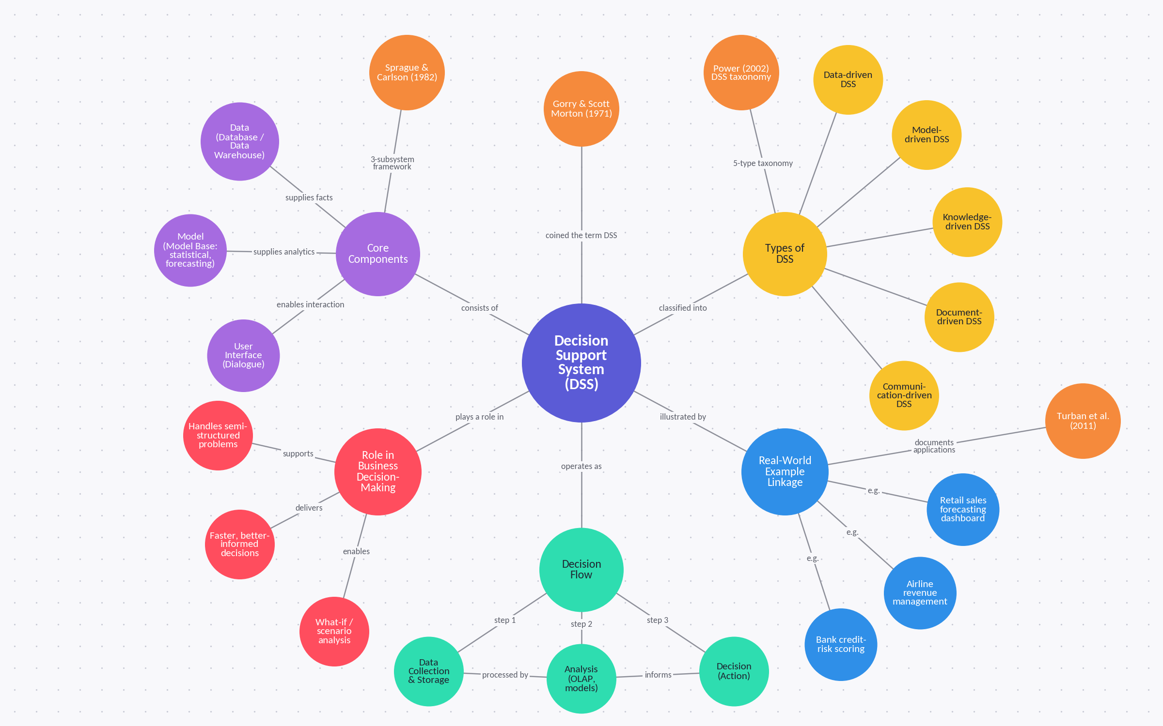
Orange nodes = literature integrated: Gorry & Scott Morton (1971); Sprague & Carlson (1982); Power (2002); Turban et al. (2011). Labelled links state how each pair of concepts is related. Full references are listed on the last page.

Concept Map 2: Operational Systems vs DSS
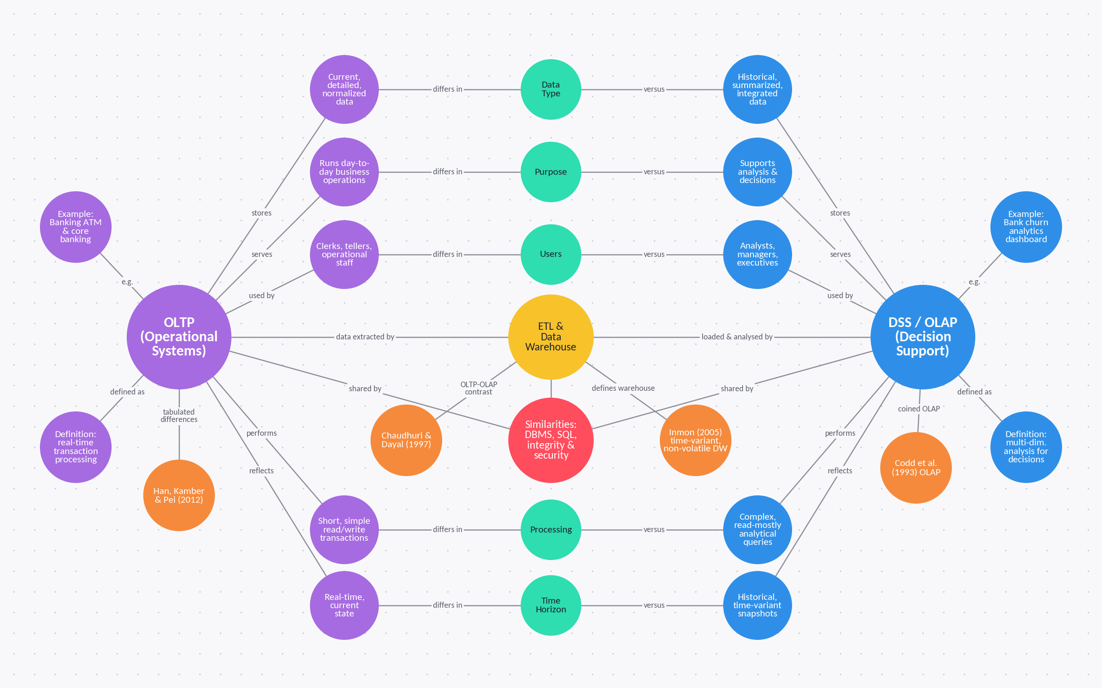
Orange nodes = literature integrated: Inmon (2005); Chaudhuri & Dayal (1997); Codd et al. (1993); Han, Kamber & Pei (2012). Labelled links state how each pair of concepts is related. Full references are listed on the last page.

Concept Map 3: Architecture of Data Warehouse
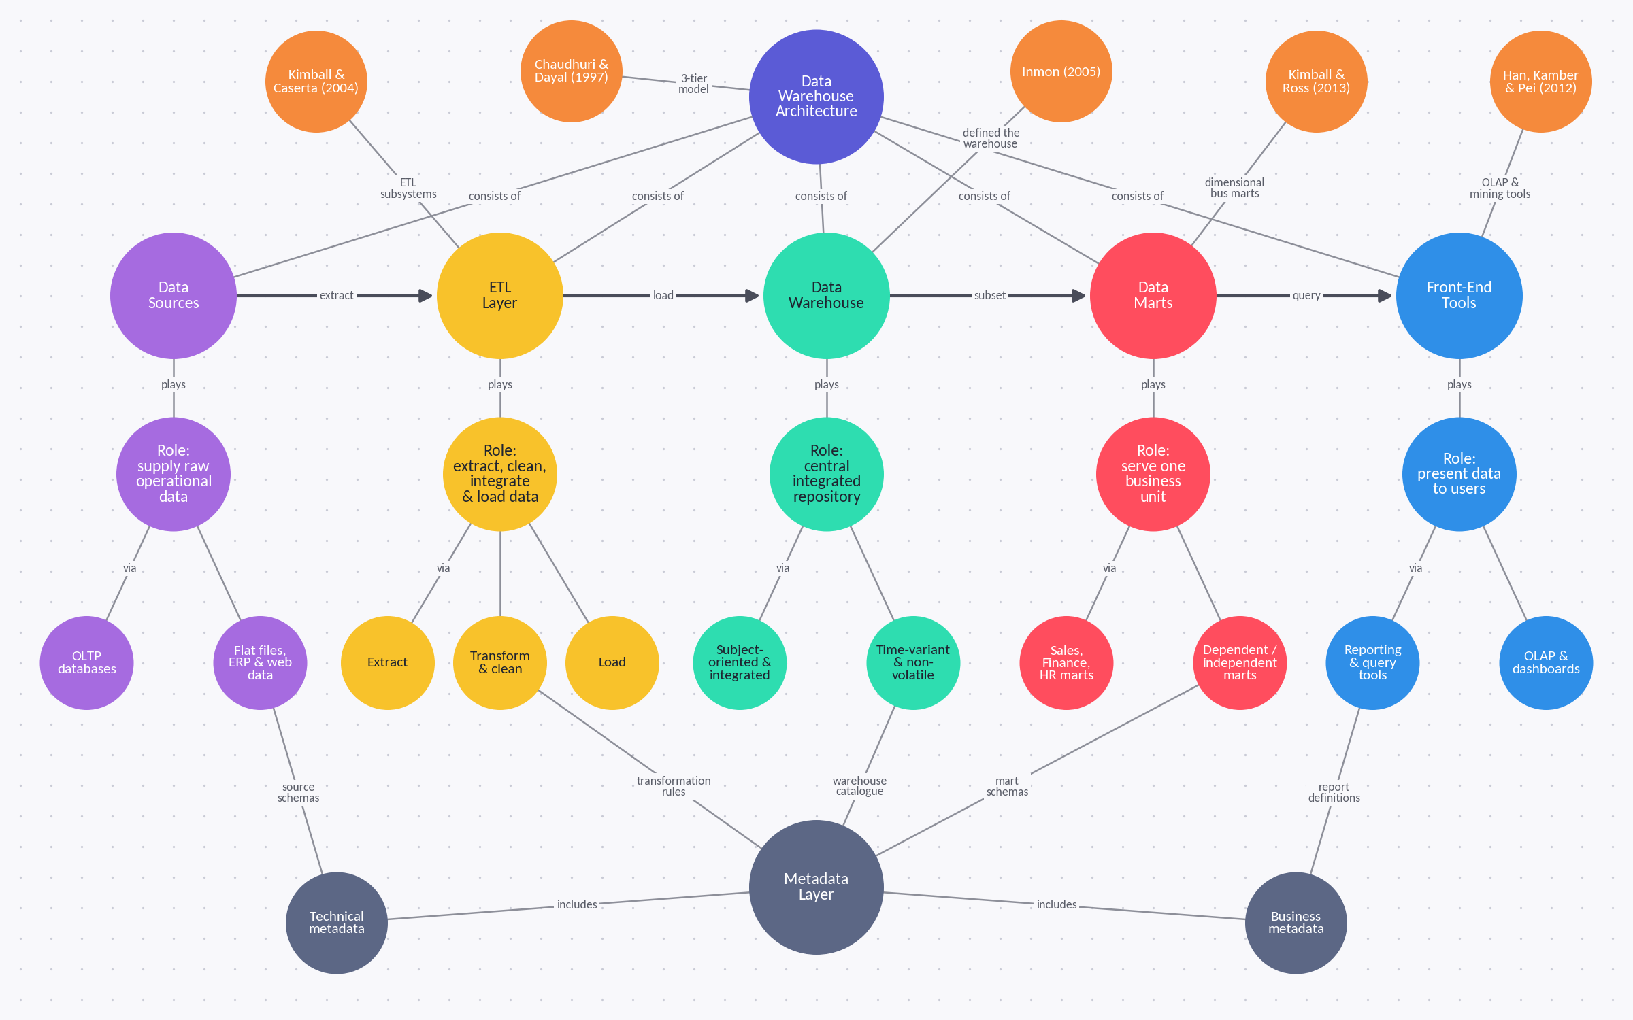
Orange nodes = literature integrated: Chaudhuri & Dayal (1997); Kimball & Caserta (2004); Inmon (2005); Kimball & Ross (2013); Han, Kamber & Pei (2012). Labelled links state how each pair of concepts is related. Full references are listed on the last page.

Concept Map 4: OLAP, Data Cubes & Dimensional Modeling
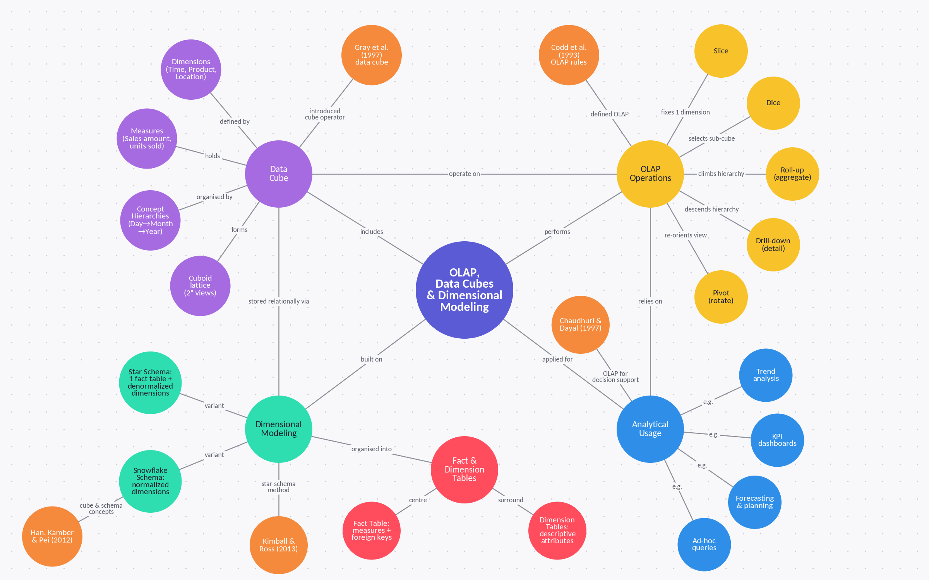
Orange nodes = literature integrated: Gray et al. (1997); Codd et al. (1993); Kimball & Ross (2013); Han, Kamber & Pei (2012); Chaudhuri & Dayal (1997). Labelled links state how each pair of concepts is related. Full references are listed on the last page.

Concept Map 5: Query Processing & BI Tools (KNIME)
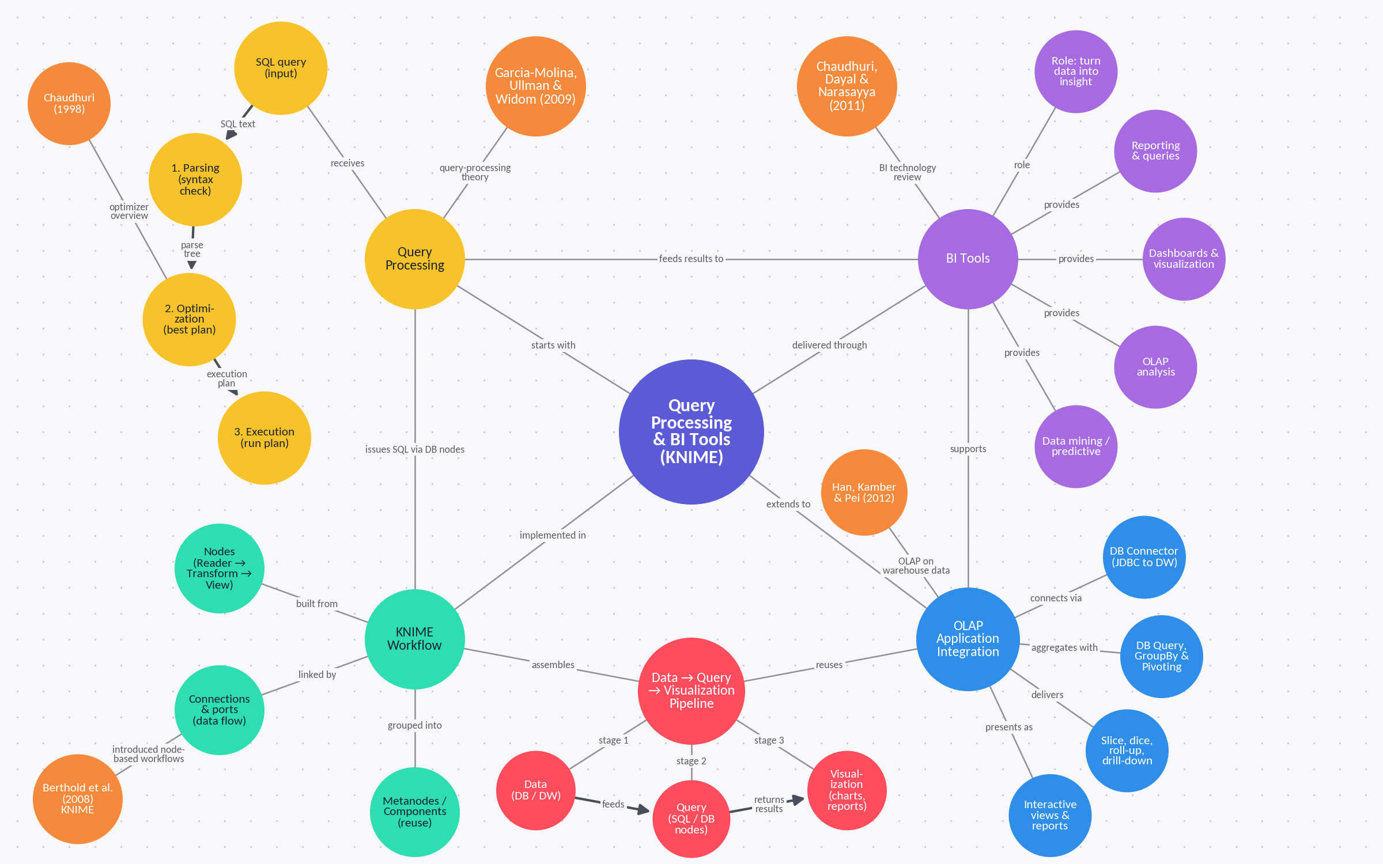
Orange nodes = literature integrated: Garcia-Molina, Ullman & Widom (2009); Chaudhuri (1998); Chaudhuri, Dayal & Narasayya (2011); Berthold et al. (2008); Han, Kamber & Pei (2012). Labelled links state how each pair of concepts is related. Full references are listed on the last page.

References (literature integrated in the concept maps)
Berthold, M. R., Cebron, N., Dill, F., Gabriel, T. R., Kötter, T., Meinl, T., Ohl, P., Sieb, C., Thiel, K., & Wiswedel, B. (2008). KNIME: The Konstanz Information Miner. In Data Analysis, Machine Learning and Applications (pp. 319–326). Springer.
Chaudhuri, S. (1998). An overview of query optimization in relational systems. Proceedings of the 17th ACM SIGACT-SIGMOD-SIGART Symposium on Principles of Database Systems (PODS), 34–43.
Chaudhuri, S., & Dayal, U. (1997). An overview of data warehousing and OLAP technology. ACM SIGMOD Record, 26(1), 65–74.
Chaudhuri, S., Dayal, U., & Narasayya, V. (2011). An overview of business intelligence technology. Communications of the ACM, 54(8), 88–98.
Codd, E. F., Codd, S. B., & Salley, C. T. (1993). Providing OLAP (On-Line Analytical Processing) to user-analysts: An IT mandate. Codd & Date, Inc.
Garcia-Molina, H., Ullman, J. D., & Widom, J. (2009). Database Systems: The Complete Book (2nd ed.). Pearson.
Gorry, G. A., & Scott Morton, M. S. (1971). A framework for management information systems. Sloan Management Review, 13(1), 55–70.
Gray, J., Chaudhuri, S., Bosworth, A., Layman, A., Reichart, D., Venkatrao, M., Pellow, F., & Pirahesh, H. (1997). Data cube: A relational aggregation operator generalizing group-by, cross-tab, and sub-totals. Data Mining and Knowledge Discovery, 1(1), 29–53.
Han, J., Kamber, M., & Pei, J. (2012). Data Mining: Concepts and Techniques (3rd ed.). Morgan Kaufmann.
Inmon, W. H. (2005). Building the Data Warehouse (4th ed.). Wiley.
Kimball, R., & Caserta, J. (2004). The Data Warehouse ETL Toolkit. Wiley.
Kimball, R., & Ross, M. (2013). The Data Warehouse Toolkit (3rd ed.). Wiley.
Power, D. J. (2002). Decision Support Systems: Concepts and Resources for Managers. Quorum Books.
Sprague, R. H., & Carlson, E. D. (1982). Building Effective Decision Support Systems. Prentice-Hall.
Turban, E., Sharda, R., & Delen, D. (2011). Decision Support and Business Intelligence Systems (9th ed.). Pearson.

