PRADEEPKUMAR S
SIMATS ENGINEERING
ASSESSMENT TOOL 1

COURSE NAME: CSA16 COURSE CODE: Data Warehousing and Data Mining

COURSE OUTCOME COVERED

CO1: Design data warehouse architectures with appropriate dimensional models for effective decision support systems. BL1,BL2
Assessment Tool Weightage: 40%

QUESTIONS: 4 Total Marks:20

Annexure A
SHORT ANSWER TEST

Criteria | Conceptual Understanding(3) | Accuracy of Answer(2.5) | Application of Knowledge(2) | Completeness of Response(1.5) | Clarity & Presentation(1) | Total(10)
Weightage | 30% | 25% | 20% | 15% | 10% | 100%
Q1
Q2
Q3
Q4

Code of Conduct:

I ___PradeepKumar_________________ (Name / Reg No) certify that this submission is my original work and that I have adhered to the guidelines specified for this assessment.
I understand that any violation of academic integrity rules will result in disciplinary action.

Signature of the student:

RUBRICS FOR CALCULATION

Criteria | Weightage | Level 4 – Exemplary (5 Marks) | Level 3 – Proficient (4 Marks) | Level 2 – Developing (2–3 Marks) | Level 1 – Beginning (0–1 Mark)
Conceptual Understanding | 30 | Demonstrates clear and complete understanding of the concept | Good understanding with minor gaps | Basic understanding with some misconceptions | Poor or incorrect understanding
Accuracy of Answer | 25 | Completely correct answer with no errors | Mostly correct with minor errors | Partially correct with noticeable errors | Incorrect or irrelevant answer
Application of Knowledge | 20 | Correctly applies concepts to solve the question/problem | Applies concepts with minor mistakes | Limited or partially correct application | No or incorrect application
Completeness of Response | 15 | Covers all required parts of the question | Covers most parts with minor omissions | Covers only some parts | Incomplete or missing response
Clarity & Presentation | 10 | Clear, concise, and well-organized answer | Understandable with minor issues | Somewhat unclear or poorly structured | Difficult to understand

Annexure A
Short Answer Test

1.Suppose that a data warehouse consists of the three dimensions time, doctor, and patient, and the two measures count and charge, where charge is the fee that a doctor charges a patient for a visit.
(a) Enumerate three classes of schemas that are popularly used for modeling data warehouses.
(b) Draw a schema diagram for the above data warehouse using one of the schema.
(c) To obtain the same list, write an SQL query assuming the data is stored in a relational database with the schema fee (day, month, year, doctor, hospital, patient, count, charge).
(5 Marks)
Ans (a): The three types of schemas used for modeling a data warehouse are:
1. Star schema – In this schema there is one fact table in the middle and all the dimension tables are connected directly to it. The diagram looks like a star.
2. Snowflake schema – This is same as the star schema but the dimension tables are split into more small tables (normalized), so the diagram looks like a snowflake.
3. Fact constellation schema – In this schema there are many fact tables and they share some of the dimension tables. It is also called galaxy schema.

Ans (b): I used the star schema for this. The fact table fee_fact is in the center and it has the two measures count and charge. It is joined to the three dimension tables time, doctor and patient using the keys.
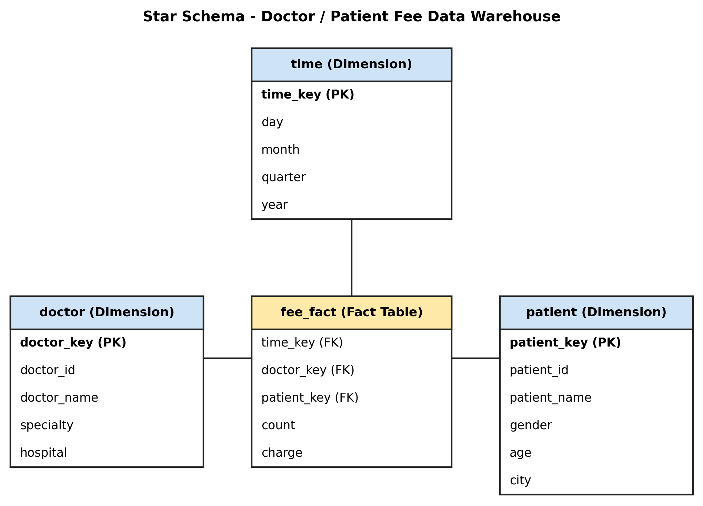

Ans (c): Here the list means the total fee collected by each doctor in 2010. The table fee (day, month, year, doctor, hospital, patient, count, charge) is created with some sample rows first. The SELECT query takes only the rows of year 2010, groups them by doctor and adds the charge of each doctor.
CREATE TABLE fee (
day INTEGER,
month INTEGER,
year INTEGER,
doctor TEXT,
hospital TEXT,
patient TEXT,
count INTEGER,
charge INTEGER
);

INSERT INTO fee VALUES
(5, 1, 2010, 'Dr. Ravi', 'City Hospital', 'Arun', 1, 500),
(12, 2, 2010, 'Dr. Ravi', 'City Hospital', 'Meena', 1, 700),
(20, 3, 2010, 'Dr. Priya', 'City Hospital', 'Karthik', 2, 1200),
(8, 5, 2010, 'Dr. Priya', 'Green Clinic', 'Divya', 1, 600),
(15, 6, 2010, 'Dr. Suresh', 'Green Clinic', 'Anand', 1, 800),
(3, 7, 2009, 'Dr. Suresh', 'Green Clinic', 'Latha', 1, 750),
(22, 9, 2010, 'Dr. Ravi', 'City Hospital', 'Vimal', 3, 1500),
(10, 11, 2011, 'Dr. Priya', 'City Hospital', 'Sneha', 1, 650);

SELECT doctor, SUM(charge) AS total_fee
FROM fee
WHERE year = 2010
GROUP BY doctor;
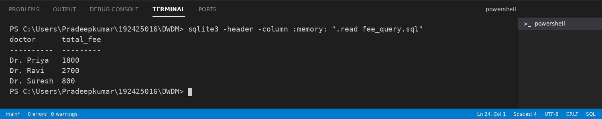

2.Suppose that a data warehouse for Big University consists of the following four dimensions: student, course, semester, and instructor, and two measures count and avg grade. When at the lowest conceptual level (e.g., for a given student, course, semester, and instructor combination), the avg grade measure stores the actual course grade of the student. At higher conceptual levels, avg grade stores the average grade for the given combination. (5 Marks)
(a) Draw a snowflake schema diagram for the data warehouse.
Ans: The snowflake schema for Big University is given below. The fact table grade_fact is in the center with the two measures count and avg_grade. The dimension tables are split into more tables. Student is split into major, status and university, course is split into department, and semester is split into year.
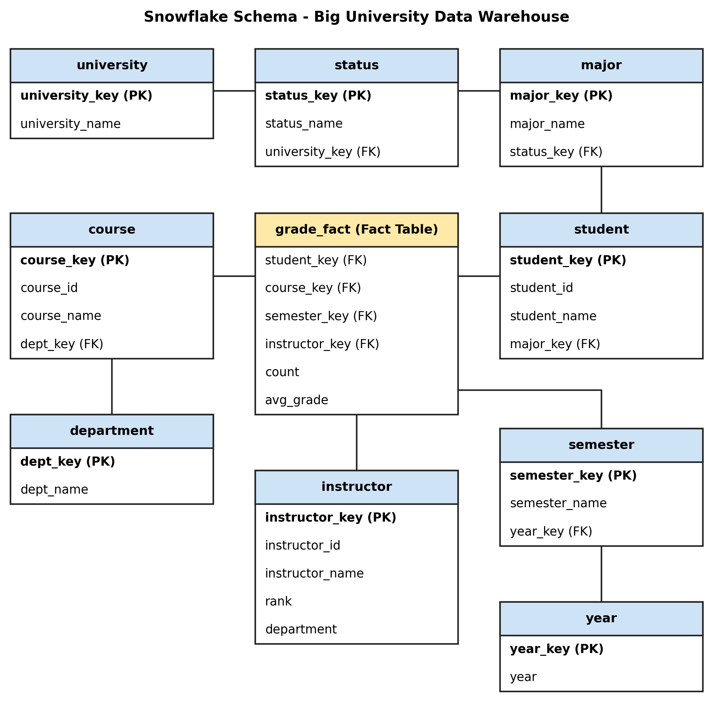
(b) Starting with the base cuboid [student,course, semester,instructor], what specific OLAP operations
(e.g., roll-up from semester to year) should one perform in order to list the average grade of CS courses
for each Big University student.
Ans: To get the average grade of CS courses for each student, we start from the base cuboid [student, course, semester, instructor] and do these OLAP operations:
1. Roll-up on course from course_id to department.
2. Roll-up on semester from semester to all, because we do not need the semester details.
3. Roll-up on instructor from instructor to all, because we do not need the instructor details.
4. Slice on the course dimension with department = “CS”, so only the CS courses are taken.
5. Keep the student dimension at the student level so that we get the result for each student.
So the final cuboid is [student, department, all, all] and it gives the average grade of CS courses for every Big University student.
(c) If each dimension has five levels (including all), such as “student < major < status < university < all”, how many cuboids will this cube contain (including the base and apex cuboids)?
Ans: The number of cuboids is the product of the number of levels of every dimension (including all). Here there are 4 dimensions and each one has 5 levels.
Total cuboids = 5 × 5 × 5 × 5 = 5⁴ = 625
So the cube will contain 625 cuboids, including the base cuboid and the apex cuboid.

3.Design a data warehouse for a regional weather bureau. The weather bureau has about 1,000 probes, which are scattered throughout various land and ocean locations in the region to collect basic weather data, including air pressure, temperature, and precipitation at each hour. All data are sent to the central station, which has collected such data for over 10 years. Your design should facilitate eﬃcient querying and on-line analytical processing, and derive general weather patterns in multidimensional space. (5 Marks)
Ans: For the weather bureau I am using a star schema because it is simple and it gives fast querying and OLAP. The design is as follows:
1. Dimension tables: time (time_key, hour, day, month, season, year), probe (probe_key, probe_id, probe_type, installed_date) and location (location_key, latitude, longitude, area, region, land_or_ocean).
2. Fact table: weather_fact has time_key, probe_key and location_key as foreign keys and the measures air_pressure, temperature and precipitation. One row is stored for each probe for every hour. For the higher levels, measures like average, maximum and minimum temperature and total precipitation can be calculated.
3. Concept hierarchies: time: hour < day < month < season < year. Location: probe < area < region < all. Land and ocean can also be used to group the locations.
4. Size of the data: 1,000 probes × 24 hours = 24,000 rows per day. For 10 years it is 24,000 × 365 × 10 = 87,600,000 rows (about 87.6 million), so the fact table is very big.
5. Efficient querying: A data cube is built using the three dimensions and some of the cuboids like [month, region] and [day, area] are pre-computed, so queries run fast. Bitmap indexes on the dimension keys and partitioning the fact table by year also help.
6. OLAP operations: Roll-up (hour to day to month), drill-down (year to month), slice (for example year = 2020), dice (for example summer season and ocean locations) and pivot can be used to see the data in different views.
7. Weather patterns: From the cube we can find general patterns like the average temperature of each region in every season, or how the rainfall is related to the fall in air pressure. Data mining can also be applied on the cube to find more patterns.
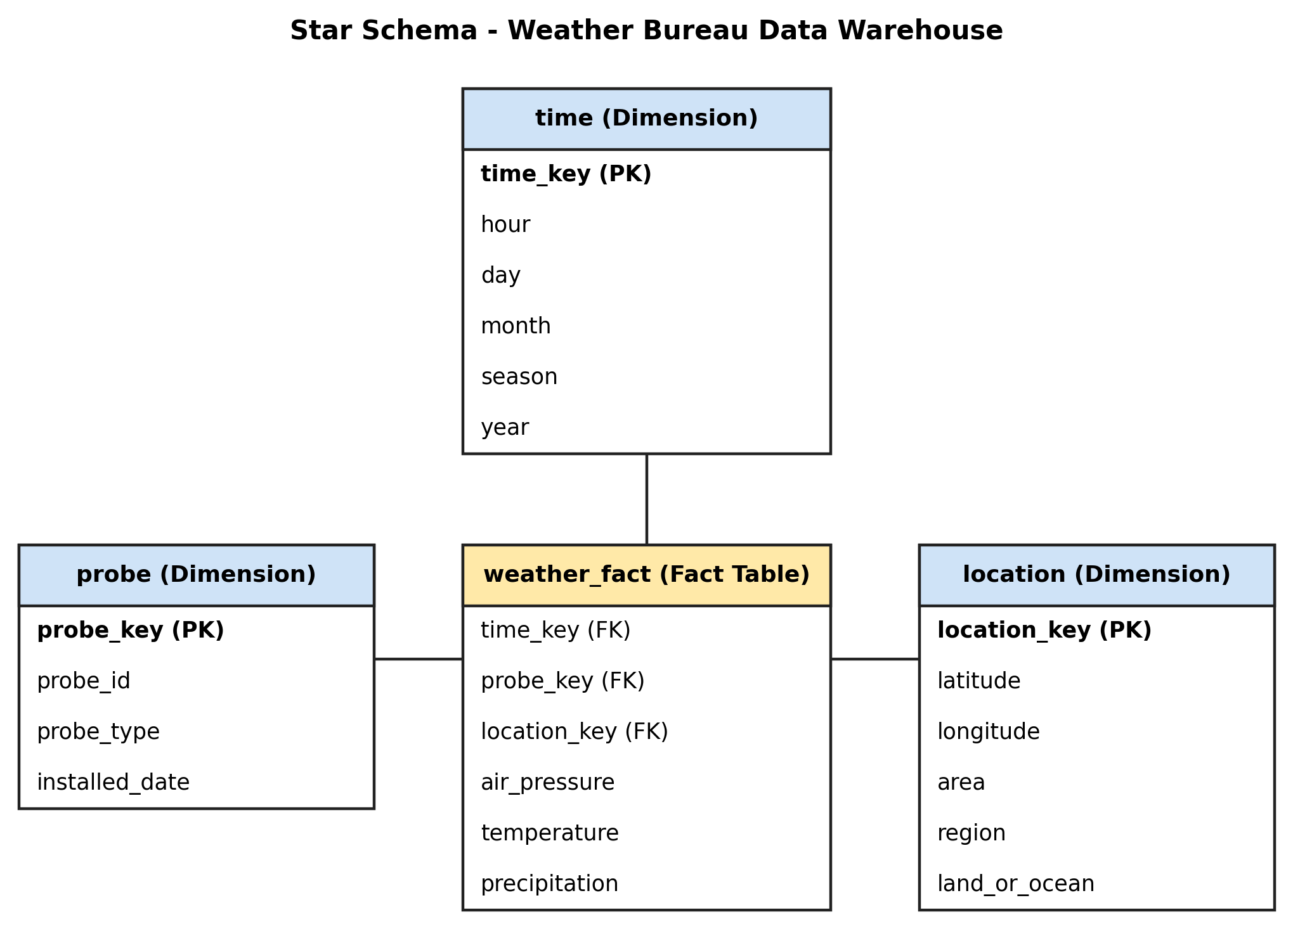

4. A data cube, C, has n dimensions, and each dimension has exactly p distinct values in the base cuboid. (5 Marks)
Assume that there are no concept hierarchies associated with the dimensions.
(a) What is the maximum number of cells possible in the base cuboid?
Ans: The base cuboid has n dimensions and each dimension has p distinct values. So the maximum number of cells = p × p × … × p (n times) = p^{n}.
(b) What is the minimum number of cells possible in the base cuboid?
Ans: The minimum number of cells in the base cuboid is p. Each dimension has exactly p distinct values and every value must come at least once, so we need at least p cells. For example the cells (1, 1, …, 1), (2, 2, …, 2), …, (p, p, …, p).
(c) What is the maximum number of cells possible (including both base cells and aggregate cells) in the
data cube, C?
Ans: In the whole data cube each dimension can take any of the p values or the value “*” (all), so every dimension has (p + 1) choices. So the maximum number of cells = (p + 1)^{n}.
(d) What is the minimum number of cells possible in the data cube, C?
Ans: The base cuboid has at least p cells. Every other cuboid (except the apex) also has at least p cells, and there are 2^{n} − 1 such cuboids including the base cuboid. The apex cuboid has only 1 cell. So the minimum number of cells = (2^{n} − 1) × p + 1.

