PRADEEPKUMAR
SIMATS ENGINEERING
ASSESSMENT TOOL 2

COURSE NAME: CSA16 COURSE CODE: Data Warehousing and Data Mining

COURSE OUTCOME COVERED

CO2: Apply suitable Data Pre processing techniques like Data cleaning, Data intergration,Data transformation and data Reduction ,for effective data preparation (BL3,BL4)
Assessment Tool Weightage: 50%

QUESTIONS: 5 Total Marks:50

Annexure A
SENARIO BASED QUESTIONS

Criteria | Understanding of Scenario (2) | Identification of Key Issues (2) | Application of Concepts (2.5) | Decision Making (2) | Clarity of Response (1.5) | Total(10)
Weightage | 20% | 20% | 25% | 20% | 15% | 100%
Q1
Q2
Q3
Q4
Q5

Code of Conduct:

I ____pradeepkumar________________ (Name / Reg No) certify that this submission is my original work and that I have adhered to the guidelines specified for this assessment.
I understand that any violation of academic integrity rules will result in disciplinary action.

Signature of the student:

RUBRICS FOR CALCULATION:

Criteria | Weightage (%) | Level 4 (Exemplary) | Level 3 (Proficient) | Level 2 (Developing) | Level 1 (Beginning)
Understanding of Scenario | 20% | Demonstrates clear and complete understanding of the scenario and context | Shows good understanding with minor gaps | Partial understanding; misses key aspects | Misinterprets or fails to understand the scenario
Identification of Key Issues | 20% | Accurately identifies all relevant issues and factors involved | Identifies most key issues with minor omissions | Identifies limited issues; some irrelevant points | Unable to identify key issues
Application of Concepts | 25% | Applies appropriate concepts effectively to address the scenario | Applies concepts with minor errors | Limited or partially correct application | Unable to apply relevant concepts
Decision Making | 20% | Makes well-reasoned, logical decisions with strong rationale | Makes reasonable decisions with some justification | Makes weak decisions with limited justification | No clear decisions made or rationale provided
Clarity of Response | 15% | Response is clear, structured, and logically presented | Generally clear with minor issues | Somewhat unclear or poorly structured | Disorganized and difficult to understand

Annexure A
Scenario based Questions

Q1. Data Preprocessing in Retail Analytics (L3, L4)
A retail analytics company is preparing customer purchase data for building a recommendation system. The dataset contains missing values, inconsistent categorical formats, and extreme values due to data collected from multiple stores and manual entries.

Sample Dataset
Customer_ID | Age | Gender | Monthly_Spend (₹K) | Purchase_Frequency | Loyalty_Level
C1 | 23 | M | 20 | 5 | Low
C2 | NaN | Male | 35 | 8 | Medium
C3 | 31 | F | NaN | 10 | High
C4 | 105 | Female | 500 | 50 | High
C5 | 27 | male | 25 | NaN | Low
C6 | 40 | FEMALE | 45 | 12 | Medium
C7 | 36 | M | 38 | 9 | Low
C8 | 42 | Female | 300 | 45 | High

Tasks

A. Handling Missing Values
i. Identify missing values in Age, Monthly_Spend, and Purchase_Frequency
ii. Apply at least two imputation techniques (e.g., Median Imputation, k-NN Imputation)
iii. Compute the imputed values and justify the selected method
Ans: i. Missing values: Age has 1 missing value (C2), Monthly_Spend has 1 (C3) and Purchase_Frequency has 1 (C5).
ii. I used two methods, median imputation and k-NN imputation with k = 2.
iii. Median imputation gave Age (C2) = 36, Monthly_Spend (C3) = 38 and Purchase_Frequency (C5) = 10. k-NN imputation gave Age = 33.5, Monthly_Spend = 36.5 and Purchase_Frequency = 7.5. I selected median imputation because the data has very big values like 105, 500 and 50 which pull the mean up, but the median is not affected by them. It is also simple and fast.
import pandas as pd
import numpy as np
from sklearn.impute import KNNImputer

df = pd.DataFrame({
"Customer_ID": ["C1","C2","C3","C4","C5","C6","C7","C8"],
"Age": [23, np.nan, 31, 105, 27, 40, 36, 42],
"Monthly_Spend": [20, 35, np.nan, 500, 25, 45, 38, 300],
"Purchase_Frequency": [5, 8, 10, 50, np.nan, 12, 9, 45]
})

cols = ["Age", "Monthly_Spend", "Purchase_Frequency"]
print("Missing values:")
print(df[cols].isnull().sum())

med = df.copy()
for c in cols:
med[c] = med[c].fillna(df[c].median())
print("\nMedian imputation:")
print(med)

knn = KNNImputer(n_neighbors=2)
knn_df = df.copy()
knn_df[cols] = knn.fit_transform(df[cols])
print("\nkNN imputation (k=2):")
print(knn_df.round(2))
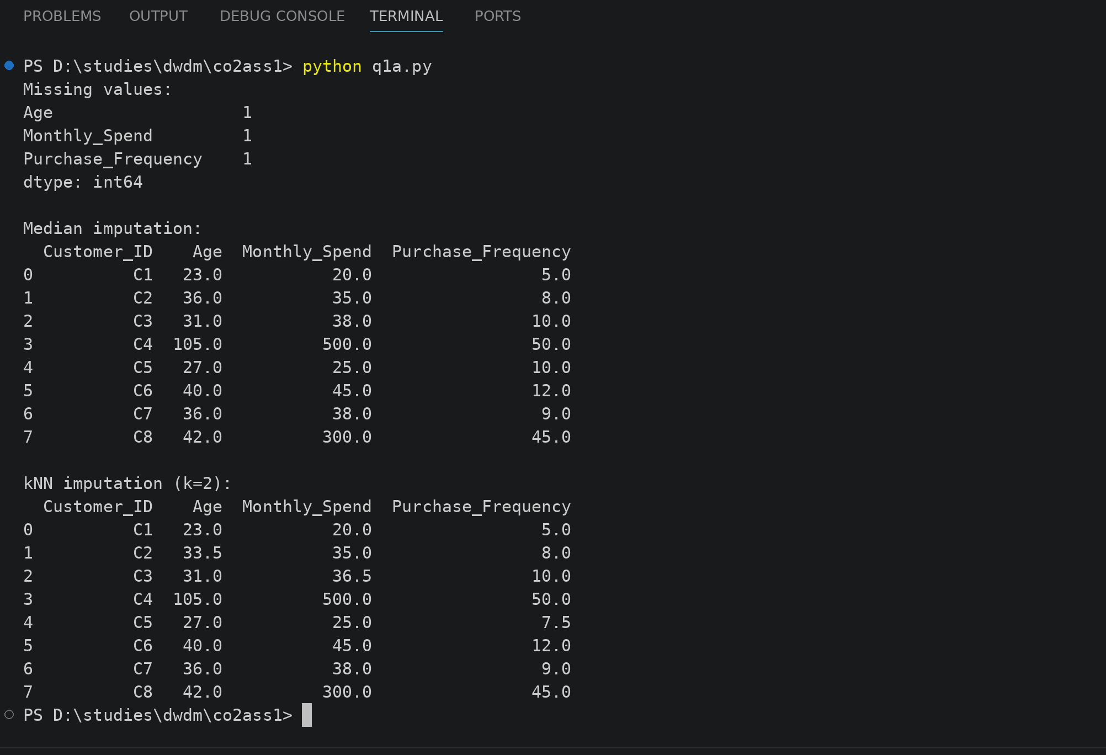

B. Outlier Detection and Treatment
i. Detect outliers in Age and Monthly_Spend using the Z-score method
ii. Identify records containing extreme values (e.g., Age = 105, Spend = 500)
iii. Apply suitable treatment methods (capping / transformation / removal) and justify
Ans: i. I found the Z-score of Age and Monthly_Spend using Z = (X - mean) / standard deviation, after filling the missing values with the median.
ii. Record C4 is the extreme one. Its Age = 105 has Z = 2.56 and its Monthly_Spend = 500 has Z = 2.25. Since there are only 8 records, the Z-score can never reach 3, so I used |Z| > 2 as the limit.
iii. I used capping, so Age 105 became 91.2 and Monthly_Spend 500 became 458.2 (mean + 2 std). I did not remove the record because we have only 8 rows and removing C4 would waste its other values. Capping keeps the record but reduces the effect of the extreme value.
import pandas as pd
import numpy as np

df = pd.DataFrame({
"Customer_ID": ["C1","C2","C3","C4","C5","C6","C7","C8"],
"Age": [23, np.nan, 31, 105, 27, 40, 36, 42],
"Monthly_Spend": [20, 35, np.nan, 500, 25, 45, 38, 300]
})

for c in ["Age", "Monthly_Spend"]:
df[c] = df[c].fillna(df[c].median())
df["Z_" + c] = ((df[c] - df[c].mean()) / df[c].std(ddof=0)).round(2)

print(df)

out = df[(df["Z_Age"].abs() > 2) | (df["Z_Monthly_Spend"].abs() > 2)]
print("\nOutlier records (|Z| > 2):")
print(out[["Customer_ID", "Age", "Monthly_Spend"]])

capped = df[["Customer_ID", "Age", "Monthly_Spend"]].copy()
for c in ["Age", "Monthly_Spend"]:
low = df[c].mean() - 2 * df[c].std(ddof=0)
high = df[c].mean() + 2 * df[c].std(ddof=0)
capped[c] = capped[c].clip(low, high).round(1)

print("\nAfter capping at mean +/- 2 std:")
print(capped)
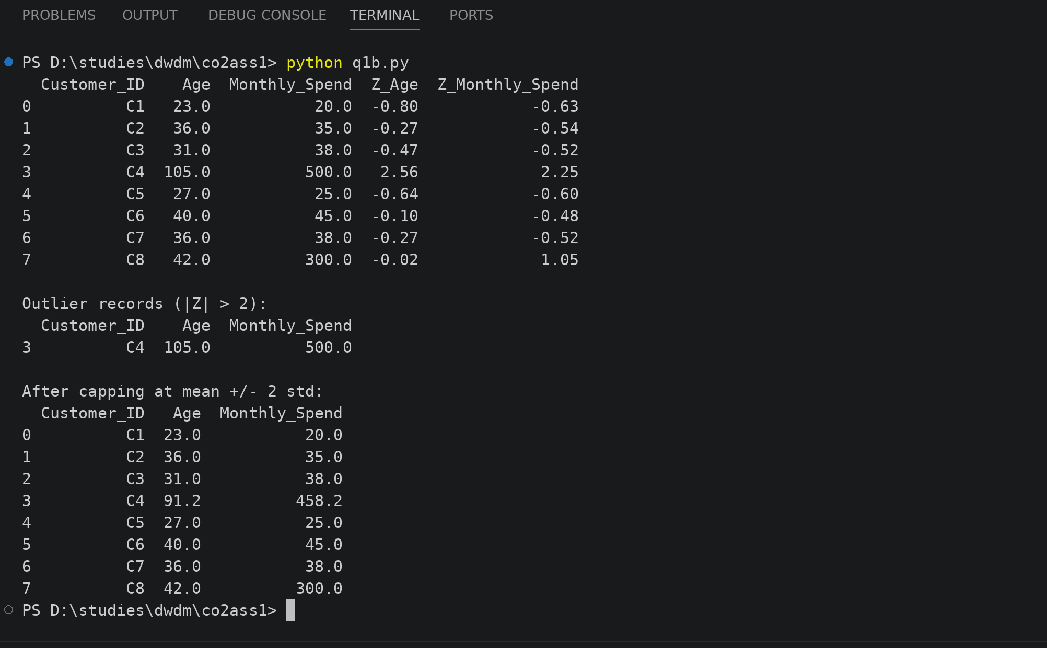

C. Categorical Data Standardization
i. Identify inconsistencies in Gender (M, Male, male, FEMALE, etc.)
ii. Convert all entries into a standardized format (Male / Female)
Ans: i. Gender is written in many ways for the same thing: M, Male, male, F, Female and FEMALE. This is inconsistent.
ii. I changed all the entries to lowercase first and then mapped them to Male or Female. Now only two values are left, Male and Female.
import pandas as pd

df = pd.DataFrame({
"Customer_ID": ["C1","C2","C3","C4","C5","C6","C7","C8"],
"Gender": ["M","Male","F","Female","male","FEMALE","M","Female"]
})

print("Before:", list(df["Gender"].unique()))

mapping = {"m": "Male", "male": "Male", "f": "Female", "female": "Female"}
df["Gender"] = df["Gender"].str.lower().map(mapping)

print("After:", list(df["Gender"].unique()))
print()
print(df)
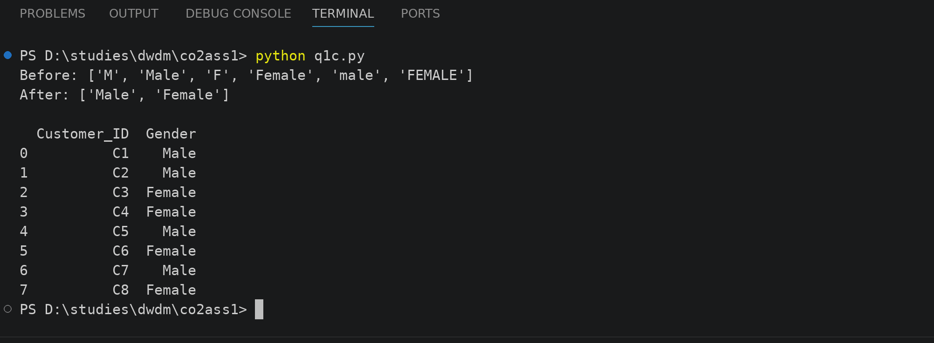
Q2. Covariance & Data Reduction in E-commerce Analytics (L4, L5)
An e-commerce platform is building a predictive model to classify high-value customers. The dataset includes several correlated financial and behavioral attributes, leading to redundancy and increased computational cost.

Sample Dataset
Cust_ID | Age | Income (₹K) | Purchase_Value (₹K) | Credit_Score | Orders | Avg_Balance (₹K) | EMI (₹) | Customer_Class
U1 | 24 | 40 | 100 | 650 | 15 | 12 | 5000 | Low
U2 | 34 | 60 | 150 | 700 | 20 | 18 | 7000 | Medium
U3 | 44 | 85 | 210 | 720 | 28 | 25 | 9000 | Medium
U4 | 52 | 120 | 320 | 800 | 35 | 40 | 15000 | High
U5 | 29 | 45 | 110 | 680 | 18 | 14 | 5500 | Low
U6 | 39 | 75 | 180 | 710 | 24 | 22 | 8500 | Medium
U7 | 56 | 150 | 360 | 820 | 40 | 50 | 18000 | High
U8 | 37 | 70 | 160 | 705 | 22 | 20 | 8000 | Medium

Tasks

A. Covariance Analysis
i. Compute covariance between Income and Purchase_Value (show steps or partial calculation)
ii. Interpret whether the relationship is positive or negative
iii. Explain how covariance helps in identifying feature relationships
Ans: i. Mean of Income = 80.625 and mean of Purchase_Value = 198.75. For each customer I multiplied (Income - mean) with (Purchase_Value - mean), for example for U1 it is (40 - 80.625) x (100 - 198.75) = 4011.72. Adding all 8 products gives 24706.25. Covariance = 24706.25 / (8 - 1) = 3529.46.
ii. The covariance is positive, so Income and Purchase_Value increase together. When income goes up the purchase value also goes up.
iii. Covariance shows if two features move in the same direction (positive), in opposite direction (negative) or have no relation (near 0). Features with a strong covariance carry almost the same information, so it helps us to find related features and remove the repeated ones.
import numpy as np

income = np.array([40, 60, 85, 120, 45, 75, 150, 70])
purchase = np.array([100, 150, 210, 320, 110, 180, 360, 160])

n = len(income)
mi = income.mean()
mp = purchase.mean()
print("Mean Income =", mi)
print("Mean Purchase_Value =", mp)

di = income - mi
dp = purchase - mp
prod = di * dp
print("\nIncome dev :", di)
print("Purchase dev:", dp)
print("Products :", prod)

total = prod.sum()
print("\nSum of products =", total)
print("Covariance (n-1) =", round(total / (n - 1), 2))
print("Check with numpy =", round(np.cov(income, purchase)[0][1], 2))
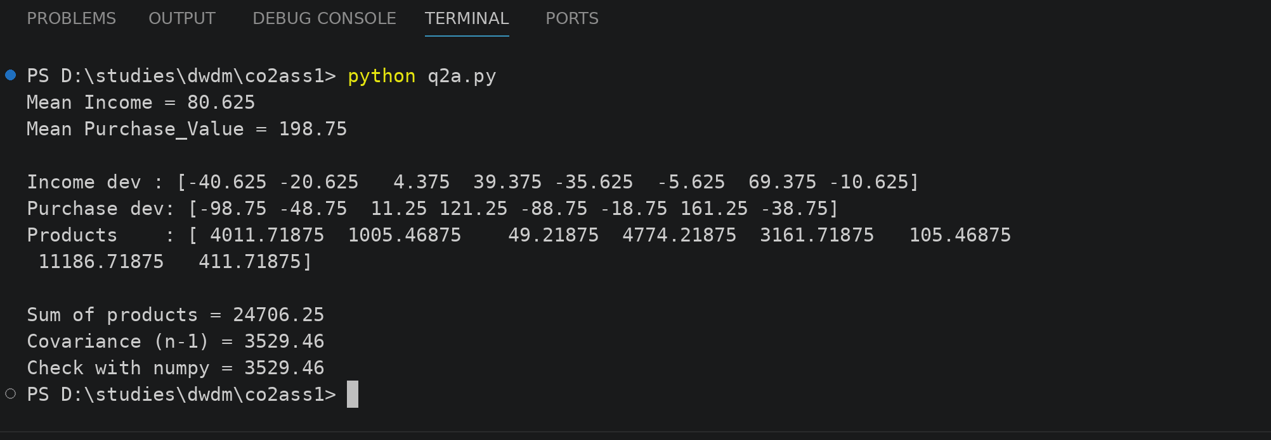

B. Feature Selection
i. Identify redundant attributes using correlation or domain knowledge
ii. Select an optimal subset of features for modeling
iii. Justify your selection
Ans: i. In the correlation matrix almost all the attributes are above 0.95 with each other. Income and Avg_Balance is 0.996, Income and Purchase_Value is 0.993, Income and Orders is 0.993, Income and EMI is 0.993. So these attributes are redundant.
ii. Selected features: Age, Income and Credit_Score. Dropped features: Purchase_Value, Orders, Avg_Balance and EMI.
iii. I dropped a feature if its correlation with an already selected feature was 0.99 or more. Income already covers Purchase_Value, Orders, Avg_Balance and EMI. Age and Credit_Score are kept because they are less correlated with Income (0.976 and 0.983) and they give different information (age of the customer and credit trust). This reduces 7 features to 3, so the model becomes faster.
import pandas as pd
pd.set_option("display.width", 100)
pd.set_option("display.max_columns", 20)

df = pd.DataFrame({
"Age": [24, 34, 44, 52, 29, 39, 56, 37],
"Income": [40, 60, 85, 120, 45, 75, 150, 70],
"Purchase_Value": [100, 150, 210, 320, 110, 180, 360, 160],
"Credit_Score": [650, 700, 720, 800, 680, 710, 820, 705],
"Orders": [15, 20, 28, 35, 18, 24, 40, 22],
"Avg_Balance": [12, 18, 25, 40, 14, 22, 50, 20],
"EMI": [5000, 7000, 9000, 15000, 5500, 8500, 18000, 8000]
})

corr = df.corr().round(3)
print(corr)

keep = []
for c in df.columns:
if all(abs(corr.loc[c, k]) < 0.99 for k in keep):
keep.append(c)

print("\nSelected features:", keep)
print("Dropped features :", [c for c in df.columns if c not in keep])
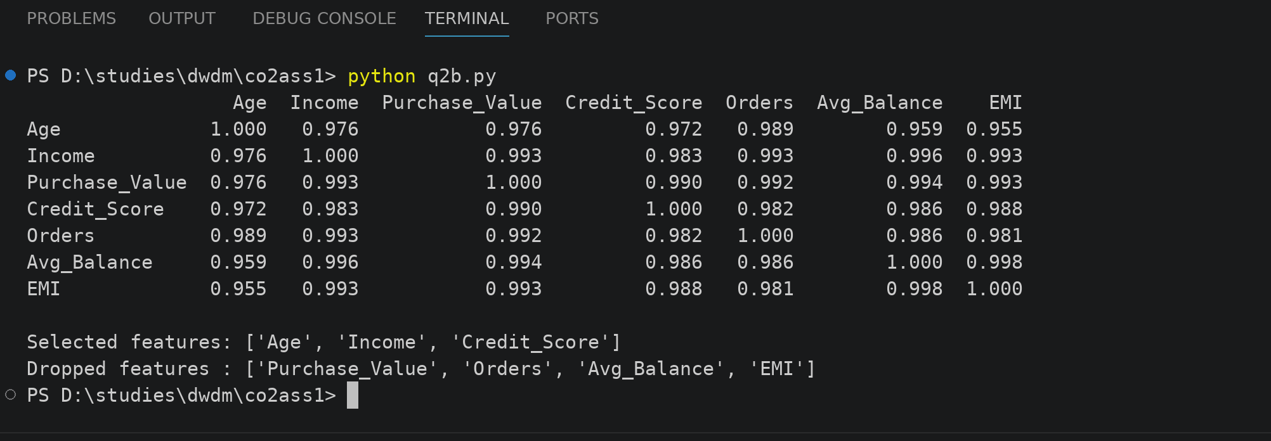

C. Data Transformation
i. Standardize the dataset (excluding Cust_ID and Customer_Class)
ii. Explain why normalization/standardization is required
Ans: i. I standardized the 7 numeric columns (Age, Income, Purchase_Value, Credit_Score, Orders, Avg_Balance and EMI) using z = (x - mean) / std. Cust_ID and Customer_Class are not changed. After this every column has mean 0 and standard deviation 1.
ii. The attributes have very different ranges, for example EMI goes up to 18000 but Orders is only up to 40. The big valued attributes would dominate the model. Standardization brings all the features to the same scale so that every feature gets equal importance and the training is also faster.
import pandas as pd
from sklearn.preprocessing import StandardScaler

pd.set_option("display.width", 100)
pd.set_option("display.max_columns", 20)

df = pd.DataFrame({
"Cust_ID": ["U1","U2","U3","U4","U5","U6","U7","U8"],
"Age": [24, 34, 44, 52, 29, 39, 56, 37],
"Income": [40, 60, 85, 120, 45, 75, 150, 70],
"Purchase_Value": [100, 150, 210, 320, 110, 180, 360, 160],
"Credit_Score": [650, 700, 720, 800, 680, 710, 820, 705],
"Orders": [15, 20, 28, 35, 18, 24, 40, 22],
"Avg_Balance": [12, 18, 25, 40, 14, 22, 50, 20],
"EMI": [5000, 7000, 9000, 15000, 5500, 8500, 18000, 8000],
"Customer_Class": ["Low","Medium","Medium","High","Low","Medium","High","Medium"]
})

num = ["Age", "Income", "Purchase_Value", "Credit_Score", "Orders", "Avg_Balance", "EMI"]
scaler = StandardScaler()
z = pd.DataFrame(scaler.fit_transform(df[num]), columns=num).round(2)
z.insert(0, "Cust_ID", df["Cust_ID"])

print(z)
print("\nMean after scaling:", z[num].mean().abs().round(2).tolist())
print("Std after scaling :", z[num].std(ddof=0).round(2).tolist())
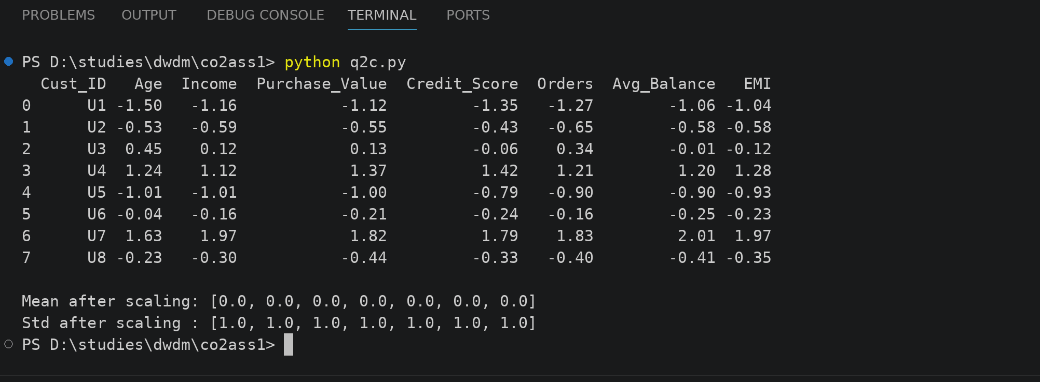

Q3. Data Transformation & Discretization in Education Analytics (L3, L4, L5)
An education analytics team is developing a model to predict student performance. Continuous variables such as study hours and test scores need to be discretized to improve interpretability and decision-making.

Sample Dataset
Student_ID | Study_Hours | Test_Score | Attendance (%) | Performance
S1 | 2 | 40 | 60 | Poor
S2 | 3 | 50 | 65 | Average
S3 | 4 | 55 | 70 | Average
S4 | 5 | 65 | 75 | Good
S5 | 6 | 75 | 80 | Good
S6 | 7 | 85 | 85 | Good
S7 | 8 | 90 | 88 | Excellent
S8 | 9 | 95 | 90 | Excellent
S9 | 10 | 98 | 92 | Excellent
S10 | 11 | 100 | 95 | Excellent

Tasks

A. Equal-Width Binning
i. Apply 3 bins for Study_Hours and Test_Score
ii. Calculate bin width and define intervals
Ans: i. For Study_Hours, min = 2 and max = 11, so bin width = (11 - 2) / 3 = 3. Intervals are 2-5, 5-8 and 8-11. For Test_Score, min = 40 and max = 100, so bin width = (100 - 40) / 3 = 20. Intervals are 40-60, 60-80 and 80-100.
ii. Study_Hours: Bin1 = S1 to S4, Bin2 = S5 to S7, Bin3 = S8 to S10. Test_Score: Bin1 = S1 to S3, Bin2 = S4 and S5, Bin3 = S6 to S10. The number of records in each bin is not equal in equal-width binning.
import pandas as pd

pd.set_option("display.width", 100)

df = pd.DataFrame({
"Student_ID": ["S1","S2","S3","S4","S5","S6","S7","S8","S9","S10"],
"Study_Hours": [2, 3, 4, 5, 6, 7, 8, 9, 10, 11],
"Test_Score": [40, 50, 55, 65, 75, 85, 90, 95, 98, 100]
})

for col in ["Study_Hours", "Test_Score"]:
low = df[col].min()
high = df[col].max()
width = (high - low) / 3
edges = [float(low), float(low + width), float(low + 2 * width), float(high)]
print(col, "-> width = (", high, "-", low, ") / 3 =", width)
print("Intervals:", edges)
df[col + "_Bin"] = pd.cut(df[col], bins=edges, labels=["Bin1", "Bin2", "Bin3"], include_lowest=True)

print()
print(df)
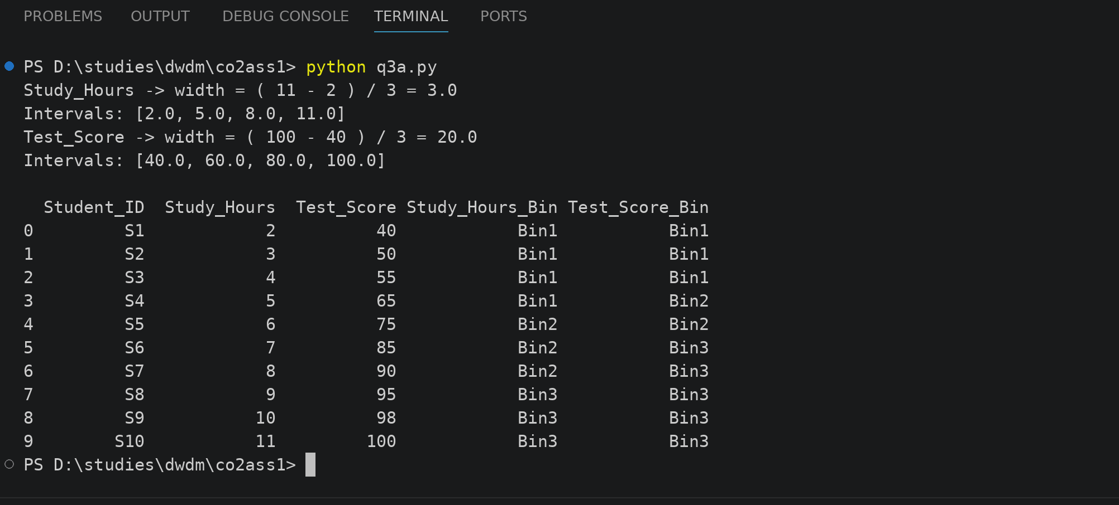

B. Equal-Frequency Binning
i. Divide data into 3 bins with equal records
ii. Assign values accordingly
Ans: i. There are 10 records, so they cannot be divided into 3 exactly equal bins. The bins have 4, 3 and 3 records.
ii. Study_Hours: Bin1 = 2, 3, 4, 5 (S1 to S4), Bin2 = 6, 7, 8 (S5 to S7), Bin3 = 9, 10, 11 (S8 to S10). Test_Score: Bin1 = 40, 50, 55, 65 (S1 to S4), Bin2 = 75, 85, 90 (S5 to S7), Bin3 = 95, 98, 100 (S8 to S10).
import pandas as pd

pd.set_option("display.width", 100)

df = pd.DataFrame({
"Student_ID": ["S1","S2","S3","S4","S5","S6","S7","S8","S9","S10"],
"Study_Hours": [2, 3, 4, 5, 6, 7, 8, 9, 10, 11],
"Test_Score": [40, 50, 55, 65, 75, 85, 90, 95, 98, 100]
})

df["Hours_Bin"] = pd.qcut(df["Study_Hours"], 3, labels=["Bin1", "Bin2", "Bin3"])
df["Score_Bin"] = pd.qcut(df["Test_Score"], 3, labels=["Bin1", "Bin2", "Bin3"])

print(df)
print()
print("Records in each Hours bin:")
print(df["Hours_Bin"].value_counts(sort=False))
print()
print("Records in each Score bin:")
print(df["Score_Bin"].value_counts(sort=False))
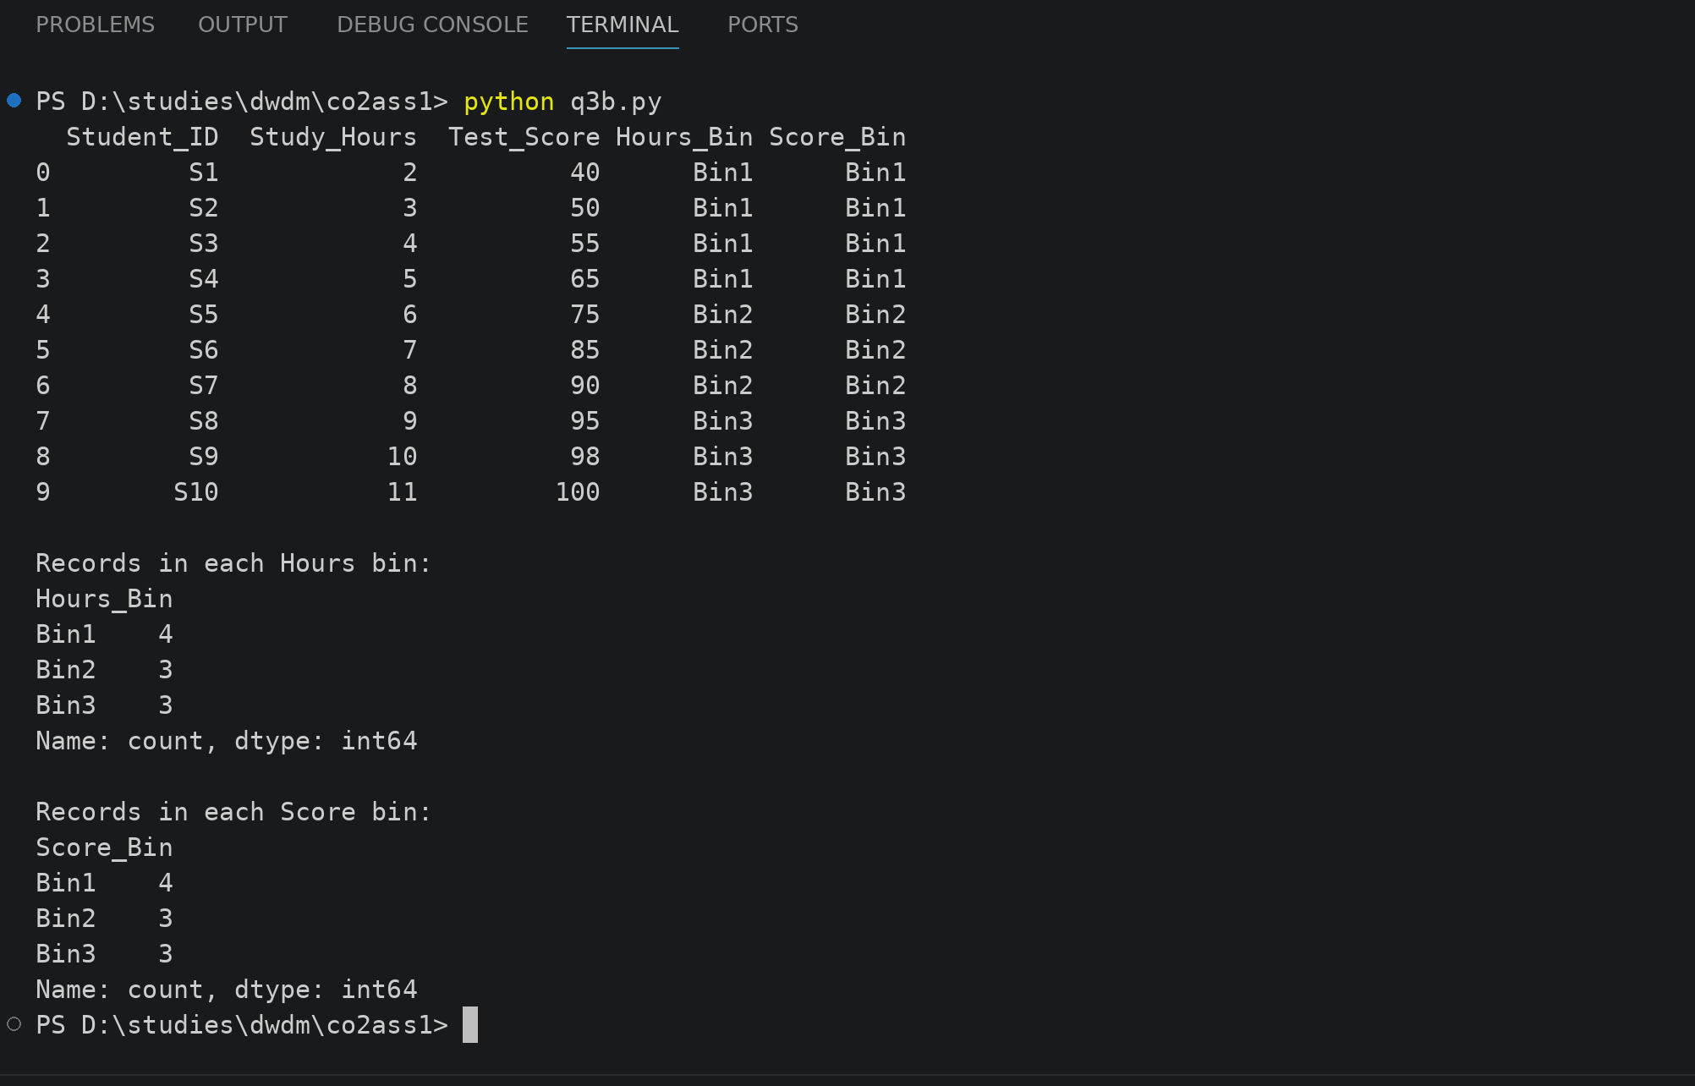

C. Concept Hierarchy Construction
- Study_Hours → Low / Medium / High
- Test_Score → Poor / Average / Excellent
Ans: Study_Hours: Low = 2 to 5 hours (S1 to S4), Medium = 6 to 8 hours (S5 to S7), High = 9 to 11 hours (S8 to S10). Test_Score: Poor = 40 to 60 (S1 to S3), Average = 61 to 80 (S4 and S5), Excellent = 81 to 100 (S6 to S10). I used the equal-width intervals from part A for the levels.
import pandas as pd

pd.set_option("display.width", 100)

df = pd.DataFrame({
"Student_ID": ["S1","S2","S3","S4","S5","S6","S7","S8","S9","S10"],
"Study_Hours": [2, 3, 4, 5, 6, 7, 8, 9, 10, 11],
"Test_Score": [40, 50, 55, 65, 75, 85, 90, 95, 98, 100]
})

df["Hours_Level"] = pd.cut(df["Study_Hours"], bins=[2, 5, 8, 11], labels=["Low", "Medium", "High"], include_lowest=True)
df["Score_Level"] = pd.cut(df["Test_Score"], bins=[40, 60, 80, 100], labels=["Poor", "Average", "Excellent"], include_lowest=True)

print(df)
print()
print(df["Hours_Level"].value_counts(sort=False))
print()
print(df["Score_Level"].value_counts(sort=False))
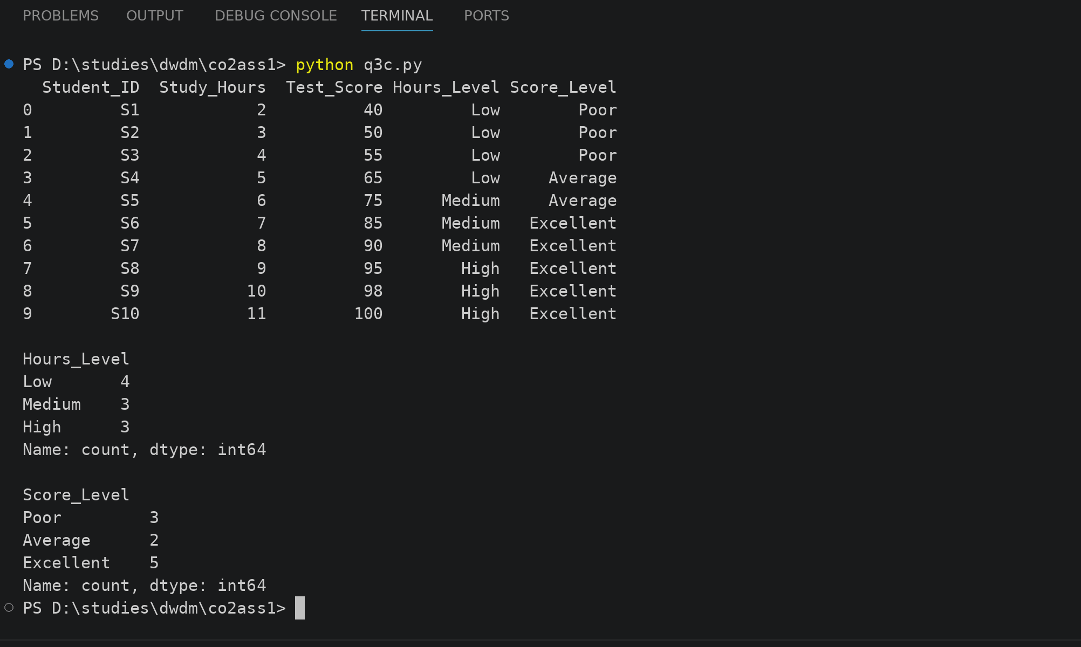
4. Use the two methods below to normalize the following group of data:
200, 300,400, 600, 1000
(a) min-max normalization by setting min = 0 and max = 1
Ans: min = 200 and max = 1000. Using v' = (v - min) / (max - min), the new values are 200 -> 0, 300 -> 0.125, 400 -> 0.25, 600 -> 0.5 and 1000 -> 1.
data = [200, 300, 400, 600, 1000]

mn = min(data)
mx = max(data)
print("min =", mn, " max =", mx)

result = []
for x in data:
v = (x - mn) / (mx - mn)
print("(", x, "-", mn, ") / (", mx, "-", mn, ") =", round(v, 3))
result.append(round(v, 3))

print("\nMin-max normalized data:", result)
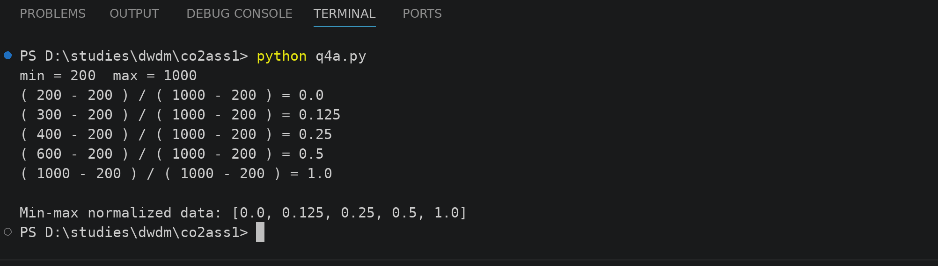
(b) z-score normalization
Ans: mean = (200 + 300 + 400 + 600 + 1000) / 5 = 500 and standard deviation = 282.84. Using z = (v - mean) / std, the new values are 200 -> -1.061, 300 -> -0.707, 400 -> -0.354, 600 -> 0.354 and 1000 -> 1.768. I used the population standard deviation here.
import numpy as np

data = np.array([200, 300, 400, 600, 1000])

mean = data.mean()
std = data.std()
print("mean =", mean)
print("std =", round(std, 3))

z = (data - mean) / std
for x, v in zip(data, z):
print("(", x, "-", int(mean), ") /", round(std, 3), "=", round(v, 3))

print("\nZ-score normalized data:", z.round(3).tolist())
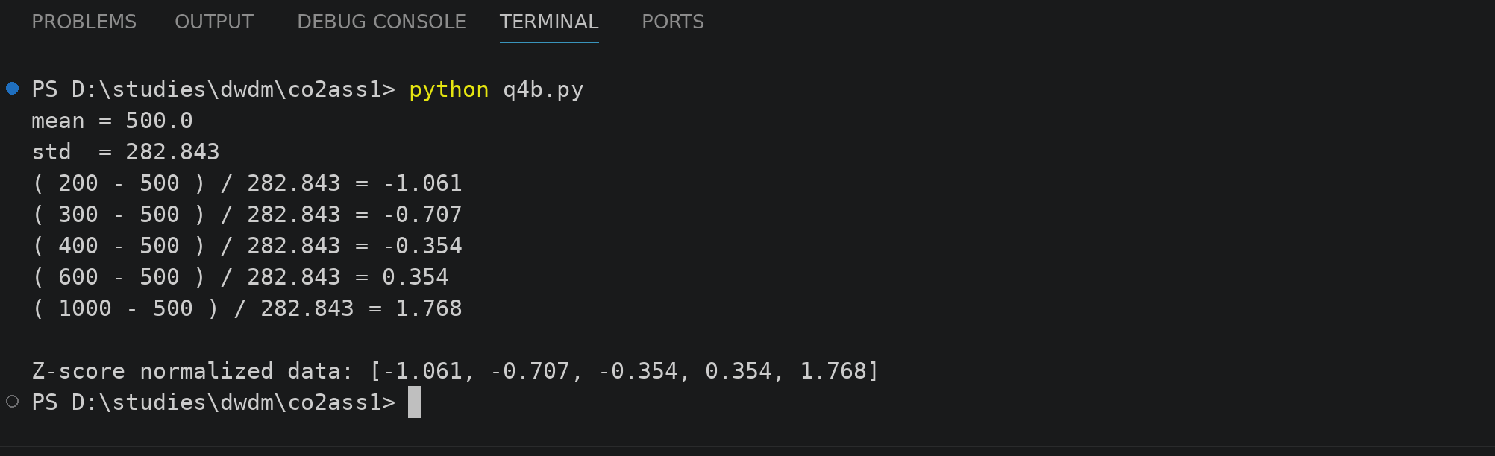

5. Data Transformation in Online Shopping Behavior Analysis (L3, L4, L5)
An e-commerce company is analyzing customer engagement by measuring the time spent (in seconds) on product pages. The duration varies significantly—from a few seconds to more than an hour—resulting in highly skewed data.
To improve the effectiveness of customer segmentation using clustering techniques, the dataset must be properly transformed and normalized.

📊 Sample Dataset: Visit Duration
Customer_ID | Visit_Duration (seconds)
C1 | 15
C2 | 30
C3 | 45
C4 | 60
C5 | 120
C6 | 300
C7 | 600
C8 | 900
C9 | 1800
C10 | 3600

✅ Tasks

A. Equal-Frequency Binning
i. Divide the dataset into 3 bins with approximately equal number of records
ii. Assign each value to its respective bin
iii. Analyze how effectively this method groups short and long visit durations
Ans: i. There are 10 records so the 3 bins have 4, 3 and 3 records.
ii. Bin1 (short) = C1 to C4 (15, 30, 45, 60 sec), Bin2 (medium) = C5 to C7 (120, 300, 600 sec), Bin3 (long) = C8 to C10 (900, 1800, 3600 sec).
iii. This method groups short and long visits quite well because every bin gets nearly the same number of customers. But the long bin is very wide (900 to 3600 sec), so a customer with 900 sec and a customer with 3600 sec are put in the same group, while the short bin is very tight (15 to 60 sec).
import pandas as pd

pd.set_option("display.width", 100)

df = pd.DataFrame({
"Customer_ID": ["C1","C2","C3","C4","C5","C6","C7","C8","C9","C10"],
"Visit_Duration": [15, 30, 45, 60, 120, 300, 600, 900, 1800, 3600]
})

df["Bin"] = pd.qcut(df["Visit_Duration"], 3, labels=["Short", "Medium", "Long"])
print(df)
print()
print(df["Bin"].value_counts(sort=False))
print()
print(df.groupby("Bin", observed=True)["Visit_Duration"].agg(["min", "max", "mean"]).round(1))


B. Z-Score Normalization
i. Compute the mean and standard deviation of visit duration
ii. Apply Z-score normalization:
$$Z=\frac{X-μ}{σ}$$
iii. Discuss how this method handles extreme values (e.g., 1800, 3600 seconds)
Ans: i. Mean = 747 seconds and standard deviation = 1090.92 seconds.
ii. Using Z = (X - 747) / 1090.92 the values are C1 = -0.671, C2 = -0.657, C3 = -0.643, C4 = -0.630, C5 = -0.575, C6 = -0.410, C7 = -0.135, C8 = 0.140, C9 = 0.965 and C10 = 2.615.
iii. The extreme values are still visible after z-score, 3600 sec gives 2.615 and 1800 sec gives 0.965, so they are not removed and there is no fixed limit. But the mean and std are also pulled by these big values, so the small visit durations all get squeezed between -0.671 and -0.575.
import pandas as pd

pd.set_option("display.width", 100)

df = pd.DataFrame({
"Customer_ID": ["C1","C2","C3","C4","C5","C6","C7","C8","C9","C10"],
"Visit_Duration": [15, 30, 45, 60, 120, 300, 600, 900, 1800, 3600]
})

mean = df["Visit_Duration"].mean()
std = df["Visit_Duration"].std(ddof=0)
print("Mean =", mean)
print("Std =", round(std, 2))
print()

df["Z_Score"] = ((df["Visit_Duration"] - mean) / std).round(3)
print(df)
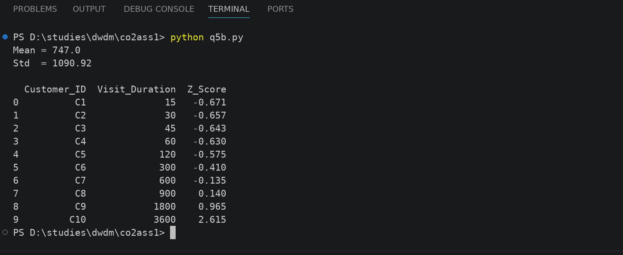

C. Min-Max Normalization
i. Apply Min-Max normalization using range [0,1]:
$$X^{'}=\frac{X-X_{min}}{X_{max}-X_{min}}$$
ii. Transform all values accordingly
iii. Compare results with Z-score normalization in terms of scaling and sensitivity to outliers
Ans: i. min = 15 and max = 3600, so X' = (X - 15) / (3600 - 15).
ii. The transformed values are C1 = 0, C2 = 0.004, C3 = 0.008, C4 = 0.013, C5 = 0.029, C6 = 0.079, C7 = 0.163, C8 = 0.247, C9 = 0.498 and C10 = 1.
iii. Min-Max keeps all values between 0 and 1, but z-score values go from -0.671 to 2.615 and have no fixed range. Min-Max is more sensitive to outliers because the one big value 3600 decides the max, so 8 out of 10 values are squeezed below 0.25 and the small durations look almost the same. Z-score is also affected by outliers but it spreads the data around 0, so it is a little better for clustering here.
import pandas as pd

pd.set_option("display.width", 100)

df = pd.DataFrame({
"Customer_ID": ["C1","C2","C3","C4","C5","C6","C7","C8","C9","C10"],
"Visit_Duration": [15, 30, 45, 60, 120, 300, 600, 900, 1800, 3600]
})

x = df["Visit_Duration"]
df["Z_Score"] = ((x - x.mean()) / x.std(ddof=0)).round(3)
df["Min_Max"] = ((x - x.min()) / (x.max() - x.min())).round(3)

print(df)
print()
print("Z-score range:", df["Z_Score"].min(), "to", df["Z_Score"].max())
print("Min-Max range:", df["Min_Max"].min(), "to", df["Min_Max"].max())
