SIMATS ENGINEERING
PRADEEPKUMAR(192425016)

Q1. Linear Regression — House Price Prediction (15 Marks – 20 Mins)
A real estate company collected the following training data:
House No | Area (sq.ft) | Bedrooms | Price (₹ Lakhs)
1 | 1000 | 2 | 50
2 | 1500 | 3 | 75
3 | 800 | 2 | 40
4 | 1200 | 3 | 60
5 | 2000 | 4 | 90

(i) Construct a linear regression model of the form Price = β0 + β1(Area) + β2(Bedrooms)
(ii) Estimate the regression coefficients.
(iii) Interpret the meaning of each coefficient.

Implementation Code
import numpy as np
x = np.array([1000,1500,800,1200,2000], dtype=float)
y = np.array([50,75,40,60,90], dtype=float)
xbar= x.mean()
ybar=y.mean()
b1 = np.sum((x-xbar)*(y-ybar)) / np.sum((x-xbar)**2)
b0 = ybar - b1*xbar

print('\n')
print("Model form: Price = b0 + b1 * Area")
print('\n')
print("Regression coefficients: b0 =", b0, " b1 =", b1)
print(" Price =", b0, "+", b1, "* Area")
print('\n')

print(" b1 means each extra sq.ft increases price by", b1, "Lakhs")
print('\n')

Implementation Screenshot
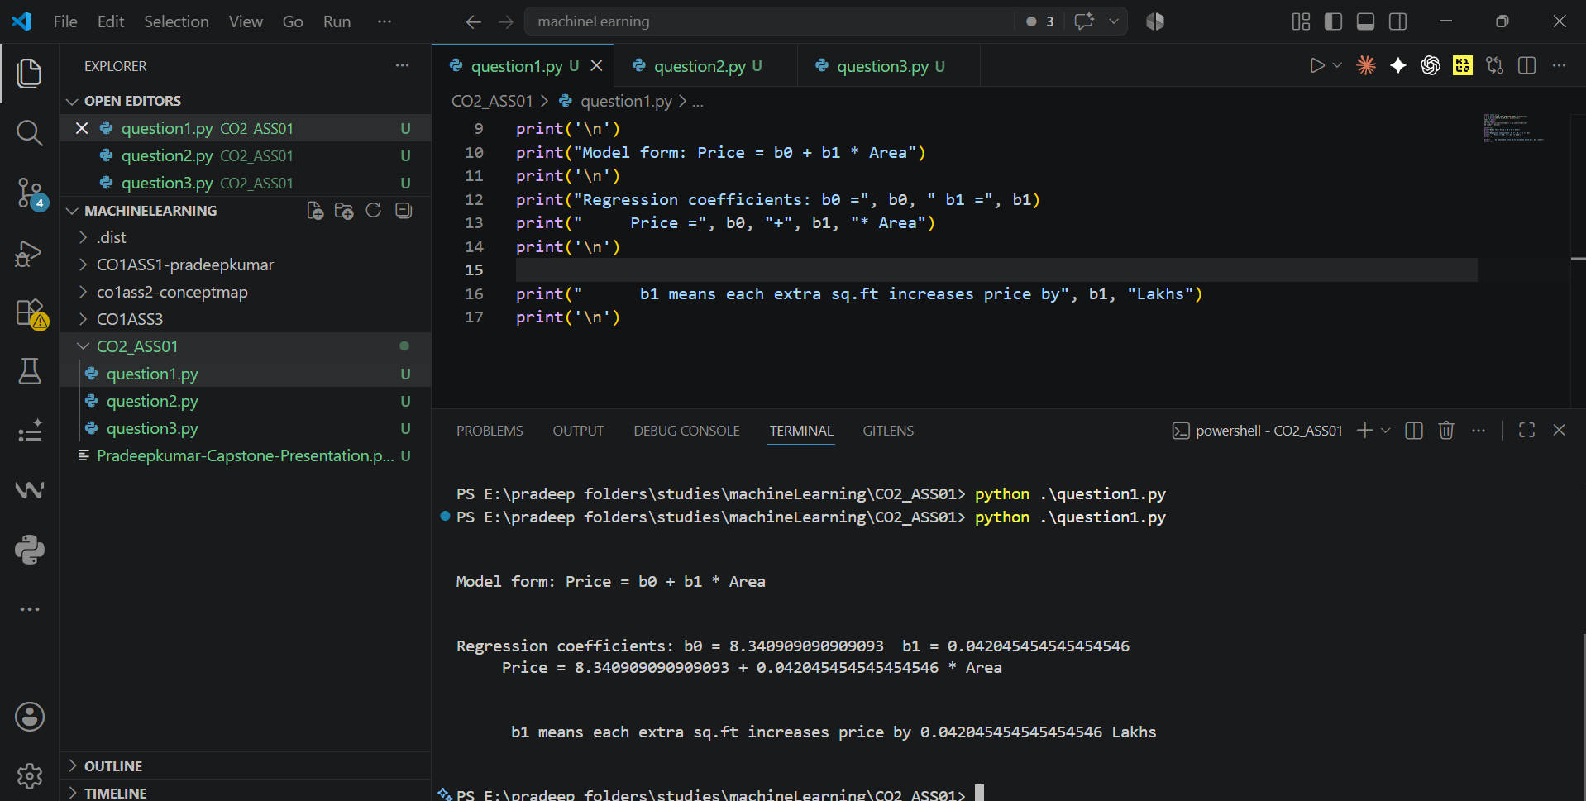

Q2. Linear Classification — Spam Email Detection (15 Marks – 20 Mins)
An email system uses the following feature values:
Email | Word Frequency (Offer) | Word Frequency (Win) | Spam (1/0)
1 | 3 | 2 | 1
2 | 2 | 1 | 1
3 | 1 | 0 | 0
4 | 3 | 3 | 1
5 | 0 | 1 | 0

(i) Construct a linear classification model.
(ii) Determine the decision boundary.
(iii) Classify a new email with: Offer = 2, Win = 1.

Implementation Code
import numpy as np
X = np.array([[3,2],[2,1],[1,0],[3,3],[0,1]], dtype=float)
y = np.array([1,1,0,1,0], dtype=float)

#2ndquestionemail

Implementation Screenshot
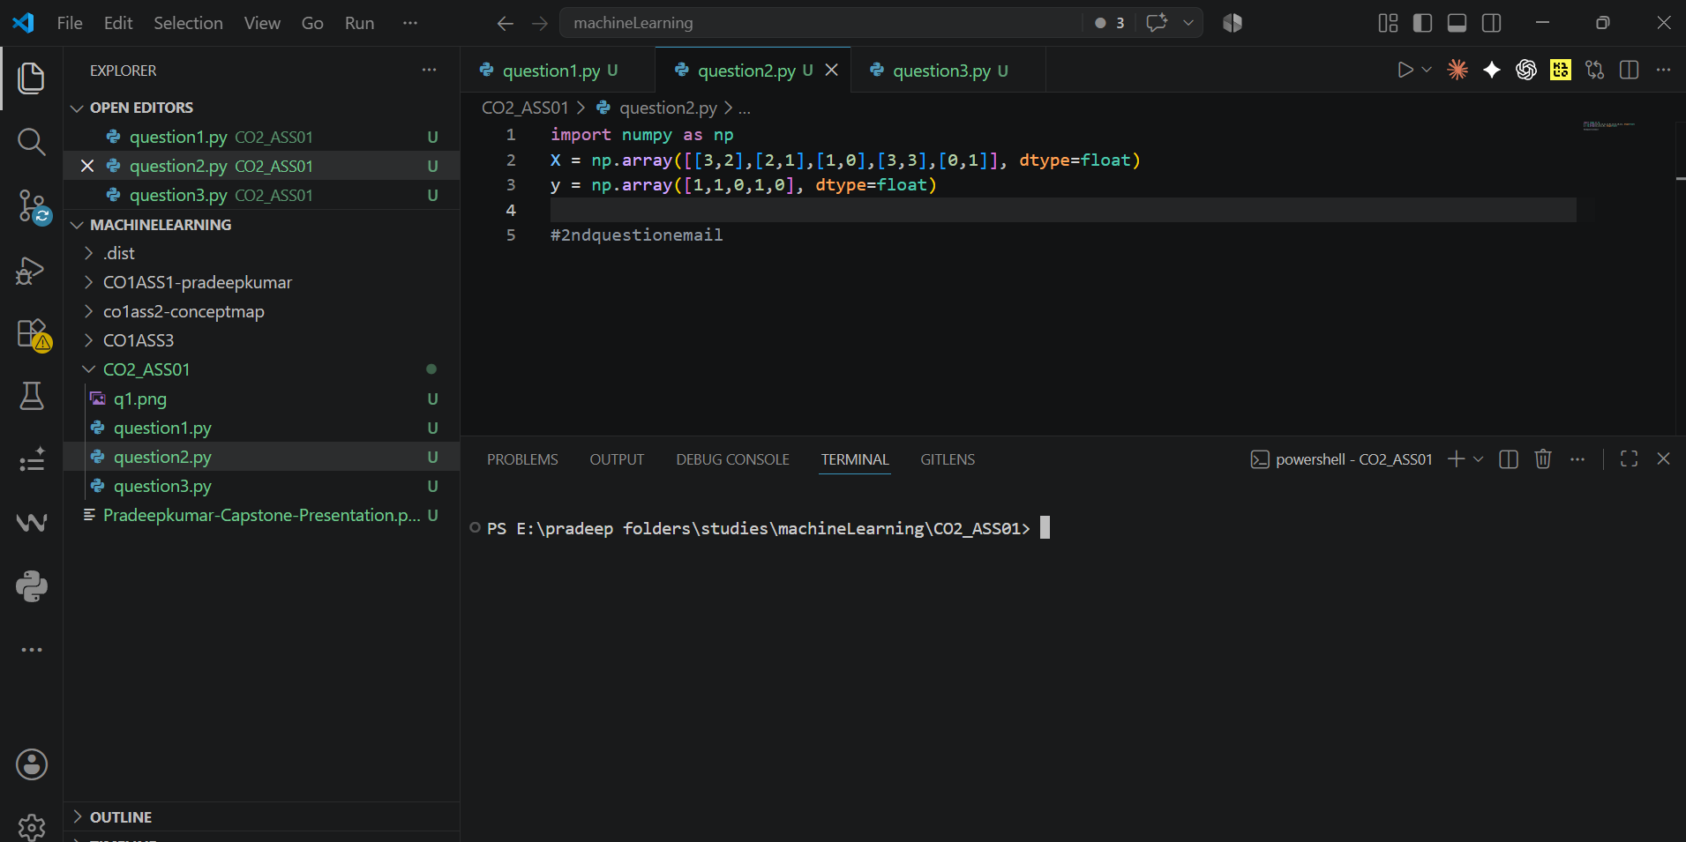

Q3. Naive Bayes — Medical Diagnosis (15 Marks – 20 Mins)
A medical dataset is given:
Patient | Fever (1/0) | Headache (1/0) | Disease (Yes/No)
1 | 1 | 1 | Yes
2 | 1 | 0 | Yes
3 | 0 | 1 | No
4 | 1 | 1 | Yes
5 | 0 | 0 | No

(i) Compute prior probabilities.
(ii) Compute conditional probabilities.
(iii) Estimate the probability that a patient with Fever = 1 and Headache = 0 has the disease.

Implementation Code
data = [(1,1,'Yes'), (1,0,'Yes'), (0,1,'No'), (1,1,'Yes'), (0,0,'No')]
yes = [d for d in data if d[2]=='Yes']
no = [d for d in data if d[2]=='No']
p_yes= len(yes)/len(data)
p_no = len(no)/len(data)
p_fever1_yes = sum(1 for d in yes if d[0]==1)/len(yes)
p_head0_yes = sum(1 for d in yes if d[1]==0)/len(yes)
p_fever1_no = sum(1 for d in no if d[0]==1)/len(no)
p_head0_no = sum(1 for d in no if d[1]==0)/len(no)
num_yes = p_yes*p_fever1_yes*p_head0_yes
num_no = p_no*p_fever1_no*p_head0_no
total = num_yes+num_no

print('\n'*1)
print("1) Prior Probabilities: P(Yes) =", p_yes, " P(No) =", p_no)
print('\n')
print("2) Conditional Probabilities:")
print("P(Fever=1|Yes) =", p_fever1_yes, " P(Headache=0|Yes) =", p_head0_yes)
print(" P(Fever=1|No) =", p_fever1_no, " P(Headache=0|No) =", p_head0_no)
print('\n')
print("(3) P(Disease=Yes | Fever=1, Headache=0) =", num_yes/total)
print('\n')

Implementation Screenshot
