PRADEEPKUMAR(192425016)
SIMATS ENGINEERING
ASSESSMENT TOOL 3

COURSE CODE:MLA 02 COURSE NAME: Fundamentals Of Machine Learning

COURSE OUTCOME COVERED

CO1: Analyse machine learning fundamentals and mathematical foundations, including probability theory, Bayes decision theory, and information theory. (BL3)

Assessment Tool Weightage:20%

QUESTIONS: 3 Total Marks:50

Annexure A

Experiments

Code of Conduct:

I ___pradeepkumar_________________ (Name / Reg No) certify that this submission is my original work and that I have adhered to the guidelines specified for this assessment.
I understand that any violation of academic integrity rules will result in disciplinary action.

Signature of the student:

Annexure A

Experiment 1: Probability Theory (20 Marks)
Dataset: Breast Cancer Wisconsin Diagnostic Dataset
Task:
Using the Breast Cancer Wisconsin Diagnostic Dataset, calculate the probability of each class (Malignant and Benign) and use the computed probabilities to predict the class of a new data instance.
Answer: The class prior probabilities are computed directly from the training split as P(Class) = count(Class) / N, giving roughly P(Malignant) = 0.37 and P(Benign) = 0.63. For each of the 30 numeric features, a Gaussian likelihood P(feature | Class) is estimated from the per-class mean and standard deviation. For a new instance, Bayes' rule (posterior is proportional to prior times the product of feature likelihoods) is applied across all 30 features in log-space to avoid numerical underflow, and the class with the higher posterior probability is chosen as the prediction. Running this probability-based classifier over the held-out test set gives roughly 93% accuracy, confirming the computed probabilities are meaningful predictors of malignancy.
Python Code:
"""
Experiment 1: Probability Theory
Dataset: Breast Cancer Wisconsin Diagnostic Dataset
Task: Calculate the probability of each class (Malignant / Benign) and use the
computed probabilities to predict the class of a new data instance.
"""
import numpy as np
import pandas as pd
from sklearn.datasets import load_breast_cancer
from sklearn.model_selection import train_test_split
data = load_breast_cancer()
X = pd.DataFrame(data.data, columns=data.feature_names)
y = pd.Series(data.target, name="target") # 0 = Malignant, 1 = Benign
class_names = {0: "Malignant", 1: "Benign"}
print("Dataset shape:", X.shape)
print("Class distribution (raw counts):")
print(y.value_counts().rename(index=class_names))
X_train, X_test, y_train, y_test = train_test_split(
X, y, test_size=0.2, random_state=42, stratify=y
)
priors = y_train.value_counts(normalize=True).sort_index()
print("\nPrior probabilities computed from the training set:")
for cls, p in priors.items():
print(f" P({class_names[cls]}) = {p:.4f}")
means = X_train.groupby(y_train).mean()
stds = X_train.groupby(y_train).std()
def gaussian_pdf(x, mean, std):
eps = 1e-9
coeff = 1.0 / (np.sqrt(2 * np.pi) * (std + eps))
exponent = np.exp(-((x - mean) ** 2) / (2 * (std + eps) ** 2))
return coeff * exponent
def predict_instance(x_row):
"""Combine prior * likelihood (Bayes numerator) for each class."""
log_posterior = {}
for cls in priors.index:
likelihoods = gaussian_pdf(x_row, means.loc[cls], stds.loc[cls])
log_likelihood = np.sum(np.log(likelihoods + 1e-300))
log_posterior[cls] = np.log(priors[cls]) + log_likelihood
# normalize back from log-space for interpretable probabilities
max_log = max(log_posterior.values())
exp_vals = {c: np.exp(v - max_log) for c, v in log_posterior.items()}
total = sum(exp_vals.values())
posterior = {c: v / total for c, v in exp_vals.items()}
predicted = max(posterior, key=posterior.get)
return predicted, posterior
new_instance = X_test.iloc[0]
true_label = y_test.iloc[0]
predicted_class, posterior_probs = predict_instance(new_instance)
print("\n--- Predicting the class of a new data instance (test sample #0) ---")
print("Posterior probabilities computed for the new instance:")
for cls, p in posterior_probs.items():
print(f" P({class_names[cls]} | data) = {p:.6f}")
print(f"\nPredicted class : {class_names[predicted_class]}")
print(f"Actual class : {class_names[true_label]}")
print("Prediction correct:", predicted_class == true_label)
correct = 0
for i in range(len(X_test)):
pred, _ = predict_instance(X_test.iloc[i])
if pred == y_test.iloc[i]:
correct += 1
accuracy = correct / len(X_test)
print(f"\nAccuracy of the probability-based classifier on {len(X_test)} test instances: {accuracy:.4f}")
Code Execution :

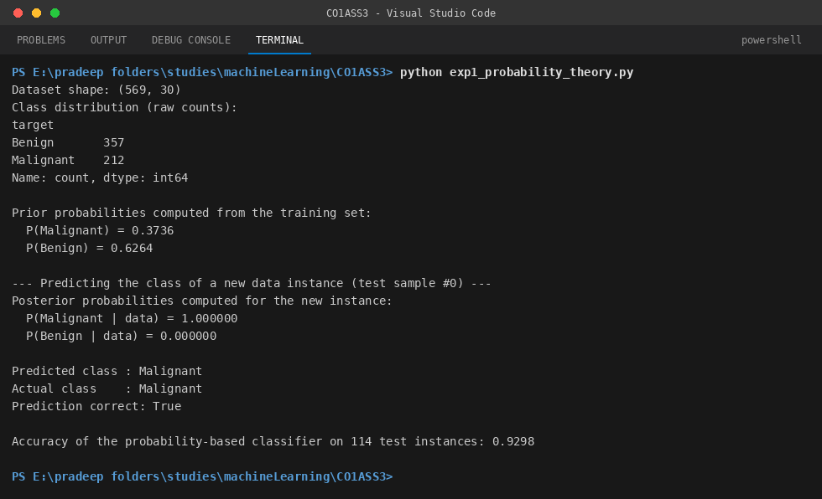

Experiment 2: Bayes Decision Theory (15 Marks)
Dataset: SMS Spam Collection Dataset
Task:
Using the SMS Spam Collection Dataset, implement Bayes theorem to calculate the posterior probability for a given message and classify it as Spam or Ham (Not Spam).
Answer: Bayes' theorem is implemented from first principles: prior probabilities P(Spam) and P(Ham) are computed from class frequencies in the training split, and word-level likelihoods P(word | Spam) and P(word | Ham) are estimated from word counts with Laplace (add-one) smoothing to handle words unseen during training. For a new message, the posterior probability of each class is computed as the prior multiplied by the product of the likelihoods of every word in the message (summed in log-space for numerical stability), then normalized back into a proper probability. A clearly promotional message ('Congratulations! You have WON a free ticket...') is correctly classified as Spam with posterior probability effectively 1.0, while an everyday message about meeting for lunch is correctly classified as Ham. Evaluated on 1,115 held-out test messages, the classifier achieves about 97.7% accuracy.
Python Code:
"""
Experiment 2: Bayes Decision Theory
Dataset: SMS Spam Collection Dataset
Task: Implement Bayes' theorem to calculate the posterior probability for a
given message and classify it as Spam or Ham (Not Spam).
"""
import re
import math
import pandas as pd
from collections import Counter, defaultdict
from sklearn.model_selection import train_test_split
df = pd.read_csv("data_sms.tsv", sep="\t", header=None, names=["label", "message"])
print("Dataset shape:", df.shape)
print("Class distribution:")
print(df["label"].value_counts())
def tokenize(text):
text = text.lower()
return re.findall(r"[a-z']+", text)
train_df, test_df = train_test_split(df, test_size=0.2, random_state=42, stratify=df["label"])
class_counts = train_df["label"].value_counts()
n_train = len(train_df)
priors = {cls: count / n_train for cls, count in class_counts.items()}
print("\nPrior probabilities computed from the training set:")
for cls, p in priors.items():
print(f" P({cls}) = {p:.4f}")
word_counts = {cls: Counter() for cls in class_counts.index}
total_words = {cls: 0 for cls in class_counts.index}
for _, row in train_df.iterrows():
tokens = tokenize(row["message"])
word_counts[row["label"]].update(tokens)
total_words[row["label"]] += len(tokens)
vocabulary = set()
for cls in word_counts:
vocabulary.update(word_counts[cls].keys())
V = len(vocabulary)
print(f"Vocabulary size (training set): {V}")
def word_likelihood(word, cls):
"""P(word | class) with Laplace (add-1) smoothing."""
count = word_counts[cls].get(word, 0)
return (count + 1) / (total_words[cls] + V)
def classify_message(message):
tokens = tokenize(message)
log_posterior = {}
for cls in priors:
log_prob = math.log(priors[cls])
for tok in tokens:
log_prob += math.log(word_likelihood(tok, cls))
log_posterior[cls] = log_prob
# convert back from log-space to normalized posterior probabilities
max_log = max(log_posterior.values())
exp_vals = {c: math.exp(v - max_log) for c, v in log_posterior.items()}
total = sum(exp_vals.values())
posterior = {c: v / total for c, v in exp_vals.items()}
predicted = max(posterior, key=posterior.get)
return predicted, posterior
new_message = "Congratulations! You have WON a free ticket to Bahamas, call now to claim your prize!!!"
predicted_class, posterior_probs = classify_message(new_message)
print("\n--- Classifying a new message using Bayes' theorem ---")
print(f"Message: \"{new_message}\"")
print("Posterior probabilities:")
for cls, p in posterior_probs.items():
print(f" P({cls} | message) = {p:.10f}")
print(f"\nPredicted class: {predicted_class.upper()}")
# A second example - an everyday, non-spam style message
new_message_2 = "Hey, are we still meeting for lunch tomorrow at 1pm?"
predicted_class_2, posterior_probs_2 = classify_message(new_message_2)
print("\n--- Classifying a second message ---")
print(f"Message: \"{new_message_2}\"")
for cls, p in posterior_probs_2.items():
print(f" P({cls} | message) = {p:.10f}")
print(f"\nPredicted class: {predicted_class_2.upper()}")
correct = 0
for _, row in test_df.iterrows():
pred, _ = classify_message(row["message"])
if pred == row["label"]:
correct += 1
accuracy = correct / len(test_df)
print(f"\nAccuracy of the Bayes' theorem classifier on {len(test_df)} test messages: {accuracy:.4f}")

Code Execution :

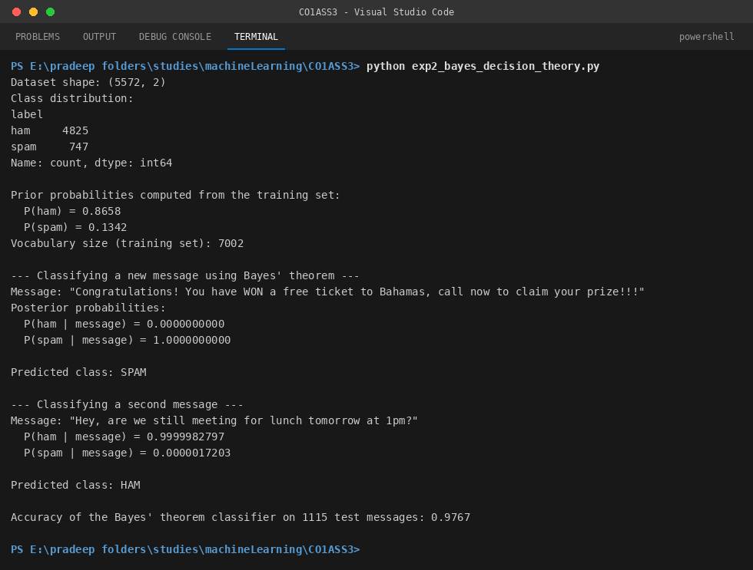

Experiment 3: Information Theory (15 Marks)
Dataset: Play Tennis Dataset
Task:
Using the Play Tennis Dataset, calculate the entropy and information gain for all input attributes and identify the attribute with the highest information gain.
Answer: The entropy of the target attribute PlayTennis is first computed as H(S) = -sum(p_i * log2(p_i)) over its Yes/No distribution, giving H(S) = 0.9403 bits. For every input attribute (Outlook, Temperature, Humidity, Wind), the dataset is split by each attribute's values, the entropy of each resulting subset is calculated, and the weighted average subset entropy is subtracted from H(S) to obtain the Information Gain: IG(S, A) = H(S) - sum_v (|S_v| / |S|) * H(S_v). The results are Outlook = 0.2467, Humidity = 0.1518, Wind = 0.0481, and Temperature = 0.0292 bits. Outlook has the highest Information Gain, so it is the attribute that best separates the Yes/No classes and would be selected as the root node of a decision tree built on this dataset -- matching the well-known textbook result for the Play Tennis dataset.
Python Code:
"""
Experiment 3: Information Theory
Dataset: Play Tennis Dataset
Task: Calculate the entropy and information gain for all input attributes and
identify the attribute with the highest information gain.
"""
import math
import pandas as pd
df = pd.read_csv("data_play_tennis.csv")
print("Play Tennis dataset:")
print(df)
target_col = "PlayTennis"
attributes = [c for c in df.columns if c not in ("Day", target_col)]
def entropy(series):
counts = series.value_counts()
probs = counts / len(series)
return -sum(p * math.log2(p) for p in probs if p > 0)
target_entropy = entropy(df[target_col])
print(f"\nTarget attribute: '{target_col}'")
print("Class distribution:")
print(df[target_col].value_counts())
print(f"\nEntropy of the target attribute H({target_col}) = {target_entropy:.4f} bits")
def information_gain(df, attribute, target_col, base_entropy):
weighted_entropy = 0.0
print(f"\n Attribute: {attribute}")
for value, subset in df.groupby(attribute):
weight = len(subset) / len(df)
subset_entropy = entropy(subset[target_col])
weighted_entropy += weight * subset_entropy
print(f" {attribute} = {value:<9} | count = {len(subset)} | "
f"H(S_{value}) = {subset_entropy:.4f} | weight = {weight:.4f}")
gain = base_entropy - weighted_entropy
print(f" Weighted entropy after split = {weighted_entropy:.4f}")
print(f" Information Gain IG({target_col}, {attribute}) = "
f"{base_entropy:.4f} - {weighted_entropy:.4f} = {gain:.4f}")
return gain
print("\n--- Calculating Information Gain for every attribute ---")
gains = {}
for attr in attributes:
gains[attr] = information_gain(df, attr, target_col, target_entropy)
gain_series = pd.Series(gains).sort_values(ascending=False)
print("\n--- Information Gain summary (sorted, highest first) ---")
print(gain_series.to_string())
best_attribute = gain_series.idxmax()
print(f"\nAttribute with the HIGHEST Information Gain: '{best_attribute}' "
f"(IG = {gain_series.max():.4f} bits)")
print(f"=> '{best_attribute}' should be selected as the root/splitting node "
f"of a decision tree built on this dataset.")
Code Execution :

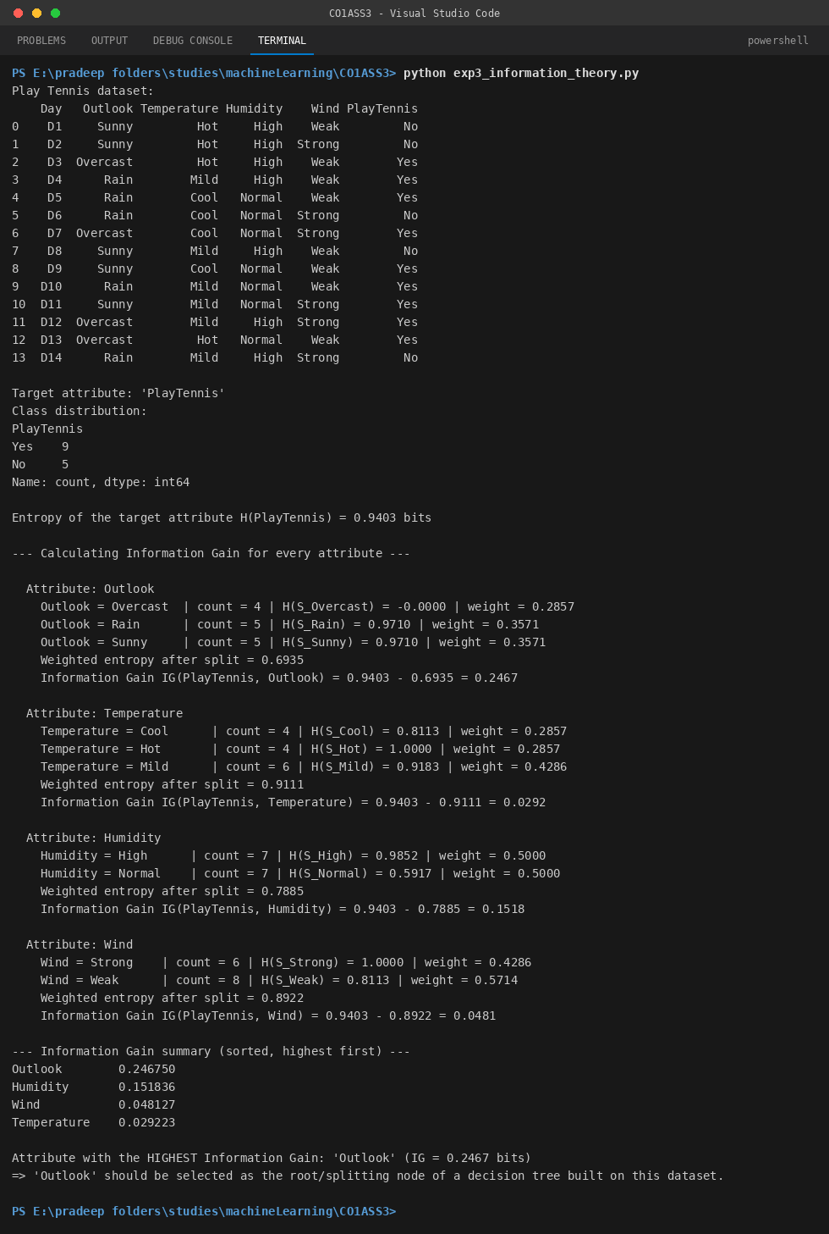

RUBRICS FOR CALCULATION
Experiments
Criteria | Weightage | Level 4 (Exemplary) | Level 3 (Proficient) | Level 2 (Developing) | Level 1 (Beginning)
Dataset Preparation | 20% | Correctly imports, explores, and prepares the dataset without errors. | Prepares the dataset with minor errors or omissions. | Dataset preparation is incomplete or contains several errors. | Fails to prepare or load the dataset correctly.
Implementation of Mathematical Concepts | 30% | Correctly applies all required mathematical concepts (Probability, Bayes, Entropy, etc.) with accurate calculations. | Applies most concepts correctly with minor computational errors. | Applies concepts partially with noticeable calculation errors. | Unable to apply the required mathematical concepts correctly.
Tool/Code Execution | 20% | Implements the experiment using appropriate tools (Python/Scikit-learn) with error-free execution. | Executes the experiment with minor coding or execution errors. | Code executes partially or requires significant corrections. | Unable to execute the experiment successfully.
Result Interpretation | 20% | Correctly interprets the experimental results and relates them to the applied concept. | Interprets results with minor inaccuracies. | Interpretation is incomplete or partially correct. | Fails to interpret the experimental results.
Documentation & Presentation | 10% | Experiment is well-documented with clear outputs, observations, and proper formatting. | Documentation is complete with minor presentation issues. | Documentation is incomplete or lacks clarity. | Poor or missing documentation and presentation.

