PRADEEPkUMAR
SIMATS ENGINEERING
ASSESSMENT TOOL 3

COURSE NAME: OPERATING SYSTEMS COURSE CODE: CSA04

COURSE OUTCOME COVERED
CO2: Analyze process management and deadlock handling techniques to improve CPU utilization and system performance

QUESTIONS: 5 Total Marks: 100

Annexure A
Debugging or Optimization task

Code of Conduct:
I ___PRADEEPkUMAR_________________ (Name / Reg No) certify that this submission is my original work and that I have adhered to the guidelines specified for this assessment.
I understand that any violation of academic integrity rules will result in disciplinary action.

Signature of the student:

SAMPLE QUESTIONS
(QUESTIONS CAN BE CHANGED AS PER YOUR REQUIREMENTS)
Q1. Deadlock Debugging (Code Trace)
You are given the following pseudo-code for two processes sharing resources R1 and R2:
Process P1:
lock(R1)
wait(100 ms)
lock(R2)
critical section
unlock(R2)
unlock(R1)
Process P2:
lock(R2)
wait(100 ms)
lock(R1)
critical section
unlock(R1)
unlock(R2)
Identify the exact condition that causes deadlock.
Suggest an optimisation to eliminate the deadlock without changing process logic.
(20 Marks)(BL4)
Deadlock happens because P1 holds R1 and waits for R2, and at the same time P2 holds R2 and waits for R1. The wait of 100 ms gives both of them time to lock their first resource, so after that both are waiting for each other and none of them can move. This is a circular wait (along with mutual exclusion, hold and wait and no preemption).
To remove it without changing the logic of the processes, make both of them lock the resources in the same order, first R1 and then R2. Then P2 cannot take R2 while P1 has R1, so the circular wait is gone and deadlock does not come.
import threading
import time

R1 = threading.Lock()
R2 = threading.Lock()

def process(name, first, second, results, barrier):
first[1].acquire()
print(name, "locked", first[0])
time.sleep(0.1)
if second[1].acquire(timeout=1):
print(name, "locked", second[0], "and entered critical section")
second[1].release()
first[1].release()
results.append(True)
else:
print(name, "is waiting for", second[0], "forever -> deadlock")
try:
barrier.wait(timeout=3)
except threading.BrokenBarrierError:
pass
first[1].release()
results.append(False)

def run(order1, order2):
results = []
barrier = threading.Barrier(2)
t1 = threading.Thread(target=process, args=("P1", order1[0], order1[1], results, barrier))
t2 = threading.Thread(target=process, args=("P2", order2[0], order2[1], results, barrier))
t1.start()
time.sleep(0.02)
t2.start()
t1.join()
t2.join()
return all(results)

print("Pradeepkumar - 192425016")
print("--- Original order ---")
ok = run((("R1", R1), ("R2", R2)), (("R2", R2), ("R1", R1)))
print("Finished without deadlock:", ok)
print("--- Same lock order for both ---")
ok = run((("R1", R1), ("R2", R2)), (("R1", R1), ("R2", R2)))
print("Finished without deadlock:", ok)
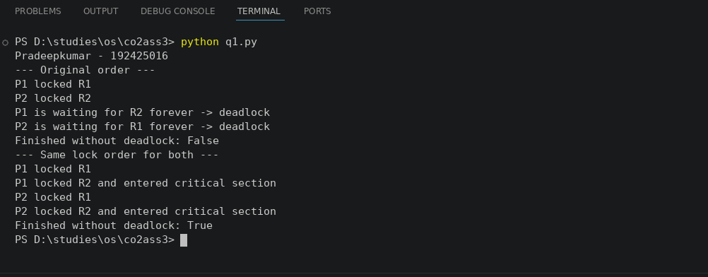

Q2. CPU Utilisation Problem
A system shows low CPU utilisation (30%) even though processes are ready.
You analyse the scheduler log and find frequent transitions:
ready → waiting → ready → waiting → ready ...
Debug the cause using process management concepts and propose a system-level optimisation to improve utilisation.
(20 Marks)(BL4)
The scheduler log shows ready to waiting to ready again and again, so the processes are I/O bound. They use the CPU for a very short time and then go for I/O, and the CPU sits idle while they wait. There are also not enough processes in memory to keep the CPU busy, so the utilisation is only 30%.
To improve it, increase the degree of multiprogramming so that another process runs when one is waiting, use buffering or asynchronous I/O to reduce the waiting time, and use a multilevel feedback queue so the I/O bound processes get the CPU quickly.
def simulate(n, cpu_burst, io_time, total_ticks):
state = ["ready"] * n
left = [cpu_burst] * n
io_left = [0] * n
busy = 0
current = None
for tick in range(total_ticks):
for i in range(n):
if state[i] == "waiting":
io_left[i] -= 1
if io_left[i] == 0:
state[i] = "ready"
left[i] = cpu_burst
if current is None:
for i in range(n):
if state[i] == "ready":
current = i
break
if current is not None:
busy += 1
left[current] -= 1
if left[current] == 0:
state[current] = "waiting"
io_left[current] = io_time
current = None
return busy * 100 / total_ticks

print("Pradeepkumar - 192425016")
print("CPU burst = 3 ms, I/O wait = 7 ms")
for n in [1, 2, 3, 4]:
print("Processes in memory:", n, "-> CPU utilisation: %.1f%%" % simulate(n, 3, 7, 1000))
print("With buffered I/O (wait = 2 ms), 1 process -> CPU utilisation: %.1f%%" % simulate(1, 3, 2, 1000))
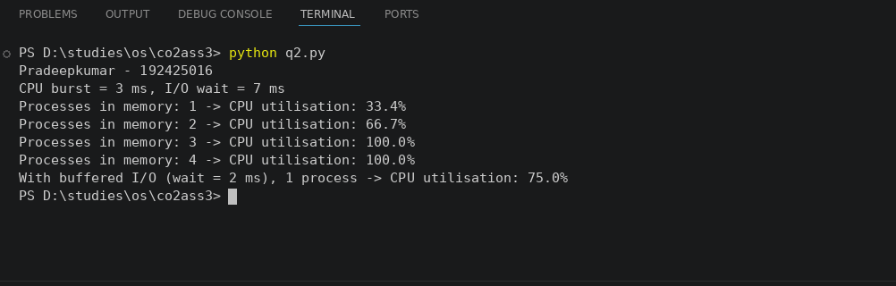

Q3. Memory Bottleneck Debugging
A multi-threaded program frequently encounters page faults, slowing performance. The memory map shows:
- Code: 5 MB
- Heap: 150 MB
- Stack: 1 MB per thread
- 25 threads running
- Physical RAM available: 2 GB
Identify the memory issue causing performance degradation and propose two optimisations.
(20 Marks)(BL4)
The total memory used is 5 MB code + 150 MB heap + 25 x 1 MB stack = 180 MB. The RAM is 2 GB, so the memory is not full. The problem is the 150 MB heap is accessed in a scattered way (poor locality) and 25 threads keep switching, so the pages they need are not in memory and page faults happen again and again, which slows the program.
Optimisation 1: improve locality by using the heap data in order and keeping the data that is used together in the same pages. Optimisation 2: use a thread pool with fewer threads and prefetch the needed pages (or use huge pages) so that fewer page faults happen.
import random

code = 5
heap = 150
stack = 1
threads = 25
ram = 2048

total = code + heap + stack * threads
print("Pradeepkumar - 192425016")
print("Total memory needed:", total, "MB")
print("Physical RAM:", ram, "MB")
print("Memory used: %.1f%%" % (total * 100 / ram))

def page_faults(pages, frames):
memory = []
faults = 0
for p in pages:
if p in memory:
memory.remove(p)
memory.append(p)
else:
faults += 1
if len(memory) == frames:
memory.pop(0)
memory.append(p)
return faults

random.seed(1)
total_pages = 600
frames = 40
random_access = [random.randint(0, total_pages - 1) for _ in range(3000)]
sequential_access = [i // 5 for i in range(3000)]

print("Page faults with random heap access:", page_faults(random_access, frames))
print("Page faults after improving locality:", page_faults(sequential_access, frames))
print("Threads after using a thread pool of 8 -> stack memory:", 8 * stack, "MB")
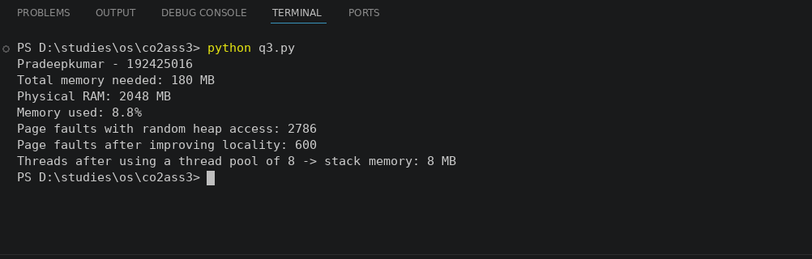

Q4. Starvation Debugging
You observe that process P5 never gets CPU time in a multilevel queue scheduler:
- Q1 (Highest Priority): Interactive
- Q2: System
- Q3: Batch
- Time Quantum: Q1 = 5ms, Q2 = 10ms, Q3 = FCFS
P5 is in Q3 but keeps getting postponed.
Debug the root cause of starvation and suggest an optimisation to ensure fairness.
(20 Marks)(BL4)
The scheduler is a multilevel queue with fixed priority, so Q3 (batch) gets the CPU only when Q1 and Q2 are empty. Interactive and system processes keep coming, so P5 in Q3 is postponed again and again and never runs. This is starvation.
To make it fair, use aging, where the priority of P5 increases the longer it waits and it is moved to a higher queue after some time. Another way is to give each queue a fixed share of CPU time (like 60%, 30% and 10%) or to use a multilevel feedback queue.
def run(aging, total_ticks=60, limit=10):
wait = 0
for t in range(1, total_ticks + 1):
if aging and wait >= limit:
return t
wait += 1
return None

print("Pradeepkumar - 192425016")
print("Q1 and Q2 always have a job ready, P5 is in Q3")
r = run(False)
if r is None:
print("Without aging: P5 waited 60 ticks and never got the CPU")
r = run(True)
print("With aging (limit = 10 ticks): P5 moved up and got the CPU at tick", r)
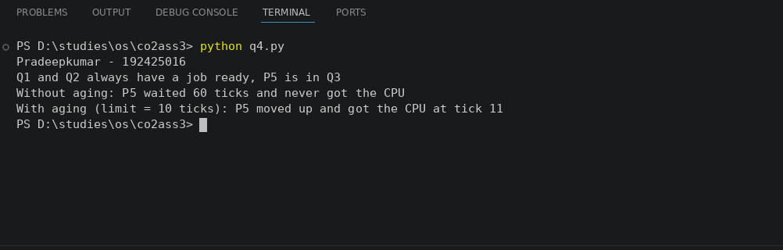
Q5. Context-Switch Overhead Debugging
A server performs 20,000 context switches/sec, causing high overhead.
Log details show:
- Average burst time per thread: 2ms
- I/O wait frequency: very high
- Preemptive scheduler with quantum = 1ms
Explain why context switching is so high and propose two optimisations to reduce overhead.
(20 Marks)(BL4)
The average burst time is 2 ms but the quantum is only 1 ms, so every burst is cut into 2 slices and each slice ends with a context switch. The I/O wait is also very high, so the threads block often and cause more switches. That is why there are 20,000 context switches per second and a lot of CPU time is wasted in switching.
Optimisation 1: increase the time quantum to 4 ms so a thread can finish its burst in one slice. Optimisation 2: use a thread pool with asynchronous (non-blocking) I/O and batch the I/O requests so that there are fewer blocks and fewer context switches.
switch_cost_us = 20
burst_ms = 2
bursts_per_sec = 10000

def switches(quantum_ms, batch=1):
slices = -(-burst_ms // quantum_ms)
return bursts_per_sec * slices // batch

def overhead(s):
return s * switch_cost_us / 1000000 * 100

print("Pradeepkumar - 192425016")
s = switches(1)
print("Quantum 1 ms: %d switches/sec, overhead %.1f%%" % (s, overhead(s)))
s = switches(4)
print("Quantum 4 ms: %d switches/sec, overhead %.1f%%" % (s, overhead(s)))
s = switches(4, 4)
print("Quantum 4 ms + batching 4 I/O requests: %d switches/sec, overhead %.1f%%" % (s, overhead(s)))
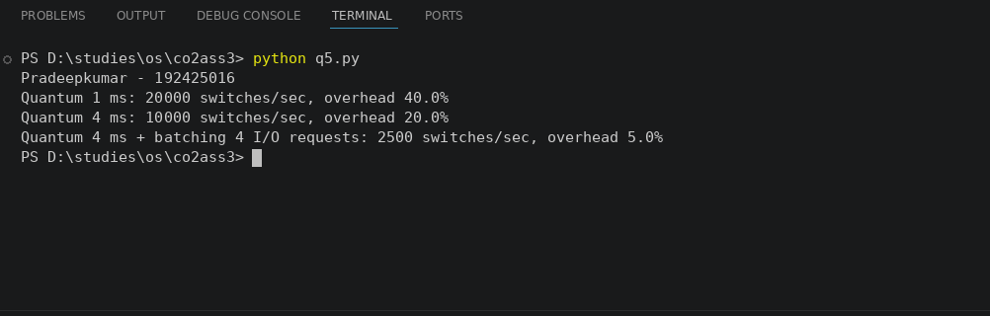

RUBRICS FOR CALCULATION

Criteria | Weightage | Level 4 (Exemplary) | Level 3 (Proficient) | Level 2 (Developing) | Level 1 (Beginning)
Problem Identification | 20% | Accurately identifies all errors and root causes with clear understanding | Identifies most errors with minor gaps | Identifies some errors but misses key issues | Unable to identify errors correctly
Debugging | 25% | Applies systematic debugging techniques effectively to resolve issues | Uses appropriate debugging methods with minor errors | Limited debugging approach; requires guidance | Unable to debug or resolve issues
Optimization | 20% | Optimizes code by significantly improving time complexity using efficient algorithms | Improves time complexity with minor gaps in efficiency | Limited improvement in time complexity | No improvement; inefficient approach retained
Analysis | 20% | Demonstrates strong logical reasoning and clear justification of solutions | Shows reasonable analysis with some justification | Limited analysis; weak reasoning | No analytical reasoning demonstrated
Code Quality | 15% | Produces clean, well-structured code with proper comments and documentation | Code is mostly clear with minor documentation gaps | Code lacks structure and proper documentation | Poorly written code with no documentation

TOTAL MARKS AWARDED FACULTY SIGNATURE

