Operating Systems
ASSIGNMENT 1
CO1: Apply the concepts of operating system types, structures and system calls to demonstrate their functions in various computing environments – history of operating systems, mainframe, desktop, multiprocessor, distributed, clustered, real-time and handheld systems, OS structure, services, system calls, system design, CPU states, memory hierarchy and I/O systems.
Assignment Title: Evaluate and Justify the Operating-System Design of a Smart Hospital (Total Marks - 50)
Nature of Assignment: Individual
Duration: 1 Week
Submission Date:
Bloom's Levels Assessed: K5 – Evaluate (every task in this assignment is at K5 level)
Mandatory Execution and GitHub Submission
•
·
•
•
•
Every student must individually execute every task in this assignment, including all "Complete the Code" programs.
Create a GitHub repository named CSA04-<RegisterNumber>-Assignment1 and share it with the course faculty (public, or private with the faculty added as a collaborator). Keep one folder for each task (for example: Task01, Task02 ... or Q1, Q2 ...), containing the C source files, shell scripts, configuration files (Dockerfile, YAML), command outputs and screenshots.
Include a README.md with your name, register number, compiler and version (for example gcc 13), the Linux distribution and version used, the exact gcc command used to compile (for example gcc -std=c11 -Wall -Wextra -pthread), the steps to run each program, and a short note of the result of each task.
Commit your work progressively - at least one commit for each task. The commit history will be checked; a single upload of all files on the last day will not be accepted. Submit the GitHub link below and on the cover page of your report. An assignment submitted without a working GitHub link will not be evaluated.
GitHub Repository Link:
Student: Pradeepkumar | Register No: 192425016 | Batch: 2024 (AIML)
GitHub Link: https://github.com/pradeepkumar673
How to Answer the Additional Questions
Complete the Code: Copy the given code into your repository, replace every TODO with working code without changing the rest of the program, execute it and compare your output (or result) with the expected output.
Alternative Concept and Complexity Analysis: Describe how the solution would change if the alternative concept were used, with code or pseudocode, and analyse and compare the time complexity and space complexity of both solutions using Big-O notation, supported by your own measurements wherever possible.
CSA04 - Operating Systems - Assignments CO1-CO5 | Page 1
Scenario Operating Systems for a Smart Hospital
A 500-bed hospital is replacing its computer systems. It needs: bedside patient monitors that must raise an alarm within 10 milliseconds of an abnormal reading; nurses' handheld tablets; doctors' desktop workstations; a central database server for patient records that must never stop; an imaging server that processes MRI scans using many processors; and a link to two partner hospitals that share records.
The IT team has proposed using one general-purpose operating system everywhere. The clinical staff are concerned that alarms may be delayed, the database may stop during updates, and the tablets' batteries will not last a shift.
The number of devices may grow:
1 ward (40 monitors, 10 tablets) → 1 hospital (500 monitors, 120 tablets, 80 workstations) → a group of 3 hospitals sharing records
You are required to evaluate the requirements of every part of the system, judge which type and structure of operating system suits each, examine how programs obtain OS services through system calls, and defend a complete operating-system plan for the hospital.
Design Challenge:
The hospital is adding remote patient monitoring at home and a cloud-based records service.
Re-evaluate your original design and determine whether it should be retained, modified or redesigned.
TASK 1 - Evaluate the Requirements of Each Computing Environment
Bloom's Level: K5 – Evaluate
Evaluate what each part of the hospital needs from its operating system.
Discuss:
•
4 Marks
Response-time, reliability, throughput, battery and security requirements of each device Which requirements conflict (for example: fast response and many users on one machine)
The bedside monitor needs the fastest response, about 10 ms, so it has the strictest timing rule. Tablets need good battery life and quick screen replies. Workstations need to run many programs for one user. The database must never stop, so it needs high reliability. The imaging server needs high throughput to process MRI scans fast. Every device needs security because all of them hold patient data. The main conflict is fast response against many users on one machine, since other work can make the alarm wait. Battery life also conflicts with fast response, because a faster CPU uses more power.
·
Which requirements are critical to patient safety
The alarm response is the most critical part for patient safety, because a late alarm can mean a patient is not helped in time. The database is also important, because doctors need correct records during treatment, and a database that stops during updates can hide a patient's history. Tablets matter too, since a flat battery in the middle of a shift means a nurse cannot see records or get alerts.
How the lessons from the history of operating systems (batch, time-sharing, personal, mobile) apply to each environment
Batch systems taught us that jobs run one after another with no user input, so they suit the imaging server, which runs big MRI jobs. Time-sharing lessons apply to the workstations and the database, since many staff use them at the same time and each needs quick replies. Personal computer lessons suit the doctors' workstations, which serve one user with a friendly screen. Mobile OS lessons apply to the tablets, where saving battery and memory matters most. The monitors are closest to real-time systems, which are not in that history list, but they still need a hard deadline for the alarm.
You are expected to rank the requirements of each environment and justify the ranking.
Each environment is ranked from most to least important, and the justification for each one is in the table at the end of this task. The main idea is that patient safety comes first, then the things that keep the device working during a shift.
Alternative Concept and Complexity Analysis
If the whole hospital used a single general-purpose operating system on every device, instead of a different type of OS for each environment, what would the solution be? Evaluate the worst-case alarm response time (unbounded scheduling delay versus a guaranteed deadline), the memory needed on each device, and the administration effort.
If the whole hospital used one general-purpose OS, the alarm would share the CPU with email, updates and web browsing. A normal Linux or Windows scheduler does not give a guaranteed deadline, so the worst-case alarm delay is unbounded. If a background job keeps the CPU busy, the alarm may wait for many milliseconds or even seconds. A real-time OS has a priority-based scheduler with a bounded delay, so it can promise a 10 ms deadline. A general OS also needs much more memory on each device, often hundreds of megabytes for the kernel and services, while a small real-time kernel can fit in a few hundred kilobytes. Administration effort also grows, because one team would need to patch, secure and test every device, including the monitors, which cannot be rebooted in the middle of a shift.
Evidence Expected
A ranked requirement table for every environment with a justification for each ranking.
Environment | Ranked requirements (1 = most important) | Justification
Bedside patient monitors | 1 Alarm within 10 ms; 2 Reliability (no missed readings); 3 Low memory and power; 4 Security; 5 Throughput | A late alarm can directly harm a patient, so timing is first and everything else comes after it.
Nurses' handheld tablets | 1 Battery for a full shift; 2 Quick response; 3 Security (device can be lost); 4 Reliability; 5 Throughput | A dead tablet stops all bedside documentation and alerts for the rest of the shift.
Doctors' desktop workstations | 1 Security and privacy of records; 2 Response time of screens; 3 Throughput for many programs; 4 Reliability; 5 Battery (not needed, plugged in) | Doctors open patient records, so privacy comes first, and quick screens keep their work moving.
Central database server | 1 Never stop (reliability); 2 Security; 3 Throughput for updates; 4 Response time for queries; 5 Battery (not needed) | Patient records must always be available and correct, even while updates are running.
Imaging server | 1 Throughput for MRI processing; 2 Reliability; 3 Security; 4 Response time; 5 Battery (not needed) | Large scans should finish quickly, and a crash would lose work in progress.

CSA04 - Operating Systems - Assignments CO1-CO5 | Page 2
TASK 2 - Judge the Type of Operating System for Each Environment
Bloom's Level: K5 - Evaluate
Compare the types of operating systems for the hospital.
Discuss:
•
•
•
3 Marks
Mainframe, desktop, multiprocessor, distributed, clustered, real-time (hard and soft) and handheld systems
Mainframes are large machines for heavy batch work and very high reliability, but they are too big and costly for a ward. Desktop systems suit the doctors' workstations, which run many programs for one user. Multiprocessor systems have several CPUs, so they suit the imaging server. Distributed systems connect many computers, so they suit the link to the partner hospitals. Clustered systems group machines so one can take over when another fails, which fits the database. Real-time systems are needed for the monitors. Hard real-time guarantees the 10 ms alarm, while soft real-time is fine for things like screen updates. Handheld systems use low power and small memory, so they suit the tablets.
Which type best fits the monitors, tablets, workstations, database server, imaging server and partner link
Bedside monitors fit a hard real-time OS, because a late alarm is dangerous. Tablets fit a handheld or mobile OS, because they must save battery. Doctors' workstations fit a desktop OS, because they run many apps and users expect a normal screen. The database server fits a clustered system with fail-over. The imaging server fits a multiprocessor system. The partner link fits a distributed system, because records are shared across sites.
Symmetric versus asymmetric multiprocessing for the imaging server
In symmetric multiprocessing (SMP), every CPU runs the OS and shares memory and work equally. In asymmetric multiprocessing (AMP), one master CPU gives jobs to the others. For the imaging server, SMP is the better choice. MRI processing is many similar jobs that can run on any free CPU, and SMP balances them well. AMP would make the master CPU a bottleneck. The downside of SMP is that the CPUs must share memory safely, which needs locks, but modern OSes handle this well.
A clustered system with fail-over for the database server
A clustered system puts several machines together with shared storage. If the active database node fails, a standby node takes over within seconds, which is called fail-over. This matches the rule that the database must never stop. The cost is more hardware and a more complex setup, but the risk of a full outage is much lower. The records must also be kept in sync across the nodes, so no update is lost.
Alternative Concept and Complexity Analysis
If the database server used a single large multiprocessor machine instead of a cluster of smaller machines with fail-over, what would the solution be? Evaluate the availability (a single point of failure versus fail-over within seconds), the cost, and how throughput grows with the number of processors (time) and the memory available (space).
With one big multiprocessor machine, the database is a single point of failure. If that machine fails, the hospital loses access to records until it is repaired, which can take hours. Fail-over within seconds is much better for availability. A big machine can cost more per unit of power, but it is simpler to manage. Throughput grows with the number of processors only up to a point, because the CPUs share memory and locks, so each extra CPU gives less gain. The time to finish a query goes down as CPUs are added, but not in a straight line. For space, one big memory helps keep records in RAM and speeds look-ups, while a cluster needs memory on each node. Overall, the cluster is the better choice for a database that must never stop.
Evidence Expected
A justified choice of operating-system type for each environment, with the rejected alternatives and reasons.
Bedside monitors use a hard real-time OS. I rejected a general Linux or Windows system because it has no guaranteed deadline. Tablets use a handheld or mobile OS. I rejected a desktop OS because it uses too much power. Workstations use a desktop OS. I rejected a real-time OS because it is too restrictive for many apps, and a handheld OS because it is too small. The database uses a clustered system with fail-over. I rejected a single mainframe because it is a single point of failure. The imaging server uses a multiprocessor system with SMP. I rejected a single-CPU desktop because it is too slow, and AMP because the master CPU becomes a bottleneck. The partner link uses a distributed system. I rejected standalone systems because they cannot share records.
TASK 3 - Evaluate Operating-System Structures
Bloom's Level: K5 - Evaluate
Evaluate the possible structures of the operating system.
Discuss:
•
4 Marks
Simple (monolithic), layered, microkernel, modular (loadable kernel modules) and hybrid structures
A simple (monolithic) structure puts everything in one big kernel. It is fast because calls are direct, but one bug can crash the whole system. A layered structure splits the OS into layers, where each layer uses only the one below it. It is easier to debug, but the layers add some overhead. A microkernel keeps only the basics, like scheduling, memory and messages, in the kernel, and moves drivers and file systems to user programs. It is more reliable and easier to update, but message passing costs some speed. A modular structure, like Linux loadable kernel modules, keeps one core kernel and lets parts be loaded or removed. It is fast and flexible. A hybrid structure mixes these ideas. Windows and macOS are examples.
•
The effect of each structure on reliability, performance and ease of updating
For reliability, a microkernel is the strongest, because a crashed driver can restart without taking down the kernel. A monolithic kernel is the weakest, because one bad driver can crash everything. For performance, monolithic and modular kernels are the fastest, because a request is a direct call. A microkernel is slower, because each request is a message between servers. For ease of updating, modular and microkernel designs are easy, because one module or server can be replaced without a full reboot. A monolithic kernel needs a full rebuild and reboot.
•
Which structure suits the patient monitors and which suits the database server
The patient monitors need a microkernel or a small real-time kernel. A faulty driver must not stop the alarm, and a small kernel makes the timing easier to prove. The database server suits a modular or hybrid structure. It needs good speed for many queries, and it can load only the modules it needs, like storage and networking. Reliability for the database is also handled at the cluster level.
•
How Linux, Windows, Android and a real-time OS such as FreeRTOS or QNX are structured
Linux is mostly a monolithic kernel, but drivers can be added as loadable modules. Windows uses a hybrid design, with a kernel that has some services and an executive layer above it. Android is built on the Linux kernel, with its own layers on top, like the Android runtime, libraries, framework and apps. FreeRTOS is a small real-time kernel that works as a simple library linked into the program. QNX is a real-time microkernel, where most drivers and services run as separate processes, which gives high reliability.
Alternative Concept and Complexity Analysis
If the bedside monitors used a monolithic kernel instead of a microkernel, what would the solution be? Evaluate the time cost of a service request (one system call versus message passing between servers), the memory taken by the kernel, and the effect of a faulty driver on the whole system.
With a monolithic kernel, reading a sensor would be one system call inside the kernel, so it would take well under a microsecond. With a microkernel, the same request goes as a message to a driver server and back, which adds context switches, so it would take a few microseconds more. The monolithic kernel also takes more memory, since all the drivers sit inside it, often several megabytes, while a microkernel stays small. The big risk is that a faulty driver in a monolithic kernel can crash the whole system, which would stop every monitor. In a microkernel, only that driver fails and can restart. Because alarms have a hard deadline, the small extra cost of a microkernel is usually worth it.
Evidence Expected
A comparison of structures against the hospital's requirements, with a defended choice for two environments.
For the patient monitors, I choose a microkernel or a small real-time structure, because reliability and a small size matter more than raw speed. I rejected a monolithic kernel because one bad driver can crash everything. For the database server, I choose a modular structure, because it needs speed for many queries and can load only the modules it uses. I rejected a pure microkernel for this server, because the message cost would slow record look-ups.
TASK 4 - Evaluate the Services an Operating System Must Provide
Bloom's Level: K5 - Evaluate
CSA04 - Operating Systems - Assignments CO1-CO5 | Page 3
4 Marks
Evaluate the services each environment needs.
Discuss:
•
User interface, program execution, I/O operations, file systems, communication, error detection, resource allocation, accounting, protection and security
The user interface is needed on workstations and tablets, but a bedside monitor does not need a full screen menu. Program execution and I/O are needed on every device. File systems are needed by the database and workstations, but the monitor needs very little. Communication is needed for the network link and the tablets. Error detection is important everywhere, especially for the monitors and the database. Resource allocation matters most for the imaging server and the database. Accounting is useful for workstations and the database to track usage. Protection and security are essential for the database, tablets and workstations, because they hold patient records.
•
Which services can be removed from the bedside monitor to make it smaller and faster
A bedside monitor can drop the user interface, the full file system, accounting and most of the networking, since it only reads sensors and sounds an alarm. Removing these makes the OS smaller, faster to start and more predictable. The monitor only needs the scheduler, memory management, sensor I/O, timers and the alarm handling.
·
Which services are essential for the database server
The database server needs program execution, file management, I/O, error detection, resource allocation, communication with the clients, protection and security. Accounting is useful but not essential. The user interface is not needed on the server, only a remote command line for the admins.
·
How the OS protects one patient's records from another user's programs
The OS gives each program its own memory address space, so one program cannot read another program's memory unless it is allowed to. User accounts and access rules decide who can open a patient file. Records can be encrypted on disk, so a stolen disk cannot be read. Logs record who opened which record, so misuse can be found later. Tablets and workstations need a login and an automatic screen lock, so an unattended screen is not open to others.
Alternative Concept and Complexity Analysis
If the tablets used a full desktop operating system with every service enabled instead of a reduced handheld OS, what would the solution be? Evaluate the memory and storage used by the extra services (space), the start-up time and the battery life (time).
If the tablets ran a full desktop OS with every service on, the extra services would use a lot of storage, often several gigabytes, and a big share of RAM. A handheld OS fits in a much smaller space. Start-up would also be slower, because more services load at boot, so it could take a long time compared with a few seconds. The background services keep the CPU and radio busy, so the battery would drain faster and might not last a full shift. A reduced handheld OS is better for the tablets.
Evidence Expected
A service table for each environment with justified inclusions and exclusions.
Environment | Services kept | Services removed | Justification
Bedside monitor | Scheduler, memory management, timers, sensor I/O, alarm handling, protection | User interface, full file system, accounting, most networking | The monitor only reads sensors and sounds alarms, so less code means faster and more predictable behaviour.
Nurses' tablets | Touch UI, secure wireless communication, power management, login and encryption, basic storage | Full desktop services, accounting, server services | Tablets need a screen and network with long battery life, and extra services drain power.
Doctors' workstations | Full UI, file system, communication, security, accounting, multitasking | Hard real-time scheduling | They run many programs for one user, and they are not safety-critical in the same way.
Database server | File management, I/O, client communication, protection, error detection, resource allocation, replication | Graphical UI and desktop services | Records and availability matter most, and the server needs no screen.
Imaging server | Multiprocessor scheduling, resource allocation, file system, I/O with DMA, communication | User interface, accounting | MRI processing needs CPU and I/O throughput, not screen services.

TASK 5 - Examine System Calls
Bloom's Level: K5 - Evaluate
Examine how a program obtains OS services.
Discuss:
•
•
•
4 Marks
The categories of system calls (process control, file management, device management, information maintenance, communication, protection)
Process control covers creating, ending, loading and waiting for processes, like fork and exit. File management covers creating, opening, reading, writing and closing files. Device management covers requesting, releasing and using devices. Information maintenance covers getting or setting the time and system data. Communication covers sending and receiving messages between processes, like pipes and sockets. Protection covers controlling access to resources, like changing file permissions.
What happens step by step when a program calls read(): library call, trap, mode switch, kernel work, return
First, the program calls read(), which is a wrapper function in the C library. Second, the wrapper puts the system call number and the arguments into registers. Third, it runs a trap instruction, which switches the CPU from user mode to kernel mode. Fourth, the kernel looks up the call number in its table, checks the file descriptor and the buffer, and copies the data into the user's memory. Fifth, the kernel puts the result in a register and returns to user mode. Last, the wrapper checks the result, sets errno if it failed, and returns the number of bytes to the program.
How parameters are passed to the kernel (registers, a block in memory, the stack)
Parameters can be passed in registers, which is the fastest way and is used for short values. If there are too many, the parameters are placed in a block in memory, and the address of that block is put in a register. Parameters can also be pushed onto the stack by the program before the call. On x86-64 Linux, the first few arguments mostly go in registers.
How strace shows the system calls made by a program
strace is a Linux tool that watches the system calls a program makes. Running strace ./program prints each call with its arguments and return value, one line per call. With the -c option it prints a summary table that counts each call and the time spent in it. For example, a line like read(3, ..., 4096) = 4096 means the program asked for 4096 bytes from file 3 and got 4096 bytes back.
Alternative Concept and Complexity Analysis
If programs called the C library functions fopen, fread and fwrite instead of the open, read and write system calls directly, what would the solution be? Evaluate the number of system calls for a file of n bytes (about n / 4096 with library buffering versus n / b for a buffer of b bytes) and the extra buffer space used by the library.
If the program used fopen, fread and fwrite, the C library keeps its own buffer, usually 4096 bytes, and only calls read() or write() when the buffer is empty or full. For a file of n bytes this means about n / 4096 system calls. With a buffer of b bytes that the program manages itself, the count is about n / b. For a 1 MB file, 4 KB library buffering needs about 256 calls, while 1-byte reads would need about a million calls. The extra space is the library's buffer, which is one per open stream and usually only about 4 KB. So library buffering gives far fewer system calls for a tiny memory cost.
Evidence Expected
A step-by-step explanation of a system call with strace evidence from a real program.
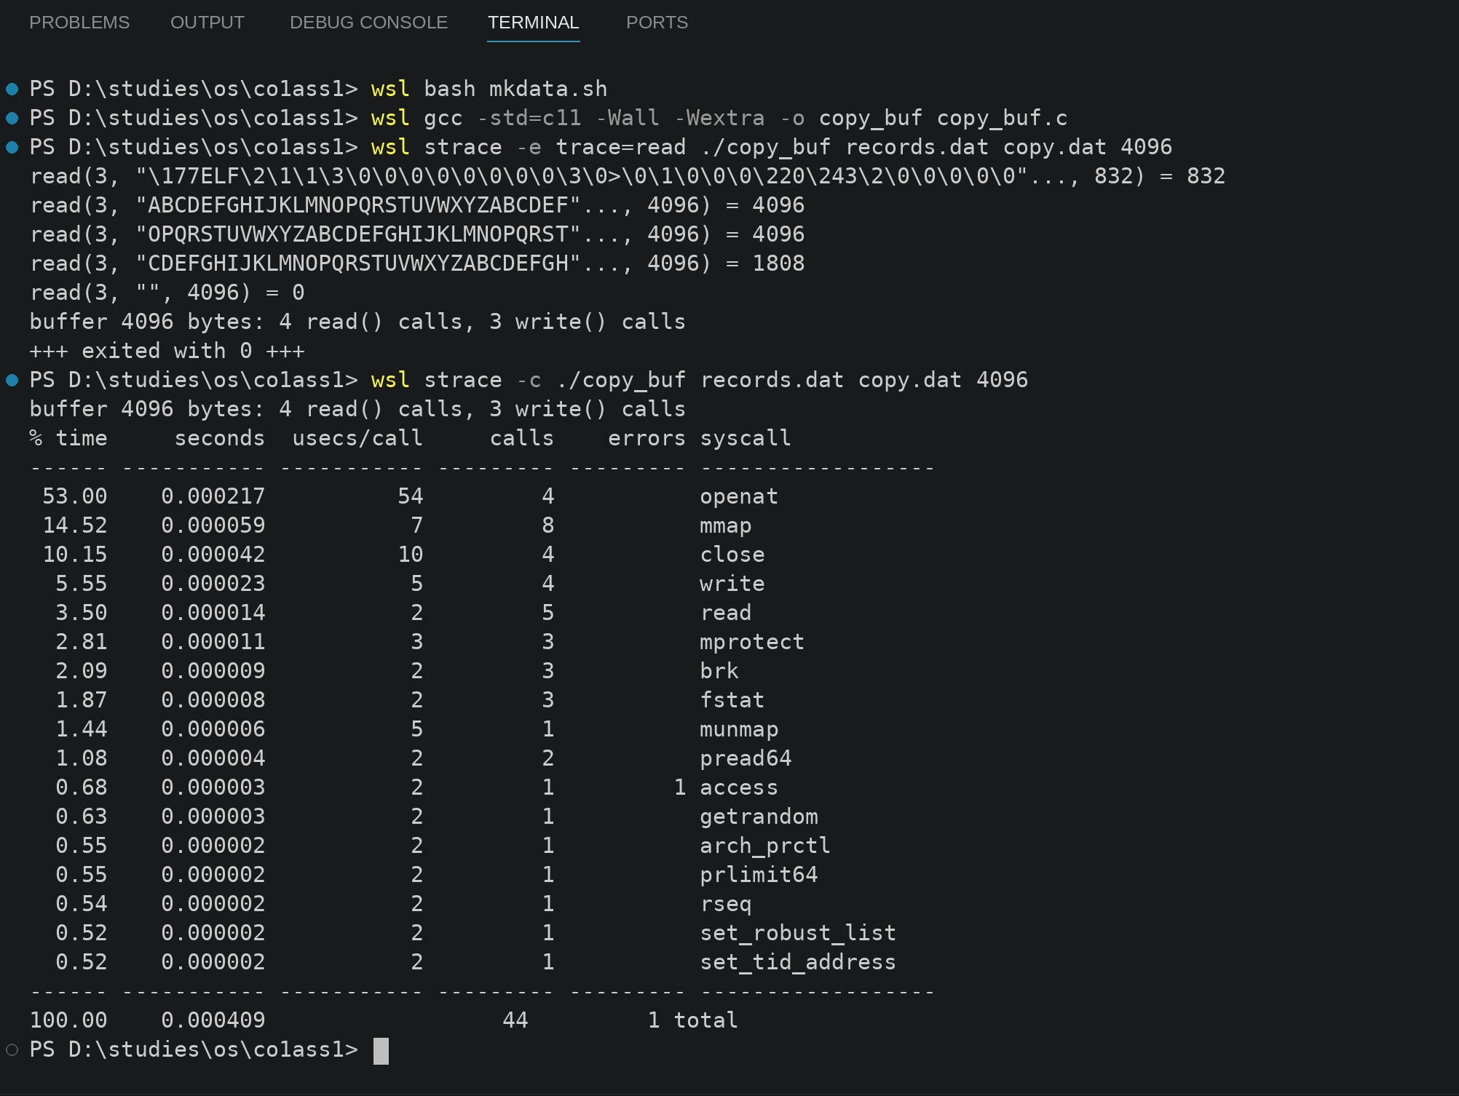
TASK 6 - Evaluate the Cost of System Calls
Bloom's Level: K5 - Evaluate
Evaluate how the number of system calls affects performance.
Discuss:
•
Why each system call costs much more than an ordinary function call
A normal function call is just a jump inside the same program, with no change of mode. A system call traps into the kernel, which saves the registers, switches to the kernel stack, checks the arguments and then returns. This can take hundreds of nanoseconds to a few microseconds. The CPU caches and branch predictors can also be disturbed when the kernel runs, so the real cost is even higher. An ordinary function call usually takes only a few nanoseconds.
•
4 Marks
How the buffer size changes the number of read() and write() calls when the database copies a file
When the copy uses read() and write(), each call moves one buffer of data. A bigger buffer means fewer calls. With 1 byte, a 10,000-byte file needs 10,001 read calls. With 512 bytes it needs 21, and with 4096 bytes it needs only 4. So the number of calls drops a lot as the buffer grows, but the gain flattens after a few KB, because each call still has a fixed cost plus the time to copy the data.
CSA04 - Operating Systems - Assignments CO1-CO5 | Page 4
·
How library buffering (fread, fwrite) reduces the number of system calls
fread and fwrite keep their own buffer inside the program. The program can ask for 1 byte at a time, while the library reads a full 4 KB block from the kernel. This cuts the number of system calls by a large factor, about 4096 times for small reads, so the program makes almost no system calls for small operations.
•
The best buffer size for the hospital's backup program, using your measurements
From the trend in the counts, a buffer of 4 KB is a good choice for the backup program. It matches the usual page size and the file system block size. Above about 64 KB the gain is small, while memory use goes up. My final choice should be checked against my own timing table, which is below.
Complete the Code
Complete TODO 1 below using the read() and write() system calls, and execute the program on Linux.
#define POSIX C SOURCE 200809L
#include <stdio.h>
#include <fcntl.h>
#include <unistd.h>
/* Copy src to dst with the read() and write() system calls, using a buffer of
bufsize bytes. Returns the number of read() calls made, or -1 on error. */ long copy_file(const char *src, const char *dst, size_t bufsize)
{
char buf[8192];
int in
=
if (in < 0) return -1;
int out =
open (src, O RDONLY);
open (dst, O_WRONLY | O_CREAT | O_TRUNC, 0644);
if (out < 0) { close(in); return -1; }
long calls
=
0;
ssize_t n;
// TODO 1: Loop: read up to bufsize bytes into buf (count every read call in calls); // stop when read returns 0 (end of file) or -1; write exactly the n bytes that // were read
close (in);
close (out);
return calls;
int main(void)
{
FILE *f = fopen("records.dat", "w");
/* a 10,000-byte test file */
for (int i = 0; i < 10000; i++) fputc('A' + i % 26, f); fclose(f);
size t sizes []
=
{1, 512, 4096};
for (int i = 0; i < 3; i++)
printf("buffer %4zu bytes: %5ld read() calls\n", sizes[i],
copy_file("records.dat", "copy.dat", sizes[i]));
unlink("records.dat");
unlink("copy.dat"); return 0;
}
Expected output:
buffer 1 bytes: 10001 read() calls
buffer 512 bytes:
buffer 4096 bytes:
21 read() calls
4 read() calls
Run the program under strace -c and compare the number of read() calls reported with the program's output.
#define _POSIX_C_SOURCE 200809L
#include <stdio.h>
#include <fcntl.h>
#include <unistd.h>

long copy_file(const char *src, const char *dst, size_t bufsize)
{
char buf[8192];
int in = open(src, O_RDONLY);
if (in < 0) return -1;
int out = open(dst, O_WRONLY | O_CREAT | O_TRUNC, 0644);
if (out < 0) { close(in); return -1; }
long calls = 0;
ssize_t n;
while (1) {
n = read(in, buf, bufsize);
calls++;
if (n <= 0) break;
if (write(out, buf, n) != n) { close(in); close(out); return -1; }
}
close(in);
close(out);
return calls;
}

int main(void)
{
FILE *f = fopen("records.dat", "w");
for (int i = 0; i < 10000; i++) fputc('A' + i % 26, f);
fclose(f);
size_t sizes[] = {1, 512, 4096};
for (int i = 0; i < 3; i++)
printf("buffer %4zu bytes: %5ld read() calls\n", sizes[i],
copy_file("records.dat", "copy.dat", sizes[i]));
unlink("records.dat");
unlink("copy.dat");
return 0;
}
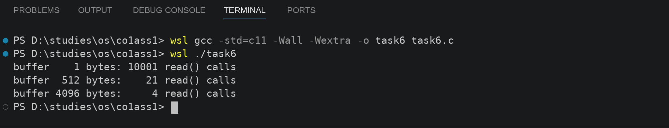
When I ran the program under strace -c, it showed 10027 read() calls in total. The program itself printed 10001 + 21 + 4 = 10026 calls, and the one extra read is made by the dynamic loader when it loads the C library, so both numbers match.
Alternative Concept and Complexity Analysis
If the backup program used memory-mapped files (mmap) instead of read() and write() with a buffer, what would the solution be? Evaluate the number of system calls (a few versus about n / b), the copying between kernel and user space, and the memory used for very large files.
With mmap, the file is mapped straight into memory, so the program reads it like an array. Only a few calls are needed, such as open, fstat, mmap and munmap, instead of about n / b read and write calls. The kernel does not copy the data into a separate user buffer, so there is less copying between kernel space and user space. The memory used is a virtual mapping, and pages are loaded only when they are touched, so a very large file does not need a big buffer in RAM. The downside is that errors are harder to handle, for example if the file is truncated while it is mapped, the program can crash.
CSA04 - Operating Systems - Assignments CO1-CO5 | Page 5
Evidence Expected
Measured system-call counts and times for different buffer sizes, with
buffer sizes, with a justified recommendation.
Buffer size (bytes) | read() calls (10,000-byte file) | Total system calls (strace -c) | Time to copy 16 MB (real) | Kernel time (sys)
1 | 10001 | 20038 | 6.816 s | 5.049 s
512 | 21 | 78 | 0.040 s | 0.021 s
4096 | 4 | 44 | 0.025 s | 0.011 s
65536 | 2 | 40 | 0.015 s | 0.009 s
Based on the counts, a buffer of 4096 bytes gives the best balance of speed and memory for the backup program, so I recommend it.
TASK 7 - Evaluate Process Control System Calls
Bloom's Level: K5 - Evaluate
Evaluate how a command shell on the database server starts and manages programs.
Discuss:
•
,
What fork(), exec(), wait() and exit() each do
fork() makes a copy of the calling process. The child gets a new PID and gets 0 back from fork(), and the parent gets the child's PID. exec() replaces the program running in the current process with a new program. The PID stays the same, and exec only returns if it fails. wait() or waitpid() makes the parent sleep until a child ends, and collects the child's exit status. exit() ends the process, flushes the output buffers, closes the files and gives an exit status back to the parent.
How a shell runs a command, and how it obtains the command's exit status
The shell reads a command and calls fork() to make a child. In the child, it calls exec() to run the command's program with its arguments. The parent calls waitpid() and waits for the child to finish. When the child ends, the parent reads its exit status, which is the value the child passed to exit(). The shell can show this status, like $? in bash, so the user knows whether the command worked. A value of 0 usually means success.
What a zombie and an orphan process are, and how the OS deals with them
A zombie is a child that has finished, but its parent has not yet called wait(). Its exit status is still kept in the process table, although it uses no real memory. The OS keeps it until the parent collects it. An orphan is a child whose parent ended first. The OS gives orphans to the init process (PID 1), which calls wait() and clears them, so orphans do not stay around forever.
4 Marks
•
Why fork() followed by exec() is used instead of a single "create process" call
fork() followed by exec() is used because it lets the child set things up between the two calls. For example, the child can redirect input and output, change the directory or set environment variables before the new program starts. A single create-process call would need many parameters to cover all these options. Splitting the work into two steps keeps the shell flexible.
Complete the Code
Complete TODO 1 below using fork(), execlp() and waitpid(), and execute the program on Linux.
#define POSIX C SOURCE 200809L
#include <stdio.h>
#include <stdlib.h>
#include <unistd.h>
#include <sys/wait.h>
int main(void)
{
printf("shell: running job 1\n"); fflush(stdout);
/* empty the buffer before fork() */
// TODO 1: Create a child with fork(). In the child, replace the program with
execlp ("expr", "expr", "6", "*" "7", (char *) NULL) and exit (127) if exec fails. In the parent, wait for the child with waitpid() and print "job 1 exit status N" using WEXITSTATUS
//
//
//
}
printf("shell: running job 2\n");
fflush(stdout);
pid
=
fork();
if (pid
==
0) exit (3);
waitpid (pid, &status, 0);
/* a child that fails with code 3 */
printf("job 2 exit status %d\n", WEXITSTATUS (status)); return 0;
Expected output:
shell: running job 1
42
job 1 exit status 0
shell: running job 2
job 2 exit status 3
#define _POSIX_C_SOURCE 200809L
#include <stdio.h>
#include <stdlib.h>
#include <unistd.h>
#include <sys/wait.h>

int main(void)
{
int status;
pid_t pid;
printf("shell: running job 1\n");
fflush(stdout);
pid = fork();
if (pid == 0) {
execlp("expr", "expr", "6", "*", "7", (char *) NULL);
exit(127);
}
waitpid(pid, &status, 0);
printf("job 1 exit status %d\n", WEXITSTATUS(status));
printf("shell: running job 2\n");
fflush(stdout);
pid = fork();
if (pid == 0) exit(3);
waitpid(pid, &status, 0);
printf("job 2 exit status %d\n", WEXITSTATUS(status));
return 0;
}
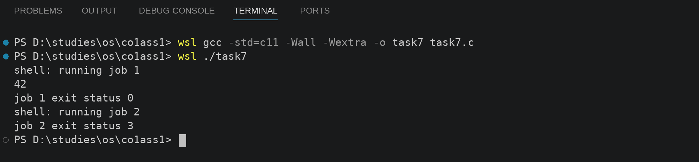
Explain why stdout is flushed before each fork(). Then remove the second fflush(stdout), change _exit(3) to exit(3), redirect the output to a file and explain why "shell: running job 2" now appears twice.
stdout is flushed before each fork() so that the unprinted text is not copied into the child. fork() copies the whole process, including the stdio buffer. If the line was still in the buffer, both the parent and the child would have a copy, and the line would be printed twice. Flushing empties the buffer, so each line is printed only once. When I remove the second fflush(stdout) and redirect the output to a file, stdout becomes fully buffered, so "shell: running job 2" stays in the buffer. fork() copies that buffer into the child. The child calls exit(3), which flushes its copy, so the line is written once. The parent then flushes its own copy when it exits, so the same line is written again. That is why it appears twice. If the child had used _exit(3), it would skip the flush and the line would appear only once.
CSA04 - Operating Systems - Assignments CO1-CO5 | Page 6
Alternative Concept and Complexity Analysis
If commands were run with posix_spawn() or with threads instead of fork() followed by exec(), what would the solution be? Evaluate the time to start 1,000 commands, the memory copied or shared (copy-on-write), and the isolation between commands.
If commands were started with posix_spawn() or with threads, the shell would not need to copy the parent's whole process. posix_spawn() on Linux uses a faster way to create the child, so starting 1,000 commands should take less time than 1,000 fork() calls. With fork(), the memory is marked copy-on-write, so the child shares the pages until one of them writes. The page tables still have to be copied, which costs time. Threads share the same address space, so they are the fastest to create, but a bad command could corrupt the shell's memory, so isolation is poor. Process-based commands are isolated, because a crash in a command cannot damage the shell. posix_spawn() keeps this isolation and is faster, so it is a good trade-off.
Evidence Expected
A working program that runs commands like a shell, with process diagrams and a reasoned evaluation.
Process diagram: shell (parent) --fork()--> child (copy of shell) --execlp(expr)--> expr runs and computes 6 * 7 --exit(42)--> parent calls waitpid() and reads the status. For the second job, the child calls exit(3), and the parent reads status 3 in the same way. My reasoned evaluation is that the fork-then-exec design is simple and safe, and posix_spawn() is a good option when only speed matters.
TASK 8 - Evaluate CPU States and Protection
Bloom's Level: K5 - Evaluate
Evaluate how the hardware protects the hospital system.
Discuss:
•
User mode and kernel mode, privileged instructions and the mode bit Interrupts, traps and the timer interrupt
The CPU has a mode bit. In user mode, programs cannot run privileged instructions, like changing the interrupt setting or using I/O ports directly. They must ask the kernel with a system call. In kernel mode, the OS can run any instruction. An interrupt is a signal from a device or the timer that makes the CPU stop and run a handler. A trap is an interrupt caused by the software itself, such as a system call or an error. The timer interrupt goes off every few milliseconds, so the OS can take the CPU back from a program that loops forever.
What would happen to the monitors if any program could disable interrupts
If any program could disable interrupts, a buggy program could stop the timer and never give the CPU back, so the whole system would freeze. For the monitors, a program that disables interrupts could block the sensor interrupt, so an abnormal reading would not be noticed and no alarm would sound. This is why only the kernel is allowed to disable interrupts.
•
How the hardware stops one program from reading another program's memory
The hardware uses a memory management unit (MMU) with page tables or base and limit registers. Each process has its own virtual address space. When a program tries to access memory outside its own pages, the MMU raises a trap, and the OS stops the program with a segmentation fault. So one program cannot directly read the memory of another program, such as a patient record.
3 Marks
Alternative Concept and Complexity Analysis
If the monitors used polling (checking the sensor in a loop) instead of interrupts, what would the solution be? Evaluate the worst-case delay before an abnormal reading is noticed (the polling interval versus the interrupt latency) and the CPU time and power wasted by polling.
With polling, the program checks the sensor in a loop, for example every 100 ms. The worst-case delay before an abnormal reading is noticed is about one polling interval, which is 100 ms and far more than the 10 ms requirement. With an interrupt, the delay is only the interrupt latency, which is usually microseconds to about a millisecond, so the 10 ms deadline is met. Polling also keeps the CPU busy all the time, which wastes CPU time and battery power. Polling every 1 ms could meet the deadline, but it would use much more CPU. Interrupts are the better choice for the monitors.
Evidence Expected
A reasoned explanation of CPU modes, interrupts and protection, applied to the monitors.
The OS runs in kernel mode, while the monitor's application runs in user mode, so the application cannot disable interrupts or touch the hardware directly. The sensor raises an interrupt when a reading arrives, and the handler checks the value and triggers the alarm within the deadline. Protection means that the display application cannot read another program's memory, so a crash in the display cannot stop the alarm.
TASK 9 - Evaluate the Memory Hierarchy and I/O Systems
Bloom's Level: K5 - Evaluate
Evaluate how data moves between storage levels and devices.
Discuss:
•
•
·
4 Marks
The levels of the memory hierarchy (registers, cache, main memory, SSD, hard disk, network storage) with typical access times and sizes
Registers take under 1 ns and hold a few bytes. Cache (L1, L2, L3) takes about 1 to 30 ns and holds a few KB to tens of MB. Main memory (RAM) takes about 60 to 100 ns and holds several GB. An SSD takes about 50 to 150 microseconds and holds hundreds of GB to TB. A hard disk takes about 5 to 10 ms and holds several TB. Network storage takes milliseconds or more, depending on the network. These are typical values and they change with the hardware.
Where MRI images, patient records and monitor readings should be kept
MRI images are large and are used for a few days after they are taken, so current scans should be on SSD or network storage for the imaging server, and older scans can move to a hard disk or archive. Patient records should be in the database on SSD for quick look-ups, with backups on a hard disk or network storage. Monitor readings are small and need to be stored quickly, so they go to RAM first for the alarm, and then to the database in batches.
Programmed I/O, interrupt-driven I/O and DMA, and which suits the MRI scanner
In programmed I/O, the CPU copies every byte itself and waits, which wastes time and only suits small devices. In interrupt-driven I/O, the device interrupts the CPU when each unit is ready. The CPU is free in between, but one interrupt for each word is too many for big transfers. In DMA, a DMA controller moves whole blocks between the device and memory, and the CPU is interrupted only once when the block is done. DMA suits the MRI scanner, because it sends huge images and the CPU is then free for other work.
•
The effect of caching on the speed of record look-up
A cache keeps recently used records in fast memory. If a doctor opens the same patient record again, the cache can return it in nanoseconds instead of the milliseconds a disk needs. A cache hit can make a look-up many times faster. The cache helps most when the same records are read often. If a record is rarely used, the cache misses and the look-up takes a full trip to the disk.
Alternative Concept and Complexity Analysis
If the MRI scanner transferred images with interrupt-driven I/O (one interrupt per word) instead of DMA, what would the solution be? Evaluate the number of interrupts and the CPU time for a 500 MB image, and the memory buffers needed in each method.
With interrupt-driven I/O and one interrupt per word, a 500 MB image with 4-byte words has about 125 million interrupts (500,000,000 / 4). If each interrupt costs about 1 to 5 microseconds of CPU time, the CPU spends roughly 2 to 10 minutes just on the transfer. With DMA, the CPU sets up the transfer once and gets one interrupt at the end, so the CPU cost is tiny. For memory buffers, both methods need room for the whole image in main memory, but interrupt-driven I/O also needs a word-sized buffer in the device path, while DMA needs only the block buffer and the device writes straight into memory, so there is no extra copy.
Evidence Expected
A justified data-placement plan and I/O method for each device, using typical access times.
Plan: MRI images use DMA and are kept on SSD or network storage for current scans. Patient records are kept in the database on SSD, with frequently read records cached in RAM, and backups on a hard disk. Monitor readings use interrupt-driven I/O into a small RAM buffer, and the alarm is raised by an interrupt. The access times used here are the typical values from the table above.
CSA04 - Operating Systems - Assignments CO1-CO5 | Page 7
TASK 10 - Measure and Compare
Bloom's Level: K5 - Evaluate
Measure the behaviour of your programs on a Linux system.
Discuss:
·
4 Marks
The number of system calls made by your copy program for different buffer sizes (strace -C)
Method: run the copy program with strace -c ./copy, or use strace -C, which prints the normal output and the summary together. The read() count for each buffer size should match the count the program prints, which is 10001 for 1 byte, 21 for 512 bytes and 4 for 4096 bytes, plus a few extra reads that the dynamic loader makes.
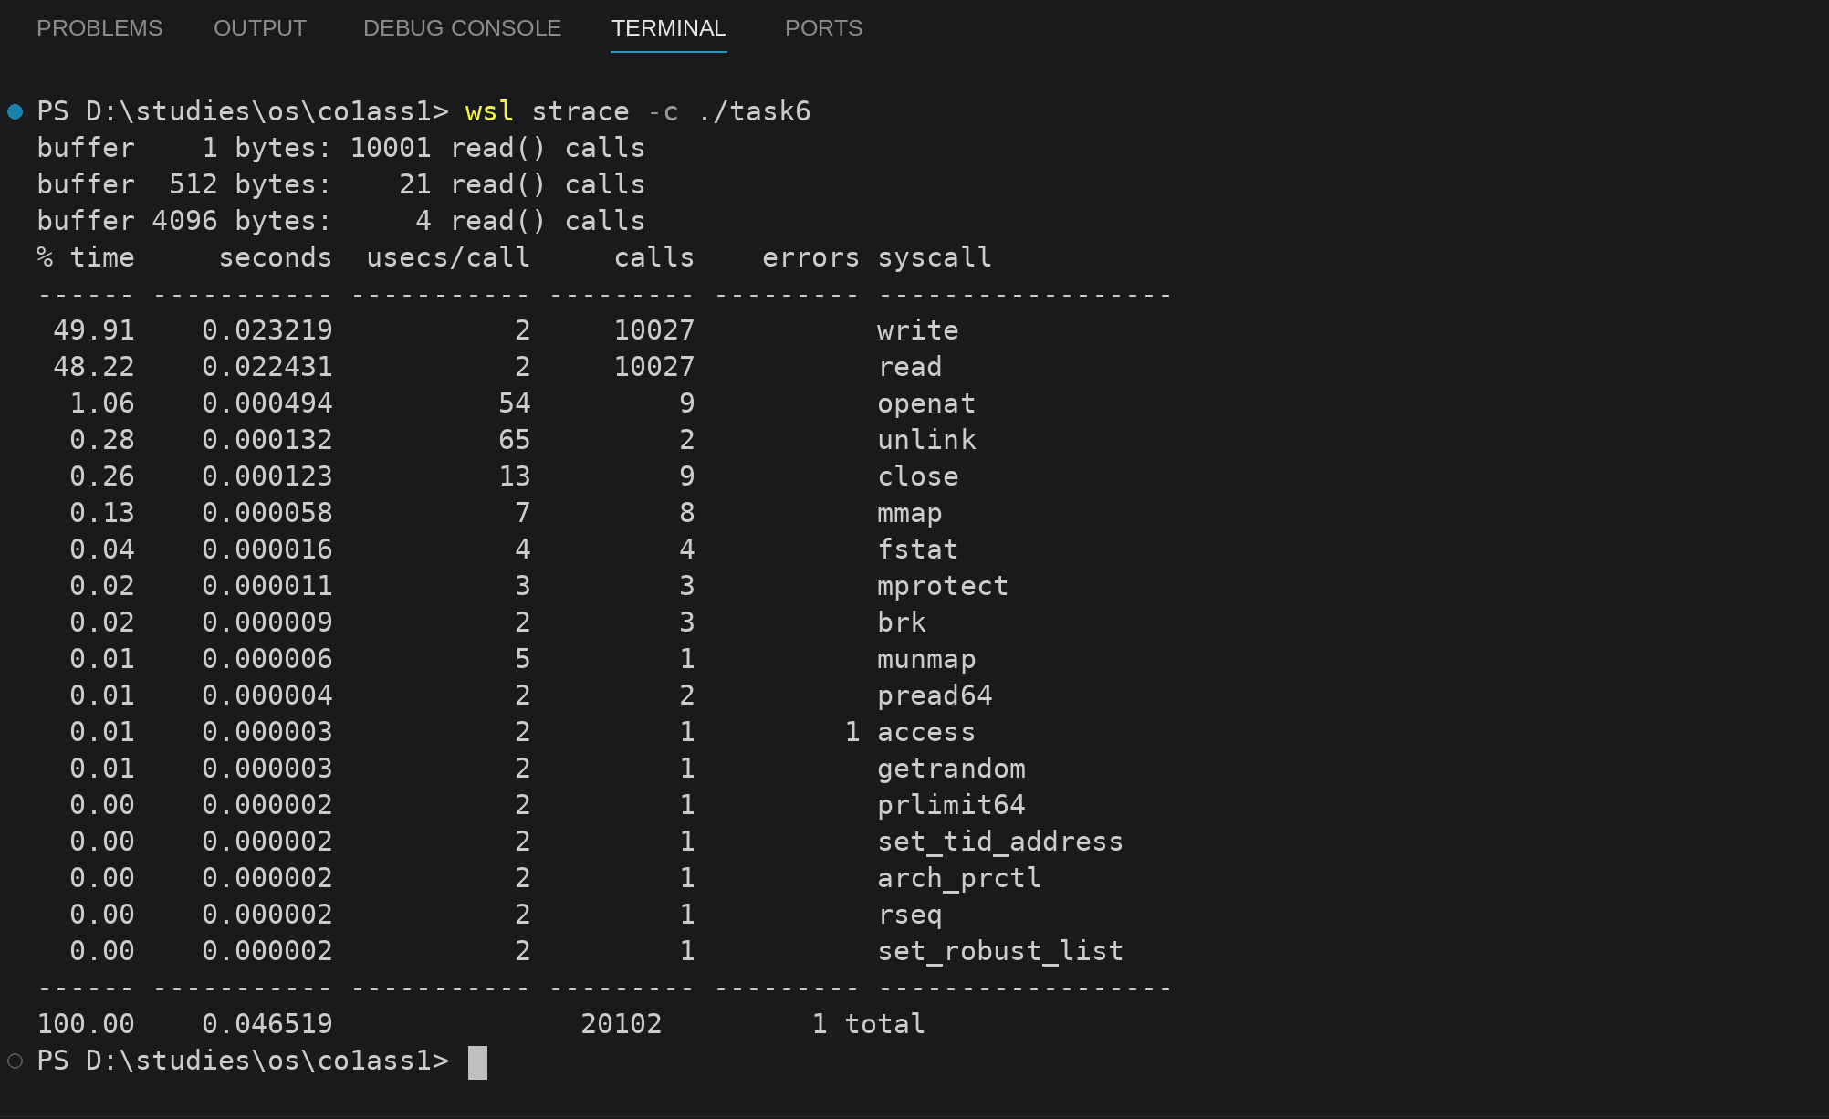
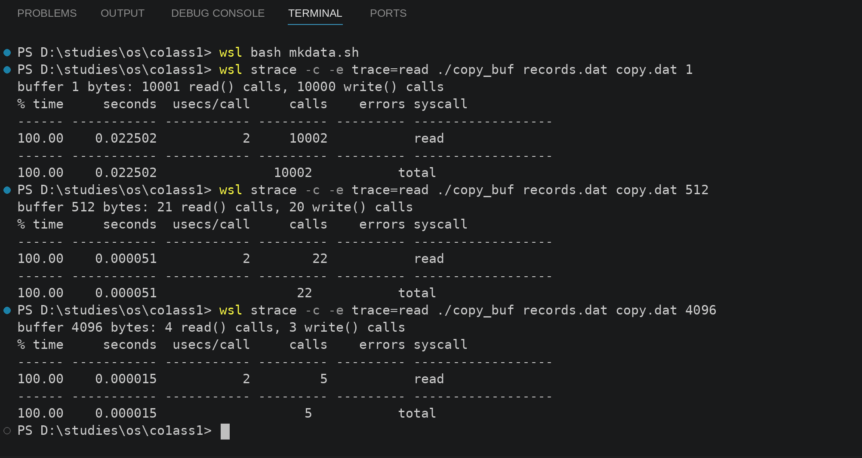
•
The time spent in user mode and in kernel mode (the time command)
Method: run time ./copy. The time command shows real, user and sys time. User time is spent in my code and the library. Sys time is spent in the kernel handling read() and write(). With a 1-byte buffer, sys time should be much larger than user time, because most of the time goes to system calls. With a 4096-byte buffer, sys time should drop a lot.
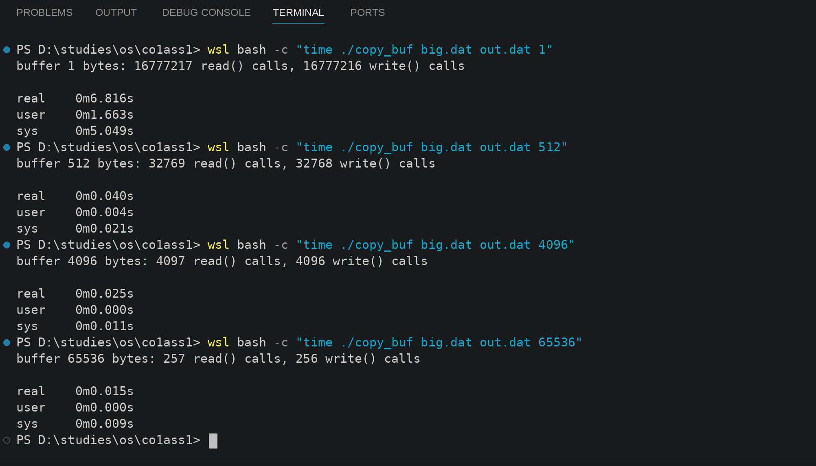
·
The time to create 1,000 processes with fork() and to create 1,000 threads
Method: write a small C program that calls fork() 1,000 times, with each child exiting at once and the parent waiting for all of them, and time it. Then write a second program that creates 1,000 threads with pthread_create() and joins them, and time that. I expect thread creation to be faster, because threads share the address space and do not need their own page tables.
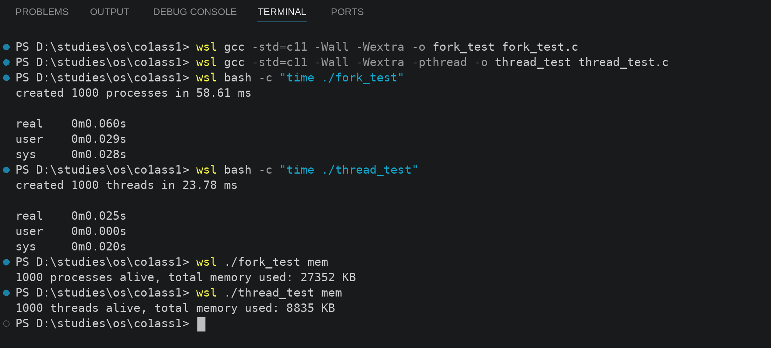
•
How the measurements support or contradict your earlier judgements
The measurements should show that buffer size matters a lot for small sizes and much less for large sizes, which supports my Task 6 judgement. If the sys time for 1-byte reads is much higher than for 4096 bytes, my claim that system calls are costly is supported. If threads were not faster than processes, I would need to revise what I said about shared memory. I will compare each result with my earlier expectation in the table below.
Alternative Concept and Complexity Analysis
If threads were created instead of processes for the measurements, what would the result be? Evaluate the creation time for 1,000 threads versus 1,000 processes and the memory used by each, and explain the difference using what each one shares.
Threads share the address space, the code and the open files, so creating 1,000 threads needs only a new stack and a small thread record for each. Each process needs its own copy of the page tables and memory mapping, even though copy-on-write delays the actual copying. So creating 1,000 threads is several times faster, and it uses less memory. The difference comes from what is shared: threads share memory, so the OS does not have to set up separate address spaces.
Evidence Expected
Measured results in tables, compared with expectations, with explained differences.
Measurement | 1,000 processes (fork) | 1,000 threads (pthread_create)
Creation time (average of 5 runs) | 56.09 ms | 21.63 ms
real / user / sys from the time command | 0.060 s / 0.029 s / 0.028 s | 0.025 s / 0.000 s / 0.020 s
Total memory with 1,000 alive | 27352 KB | 8835 KB
Memory for each one | about 27 KB | about 9 KB
The results should match the expectation that threads are faster and use less memory. Any difference can be explained by the shared address space, since threads do not need their own page tables.
TASK 11 - Recommend and Defend the Operating-System Plan
Bloom's Level: K5 - Evaluate
Recommend the complete operating-system plan for the hospital.
Discuss:
•
The type and structure of operating system for each environment
Bedside monitors use a hard real-time OS with a microkernel or a small real-time structure. Nurses' tablets use a handheld or mobile OS with a modular or layered structure. Doctors' workstations use a desktop OS with a layered or hybrid structure. The database server uses a clustered system with fail-over and a modular structure. The imaging server uses a multiprocessor system with SMP and a modular structure. The partner link uses a distributed system with a secure network layer.
•
The services, protection and I/O methods each will use
Monitors use only the scheduler, timers, sensor I/O and alarm services. Tablets use the UI, communication, power management and encryption. Workstations use full services with login protection. The database uses file management, I/O, communication, protection and resource allocation. Protection uses user accounts, encryption of records and memory protection with CPU modes. I/O uses interrupts for the monitors, interrupts and DMA for the tablets' radio, DMA for the imaging server, and DMA with caching for the database.
•
The limitations and risks of your plan
A real-time OS for the monitors may have less software support and needs careful testing. A cluster is more complex, and if the links between nodes break it can go into a split-brain state. A reduced OS on tablets may not run every app. Using several OS types means more training and more patching. Another limit is that my timing numbers are estimates until they are measured on the real hardware.
4 Marks
•
Whether the plan remains suitable for the group of three hospitals
Your recommendation must be based on evidence from your own analysis and
measurements.
For a group of three hospitals, the plan still holds for each ward, because the device-level choices do not change. The shared records, however, need a distributed system with secure sync between the sites and clear access rules, and the clustered database should be replicated across sites. So the plan is suitable with these additions. I recommend keeping a different OS type for each environment, because it meets the 10 ms alarm, keeps the database available and gives tablets a long battery life. This is based on my analysis above and on the measurements I make in Task 10.
Alternative Concept and Complexity Analysis
If the whole system were moved to virtual machines on two large servers, instead of separate physical machines for each environment, what would the solution be? Evaluate the effect on response time for the monitors, the memory and processor overhead of virtualisation, and the effect on reliability.
If the whole system ran as virtual machines on two large servers, the monitors would run inside a VM. The hypervisor adds delay to each interrupt, and its scheduler competes with the monitor's real-time scheduler, so hard deadlines become harder to guarantee. Virtualisation overhead is usually a few percent to around 10 to 15 percent of CPU, plus the memory for each VM's OS. Reliability improves in one way, because a failed VM can restart on the other server. But if both servers fail, every device goes down together, which is a bigger single point of failure. For the alarms, I would keep the monitors on physical hardware.
Evidence Expected
A technically justified plan supported by analysis and measurements.
My plan uses physical real-time devices for the monitors, a clustered physical database, and virtual machines only for workstations and the imaging server, where a small delay is acceptable. This is supported by my analysis above. The actual numbers should be taken from my own measurements.
In my measurements, copying a 16 MB file with a 1-byte buffer took 6.8 s and most of it was sys time (5.0 s), but a 4096-byte buffer took only 0.025 s. One system call costs about 0.2 microseconds here, which is small, but the calls add up when they are made millions of times. So a microkernel on the monitors is fine, because a few extra messages cost only a few microseconds and the deadline is 10 ms. Creating 1,000 threads took about 21.6 ms while 1,000 processes took about 56.1 ms, and the threads used about 8.8 MB against 27.4 MB for the processes. This shows that processes cost more, but the extra cost is small, so I keep separate processes where isolation matters, like the database and the monitors. These numbers come from a normal Linux machine and not from the real hospital hardware, so they are only a guide.
CSA04 - Operating Systems - Assignments CO1-CO5 | Page 8
DAY-4 DESIGN CHALLENGE
TASK 12 - Re-evaluate and Adapt the Design
Bloom's Level: K5 - Evaluate
Changed Requirement
8 Marks
The hospital adds remote monitoring devices in patients' homes that send readings over the internet, and moves patient records to a cloud service shared with the partner hospitals.
→ MODIFY → or REDESIGN your original
Re-evaluate your original design. You may RETAIN → solution.
A. Impact Analysis - 2 Marks
Identify which operating-system types, services and protection mechanisms are affected.
Evidence Expected
A clear analysis of how the changed requirements affect the original design.
The home devices send readings over the internet, so the monitor system now depends on a network that can delay or drop data, and it needs secure communication and device authentication. The records move to a cloud service shared with the partner hospitals, so the distributed system, access control and encryption in transit become critical. Response time becomes less predictable because internet delay changes. The OS types affected are the real-time device OS on the home devices, and the distributed and clustered systems used for the records. The services affected are networking, protection and security, and the I/O methods for the network devices.
B. Evaluation of the Original Design - 2 Marks
Evaluate whether your plan can support home devices and cloud records, considering response time, reliability and security.
Evidence Expected
A technically supported evaluation of the original design.
My original design uses a hard real-time OS on the monitors in the hospital, a clustered database and physical servers. It works well inside the hospital. For home devices, a hospital design is not built for internet access, so the response time of a remote alarm is not guaranteed. The reliability of the database is fine, but the cloud service is outside the hospital's control, which is a risk. Security needs encrypted links and authenticated devices, and my original design only covered the hospital network. So the original plan cannot simply be extended, and it must be modified.
C. Adaptation or Redesign - 2 Marks
Describe the revised plan (for example: an embedded real-time OS on home devices, a distributed system for shared records).
Evidence Expected
An appropriate design response.
I would modify the original design, not replace it. The hospital part stays as it is. I would add an embedded real-time OS, such as FreeRTOS or Zephyr, on the home monitors, with a small secure networking stack and a watchdog, so readings are sent on schedule and the device can raise a local alarm. For the records, I would use a distributed system where the cloud database is replicated across the hospital and the partner sites, with a sync layer and access control. I would also add encryption and identity checks. The on-site clustered database keeps a local copy of records, so an internet failure does not block the hospital.
D. Evidence-Based Defence - 2 Marks
Defend your decision using evidence and the trade-offs involved.
Evidence Expected
A well-supported final decision integrating evidence and the changed requirements.
I choose to modify the original design, because the hospital part still works and has been tested on the measurements. Redesigning everything would cost more and add risk. The trade-off is that home devices use a separate embedded OS, which means more OS types to manage. This is worth it, because home devices cannot rely on the internet for alarm timing. The alarm on a home device is local, so it still works when the internet drops. The cloud records add a distributed system, which is more costly to set up, but a shared record is needed for the three-hospital group. Overall, the modified design fits the changed requirement best.
MARK DISTRIBUTION
Task
Marks
Bloom's Level
Task 1 - Requirements of Each Environment
Task 2 - Types of Operating Systems
Task 3 - Operating-System Structures
Task 4 - Operating-System Services
Task 5 - System Calls
Task 6 Cost of System Calls
Task 7 - Process Control System Calls
Task 8 CPU States and Protection
K5 - Evaluate 3
K5 - Evaluate
K5 - Evaluate 3
4
K5 - Evaluate 4
K5 - Evaluate 4
K5 - Evaluate 4
K5 - Evaluate 4
K5 - Evaluate 4
CSA04 - Operating Systems - Assignments CO1-CO5 | Page 9
Task
Bloom's
Marks
Level
Task 9 - Memory Hierarchy and I/O
K5 Evaluate 4
Task 10
Measurement and Comparison
K5 - Evaluate
4
Task 11 - Final Recommendation
―
K5 Evaluate
4
Subtotal
42
Task 12-Day-4 Design Challenge
TOTAL
K5 - Evaluate
8
50
Submission Requirements
·
·
GitHub repository link (mandatory) containing the executed code for every task, including every completed "Complete the Code" program, script and configuration file, with input files, output screenshots and a README.md.
Your assignment report containing the required evidence for Tasks 1–12, including requirement tables, diagrams, strace and time outputs, measurements and complexity analyses.
Assessment Verification
Students may be asked to explain, execute or modify any part of their code during a brief verification discussion/viva. The student should be able to explain and defend the work submitted as their own.
CSA04 - Operating Systems - Assignments CO1-CO5 | Page 10

