OPERATING SYSTEMS
ASSIGNMENT 2 CO2
Name: Pradeepkumar Reg No: 192425016 Batch: 2024 - AIML
CO2 Coverage: Analyse process management and deadlock-handling techniques to improve CPU utilisation and system performance - processes, process scheduling, threads, inter-process communication, synchronisation using semaphores, monitors and the critical-section problem, and deadlock handling including the Banker's algorithm.
Nature of Assignment: Individual
Duration: 1 Week
Total Marks: 50
Submission Date:
Bloom's Levels Assessed: K5 - Evaluate (every task in this assignment is at K5 level)
Mandatory Execution and GitHub Submission
·
·
·
•
•
Every student must individually execute every task in this assignment, including all "Complete the Code" programs.
Create a GitHub repository named CSA04-<RegisterNumber>-Assignment2 and share it with the course faculty (public, or private with the faculty added as a collaborator).
Keep one folder for each task (for example: Task01, Task02... or Q1, Q2 ...), containing the C source files, shell scripts, configuration files (Dockerfile, YAML), command outputs and screenshots.
Include a README.md with your name, register number, compiler and version (for example gcc 13), the Linux distribution and version used, the exact gcc command used to compile (for example gcc -std=c11 -Wall -Wextra -pthread), the steps to run each program, and a short note of the result of each task.
Commit your work progressively - at least one commit for each task. The commit history will be checked; a single upload of all files on the last day will not be accepted. Submit the GitHub link below and on the cover page of your report. An assignment submitted without a working GitHub link will not be evaluated.
GitHub Repository Link:
https://github.com/pradeepkumar673/CSA04-192425016-Assignment2
How to Answer the Additional Questions
Complete the Code: Copy the given code into your repository, replace every TODO with working code without changing the rest of the program, execute it and compare your output (or result) with the expected output.
Alternative Concept and Complexity Analysis: Describe how the solution would change if the alternative concept were used, with code or pseudocode, and analyse and compare the time complexity and space complexity of both solutions using Big-O notation, supported by your own measurements wherever possible.
CSA04 - Operating Systems - Assignments CO1-CO5 | Page 11
Q1 - Processes and Process States
Bloom's Level: K5 - Evaluate
Problem Context - Online Examination Server
6 Marks
During an online examination, the server runs a separate process for every student's session, plus processes for auto-saving answers and for proctoring video. When 2,000 students log in together, the server becomes slow and some sessions appear to "hang".
Your Challenge
Draw the process-state diagram (new, ready, running, waiting, terminated) and the process control block (PCB). Write a program that creates child processes with fork() and observe them with ps and /proc.
Process state diagram
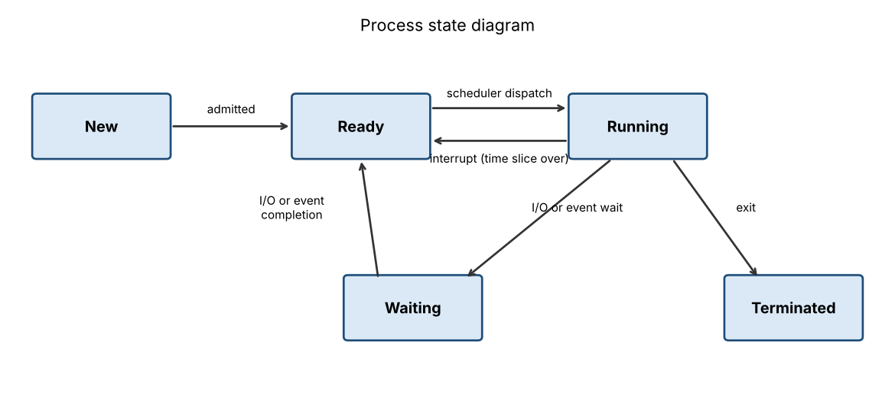
A new process is created in the new state and admitted to the ready queue. The scheduler picks it and it goes to running. From running it can go back to ready when its time slice ends (interrupt), it can go to waiting when it asks for I/O, or it goes to terminated when it exits. After the I/O finishes the process goes from waiting to ready, not directly to running.
Process control block (PCB)
The PCB is the table entry that the OS keeps for every process. The OS uses it to save and restore a process at every context switch.
PCB field | What it stores
Process ID and parent ID | PID and PPID, used by ps and fork()
Process state | new, ready, running, waiting or terminated
Program counter | address of the next instruction to run
CPU registers | accumulator, stack pointer and other registers saved at a switch
Scheduling information | priority, queue pointers, time used
Memory management information | page table, base and limit registers
Accounting information | CPU time used, time limits, process numbers
I/O status information | open files and devices allocated to the process

fork() program (fork_demo.c)
#define _DEFAULT_SOURCE
#include <stdio.h>
#include <stdlib.h>
#include <unistd.h>
#include <string.h>
#include <sys/wait.h>

#define CHILDREN 4

void show_state(pid_t pid)
{
char path[64], line[256];
snprintf(path, sizeof path, "/proc/%d/status", pid);
FILE *f = fopen(path, "r");
if (!f) return;
while (fgets(line, sizeof line, f)) {
if (strncmp(line, "Name:", 5) == 0 || strncmp(line, "State:", 6) == 0 ||
strncmp(line, "VmRSS:", 6) == 0)
printf(" [%d] %s", pid, line);
}
fclose(f);
}

int main(void)
{
pid_t kids[CHILDREN];
setvbuf(stdout, NULL, _IOLBF, 0);
printf("parent pid = %d\n", getpid());
for (int i = 0; i < CHILDREN; i++) {
pid_t pid = fork();
if (pid < 0) {
perror("fork");
return 1;
}
if (pid == 0) {
printf("child %d started, pid = %d, ppid = %d\n", i + 1, getpid(), getppid());
sleep(2);
exit(i + 1);
}
kids[i] = pid;
}
usleep(300000);
printf("\n--- ps output ---\n");
char cmd[160];
snprintf(cmd, sizeof cmd, "ps -o pid,ppid,stat,etime,comm -p %d,%d,%d,%d,%d",
getpid(), kids[0], kids[1], kids[2], kids[3]);
fflush(stdout);
system(cmd);
printf("\n--- /proc info ---\n");
for (int i = 0; i < CHILDREN; i++)
show_state(kids[i]);
printf("\n");
for (int i = 0; i < CHILDREN; i++) {
int status;
pid_t done = waitpid(kids[i], &status, 0);
printf("child pid %d finished with exit code %d\n", done, WEXITSTATUS(status));
}
printf("parent: all children are terminated\n");
return 0;
}
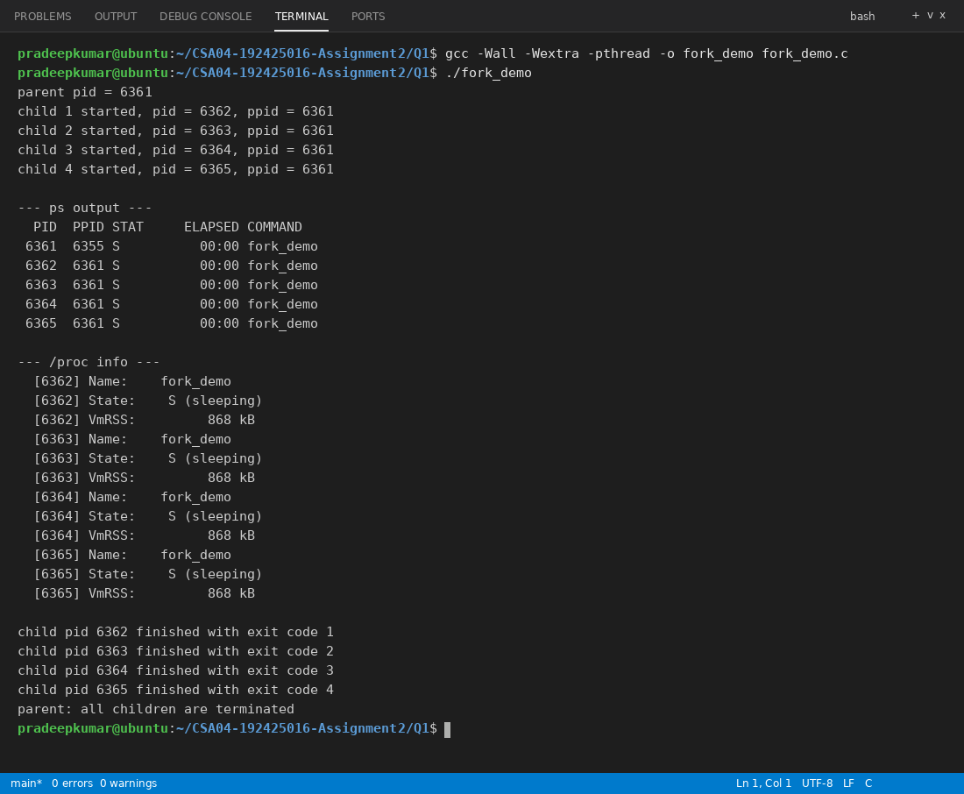
In the output the parent has 4 children with the same PPID. ps shows state S for the children because they are inside sleep(), which means they are in the waiting state. /proc/<pid>/status also shows State: S (sleeping) and each tiny child uses about 872 kB of memory (VmRSS). After the sleep the children exit with codes 1 to 4 and the parent collects them with waitpid(), so no zombie process is left.
Evaluation
Evaluate where the time goes when 2,000 processes are active: context-switch cost, memory per process, and time spent waiting for I/O. Judge whether a separate process per student is a sound design.
When 2,000 processes are active the time goes mainly in three places.
Context switch cost: Every switch saves one PCB and loads another, changes the page table and flushes the TLB and cache. One switch takes only a few microseconds, but with 2,000 ready processes on a few cores the CPU keeps switching and the useful work becomes less. The ready queue also becomes very long, so a session waits a long time for its turn, and this is why it looks like it is hanging.
Memory per process: Each process has its own address space, page tables, kernel stack and PCB. My small test process already used about 872 kB, and a real exam session with the web code and auto-save buffers will use many MB. 2,000 sessions can easily need several GB and then the system starts swapping, which makes everything slower.
Waiting for I/O: Most of the time a student session is not computing. It waits for the network, the keyboard and the disk (auto-save). Processes in the waiting state do not use CPU, but when all 2,000 students login together the disk and network become the bottleneck and many processes sit in the waiting state at the same time.
Judgement: One process for each student is not a good design for 2,000 students. It gives good protection between students, but the memory use and the switching cost are too high.
Design Decision
Decide between one process per student, one thread per student and a fixed pool of worker processes, and defend your decision.
My decision: a fixed pool of worker processes. For example 8 worker processes (about the number of CPU cores) where each worker handles many student sessions using a few threads or an event loop. Proctoring video and auto-save can be separate small processes.
Reasons: the memory is limited and known in advance, the number of context switches stays small, and 2,000 logins at the same time only wait in a queue instead of crashing the server. If one worker crashes only the students on that worker are affected, not the whole exam. One process per student wastes memory, and one thread per student is light but one bug can kill every session in the process.
Alternative Concept and Complexity Analysis
If each student session were a thread inside one server process, instead of a separate process, what would the solution be? Evaluate the context-switch time and the memory per session (a few KB of stack versus a full address space), and the effect of one session crashing.
If every student session is a thread inside one server process, the threads share the same address space, code and open files. Each thread needs only its own stack and a small thread control block, so it uses a few KB to some tens of KB instead of a full address space.
Point | Process per session | Thread per session
Creation time (my test, create_cost.c) | about 42.9 µs for fork + wait | about 8.9 µs for thread + join
Context switch | changes page table, TLB flush, slower | same address space, faster
Memory per session | about 872 kB for a tiny process, MB for a real one | few KB for stack and thread block
If one session crashes | only that student is lost | whole server process dies, all 2,000 sessions are lost
Sharing data | needs IPC (pipes, shared memory) | shared variables, but needs locks

Both need memory that grows with the number of sessions, O(n), but the constant for a thread is much smaller, and one switch is O(1) in both cases. So threads are faster and smaller, but processes are safer.
Evidence Expected
A state diagram, a PCB description, a working fork() program with ps evidence and a defended design decision.
Q2 - CPU Scheduling
Bloom's Level: K5 - Evaluate
Problem Context - Cloud Video-Encoding Service
8 Marks
A video service receives short jobs (thumbnails, 2 seconds) and long jobs (full films, 20 minutes) on the same servers. Customers complain that small jobs wait behind large ones, while the company wants the processors fully used.
Your Challenge
Compute the Gantt chart, waiting time, turnaround time and response time for the same set of jobs under FCFS, SJF, SRTF, priority and Round Robin scheduling. Implement Round Robin.
I used the same 4 jobs that are given in the Complete the Code program: P1 (arrival 0, burst 8), P2 (arrival 1, burst 4), P3 (arrival 2, burst 9) and P4 (arrival 3, burst 5). For the priority scheduling I took P3 = 1 (highest), P1 = 2, P2 = 3 and P4 = 4, and a smaller number means higher priority. Priority is non-preemptive and SJF is non-preemptive, SRTF is the preemptive form of SJF. Round Robin uses quantum 3.
Gantt charts
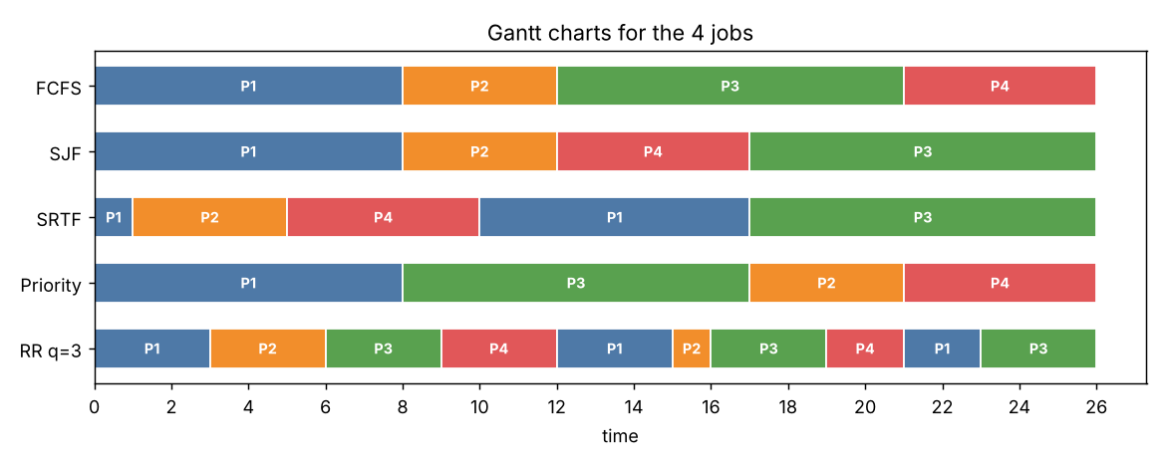
Turnaround time = finish - arrival, waiting time = turnaround - burst, response time = first run - arrival. Each cell below is TAT / WT / RT.
Algorithm | P1 | P2 | P3 | P4 | Avg TAT | Avg WT | Avg RT
FCFS | 8/0/0 | 11/7/7 | 19/10/10 | 23/18/18 | 15.25 | 8.75 | 8.75
SJF | 8/0/0 | 11/7/7 | 24/15/15 | 14/9/9 | 14.25 | 7.75 | 7.75
SRTF | 17/9/0 | 4/0/0 | 24/15/15 | 7/2/2 | 13.00 | 6.50 | 4.25
Priority | 8/0/0 | 20/16/16 | 15/6/6 | 23/18/18 | 16.50 | 10.00 | 10.00
RR (q = 3) | 23/15/0 | 15/11/2 | 24/15/4 | 18/13/6 | 20.00 | 13.50 | 3.00

Round Robin is implemented in the Complete the Code program below (rr.c).
Evaluation
Evaluate how the time quantum affects Round Robin (try 1, 3, 5 and 20), the risk of starvation in SJF and priority scheduling, and how ageing removes it. Explain how a multilevel feedback queue treats short and long jobs.
Effect of the time quantum on Round Robin
Quantum | Time slices | Context switches | Avg WT | Avg TAT | Avg RT
1 | 26 | 25 | 12.50 | 19.00 | 0.75
3 | 10 | 9 | 13.50 | 20.00 | 3.00
5 | 6 | 5 | 11.00 | 17.50 | 5.50
20 | 4 | 3 | 8.75 | 15.25 | 8.75

With a small quantum like 1 the response time is very good, but there are too many context switches (25), so the overhead is high. With a big quantum like 20 every job finishes in its first turn, so Round Robin behaves like FCFS (same averages 8.75 and 15.25) and short jobs wait behind long ones. So the quantum should be a little bigger than a typical short job.
Starvation: In SJF/SRTF a long job (a full film) can wait forever if short jobs keep arriving. In priority scheduling a low priority job can wait forever if high priority jobs keep coming. Ageing removes this: the priority of a waiting job is increased a little after some time (for example one level every 10 minutes), so after a while even the oldest job gets the highest priority and runs.
Multilevel feedback queue: A new job enters the top queue with a small quantum, so short jobs like thumbnails finish there quickly. A job that uses its full quantum is moved down to a queue with a longer quantum, so long jobs slowly sink to the bottom and run in bigger slices. Ageing moves old jobs up again, so they do not starve.
CSA04 - Operating Systems - Assignments CO1-CO5 | Page 12
Design Decision
Recommend the scheduling policy for the video service and justify it with your calculated
averages.
Recommendation: multilevel feedback queue with ageing. From my averages SRTF is the best (average WT 6.50, average RT 4.25, and the short job P2 waits 0), SJF is second (7.75), FCFS is 8.75, priority is 10.00 and Round Robin is the worst for waiting (13.50), although its response time (3.00) is good. But SRTF and SJF need to know the burst time in advance and they starve the full films. FCFS makes the thumbnails wait behind the films (P4 waited 18). The multilevel feedback queue gives almost the SRTF behaviour without knowing the burst time, because short jobs finish in the top queues and long jobs take the leftover CPU time, so the processors stay fully used.
Complete the Code
Complete TODO 1 below and execute the program.
#include <stdio.h>
#define N 4
int main(void)
{
const char *name [N]
=
{"P1", "P2", "P3", "P4"};
int arrival [N] = {0, 1, 2, 3};
int burst [N]
=
{8, 4, 9, 5};
int quantum
=
3;
int left [N], finish [N], queue[64], head 0, tail for (int i int time
=
=
0; i < N; i++) left[i] 0, done = 0;
=
burst[i];
= 0;
queue [tail++]
added [0] = 1;
printf("Gantt:");
while (done < N) {
int p = queue [head++];
//
//
=
0, added [N]
=
{0};
P(time-newtime)",
// TODO 1: Run p for min (quantum, left[p]) time units: print
advance time, reduce left[p]; add every process that has now arrived and is not yet added to the queue; then put p back at the end of the queue if it // still has time left, otherwise record finish [p] and count it as done
}
double tw = 0, tt = 0;
printf("\nProcess TAT
WT\n");
for (int i
=
0; i < N; i++) {
=
finish [i]
-
arrival [i], wt
= tat
burst [i];
int tat
tt += tat;
tw += wt;
printf("%-7s %4d %3d\n", name [i], tat, wt);
}
printf("Average TAT return 0;
=
%.2f, average WT
=
%.2f\n", tt / N, tw / N);
}
Expected output:
Gantt: P1 (0-3) P2 (3-6) P3(6-9) P4 (9-12) P1 (12-15) P2 (15-16) P3 (16-19) P4 (19-21) P1 (21-23) P3 (23-26)
Process TAT WT
P1
23 15
P2
15
11
P3
24
15
P4
18
13
Average TAT
=
20.00, average WT
= 13.50
Completed code (TODO 1 replaced)
#include <stdio.h>

#define N 4

int main(void)
{
const char *name[N] = {"P1", "P2", "P3", "P4"};
int arrival[N] = {0, 1, 2, 3};
int burst[N] = {8, 4, 9, 5};
int quantum = 3;

int left[N], finish[N], queue[64], head = 0, tail = 0;
for (int i = 0; i < N; i++) left[i] = burst[i];
int time = 0, done = 0, added[N] = {0};
queue[tail++] = 0;
added[0] = 1;
printf("Gantt:");
while (done < N) {
int p = queue[head++];
int run = quantum < left[p] ? quantum : left[p];
printf(" %s (%d-%d)", name[p], time, time + run);
time += run;
left[p] -= run;
for (int i = 0; i < N; i++) {
if (!added[i] && arrival[i] <= time) {
queue[tail++] = i;
added[i] = 1;
}
}
if (left[p] > 0) {
queue[tail++] = p;
} else {
finish[p] = time;
done++;
}
}
double tw = 0, tt = 0;
printf("\nProcess TAT WT\n");
for (int i = 0; i < N; i++) {
int tat = finish[i] - arrival[i], wt = tat - burst[i];
tt += tat;
tw += wt;
printf("%-7s %4d %3d\n", name[i], tat, wt);
}
printf("Average TAT = %.2f, average WT = %.2f\n", tt / N, tw / N);
return 0;
}
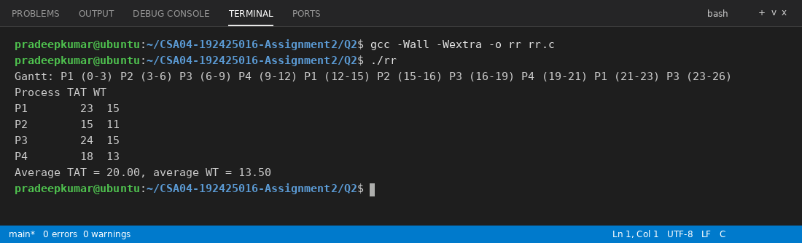
The Gantt line and all the values are the same as the expected output (average TAT = 20.00, average WT = 13.50).
Run the program with quantum 1 and quantum 20, and evaluate how the average waiting time. and the number of context switches change.
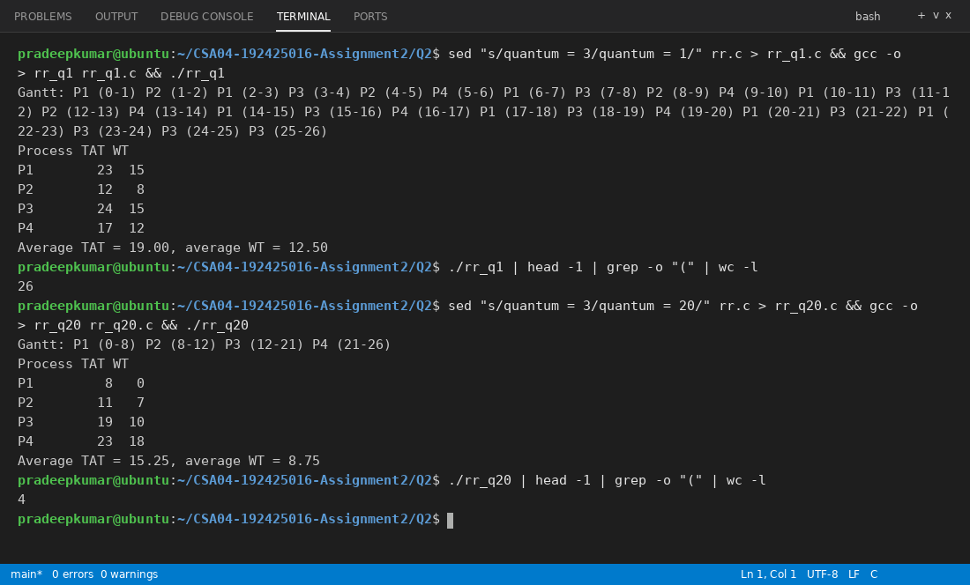
With quantum 1 the Gantt chart has 26 slices, which means 25 context switches, and the average waiting time is 12.50. With quantum 20 every job runs once without being cut, so there are only 4 slices and 3 context switches and the average waiting time is 8.75 (same as FCFS). With quantum 3 it was 9 switches and 13.50. So the waiting time does not always go down when the quantum becomes bigger (quantum 5 gives 11.00), but the number of context switches always goes down when the quantum becomes bigger.
Alternative Concept and Complexity Analysis
If the service used a multilevel feedback queue (short quantum for new jobs, longer quanta for jobs that use them up) instead of a single Round Robin queue, what would the solution be? Evaluate the average waiting time for short and long jobs, the scheduling cost per decision (O(1) per queue versus O(n) for SJF) and the risk of starvation.
I took 3 queues. Queue 0 is Round Robin with quantum 2, queue 1 is Round Robin with quantum 4 and queue 2 is FCFS. The steps are:
new job -> put in queue 0
always run the first job of the highest non-empty queue
if a job uses its full quantum -> move it to the next lower queue
if a job leaves early for I/O -> it stays in the same queue
if a job arrives in a higher queue -> the running job is preempted
after every S seconds -> move all jobs to queue 0 (priority boost)
For the same 4 jobs I simulated this and got waiting times P1 = 15, P2 = 9, P3 = 15 and P4 = 13. The short jobs (P2 and P4) have an average waiting time of 11.0 and the long jobs (P1 and P3) have 15.0, and the overall average is 13.0. In single Round Robin (q = 3) the short jobs had 12.0 and the long jobs 15.0, with the overall average 13.5. So the short jobs get better treatment and the long jobs lose nothing. With a larger mix of short and long jobs the difference becomes bigger.
Scheduling cost: MLFQ picks the next job from a fixed number of queues, so one decision is O(1) per queue (O(k) for k queues, k is small). SJF has to find the shortest job among n jobs, which is O(n) (or O(log n) with a heap). The memory is O(n) for both. Starvation: in MLFQ a long job in the bottom queue could starve, but the priority boost or ageing removes it. In SJF the long jobs can starve without ageing.
CSA04 - Operating Systems - Assignments CO1-CO5 | Page 13
Evidence Expected
Correct Gantt charts and averages for every algorithm, a working Round Robin program, a quantum study and a justified recommendation.
Q3 Threads
Bloom's Level: K5 - Evaluate
Problem Context - Traffic-Camera Number-Plate Reader
6 Marks
A city traffic system reads number plates from 64 cameras. The first version processes the cameras one after another and falls behind during peak hours.
Your Challenge
Process the camera frames with POSIX threads (one thread per camera, and a pool of 4, 8 and 16 threads). Determine:
I wrote cameras.c. There are 64 camera frames. Each worker thread takes the next camera number from a shared counter (protected by a mutex), reads and processes that frame (20 ms of waiting for the frame and then a loop for the plate detection) and adds the plates found to a shared total (also protected by a mutex). The number of threads is given on the command line, so 1 is the sequential version, 4, 8 and 16 are the pools and 64 is one thread per camera.
#define _GNU_SOURCE
#include <stdio.h>
#include <stdlib.h>
#include <pthread.h>
#include <time.h>
#include <unistd.h>

#define CAMERAS 64

int next_camera = 0;
int plates_found = 0;
pthread_mutex_t lock = PTHREAD_MUTEX_INITIALIZER;

double now(void)
{
struct timespec ts;
clock_gettime(CLOCK_MONOTONIC, &ts);
return ts.tv_sec + ts.tv_nsec / 1e9;
}

int process_frame(int cam)
{
usleep(20000);
unsigned long x = cam + 1;
for (long i = 0; i < 3000000; i++)
x = x * 1103515245UL + 12345UL;
return (x % 3) + 1;
}

void *worker(void *arg)
{
(void) arg;
while (1) {
pthread_mutex_lock(&lock);
int cam = next_camera++;
pthread_mutex_unlock(&lock);
if (cam >= CAMERAS) break;
int found = process_frame(cam);
pthread_mutex_lock(&lock);
plates_found += found;
pthread_mutex_unlock(&lock);
}
return NULL;
}

int main(int argc, char *argv[])
{
int n = argc > 1 ? atoi(argv[1]) : 1;
pthread_t t[CAMERAS];
double start = now();
for (int i = 0; i < n; i++)
pthread_create(&t[i], NULL, worker, NULL);
for (int i = 0; i < n; i++)
pthread_join(t[i], NULL);
printf("threads = %2d, plates read = %d, time = %.2f s\n", n, plates_found, now() - start);
return 0;
}
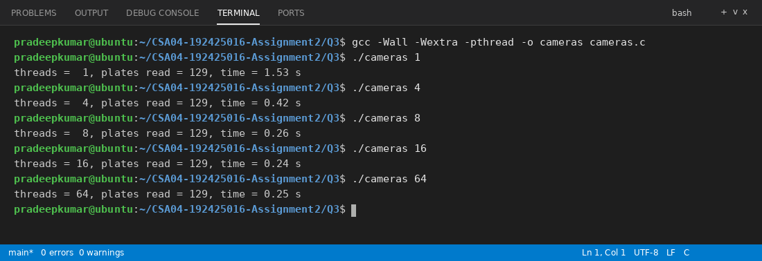
All runs read the same 129 plates, so the result is correct for every pool size.
•
Which resources threads share and which each thread has of its own
Shared by all threads: code, global and static data, heap, open files, signal handlers and the process ID. Own for each thread: thread ID, program counter, register set, stack and thread-local data.
•
The difference between user-level and kernel-level threads and the many-to-one,
one-to-one and many-to-many models
User-level threads are made and scheduled by a thread library in user space and the kernel does not know about them. They are fast to create and switch, but if one thread does a blocking system call the whole process blocks, and they cannot run on many cores. Kernel-level threads are managed by the OS, so they can run on different cores at the same time and one blocked thread does not block the others, but creating and switching them is slower because of system calls.
Many-to-one: many user threads map to one kernel thread. It is cheap, but there is no parallelism and one blocking call blocks all. One-to-one: every user thread has its own kernel thread (Linux pthreads). It gives true parallelism, but too many threads cost a lot of memory. Many-to-many: many user threads are multiplexed over a smaller or equal number of kernel threads. It is flexible but hard to implement.
The speed-up obtained on your machine, and why it stops increasing
Threads | Time (s) | Speed-up
1 (sequential) | 1.53 | 1.00
4 | 0.42 | 3.64
8 | 0.26 | 5.88
16 | 0.24 | 6.38
64 (one per camera) | 0.25 | 6.12

Speed-up = time with 1 thread / time with n threads. The speed-up grows from 1 to 4 to 8 threads, but after 8 threads it stays near 6 and does not increase. The reasons are that my machine has only a few CPU cores, so the extra threads can only share the same cores. The waiting part (20 ms per frame) is already overlapped, the serial part and the mutex and thread creation overhead remain (Amdahl's law), so more threads give no more speed.
What happens to shared counters when two threads update them without protection
A shared counter update like count++ is really three steps: load, add and store. If two threads load the same old value, both write back old + 1 and one update is lost. I tested this with race.c, where both threads add 100,000 times:
#define _GNU_SOURCE
#include <stdio.h>
#include <pthread.h>
#include <sched.h>

#define LOOPS 100000

long unsafe_count = 0;
long safe_count = 0;
pthread_mutex_t lock = PTHREAD_MUTEX_INITIALIZER;

void *add(void *arg)
{
long off = (long) arg;
for (int i = 0; i < LOOPS; i++) {
long temp = unsafe_count;
if (i % 50 == off) sched_yield();
unsafe_count = temp + 1;
pthread_mutex_lock(&lock);
safe_count++;
pthread_mutex_unlock(&lock);
}
return NULL;
}

int main(void)
{
pthread_t a, b;
pthread_create(&a, NULL, add, (void *) 0);
pthread_create(&b, NULL, add, (void *) 7);
pthread_join(a, NULL);
pthread_join(b, NULL);
printf("expected = %d\n", 2 * LOOPS);
printf("without mutex = %ld\n", unsafe_count);
printf("with mutex = %ld\n", safe_count);
return 0;
}
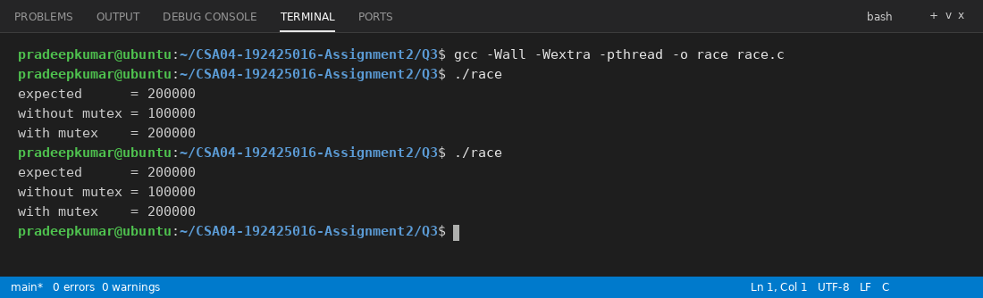
Without the mutex the final value was 100,000 instead of 200,000 (many updates were lost), and with the mutex the answer is always correct (200,000).
Alternative Concept and Complexity Analysis
If the camera frames were processed by several processes instead of threads, what would the solution be? Evaluate the creation and switching time, the memory used (separate address spaces versus shared), and how the results would be combined (IPC versus shared variables).
If the frames were processed by several processes, the program would use fork() to make 4, 8 or 16 child processes, and each child would handle some cameras. Each child has its own address space, so the plates found by a child have to be sent back to the parent through a pipe or shared memory, and the parent adds them up. In the thread version this was just a shared variable with a mutex.
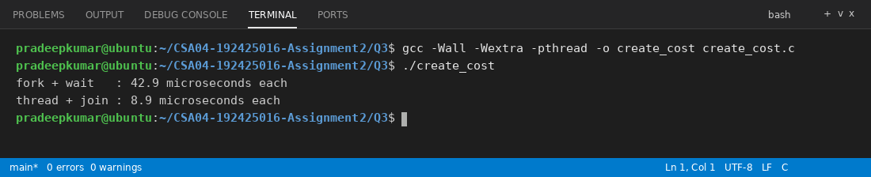
Creation: my test shows 42.9 µs for fork + wait and 8.9 µs for thread create + join, so a process is about 5 times slower to create. Switching: a process switch changes the page table and flushes the TLB, so it is slower than a thread switch. Memory: every process has its own address space and page tables (copy-on-write helps only a little), while threads share one. Combining results: processes need IPC (system calls and copying), threads only need a shared variable. Both creation and work are O(n) for n cameras, but the constants of processes are larger. The good point of processes is protection: one crashed worker does not kill the others.
Evidence Expected
A working multithreaded program, measured speed-ups for each pool size and a reasoned evaluation of the thread models.
Q4 Inter-Process Communication
—
Bloom's Level: K5 - Evaluate
Problem Context - Weather Station Data Pipeline
6 Marks
A weather station has one process that reads sensors and another that analyses the readings. They must exchange data continuously without losing readings.
Your Challenge
Implement the exchange using a pipe, and then using shared memory or a message queue. Determine:
Pipe: the pipe version is the program in the Complete the Code part below (pipe_demo.c). Shared memory: I made shm_demo.c, where the parent writes the readings into a shared memory area (mmap) and posts a semaphore, and the child waits on the semaphore and then reads them.
#define _POSIX_C_SOURCE 200809L
#include <stdio.h>
#include <stdlib.h>
#include <unistd.h>
#include <semaphore.h>
#include <sys/mman.h>
#include <sys/wait.h>

struct shared {
sem_t filled;
int count;
int data[6];
};

int main(void)
{
struct shared *sh = mmap(NULL, sizeof *sh, PROT_READ | PROT_WRITE,
MAP_SHARED | MAP_ANONYMOUS, -1, 0);
if (sh == MAP_FAILED) { perror("mmap"); return 1; }
sem_init(&sh->filled, 1, 0);
pid_t pid = fork();
if (pid == 0) {
sem_wait(&sh->filled);
int sum = 0, max = 0;
for (int i = 0; i < sh->count; i++) {
sum += sh->data[i];
if (sh->data[i] > max) max = sh->data[i];
}
printf("analyser: %d readings, average %.1f, max %d\n", sh->count,
(double) sum / sh->count, max);
exit(0);
}
int readings[] = {31, 33, 36, 34, 41, 38};
for (int i = 0; i < 6; i++)
sh->data[i] = readings[i];
sh->count = 6;
sem_post(&sh->filled);
waitpid(pid, NULL, 0);
printf("reader: done\n");
sem_destroy(&sh->filled);
munmap(sh, sizeof *sh);
return 0;
}
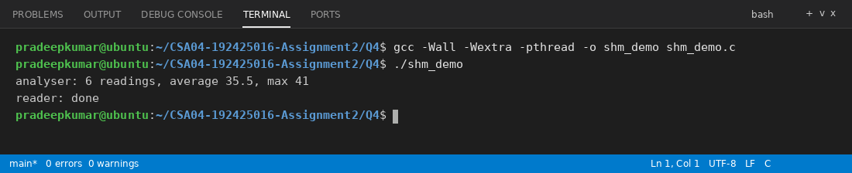
•
How the pipe signals end of data to the reader
When the writer closes its end of the pipe (close(fd[1]) in the parent) and no other process has the write end open, read() in the reader returns 0. The reader treats 0 as end of data and leaves its loop.
•
The difference between the shared-memory and message-passing models
In shared memory the processes map the same memory area and read and write it directly, and the kernel is used only for setting it up. In message passing the processes use send and receive (pipes, message queues) and the kernel carries the data, so there are no shared variables. Shared memory is faster, message passing is easier and good for small data.
•
Which method copies the data and which does not
A pipe (and a message queue) copies the data: from the user buffer into the kernel and then from the kernel into the reader's buffer. Shared memory does not copy through the kernel, because both processes see the same memory.
•
Which method needs extra synchronisation, and why
Shared memory needs extra synchronisation (a semaphore or mutex), because both processes can touch the same memory at the same time and the reader must know when the data is ready. A pipe does not need it, because the kernel blocks the reader when the pipe is empty and blocks the writer when it is full.
Growth Investigation
Measure the time to transfer 1 MB, 10 MB and 100 MB with each method, and evaluate the results.
#define _POSIX_C_SOURCE 200809L
#include <stdio.h>
#include <stdlib.h>
#include <string.h>
#include <unistd.h>
#include <time.h>
#include <semaphore.h>
#include <sys/mman.h>
#include <sys/wait.h>

#define CHUNK 65536

struct shared {
sem_t full, empty;
int len;
char buf[CHUNK];
};

double now(void)
{
struct timespec ts;
clock_gettime(CLOCK_MONOTONIC, &ts);
return ts.tv_sec + ts.tv_nsec / 1e9;
}

double pipe_test(long total)
{
int fd[2];
pipe(fd);
static char data[CHUNK];
memset(data, 'x', sizeof data);
double start = now();
pid_t pid = fork();
if (pid == 0) {
close(fd[1]);
static char in[CHUNK];
while (read(fd[0], in, sizeof in) > 0) ;
_exit(0);
}
close(fd[0]);
for (long sent = 0; sent < total; sent += CHUNK)
write(fd[1], data, CHUNK);
close(fd[1]);
waitpid(pid, NULL, 0);
return now() - start;
}

double shm_test(long total)
{
struct shared *sh = mmap(NULL, sizeof *sh, PROT_READ | PROT_WRITE,
MAP_SHARED | MAP_ANONYMOUS, -1, 0);
sem_init(&sh->full, 1, 0);
sem_init(&sh->empty, 1, 1);
static char data[CHUNK];
memset(data, 'x', sizeof data);
double start = now();
pid_t pid = fork();
if (pid == 0) {
long got = 0;
volatile char sink;
while (got < total) {
sem_wait(&sh->full);
sink = sh->buf[0];
got += sh->len;
sem_post(&sh->empty);
}
(void) sink;
_exit(0);
}
for (long sent = 0; sent < total; sent += CHUNK) {
sem_wait(&sh->empty);
memcpy(sh->buf, data, CHUNK);
sh->len = CHUNK;
sem_post(&sh->full);
}
waitpid(pid, NULL, 0);
return now() - start;
}

int main(void)
{
int sizes[] = {1, 10, 100};
printf("%-8s %-12s %-12s\n", "Size", "Pipe (s)", "Shm+sem (s)");
for (int i = 0; i < 3; i++) {
long total = (long) sizes[i] * 1024 * 1024;
printf("%-8s %-12.4f %-12.4f\n", sizes[i] == 1 ? "1 MB" : sizes[i] == 10 ? "10 MB" : "100 MB",
pipe_test(total), shm_test(total));
}
return 0;
}
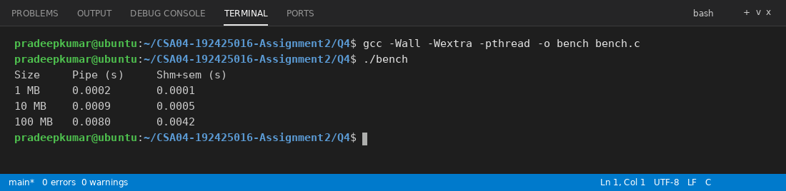
Data size | Pipe (s) | Shared memory + semaphore (s)
1 MB | 0.0002 | 0.0001
10 MB | 0.0009 | 0.0005
100 MB | 0.0080 | 0.0042

For both methods the time grows almost linearly with the size (10 times more data takes about 10 times more time). Shared memory is about 2 times faster for the big sizes, because the pipe copies the data twice through the kernel and has a system call for every chunk. For tiny data like 1 MB the difference is too small to matter. In my shared memory test one copy into the shared buffer is still done, so a real zero-copy design would be even faster.
CSA04 - Operating Systems - Assignments CO1-CO5 | Page 14
Complete the Code
Complete TODO 1 below and execute the program on Linux.
#define POSIX C SOURCE 200809L
#include <stdio.h>
#include <unistd.h>
#include <sys/wait.h>
/* The parent (sensor reader) sends readings to the child (analyser) through a pipe. */ int main(void)
{
int fd[2];
}
= fork();
==
0) {
if (pipe (fd) == -1) { perror("pipe"); return 1; }
pid_t pid
if (pid
close (fd[1]);
/* child only reads */
int r, count =
0, sum =
0, max = 0;
}
// TODO 1: Read one int at a time from fd[0] until read returns 0 (the parent
closed the pipe); keep the count, the sum and the maximum
//
printf("analyser: %d readings, average %.1f, max %d\n", count,
count? (double) sum / count : 0.0, max);
close (fd[0]);
fflush(stdout);
exit(0);
close (fd[0]);
/* parent only writes
int readings[]
=
{31, 33, 36, 34, 41, 38};
for
(int i = 0; i < 6; i++)
if (write(fd[1], &readings[i], sizeof readings[i]) < 0) perror("write"); close (fd[1]);
waitpid (pid, NULL, 0);
printf("reader: done\n"); return 0;
/* signals end of data to the child */
Expected output:
analyser: 6 readings, average 35.5, max 41
reader: done
Completed code (TODO 1 replaced)
#define _POSIX_C_SOURCE 200809L
#include <stdio.h>
#include <stdlib.h>
#include <unistd.h>
#include <sys/wait.h>

int main(void)
{
int fd[2];
if (pipe(fd) == -1) { perror("pipe"); return 1; }
pid_t pid = fork();
if (pid == 0) {
close(fd[1]);
int r, count = 0, sum = 0, max = 0, value;
while ((r = read(fd[0], &value, sizeof value)) > 0) {
count++;
sum += value;
if (value > max) max = value;
}
printf("analyser: %d readings, average %.1f, max %d\n", count,
count ? (double) sum / count : 0.0, max);
close(fd[0]);
fflush(stdout);
exit(0);
}
close(fd[0]);
int readings[] = {31, 33, 36, 34, 41, 38};
for (int i = 0; i < 6; i++)
if (write(fd[1], &readings[i], sizeof readings[i]) < 0) perror("write");
close(fd[1]);
waitpid(pid, NULL, 0);
printf("reader: done\n");
return 0;
}
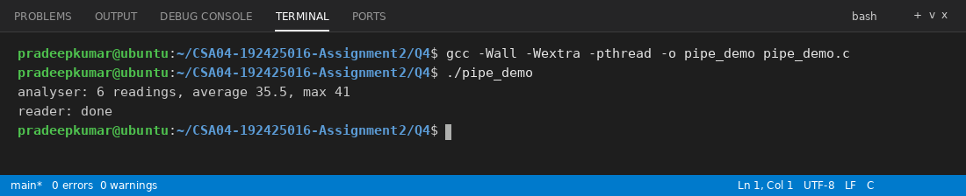
The output is the same as the expected output.
Remove close(fd[1]) in the parent and explain why the child never finishes.
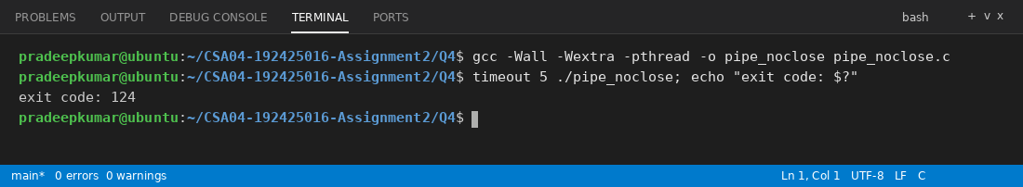
I removed the close(fd[1]) line of the parent and ran it with timeout. The child never finishes (the timeout had to kill it, exit code 124). The reason is that read() returns 0 only when all write ends of the pipe are closed. The parent still keeps its write end open, so the child waits for more data forever, and the parent is waiting in waitpid() for the child. So both wait for each other and the program hangs.
Alternative Concept and Complexity Analysis
If the readings were exchanged through shared memory with a semaphore instead of a pipe, what would the solution be? Evaluate the time to transfer n readings (two copies through the kernel for a pipe versus none for shared memory) and the synchronisation needed.
With shared memory and a semaphore (shm_demo.c above) the sensor process writes the readings directly into the shared area and calls sem_post, and the analyser calls sem_wait and reads them in place. The data is not copied through the kernel.
Time for n readings: with a pipe each reading goes user to kernel and kernel to user, so about 2n copies plus system calls, which is O(n) with a bigger constant. With shared memory there is one write and one read in place, so O(n) with a smaller constant, and the kernel is used only for the semaphore (and only once per batch). The measured results above show about 2 times difference for large data. The price is the synchronisation: the semaphore (or mutex) is needed so that the reader does not read half-written data, and for a continuous stream we need two semaphores (full and empty) to avoid overwriting readings. My choice: a pipe for small and simple data because it is safe and easy, shared memory for big data like the 100 MB case.
Evidence Expected
Two working IPC implementations, measured transfer times and a justified choice of method.
Q5 - Synchronisation: Critical Sections, Semaphores and Monitors
Bloom's Level: K5 - Evaluate
Problem Context - Railway Ticket Booking
11 Marks
Thousands of agents book seats on the same trains at the same time. Without synchronisation the same seat is sometimes sold twice; with a single global lock the system becomes very slow.
Design Starting Point
You are given only the following principle:
CSA04 - Operating Systems - Assignments CO1-CO5 | Page 15
A solution to the critical-section problem must guarantee mutual exclusion, progress and bounded waiting.
Your Challenge
Convert this principle into a design. Determine:
My design: the seat counter of a train is the shared data, and the code that checks the seats and books one is the critical section. Every agent runs: entry section (wait on the lock), critical section (check seat and book it), exit section (signal the lock) and then the remainder section. Mutual exclusion means only one agent is inside the booking code of that train, so one seat cannot be sold twice. Progress means if nobody is inside, one of the waiting agents is allowed in without waiting for agents that are not trying to book. Bounded waiting means an agent waits only for a limited number of other agents, which a semaphore with a FIFO queue gives.
·
•
•
•
Why Peterson's solution satisfies the three requirements for two processes, and why it may fail on modern processors
Peterson's solution uses two shared variables: flag[2] and turn. Process i does: flag[i] = true; turn = j; while (flag[j] && turn == j) wait; critical section; flag[i] = false.
Mutual exclusion: both processes can be inside only if flag[j] is false or turn == i for Pi and the same for Pj, but turn has only one value, so it is impossible. Progress: if Pj is not interested then flag[j] is false and Pi enters at once. Bounded waiting: when Pj leaves and tries again it sets turn = i, so Pi gets the next chance and waits at most one turn of Pj.
On modern processors it may fail because the compiler and the CPU can reorder the instructions and the stores wait in store buffers. Then flag[i] = true may become visible after the check of flag[j], and both processes enter the critical section. It needs memory barriers or atomic instructions to work.
How counting and binary semaphores (wait and signal) protect the seat counter
A counting semaphore is started with the number of free seats (for example 60). An agent does wait() before booking, which reduces the value, and if the value is 0 the agent blocks, so a train cannot be overbooked. A cancel does signal() which increases the value and wakes one waiting agent. A binary semaphore (value 0 or 1) works as a lock for the counter itself: wait(mutex); seat_counter--; signal(mutex); so only one agent changes the counter at a time.
How the bounded-buffer (producer-consumer), readers-writers and dining-philosophers problems are solved with semaphores
Bounded buffer: three semaphores, empty = N, full = 0, mutex = 1. Producer: wait(empty), wait(mutex), add item, signal(mutex), signal(full). Consumer: wait(full), wait(mutex), remove item, signal(mutex), signal(empty).
Readers-writers: a semaphore wrt = 1 and a mutex for read_count. The first reader does wait(wrt) and the last reader does signal(wrt). A writer does wait(wrt), writes and then signal(wrt). Many readers can read together but a writer is alone (writers may starve).
Dining philosophers: one semaphore for each chopstick. If every philosopher takes the left chopstick first, all wait forever (deadlock). It is solved by letting only 4 philosophers sit at the table (a semaphore with value 4), or by making the last philosopher take the right chopstick first, or by taking both chopsticks only together.
How a monitor with condition variables makes the solution easier to get right
A monitor keeps the shared data and the procedures that use it together, and only one process can be active inside the monitor at a time, so mutual exclusion is automatic. Condition variables (wait and signal) let a process sleep inside the monitor until a condition is true, for example "seat available", and the monitor lock is released while it sleeps. It is easier to get right, because the programmer does not need to put wait() and signal() in the correct pairs (with semaphores, a wrong order can cause a deadlock). In C it is made with pthread_mutex and pthread_cond.
Test Your Design
Run the bounded-buffer program with 1 and with 4 producers and consumers, and show that every item is consumed exactly once.
I changed the bounded-buffer program so that the number of producers and consumers is taken from the command line (multi.c). Each producer makes 1000 unique items and the program checks that each item is consumed exactly once.
#define _POSIX_C_SOURCE 200809L
#include <stdio.h>
#include <stdlib.h>
#include <pthread.h>
#include <semaphore.h>

#define SIZE 5
#define ITEMS 1000

int buffer[SIZE], in = 0, out = 0, workers;
sem_t empty, full;
pthread_mutex_t lock = PTHREAD_MUTEX_INITIALIZER;
long consumed_sum = 0;
int seen[ITEMS * 4 + 1];

void *producer(void *arg)
{
int id = (int)(long) arg;
for (int k = 0; k < ITEMS; k++) {
int item = id * ITEMS + k + 1;
sem_wait(&empty);
pthread_mutex_lock(&lock);
buffer[in] = item;
in = (in + 1) % SIZE;
pthread_mutex_unlock(&lock);
sem_post(&full);
}
return NULL;
}

void *consumer(void *arg)
{
(void) arg;
for (int k = 0; k < ITEMS; k++) {
sem_wait(&full);
pthread_mutex_lock(&lock);
int item = buffer[out];
out = (out + 1) % SIZE;
consumed_sum += item;
seen[item]++;
pthread_mutex_unlock(&lock);
sem_post(&empty);
}
return NULL;
}

int main(int argc, char *argv[])
{
workers = argc > 1 ? atoi(argv[1]) : 1;
sem_init(&empty, 0, SIZE);
sem_init(&full, 0, 0);
pthread_t p[4], c[4];
for (int i = 0; i < workers; i++) {
pthread_create(&p[i], NULL, producer, (void *)(long) i);
pthread_create(&c[i], NULL, consumer, NULL);
}
for (int i = 0; i < workers; i++) {
pthread_join(p[i], NULL);
pthread_join(c[i], NULL);
}
int total = workers * ITEMS, bad = 0;
for (int i = 1; i <= total; i++)
if (seen[i] != 1) bad++;
printf("%d producers, %d consumers: consumed %d items, sum = %ld (expected %ld), items not exactly once = %d\n",
workers, workers, total, consumed_sum, (long) total * (total + 1) / 2, bad);
return 0;
}
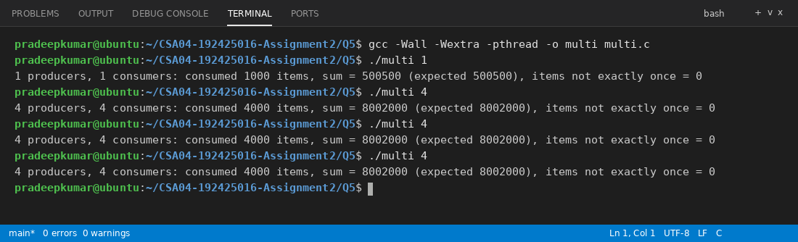
With 1 producer and 1 consumer and also with 4 producers and 4 consumers (run 3 times), the sum is always as expected and "items not exactly once = 0", so every item is consumed exactly once.
Deployment Decision
Decide between one lock for the whole booking system, one lock per train and one lock per coach. Measure the throughput of each and defend your choice.
I wrote booking.c with 10 trains and 5 coaches each. 8 agent threads make 400 bookings each, and every booking holds the lock for a short time (100 µs) to check and update the seats. I measured three lock levels.
#define _GNU_SOURCE
#include <stdio.h>
#include <stdlib.h>
#include <pthread.h>
#include <unistd.h>
#include <time.h>

#define TRAINS 10
#define COACHES 5
#define THREADS 8
#define BOOKINGS 400

pthread_mutex_t global_lock = PTHREAD_MUTEX_INITIALIZER;
pthread_mutex_t train_lock[TRAINS];
pthread_mutex_t coach_lock[TRAINS][COACHES];
int seats[TRAINS][COACHES];
int level;

double now(void)
{
struct timespec ts;
clock_gettime(CLOCK_MONOTONIC, &ts);
return ts.tv_sec + ts.tv_nsec / 1e9;
}

void *agent(void *arg)
{
unsigned int seed = (unsigned int)(long) arg;
for (int i = 0; i < BOOKINGS; i++) {
int t = rand_r(&seed) % TRAINS, c = rand_r(&seed) % COACHES;
pthread_mutex_t *m = level == 0 ? &global_lock : level == 1 ? &train_lock[t] : &coach_lock[t][c];
pthread_mutex_lock(m);
int now_seats = seats[t][c];
usleep(100);
seats[t][c] = now_seats + 1;
pthread_mutex_unlock(m);
}
return NULL;
}

int main(void)
{
for (int t = 0; t < TRAINS; t++) {
pthread_mutex_init(&train_lock[t], NULL);
for (int c = 0; c < COACHES; c++) pthread_mutex_init(&coach_lock[t][c], NULL);
}
const char *names[] = {"one global lock", "one lock per train", "one lock per coach"};
printf("%-20s %-10s %-14s %-8s\n", "locking", "time (s)", "bookings/sec", "lost");
for (level = 0; level < 3; level++) {
for (int t = 0; t < TRAINS; t++)
for (int c = 0; c < COACHES; c++) seats[t][c] = 0;
pthread_t th[THREADS];
double start = now();
for (long i = 0; i < THREADS; i++) pthread_create(&th[i], NULL, agent, (void *) (i + 1));
for (int i = 0; i < THREADS; i++) pthread_join(th[i], NULL);
double total = now() - start;
int sum = 0;
for (int t = 0; t < TRAINS; t++)
for (int c = 0; c < COACHES; c++) sum += seats[t][c];
printf("%-20s %-10.2f %-14.0f %-8d\n", names[level], total,
THREADS * BOOKINGS / total, THREADS * BOOKINGS - sum);
}
return 0;
}
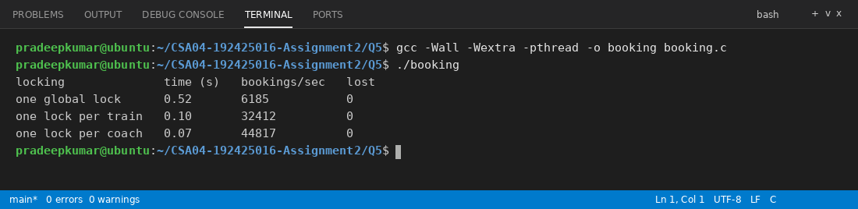
Locking | Time (s) | Bookings per second
One lock for the whole system | 0.52 | 6185
One lock per train | 0.10 | 32412
One lock per coach | 0.07 | 44817

No booking is lost in any of them. The global lock is the slowest, because all agents wait for one lock even when they book different trains. The lock per train is about 5 times faster. The lock per coach is faster again, but only about 1.4 times more than per train. My choice is one lock per train. It gives most of the gain, and it is simple, with only 10 locks. Per-coach locks need many more locks, and a booking that needs seats from several coaches (for example a family) must take many locks in a fixed order, otherwise a deadlock can happen.
Complete the Code
Complete TODO 1 and TODO 2 below using the semaphores and the mutex, and execute the program (compile with -pthread).
CSA04 - Operating Systems - Assignments CO1-CO5 | Page 16
#define POSIX C SOURCE 200809L
#include <stdio.h>
#include <pthread.h>
#include <semaphore.h>
#define SIZE 5
#define ITEMS 20
int buffer[SIZE], in
sem_t empty, full;
=
0, out
=
0;
pthread_mutex_t lock = PTHREAD MUTEX INITIALIZER; long consumed_sum = 0;
void *producer (void *arg)
{
(void) arg;
for (int item = 1; item <= ITEMS; item++) {
// TODO 1: Wait on empty, lock the mutex, put item at buffer[in], advance in // circularly, unlock, then post full
}
}
return NULL;
void consumer (void *arg)
{
(void) arg;
for (int k
=
0; k < ITEMS; k++) {
}
}
// TODO 2: Wait on full, lock the mutex, take the item at buffer[out], advance
// out circularly, unlock, post empty and add the item to consumed_sum
return NULL;
int main(void)
{
sem_init(& empty, 0, SIZE);
sem init(&full, 0, 0);
pthread_t p, c;
pthread_create(&p, NULL, producer, NULL);
pthread_create(&c, NULL, consumer, NULL);
pthread_join(p, NULL);
pthread_join(c, NULL);
printf("items consumed: %d, sum
ITEMS * (ITEMS + 1) / 2);
sem_destroy(& empty);
sem_destroy(&full);
return 0;
}
=
%ld (expected %d)\n", ITEMS, consumed_sum,
Expected output:
items consumed: 20,
= sum 210 (expected 210)
Completed code (TODO 1 and TODO 2 replaced)
#define _POSIX_C_SOURCE 200809L
#include <stdio.h>
#include <pthread.h>
#include <semaphore.h>

#define SIZE 5
#define ITEMS 20

int buffer[SIZE], in = 0, out = 0;
sem_t empty, full;
pthread_mutex_t lock = PTHREAD_MUTEX_INITIALIZER;
long consumed_sum = 0;

void *producer(void *arg)
{
(void) arg;
for (int item = 1; item <= ITEMS; item++) {
sem_wait(&empty);
pthread_mutex_lock(&lock);
buffer[in] = item;
in = (in + 1) % SIZE;
pthread_mutex_unlock(&lock);
sem_post(&full);
}
return NULL;
}

void *consumer(void *arg)
{
(void) arg;
for (int k = 0; k < ITEMS; k++) {
sem_wait(&full);
pthread_mutex_lock(&lock);
int item = buffer[out];
out = (out + 1) % SIZE;
pthread_mutex_unlock(&lock);
sem_post(&empty);
consumed_sum += item;
}
return NULL;
}

int main(void)
{
sem_init(&empty, 0, SIZE);
sem_init(&full, 0, 0);
pthread_t p, c;
pthread_create(&p, NULL, producer, NULL);
pthread_create(&c, NULL, consumer, NULL);
pthread_join(p, NULL);
pthread_join(c, NULL);
printf("items consumed: %d, sum = %ld (expected %d)\n", ITEMS, consumed_sum,
ITEMS * (ITEMS + 1) / 2);
sem_destroy(&empty);
sem_destroy(&full);
return 0;
}
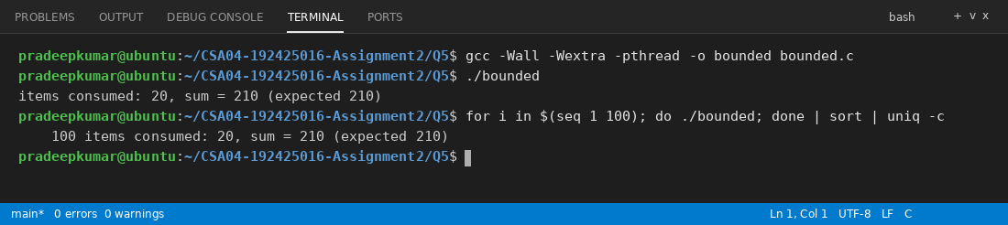
The output is the same as expected, and in the 100 runs the line "items consumed: 20, sum = 210 (expected 210)" came 100 times.
Run the program 100 times and show that the sum is always 210. Then remove the mutex and evaluate whether the result is still correct with several producers and consumers.
The sum was 210 in all 100 runs. Next I removed the mutex lock and unlock lines from the producer and consumer of multi.c and put a sched_yield() between reading and updating in and out, so that the problem can be seen on my small machine. Only the changed functions are shown, the rest is same as multi.c.
void *producer(void *arg)
{
int id = (int)(long) arg;
for (int k = 0; k < ITEMS; k++) {
int item = id * ITEMS + k + 1;
sem_wait(&empty);
buffer[in] = item;
if (k % 5 == 0) sched_yield();
in = (in + 1) % SIZE;
sem_post(&full);
}
return NULL;
}

void *consumer(void *arg)
{
(void) arg;
for (int k = 0; k < ITEMS; k++) {
sem_wait(&full);
int item = buffer[out];
if (k % 7 == 0) sched_yield();
out = (out + 1) % SIZE;
consumed_sum += item;
seen[item]++;
sem_post(&empty);
}
return NULL;
}
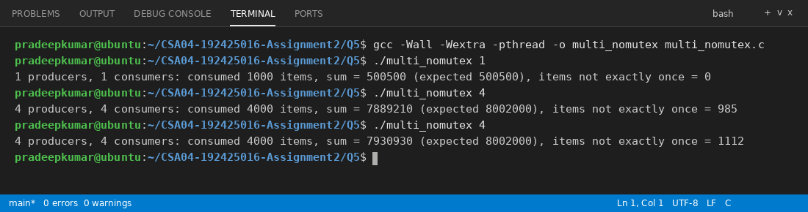
With 1 producer and 1 consumer the result is still correct, because only one thread changes in and only one thread changes out, and the two semaphores already control the buffer slots. With 4 producers and 4 consumers the result is wrong (the sum is not 8,002,000 and about 1000 items are not consumed exactly once). Two producers read the same value of in and write on the same slot, so an item is lost, and two consumers read the same slot, so an item is consumed twice. So the mutex is needed when there are several producers or consumers.
Alternative Concept and Complexity Analysis
If the shared counter were protected by atomic operations (C11 atomic_fetch_add) or by a spin lock instead of a semaphore and mutex, what would the solution be? Evaluate the time per update with 1, 4 and 16 threads, the CPU time wasted by spinning, and which method suits a long critical section.
I wrote locks.c to compare a mutex, a spin lock and atomic_fetch_add on one counter with 1, 4 and 16 threads, each making 200,000 updates.
#define _GNU_SOURCE
#include <stdio.h>
#include <stdlib.h>
#include <pthread.h>
#include <stdatomic.h>
#include <time.h>

#define UPDATES 200000

long plain_count = 0;
atomic_long atomic_count = 0;
pthread_mutex_t mlock = PTHREAD_MUTEX_INITIALIZER;
pthread_spinlock_t slock;
int mode;

double now(void)
{
struct timespec ts;
clock_gettime(CLOCK_MONOTONIC, &ts);
return ts.tv_sec + ts.tv_nsec / 1e9;
}

void *work(void *arg)
{
(void) arg;
for (int i = 0; i < UPDATES; i++) {
if (mode == 0) {
pthread_mutex_lock(&mlock);
plain_count++;
pthread_mutex_unlock(&mlock);
} else if (mode == 1) {
pthread_spin_lock(&slock);
plain_count++;
pthread_spin_unlock(&slock);
} else {
atomic_fetch_add(&atomic_count, 1);
}
}
return NULL;
}

int main(void)
{
pthread_spin_init(&slock, PTHREAD_PROCESS_PRIVATE);
const char *names[] = {"mutex", "spinlock", "atomic"};
int counts[] = {1, 4, 16};
printf("%-9s %-8s %-14s\n", "method", "threads", "ns per update");
for (mode = 0; mode < 3; mode++) {
for (int c = 0; c < 3; c++) {
plain_count = 0;
atomic_store(&atomic_count, 0);
pthread_t t[16];
double start = now();
for (int i = 0; i < counts[c]; i++) pthread_create(&t[i], NULL, work, NULL);
for (int i = 0; i < counts[c]; i++) pthread_join(t[i], NULL);
double total = now() - start;
printf("%-9s %-8d %-14.1f\n", names[mode], counts[c],
total * 1e9 / ((double) UPDATES * counts[c]));
}
}
return 0;
}
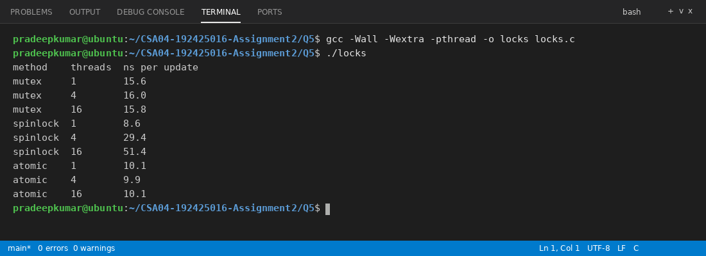
Method | 1 thread (ns) | 4 threads (ns) | 16 threads (ns)
Mutex | 15.6 | 16.0 | 15.8
Spin lock | 8.6 | 29.4 | 51.4
Atomic (atomic_fetch_add) | 10.1 | 9.9 | 10.1

The atomic operation is the fastest and stays the same for any number of threads, because it is one hardware instruction and there is no waiting. The spin lock is fast with one thread but gets slower with 4 and 16 threads, because the waiting threads keep looping and waste CPU time, and the spinning gets worse when the lock holder is not running. The mutex is a bit slower, but the time is steady, because a waiting thread sleeps and does not waste CPU. For a very short update like a counter, an atomic operation is the best. For a long critical section (like database work or I/O) the mutex or semaphore is better, because spinning for a long time wastes the CPU.
CSA04 - Operating Systems - Assignments CO1-CO5 | Page 17
Evidence Expected
A student-derived synchronisation design, working semaphore code, test evidence and a measured, defended locking decision.
DAY-4 DESIGN CHALLENGE
Q6 - Deadlock Handling and the Banker's Algorithm
Bloom's Level: K5 – Evaluate
Problem Context - Shared Laboratory Equipment Scheduler
13 Marks
A research centre runs jobs that need several shared resources at once (GPUs, licences for simulation software and high-speed storage). Jobs sometimes wait for each other forever and the whole cluster stops until an administrator intervenes.
A. Characterise Deadlock - 2 Marks
State the four necessary conditions for deadlock and show them in a resource-allocation graph for the cluster.
The four necessary conditions for deadlock are: (1) mutual exclusion: a resource can be used by only one job at a time. (2) Hold and wait: a job holds some resource and waits for another one. (3) No preemption: a resource cannot be taken away from a job, it is released only by the job. (4) Circular wait: there is a circle of jobs where each waits for a resource held by the next one.
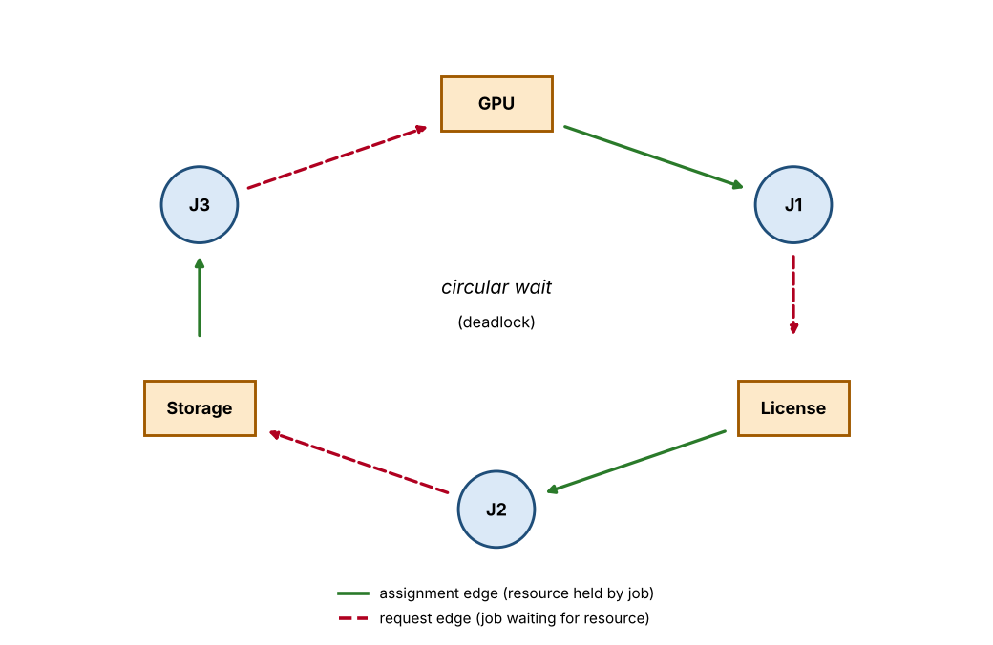
In the graph J1 holds the GPU and waits for the licence, J2 holds the licence and waits for the storage, and J3 holds the storage and waits for the GPU. The GPU, licence and storage are used by one job at a time (mutual exclusion). Every job holds one resource while waiting for another (hold and wait). A GPU or licence cannot be taken away from a running job (no preemption). The circle J1 - licence - J2 - storage - J3 - GPU - J1 is the circular wait. Each resource has one instance, so the cycle means a real deadlock.
Complete the Code
Complete TODO 1 below and execute the program.
CSA04 - Operating Systems - Assignments CO1-CO5 | Page 18
#include <stdio.h> #include <string.h>
#define P 5
#define R 3
int avail [R] int maxm [P] [R] int alloc[P] [R]
=
=
{3, 3, 2};
{{7, 5, 3}, = {{0, 1, 0},
{3, 2, 2}, {9, 0, 2},
{2, 0, 0}, {3, 0, 2},
{2, 2, 2}, {4, 3, 3}};
{2, 1, 1}, {0, 0, 2}};
/* Returns 1 if the state is safe and stores a safe sequence in seq. int is_safe(int seq[P])
{
=
int work [R], finish [P] {0}, count memcpy (work, avail, sizeof work); while (count < P) {
int found =
0;
for (int p = 0; p < P; p++) {
if (finish [p]) continue;
// TODO 1: If need = maxm [p] //
=
0;
-
let p
alloc[p] is <= work for every resource, finish: add alloc[p] to work, mark finish[p], append p to seq and set // found = 1
}
if (!found) return 0;
}
return 1;
}
void request(int p, const int req[R])
{
=
for (int r 0; r < R; r++) if (req[r] > maxm [p] [r]
alloc[p] [r] || req[r] > avail[r]) { printf("P%d request: must wait (not available)\n", p); return;
}
for (int r
=
0; r < R; r++) { avail[r]
==
req[r]; alloc[p][r] += req[r]; }
int seq[P];
=
if (is safe (seq)) {
printf("P%d request: granted, safe sequence", p);
for (int i printf("\n");
} else {
0; i < P; i++) printf(" P%d", seq[i]);
=
for (int r 0; r < R; r++) { avail[r] += req[r]; alloc[p][r] printf("P%d request: denied (unsafe)\n", p);
==
req[r]; }
}
}
int main(void)
{
int seq[P];
}
if (is_safe (seq)) {
}
printf("initial state safe:");
for (int i = 0; i < P; i++) printf(" P%d", seq[i]); printf("\n");
request (1,
request (4, request (0,
(int[R]) {1, 0, 2}); (int [R]) {3, 3, 0}); (int[R]) {0, 2, 0});
return 0;
Expected output:
initial state safe: P1 P3 P4 PO P2
Pl request: granted, safe sequence Pl P3 P4 PO P2
P4 request: must wait (not available)
PO request: denied (unsafe)
Completed code (TODO 1 replaced)
#include <stdio.h>
#include <string.h>

#define P 5
#define R 3

int avail[R] = {3, 3, 2};
int maxm[P][R] = {{7, 5, 3}, {3, 2, 2}, {9, 0, 2}, {2, 2, 2}, {4, 3, 3}};
int alloc[P][R] = {{0, 1, 0}, {2, 0, 0}, {3, 0, 2}, {2, 1, 1}, {0, 0, 2}};

int is_safe(int seq[P])
{
int work[R], finish[P] = {0}, count = 0;
memcpy(work, avail, sizeof work);
while (count < P) {
int found = 0;
for (int p = 0; p < P; p++) {
if (finish[p]) continue;
int ok = 1;
for (int r = 0; r < R; r++)
if (maxm[p][r] - alloc[p][r] > work[r]) { ok = 0; break; }
if (ok) {
for (int r = 0; r < R; r++) work[r] += alloc[p][r];
finish[p] = 1;
seq[count++] = p;
found = 1;
}
}
if (!found) return 0;
}
return 1;
}

void request(int p, const int req[R])
{
for (int r = 0; r < R; r++)
if (req[r] > maxm[p][r] - alloc[p][r] || req[r] > avail[r]) {
printf("P%d request: must wait (not available)\n", p);
return;
}
for (int r = 0; r < R; r++) { avail[r] -= req[r]; alloc[p][r] += req[r]; }
int seq[P];
if (is_safe(seq)) {
printf("P%d request: granted, safe sequence", p);
for (int i = 0; i < P; i++) printf(" P%d", seq[i]);
printf("\n");
} else {
for (int r = 0; r < R; r++) { avail[r] += req[r]; alloc[p][r] -= req[r]; }
printf("P%d request: denied (unsafe)\n", p);
}
}

int main(void)
{
int seq[P];
if (is_safe(seq)) {
printf("initial state safe:");
for (int i = 0; i < P; i++) printf(" P%d", seq[i]);
printf("\n");
}
request(1, (int[R]) {1, 0, 2});
request(4, (int[R]) {3, 3, 0});
request(0, (int[R]) {0, 2, 0});
return 0;
}
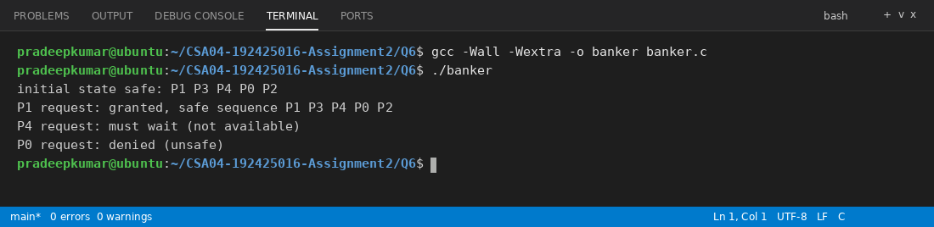
The output is the same as the expected output.
Show by hand why the request of PO for (0, 2, 0) leads to an unsafe state.
After P1 is granted (1, 0, 2): Available = (2, 3, 0) and Allocation of P1 = (3, 0, 2). P4 asks for (3, 3, 0) which is more than Available, so it waits. Now P0 asks for (0, 2, 0). It is less than its Need and less than Available, so we pretend to give it: Available = (2, 1, 0) and Allocation of P0 = (0, 3, 0). The Need matrix (Max - Allocation) is:
Process | Need R1 R2 R3
P0 | 7 2 3
P1 | 0 2 0
P2 | 6 0 0
P3 | 0 1 1
P4 | 4 3 1

Work = (2, 1, 0). P0 needs (7, 2, 3), which is more than Work. P1 needs (0, 2, 0), but only 1 unit of R2 is available. P2 needs 6 units of R1 and only 2 are available. P3 needs (0, 1, 1) but R3 is 0. P4 needs (4, 3, 1), which is more than Work. No process can finish, so there is no safe sequence. The state is unsafe and the request of P0 is denied (P0 has to wait).
CSA04 - Operating Systems - Assignments CO1-CO5 | Page 19
Alternative Concept and Complexity Analysis
If deadlock were handled by detection and recovery (running a detection algorithm every few minutes and aborting a job) instead of the Banker's algorithm, what would the solution be? Evaluate the time per request (O(m × n2) for every Banker's check versus no check), the cost of detection, and the work lost when a job is aborted.
In detection and recovery the system lets jobs request freely and runs a detection algorithm (like the safety algorithm but using the current requests, so it does not need the maximum demands) every few minutes. If it finds a deadlock, it recovers by aborting all the deadlocked jobs, or one job at a time until the cycle is broken, or by taking the resource from a job and rolling it back to a checkpoint.
Time: the Banker's algorithm runs a check at every request, which costs O(m x n^2) each time, and my measurement for 1,000 jobs was about 1.4 ms per check. In detection, a request has no check (O(1)), and the detection algorithm is O(m x n^2) but runs only once in a few minutes, so its total cost is very small. The big cost is the work lost when a job is aborted: a simulation that ran for many hours is lost (unless it has checkpoints), and the cluster stays stuck until the next detection run. Banker's algorithm never lets a deadlock happen, but needs the maximum demand of every job in advance.
Evidence Expected
A correct resource-allocation graph identifying all four conditions.
B. Compare the Strategies - 3 Marks
Evaluate prevention (removing one condition), avoidance (Banker's algorithm), detection and recovery, and ignoring deadlock (the ostrich approach) for the cluster.
Strategy | Idea | Cost / problem for the cluster
Prevention | Remove one of the four conditions, for example ask all resources at the start (no hold and wait) or use a fixed resource order (no circular wait) | Cheap to run, but jobs hold the GPU and licence for the whole time, so the utilisation is low. Mutual exclusion and no preemption cannot be removed for GPUs and licences.
Avoidance (Banker's) | Grant a request only if the state stays safe | Never deadlocks, but needs the maximum demand in advance, O(m x n^2) per request, and is careful, so some jobs wait even when there would be no deadlock.
Detection and recovery | Allow deadlock, detect it by a periodic check and abort or roll back jobs | Good utilisation and no maximum demand needed, but the cluster stops until the next check and the work of aborted jobs is lost.
Ignore (ostrich) | Pretend it never happens, reboot when it does | No cost, but this is exactly the present problem: the whole cluster stops until the administrator comes.

For a research cluster with expensive long jobs, ignoring is not acceptable and prevention wastes the equipment, so the choice is between avoidance and detection and recovery.
Evidence Expected
A reasoned comparison of the four strategies for this environment.
C. Apply the Banker's Algorithm – 4 Marks
Implement the safety algorithm and the resource-request algorithm. Find a safe sequence for the given state and decide whether each request can be granted.
The safety algorithm (is_safe) and the resource-request algorithm (request) are both in the program banker.c shown above in the Complete the Code part. The Need matrix at the start is P0 (7,4,3), P1 (1,2,2), P2 (6,0,0), P3 (0,1,1), P4 (4,3,1). With Work = (3,3,2) the safety algorithm picks P1 (Work becomes 5,3,2), then P3 (7,4,3), then P4 (7,4,5), then P0 (7,5,5) and last P2 (10,5,7). So the safe sequence is P1 P3 P4 P0 P2.
Request | Decision | Reason
P1 asks (1, 0, 2) | Granted | Need and Available are enough and the new state is safe: P1 P3 P4 P0 P2
P4 asks (3, 3, 0) | Must wait | It is more than Available (2, 3, 0)
P0 asks (0, 2, 0) | Denied | Resources are available, but the new state is unsafe (no process can finish)

Evidence Expected
A working implementation with correct safe sequences and decisions.
D. Predict Before Implementing - 1 Mark
Predict how the running time of the Banker's algorithm grows with the number of processes n and resource types m.
The safety algorithm has an outer loop that can run up to n times (each time at least one process finishes), and in each pass it checks up to n processes, and each check compares m resource types. So the time is O(m x n^2). The request algorithm adds only O(m) before calling the safety algorithm, so a request is also O(m x n^2). My prediction: the time grows linearly with m and quadratically with n, so when n becomes 10 times bigger the time becomes about 100 times bigger.
Evidence Expected
A clear, testable prediction.
E. Measure - 1 Mark
Measure the time of the safety algorithm for 10, 100 and 1,000 processes and compare it with your prediction.
#define _POSIX_C_SOURCE 200809L
#include <stdio.h>
#include <stdlib.h>
#include <string.h>
#include <time.h>

#define R 3

double now(void)
{
struct timespec ts;
clock_gettime(CLOCK_MONOTONIC, &ts);
return ts.tv_sec + ts.tv_nsec / 1e9;
}

int safe(int n, int *need, int *alloc, int *avail)
{
int work[R], count = 0;
int *finish = calloc(n, sizeof(int));
memcpy(work, avail, sizeof work);
while (count < n) {
int found = 0;
for (int p = 0; p < n; p++) {
if (finish[p]) continue;
int ok = 1;
for (int r = 0; r < R; r++)
if (need[p * R + r] > work[r]) { ok = 0; break; }
if (ok) {
for (int r = 0; r < R; r++) work[r] += alloc[p * R + r];
finish[p] = 1;
count++;
found = 1;
}
}
if (!found) { free(finish); return 0; }
}
free(finish);
return 1;
}

int main(void)
{
int sizes[] = {10, 100, 1000};
int reps[] = {20000, 200, 2};
printf("%-10s %-14s %-12s\n", "n", "time (ms)", "ratio");
double prev = 0;
for (int s = 0; s < 3; s++) {
int n = sizes[s];
int *need = malloc(n * R * sizeof(int)), *alloc = malloc(n * R * sizeof(int));
int avail[R] = {1, 1, 1};
for (int p = 0; p < n; p++)
for (int r = 0; r < R; r++) { need[p * R + r] = n - p; alloc[p * R + r] = 1; }
double start = now();
for (int k = 0; k < reps[s]; k++) safe(n, need, alloc, avail);
double ms = (now() - start) * 1000 / reps[s];
if (prev > 0) printf("%-10d %-14.4f %-12.1f\n", n, ms, ms / prev);
else printf("%-10d %-14.4f %-12s\n", n, ms, "-");
prev = ms;
free(need);
free(alloc);
}
return 0;
}
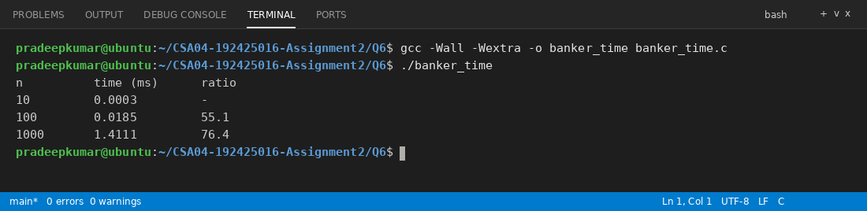
Processes (n) | Time of one safety check (ms) | Increase from previous
10 | 0.0003 | -
100 | 0.0185 | 55.1 times
1000 | 1.4111 | 76.4 times

The prediction said about 100 times for each 10 times increase in n. I got 55 times and 76 times, so the time grows faster than linear (which would be 10 times) and close to quadratic. The numbers are a bit lower than 100 because for small n the fixed costs of the function call and the memory allocation are big, and my loop can finish more than one process in a pass. The trend is clearly O(n^2).
Evidence Expected
Measured times compared with the prediction.
F. Defend the Final Design - 2 Marks
Recommend the deadlock strategy for the research centre and justify it, including the cost of the Banker's algorithm and the need to know maximum demands in advance.
Recommendation: Banker's algorithm (deadlock avoidance) for the research centre, with detection as a backup. Jobs in a cluster are normally submitted with their requested GPUs, licences and storage, so the maximum demand is known in advance. The number of jobs waiting for these shared resources is small, and my measurement shows one safety check takes only about 0.0003 ms for 10 jobs and 0.0185 ms for 100 jobs (even 1.4 ms for 1,000 jobs), which is nothing compared to jobs that run for hours. A deadlock, on the other hand, stops the entire cluster and loses the work of the jobs.
The weak points are that every job must declare its maximum demand correctly (if it asks for more than it needs, resources are wasted), the number of resources must be fixed, and the algorithm is careful, so some jobs wait although they would not deadlock. To reduce these, a detection run every few minutes can be kept as a safety net, with checkpoints for the long jobs so that little work is lost if one has to be aborted.
Evidence Expected
A critical, evidence-based recommendation.
MARK DISTRIBUTION
Question
Q1
Q2
Q3
Assessed Area
Bloom's Level
Marks
Processes and process states
K5 - Evaluate
6
CPU scheduling
K5 - Evaluate 8
Threads
K5 - Evaluate
CSA04 - Operating Systems - Assignments CO1-CO5 | Page 20
Question
08
Q4
Assessed Area
Inter-process communication
Bloom's Level
Marks
K5 - Evaluate 6
Q5
Synchronisation: critical sections, semaphores and monitors
K5 - Evaluate 11
Q6
Day-4 Design Challenge - Deadlock handling and Banker's algorithm
K5 - Evaluate 13
TOTAL
50
Submission Requirements
GitHub repository link (mandatory) containing the executed code for every task, including every completed "Complete the Code" program, script and configuration file, with input files, output screenshots and a README.md.
•
Your assignment report containing the required evidence for Q1-Q6
·
C source code for all programs
•
Gantt charts, diagrams, outputs and timings used as evidence
Assessment Verification
Students may be asked to explain any part of their design, code, calculations or results during a brief verification discussion/viva.
Overall Assessment Expectation
Model → Design → Implement → Measure → → Compare Recommend
→ Evaluate
←
CSA04 - Operating Systems - Assignments CO1-CO5 | Page 21

