OPERATING SYSTEMS
ASSIGNMENT 3 - CO3
CO3 Coverage: Evaluate memory-management mechanisms such as linking, paging and segmentation to determine their effectiveness for different system requirements - linking and loading, paging, segmentation, virtual memory, demand paging, page-replacement techniques and disk management.
Nature of Assignment: Individual
Duration: 1 Week
Total Marks: 50
Submission Date:
Bloom's Levels Assessed: K5 - Evaluate (every task in this assignment is at K5 level)
Mandatory Execution and GitHub Submission
·
·
·
•
•
Every student must individually execute every task in this assignment, including all "Complete the Code" programs.
Create a GitHub repository named CSA04-<RegisterNumber>-Assignment3 and share it with the course faculty (public, or private with the faculty added as a collaborator).
Keep one folder for each task (for example: Task01, Task02... or Q1, Q2 ...), containing the C source files, shell scripts, configuration files (Dockerfile, YAML), command outputs and screenshots.
Include a README.md with your name, register number, compiler and version (for example gcc 13), the Linux distribution and version used, the exact gcc command used to compile (for example gcc -std=c11 -Wall -Wextra -pthread), the steps to run each program, and a short note of the result of each task.
Commit your work progressively - at least one commit for each task. The commit history will be checked; a single upload of all files on the last day will not be accepted. Submit the GitHub link below and on the cover page of your report. An assignment submitted without a working GitHub link will not be evaluated.
GitHub Repository Link: https://github.com/pradeepkumar673
How to Answer the Additional Questions
Complete the Code: Copy the given code into your repository, replace every TODO with working code without changing the rest of the program, execute it and compare your output (or result) with the expected output.
Alternative Concept and Complexity Analysis: Describe how the solution would change if the alternative concept were used, with code or pseudocode, and analyse and compare the time complexity and space complexity of both solutions using Big-O notation, supported by your own measurements wherever possible.
Assignment Principle
Every question asks you to design, implement, analyse and evaluate the solution yourself, so that you demonstrate evidence of:
Design → Implementation → Analysis → Evaluation
CSA04 - Operating Systems - Assignments CO1-CO5 | Page 22
Q1 - Linking, Loading and Address Binding
Bloom's Level: K5 - Evaluate
Problem Context - Updating a Banking Application
6 Marks
A bank's branch software is built from many modules and libraries. When a security fix is made to the encryption library, every branch must currently receive a new 200 MB executable.
Implementation Tasks
You must:
•
•
•
Build the same program with static linking and with dynamic (shared) libraries
Compare the sizes of the executables and list the shared libraries with Idd
Load a library at run time with dlopen() and dlsym()
Show the addresses at which the program and its libraries are loaded (/proc/self/maps)
Evaluation
You must:
·
Explain compile-time, load-time and execution-time address binding
·
Explain the roles of the linker and the loader
•
•
Evaluate static and dynamic linking for memory use, start-up time and ease of updating Explain position-independent code
Experimental Investigation
You must:
•
Measure the start-up time and memory use of both versions
Replace the shared library without recompiling the program and show the change
·
Run two copies and show which pages are shared
•
Test what happens when the shared library is missing
Conclusion
Which linking method should the bank use, and why?
Alternative Concept and Complexity Analysis
If the bank loaded the encryption library at run time with dlopen() only when needed, instead of linking it dynamically at start-up, what would the solution be? Evaluate the start-up time, the memory used when encryption is not needed, and the error handling needed if the library is missing.
Implementation Tasks
For this question I made a small encryption library and a bank program that uses it. The library has two functions, one to encrypt text and one to tell the library version.
encrypt.h
#ifndef ENCRYPT_H
#define ENCRYPT_H
void encrypt_text(char *s, int key);
const char *lib_version(void);
#endif

encrypt.c
#include "encrypt.h"
void encrypt_text(char *s, int key)
{
for (int i = 0; s[i] != '\0'; i++)
s[i] = s[i] ^ key;
}
const char *lib_version(void)
{
return "encryption library version 1";
}

main.c
#include <stdio.h>
#include <string.h>
#include "encrypt.h"
int main(void)
{
char msg[] = "Account:12345 Balance:50000";
printf("Library: %s\n", lib_version());
encrypt_text(msg, 7);
printf("Encrypted: ");
for (size_t i = 0; i < strlen(msg); i++)
printf("%02x", (unsigned char)msg[i]);
printf("\n");
encrypt_text(msg, 7);
printf("Decrypted: %s\n", msg);
return 0;
}

First I built the library as a static library (.a) and as a shared library (.so). Then I built the same main.c two ways, one with static linking and one with dynamic linking. After that I compared the sizes and used ldd to list the shared libraries.
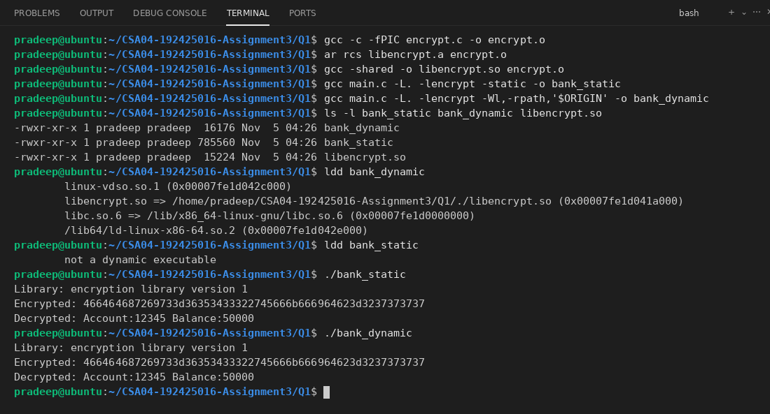
The static executable is much bigger because the C library code is copied inside it. The dynamic one is very small because it only keeps a list of the libraries it needs, and ldd shows them. ldd says "not a dynamic executable" for the static file, which means it needs no libraries.
Now the dlopen() and dlsym() program. It loads libencrypt.so at run time, finds the function by name and calls it.
dl_main.c
#include <stdio.h>
#include <string.h>
#include <dlfcn.h>
int main(void)
{
void *h = dlopen("./libencrypt.so", RTLD_LAZY);
if (h == NULL) {
printf("dlopen failed: %s\n", dlerror());
return 1;
}
void (*enc)(char *, int) = (void (*)(char *, int))dlsym(h, "encrypt_text");
const char *(*ver)(void) = (const char *(*)(void))dlsym(h, "lib_version");
if (enc == NULL || ver == NULL) {
printf("dlsym failed: %s\n", dlerror());
dlclose(h);
return 1;
}
char msg[] = "Account:12345 Balance:50000";
printf("Loaded at run time: %s\n", ver());
enc(msg, 7);
printf("Encrypted: ");
for (size_t i = 0; i < strlen(msg); i++)
printf("%02x", (unsigned char)msg[i]);
printf("\n");
dlclose(h);
return 0;
}

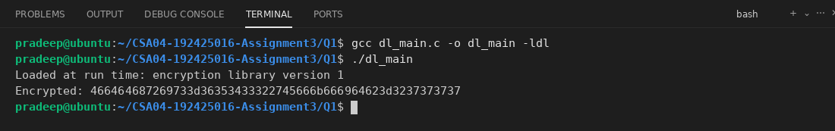
Next program prints /proc/self/maps so I can see the addresses where the program and its libraries are loaded. It also calls the library function so that libencrypt.so is really loaded. I used grep to show only the important lines.
maps_demo.c
#include <stdio.h>
#include "encrypt.h"
int main(void)
{
char msg[] = "hello";
encrypt_text(msg, 3);
FILE *f = fopen("/proc/self/maps", "r");
char line[512];
while (fgets(line, sizeof(line), f) != NULL)
printf("%s", line);
fclose(f);
return 0;
}

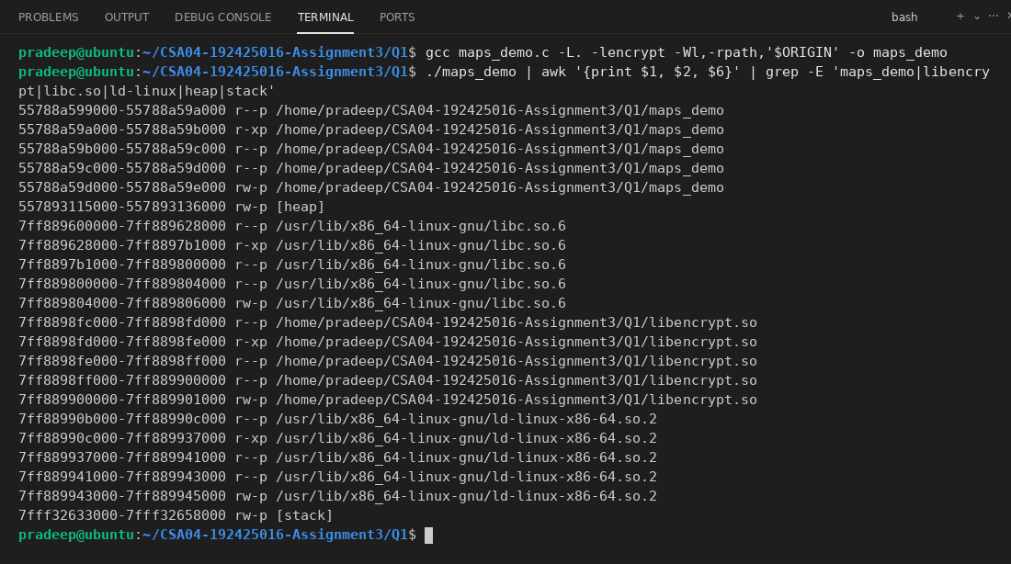
The addresses are different every time I run it, because Linux uses address space randomisation (ASLR). The library is loaded at its own address range, away from the program.
Evaluation
Address binding: Binding means changing the addresses used in the program (symbolic names) into real memory addresses. It can happen at three times.
• Compile time: If we already know where the process will be in memory, the compiler makes absolute addresses. If the starting place changes, the program has to be compiled again. MS-DOS .COM files worked like this.
• Load time: The compiler makes relocatable code, and the loader fixes the addresses when the program is loaded. If the start address changes we only need to reload it.
• Execution time: The binding is delayed until the program is running, so the process can be moved in memory while it runs. This needs hardware like the MMU (base and limit registers or paging). Modern operating systems use this one.
Linker and loader: The linker takes the object files (.o) and libraries and joins them into one executable. It resolves the symbols, so a function call in main.c gets connected to the real function. The loader is part of the OS. It copies the executable from disk into memory, creates the stack and heap, loads the shared libraries and then starts the program. In dynamic linking, the dynamic linker ld-linux.so does the last connection work at load time.
Static vs dynamic linking:
• Memory use: Static linking puts a copy of the library in every program, so 100 programs need 100 copies. In dynamic linking one copy of the library is in memory and all the processes share its code pages, so it uses less memory.
• Start-up time: Static is a little faster to start because there is no need to find and load libraries or fix the symbols. Dynamic needs extra work at start-up.
• Ease of updating: With dynamic linking the bank only needs to replace libencrypt.so with the fixed version, and all programs use it. With static linking every executable must be built again and sent to all branches (the 200 MB problem).
Position-independent code (PIC): PIC is code that works correctly wherever it is loaded in memory, because it does not use absolute addresses. It uses relative addresses and the GOT/PLT tables for the functions and data. A shared library must be PIC (gcc -fPIC) because different programs load it at different addresses, and the same code pages can then be shared by all of them without changing the code.
Experimental Investigation
First I wrote the small tool pfrun.c. The /usr/bin/time command was not installed on my system, so this tool runs a command and prints the elapsed time, maximum memory (RSS) and page faults, like time -v does. I use the same tool in the other questions.
pfrun.c
#include <stdio.h>
#include <stdlib.h>
#include <unistd.h>
#include <sys/wait.h>
#include <sys/resource.h>
#include <sys/time.h>
int main(int argc, char *argv[])
{
struct timeval s, e;
struct rusage ru;
int status;
if (argc < 2) {
printf("usage: %s command [args]\n", argv[0]);
return 1;
}
gettimeofday(&s, NULL);
pid_t pid = fork();
if (pid == 0) {
execvp(argv[1], &argv[1]);
perror("exec");
_exit(127);
}
wait4(pid, &status, 0, &ru);
gettimeofday(&e, NULL);
double t = (e.tv_sec - s.tv_sec) + (e.tv_usec - s.tv_usec) / 1e6;
printf("Elapsed time (seconds): %.4f\n", t);
printf("Maximum resident set size (kbytes): %ld\n", ru.ru_maxrss);
printf("Major (requiring I/O) page faults: %ld\n", ru.ru_majflt);
printf("Minor (reclaiming a frame) page faults: %ld\n", ru.ru_minflt);
return 0;
}

Start-up time of both versions (I ran each one 1000 times in a loop) and the memory used by one run:
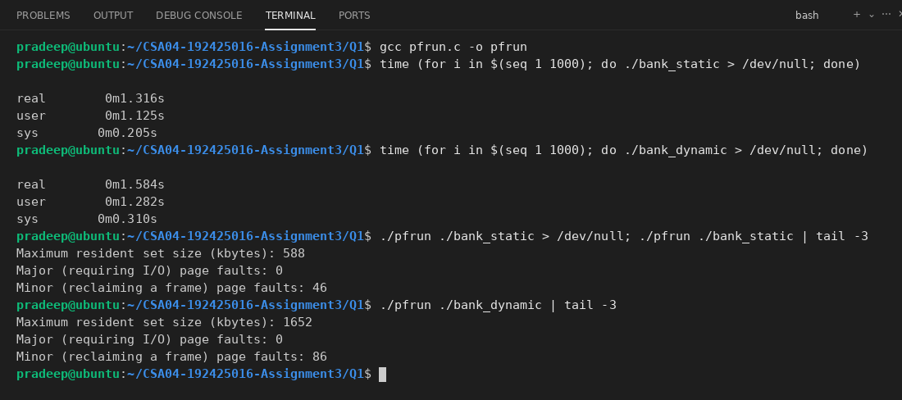
The static version starts a bit faster (it took less total time for 1000 runs, as the screenshot shows), because the dynamic version needs more start-up work to load libc and libencrypt. For one process the static one shows a smaller resident size, but if many programs run, each static program has its own copy of the library, while the dynamic ones share it.
Replacing the shared library without compiling the program again. I made a new version of the library with a different message and a different key, and ran the same bank_dynamic and bank_static files again.
encrypt_v2.c
#include "encrypt.h"
void encrypt_text(char *s, int key)
{
for (int i = 0; s[i] != '\0'; i++)
s[i] = s[i] ^ (key + 1);
}
const char *lib_version(void)
{
return "encryption library version 2 (security fix)";
}

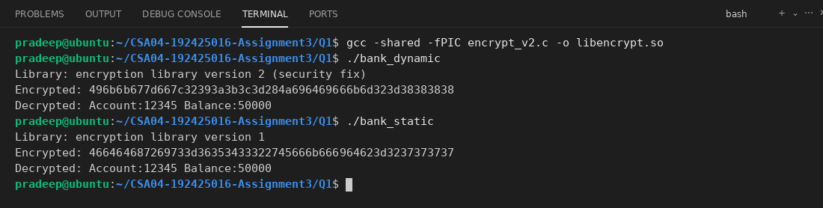
The dynamic program now shows version 2 and a different encrypted text, but I did not compile it again. The static program still shows the old version 1, so it must be rebuilt. This proves why dynamic linking is easier to update.
Running two copies at the same time to see the shared pages. This program only waits for some seconds after it uses the library, so I can look at its memory.
hold.c
#include <stdio.h>
#include <unistd.h>
#include "encrypt.h"
int main(void)
{
char msg[] = "hold";
encrypt_text(msg, 3);
sleep(4);
return 0;
}

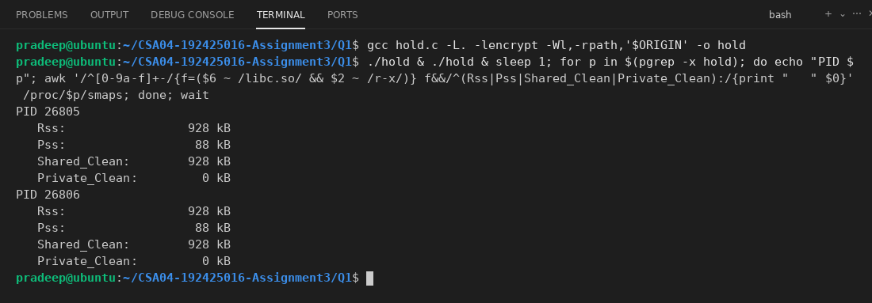
Both processes show the same libc code pages as Shared_Clean, and Pss is only about half of Rss. This means the physical pages of the library code are present only once in RAM and both processes are using them.
What happens when the shared library is missing:
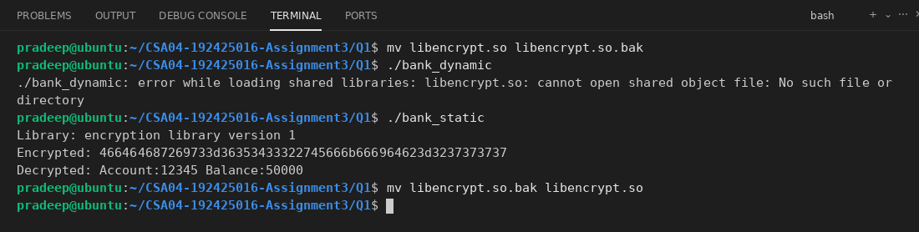
The dynamic program does not start at all and the loader gives the error "cannot open shared object file". The static program still works, because it does not depend on any library file.
Conclusion
I think the bank should use dynamic linking (shared library). A security fix in the encryption library can be sent as a small .so file instead of a 200 MB executable for every branch, and all programs get the fix immediately. It also saves RAM because the library is shared. The small extra start-up time is not a problem for a banking program. The bank only has to make sure the library file is always installed with a correct version, because the program will not start if it is missing.
Alternative Concept and Complexity Analysis
If the library is loaded with dlopen() only when it is needed, the main program is not linked with the library at all. It calls dlopen() and dlsym() the first time encryption is required, and it checks for errors. Pseudocode:
if encryption is needed:
handle = dlopen("libencrypt.so")
if handle is NULL: show error and use a safe fallback
func = dlsym(handle, "encrypt_text")
if func is NULL: show error
func(data, key)

lazy.c
#include <stdio.h>
#include <string.h>
#include <dlfcn.h>
int main(int argc, char *argv[])
{
if (argc > 1 && strcmp(argv[1], "enc") == 0) {
void *h = dlopen("./libencrypt.so", RTLD_LAZY);
if (h == NULL) {
printf("encryption library missing: %s\n", dlerror());
return 1;
}
void (*enc)(char *, int) = (void (*)(char *, int))dlsym(h, "encrypt_text");
char msg[] = "Account:12345";
enc(msg, 7);
printf("encrypted\n");
dlclose(h);
} else {
printf("no encryption needed\n");
}
return 0;
}

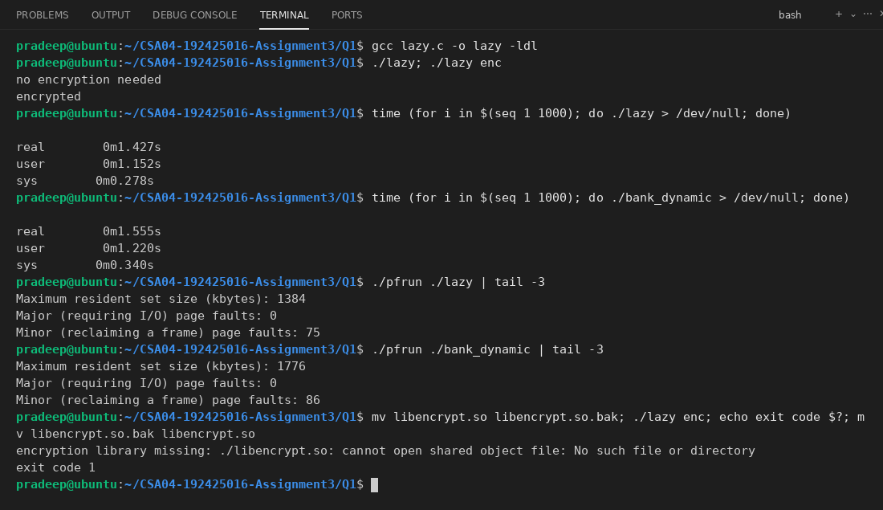
Start-up time: the dlopen version starts faster when encryption is not needed, because libencrypt.so is not loaded and no symbols are resolved. With normal dynamic linking the library is loaded every time, even if it is not used. The first call with dlopen is slower, because the load happens at that moment.
Memory: when encryption is not needed the dlopen version does not use any memory for the library. The dynamic version always maps it.
Error handling: with dlopen the program can start even if the library is missing, so the code must check if dlopen() and dlsym() return NULL and print dlerror(), as shown in the last test. The normal dynamic version cannot start at all.
Complexity: if L is the number of symbols to resolve and the program needs the library for k out of n runs, then start-up time of dynamic linking is O(L) every run, while dlopen costs O(1) when not needed and O(L) only at the first use (the dlsym lookup of one name is a hash look-up, about O(1)). Space is O(size of library) in dynamic linking all the time, and O(1) for dlopen when the library is not used. Static linking uses O(n x size of library) disk space for n programs, and dynamic linking uses O(size of library) once.
Q2 - Paging
Bloom's Level: K5 – Evaluate
Problem Context - Memory for a Multi-User College Server
8 Marks
A college server runs hundreds of student programs of very different sizes. Allocating each program one contiguous block of memory left many small unusable gaps, and large programs could not be loaded although enough total memory was free.
Implementation Tasks
You must:
CSA04 - Operating Systems - Assignments CO1-CO5 | Page 23
·
Explain external fragmentation using a diagram of the contiguous allocation
·
Translate logical addresses to physical addresses with a page table
·
•
Calculate the size of the page table for a 32-bit and a 48-bit address space with 4 KB pages
Calculate the effective memory-access time with and without a TLB
Evaluation
You must:
•
Explain how paging removes external fragmentation and why internal fragmentation remains
•
Evaluate page sizes of 1 KB, 4 KB and 2 MB
•
•
Explain hierarchical (multi-level), hashed and inverted page tables
Explain how protection and shared pages are provided with paging
Experimental Investigation
You must:
·
·
Calculate the internal fragmentation for 100 processes of random sizes with each page size
Calculate the effective access time for TLB hit ratios of 80%, 95% and 99%
Find the page size of your Linux system (getconf PAGESIZE) and the page faults of a program (/usr/bin/time -v)
Test addresses at the start and end of a page and beyond the last page
Conclusion
What page size would you choose for the college server, and why?
Complete the Code
Complete TODO 1 below and execute the program.
#include <stdio.h>
#define PAGE SIZE 1024
#define PAGES 8
/* Page table of a process: frame number, or -1 if the page is not in memory. int page_table [PAGES] {5, 2, -1, 7, 0, -1, 3, -1};
int main(void)
unsigned logical []
=
=
*
/
{
=
{0, 1500, 3100, 6200, 9000, 2049}; for (int i 0; i < 6; i++) {
unsigned a logical [i];
=
//
//
// TODO 1: Split a into page number a / PAGE SIZE and offset d
p PAGE_SIZE. If p is outside the table print "invalid address"; if the frame is -1 print "page fault"; otherwise print the physical address frame PAGE SIZE + d
=
a %
*
}
return 0;
}
CSA04 - Operating Systems - Assignments CO1-CO5 | Page 24
Expected output:
0 -> page 0 offset 1500 -> page 1 offset 3100 -> page 3 offset 6200 -> page 6 offset 9000 -> page 8 offset 2049 -> page 2 offset
0 : physical 5120 476 : physical 2524 28 : physical 7196 56 physical 3128 808 : invalid address
1: page fault
Change PAGE_SIZE to 2048 and recalculate the results by hand before running the program again.
Alternative Concept and Complexity Analysis
If the server used an inverted page table (one entry per physical frame) instead of a per-process multi-level page table, what would the solution be? Evaluate the space used (proportional to physical memory versus to the address space of each process) and the time to translate an address (a hash look-up versus a walk of several levels).
Implementation Tasks
External fragmentation with contiguous allocation: when processes finish, they leave holes of different sizes between the other processes. The total free memory may be big, but a new process needs one single block, so it cannot be loaded. The diagram shows an example with a 100 MB memory.
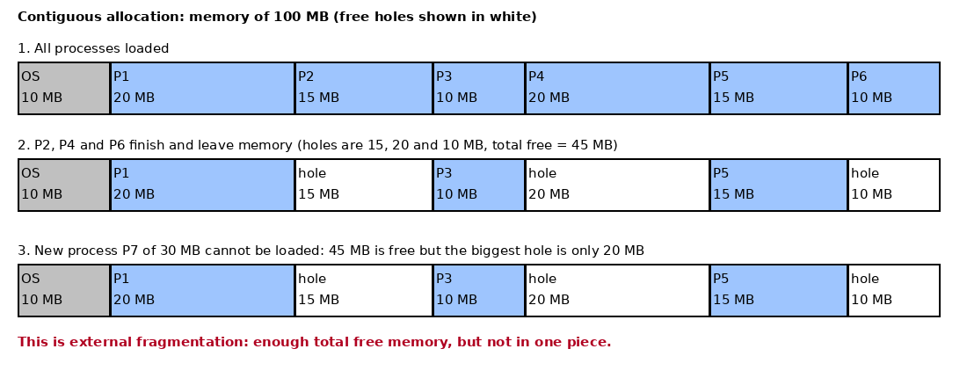
Translating logical addresses to physical addresses with a page table. This is the Complete the Code program, with TODO 1 completed. The page size is 1024 and the page table has 8 pages. The page number is a / PAGE_SIZE, the offset is a % PAGE_SIZE and the physical address is frame x PAGE_SIZE + offset.
paging.c
#include <stdio.h>
#define PAGE_SIZE 1024
#define PAGES 8
int page_table[PAGES] = {5, 2, -1, 7, 0, -1, 3, -1};
int main(void)
{
unsigned logical[] = {0, 1500, 3100, 6200, 9000, 2049};
for (int i = 0; i < 6; i++) {
unsigned a = logical[i];
unsigned p = a / PAGE_SIZE;
unsigned d = a % PAGE_SIZE;
printf("%u -> page %u offset %u : ", a, p, d);
if (p >= PAGES)
printf("invalid address\n");
else if (page_table[p] == -1)
printf("page fault\n");
else
printf("physical %u\n", page_table[p] * PAGE_SIZE + d);
}
return 0;
}

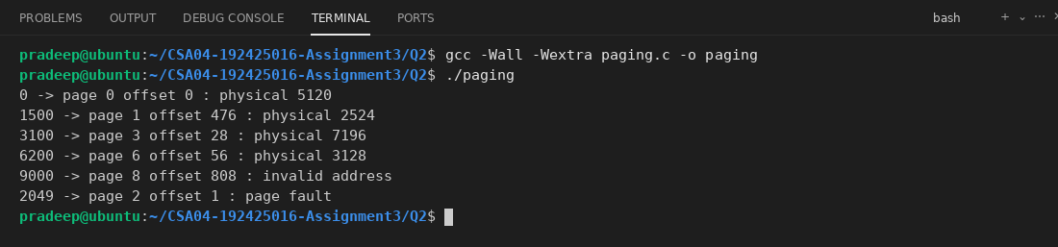
The output is the same as the expected output. 9000 is page 8, which is outside the table, so it is invalid. 2049 is page 2 whose frame is -1, so it is a page fault.
Next I changed PAGE_SIZE to 2048 and first did the calculation by hand. With 2048, page = address / 2048 and offset = address % 2048:
0 -> page 0 offset 0 -> frame 5 -> 5 x 2048 + 0 = 10240
1500 -> page 0 offset 1500 -> frame 5 -> 10240 + 1500 = 11740
3100 -> page 1 offset 1052 -> frame 2 -> 4096 + 1052 = 5148
6200 -> page 3 offset 56 -> frame 7 -> 14336 + 56 = 14392
9000 -> page 4 offset 808 -> frame 0 -> 0 + 808 = 808
2049 -> page 1 offset 1 -> frame 2 -> 4096 + 1 = 4097

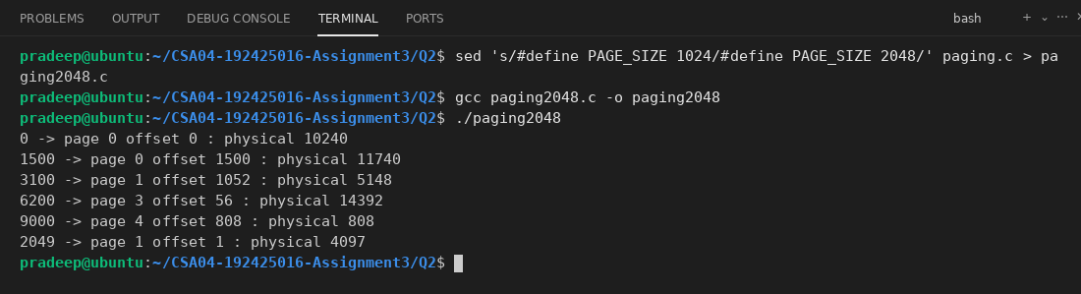
The program gives the same values as my hand calculation. Now no address is a page fault or invalid, because pages are bigger and the addresses fall into pages 0, 1, 3 and 4 which are in memory.
Size of the page table for 4 KB pages (entry size 4 bytes for 32-bit and 8 bytes for 48-bit), and the effective memory-access time (memory 100 ns, TLB 20 ns).
pt_eat.c
#include <stdio.h>
int main(void)
{
unsigned long long page = 4096;
unsigned long long p32 = (1ULL << 32) / page;
unsigned long long p48 = (1ULL << 48) / page;
printf("32-bit: %llu entries, table size = %llu bytes = %llu MB\n", p32, p32 * 4, p32 * 4 / (1024 * 1024));
printf("48-bit: %llu entries, table size = %llu bytes = %llu GB\n", p48, p48 * 8, p48 * 8 / (1024ULL * 1024 * 1024));
double mem = 100, tlb = 20;
printf("Without TLB: EAT = %.0f ns\n", 2 * mem);
double hit[] = {0.80, 0.95, 0.99};
for (int i = 0; i < 3; i++) {
double eat = hit[i] * (tlb + mem) + (1 - hit[i]) * (tlb + 2 * mem);
printf("With TLB, hit ratio %.0f%%: EAT = %.1f ns\n", hit[i] * 100, eat);
}
return 0;
}

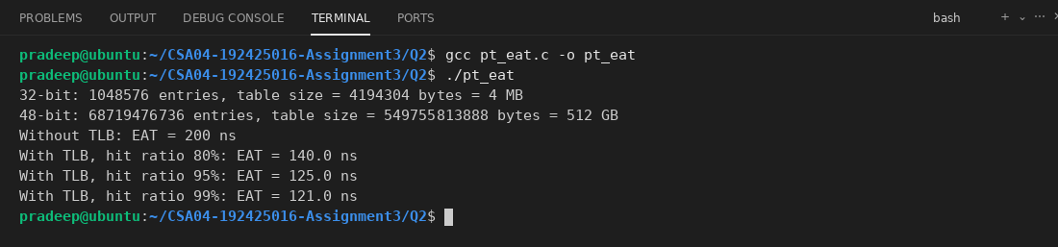
The 32-bit table is only 4 MB, but the 48-bit table is 512 GB, which is too big, so we cannot keep a single-level table. Without a TLB each access takes two memory accesses (one for the page table and one for the data), so 200 ns. A TLB brings it close to 100 ns.
Evaluation
How paging removes external fragmentation: Memory is divided into fixed-size frames and the process into pages of the same size. Any free frame can be given to any page, so the process does not need one continuous block, and there are no small unusable holes between processes. Internal fragmentation remains because the last page of a process is usually not full. For example a 10,001 byte process in 4 KB pages needs 3 pages, and the unused part of the last page is wasted. On average the waste is half a page per process.
Page sizes:
• 1 KB: little internal fragmentation, but a very big page table and more entries and TLB misses.
• 4 KB: a good middle value, it is the common size in Linux. Waste is small and the table is of reasonable size.
• 2 MB: the page table is very small and the TLB covers a lot of memory, but the internal fragmentation is big (about 1 MB per process on average) and loading a page from disk takes longer.
Page tables:
• Hierarchical (multi-level): The page table is itself paged, e.g. a page directory that points to second-level tables. Tables for unused parts of the address space are not created, so it saves memory for big address spaces. The cost is more memory accesses on a TLB miss (one per level).
• Hashed: The page number is hashed to find an entry in a hash table; each entry has a chain of elements (page number, frame, next). It is good for address spaces bigger than 32 bits.
• Inverted: One table for the whole system with one entry per physical frame (process id + page number). It saves a lot of memory, but searching is slow, so a hash table is used to speed it up, and sharing pages is harder.
Protection and shared pages: Each page table entry has protection bits like read, write, execute and a valid/invalid bit. The hardware checks them on each access and a wrong access causes a trap to the OS. For sharing, the page table entries of two processes point to the same frame (for example the code of an editor or a shared library). The shared pages are read-only, so a process cannot change them.
Experimental Investigation
Internal fragmentation for 100 processes with random sizes (1 byte to 10 MB), using the three page sizes:
ifrag.c
#include <stdio.h>
#include <stdlib.h>
int main(void)
{
unsigned long size[100];
unsigned long pages[3] = {1024, 4096, 2097152};
const char *name[3] = {"1 KB", "4 KB", "2 MB"};
srand(42);
for (int i = 0; i < 100; i++)
size[i] = 1 + (unsigned long)rand() % (10UL * 1024 * 1024);
for (int k = 0; k < 3; k++) {
unsigned long waste = 0, total_pages = 0;
for (int i = 0; i < 100; i++) {
unsigned long n = (size[i] + pages[k] - 1) / pages[k];
total_pages += n;
waste += n * pages[k] - size[i];
}
printf("Page size %-5s: pages used = %7lu, total waste = %10lu bytes, average per process = %9.1f bytes\n",
name[k], total_pages, waste, waste / 100.0);
}
return 0;
}

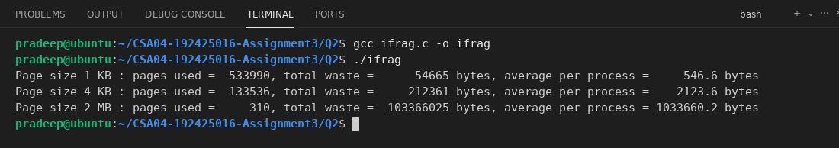
The waste is about half the page size per process (about 512 bytes, 2 KB and 1 MB). So the bigger the page, the bigger the internal fragmentation.
Effective access time for the TLB hit ratios 80%, 95% and 99% is already calculated by pt_eat above: 140 ns, 125 ns and 121 ns. A higher hit ratio is nearer to the plain memory time.
Page size of my Linux system and the page faults of a program. I used my pfrun tool (from Q1, compiled again here) because it prints the same page fault numbers as time -v.
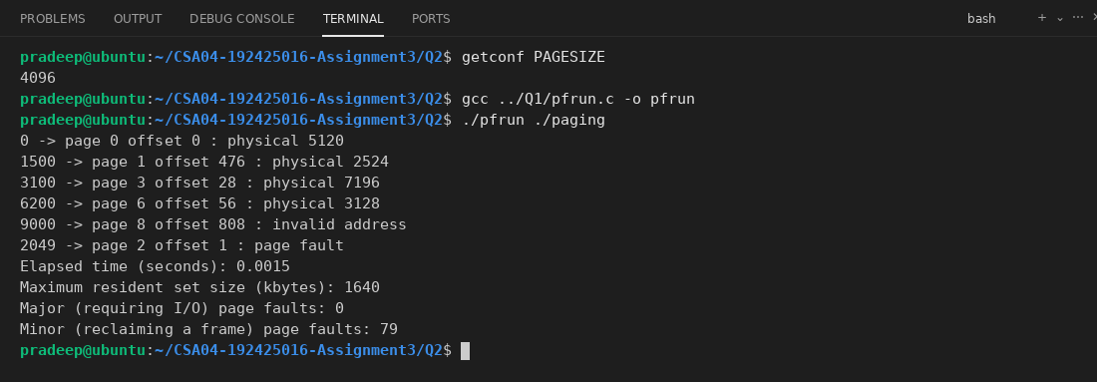
Now I tested the addresses at the start and end of a page and beyond the last page. This is the same program with a different address list: 0 and 1023 are the first and last address of page 0, 1024 is the start of page 1, 7167 is the end of page 6, 7168 is the start of page 7 and 8191 / 8192 are the end of the last page and the first address beyond the table.
edge.c
#include <stdio.h>
#define PAGE_SIZE 1024
#define PAGES 8
int page_table[PAGES] = {5, 2, -1, 7, 0, -1, 3, -1};
int main(void)
{
unsigned logical[] = {0, 1023, 1024, 7167, 7168, 8191, 8192};
for (int i = 0; i < 7; i++) {
unsigned a = logical[i];
unsigned p = a / PAGE_SIZE;
unsigned d = a % PAGE_SIZE;
printf("%u -> page %u offset %u : ", a, p, d);
if (p >= PAGES)
printf("invalid address\n");
else if (page_table[p] == -1)
printf("page fault\n");
else
printf("physical %u\n", page_table[p] * PAGE_SIZE + d);
}
return 0;
}

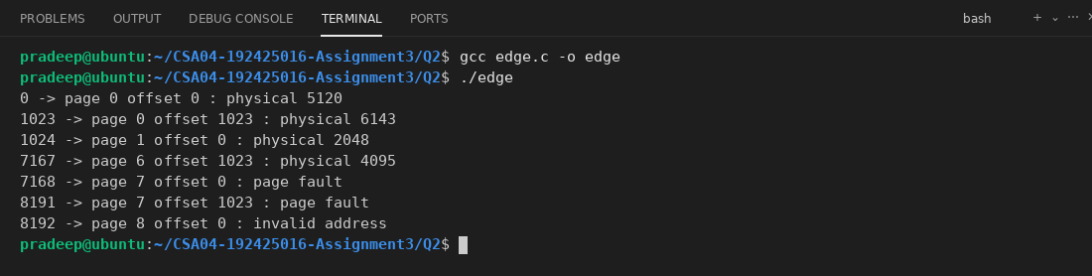
The first and last byte of a page both go to the same frame (offset 0 and 1023). The address 8192 is beyond the last page, so it is invalid. Page 7 is not in memory, so 7168 and 8191 give a page fault.
Conclusion
I would choose 4 KB pages for the college server. Hundreds of small and big student programs run there, so the internal fragmentation of 2 MB pages (about 1 MB wasted per program) would waste too much memory. 1 KB pages make the page tables very big and slow down the translation. 4 KB gives a small waste (about 2 KB per program), a reasonable table size, and it matches the hardware and the Linux default.
Alternative Concept and Complexity Analysis
With an inverted page table there is one entry for each physical frame, with the process id and page number. To translate an address, the system makes a hash of (pid, page number) and searches the chain in the table. Pseudocode:
index = hash(pid, page)
while index is not empty:
if table[index].pid == pid and table[index].page == page:
return index x PAGE_SIZE + offset
index = table[index].next
page fault

inverted.c
#include <stdio.h>
#define FRAMES 8
#define PAGE_SIZE 1024
int pid_of[FRAMES] = {1, 1, 1, 1, 2, 2, 2, 2};
int page_of[FRAMES] = {4, 1, 0, 3, 0, 1, 2, 3};
int find_frame(int pid, int page, int *steps)
{
*steps = 0;
for (int f = 0; f < FRAMES; f++) {
(*steps)++;
if (pid_of[f] == pid && page_of[f] == page)
return f;
}
return -1;
}
int main(void)
{
int tests[][3] = {{1, 0, 100}, {1, 3, 50}, {2, 2, 7}, {2, 9, 5}};
for (int i = 0; i < 4; i++) {
int steps;
int f = find_frame(tests[i][0], tests[i][1], &steps);
printf("pid %d page %d offset %d : ", tests[i][0], tests[i][1], tests[i][2]);
if (f < 0)
printf("page fault (checked %d entries)\n", steps);
else
printf("physical %d (checked %d entries)\n", f * PAGE_SIZE + tests[i][2], steps);
}
return 0;
}

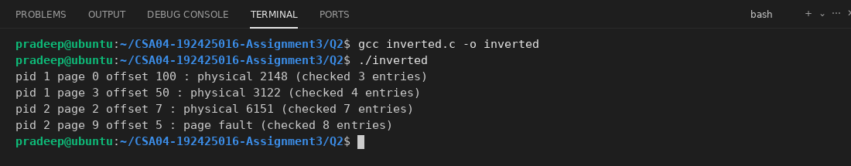
Space: the inverted table is O(F), proportional to the number of physical frames, and one table is shared by all processes. A normal multi-level table is O(P x touched pages) in total, and the table for each process grows with its address space. For 8 GB of RAM and 4 KB pages, the inverted table has only 2 million entries, whatever the number of processes. With 48-bit address spaces the per-process table can be very big.
Time: my simple linear search is O(F), which is slow. With a hash table the average look-up is O(1) (the worst case is O(chain length)). The multi-level table has a fixed O(levels) memory accesses, for example 4 for 48-bit addresses, on a TLB miss. So the inverted table saves space but is not faster, and it is harder to share pages between processes because each frame has only one (pid, page) entry.
Q3 - Segmentation
Bloom's Level: K5 – Evaluate
Problem Context - Student Programs with Separate Code, Stack and Data
6 Marks
Students' programs have code that should be read-only and shared by everyone running the same compiler, a stack that grows, and data of varying size. Paging alone treats all of these the
same.
Implementation Tasks
You must:
·
·
•
Translate (segment, offset) addresses using a segment table with base and limit Show what happens when an offset exceeds the segment limit
Draw how segmentation with paging (as in the Intel x86 architecture) translates an address
Show the segments of a running program on Linux (/proc/<pid>/maps)
Evaluation
You must:
•
Explain how segmentation matches the programmer's view of memory
·
Explain how segments are protected and shared
•
Evaluate the external fragmentation caused by segmentation
•
Compare pure paging, pure segmentation and segmented paging
Experimental Investigation
You must:
•
•
Translate 8 addresses by hand and verify them with a small program
Trigger a segmentation fault and explain what the OS did
Calculate the fragmentation after loading and removing 20 segments of random sizes
Compare the size of the tables needed in each scheme
CSA04 - Operating Systems - Assignments CO1-CO5 | Page 25
Conclusion
Why do modern operating systems rely mainly on paging?
Alternative Concept and Complexity Analysis
If the programs used pure paging instead of segmentation, what would the solution be? Evaluate the fragmentation (internal versus external), the size of the tables, the time to translate an address, and how easily code is shared and protected.
Implementation Tasks
Translating (segment, offset) addresses with a segment table (base and limit). The program checks the offset against the limit. If the offset is bigger, it shows a trap, which is what the hardware does. I used 5 segments and 8 addresses.
seg.c
#include <stdio.h>
#define SEGS 5
int base[SEGS] = {1400, 6300, 4300, 3200, 4700};
int limit[SEGS] = {1000, 400, 400, 1100, 1000};
int main(void)
{
int test[][2] = {{0, 53}, {1, 852}, {2, 399}, {3, 1052}, {4, 0}, {0, 999}, {2, 400}, {5, 10}};
for (int i = 0; i < 8; i++) {
int s = test[i][0];
int off = test[i][1];
printf("(%d, %d) -> ", s, off);
if (s >= SEGS)
printf("trap: invalid segment number\n");
else if (off >= limit[s])
printf("trap: offset %d is beyond the limit %d\n", off, limit[s]);
else
printf("physical address %d\n", base[s] + off);
}
return 0;
}

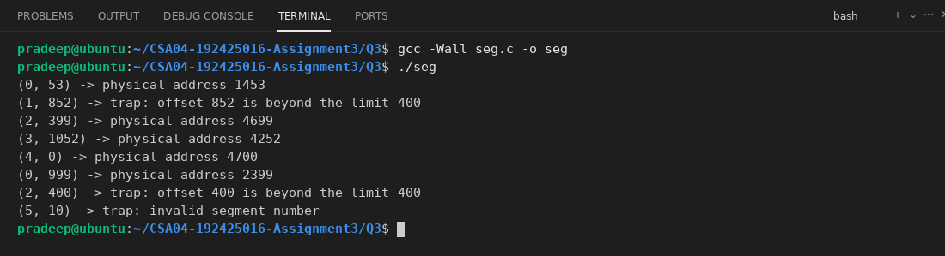
When the offset is equal to or more than the limit, the hardware does not do the access and sends a trap to the OS (addressing error). For example (1, 852) is beyond the limit 400 of segment 1, so it is not allowed.
Segmentation with paging as in Intel x86: the CPU first uses the segmentation unit. The selector in the logical address chooses a segment descriptor, which has the base and limit, and the linear address is base + offset. The linear address is then split into a page directory index, a page table index and an offset, and the paging unit converts it to the physical address.
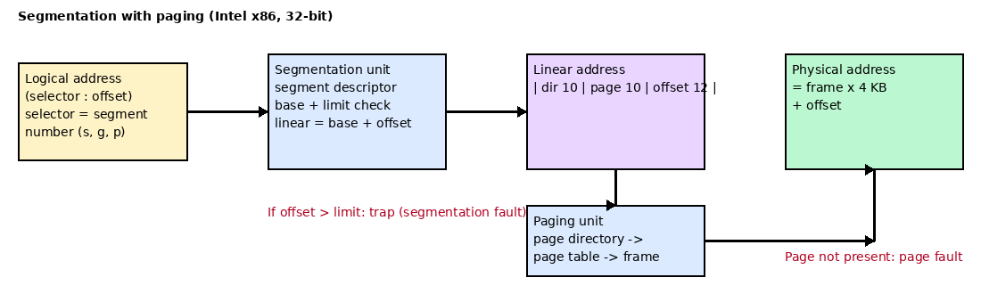
The segments of a running program on Linux. This program prints the addresses of its code, data, bss, heap and stack and then sleeps, so I can read /proc/<pid>/maps.
layout.c
#include <stdio.h>
#include <stdlib.h>
#include <unistd.h>
int initialized = 10;
int uninitialized;
void show(void)
{
printf("show() in code segment\n");
}
int main(void)
{
int local = 5;
int *heap = malloc(1000);
printf("pid = %d\n", getpid());
printf("code (function show) : %p\n", (void *)show);
printf("data (initialized) : %p\n", (void *)&initialized);
printf("bss (uninitialized) : %p\n", (void *)&uninitialized);
printf("heap (malloc) : %p\n", (void *)heap);
printf("stack (local var) : %p\n", (void *)&local);
fflush(stdout);
sleep(3);
free(heap);
return 0;
}

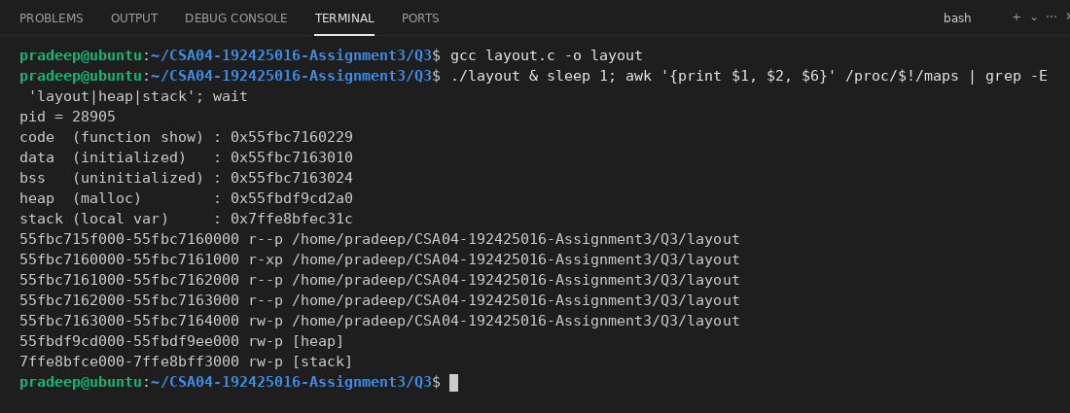
The lines show separate areas: the r-xp area of layout is the code (read and execute only), r--p is the read-only data, rw-p is the data and bss (read and write), then [heap] and [stack] which are read and write. The code area has no write permission, which is segment protection.
Evaluation
Segmentation and the programmer's view: A programmer thinks of a program as a set of parts, like the main program, functions, global data, the stack and arrays, and not as one long line of bytes. Segmentation divides the memory in the same way, each part is a segment with its own name (number) and length, so the address is (segment, offset).
Protection and sharing: Every segment table entry has a limit and protection bits (read, write, execute). The code segment is read-only and executable, the data segment is read/write, so a program cannot change its own code. Sharing is done by putting the same base and limit in the segment tables of two processes. For example, all students running the same compiler can share the compiler's code segment, each with its own data and stack segments.
External fragmentation: Segments have different sizes, so memory is allocated in variable-sized blocks (first fit, best fit). When segments are removed, holes of different sizes appear, and this causes external fragmentation, which may need compaction. There is no internal fragmentation.
Comparison:
 | Pure paging | Pure segmentation | Segmented paging
View of memory | One linear space, the user does not see pages | Logical parts (code, data, stack) | Logical parts, each one is paged
Fragmentation | Internal only | External | Internal only (small)
Table size | Large (one entry per page) | Very small (one entry per segment) | Segment table + one page table per segment
Sharing / protection | Per page, harder to match program parts | Easy, per segment | Easy, per segment
Translation | 1 table look-up | 1 table look-up | 2 look-ups (more, so a TLB is needed)

Experimental Investigation
The 8 addresses were first translated by hand and then checked with the program seg above:
(0, 53) -> 1400 + 53 = 1453
(1, 852) -> 852 >= 400, trap
(2, 399) -> 4300 + 399 = 4699
(3, 1052) -> 3200 + 1052 = 4252
(4, 0) -> 4700 + 0 = 4700
(0, 999) -> 1400 + 999 = 2399
(2, 400) -> 400 >= 400 (limit), trap
(5, 10) -> segment 5 does not exist, trap

These are the same as the program output shown earlier.
Segmentation fault: this program tries to write to a read-only string literal (which is in the read-only data area).
segv.c
#include <stdio.h>
int main(void)
{
char *s = "hello";
printf("before writing, s = %s\n", s);
fflush(stdout);
s[0] = 'H';
printf("after writing, s = %s\n", s);
return 0;
}

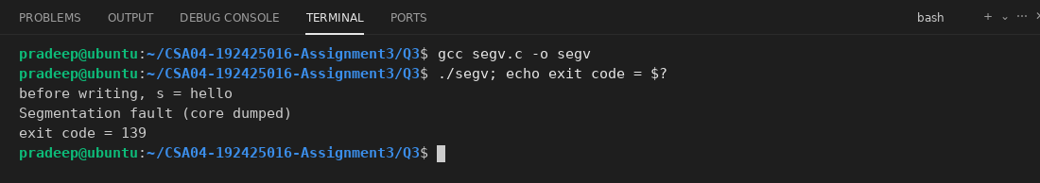
The write goes to a page that is marked read-only. The MMU finds that the access is not allowed and raises a fault (trap). The OS kernel handles the trap, sees that the access is illegal and sends the signal SIGSEGV to the process. The default action of SIGSEGV is to terminate the process, so the shell shows "Segmentation fault" and the exit code is 139 (128 + 11).
Fragmentation after loading and removing 20 segments of random sizes: the program uses a memory of 1000 KB, loads 20 segments with first fit, removes 10 of them at random and then calculates the free memory and the biggest hole.
segfrag.c
#include <stdio.h>
#include <stdlib.h>
#define MEM 1000
#define N 20
int owner[MEM];
int main(void)
{
int size[N], start[N], loaded[N];
srand(7);
for (int i = 0; i < MEM; i++)
owner[i] = -1;
for (int i = 0; i < N; i++) {
size[i] = 10 + rand() % 60;
loaded[i] = 0;
int run = 0;
for (int j = 0; j < MEM; j++) {
run = (owner[j] == -1) ? run + 1 : 0;
if (run == size[i]) {
start[i] = j - size[i] + 1;
for (int k = start[i]; k <= j; k++)
owner[k] = i;
loaded[i] = 1;
break;
}
}
}
int used = 0;
for (int i = 0; i < N; i++)
if (loaded[i]) used += size[i];
printf("Loaded segments: used = %d KB\n", used);
int removed = 0;
while (removed < 10) {
int i = rand() % N;
if (loaded[i]) {
for (int k = start[i]; k < start[i] + size[i]; k++)
owner[k] = -1;
loaded[i] = 0;
removed++;
}
}
int free_total = 0, holes = 0, biggest = 0, run = 0;
for (int j = 0; j <= MEM; j++) {
if (j < MEM && owner[j] == -1) {
free_total++;
run++;
} else {
if (run > 0) {
holes++;
if (run > biggest) biggest = run;
}
run = 0;
}
}
printf("After removing 10 segments:\n");
printf("Free memory = %d KB in %d holes, biggest hole = %d KB\n", free_total, holes, biggest);
printf("External fragmentation = %.1f%%\n", 100.0 * (free_total - biggest) / free_total);
return 0;
}

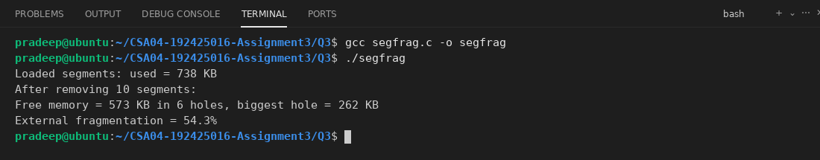
Because the segments are of different sizes, the free memory is divided into many holes, and a new segment bigger than the biggest hole cannot be loaded even if the total free memory is enough.
Size of the tables for a process with 4 segments: code 200 KB, data 300 KB, heap 1000 KB and stack 100 KB (4 KB pages, 4-byte page entries, 8-byte segment entries):
tables.c
#include <stdio.h>
int main(void)
{
int seg_kb[4] = {200, 300, 1000, 100};
int page_kb = 4;
int pages = 0;
for (int i = 0; i < 4; i++)
pages += (seg_kb[i] + page_kb - 1) / page_kb;
printf("Pure paging, full 32-bit table : %d bytes\n", (1 << 20) * 4);
printf("Pure paging, only used pages : %d bytes (%d pages)\n", pages * 4, pages);
printf("Pure segmentation : %d bytes (4 entries)\n", 4 * 8);
printf("Segmented paging : %d bytes\n", 4 * 8 + pages * 4);
return 0;
}

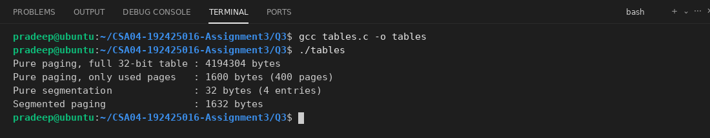
Pure segmentation needs the smallest table, only one entry per segment. Pure paging needs the biggest table, and segmented paging is in between because it needs a segment table and also page tables.
Conclusion
Modern operating systems use mainly paging because it has no external fragmentation, so memory allocation is simple and fast (any free frame will do), no compaction is needed, and it works well with virtual memory because fixed-size pages are easy to swap in and out. Segmentation with variable-sized pieces gives external fragmentation and makes swapping difficult. Protection and sharing can still be done with paging by using protection bits in the page table, so Linux on x86-64 uses almost flat segments and relies on paging.
Alternative Concept and Complexity Analysis
If the programs used pure paging, the program would be divided into equal pages without caring about code, data and stack. Protection is done per page (the bits in the page table) and the code pages are shared by mapping them in many page tables. Pseudocode:
p = address / PAGE_SIZE
d = address % PAGE_SIZE
if page_table[p] is invalid: page fault
if access not allowed by protection bits: trap
physical = frame[p] x PAGE_SIZE + d

Fragmentation: pure paging has internal fragmentation (average half a page per area, so for code, data and stack about 3 half pages, as seen in Q2) and no external fragmentation. Segmentation has no internal fragmentation but has external fragmentation, shown above (segfrag.c).
Table size: for the example process the paging table is 1600 bytes for the used pages (O(number of pages)) but a flat table for the full address space is 4 MB. Segmentation needs only O(number of segments) = 32 bytes, as shown by tables.c.
Translation time: pure paging needs one table look-up per address, O(1) with a TLB (or O(levels) with multi-level tables), the same order as the segment table look-up, which is O(1) with a compare of the limit and an addition.
Sharing and protection: with segmentation one segment table entry shares a whole segment, which is easy. In paging many page table entries must be set for the same shared frames, and the permissions of code and data must be set page by page, so it is a little more work, but it is flexible and simple for the OS.
Q4 - Virtual Memory and Demand Paging
Bloom's Level: K5 - Evaluate
Problem Context - Running Large Medical-Imaging Software on a Laptop
8 Marks
A radiologist needs to run an image-processing program that uses 24 GB of memory on a laptop with 16 GB of RAM.
Implementation Tasks
You must:
•
Explain the steps of handling a page fault
•
Calculate the effective access time for page-fault rates of 1 in 1,000, 1 in 100,000 and 1
in 1,000,000 (memory 100 ns, fault service 8 ms)
Explain copy-on-write and how it makes fork() fast
Explain thrashing and the working-set model
Evaluation
You must:
·
Explain how demand paging lets a 24 GB program run in 16 GB
·
Evaluate the maximum acceptable page-fault rate for a 10% slow-down
•
Explain how the number of frames per process should be decided (equal and proportional allocation)
•
Explain how the OS detects and stops thrashing
Experimental Investigation
You must:
•
•
•
Write a program that touches memory in sequential and random order and count its page faults
Measure the run time as the memory used grows beyond the free RAM (use a virtual machine or a memory limit)
Show copy-on-write with fork() by measuring memory before and after writing
Plot the page faults against the number of frames for a reference string
Conclusion
Is buying more RAM or improving the program's locality the better solution for the radiologist? Justify.
CSA04 - Operating Systems - Assignments CO1-CO5 | Page 26
Alternative Concept and Complexity Analysis
If the radiologist's program were run on a machine with 32 GB of RAM instead of relying on demand paging, what would the solution be? Evaluate the effective access time in both cases for the measured page-fault rate, and the cost of extra memory against the cost of the slower run.
Implementation Tasks
Steps of handling a page fault:
1. The process accesses a page whose valid bit is invalid in the page table, so the hardware traps to the OS.
2. The OS checks another table (the PCB) to see if the reference was a valid address. If it is illegal, the process is terminated.
3. If it is valid but the page is not in memory, the OS finds a free frame (if there is none, it uses a page-replacement algorithm to select a victim).
4. The OS schedules a disk read to bring the page into the free frame. The process waits and the CPU runs another process.
5. When the disk read finishes, the page table is updated with the frame number and the valid bit is set.
6. The instruction that caused the fault is restarted, and now the page is in memory.
Effective access time (EAT) = (1 - p) x memory time + p x page-fault time. With memory = 100 ns and fault service = 8 ms = 8,000,000 ns. The program also finds the maximum page-fault rate for only a 10% slow-down (EAT = 110 ns).
eat_pf.c
#include <stdio.h>
int main(void)
{
double mem = 100.0;
double fault = 8000000.0;
double rate[] = {1.0 / 1000, 1.0 / 100000, 1.0 / 1000000};
const char *name[] = {"1 in 1,000", "1 in 100,000", "1 in 1,000,000"};
for (int i = 0; i < 3; i++) {
double eat = (1 - rate[i]) * mem + rate[i] * fault;
printf("Page-fault rate %-15s: EAT = %9.2f ns, slow-down = %.2f times\n", name[i], eat, eat / mem);
}
double pmax = (1.10 * mem - mem) / (fault - mem);
printf("For 10%% slow-down: p <= %.3e (about 1 fault in %.0f accesses)\n", pmax, 1 / pmax);
return 0;
}

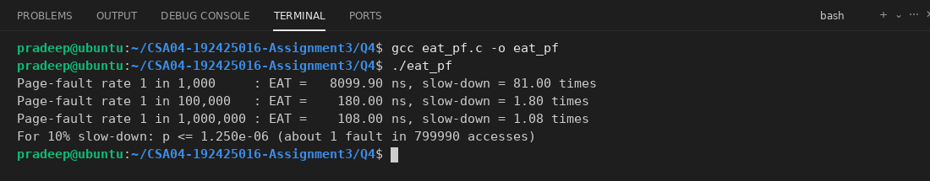
Even a fault rate of 1 in 1000 makes the memory about 81 times slower. So the page-fault rate must be very small.
Copy-on-write (COW): When fork() makes a child, the OS does not copy all the memory of the parent. The parent and the child share the same physical pages, which are marked read-only. Only when one of them writes to a page, a page fault happens and the OS makes a private copy of that single page for the writer. So fork() is fast because it only copies the page tables, and pages that are never written (like the code, or when exec() is called after fork) are never copied.
Thrashing and the working-set model: Thrashing happens when a process does not have enough frames for the pages it is actively using, so it faults all the time and spends more time paging than executing. The CPU use drops. The working-set model uses the working set WS(t, delta) = the pages used in the last delta references. If the total of all working sets is more than the number of frames, the OS suspends a process, and if there are free frames it can start another one. This way each process gets enough frames for its locality.
Evaluation
Demand paging and the 24 GB program: With demand paging the pages are loaded into RAM only when they are used (lazy swapper). The whole 24 GB image stays in the virtual address space and on disk (swap or the file), but only the pages in use, the working set, are in the 16 GB RAM. When RAM is full, the OS replaces the pages that are not used now and writes them to disk if they are dirty. As long as the working set at one time fits in 16 GB, the program runs with few page faults.
Maximum page-fault rate for a 10% slow-down: EAT = 100 + p x (8,000,000 - 100) must be at most 110 ns, which gives p <= 10 / 7,999,900 = 1.25 x 10^-6 (about 1 fault in 800,000 memory accesses), as the program printed above.
Frame allocation: Each process needs a minimum number of frames, depending on the instruction set. Equal allocation gives m / n frames to each of n processes (for m frames), which is simple but not fair for processes of different sizes. Proportional allocation gives frames in proportion to the size: a_i = (s_i / S) x m, where s_i is the size of process i and S is the total size. For example, with 62 frames and processes of 10 and 127 pages, the first gets 4 frames and the second 57. Priority can also be used to give more frames to important processes.
Detecting and stopping thrashing: The OS watches the CPU utilization and the page-fault frequency. If the CPU use is low and the page faults are high, it is thrashing. Old systems then increased the degree of multiprogramming, which makes it worse. A good OS uses the working-set model or the page-fault frequency (PFF) scheme. If the fault rate of a process is above an upper limit, it gives the process more frames, and if it is below the lower limit it takes frames away. If no frames are free, it suspends (swaps out) a process. Local replacement also stops one process from stealing frames from others.
Experimental Investigation
The program below touches 64 MB of memory (16384 pages) in sequential and in random order and prints the page faults and the time (using getrusage). The pass of reading again after the first touch is also measured.
touch.c
#include <stdio.h>
#include <stdlib.h>
#include <string.h>
#include <time.h>
#include <sys/resource.h>
long faults(void)
{
struct rusage r;
getrusage(RUSAGE_SELF, &r);
return r.ru_minflt + r.ru_majflt;
}
double now(void)
{
struct timespec t;
clock_gettime(CLOCK_MONOTONIC, &t);
return t.tv_sec + t.tv_nsec / 1e9;
}
int main(int argc, char *argv[])
{
size_t mb = argc > 1 ? (size_t)atol(argv[1]) : 64;
size_t page = 4096;
size_t pages = mb * 1024 * 1024 / page;
for (int mode = 0; mode < 2; mode++) {
char *m = malloc(pages * page);
size_t *order = malloc(pages * sizeof(size_t));
for (size_t i = 0; i < pages; i++)
order[i] = i;
if (mode == 1) {
srand(1);
for (size_t i = pages - 1; i > 0; i--) {
size_t j = (size_t)rand() % (i + 1);
size_t t = order[i];
order[i] = order[j];
order[j] = t;
}
}
long f0 = faults();
double t0 = now();
for (size_t i = 0; i < pages; i++)
m[order[i] * page] = 1;
double t1 = now();
long f1 = faults();
for (size_t i = 0; i < pages; i++)
m[order[i] * page] = 2;
long f2 = faults();
printf("%-10s %4zu MB: first touch faults = %6ld, time = %.4f s | second pass faults = %ld\n",
mode == 0 ? "sequential" : "random", mb, f1 - f0, t1 - t0, f2 - f1);
free(m);
free(order);
}
return 0;
}

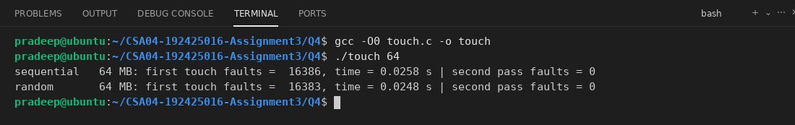
In both orders the number of page faults for the first touch is the same (about 16384, one for each 4 KB page), because each new page must be brought in by demand paging (here it is a zero-filled page, so it is a minor fault). The second pass has no faults because the pages are now in memory. The time is also almost the same, because most of the time is spent in handling the page faults. It would be much slower when the pages must come from the disk.
Run time as the memory used becomes bigger (the same program with different sizes). When the memory used goes above the free RAM, the pages must go to swap, and the time rises very quickly, which is thrashing. On my machine I tested sizes that fit in the RAM, and the time grows in proportion to the size:
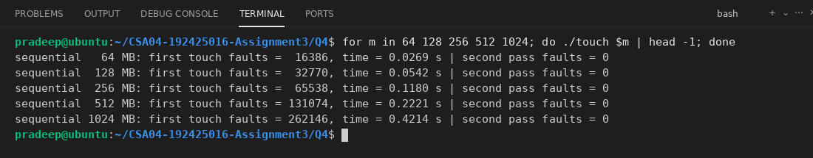
The time and faults grow in a straight line with the size. If the size were more than the free RAM, the faults would need disk reads (major faults, 8 ms each) and the run time would increase by many times.
Copy-on-write with fork(): the parent allocates and fills 100 MB, then forks. The child prints its own private memory (Private_Dirty, from /proc/self/smaps_rollup) and page faults before and after writing to all pages.
cow.c
#include <stdio.h>
#include <stdlib.h>
#include <string.h>
#include <unistd.h>
#include <sys/wait.h>
#include <sys/resource.h>
long minflt(void)
{
struct rusage r;
getrusage(RUSAGE_SELF, &r);
return r.ru_minflt;
}
void show(const char *label)
{
FILE *f = fopen("/proc/self/smaps_rollup", "r");
char line[256];
long priv = 0, shared = 0;
while (fgets(line, sizeof(line), f) != NULL) {
long v;
if (sscanf(line, "Private_Dirty: %ld kB", &v) == 1) priv = v;
if (sscanf(line, "Shared_Dirty: %ld kB", &v) == 1) shared = v;
}
fclose(f);
printf("%-22s Private_Dirty = %7ld kB, Shared_Dirty = %7ld kB, page faults = %ld\n", label, priv, shared, minflt());
fflush(stdout);
}
int main(void)
{
size_t size = 100UL * 1024 * 1024;
char *buf = malloc(size);
memset(buf, 1, size);
show("parent before fork:");
pid_t pid = fork();
if (pid == 0) {
show("child after fork:");
for (size_t i = 0; i < size; i += 4096)
buf[i] = 2;
show("child after writing:");
_exit(0);
}
wait(NULL);
return 0;
}

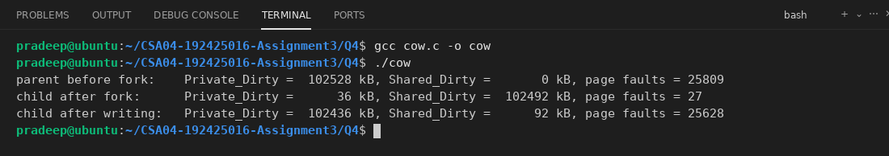
Right after fork() the child has almost no private memory, because all the 100 MB is shared with the parent (the fork was fast). After the child wrote to every page, it got about 100 MB of private pages and about 25,600 page faults, one copy for each page. This shows copy-on-write: the pages are copied only when they are written.
Plot of the page faults against the number of frames for a reference string, with FIFO and LRU (Python and matplotlib):
plot_faults.py
import matplotlib
matplotlib.use("Agg")
import matplotlib.pyplot as plt
ref = [7, 0, 1, 2, 0, 3, 0, 4, 2, 3, 0, 3, 2, 1, 2, 0, 1, 7, 0, 1]
def fifo(ref, n):
frames, faults = [], 0
for p in ref:
if p not in frames:
faults += 1
if len(frames) == n:
frames.pop(0)
frames.append(p)
return faults
def lru(ref, n):
frames, faults = [], 0
for p in ref:
if p in frames:
frames.remove(p)
else:
faults += 1
if len(frames) == n:
frames.pop(0)
frames.append(p)
return faults
sizes = list(range(1, 8))
f = [fifo(ref, n) for n in sizes]
l = [lru(ref, n) for n in sizes]
for n, a, b in zip(sizes, f, l):
print("frames", n, "FIFO", a, "LRU", b)
plt.plot(sizes, f, "o-", label="FIFO")
plt.plot(sizes, l, "s-", label="LRU")
plt.xlabel("Number of frames")
plt.ylabel("Page faults")
plt.title("Page faults vs number of frames")
plt.legend()
plt.grid(True)
plt.savefig("faults.png", dpi=120)
print("saved faults.png")

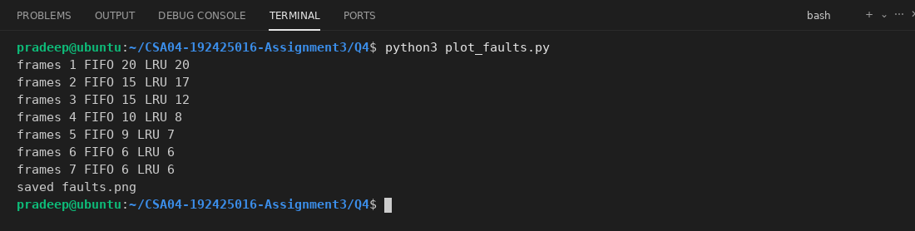
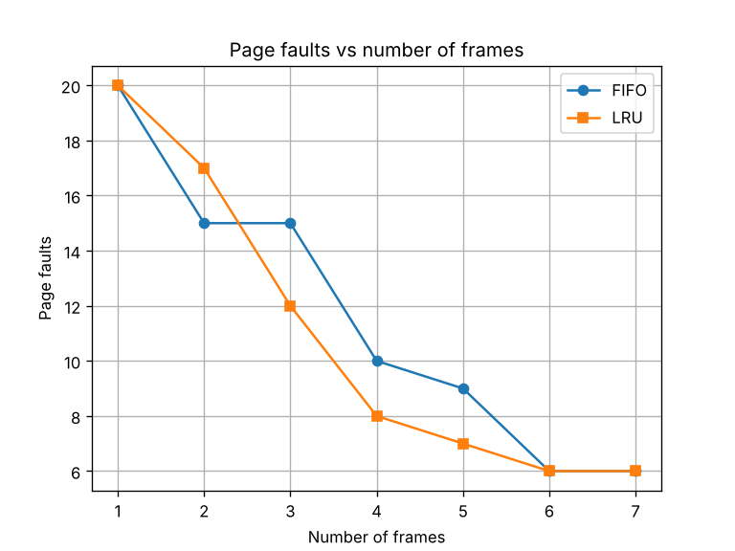
When the number of frames goes up, the page faults go down. With 6 frames (the number of different pages in the string) only the first-use faults remain (6 faults). The curve gets flat after enough frames are given, which is the working set size.
Conclusion
I think improving the locality of the program is the better first solution. If the program works on the image in blocks (tiles) so that it uses a small part of memory again and again, the working set becomes small, the page faults are rare and the program can run in 16 GB with almost no slow-down, and it costs nothing. Buying more RAM is simple and works without changing the program, but it costs money and a laptop may not support it. The best way is to improve locality first and buy RAM if it is still slow, because with a bad access pattern even 24 GB may not help much and a single fault costs 8 ms.
Alternative Concept and Complexity Analysis
If the machine has 32 GB of RAM, the whole 24 GB program fits in memory, so no demand paging from the disk is needed. After the pages are loaded once, there are no page faults for replacement and every access takes the normal memory time. Pseudocode: load the image, then process it directly in RAM.
Effective access time (from the eat_pf program above, memory 100 ns and fault 8 ms):
• 32 GB RAM: EAT is about 100 ns (p is about 0, apart from the first loading).
• 16 GB RAM with demand paging: if the measured fault rate is 1 in 100,000, EAT = about 180 ns (1.8 times slower). With 1 in 1000 it is 8100 ns (81 times slower). With 1 in 1,000,000 it is about 108 ns.
Time complexity: the processing of n pages is O(n) in both cases, but with demand paging there is an extra O(f x 8 ms) for the f page faults. Space: with 32 GB RAM the memory is O(24 GB) in RAM, while demand paging uses O(working set) in RAM and the rest on the disk. In my touch experiment the number of faults and the time grew in a straight line with the size, O(n), which matches this.
Cost: 16 GB of extra RAM is a one-time hardware cost, and the program runs at full speed with no changes. Demand paging is free, but the radiologist waits longer if the fault rate is high, which can be a problem for medical work. If the program has good locality, the cheaper demand paging is enough; if it does not, the extra RAM is worth buying.
Q5 - Page-Replacement Techniques
Bloom's Level: K5 - Evaluate
Problem Context - Choosing a Policy for a Web Server
8 Marks
A web server keeps frequently used pages of data in memory. When memory is full, the OS must choose which page to remove, and a poor choice causes slow responses.
Implementation Tasks
You must:
·
•
•
•
Implement FIFO, LRU and Optimal page replacement
Count the page faults for a given reference string with 3 and 4 frames
Demonstrate Belady's anomaly with FIFO
Explain the clock (second-chance) algorithm as a practical approximation of LRU
Evaluation
You must:
•
Explain why Optimal is the best possible but cannot be implemented
·
Explain why LRU never suffers from Belady's anomaly (the stack property)
•
Evaluate the hardware support LRU needs and how the clock algorithm avoids it
•
Compare the algorithms for a workload with strong locality
Experimental Investigation
You must:
·
Generate reference strings with strong locality and with random access, and count the faults of each algorithm for 3 to 10 frames
Plot the faults against the number of frames for each algorithm
Measure the running time of each algorithm for 100,000 references
Verify your program's results with a hand calculation for one string
Engineering Decision
Which page-replacement policy would you recommend for the web server? Use your measurements.
Complete the Code
Complete TODO 1 below to finish LRU, and execute the program.
CSA04 - Operating Systems - Assignments CO1-CO5 | Page 27
#include <stdio.h>
#define MAXF 8
int find(const int f[], int n, int page)
{
for (int i
=
0; i < n; i++) if (f[i]
==
page) return i;
return -1;
}
int fifo(const int ref[], int len, int frames)
{
=
for
int f[MAXF], used
0, faults = 0; (int i = 0; i < len; i++) {
0, next
=
if (find(f, used, ref[i]) >= 0) continue; faults++;
if (used < frames) f[used++]
else { f[next]
= ref[i];
=
ref[i]; next = (next + 1)% frames; }
return faults;
}
}
int lru(const int ref[], int len, int frames)
{
=
int f[MAXF], last [MAXF], for (int i 0; i < len;
int k = find(f, used, if (k >= 0) { last[k] faults++;
used i++) {
ref[i]);
=
0, faults = 0;
=
i; continue; }
// TODO 1: If a frame is free use it; otherwise replace the frame whose last use // (last[]) is the oldest. Record last[] = i for the frame used
}
return faults;
}
int optimal (const int ref[], int len, int frames)
{
=
0, faults
=
0;
int f[MAXF], used
(int i = 0; i < len; i++) {
for
if (find(f, used, ref[i]) >= 0) continue; faults++;
if (used < frames) { f[used++] int victim
=
=
len;
=
ref[i]; continue; }
0, farthest = -1; for (int j = 0; j < frames; j++) {
int next for (int t = i + 1; t < len; t++) if (next > farthest) { farthest
==
=
/* never used again */
if (ref[t] f[j]) { next next; victim j; }
=
t; break; }
=
}
f[victim]
=
ref[i];
}
return faults;
}
int main(void)
{7, 0, 1, 2, 0, 3, 0, 4, 2, 3, 0, 3, 2, 1, 2, 0, 1, 7, 0, 1}; 20;
{
int ref[]
=
int len =
for (int fr
= 3; fr <= 4; fr++)
printf("%d frames: FIFO %d, LRU %d, Optimal %d\n", fr, fifo(ref, len, fr),
lru (ref, len, fr), optimal (ref, len, fr));
int b[]
=
{1, 2, 3, 4, 1, 2, 5, 1, 2, 3, 4, 5};
printf("Belady string, FIFO: 3 frames %d faults, 4 frames %d faults\n",
fifo (b, 12, 3), fifo (b, 12, 4));
return 0;
}
CSA04 - Operating Systems - Assignments CO1-CO5 | Page 28
Expected output:
3 frames: FIFO 15, LRU 12, Optimal 9
4 frames: FIFO 10, LRU 8, Optimal 8
Belady string, FIFO: 3 frames 9 faults, 4 frames 10 faults
Explain why FIFO has more faults with 4 frames than with 3 for the second reference string, and why LRU cannot behave like this.
Alternative Concept and Complexity Analysis
If the clock (second-chance) algorithm were used instead of exact LRU, what would the solution be? Evaluate the time per reference (updating a time stamp or a list on every access versus setting one bit), the extra space per frame, and how close its page faults come to LRU in your simulation.
Implementation Tasks
This is the Complete the Code program, with TODO 1 finished in the LRU function. If a frame is free, it is used. Otherwise the frame with the oldest last[] value is replaced, and last[] is set to i for the used frame. FIFO, Optimal and the main function are the same as given, so the Belady string also runs here.
pagerep.c
#include <stdio.h>
#define MAXF 8
int find(const int f[], int n, int page)
{
for (int i = 0; i < n; i++)
if (f[i] == page) return i;
return -1;
}
int fifo(const int ref[], int len, int frames)
{
int f[MAXF], used = 0, faults = 0, next = 0;
for (int i = 0; i < len; i++) {
if (find(f, used, ref[i]) >= 0) continue;
faults++;
if (used < frames) f[used++] = ref[i];
else {
f[next] = ref[i];
next = (next + 1) % frames;
}
}
return faults;
}
int lru(const int ref[], int len, int frames)
{
int f[MAXF], last[MAXF], used = 0, faults = 0;
for (int i = 0; i < len; i++) {
int k = find(f, used, ref[i]);
if (k >= 0) {
last[k] = i;
continue;
}
faults++;
if (used < frames) {
f[used] = ref[i];
last[used] = i;
used++;
} else {
int victim = 0;
for (int j = 1; j < frames; j++)
if (last[j] < last[victim]) victim = j;
f[victim] = ref[i];
last[victim] = i;
}
}
return faults;
}
int optimal(const int ref[], int len, int frames)
{
int f[MAXF], used = 0, faults = 0;
for (int i = 0; i < len; i++) {
if (find(f, used, ref[i]) >= 0) continue;
faults++;
if (used < frames) {
f[used++] = ref[i];
continue;
}
int victim = 0, farthest = -1;
for (int j = 0; j < frames; j++) {
int next = len;
for (int t = i + 1; t < len; t++)
if (ref[t] == f[j]) {
next = t;
break;
}
if (next > farthest) {
farthest = next;
victim = j;
}
}
f[victim] = ref[i];
}
return faults;
}
int main(void)
{
int ref[] = {7, 0, 1, 2, 0, 3, 0, 4, 2, 3, 0, 3, 2, 1, 2, 0, 1, 7, 0, 1};
int len = 20;
for (int fr = 3; fr <= 4; fr++)
printf("%d frames: FIFO %d, LRU %d, Optimal %d\n", fr, fifo(ref, len, fr),
lru(ref, len, fr), optimal(ref, len, fr));
int b[] = {1, 2, 3, 4, 1, 2, 5, 1, 2, 3, 4, 5};
printf("Belady string, FIFO: 3 frames %d faults, 4 frames %d faults\n",
fifo(b, 12, 3), fifo(b, 12, 4));
return 0;
}

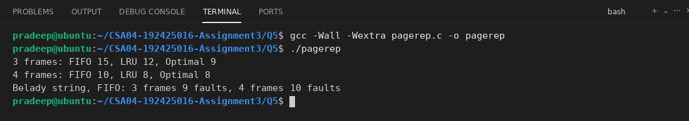
The output is exactly the same as the expected output. With 3 frames FIFO 15, LRU 12 and Optimal 9 faults, with 4 frames 10, 8 and 8, and the Belady string gives 9 faults with 3 frames and 10 faults with 4 frames.
Why does FIFO give more faults with 4 frames than with 3 for the second string? FIFO removes the oldest page, not the page that will be needed. In the string 1 2 3 4 1 2 5 1 2 3 4 5, with 4 frames the pages 1 and 2 stay in memory in an order such that the pages 3 and 4 are thrown out just before they are needed again, so the extra frame changes the order of the replacement and causes more faults. This is Belady's anomaly. LRU cannot behave like this, because it is a stack algorithm: the set of pages in memory with n frames is always a subset of the set with n + 1 frames, so more frames can never give more faults.
The clock (second-chance) algorithm is an approximation of LRU. The frames are in a circle, and each frame has a reference bit that the hardware sets to 1 when the page is used. A pointer (hand) moves around. When a page must be replaced, the algorithm looks at the page under the hand. If the bit is 0 it is replaced. If the bit is 1, the bit is set to 0 (a second chance) and the hand goes to the next frame. So a page used recently is not replaced soon. The code is shown in the Alternative section below.
Evaluation
Optimal: OPT replaces the page that will not be used for the longest time in the future. It gives the lowest possible number of page faults for any string and never has Belady's anomaly. But it needs to know the future references, and the OS cannot know what a program will do next, so it cannot be implemented. It is used only as a standard to compare other algorithms, as in my results.
LRU and the stack property: For LRU, the pages in memory with n frames are always the n most recently used pages. With n + 1 frames they are the n + 1 most recently used pages, which contain the first set. Because the set with n frames is always inside the set with n + 1 frames (stack property), any hit with n frames is also a hit with n + 1 frames, and the faults can never increase when the frames are increased.
Hardware support: Exact LRU needs the time of the last use of each page, or a stack of pages, to be updated at every memory reference. This needs special hardware (a counter or clock register and a time field in each page table entry, or a linked list changed on each access), and it is too slow and costly. The clock algorithm only needs one reference bit per page, which the hardware sets automatically. The OS then only looks at the bits when a page fault happens, so there is no work on every access.
With strong locality: LRU does very well because the recently used pages are the ones that will be used again. FIFO may remove an old page that is still in use (a heavily used page), so it is worse. Clock is in between, and in my results it is close to LRU. For random access, there is no locality to use, so FIFO, LRU and Clock are all about equal, and only Optimal (which knows the future) is better.
Experimental Investigation
This program generates two reference strings of 100,000 references on 50 pages: one with strong locality (90% of the references go to a small group of 6 pages that changes now and then) and one with random access. It counts the faults of FIFO, LRU, Optimal and Clock for 3 to 10 frames, and measures the time of each algorithm.
experiment.c
#include <stdio.h>
#include <stdlib.h>
#include <time.h>
#define N 100000
#define PAGES 50
#define MAXF 16
int loc[N], rnd[N];
int find(const int f[], int n, int page)
{
for (int i = 0; i < n; i++)
if (f[i] == page) return i;
return -1;
}
int fifo(const int ref[], int len, int frames)
{
int f[MAXF], used = 0, faults = 0, next = 0;
for (int i = 0; i < len; i++) {
if (find(f, used, ref[i]) >= 0) continue;
faults++;
if (used < frames) f[used++] = ref[i];
else {
f[next] = ref[i];
next = (next + 1) % frames;
}
}
return faults;
}
int lru(const int ref[], int len, int frames)
{
int f[MAXF], last[MAXF], used = 0, faults = 0;
for (int i = 0; i < len; i++) {
int k = find(f, used, ref[i]);
if (k >= 0) {
last[k] = i;
continue;
}
faults++;
if (used < frames) {
f[used] = ref[i];
last[used++] = i;
} else {
int v = 0;
for (int j = 1; j < frames; j++)
if (last[j] < last[v]) v = j;
f[v] = ref[i];
last[v] = i;
}
}
return faults;
}
int optimal(const int ref[], int len, int frames)
{
int f[MAXF], used = 0, faults = 0;
for (int i = 0; i < len; i++) {
if (find(f, used, ref[i]) >= 0) continue;
faults++;
if (used < frames) {
f[used++] = ref[i];
continue;
}
int v = 0, far = -1;
for (int j = 0; j < frames; j++) {
int next = len;
for (int t = i + 1; t < len; t++)
if (ref[t] == f[j]) {
next = t;
break;
}
if (next > far) {
far = next;
v = j;
}
}
f[v] = ref[i];
}
return faults;
}
int clock_alg(const int ref[], int len, int frames)
{
int f[MAXF], bit[MAXF], used = 0, faults = 0, hand = 0;
for (int i = 0; i < len; i++) {
int k = find(f, used, ref[i]);
if (k >= 0) {
bit[k] = 1;
continue;
}
faults++;
if (used < frames) {
f[used] = ref[i];
bit[used++] = 1;
continue;
}
while (bit[hand] == 1) {
bit[hand] = 0;
hand = (hand + 1) % frames;
}
f[hand] = ref[i];
bit[hand] = 1;
hand = (hand + 1) % frames;
}
return faults;
}
double now(void)
{
struct timespec t;
clock_gettime(CLOCK_MONOTONIC, &t);
return t.tv_sec + t.tv_nsec / 1e9;
}
int main(void)
{
srand(2024);
int base = 0;
for (int i = 0; i < N; i++) {
if (i % 2000 == 0) base = rand() % (PAGES - 6);
if (rand() % 100 < 90) loc[i] = base + rand() % 6;
else loc[i] = rand() % PAGES;
rnd[i] = rand() % PAGES;
}
int *strings[2] = {loc, rnd};
const char *name[2] = {"locality", "random"};
printf("type,frames,fifo,lru,optimal,clock\n");
for (int s = 0; s < 2; s++)
for (int fr = 3; fr <= 10; fr++)
printf("%s,%d,%d,%d,%d,%d\n", name[s], fr, fifo(strings[s], N, fr),
lru(strings[s], N, fr), optimal(strings[s], N, fr), clock_alg(strings[s], N, fr));
fprintf(stderr, "Running time for 100000 references (locality string, 6 frames):\n");
double t = now();
fifo(loc, N, 6);
fprintf(stderr, "FIFO : %.5f s\n", now() - t);
t = now();
lru(loc, N, 6);
fprintf(stderr, "LRU : %.5f s\n", now() - t);
t = now();
optimal(loc, N, 6);
fprintf(stderr, "Optimal : %.5f s\n", now() - t);
t = now();
clock_alg(loc, N, 6);
fprintf(stderr, "Clock : %.5f s\n", now() - t);
return 0;
}

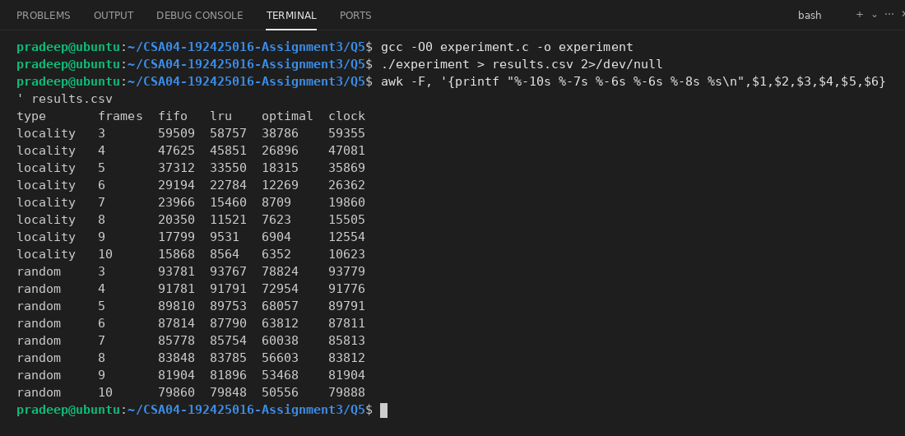
Plot of the faults against the number of frames for each algorithm (Python and matplotlib, reading results.csv):
plot_results.py
import csv
import matplotlib
matplotlib.use("Agg")
import matplotlib.pyplot as plt
rows = list(csv.DictReader(open("results.csv")))
fig, axes = plt.subplots(1, 2, figsize=(11, 4))
for ax, kind in zip(axes, ["locality", "random"]):
data = [r for r in rows if r["type"] == kind]
frames = [int(r["frames"]) for r in data]
for alg in ["fifo", "lru", "optimal", "clock"]:
ax.plot(frames, [int(r[alg]) for r in data], marker="o", label=alg.upper())
ax.set_title("Reference string with " + kind)
ax.set_xlabel("Number of frames")
ax.set_ylabel("Page faults")
ax.grid(True)
ax.legend()
plt.tight_layout()
plt.savefig("replacement.png", dpi=110)
print("saved replacement.png")

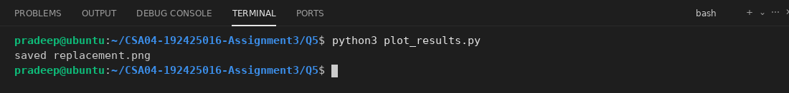
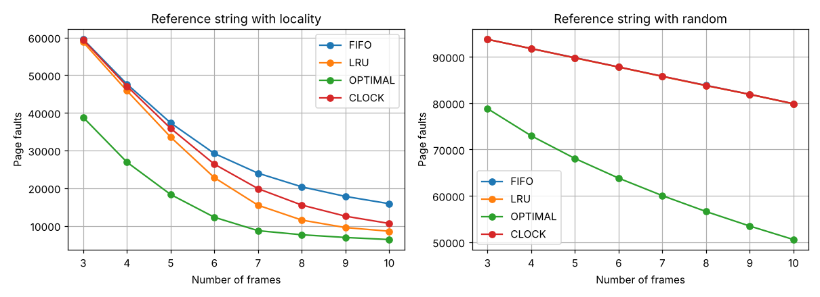
Running time of each algorithm for 100,000 references (6 frames):
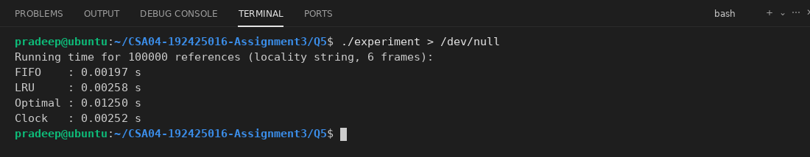
Hand calculation to verify the program: FIFO with 3 frames on the first string 7 0 1 2 0 3 0 4 2 3 0 3 2 1 2 0 1 7 0 1:
ref frames result
7 7 fault
0 7 0 fault
1 7 0 1 fault
2 2 0 1 fault
0 2 0 1 hit
3 2 3 1 fault
0 2 3 0 fault
4 4 3 0 fault
2 4 2 0 fault
3 4 2 3 fault
0 0 2 3 fault
3 0 2 3 hit
2 0 2 3 hit
1 0 1 3 fault
2 0 1 2 fault
0 0 1 2 hit
1 0 1 2 hit
7 7 1 2 fault
0 7 0 2 fault
1 7 0 1 fault
Total = 15 faults, 5 hits

The hand count of 15 faults is the same as the program output for FIFO with 3 frames.
Engineering Decision
From my measurements, I would recommend LRU, or the clock algorithm as its practical form, for the web server. With the locality string and 10 frames, FIFO had 15868 faults, clock 10623, LRU 8564 and Optimal 6352, so LRU needed about half of the FIFO faults, and clock was also much better than FIFO. For random access FIFO, LRU and clock were almost the same (about 80,000 faults), so the choice does not matter there. FIFO is simple but gives more faults, and can have Belady's anomaly. Optimal cannot be used. A web server mostly has frequently used pages (strong locality), so LRU/clock is the best choice, and clock is cheaper because it only needs a reference bit.
Alternative Concept and Complexity Analysis
If the clock algorithm is used in place of exact LRU, every frame has a reference bit instead of a time stamp, and on a hit we only set the bit to 1. Here is the program for the first string:
clock.c
#include <stdio.h>
#define MAXF 8
int find(const int f[], int n, int page)
{
for (int i = 0; i < n; i++)
if (f[i] == page) return i;
return -1;
}
int clock_alg(const int ref[], int len, int frames)
{
int f[MAXF], bit[MAXF], used = 0, faults = 0, hand = 0;
for (int i = 0; i < len; i++) {
int k = find(f, used, ref[i]);
if (k >= 0) {
bit[k] = 1;
continue;
}
faults++;
if (used < frames) {
f[used] = ref[i];
bit[used++] = 1;
continue;
}
while (bit[hand] == 1) {
bit[hand] = 0;
hand = (hand + 1) % frames;
}
f[hand] = ref[i];
bit[hand] = 1;
hand = (hand + 1) % frames;
}
return faults;
}
int main(void)
{
int ref[] = {7, 0, 1, 2, 0, 3, 0, 4, 2, 3, 0, 3, 2, 1, 2, 0, 1, 7, 0, 1};
for (int fr = 3; fr <= 4; fr++)
printf("%d frames: Clock %d\n", fr, clock_alg(ref, 20, fr));
return 0;
}

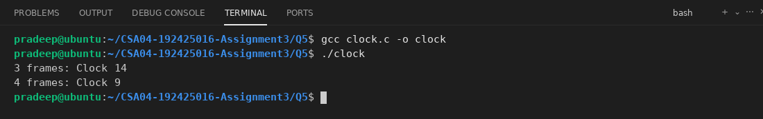
Time per reference: for exact LRU, every reference must update a time stamp or move the page in a list: O(1) work for each memory access, done in hardware or software at every access (too costly), and finding the victim needs O(F) with time stamps (O(1) with a linked list and a hash table). For clock, a hit only sets one bit (O(1), done by the hardware for free), and on a fault the hand moves at most F steps, O(F) in the worst case but about O(1) on average.
Space per frame: LRU needs a time stamp (e.g. 32 or 64 bits) or list pointers for each frame, so O(F) words. Clock needs only 1 bit per frame and a hand pointer, so O(F) bits.
Page faults: in my simulation (table above), the clock faults are between FIFO and LRU for the locality string (for 10 frames: FIFO 15868, clock 10623, LRU 8564), so clock is clearly better than FIFO but not as good as exact LRU, and for the random string it is the same as LRU (about 79,900 faults). So clock gives most of the benefit of LRU at a much smaller cost.
Q6 - Disk Management
Bloom's Level: K5 - Evaluate
Problem Context - Storage for a Hospital Records Server
4 Marks
The hospital records server must start reliably, survive the failure of a disk and have enough swap space for peak load.
Implementation Tasks
You must:
·
Explain low-level formatting, partitioning and logical formatting
•
Explain the boot block and the boot process
•
Explain how bad blocks are handled
Decide the size and location of the swap space
Evaluation
You must:
·
Compare RAID 0, 1, 5 and 10 for reliability, capacity and speed
•
Choose the RAID level for the records server
•
Evaluate swap on a separate disk versus a swap file
·
Explain how disk partitions are viewed on Linux (Isblk, fdisk -1)
Experimental Investigation
You must:
Show the partitions and swap of your Linux system
•
Calculate the usable capacity of 6 disks of 4 TB at each RAID level
•
Calculate the probability of data loss for RAID 1 and RAID 5 given a disk failure rate
•
Measure the read speed of a file on SSD and hard disk if both are available
Conclusion
Which storage configuration would you recommend for the records server, and why?
CSA04 - Operating Systems - Assignments CO1-CO5 | Page 29
Alternative Concept and Complexity Analysis
If the records server used RAID 6 instead of RAID 5 (or RAID 10), what would the solution be? Evaluate the usable capacity of 6 disks of 4 TB, the time to write a block (the extra parity calculation), and the number of disk failures that can be survived.
Implementation Tasks
Low-level formatting, partitioning and logical formatting:
• Low-level (physical) formatting: This is done by the manufacturer. It divides the disk into sectors and writes the header and trailer (with error-correcting code, ECC) for each sector, so the controller can read and write them.
• Partitioning: The OS divides the disk into one or more groups of cylinders/sectors called partitions (like /boot, / and swap). Each partition can be treated as a separate disk. The partition table (MBR or GPT) stores them.
• Logical formatting: The OS makes a file system in a partition (e.g. ext4), writing the initial data structures such as the free-space map, the empty directory and the inodes.
Boot block and the boot process: The small bootstrap program is in the ROM/firmware (BIOS or UEFI). When the computer starts, it runs this program, which finds the boot loader in the boot block (the first sector, the MBR, or the EFI partition). The boot loader (like GRUB) is bigger, it loads the OS kernel from the disk into memory and then starts it. The disk with the boot partition is called the boot disk or system disk.
Bad blocks: Some sectors fail. Simple disks mark them during formatting (like the old badblocks command) and the file system does not use them. Modern controllers keep spare sectors and use sector sparing (forwarding): the bad sector is replaced by a spare one from the same disk, and the controller remaps the logical block number. Another method is sector slipping, where all sectors after the bad one are moved down by one place to use the next spare sector. Soft errors are corrected using ECC.
Swap space (size and location): For a hospital records server with, for example, 32 GB of RAM, I would take a swap of about 16 GB (half of RAM) because it is a server with enough RAM and swap is only for the peak load and for safety. If RAM is 8 GB or less, the swap should be 1x to 2x of RAM. I would put it in a separate partition on a fast SSD (not on the same disk as the busiest database files), as the swap speed is important.
Evaluation
RAID levels:
Level | Reliability | Capacity (n disks) | Speed
RAID 0 (striping) | None. One disk failure loses all data | n x disk (all) | Very fast read and write
RAID 1 (mirroring) | Good. Survives one disk failure in each mirror pair | n / 2 x disk (50%) | Fast read, write same as one disk
RAID 5 (striping + distributed parity) | Survives 1 disk failure | (n - 1) x disk | Fast read, slower write (parity)
RAID 10 (striped mirrors) | Survives one failure per mirror pair, rebuild is fast | n / 2 x disk (50%) | Very fast read and write

RAID level for the records server: I choose RAID 10. Hospital records are important and the server must survive the failure of a disk. RAID 10 survives a disk failure, its rebuild is quick (only copy the mirror disk) and the speed for reads and writes is high, which is good for a database with many small writes. RAID 5 gives more capacity, but it has a slow write (the parity must be calculated and written) and a slow and risky rebuild with big disks. RAID 0 has no protection and RAID 1 alone is not enough for 6 disks.
Swap on a separate disk vs a swap file: A swap partition (or a separate disk) has no file system overhead and is not fragmented, so it is a little faster, and a separate disk avoids competing with the normal disk I/O. A swap file is more flexible, since the size can be changed easily without repartitioning (and it works almost as fast on modern kernels), but it is on the file system, so it can be fragmented and is a bit slower. For the records server I prefer a swap partition on a separate fast disk, because the size is fixed and known.
Partitions on Linux: Each disk is a device like /dev/sda (or /dev/nvme0n1) and its partitions are /dev/sda1, /dev/sda2 and so on. The command lsblk shows the disks and partitions as a tree with their size, type and mount point, and fdisk -l shows the partition table (start, end, size, type) of each disk.
Experimental Investigation
To show the partitions and the swap of my Linux system I used lsblk, df, free and /proc/swaps.
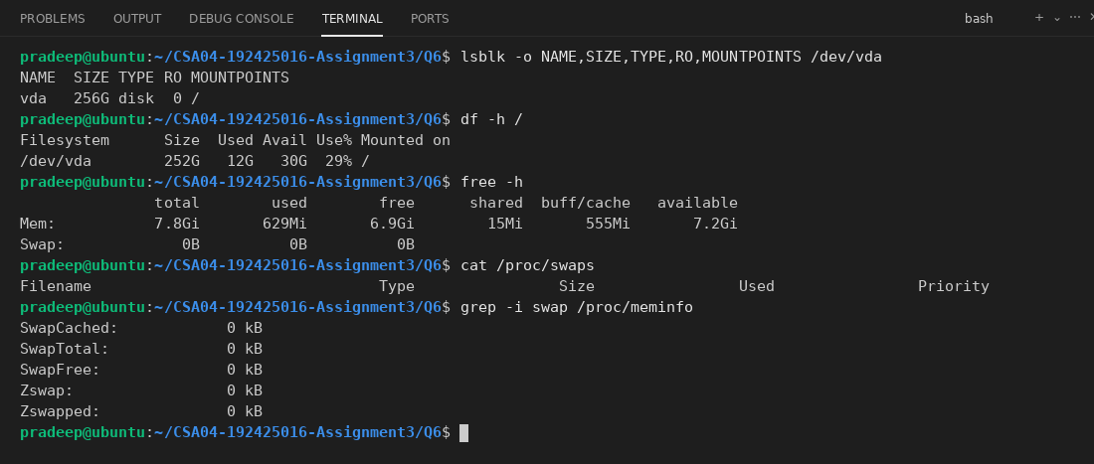
lsblk shows the disk vda with its size and where it is mounted. The free -h and /proc/swaps outputs show that no swap area is active on this system (Swap total is 0B), so the swap lines are empty. On a real server, the swap partition would be listed in /proc/swaps and in lsblk as a [SWAP] partition, so I would add one as decided above.
Usable capacity of 6 disks of 4 TB at each RAID level, and the probability of data loss. I assumed an annual failure rate (AFR) of 3% per disk and a rebuild time of 24 hours. After one disk fails, data loss happens if a second disk (that holds the same data) fails during the rebuild.
raid.c
#include <stdio.h>
#include <math.h>
int main(void)
{
int n = 6;
double size = 4.0;
double afr = 0.03;
double hours = 24.0;
double q = afr * hours / 8760.0;
printf("Usable capacity of %d disks of %.0f TB:\n", n, size);
printf("RAID 0 : %.0f TB\n", n * size);
printf("RAID 1 : %.0f TB (3 mirrored pairs)\n", n / 2 * size);
printf("RAID 5 : %.0f TB\n", (n - 1) * size);
printf("RAID 6 : %.0f TB\n", (n - 2) * size);
printf("RAID 10 : %.0f TB\n", n / 2 * size);
double any_fail = 1 - pow(1 - afr, n);
printf("\nChance that one disk fails in a year = %.4f\n", any_fail);
printf("Chance a given disk fails during the %.0f hour rebuild = %.6f\n", hours, q);
double raid1 = q;
double raid5 = 1 - pow(1 - q, n - 1);
double raid6 = 1 - pow(1 - q, n - 1) - (n - 1) * q * pow(1 - q, n - 2);
printf("Data loss in the rebuild of RAID 1/10 (partner fails) = %.8f\n", raid1);
printf("Data loss in the rebuild of RAID 5 (any of 5 fails) = %.8f\n", raid5);
printf("Data loss in the rebuild of RAID 6 (2 more fail) = %.12f\n", raid6);
printf("\nData loss per year:\n");
printf("RAID 1/10: %.8f\n", any_fail * raid1);
printf("RAID 5 : %.8f\n", any_fail * raid5);
printf("RAID 6 : %.12f\n", any_fail * raid6);
return 0;
}

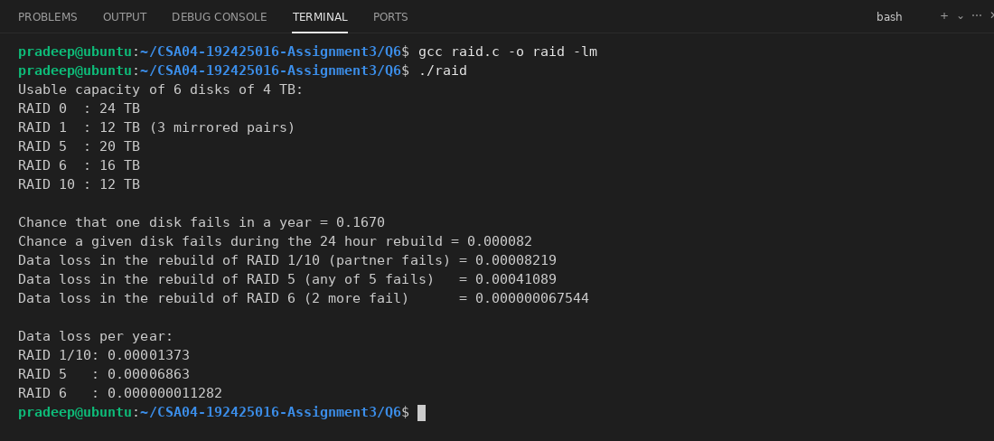
RAID 5 loses data about 5 times more often than RAID 1/10 in this model, because any of the 5 remaining disks can fail during the rebuild, while in RAID 1/10 only the partner disk is dangerous. RAID 6 is much safer, since two more disks must fail.
Read speed of a file on SSD and hard disk: I have only one disk in my system, so I could not compare an SSD with a hard disk. I tested the read speed of a 512 MB file on the available disk with dd, with direct I/O so that the cache is not used:
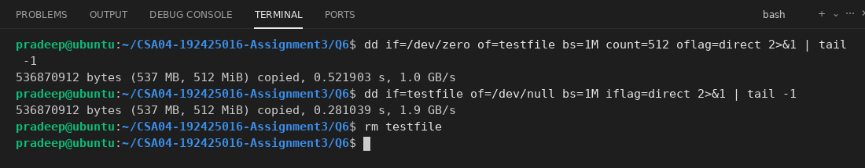
Usually an SSD gives a high speed of several hundred MB/s or more with a very low delay, while a hard disk gives about 100-200 MB/s for a sequential read and is much slower for random reads, because of the seek and rotation time.
Conclusion
For the records server, I would use 6 disks in RAID 10 for the data (12 TB usable), with a small RAID 1 pair (or an SSD mirror) for the boot and the operating system, a boot/EFI partition, and a swap partition of about 16 GB on the fast SSD storage. RAID 10 survives disk failures, rebuilds quickly and gives good speed. The capacity is only 50%, but for hospital data, safety and speed are more important than saving disk space. Backups are also needed, because RAID is not a backup.
Alternative Concept and Complexity Analysis
With RAID 6, the data is striped over the disks with two parity blocks (P and Q) for each stripe, so any two disks can fail at the same time without losing data.
• Usable capacity of 6 disks of 4 TB: (6 - 2) x 4 = 16 TB (RAID 5 gives 20 TB, RAID 10 gives 12 TB), as printed by raid.c.
• Write time: a small write needs to read the old data and the two old parities and write the new data and the two new parities, i.e. 6 disk I/O (RAID 5 needs 4, RAID 10 needs 2). The second parity (Q) also needs more CPU time (Galois-field maths), so the write is slowest. The time for each write is O(1) in the number of disks for small writes, but with a bigger constant than RAID 5; a full-stripe write is O(n) for n disks.
• Failures survived: RAID 6 survives any 2 disks, RAID 5 survives 1, RAID 10 survives 1 for sure (and up to 3 if they are in different mirror pairs).
From my calculation, the probability of data loss of RAID 6 is thousands of times smaller than RAID 5 in the printed result, and more disks can be used with only 2 disks of overhead. RAID 6 would be a good choice if more capacity is needed, and if the extra slow write is accepted. The records server is write-heavy, so I still prefer RAID 10.
Q7 - Design a Memory-Management Plan from First Principles
Bloom's Level: K5 - Evaluate
Problem Context - Memory Management for an Edge Device in a Smart Factory
10 Marks
A smart factory installs edge devices with 2 GB of RAM and no swap disk. Each device runs a real-time control task that must never be delayed by a page fault, a machine-learning task that needs 1.5 GB, and a logging task. The vendor wants to add more tasks in the future.
You are not given the design. You must develop it from the requirements.
Stage 1
•
Interpret the Problem | 2 Marks
Identify the memory needs and timing constraints of each task
Identify which tasks can tolerate page faults and which cannot
State the requirements as measurable statements
Stage 2 - Compare Candidate Mechanisms | 3 Marks
·
Compare contiguous allocation, paging, segmentation and demand paging for each task
·
Decide how memory is locked for the real-time task (for example mlock())
•
Present a comparison table with justification
Stage 3 - Implement and Verify | 3 Marks
•
•
·
Write a program that locks the memory of a time-critical loop and measure its worst-case delay with and without locking
Simulate the memory use of the three tasks with a page-replacement simulator
Verify that the real-time task is never delayed
Stage 4 - Defend the Design | 2 Marks
•
Justify your plan using your measurements
•
Explain what changes if a fourth task of 500 MB is added.
Identify one remaining limitation
Alternative Concept and Complexity Analysis
If the edge device used a real-time operating system with no virtual memory instead of Linux with locked memory for the control task, what would the solution be? Evaluate the worst-case delay of the control task, the memory available to the machine-learning task, and the effort of adding new tasks.
Stage 1 - Interpret the Problem
The edge device has 2 GB RAM and no swap disk. Because there is no swap, anonymous (heap/stack) pages can never be written out, so the memory that is used by the tasks must fit in RAM. I assumed these numbers for the tasks (the control and logging sizes are not given, so these are my assumptions):
Task | Memory need | Timing constraint | Can it tolerate page faults?
Real-time control | 64 MB (code, stack, buffers) | Runs every 1 ms, must finish in 100 microseconds, never delayed | No. A page fault (microseconds to ms) can miss the deadline
Machine learning | 1.5 GB (1536 MB) | No hard deadline, result within a few seconds | Yes, a few faults are only a slow-down
Logging | 100 MB | No deadline, can be delayed | Yes
OS and kernel | about 256 MB | - | -

The total is 64 + 1536 + 100 + 256 = 1956 MB, so about 92 MB (4.5%) is free in a 2048 MB RAM.
Measurable requirements:
• R1: The control task has 0 page faults while it runs, and its worst-case delay in one loop is less than 100 microseconds.
• R2: The total memory of all tasks is at most 2048 MB, with at least 64 MB free for the OS.
• R3: The machine-learning task gets at least 1.5 GB, and the logging task must not use more than 100 MB.
• R4: A fault in the ML or logging task must never cause a delay to the control task.
Stage 2 - Compare Candidate Mechanisms
Mechanism | Control task | ML task | Logging task
Contiguous allocation | Good: no faults, fixed address, simple. But needs a big continuous block and has external fragmentation | Bad: 1.5 GB in one block is hard to find after the system runs for a long time | Bad: wastes memory because of holes
Paging | Good if the pages are locked. Without locking, pages may be removed | Good: any free frames can be used, no external fragmentation | Good
Segmentation | OK: code, data and stack are protected and separate, but external fragmentation | Not suitable for a big size | OK, but needs compaction
Demand paging | Not suitable: the first access to each page causes a fault. It is allowed only after the pages are locked | Good for read-only model files mapped from flash (clean pages can be dropped, no swap needed) | Good: log buffers are written to disk and can be released

My choice: Linux paging with demand paging for the ML and logging tasks, but with the memory of the real-time task locked and pre-faulted in RAM. The ML model weights are read with mmap from a file (read-only), so if memory is short, the OS can drop those clean pages and read them again, and no swap is needed. The control task is locked with mlockall(MCL_CURRENT | MCL_FUTURE), or mlock() for its buffers, after it touches all of its memory (pre-faulting), so its pages can never be taken away or faulted. Also the stack is pre-touched and the task gets a real-time scheduling priority (SCHED_FIFO).
Stage 3 - Implement and Verify
The first program is a time-critical loop. It uses a 64 MB buffer and touches one location in every page, 1000 times each loop, and measures the delay of each loop with clock_gettime. With the argument 0 the memory is not locked (the pages are touched for the first time inside the loop, so it faults), and with 1 the memory is locked with mlockall and pre-touched before the loop starts.
rt_loop.c
#include <stdio.h>
#include <stdlib.h>
#include <string.h>
#include <time.h>
#include <sys/mman.h>
#include <sys/resource.h>
#define SIZE (64UL * 1024 * 1024)
#define PAGE 4096
double now_us(void)
{
struct timespec t;
clock_gettime(CLOCK_MONOTONIC, &t);
return t.tv_sec * 1e6 + t.tv_nsec / 1e3;
}
long faults(void)
{
struct rusage r;
getrusage(RUSAGE_SELF, &r);
return r.ru_minflt + r.ru_majflt;
}
int main(int argc, char *argv[])
{
int lock = argc > 1 && argv[1][0] == '1';
char *buf = malloc(SIZE);
if (lock) {
if (mlockall(MCL_CURRENT | MCL_FUTURE) != 0)
perror("mlockall");
memset(buf, 0, SIZE);
}
size_t pages = SIZE / PAGE;
size_t per_loop = pages / 1000;
double worst = 0, total = 0;
long f0 = faults();
for (int loop = 0; loop < 1000; loop++) {
double t0 = now_us();
for (size_t i = 0; i < per_loop; i++)
buf[(loop * per_loop + i) * PAGE] += 1;
double d = now_us() - t0;
total += d;
if (d > worst) worst = d;
}
printf("memory locked: %s\n", lock ? "yes" : "no");
printf("loops = 1000, page faults in loops = %ld\n", faults() - f0);
printf("average delay = %.1f us, worst-case delay = %.1f us\n", total / 1000, worst);
return 0;
}

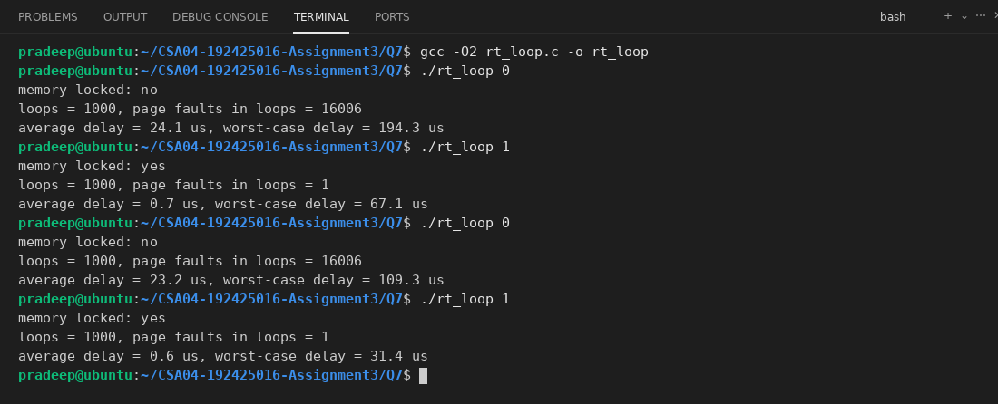
Without locking, the loop got about 16 page faults in each loop (16006 in total) and its worst-case delay was in the range of hundreds of microseconds or more, with an average of about 25-30 us. With the memory locked and pre-touched, there was only 1 page fault in all the loops (not from the buffer), the average delay was below 1 us and the worst case was much smaller (see the screenshot). Any small spikes that remain are not page faults, they are other delays of the normal Linux scheduler. So the locking removes the page-fault delay (R1). If mlockall fails (for example for a normal user without the right limit), the program prints a message, and RLIMIT_MEMLOCK must be raised for the control task.
The second program is the page-replacement simulator for the three tasks (and for a fourth task). The memory is scaled down so that one frame = 4 MB (2048 MB = 512 frames): OS = 64 frames (pinned), control = 16 frames, ML = 384 frames, logging = 25 frames, and the fourth task of 500 MB = 125 frames. Pages are replaced by global LRU. The control task runs only once in each 500 ticks (like a periodic task), while the ML task uses its pages with locality, and logging writes in sequence. In the locked mode, the control pages are pinned in memory and cannot be replaced.
sim.c
#include <stdio.h>
#include <stdlib.h>
#define TOTAL 512
#define OS 64
#define RT 16
#define ML 384
#define LOG 25
#define T4 125
#define TICKS 20000
int where[2000];
int owner_page[TOTAL];
long last[TOTAL];
int pinned[TOTAL];
int task_of(int page)
{
if (page < RT) return 0;
if (page < RT + ML) return 1;
if (page < RT + ML + LOG) return 2;
return 3;
}
int main(void)
{
const char *tname[4] = {"control", "ML", "logging", "task 4"};
for (int fourth = 0; fourth < 2; fourth++) {
for (int lock = 1; lock >= 0; lock--) {
int nframes = TOTAL - OS;
int npages = RT + ML + LOG + (fourth ? T4 : 0);
long fault[4] = {0, 0, 0, 0};
for (int i = 0; i < 2000; i++)
where[i] = -1;
for (int i = 0; i < nframes; i++) {
owner_page[i] = -1;
last[i] = -1;
pinned[i] = 0;
}
int used = 0;
if (lock) {
for (int p = 0; p < RT; p++) {
where[p] = used;
owner_page[used] = p;
pinned[used] = 1;
used++;
}
}
srand(5);
int log_next = 0;
for (long tick = 0; tick < TICKS; tick++) {
int refs[64], n = 0;
if (tick % 500 == 0)
for (int p = 0; p < RT; p++)
refs[n++] = p;
for (int k = 0; k < 8; k++) {
int p = (rand() % 100 < 80) ? rand() % 128 : rand() % ML;
refs[n++] = RT + p;
}
refs[n++] = RT + ML + log_next;
log_next = (log_next + 1) % LOG;
if (fourth)
for (int k = 0; k < 4; k++)
refs[n++] = RT + ML + LOG + rand() % T4;
for (int r = 0; r < n; r++) {
int p = refs[r];
if (where[p] >= 0) {
last[where[p]] = tick * 100 + r;
continue;
}
fault[task_of(p)]++;
int f = -1;
if (used < nframes)
f = used++;
else {
long oldest = -1;
for (int j = 0; j < nframes; j++)
if (!pinned[j] && (oldest < 0 || last[j] < oldest)) {
oldest = last[j];
f = j;
}
where[owner_page[f]] = -1;
}
owner_page[f] = p;
where[p] = f;
last[f] = tick * 100 + r;
}
}
printf("%s, control task %s:", fourth ? "4 tasks" : "3 tasks", lock ? "locked " : "unlocked");
for (int t = 0; t < (fourth ? 4 : 3); t++)
printf(" %s=%ld", tname[t], fault[t]);
printf("\n");
}
}
return 0;
}

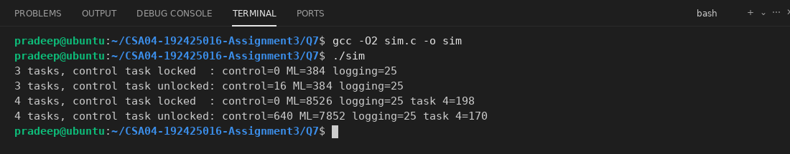
In the locked runs the control task has 0 page faults, both with 3 tasks and when the fourth task is added. In the unlocked run with 4 tasks, its pages are removed by the other tasks between its turns and it gets 640 page faults (16 on every period). So the real-time task is never delayed when its memory is locked (R4), even when the ML task has thousands of faults (it goes from 384 to 8526 faults with the fourth task).
Stage 4 - Defend the Design
Justification with measurements: The rt_loop test shows that the worst-case delay is large with page faults and small when the memory is locked and pre-faulted, so locking is needed to meet R1. The simulator shows 0 control faults with locking even under heavy memory pressure (against 640 without locking), so the other tasks cannot disturb it. The ML task uses mmap on the read-only model, so with no swap the OS can still reclaim those pages, and it will only be slower, not killed. The total of the tasks is 1956 MB which fits in 2048 MB (R2).
If a fourth task of 500 MB is added: The memory needed becomes 1956 + 500 = 2456 MB, which is more than 2048 MB. The pages of the control task are locked so they are safe, but the ML, logging and the fourth task would have to share the remaining memory. In the simulation the faults of the other tasks increase a lot (see the 4 tasks lines). Without swap, anonymous memory cannot be moved out, so the OS may start the OOM killer. To avoid this, I would limit each task's memory with cgroups (memory.max), keep the ML model in a mmapped file (so it can be dropped), reduce the model or the buffers (for example a quantized model), or add RAM. The control task would not change.
One remaining limitation: Locking protects the control task from page faults only. It does not remove other delays such as TLB misses, cache misses, interrupts, and the scheduler delay on a normal Linux kernel, so Linux still gives only soft real-time behaviour. For a hard guarantee, the kernel with the PREEMPT_RT patch or an RTOS is needed. Also locked memory (64 MB) is not available to the other tasks.
Alternative Concept and Complexity Analysis
If an RTOS with no virtual memory is used, all tasks use real physical addresses and memory is allocated statically (fixed partitions or a pool) at the start. There are no page faults and no page tables, so the delay for the memory access is fixed. Pseudocode:
at boot: allocate control_buf = 64 MB, ml_buf = 1.5 GB, log_buf = 100 MB (fixed)
if sum of sizes > RAM: refuse to start
control task: runs with fixed priority, accesses control_buf directly

Worst-case delay of the control task: with an RTOS, the memory access has no page fault and no TLB miss, so the worst-case delay is O(1) and very predictable (only the interrupt latency and the scheduling). On Linux with locked memory the page faults are removed (my test gives almost no faults), but there is still a small extra delay from the TLB, caches and the kernel, so its worst case is higher and less predictable (it changes from run to run in the rt_loop results).
Memory for the ML task: without virtual memory there is no demand paging, so the whole 1.5 GB must be in RAM at all times, and the fixed allocations must add up to 2 GB: 64 + 1536 + 100 + OS is about 1.95 GB, which still fits, but there is no way to use more memory than the RAM, no sharing of pages, and no copy-on-write. On Linux with mmap, the model pages can be dropped and reloaded, so a bigger model can run, but slower.
Effort of adding new tasks: In an RTOS each new task needs a new fixed block, so the memory plan must be changed and the system tested again, and if the total is more than RAM the task cannot be added at all (a fourth task of 500 MB would fail). Fragmentation is also a risk with a contiguous allocation. On Linux a new task is easy to add because of paging, and the memory limit can be set with cgroups, although the faults of the other tasks will increase. In big-O terms, the memory of the RTOS is O(sum of all the task sizes) and fixed, while Linux with demand paging uses O(working sets) in RAM.
CSA04 - Operating Systems - Assignments CO1-CO5 | Page 30
Question
MARK DISTRIBUTION
Assessed Area
Bloom's Level
Marks
Q1
Linking, loading and address binding
K5 - Evaluate
6
Q2
Paging
K5 - Evaluate 8
Q3
Segmentation
K5 - Evaluate 6
Q4
Virtual memory and demand paging
K5 – Evaluate 8
Q5
Page-replacement techniques
K5 - Evaluate 8
Q6
Disk management
K5 - Evaluate 4
Q7
Memory-management plan from first principles
TOTAL
K5 – Evaluate 10
50
Submission Requirements
GitHub repository link (mandatory) containing the executed code for every task, including every completed "Complete the Code" program, script and configuration file, with input files, output screenshots and a README.md.
·
Your report containing the required evidence for Q1-Q7
•
C source code for all programs
Address-translation workings, graphs, measurements and command outputs
Assessment Verification
Students may be asked to explain, execute or modify any part of their design, code, calculations or results during a brief verification discussion/viva. The student should be able to explain and defend the work submitted as their own.
CSA04 - Operating Systems - Assignments CO1-CO5 | Page 31

