PRADEEPKUMAR
SIMATS ENGINEERING
ASSESSMENT TOOL 2

COURSE NAME: OPERATING SYSTEMS COURSE CODE: CSA04

COURSE OUTCOME COVERED
CO2: Analyze process management and deadlock handling techniques to improve CPU utilization and system performance(BL3-BL4)

QUESTIONS: 5 Total Marks : 50

Annexure A
Scenario based Questions

Code of Conduct:
I Pradeepkumar / 192425016 (Name / Reg No) certify that this submission is my original work and that I have adhered to the guidelines specified for this assessment.
I understand that any violation of academic integrity rules will result in disciplinary action.

Signature of the student:

SAMPLE QUESTIONS
(QUESTIONS CAN BE CHANGED AS PER YOUR REQUIREMENTS)
Question 1 — CPU Scheduling in a Real-Time Ticket Booking System
A railway ticket booking system experiences heavy load during festival seasons. The system handles three categories of processes:
- P1 – Payment gateway transactions (High priority)
- P2 – Seat availability checks (Medium priority)
- P3 – Ticket confirmation and printing (Low priority)
- Burst times vary from 2 ms to 20 ms.
Recently, customers complained that ticket confirmations are taking too long.
Tasks
- Identify the most suitable scheduling algorithm (FCFS, SJF, Priority, RR) for this scenario.
- Justify why your chosen method improves CPU utilization and reduces customer wait time.
- Provide a sample execution order for the above categories.
- Discuss one drawback of this scheduling method in real-time systems.
(10 Marks) (BL 4)
1. The most suitable one is Priority Scheduling. Payment is P1 (high), seat check is P2 (medium) and ticket printing is P3 (low), so the CPU always picks the most important work first.
2. Payment and seat checks are short and urgent, so they finish fast and the CPU does not sit idle waiting. Because the short high priority jobs go first, most customers get their result quickly and the average waiting time goes down (5.33 ms in my program). Ticket confirmation can also be given a higher priority number after it waits for some time so it does not take too long.
3. Sample execution order: P1 (Payment, 6 ms) -> P2 (Seat check, 4 ms) -> P3 (Ticket printing, 10 ms). Gantt chart: | P1 | P2 | P3 |, total time 20 ms.
4. The drawback is starvation. If many high priority payment requests keep coming in festival time, the low priority ticket confirmation may never get the CPU, which is bad in a real-time system. Aging can be used to solve this.

processes = [("P1", 6, 1), ("P2", 4, 2), ("P3", 10, 3)]

order = sorted(processes, key=lambda p: p[2])

time = 0
total_wait = 0
total_tat = 0
gantt = ""

print("Process Burst Priority Waiting Turnaround")
for name, burst, priority in order:
wait = time
time += burst
tat = time
total_wait += wait
total_tat += tat
gantt += "| " + name + " "
print(f"{name:<9}{burst:<7}{priority:<10}{wait:<9}{tat}")

gantt += "|"
print()
print("Execution order:", " -> ".join(p[0] for p in order))
print("Gantt chart:", gantt)
print("Average waiting time:", round(total_wait / len(order), 2), "ms")
print("Average turnaround time:", round(total_tat / len(order), 2), "ms")
print("CPU busy time:", time, "ms")
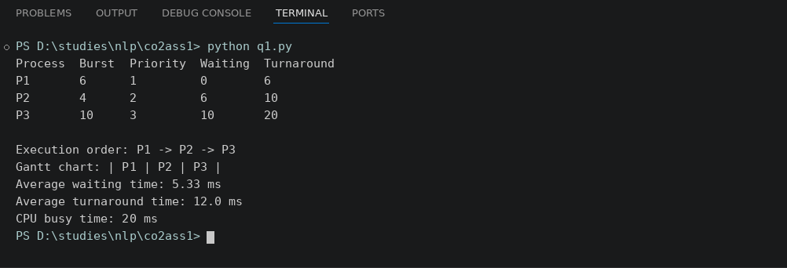
Question 2 — Deadlock in a Banking Transaction Server
A bank server handles the following operations simultaneously:
- T1: Transfers money between accounts
- T2: Updates passbook entries
- T3: Generates monthly statements
Due to simultaneous locking of Account Database (A), Customer Info Database (B), and Transaction Logs (C), the system enters a state where:
- T1 holds A and requests B
- T2 holds B and requests C
- T3 holds C and requests A
Tasks
- Draw the resource request situation (text-based RAG).
- Identify whether a deadlock has occurred and justify your answer.
- Recommend one specific technique (avoidance/prevention/recovery) and explain how it fixes the issue.
- Suggest a redesign for the locking order to avoid future deadlocks.
(10 Marks) (BL 4)
1. Text based RAG (resource -> transaction means held, transaction -> resource means requested):
A -> T1 -> B -> T2 -> C -> T3 -> A
2. Yes, a deadlock has occurred. T1 waits for T2, T2 waits for T3 and T3 waits for T1, so there is a cycle in the graph. Every resource has only one instance, so a cycle means deadlock. All four conditions are there: mutual exclusion, hold and wait, no preemption and circular wait.
3. I recommend deadlock prevention by breaking the circular wait condition. Every transaction must ask for the locks in one fixed order, so a cycle can never form and the system never gets stuck.
4. Redesign: give numbers to the resources, A = 1, B = 2, C = 3, and always lock in increasing order. T1 locks A then B, T2 locks B then C, and T3 locks A first and then C (not C then A). Now nobody holds a higher lock while waiting for a lower one.

holds = {"T1": "A", "T2": "B", "T3": "C"}
requests = {"T1": "B", "T2": "C", "T3": "A"}

owner = {}
for t, r in holds.items():
owner[r] = t

wait_for = {}
for t, r in requests.items():
wait_for[t] = owner[r]

print("Resource Allocation Graph:")
for t in holds:
print(f"{holds[t]} --held by--> {t} --requests--> {requests[t]}")

print()
print("Wait-for graph:")
for t, o in wait_for.items():
print(f"{t} waits for {o}")

def find_cycle(start):
path = [start]
current = wait_for.get(start)
while current is not None and current not in path:
path.append(current)
current = wait_for.get(current)
if current == start:
return path + [start]
return None

cycle = None
for t in wait_for:
cycle = find_cycle(t)
if cycle:
break

print()
if cycle:
print("Deadlock detected:", " -> ".join(cycle))
else:
print("No deadlock")

needs = {"T1": ["A", "B"], "T2": ["B", "C"], "T3": ["C", "A"]}
print()
print("Fixed locking order: A, B, C")
for t, res in needs.items():
ordered = sorted(res)
print(t, "locks", " then ".join(ordered))

lock_order = {"A": 1, "B": 2, "C": 3}
safe = True
for t, res in needs.items():
ordered = sorted(res, key=lambda r: lock_order[r])
for i in range(len(ordered) - 1):
if lock_order[ordered[i]] > lock_order[ordered[i + 1]]:
safe = False
print("Circular wait possible:", not safe)
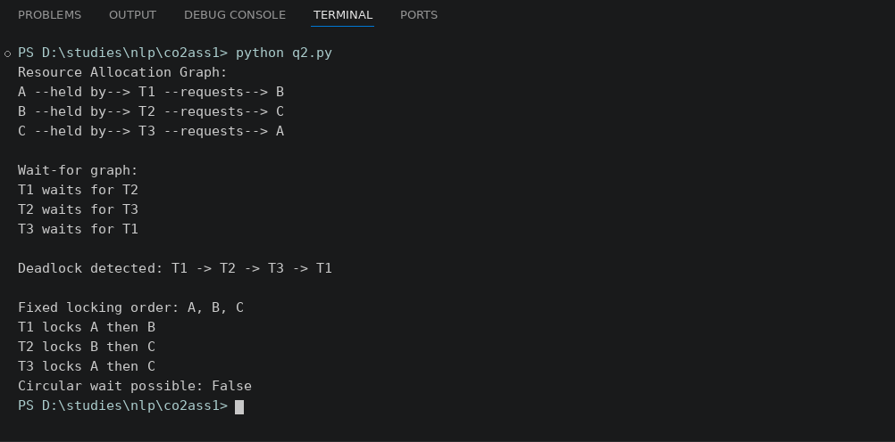
Question 3 — Mobile OS App Switching Lag
A mobile operating system is designed to support smooth app switching.
But users report that:
- Opening WhatsApp delays the background music player.
- Switching between social media apps feels laggy.
- CPU shows high idle times despite multiple running apps.
The OS currently uses Round Robin (quantum = 20 ms) with 20 background apps active.
Tasks
- Analyze why the CPU remains idle despite many active processes.
- Determine whether the time quantum is helping or hurting performance.
- Recommend a better scheduling method or quantum value, with justification.
- Explain how the change will reduce switching lag and improve system throughput.
(10 Marks) (BL 4)
1. The CPU is idle because most of the 20 background apps are not really ready to run. They are blocked, waiting for network, disk or user input, so the ready queue is almost empty. Also a lot of time is lost in context switching between the apps, so the CPU is not doing useful work.
2. The quantum of 20 ms is hurting. All apps get the same time, so WhatsApp and the music player have to wait for a long round of 20 apps before they run again. From my program, the average response time at 20 ms is 169.35 ms, which is the reason for the lag.
3. I suggest Multilevel Feedback Queue (or priority scheduling) where foreground and audio apps are in the top queue, with a smaller quantum of about 10 ms. Background apps stay in lower queues with a bigger quantum. 10 ms is a good balance because response time falls to 101.90 ms and the CPU useful time is still about 90%. Going too low like 2 ms wastes the CPU on switching (only 66.54% useful).
4. Interactive apps like WhatsApp and the music player will get the CPU sooner, so the switching lag becomes less. Background apps will not steal time from them, so the CPU is used better and more work gets finished in the same time, which increases throughput.

bursts = [30, 12, 45, 8, 25, 40, 15, 50, 10, 35, 20, 28, 18, 42, 6, 33, 22, 16, 38, 14]
switch_cost = 1

def round_robin(quantum):
n = len(bursts)
remaining = bursts[:]
first_run = [None] * n
finish = [0] * n
queue = list(range(n))
time = 0
switches = 0
while queue:
p = queue.pop(0)
if first_run[p] is None:
first_run[p] = time
run = min(quantum, remaining[p])
time += run
remaining[p] -= run
if remaining[p] > 0:
queue.append(p)
else:
finish[p] = time
if queue:
time += switch_cost
switches += 1
busy = sum(bursts)
avg_wait = sum(finish[i] - bursts[i] for i in range(n)) / n
avg_resp = sum(first_run) / n
return avg_resp, avg_wait, switches, busy / time * 100

print("Quantum AvgResponse AvgWaiting Switches CPU Useful%")
for q in [20, 10, 5, 2]:
r, w, s, u = round_robin(q)
print(f"{q:<9}{r:<14.2f}{w:<12.2f}{s:<10}{u:.2f}")
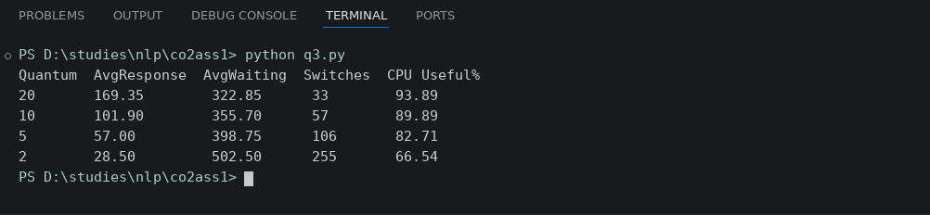

Question 4 — Deadlock Risk in an Operating System Update
During a Windows OS update, several modules run in parallel:
- M1: Copy update files
- M2: Install drivers
- M3: Update registry
- M4: Validate system integrity
Resources involved:
- R1 = Disk I/O
- R2 = Kernel lock
- R3 = Configuration lock
Recently logs show:
- M1 holds R1, waiting for R2
- M2 holds R2, waiting for R3
- M3 holds R3, waiting for R1
Tasks
- Identify whether this sequence can lead to a deadlock.
- If yes, explain the exact circular wait condition.
- Propose Banker’s algorithm style resource allocation to avoid risk.
- Suggest how OS designers can prioritize modules to improve CPU utilization during update.
(10 Marks) (BL 4)
1. Yes, it can lead to a deadlock. M1 holds R1 and waits for R2, M2 holds R2 and waits for R3, and M3 holds R3 and waits for R1.
2. The circular wait is M1 -> M2 -> M3 -> M1. M1 needs R2 which is held by M2, M2 needs R3 which is held by M3, and M3 needs R1 which is held by M1. Nobody can go ahead and nobody releases, so it is a circular wait.
3. In Banker's algorithm style, a module has to declare its maximum need first. Before giving any resource, the OS checks if the system will still be in a safe state after giving it. In my program M3 asking for R3 was denied because it made the state unsafe, and it got R3 later after M2 finished. In this way the circular wait never forms.
4. The OS designers can give higher priority to the modules that free resources fast and that other modules depend on, like copy update files (M1) and install drivers (M2), and give lower priority to validate system integrity (M4) because it can run at the end. Short modules should go first, so the CPU and disk stay busy and the update finishes faster.

resources = ["R1", "R2", "R3"]
available = [1, 1, 1]
maximum = {"M1": [1, 1, 0], "M2": [0, 1, 1], "M3": [1, 0, 1], "M4": [0, 0, 1]}
allocation = {"M1": [0, 0, 0], "M2": [0, 0, 0], "M3": [0, 0, 0], "M4": [0, 0, 0]}

def need(m):
return [maximum[m][i] - allocation[m][i] for i in range(3)]

def is_safe(avail, alloc):
work = avail[:]
done = set()
sequence = []
while len(done) < len(alloc):
found = False
for m in alloc:
if m in done:
continue
nd = [maximum[m][i] - alloc[m][i] for i in range(3)]
if all(nd[i] <= work[i] for i in range(3)):
work = [work[i] + alloc[m][i] for i in range(3)]
done.add(m)
sequence.append(m)
found = True
if not found:
return False, sequence
return True, sequence

def request(m, r):
req = [1 if x == r else 0 for x in resources]
if any(req[i] > need(m)[i] for i in range(3)):
print(m, "asks", r, "-> DENIED (more than max)")
return
if any(req[i] > available[i] for i in range(3)):
print(m, "asks", r, "-> WAIT (not available)")
return
new_avail = [available[i] - req[i] for i in range(3)]
new_alloc = {k: v[:] for k, v in allocation.items()}
new_alloc[m] = [new_alloc[m][i] + req[i] for i in range(3)]
ok, seq = is_safe(new_avail, new_alloc)
if ok:
for i in range(3):
available[i] = new_avail[i]
allocation[m] = new_alloc[m]
print(m, "asks", r, "-> GRANTED, safe sequence:", " -> ".join(seq))
else:
print(m, "asks", r, "-> DENIED, would be unsafe state")

def release(m):
for i in range(3):
available[i] += allocation[m][i]
allocation[m] = [0, 0, 0]
print(m, "finished and released resources, available =", available)

request("M1", "R1")
request("M2", "R2")
request("M3", "R3")
request("M2", "R3")
release("M2")
request("M3", "R3")
request("M1", "R2")
release("M1")
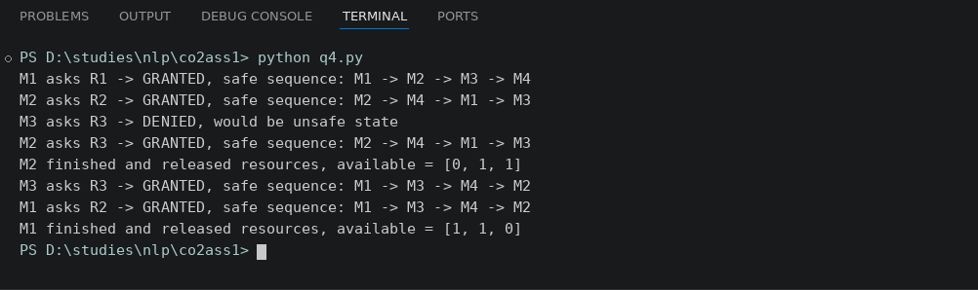

Question 5 — Cloud Server CPU Utilization Analysis
A cloud hosting provider notices:
- 80% of the time, VM processes wait for network or disk
- Only 20% of the time is spent on CPU
- Each server runs 7 VMs
Using the formula:
$$U=1-p^{n}$$
where p = I/O wait probability
Tasks
- Calculate CPU utilization.
- Interpret whether the server is underutilized or optimally loaded.
- Suggest how increasing or decreasing number of VMs affects throughput.
- Propose two OS-level strategies for improving CPU utilization in this cloud environment.
(10 Marks) (BL 4)
1. Given p = 0.8 and n = 7, U = 1 - p^n = 1 - 0.8^7 = 1 - 0.2097 = 0.7903, so CPU utilization is about 79%.
2. The server is not fully used but it is also not bad. 79% is good, but about 21% of the CPU time is still idle, so it can be called a little underutilized and it can take some more VMs.
3. If we increase the number of VMs, the utilization goes up (10 VMs gives 89.26% and 12 VMs gives 93.13%), so throughput increases. But after some point the increase is very small and too many VMs cause memory problems and more context switching. If we decrease the VMs, the utilization falls (for 4 VMs it is only 59.04%), so throughput goes down.
4. Strategy 1: use a good CPU scheduler (like multilevel queue or priority) so that when one VM waits for I/O the CPU quickly switches to another ready VM. Strategy 2: use better I/O handling like asynchronous I/O, disk caching and buffering so that the VMs wait less for disk and network.

p = 0.8
n = 7

u = 1 - p ** n
print("p =", p)
print("n =", n)
print("CPU utilization = 1 - 0.8^7 =", round(u, 4))
print("CPU utilization in percent =", round(u * 100, 2), "%")
print()
print("VMs CPU Utilization")
for vms in range(1, 13):
print(f"{vms:<5}{(1 - p ** vms) * 100:.2f}%")
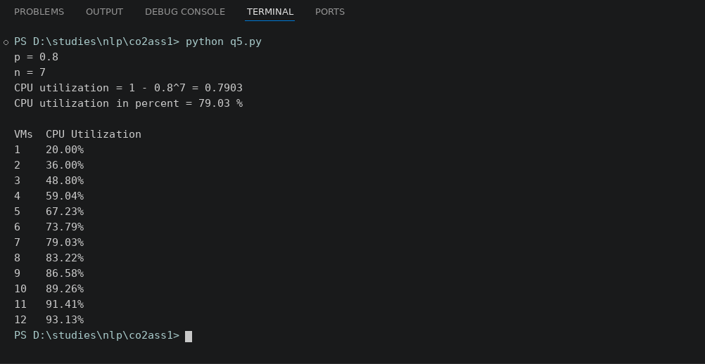

RUBRICS FOR CALCULATION- Scenario based assessment
Criteria | Weightage (%) | Level 4 (Exemplary) | Level 3 (Proficient) | Level 2 (Developing) | Level 1 (Beginning)
Understanding of Scenario | 20% | Demonstrates clear and complete understanding of the scenario and context | Shows good understanding with minor gaps | Partial understanding; misses key aspects | Misinterprets or fails to understand the scenario
Identification of Key Issues | 20% | Accurately identifies all relevant issues and factors involved | Identifies most key issues with minor omissions | Identifies limited issues; some irrelevant points | Unable to identify key issues
Application of Concepts | 25% | Applies appropriate concepts effectively to address the scenario | Applies concepts with minor errors | Limited or partially correct application | Unable to apply relevant concepts
Decision Making | 20% | Makes well-reasoned, logical decisions with strong rationale | Makes reasonable decisions with some justification | Makes weak decisions with limited justification | No clear decisions made or rationale provided
Clarity of Response | 15% | Response is clear, structured, and logically presented | Generally clear with minor issues | Somewhat unclear or poorly structured | Disorganized and difficult to understand

TOTAL MARKS AWARDED FACULTY SIGNATURE

