PRADEEPKUMAR
SIMATS ENGINEERING
ASSESSMENT TOOL 1

COURSE CODE: CSA04
COURSE NAME: Operating Systems

COURSE OUTCOME COVERED

CO1: Apply the concepts of Operating System types, structures, and system calls to demonstrate their functions in various computing environments.

QUESTIONS: 5 Total Marks:100

Annexure A

SHORT ANSWER TEST

Code of Conduct:

I ____PradeepKumarS________________ (Name / Reg No) certify that this submission is my original work and that I have adhered to the guidelines specified for this assessment.
I understand that any violation of academic integrity rules will result in disciplinary action.

Signature of the student:

Annexure A

Short Answer Test

Question 1 (5 Marks)
Suppose a modern Operating System supports multiple users and processes with shared resources like CPU, memory, and I/O devices.
(a) Classify different types of Operating Systems suitable for this scenario and justify your choice.

Ans: A modern OS that has many users and many processes sharing CPU, memory and I/O devices is mostly a Multi-user Time-Sharing OS. It is also a Multiprogramming and Multitasking OS, and if the system has more than one CPU it is a Multiprocessor OS.

Time-sharing: the CPU time is divided into small slices and given to each user or process one by one, so every user feels that he is getting the CPU alone.

Multiprogramming: many programs are kept in memory at the same time, so when one program waits for I/O the CPU runs another one and the CPU is not wasted.

Multiprocessor: more than one CPU share the same memory and devices, so the work gets done faster.

I choose time-sharing with multiprogramming because it gives a good response time, uses the CPU properly and allows many users to share the resources safely.

(b) Draw the structure of an Operating System showing how resources are managed.

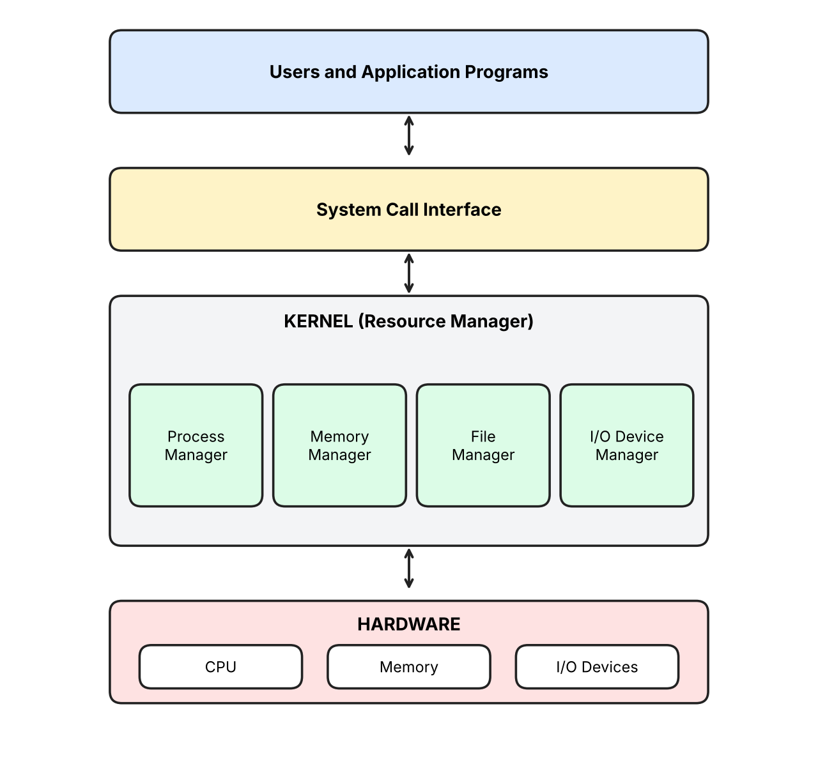

(c) Write a sequence of system calls required to create and execute a new process in such an environment. (BL2)

Ans: To create and run a new process the system calls are used in this order: fork() creates a new child process, exec() loads the new program into the child, wait() makes the parent wait until the child finishes and exit() ends the child process. In Windows the same work is done by CreateProcess(), WaitForSingleObject() and ExitProcess(). The program below uses subprocess in Python, which calls these system calls inside.

import subprocess
import sys
import os

print("Parent process PID:", os.getpid())
child = subprocess.Popen([sys.executable, "-c", "import os; print('Child process running, PID:', os.getpid())"])
print("New process created with PID:", child.pid)
code = child.wait()
print("Child finished with exit code:", code)

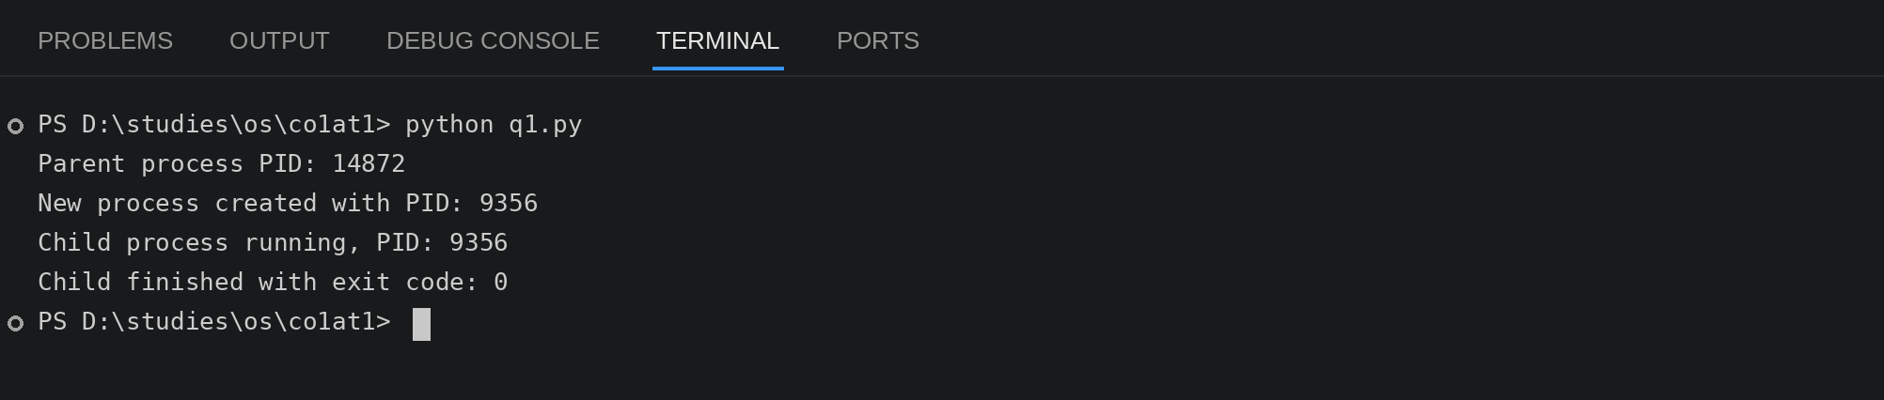

Question 2 (5 Marks)
Consider an Operating System managing multiple files and devices for concurrent users.
(a) Categorize system calls used for file and device management.

Ans: The system calls for file and device management are grouped like this:

File management: create(), open(), read(), write(), close(), delete(), seek(), get and set file attributes.

Device management: request device (ioctl or open), release device (close), read(), write(), reposition, get and set device attributes, attach and detach devices logically.

Because many users use them at the same time, the OS uses these calls to give access to one user at a time and keeps the files and devices safe.

(b) Illustrate how the OS handles file operations using a layered structure diagram.

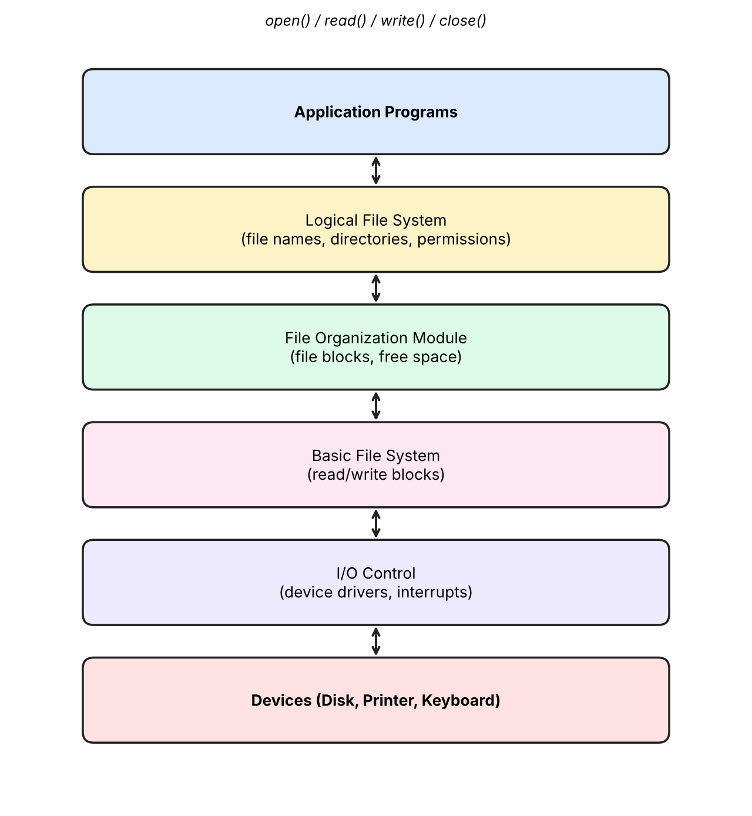

(c) Write a pseudo-code or C-based system call sequence to open, read, and close a file. (BL3)

Ans: The sequence is open() the file, read() the data, then close() the file. I wrote a file first so that there is something to read. In the program os.open, os.read and os.close directly call the system calls.

import os

fd = os.open("notes.txt", os.O_WRONLY | os.O_CREAT | os.O_TRUNC)
os.write(fd, b"Operating system manages files and devices.\n")
os.close(fd)

fd = os.open("notes.txt", os.O_RDONLY)
print("File opened, descriptor =", fd)
data = os.read(fd, 100)
print("Data read from file:", data.decode().strip())
os.close(fd)
print("File closed")

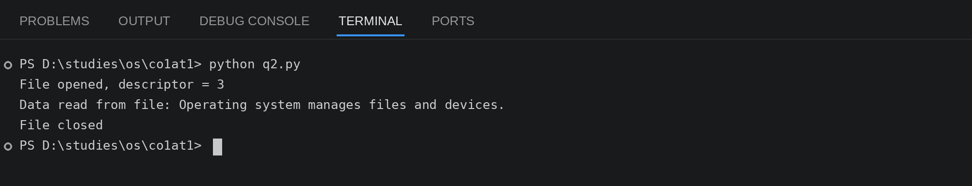

Question 3 (5 Marks)
Assume a real-time Operating System used in an embedded system controlling industrial machinery.
(a) Identify the type of OS and explain why it is suitable for real-time applications.

Ans: The OS used here is a Real-Time Operating System (RTOS), mostly a hard real-time OS because the machinery in the industry must respond within a fixed time.

It is suitable because it gives very fast and predictable response, which means tasks always finish before their deadline. It uses priority based scheduling so the important task like an emergency stop runs first, it has very low interrupt latency, and it is small and reliable so the machine does not fail in the middle of work.

(b) Draw a diagram representing the interaction between hardware, kernel, and user processes.

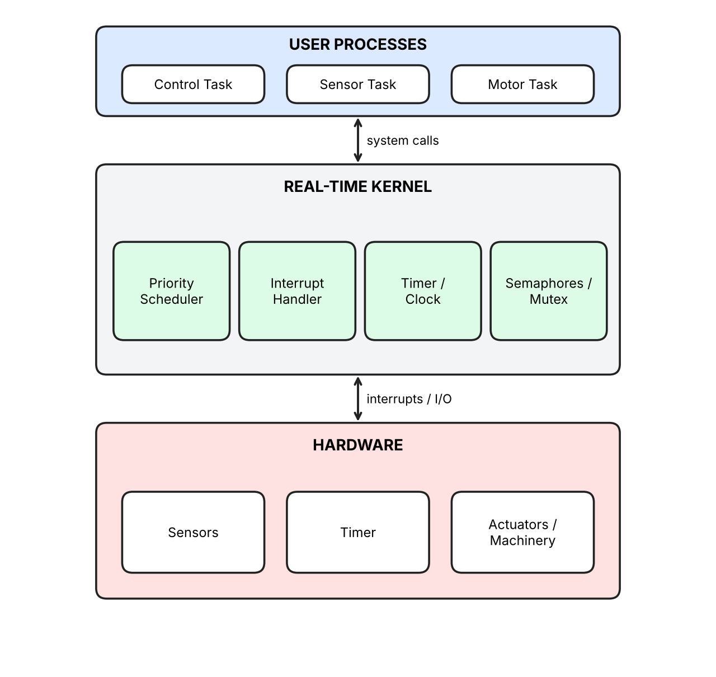

(c) List and explain system calls required for process synchronization in this system. (BL2)

Ans: For process synchronization in this system the following calls are needed:

1. sem_init() / sem_wait() / sem_post(): sem_wait() decreases the semaphore and blocks if it is zero, sem_post() increases it and wakes up a waiting task.

2. pthread_mutex_lock() / pthread_mutex_unlock(): only one task can enter the critical section at a time.

3. signal() / wait(): used to tell one task that an event has happened.

4. fork() / join: to create tasks and wait for them to finish.

The program below uses a lock (mutex) and a semaphore with two threads like a sensor task and a motor task, and the counter comes out correct as 2000.

import threading

counter = 0
lock = threading.Lock()
done = threading.Semaphore(0)

def machine_task(name):
global counter
for i in range(1000):
lock.acquire()
counter += 1
lock.release()
print(name, "finished its work")
done.release()

t1 = threading.Thread(target=machine_task, args=("Sensor task",))
t2 = threading.Thread(target=machine_task, args=("Motor task",))
t1.start()
t2.start()

done.acquire()
done.acquire()
print("Final counter value:", counter)

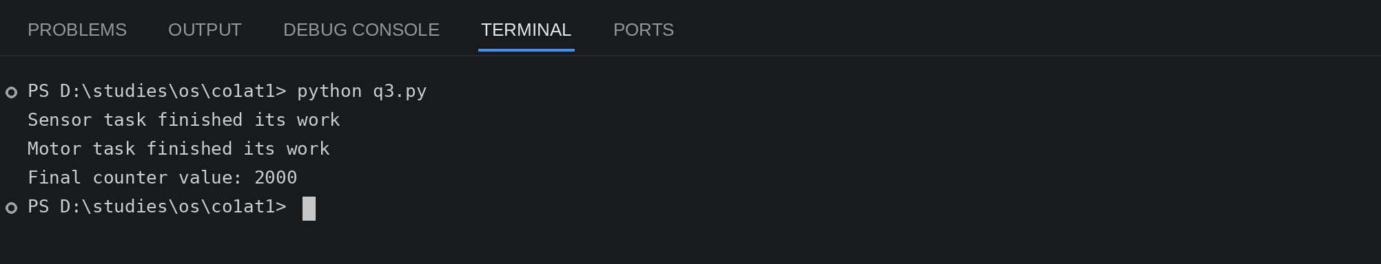

Question 4 (5 Marks)
A distributed computing system consists of multiple interconnected computers sharing resources over a network.
(a) Classify the type of Operating System used and compare it with centralized OS.

Ans: The OS used here is a Distributed Operating System. It joins many computers in a network and makes them look like one single system to the user.

Distributed OS: many computers with their own CPU and memory, resources are shared over the network, if one node fails the others keep working, it is easy to add new nodes, but it is hard to design and needs good network security.

Centralized OS: a single computer controls everything, all resources are in one place, if that computer fails the whole system stops, and it is simple to manage but it cannot grow much.

So the distributed OS is better for reliability and speed, and the centralized OS is better for simplicity.

(b) Draw the architecture of a distributed OS showing communication between nodes.

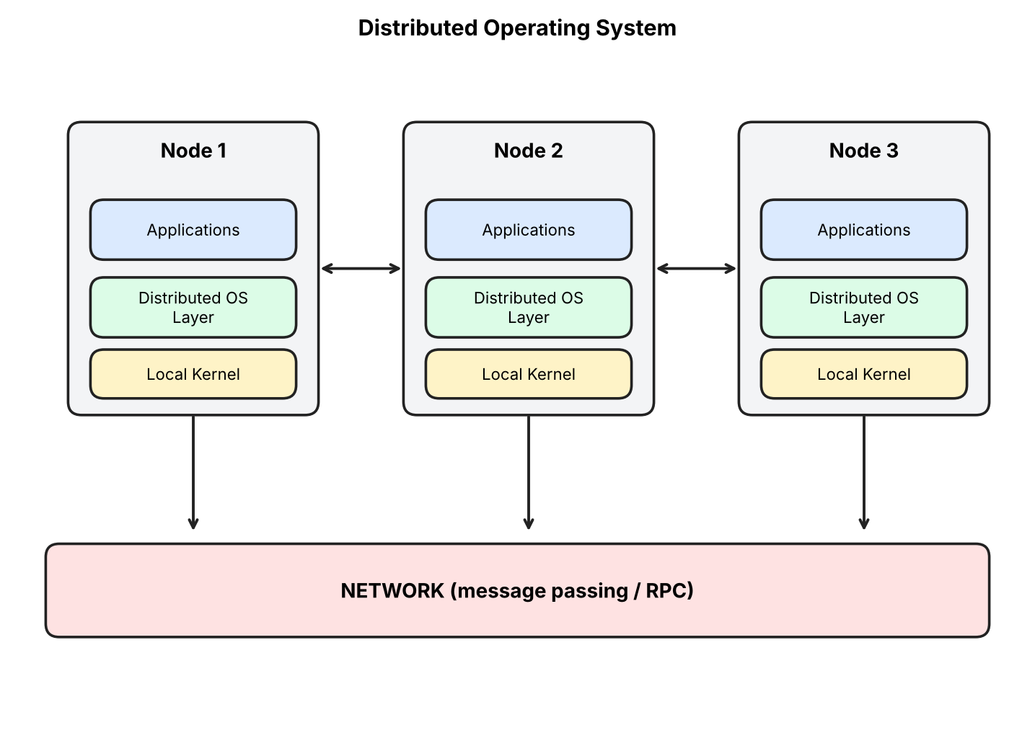

(c) Write the sequence of system calls involved in inter-process communication (IPC). (BL3)

Ans: The sequence of system calls for IPC with a pipe is: pipe() creates the pipe, fork() creates the other process, write() / send() sends the message, read() / recv() receives the message and close() closes the pipe. In the program, Pipe() and Process() are used for the same thing.

from multiprocessing import Process, Pipe

def sender(conn):
conn.send("Hello from node 1")
conn.close()

if __name__ == "__main__":
parent_conn, child_conn = Pipe()
print("Pipe created")
p = Process(target=sender, args=(child_conn,))
p.start()
print("Sender process started")
msg = parent_conn.recv()
print("Message received:", msg)
p.join()
print("IPC finished")

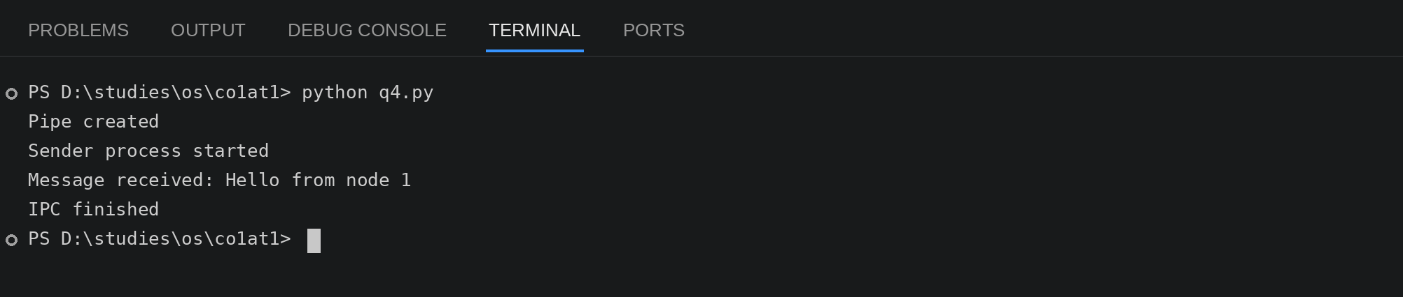

Question 5 (5 Marks)
Consider a scenario where an Operating System must manage process scheduling, memory allocation, and device communication efficiently.
(a) Explain the major functions of an OS in handling these tasks.

Ans: The OS has to handle these main tasks:

Process scheduling: the OS decides which process gets the CPU and for how long using algorithms like FCFS, Round Robin and Priority. It also creates and ends processes and does context switching.

Memory allocation: it keeps track of which memory is free or used, gives memory to a process when it asks and takes it back when finished. It uses paging and virtual memory so that big programs can run.

Device communication: it talks to the devices using device drivers and interrupts, uses buffering and spooling, and makes sure many processes can use a device without any conflict.

In this way the OS uses the CPU, memory and devices in an efficient way.

(b) Draw a block diagram representing OS components and their interactions.

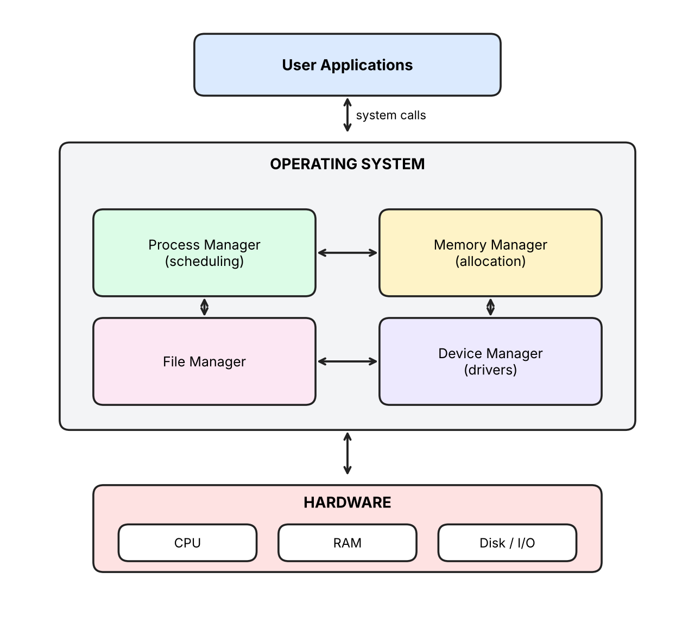

(c) Write system call examples for memory allocation and device management. (BL3)

Ans: For memory allocation the system calls are brk(), sbrk() and mmap() (malloc() uses them) and munmap() to free the memory. For device management the calls are open(), read(), write(), ioctl() and close(). In the program, mmap is used for memory and the null device is opened, written and closed for the device part.

import mmap
import os

mem = mmap.mmap(-1, 4096)
mem.write(b"Memory given by the OS")
mem.seek(0)
print("Memory allocated:", len(mem), "bytes")
print("Memory content:", mem.read(22).decode())
mem.close()

fd = os.open(os.devnull, os.O_WRONLY)
n = os.write(fd, b"hello device")
print("Bytes written to device:", n)
os.close(fd)
print("Device closed")

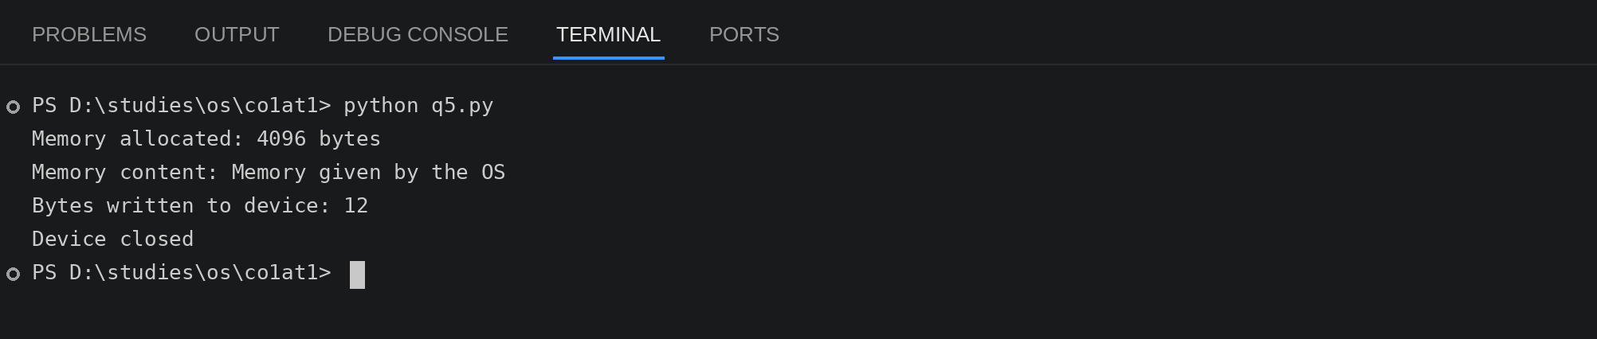

RUBRICS FOR CALCULATION

Criteria | Weightage (Marks) | Level 4 – Exemplary (Full Marks) | Level 3 – Proficient | Level 2 – Developing | Level 1 – Beginning
Conceptual Understanding | 35 Marks | Demonstrates clear, complete, and in-depth understanding of OS concepts (types, structure, system calls) | Good understanding with minor gaps | Basic understanding with some misconceptions | Poor or incorrect understanding
Accuracy of Answers | 25 Marks | All answers are correct, precise, and relevant | Mostly correct with minor errors | Partially correct with noticeable errors | Mostly incorrect or irrelevant
Application of Knowledge | 15 Marks | Effectively applies concepts to scenarios/questions | Applies with minor mistakes | Limited or partial application | No meaningful application
Completeness of Response | 15 Marks | All parts of each question are fully answered | Most parts covered with small omissions | Some parts missing | Incomplete answers
Clarity & Presentation | 10 Marks | Clear, well-structured, and neatly presented answers | Understandable with minor issues | Somewhat unclear or poorly structured | Difficult to understand

