PRADEEPKUMAR
SIMATS ENGINEERING
ASSESSMENT TOOL 2

COURSE CODE: CSA04 COURSE NAME: Operating Systems

COURSE OUTCOME COVERED

CO1: Apply the concepts of Operating System types, structures, and system calls to demonstrate their functions in various computing environments. (BL2, BL3)

QUESTIONS: 5 Total Marks:100

Annexure A

Concept Mapping

Code of Conduct:

I ____PradeepKumar________________ (Name / Reg No) certify that this submission is my original work and that I have adhered to the guidelines specified for this assessment.
I understand that any violation of academic integrity rules will result in disciplinary action.

Signature of the student:

Annexure A

Concept Mapping

Question 1
Show a multi-level concept map integrating:
Operating System Types → OS Structures → System Calls → OS Functions.
Your map must show cross-links (e.g., how OS structure influences system call implementation). (BL2)

Question 2
Construct a comprehensive concept map representing:
Process Management, Memory Management, File System, and I/O System.
Include interdependencies and indicate where system calls interact with each component. (BL3)

Question 3
Sketch a comparative concept map for:
Batch OS, Time-Sharing OS, Distributed OS, and Real-Time OS.
Highlight differences, similarities, advantages, and limitations using linking phrases. (BL2)

Question 4
Illustrate a dynamic concept map showing the execution flow:
User Program → API → System Call Interface → Kernel → Hardware → Response back to User.
Include feedback loops and control flow paths. (BL3)

Question 5
Sketch a hierarchical + functional concept map for system calls:
Process, File, Device, and Information system calls.
Also show how they relate to OS services like scheduling, memory allocation, and device handling. (BL3)
Answer 1: Multi-level concept map: OS Types → OS Structures → System Calls → OS Functions (with cross-links)
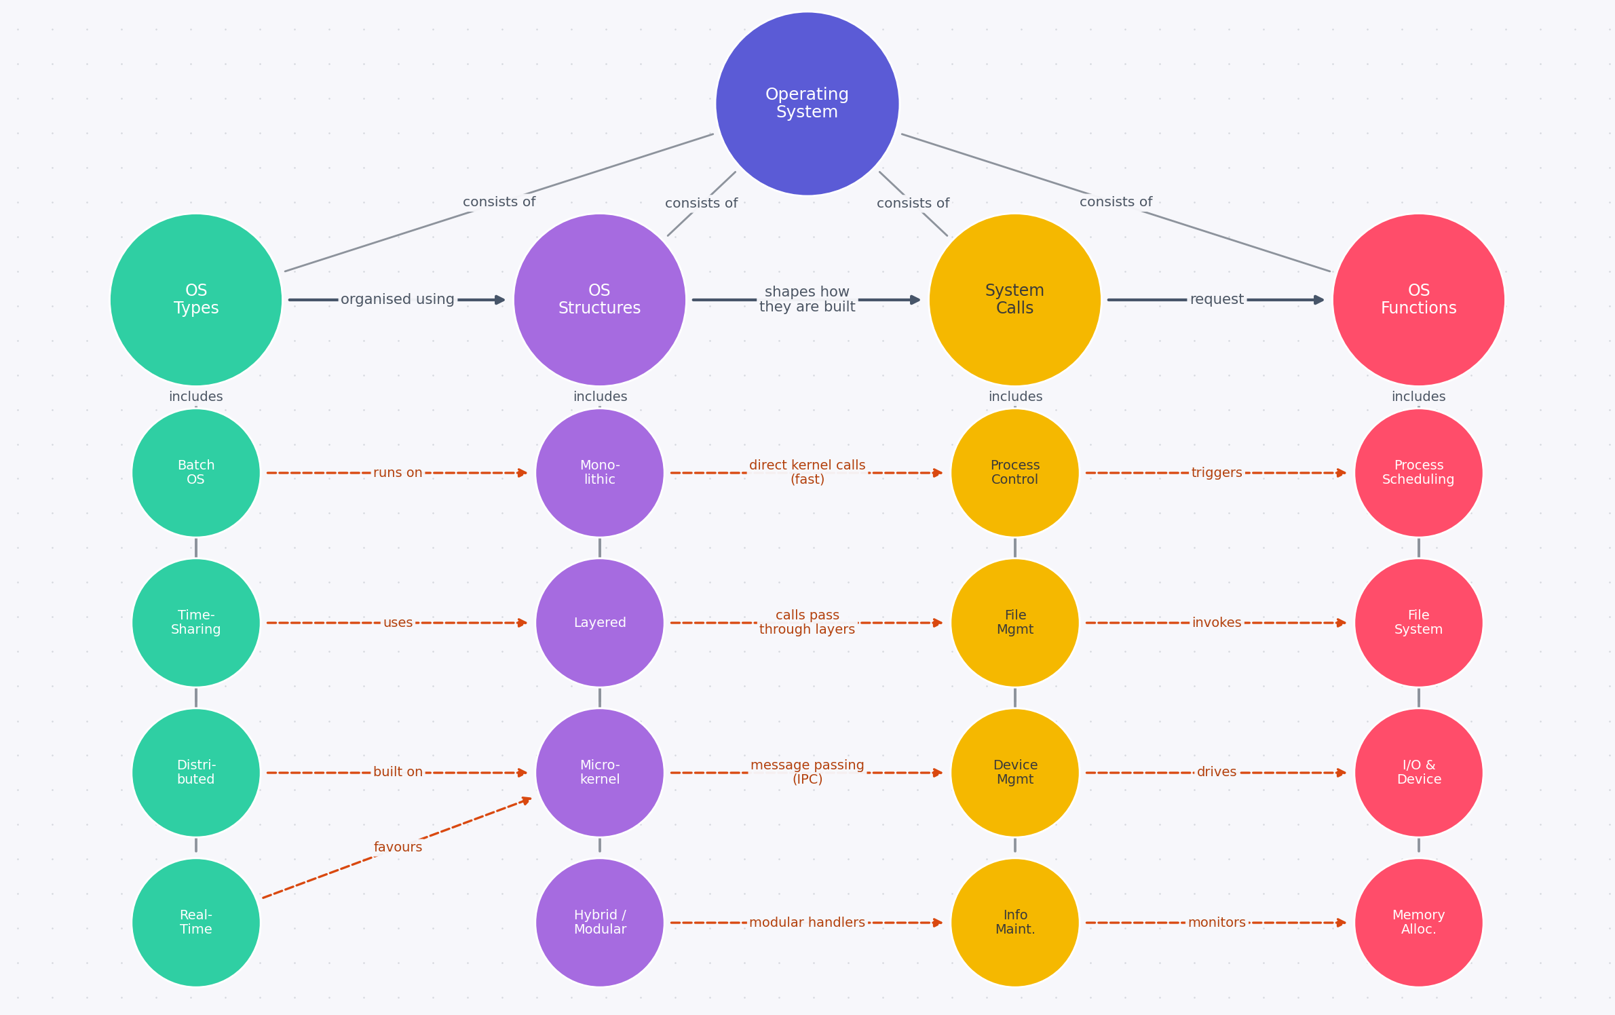
Legend: Solid grey lines = hierarchy; thick arrows = level-to-level flow; dashed orange arrows = cross-links (e.g., kernel structure influences how system calls are implemented).
Answer 2: Concept map: Process Management, Memory Management, File System and I/O System
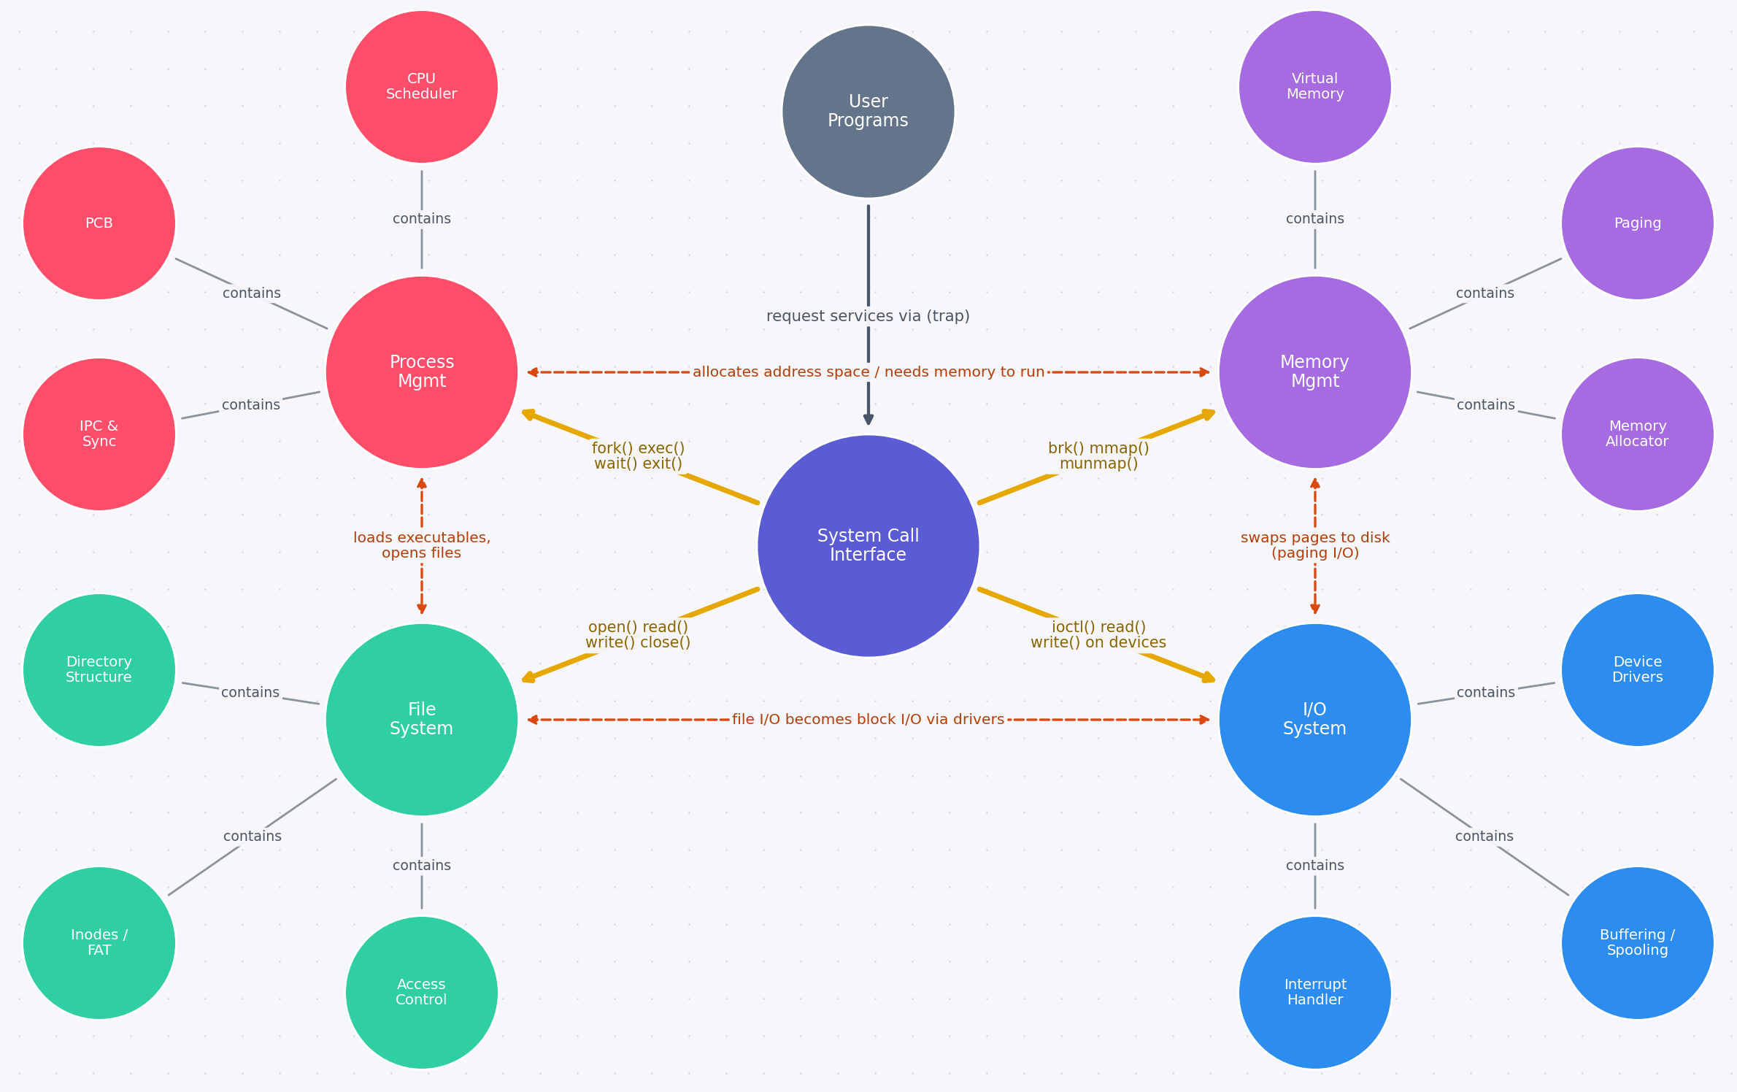
Legend: Yellow arrows = system-call paths through the System Call Interface; dashed orange double arrows = interdependencies between components.
Answer 3: Comparative concept map: Batch, Time-Sharing, Distributed and Real-Time OS
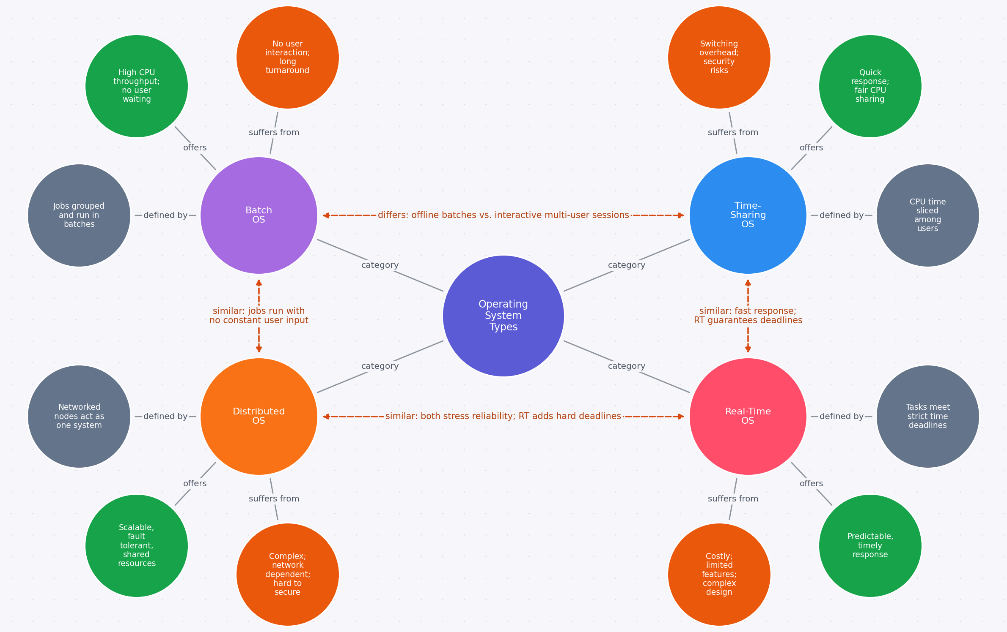
Legend: Grey = key idea, green = advantage, orange = limitation; dashed orange double arrows = similarities / differences between OS types.
Answer 4: Dynamic concept map: User Program → API → System Call Interface → Kernel → Hardware → Response to User
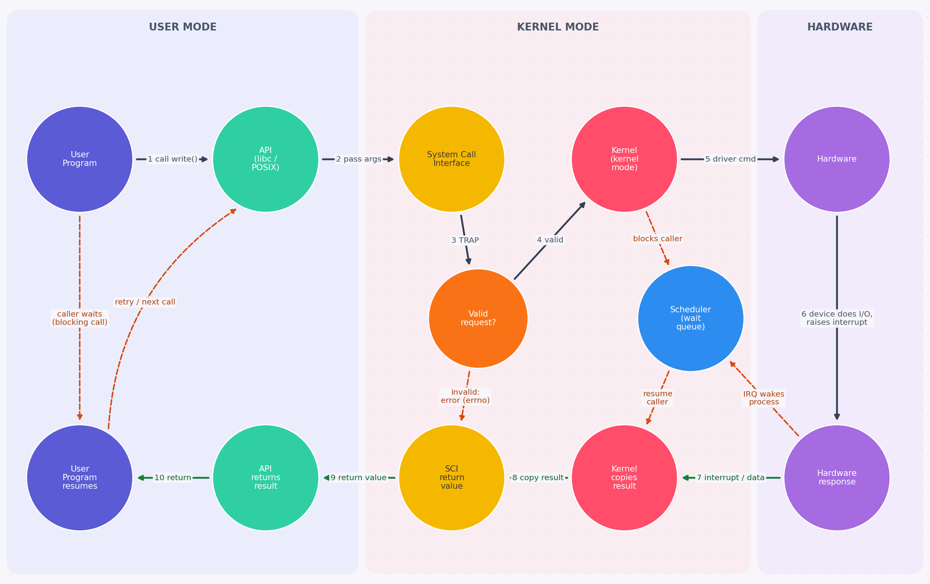
Legend: Solid dark arrows = request path (steps 1–6); green arrows = response path (7–10); dashed orange arrows = feedback loops (blocking wait, error return, wake-up on interrupt, retry).
Answer 5: Hierarchical + functional concept map of system calls (Process, File, Device, Information)
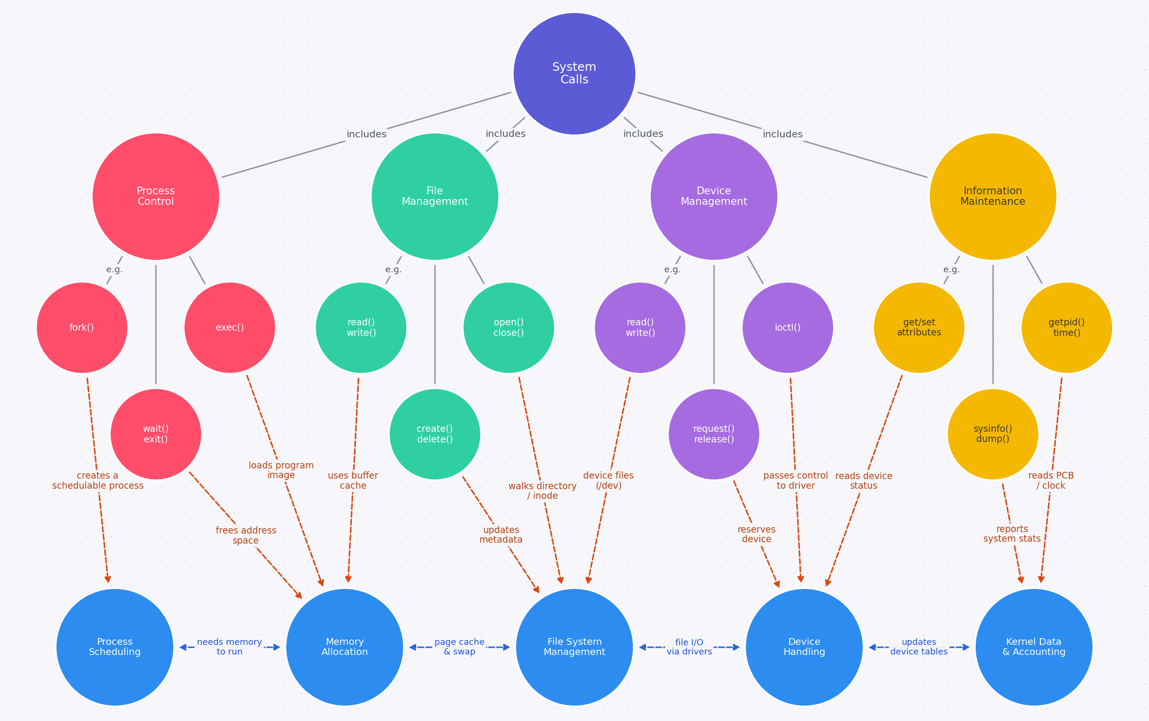
Legend: Top = hierarchy of call categories; dashed orange arrows = which OS service each call uses; blue double arrows = dependencies among OS services.
RUBRICS FOR CALCULATION

Concept Mapping
Criteria | Weightage | Level 4 (Exemplary) | Level 3 (Proficient) | Level 2 (Developing) | Level 1 (Beginning)
Concept Identification | 25% | Identifies all key concepts from literature accurately and comprehensively | Identifies most key concepts with minor omissions | Identifies limited concepts; some are irrelevant or missing | Fails to identify essential concepts
Linkages | 25% | Establishes clear, meaningful, and accurate relationships between concepts | Shows correct relationships with minor gaps | Relationships are weak, unclear, or partially incorrect | No meaningful relationships established
Organization | 20% | Concepts are well-structured hierarchically with logical flow and grouping | Mostly organized with minor structural issues | Some organization but lacks clear hierarchy | No logical organization or structure
Integration of Literature | 20% | Integrates multiple studies effectively to show connections and comparisons | Shows some integration of literature | Limited integration; mostly isolated concepts | No integration of literature evidence
Clarity | 10% | Concept map is clear, neat, visually structured, and easy to interpret | Generally clear with minor readability issues | Clarity is reduced; difficult to interpret in parts | Poorly presented and hard to understand

