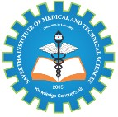

SIMATS ENGINEERING

Saveetha Institute of Medical and Technical Sciences
Chennai- 602105

Student Name:S.PradeepKumar Reg. No.: 192425016
Course Code: CSA1014 Slot: C
Course Name: Software Engineering for E-Commerce
Course Faculty: Dr. K.C. Shramili, Dr.P.Geetha
Project Title: “Real-Time Chat Application Using websockets”
Module : MERN stack development and deployment
Module Photographs: (2 photographs –Module Photo, Individual student contribution module )
MODULE REVIEW 1

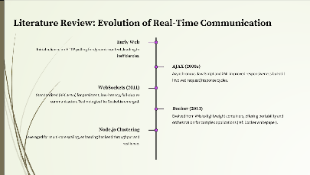
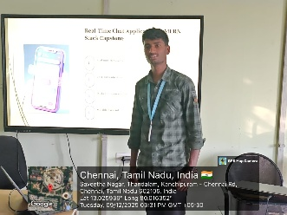
Project Description: (here you write what you did in this project (contribution) including Model
Description
The rapid growth of instant communication platforms has highlighted the need for efficient, scalable, and easily deployable real-time applications. This project develops a full-stack real-time chat application using the MERN stack (MongoDB, Express.js, React.js, Node.js) integrated with Socket.io to enable bidirectional, low-latency communication between users.
The system provides essential features such as user registration and authentication using JWT, live online/offline status indication with visual green dots, private one-on-one messaging, typing indicators, and persistent message storage. To ensure production readiness and environment consistency, the entire application — including the React frontend, Node.js backend, and MongoDB database — is containerized using Docker. Docker Compose is employed to orchestrate multiple services, allowing the application to be deployed with a single command on any platform supporting Docker.
This work demonstrates the effective integration of modern web technologies with DevOps practices, achieving a scalable, maintainable, and portable real-time communication system suitable for both development and production environments.

A.SHEIK MOHAMMED AFNAN
Student Signature Guide Signature

