Dilip SV (192424424L)

Merging Data Frames in R Programming
Merging data frames is an essential task in R programming when working with multiple datasets.
The `merge()` function and the `dplyr` package are commonly used for combining datasets.
1. Using merge():
----------------
The merge() function combines two data frames by common columns or row names.
Syntax:
merge(x, y, by = "column_name")
Example:
df1 <- data.frame(ID = c(1,2,3), Name = c("A","B","C"))
df2 <- data.frame(ID = c(1,2,3), Score = c(90,85,88))
merged_df <- merge(df1, df2, by = "ID")
2. Types of Merge:
------------------
- Inner Join: merge(df1, df2, by = "ID")
- Left Join: merge(df1, df2, by = "ID", all.x = TRUE)
- Right Join: merge(df1, df2, by = "ID", all.y = TRUE)
- Full Join: merge(df1, df2, by = "ID", all = TRUE)
3. Using dplyr for merging:
---------------------------
library(dplyr)
left_join(df1, df2, by = "ID")
right_join(df1, df2, by = "ID")
inner_join(df1, df2, by = "ID")
full_join(df1, df2, by = "ID")

4. Key Points:
--------------
- Ensure column names match before merging.
- Check for duplicate keys to avoid unexpected row expansion.
- Merging helps combine attributes from multiple datasets for analysis.

Topic 1: Data Reshaping in R
Q1. Create a data frame and display its structure.
Answer:
student <- data.frame(
Name = c("Asha", "Ravi", "Kiran"),
Marks = c(85, 90, 78)
)

str(student)
Output:
'data.frame': 3 obs. of 2 variables
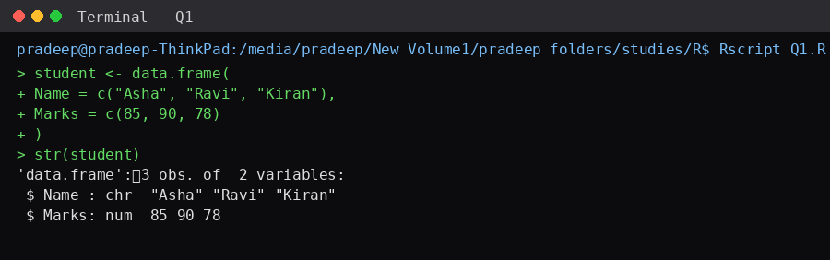

Q2. Rename the column "Marks" to "Score".
Answer:
student <- data.frame(
Name = c("Asha", "Ravi"),
Marks = c(85, 90)
)

names(student)[2] <- "Score"
student
Output
Name Score
1 Asha 85
2 Ravi 90
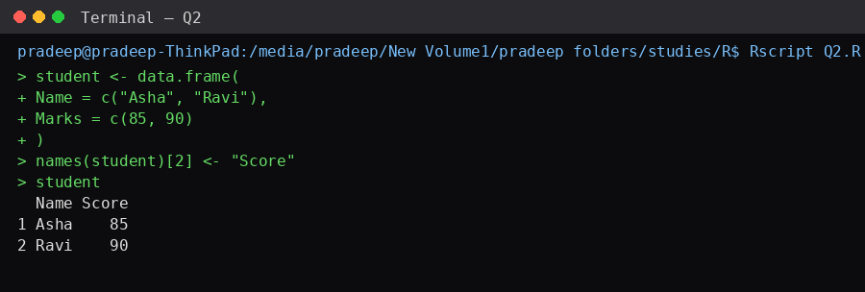

Q3. Add a new column called "Grade".
Answer:
student <- data.frame(
Name=c("Asha","Ravi"),
Marks=c(85,90)
)

student$Grade <- c("A","A")
student
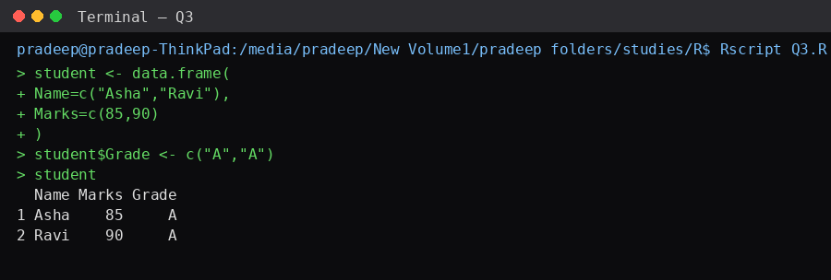

Q4. Delete the Grade column.
Answer
student$Grade <- NULL
student
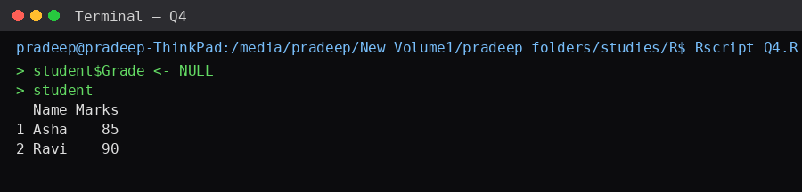

Q5. Change the order of columns.
Answer
student <- student[, c("Marks","Name")]
student
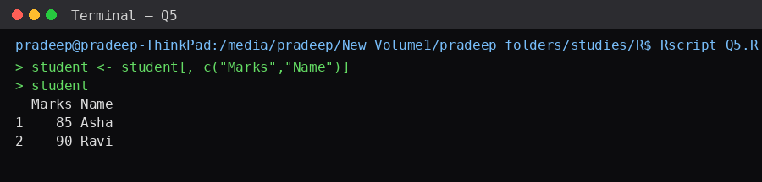

Topic 2: Melting Data
Q6. Convert a wide-format data frame into long format using melt().
Answer
library(reshape2)

data <- data.frame(
Name=c("A","B"),
Math=c(80,85),
Science=c(90,88)
)

melt(data, id.vars="Name")
Output
Name variable value
A Math 80
B Math 85
A Science 90
B Science 88
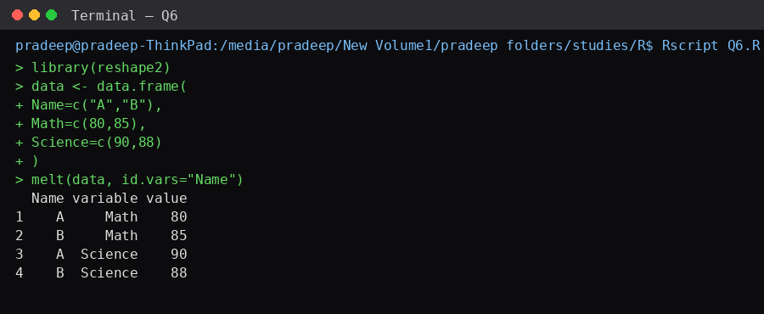

Q7. Melt multiple subject columns.
Answer
library(reshape2)

marks <- data.frame(
Student=c("S1","S2"),
English=c(75,80),
Math=c(82,90),
Science=c(88,91)
)

melt(marks,id.vars="Student")
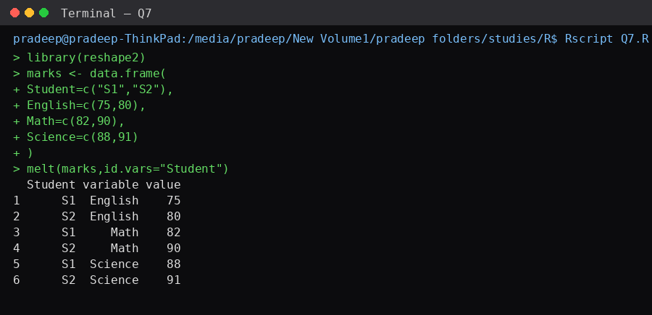

Q8. Use variable.name and value.name in melt().
Answer
library(reshape2)

melt(data,
id.vars="Name",
variable.name="Subject",
value.name="Marks")
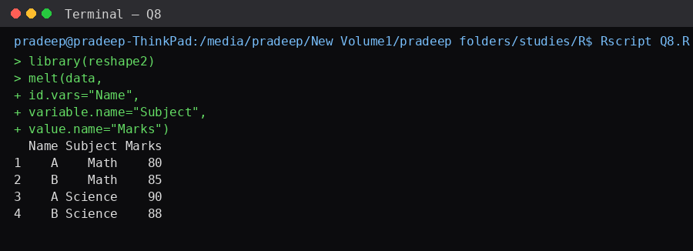

Q9. Melt employee salary data.
Answer
library(reshape2)

emp <- data.frame(
Employee=c("E1","E2"),
Jan=c(25000,28000),
Feb=c(26000,28500)
)

melt(emp,id.vars="Employee")
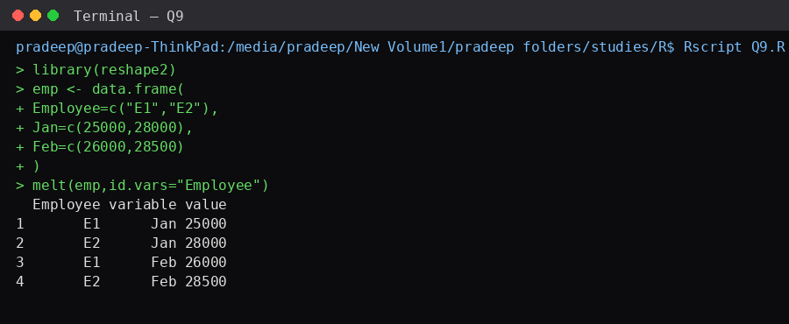

Q10. Melt sales data.
Answer
library(reshape2)

sales <- data.frame(
Product=c("Pen","Book"),
Jan=c(50,80),
Feb=c(70,90)
)

melt(sales,id.vars="Product")
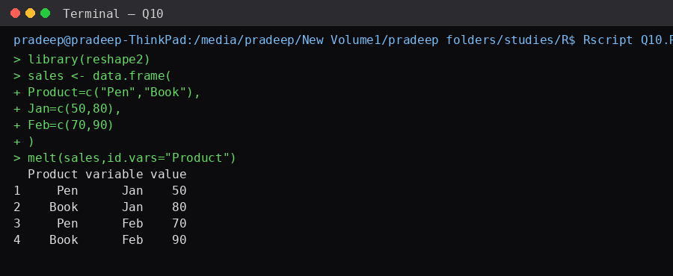

Topic 3: Casting Data
Q11. Convert melted data back into wide format.
Answer
library(reshape2)

longdata <- melt(data,id.vars="Name")

dcast(longdata,
Name~variable)
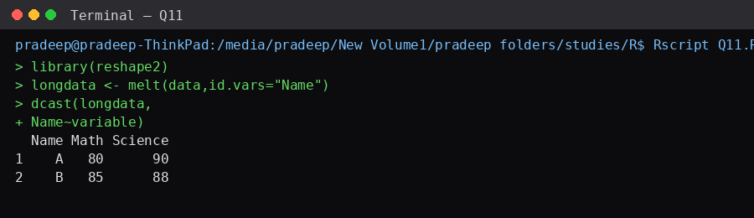

Q12. Create subjects as columns.
Answer
dcast(longdata,
Name~variable,
value.var="value")
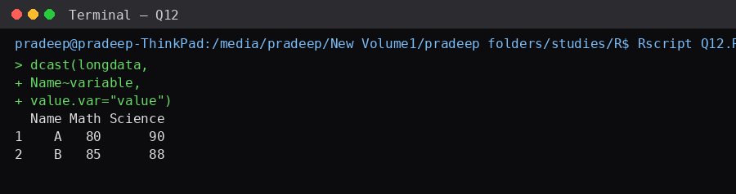

Q13. Find average marks using dcast().
Answer
dcast(longdata,
Name~variable,
mean)
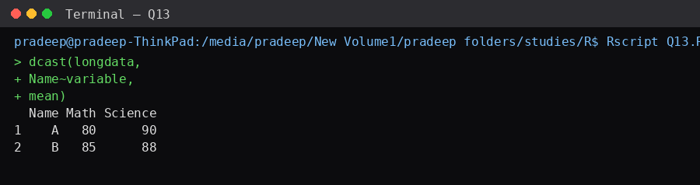

Q14. Count observations using dcast().
Answer
dcast(longdata,
Name~variable,
length)
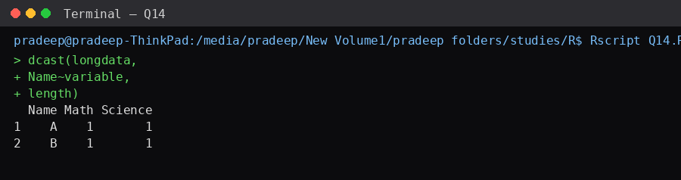

Q15. Reshape employee data using dcast().
Answer
emp.long <- melt(emp,id.vars="Employee")

dcast(emp.long,
Employee~variable)
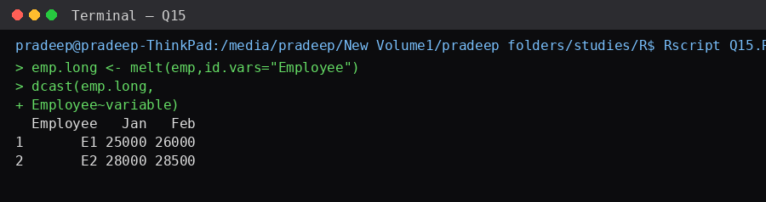

Topic 4: Merging Data Frames
Q16. Merge two data frames using a common column.
Answer
student <- data.frame(
ID=c(1,2),
Name=c("Asha","Ravi")
)

marks <- data.frame(
ID=c(1,2),
Marks=c(90,85)
)

merge(student,marks,by="ID")
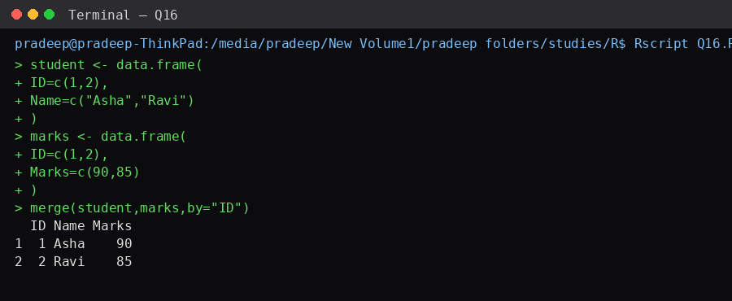

Q17. Perform a left join.
Answer
merge(student,
marks,
by="ID",
all.x=TRUE)
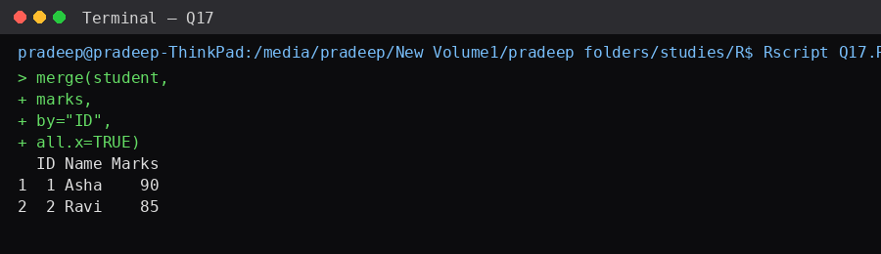

Q18. Perform a right join.
Answer
merge(student,
marks,
by="ID",
all.y=TRUE)
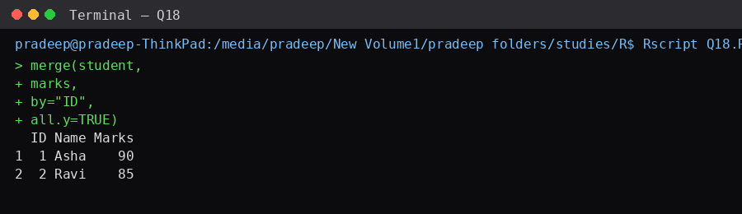

Q19. Perform a full outer join.
Answer
merge(student,
marks,
by="ID",
all=TRUE)
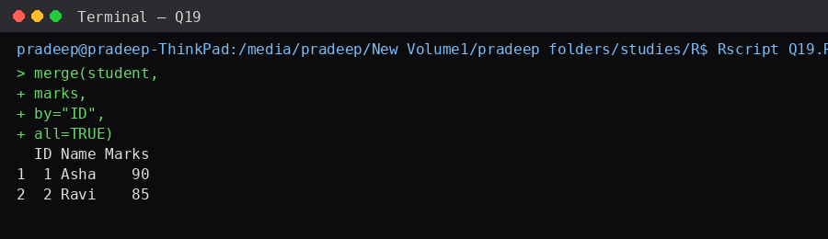

Q20. Merge two data frames with different column names.
Answer
student <- data.frame(
SID=c(1,2),
Name=c("A","B")
)

marks <- data.frame(
ID=c(1,2),
Marks=c(90,80)
)

merge(student,
marks,
by.x="SID",
by.y="ID")
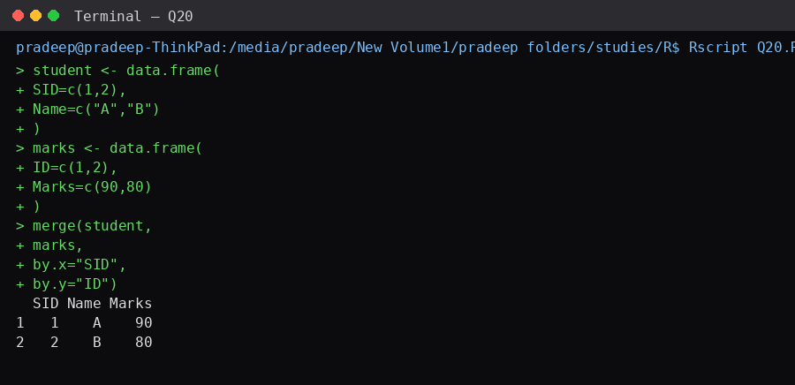

Additional Practice Questions
Q21. Create a data frame with student names and marks and reshape it into long format.
Answer
library(reshape2)

df <- data.frame(
Name=c("A","B"),
Math=c(90,85),
Science=c(80,88)
)

melt(df,id.vars="Name")
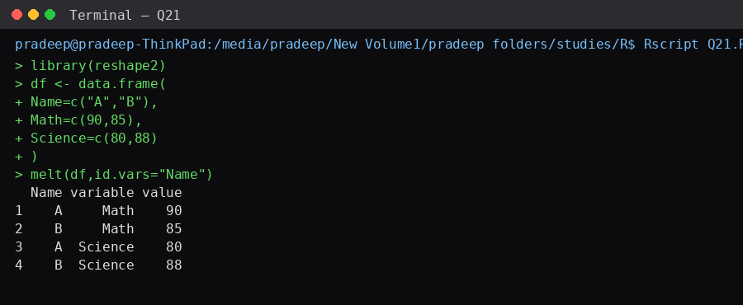

Q22. Convert long-format data back into wide format.
Answer
long <- melt(df,id.vars="Name")
dcast(long,Name~variable)
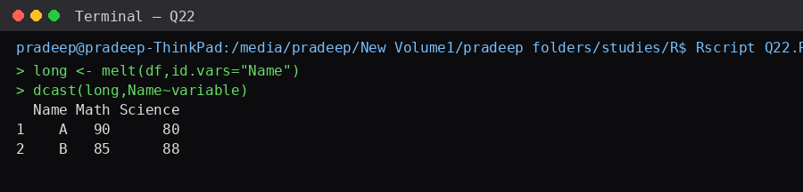

Q23. Merge employee and department data frames.
Answer
emp <- data.frame(
ID=c(101,102),
Name=c("John","Mary")
)

dept <- data.frame(
ID=c(101,102),
Department=c("HR","IT")
)

merge(emp,dept,by="ID")
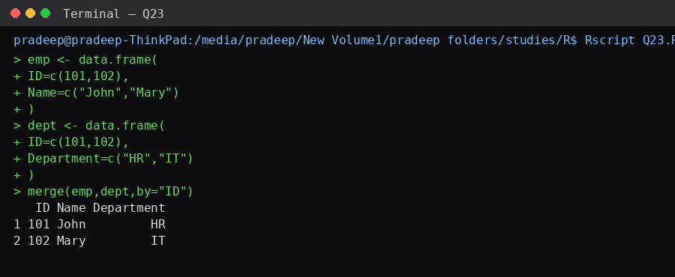

Q24. Display all records after merging.
Answer
merge(emp,dept,
by="ID",
all=TRUE)
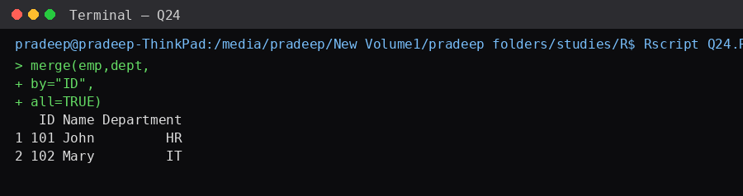

Q25. Reshape monthly sales data from wide to long format.
Answer
library(reshape2)

sales <- data.frame(
Product=c("Pen","Book"),
Jan=c(100,200),
Feb=c(150,250)
)

melt(sales,id.vars="Product")
