R Programming Lab Record
Lab Experiments 1 – 7
PradeepKumar(192425016)

Experiment 1
Question: Create numeric, character, and logical vectors and display their type and content.
R Code:
# Question: Create numeric, character, and logical vectors and display their type and content.

cat("=== EXPERIMENT 1: VECTORS IN R ===\n\n")

num_vector <- c(10.5, 20.3, 30.8, 40.2, 50.0)
int_vector <- c(1L, 5L, 10L, 15L, 20L)

cat("--- Numeric Vectors ---\n")
cat("Double Vector Content:\n")
print(num_vector)
cat("Type of Double Vector:", typeof(num_vector), "\n")
cat("Class of Double Vector:", class(num_vector), "\n\n")

cat("Integer Vector Content:\n")
print(int_vector)
cat("Type of Integer Vector:", typeof(int_vector), "\n")
cat("Class of Integer Vector:", class(int_vector), "\n\n")

char_vector <- c("Apple", "Banana", "Cherry", "Date", "Elderberry")

cat("--- Character Vector ---\n")
cat("Character Vector Content:\n")
print(char_vector)
cat("Type of Character Vector:", typeof(char_vector), "\n")
cat("Class of Character Vector:", class(char_vector), "\n\n")

log_vector <- c(TRUE, FALSE, TRUE, TRUE, FALSE)

cat("--- Logical Vector ---\n")
cat("Logical Vector Content:\n")
print(log_vector)
cat("Type of Logical Vector:", typeof(log_vector), "\n")
cat("Class of Logical Vector:", class(log_vector), "\n\n")

cat("--- Structure Summary ---\n")
str(num_vector)
str(char_vector)
str(log_vector)

Output / Implementation Screenshot:
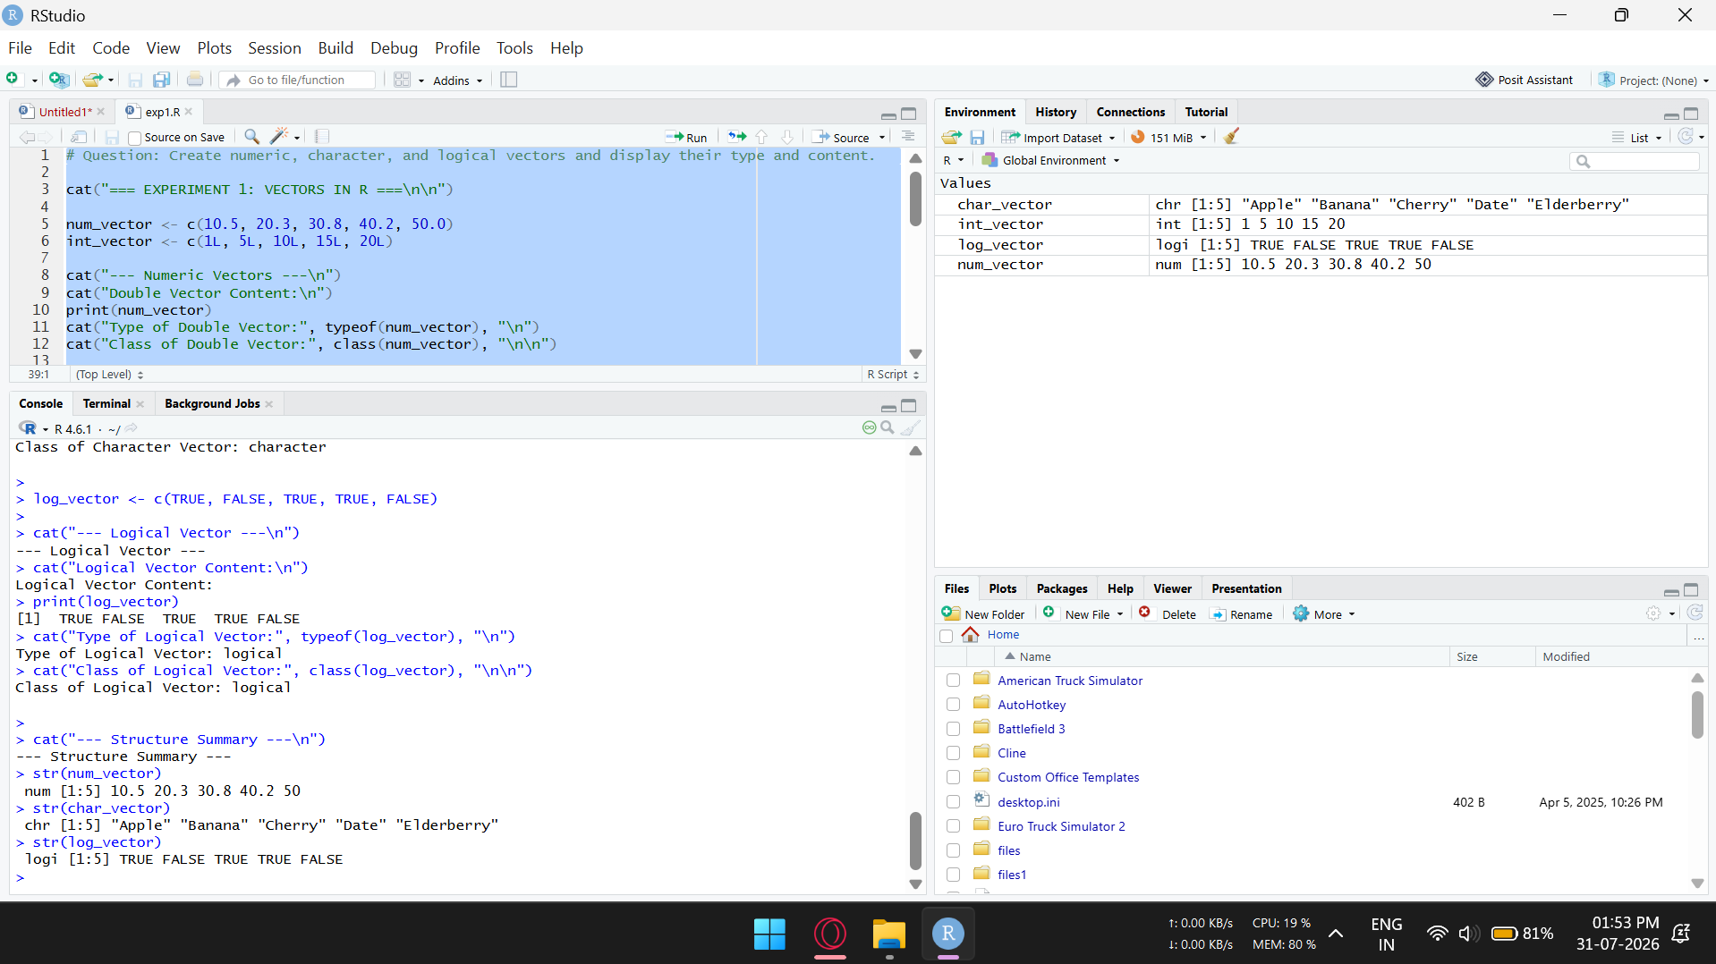

Experiment 2
Question: Create labeled matrices (5×4, 3×3, 2×2) filled by row/column.
R Code:
# Question: Create labeled matrices (5x4, 3x3, 2x2) filled by row/column.

cat("=== EXPERIMENT 2: LABELED MATRICES ===\n\n")

mat_5x4 <- matrix(
data = 1:20,
nrow = 5,
ncol = 4,
byrow = TRUE,
dimnames = list(
Row_Names = paste0("Row_", 1:5),
Col_Names = paste0("Col_", 1:4)
)
)

cat("--- 5x4 Matrix (Filled by Row) ---\n")
print(mat_5x4)
cat("\n")

mat_3x3 <- matrix(
data = seq(10, 90, by = 10),
nrow = 3,
ncol = 3,
byrow = FALSE,
dimnames = list(
Row_Labels = c("R1", "R2", "R3"),
Col_Labels = c("C1", "C2", "C3")
)
)

cat("--- 3x3 Matrix (Filled by Column) ---\n")
print(mat_3x3)
cat("\n")

mat_2x2 <- matrix(
data = c("A", "B", "C", "D"),
nrow = 2,
ncol = 2,
byrow = TRUE,
dimnames = list(
Group = c("G1", "G2"),
Variable = c("V1", "V2")
)
)

cat("--- 2x2 Labeled Character Matrix (Filled by Row) ---\n")
print(mat_2x2)

Output / Implementation Screenshot:
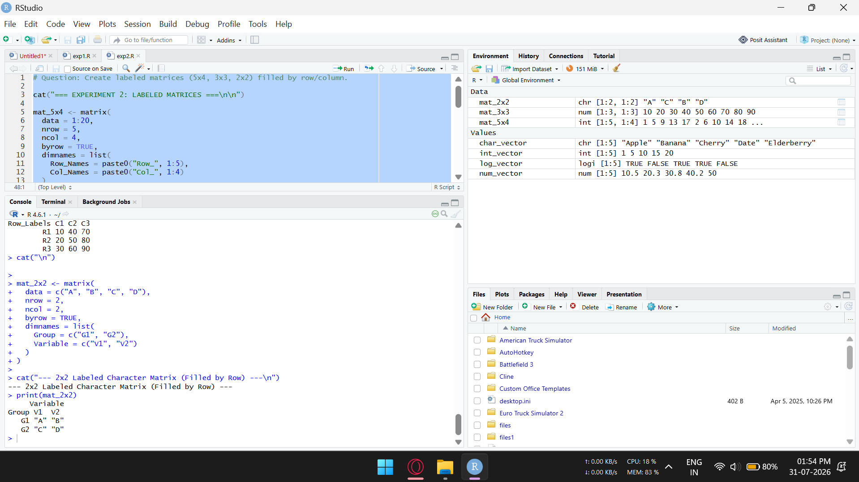

Experiment 3
Question: Write an R program to create and display a 3D array with specified rows, columns, and tables.
R Code:
# Question: Write an R program to create and display a 3D array with specified rows, columns, and tables.

cat("=== EXPERIMENT 3: 3D ARRAY CREATION AND DISPLAY ===\n\n")

array_data <- 1:24

row_names <- c("Row1", "Row2", "Row3")
col_names <- c("Col1", "Col2", "Col3", "Col4")
table_names <- c("Table1", "Table2")

my_3d_array <- array(
data = array_data,
dim = c(3, 4, 2),
dimnames = list(row_names, col_names, table_names)
)

cat("--- Complete 3D Array ---\n")
print(my_3d_array)
cat("\n")

cat("--- Array Properties ---\n")
cat("Dimensions:", dim(my_3d_array), "\n")
cat("Dimension Names:\n")
print(dimnames(my_3d_array))
cat("\n")

cat("--- Displaying Specific Sections ---\n")
cat("Table 1 content:\n")
print(my_3d_array[, , 1])
cat("\nTable 2 content:\n")
print(my_3d_array[, , 2])

Output / Implementation Screenshot:
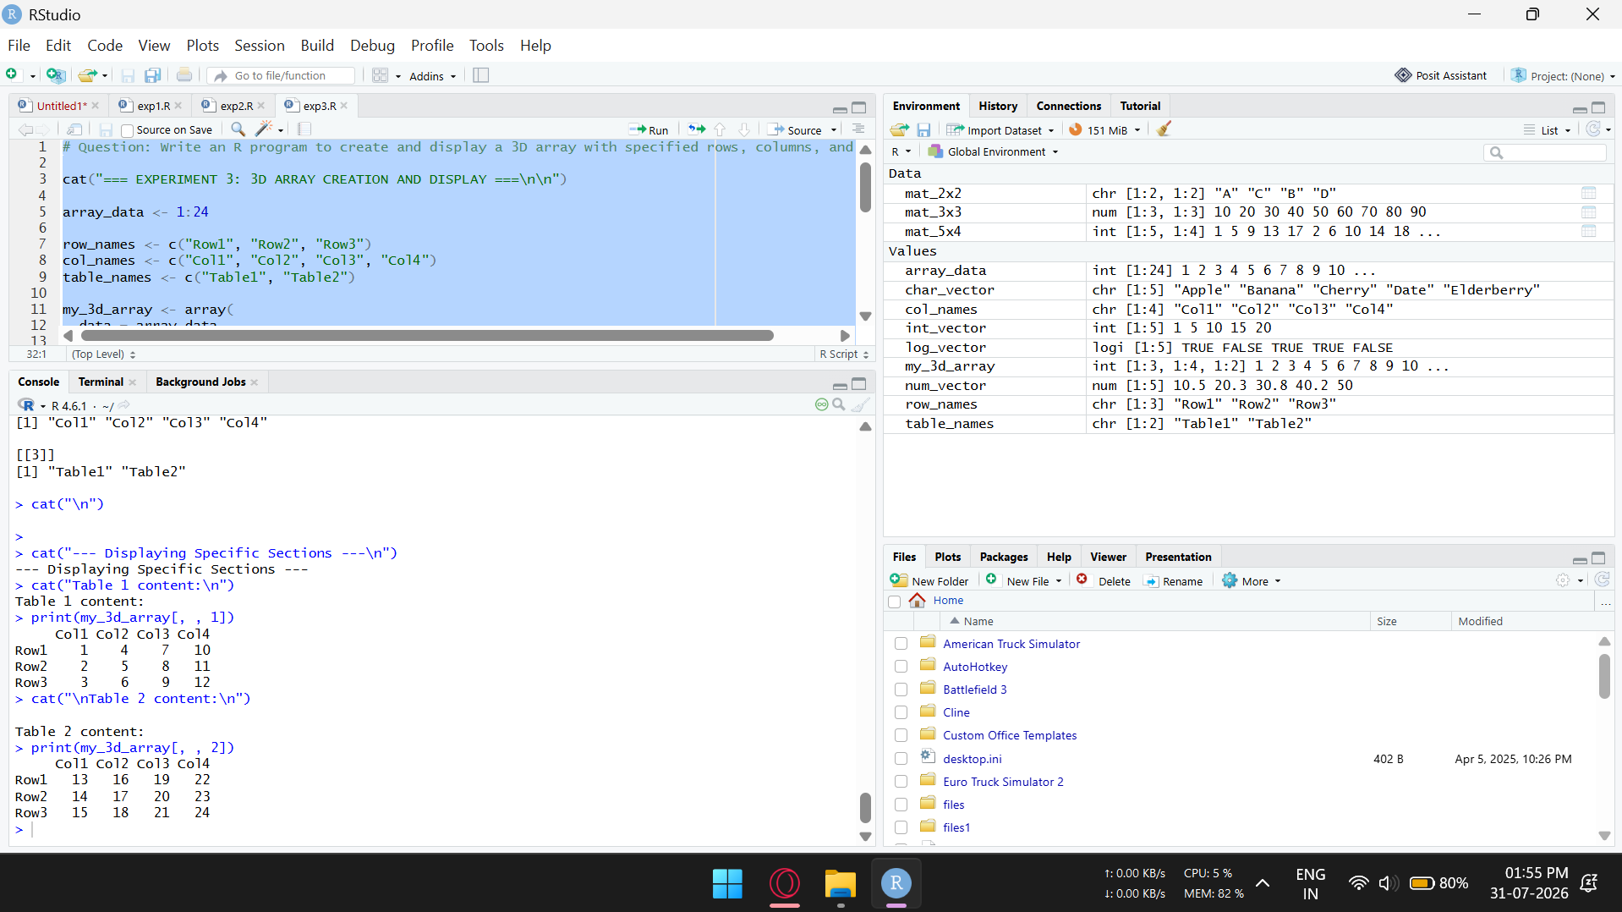

Experiment 4
Question: Create arrays from vectors with dimension names and print specific elements.
R Code:
# Question: Create arrays from vectors with dimension names and print specific elements.

cat("=== EXPERIMENT 4: ARRAYS FROM VECTORS & ELEMENT ACCESS ===\n\n")

v1 <- c(1, 3, 5, 7, 9, 11)
v2 <- c(2, 4, 6, 8, 10, 12)

combined_data <- c(v1, v2)

row_names <- c("R1", "R2", "R3")
col_names <- c("C1", "C2")
matrix_names <- c("Matrix_A", "Matrix_B")

arr <- array(
data = combined_data,
dim = c(3, 2, 2),
dimnames = list(row_names, col_names, matrix_names)
)

cat("--- Entire 3D Array ---\n")
print(arr)
cat("\n")

cat("--- Printing Specific Elements ---\n")

cat("1. Element at [Row 2, Column 1, Matrix_A]:\n")
print(arr[2, 1, 1])
cat("\n")

cat("2. 2nd Row of Matrix_B:\n")
print(arr[2, , 2])
cat("\n")

cat("3. 1st Column across all matrices:\n")
print(arr[, 1, ])
cat("\n")

cat("4. Entire Matrix_A:\n")
print(arr[, , "Matrix_A"])

Output / Implementation Screenshot:
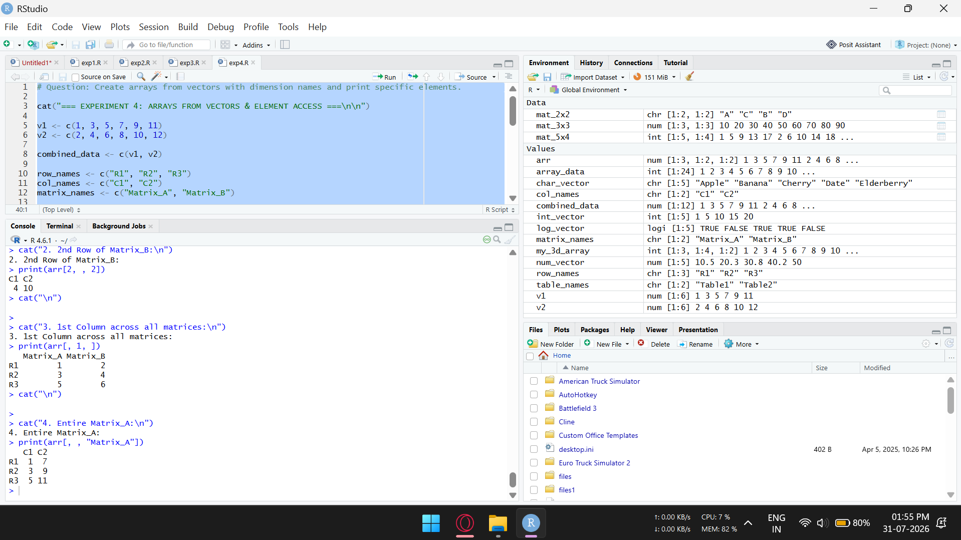

Experiment 5
Question: Create and manipulate factor variables (e.g., women's dataset heights, random LETTERS sample).
R Code:
# Question: Create and manipulate factor variables (e.g., women’s dataset heights, random LETTERS sample).

cat("=== EXPERIMENT 5: FACTOR CREATION & MANIPULATION ===\n\n")

data(women)
heights <- women$height

cat("--- 1. Heights from 'women' Dataset ---\n")
cat("Original Heights:\n")
print(heights)

height_categories <- cut(
heights,
breaks = c(57, 63, 68, 73),
labels = c("Short", "Medium", "Tall")
)

cat("\nHeight Categories as Factor:\n")
print(height_categories)

cat("Levels of Height Factor:", levels(height_categories), "\n")
cat("Summary / Frequency Count:\n")
print(table(height_categories))
cat("\n")

set.seed(42)
letter_sample <- sample(LETTERS[1:5], size = 20, replace = TRUE)
letter_factor <- factor(letter_sample)

cat("--- 2. Random LETTERS Sample Factor ---\n")
cat("Sample Vector:\n")
print(letter_sample)
cat("\nFactor Representation:\n")
print(letter_factor)

cat("\nFactor Levels:", levels(letter_factor), "\n")
cat("Frequency Table of Letters:\n")
print(table(letter_factor))
cat("\n")

cat("--- 3. Factor Manipulation ---\n")
levels(letter_factor) <- c(levels(letter_factor), "X")
cat("Levels after adding 'X':", levels(letter_factor), "\n")

letter_factor[1] <- "X"
cat("Factor after updating first element to 'X':\n")
print(letter_factor)

Output / Implementation Screenshot:
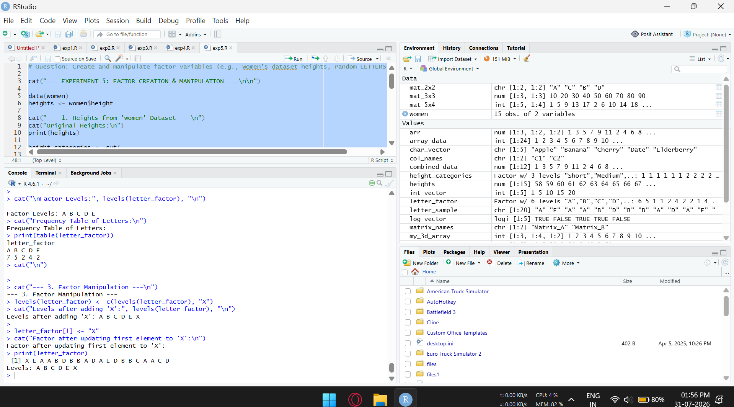

Experiment 6
Question: Create an R list containing vectors, matrices, and functions; display its contents.
R Code:
# Question: Create an R list containing vectors, matrices, and functions; display its contents.

cat("=== EXPERIMENT 6: R LIST WITH VECTORS, MATRICES & FUNCTIONS ===\n\n")

vec <- c(10, 20, 30, 40, 50)
mat <- matrix(1:6, nrow = 2, ncol = 3, dimnames = list(c("R1", "R2"), c("C1", "C2", "C3")))
str_vec <- c("R Programming", "Data Science", "Statistics")

summary_stats <- function(x) {
list(
Mean = mean(x),
Median = median(x),
Range = range(x)
)
}

my_list <- list(
Numbers = vec,
DataMatrix = mat,
Courses = str_vec,
CalculateStats = summary_stats
)

cat("--- Complete List Content ---\n")
print(my_list)
cat("\n")

cat("--- Structure of the List ---\n")
str(my_list)
cat("\n")

cat("--- Accessing List Elements ---\n")
cat("1. Numbers Vector (using $):\n")
print(my_list$Numbers)

cat("\n2. Data Matrix (using [[]]):\n")
print(my_list[["DataMatrix"]])

cat("\n3. Executing stored function on Numbers Vector:\n")
result <- my_list$CalculateStats(my_list$Numbers)
print(result)

Output / Implementation Screenshot:
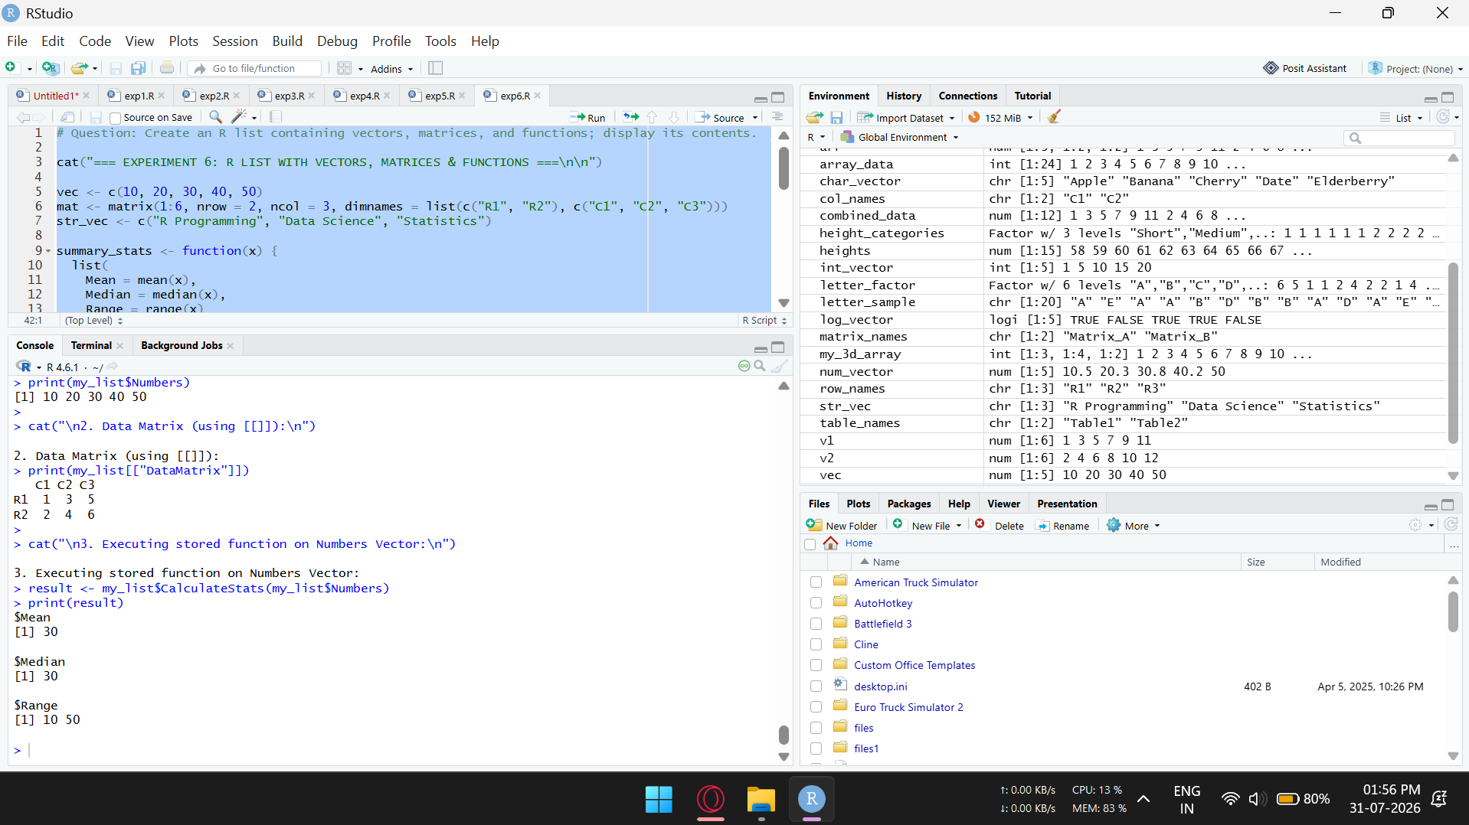

Experiment 7
Question: Write R programs for basic tasks: find the factors of a number, generate a vector of 10 random integers between -50 and 50, and print numbers 1-100 with FizzBuzz logic.
R Code:
# Question: Write R programs for basic tasks:
# 1. Find the factors of a number
# 2. Generate a vector of 10 random integers between -50 and 50
# 3. Print numbers 1-100 with FizzBuzz logic

cat("=== EXPERIMENT 7: BASIC R PROGRAMS ===\n\n")

find_factors <- function(n) {
if (n <= 0) {
stop("Please enter a positive integer.")
}
factors <- c()
for (i in 1:n) {
if (n %% i == 0) {
factors <- c(factors, i)
}
}
return(factors)
}

number <- 36
cat("--- Task 1: Factors of a Number ---\n")
cat("Factors of", number, "are:\n")
print(find_factors(number))
cat("\n")

cat("--- Task 2: Random Integers Between -50 and 50 ---\n")
set.seed(123)
random_integers <- sample(-50:50, 10, replace = TRUE)
cat("Generated 10 Random Integers:\n")
print(random_integers)
cat("\n")

cat("--- Task 3: FizzBuzz Logic (1 to 100) ---\n")

fizz_buzz <- function() {
output <- character(100)
for (i in 1:100) {
if (i %% 3 == 0 && i %% 5 == 0) {
output[i] <- "FizzBuzz"
} else if (i %% 3 == 0) {
output[i] <- "Fizz"
} else if (i %% 5 == 0) {
output[i] <- "Buzz"
} else {
output[i] <- as.character(i)
}
}
return(output)
}

fizzbuzz_result <- fizz_buzz()
for (i in 1:100) {
cat(sprintf("%-8s", fizzbuzz_result[i]))
if (i %% 10 == 0) cat("\n")
}

Output / Implementation Screenshot:
