Activity Description Guide

1. **Development platform**

GCloud environment is used for client server tool development and Dockerisation.

1. **Design**

Block diagram:

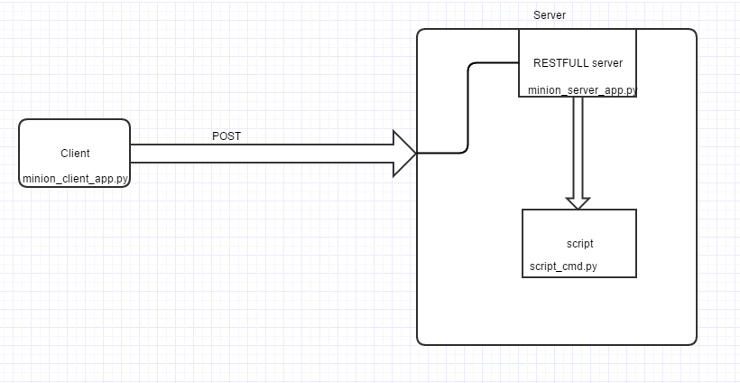

Sequence diagram:

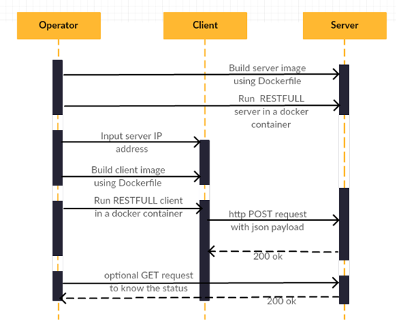

1. **Tools description**

Server:

docker_client/

-Dockerfile

- dependency.txt

-minion_server_app.py

-script_cmd.py

Client:

docker_client/

-Dockerfile

-dependency.txt

-minion_client_app.py

-action_list.json

-operator_input_file.yaml

Dockerfile :

In a docker environment Dockerfile is the input file for image build.

Contains set of commands to download the base image(python), copy application into base directory of the image, ports to be opened and commands to run the application.

A separate file is created for client and server respectively.

Dependency.txt:

Dependent packages for application to get executed. This file is provided in the Dckerfile.

During image build, relevant packages are downloaded before application is run.

Script_cmd.py:

A small script which is triggered from the minion_server_app.py script on RESTFULL request.

This creates a sample predefined file and directory.

Minion_server_app.py:

A RESTFULL server application created on the server. Accepts request on port 5000 and triggers

Script_cmd.py accordingly. Also logs the action at info, error and debug levels into logfile and console.

Above files are copied on to multiple servers and executed .

Action_list.json:

A flat file containing Json data about the actions to be performed on the server.

Has information to touch a file and create a directory.

operator_input_file.yaml:

An input file where operator can provide the server ip addresses, on which script should be triggered.

minion_client_app.py:

A client tool which reads and parses the operator_input_file.yaml and attaches the json payload(action_list.json) to http url for triggering the server application.

Does ping test before sending requests and logs the details.

1. **Working logs**

Server dockerisation:

1. Image build

………

*Successfully installed Jinja2-2.9.5 MarkupSafe-0.23 Werkzeug-0.11.15 click-6.7 flask-0.12 itsdangerous-0.24*

*---> 6ff1b61fa3b8*

*Removing intermediate container 7afd5d6d2070*

*Step 6/11 : EXPOSE 22*

*---> Running in 7fbcd8790b9b*

*---> 4e263c20474c*

*Removing intermediate container 7fbcd8790b9b*

*Step 7/11 : EXPOSE 80*

*---> Running in c3607525f593*

*---> 52a37cf3d40f*

*Removing intermediate container c3607525f593*

*Step 8/11 : EXPOSE 443*

*---> Running in 5463050fa459*

*---> 512849013ce8*

*Removing intermediate container 5463050fa459*

*Step 9/11 : EXPOSE 8080*

*---> Running in 9f2847d3fd7d*

*---> b0af6400f065*

*Removing intermediate container 9f2847d3fd7d*

*Step 10/11 : ENTRYPOINT python*

*---> Running in dafc651be458*

*---> ee9b61f6f07f*

*Removing intermediate container dafc651be458*

*Step 11/11 : CMD minion_server_app.py*

*---> Running in 2e0ce8c5423a*

*---> c6d0aed31885*

*Removing intermediate container 2e0ce8c5423a*

*Successfully built c6d0aed31885*

1. Creating server containers:

*[ppradeepkumards@instance-docker-vm docker_prj]$ sudo docker run -d -p 5000:5000 minion_server*

*df41b1a2239dde154f96d390c65c976566d99801ede5583289279b4d0aef243f*

*[ppradeepkumards@instance-docker-vm docker_prj]$ sudo docker container list*

*CONTAINER ID IMAGE COMMAND CREATED STATUS PORTS NAMES*

*df41b1a2239d minion_server "python minion_ser..." 7 seconds ago Up 7 seconds 22/tcp, 80/tcp, 443/tcp, 8080/tcp, 0.0.0.0:5000->5000/tcp reverent_ptolemy*

*[ppradeepkumards@instance-docker-vm docker_prj]$*

1. Client image build

*Installing collected packages: requests, PyYAML, pyaml*

*Successfully installed PyYAML-3.12 pyaml-16.12.2 requests-2.13.0*

*---> d8f96fec53aa*

*Removing intermediate container 3b7a802cd2ab*

*Step 6/11 : EXPOSE 22*

*---> Running in 42869e7f6eb0*

*---> ac83c3bc02de*

*Removing intermediate container 42869e7f6eb0*

*Step 7/11 : EXPOSE 80*

*---> Running in 0ed62e8cae0d*

*---> 0572cd7606b8*

*Removing intermediate container 0ed62e8cae0d*

*Step 8/11 : EXPOSE 443*

*---> Running in d1dd8dc5561e*

*---> 703cca85be26*

*Removing intermediate container d1dd8dc5561e*

*Step 9/11 : EXPOSE 8080*

*---> Running in 9d04d9c0dc28*

*---> 2a542ae4ad3e*

*Removing intermediate container 9d04d9c0dc28*

*Step 10/11 : ENTRYPOINT python*

*---> Running in 767868b396e7*

*---> c5efc5f61e53*

*Removing intermediate container 767868b396e7*

*Step 11/11 : CMD minion_client_app.py*

*---> Running in f945f4f8e86d*

*---> f42780677609*

*Removing intermediate container f945f4f8e86d*

*Successfully built f42780677609*

1. Creating client container

*Since this is not process/deamon we won’t see container in running state.*

*[ppradeepkumards@instance-docker-vm-client docker_client]$ sudo docker run -d minion_client:latest*

*78d2a9dfedd3ea390f8516134b928e41de96da7f336bdb759f317ef9733a9f7a*

1. Check whether actions performed as per request.

On client :

[ppradeepkumards@instance-docker-vm-client docker_client]$ sudo docker logs 78d2a9dfedd3

Sun, 19 Feb 2017 13:27:10 INFO Started logging to tmp/minion_client_app_20170219-132710

Sun, 19 Feb 2017 13:27:10 INFO Intiating restful action on minion servers....

Sun, 19 Feb 2017 13:27:10 INFO Restfull request posted on server 104.197.42.202

On server:

Login into server container. **Testing_file and testing_dir are created as a part of client request**

root@df41b1a2239d:/minion_server# ls -lrt

total 24

-rw-rw-r--. 2 root root 6 Feb 19 08:11 dependency.txt

-rw-r--r--. 2 root root 182 Feb 19 10:11 script_cmd.py

-rw-rw-r--. 2 root root 242 Feb 19 12:48 Dockerfile

-rw-r--r--. 2 root root 3706 Feb 19 13:12 minion_server_app.py

-rw-rw-r--. 2 root root 4683 Feb 19 13:13 minion_server_app.pyc

-rw-r--r--. 1 root root 0 Feb 19 13:27 **testing_file**

drwxr-xr-x. 2 root root 75 Feb 19 13:27 tmp

drwxr-xr-x. 2 root root 6 Feb 19 13:27 **testing_dir**

root@df41b1a2239d:/minion_server# cat tmp/minion_server_app

minion_server_app.done minion_server_app_20170219-131439

root@df41b1a2239d:/minion_server# ls tmp/

minion_server_app.done minion_server_app_20170219-131439

root@df41b1a2239d:/minion_server# cat tmp/minion_server_app_20170219-131439

2017-02-19 13:14:39,493 - INFO - Started logging to tmp//minion_server_app_20170219-131439

2017-02-19 13:27:10,883 - INFO - Executing: python script_cmd.py touch

2017-02-19 13:27:10,898 - INFO - Command output ("['script_cmd.py', 'touch']\n", '', 0)

2017-02-19 13:27:10,898 - INFO - Executing: python script_cmd.py mkdir

2017-02-19 13:27:10,911 - INFO - Command output ("['script_cmd.py', 'mkdir']\n", '', 0)

root@df41b1a2239d:/minion_server#