Java Design Patterns

Design patterns in Java are reusable solutions to common software design problems. They are not language-specific, but Java is a very common language for learning and applying them because its object-oriented features make the patterns natural to implement.

At a high level, design patterns help you write code that is easier to **maintain, extend, test, and understand**.

## The three main categories

Design patterns are usually grouped into three types:

1. **Creational patterns**
Concerned with how objects are created.

2. **Structural patterns**
Concerned with how classes and objects are composed.

3. **Behavioral patterns**
Concerned with how objects communicate and share responsibilities.

---

# 1. Creational Patterns

These patterns focus on object creation logic.

## Singleton
Ensures a class has only one instance and provides a global access point to it.

### Use case
- configuration manager
- logger
- connection pool

### Java example
```java
public class Singleton {
private static final Singleton instance = new Singleton();

private Singleton() {}

public static Singleton getInstance() {
return instance;
}
}
```

### Note
Singleton can be useful, but overuse can make testing harder because it introduces global state.

---

## Factory Method
Defines an interface for creating objects, but lets subclasses decide which class to instantiate.

### Use case
When the exact object type depends on runtime conditions.

### Example
Imagine a `ShapeFactory` that creates `Circle`, `Square`, or `Rectangle` objects.

```java
interface Shape {
void draw();
}

class Circle implements Shape {
public void draw() {
System.out.println("Drawing Circle");
}
}

class Square implements Shape {
public void draw() {
System.out.println("Drawing Square");
}
}

class ShapeFactory {
public static Shape createShape(String type) {
if (type.equals("circle")) return new Circle();
if (type.equals("square")) return new Square();
throw new IllegalArgumentException("Unknown shape");
}
}
```

---

## Builder
Separates the construction of a complex object from its representation.

### Use case
Useful when an object has many optional fields.

### Example
Java’s `StringBuilder` is a good example of the builder idea.

```java
class User {
private final String name;
private final int age;
private final String address;

private User(Builder builder) {
this.name = builder.name;
this.age = builder.age;
this.address = builder.address;
}

public static class Builder {
private String name;
private int age;
private String address;

public Builder setName(String name) {
this.name = name;
return this;
}

public Builder setAge(int age) {
this.age = age;
return this;
}

public Builder setAddress(String address) {
this.address = address;
return this;
}

public User build() {
return new User(this);
}
}
}
```

### Benefit
Avoids constructors with too many parameters.

---

## Prototype
Creates new objects by copying an existing object.

### Use case
When object creation is expensive or complex.

---

# 2. Structural Patterns

These patterns help structure classes and objects into larger systems.

## Adapter
Allows incompatible interfaces to work together.

### Use case
Integrating legacy code with a new interface.

### Example
If one class expects `PaymentProcessor.pay()` but another provides `StripeGateway.charge()`, an adapter bridges them.

---

## Decorator
Adds new behavior to an object dynamically without modifying its class.

### Use case
Adding responsibilities like logging, caching, or compression.

### Example
Java I/O streams use this idea heavily.

```java
InputStream in = new BufferedInputStream(new FileInputStream("file.txt"));
```

---

## Facade
Provides a simplified interface to a complex subsystem.

### Use case
When you want to hide complexity from the client code.

### Example
A `HomeTheaterFacade` can wrap TV, speakers, and projector control.

---

## Proxy
Provides a placeholder or surrogate for another object.

### Use case
- lazy loading
- access control
- remote object access
- caching

---

## Composite
Lets you treat individual objects and groups of objects uniformly.

### Use case
Tree structures like filesystems or UI components.

### Example
A folder can contain files and other folders, and both can be treated through a common interface.

---

# 3. Behavioral Patterns

These patterns focus on object interaction and responsibility.

## Observer
Defines a one-to-many dependency so when one object changes, all dependents are notified.

### Use case
Event systems, GUI listeners, publish-subscribe style updates.

### Example
A stock price update notifies multiple displays.

---

## Strategy
Defines a family of algorithms, encapsulates each one, and makes them interchangeable.

### Use case
Different sorting, payment, compression, or routing behaviors.

### Example
Choose payment method at runtime: card, UPI, wallet.

```java
interface PaymentStrategy {
void pay(int amount);
}

class CreditCardPayment implements PaymentStrategy {
public void pay(int amount) {
System.out.println("Paid by credit card: " + amount);
}
}

class UpiPayment implements PaymentStrategy {
public void pay(int amount) {
System.out.println("Paid by UPI: " + amount);
}
}
```

---

## Command
Encapsulates a request as an object.

### Use case
Undo/redo, task queues, job scheduling.

### Example
A button click can be represented as a command object.

---

## Template Method
Defines the skeleton of an algorithm, while subclasses fill in specific steps.

### Use case
When the overall flow stays the same but some steps vary.

---

## Chain of Responsibility
Passes a request through a chain of handlers until one handles it.

### Use case
Logging, authentication filters, request validation pipelines.

---

## State
Allows an object to change behavior when its internal state changes.

### Use case
Workflow systems, order states, document states.

---

## Mediator
Centralizes communication between objects so they do not refer to each other directly.

### Use case
Complex UI logic, chat rooms, workflow coordination.

---

## Iterator
Provides a way to access elements of a collection sequentially without exposing its internal structure.

### Use case
Java’s collection iteration.

---

## Memento
Captures and restores an object’s internal state without exposing its internals.

### Use case
Undo functionality.

---

## Visitor
Lets you add new operations to object structures without changing the classes of the elements.

### Use case
Operations over tree structures, ASTs, document objects.

---

# Common Java design patterns to know for interviews

If you are preparing for interviews, focus on these first:

- Singleton
- Factory Method
- Builder
- Adapter
- Decorator
- Facade
- Proxy
- Strategy
- Observer
- Command
- State

These are the ones you will see most often in Java design discussions and low-level design interviews.

---

# Important Java-specific examples

Java itself uses many patterns internally:

- `Collections.unmodifiableList()` behaves like a **Decorator**
- `java.util.Arrays.asList()` is often used like a **Factory**
- `BufferedInputStream` is a **Decorator**
- `java.util.concurrent.Executor` is often used with **Command**
- `java.util.Observer` and event listeners follow the **Observer** idea
- `java.lang.Runtime.getRuntime()` is a **Singleton-like** API

---

# How to think about them in interviews

A strong answer is not just naming a pattern. It is explaining:

- what problem it solves
- why simpler code would be worse
- how it improves flexibility
- what trade-offs it introduces

For example, instead of saying “use Strategy,” say:

> “I would use Strategy because the payment behavior may change at runtime, and I want to avoid a large if-else chain. Each payment method becomes its own implementation, which keeps the code open for extension and easy to test.”

---

# Quick summary

Java design patterns are reusable solutions for object creation, composition, and interaction.

- **Creational**: Singleton, Factory, Builder, Prototype
- **Structural**: Adapter, Decorator, Facade, Proxy, Composite
- **Behavioral**: Strategy, Observer, Command, State, Chain of Responsibility

If you want, I can also give you:
1. a **Java design patterns cheat sheet**
2. **one example code for each important pattern**
3. a **design patterns interview Q&A set**
4. **a Mermaid diagram showing how the patterns are grouped**

Design Patterns

Absolutely. In Java, **design patterns** are reusable solutions to common software design problems. They help you write code that is **cleaner, more maintainable, flexible, and easier to extend**.

The best way to understand them is to group them into three categories:

- **Creational patterns**: how objects are created
- **Structural patterns**: how classes and objects are composed
- **Behavioral patterns**: how objects communicate and share responsibilities

Below, I’ll explain the most important Java design patterns with **real-world examples**, **use cases**, and **Java code**.

---

# 1) Creational Design Patterns

Creational patterns focus on object creation. They help hide the complexity of constructing objects and make your code more flexible.

---

## 1. Singleton Pattern

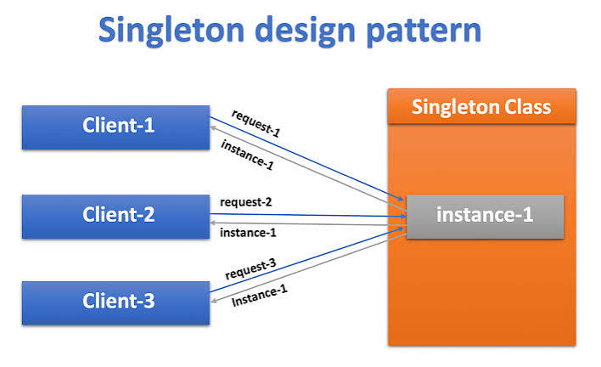

### Intent
Ensure that a class has only one instance and provide a global access point to it.

### Real-time example
A **configuration manager** or **logging service** is often a singleton. You usually want one shared instance across the application.

### When to use
- Application-wide configuration
- Logging
- Cache manager
- Thread pool manager

### Java example
```java
public class Logger {
private static Logger instance;

private Logger() {
}

public static synchronized Logger getInstance() {
if (instance == null) {
instance = new Logger();
}
return instance;
}

public void log(String message) {
System.out.println("LOG: " + message);
}
}
```

### Usage
```java
Logger logger = Logger.getInstance();
logger.log("Application started");
```

### Advantages
- Controlled access to a single object
- Saves memory
- Useful for shared resources

### Disadvantages
- Makes testing harder
- Can become a hidden global state
- Needs care in multithreaded environments

### Better Java approach
For thread safety and simplicity, many Java developers use an **enum singleton**.

```java
public enum AppConfig {
INSTANCE;

public String getConfig() {
return "Production Config";
}
}
```

---

## 2. Factory Method Pattern

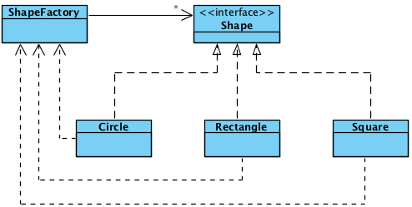

### Intent
Define an interface for creating an object, but let subclasses decide which class to instantiate.

### Real-time example
In a **notification system**, you might send notifications through email, SMS, or push. The client should not know the exact class being created.

### When to use
- Object creation depends on runtime input
- You want to decouple creation from usage

### Java example
```java
interface Notification {
void send();
}

class EmailNotification implements Notification {
public void send() {
System.out.println("Sending email notification");
}
}

class SMSNotification implements Notification {
public void send() {
System.out.println("Sending SMS notification");
}
}

abstract class NotificationFactory {
abstract Notification createNotification();
}

class EmailNotificationFactory extends NotificationFactory {
Notification createNotification() {
return new EmailNotification();
}
}

class SMSNotificationFactory extends NotificationFactory {
Notification createNotification() {
return new SMSNotification();
}
}
```

### Usage
```java
NotificationFactory factory = new EmailNotificationFactory();
Notification notification = factory.createNotification();
notification.send();
```

### Real benefit
If tomorrow you add WhatsApp notifications, you can create a new factory without changing existing client code much.

---

## 3. Abstract Factory Pattern

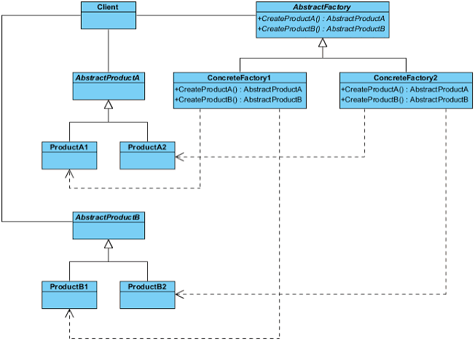

### Intent
Provide an interface for creating families of related objects without specifying their concrete classes.

### Real-time example
A **UI toolkit** for Windows and Mac may need buttons, checkboxes, and text fields that match the same theme.

### When to use
- You need to create related objects together
- You want consistency across product families

### Java example
```java
interface Button {
void render();
}

interface Checkbox {
void render();
}

class WindowsButton implements Button {
public void render() {
System.out.println("Rendering Windows button");
}
}

class MacButton implements Button {
public void render() {
System.out.println("Rendering Mac button");
}
}

class WindowsCheckbox implements Checkbox {
public void render() {
System.out.println("Rendering Windows checkbox");
}
}

class MacCheckbox implements Checkbox {
public void render() {
System.out.println("Rendering Mac checkbox");
}
}

interface UIFactory {
Button createButton();
Checkbox createCheckbox();
}

class WindowsUIFactory implements UIFactory {
public Button createButton() {
return new WindowsButton();
}

public Checkbox createCheckbox() {
return new WindowsCheckbox();
}
}

class MacUIFactory implements UIFactory {
public Button createButton() {
return new MacButton();
}

public Checkbox createCheckbox() {
return new MacCheckbox();
}
}
```

### Why it matters
It ensures all components in the UI belong to the same style family.

---

## 4. Builder Pattern

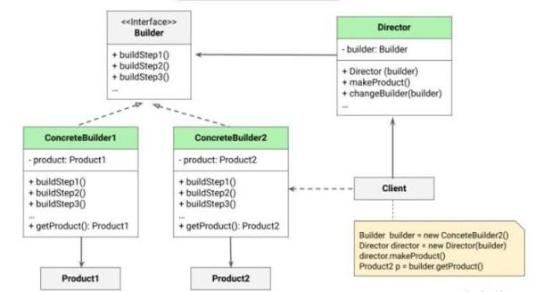

### Intent
Construct complex objects step by step.

### Real-time example
Building a **custom meal** or **laptop configuration**. You may want optional parts like extra cheese, toppings, RAM, SSD, and warranty.

### When to use
- Object has many optional parameters
- You want readable construction
- You want immutable objects

### Java example
```java
public class Pizza {
private final String dough;
private final String sauce;
private final boolean cheese;
private final boolean olives;

private Pizza(Builder builder) {
this.dough = builder.dough;
this.sauce = builder.sauce;
this.cheese = builder.cheese;
this.olives = builder.olives;
}

public static class Builder {
private String dough;
private String sauce;
private boolean cheese;
private boolean olives;

public Builder dough(String dough) {
this.dough = dough;
return this;
}

public Builder sauce(String sauce) {
this.sauce = sauce;
return this;
}

public Builder cheese(boolean cheese) {
this.cheese = cheese;
return this;
}

public Builder olives(boolean olives) {
this.olives = olives;
return this;
}

public Pizza build() {
return new Pizza(this);
}
}
}
```

### Usage
```java
Pizza pizza = new Pizza.Builder()
.dough("Thin Crust")
.sauce("Tomato")
.cheese(true)
.olives(true)
.build();
```

### Advantages
- Very readable
- Avoids telescoping constructors
- Good for immutable objects

---

## 5. Prototype Pattern

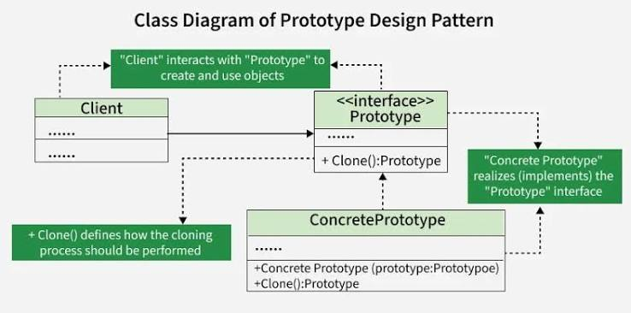

### Intent
Create new objects by cloning existing ones.

### Real-time example
In games, if you need many similar enemies or characters, cloning is often faster than creating each from scratch.

### When to use
- Object creation is expensive
- You need many similar copies

### Java example
```java
class UserProfile implements Cloneable {
private String name;
private String email;

public UserProfile(String name, String email) {
this.name = name;
this.email = email;
}

public UserProfile clone() throws CloneNotSupportedException {
return (UserProfile) super.clone();
}
}
```

---

# 2) Structural Design Patterns

Structural patterns focus on how classes and objects are combined to form larger structures.

---

## 6. Adapter Pattern

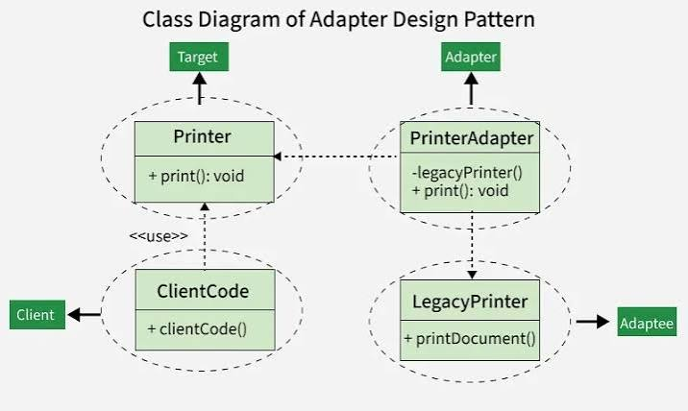

### Intent
Convert one interface into another interface that the client expects.

### Real-time example
Suppose your app expects `PaymentProcessor`, but a third-party library gives you `LegacyPayService`. Adapter helps connect them.

### When to use
- Integrating old systems
- Working with third-party APIs

### Java example
```java
interface PaymentProcessor {
void pay(double amount);
}

class OldPaymentSystem {
void makePayment(double amount) {
System.out.println("Paid using old system: " + amount);
}
}

class PaymentAdapter implements PaymentProcessor {
private OldPaymentSystem oldPaymentSystem;

public PaymentAdapter(OldPaymentSystem oldPaymentSystem) {
this.oldPaymentSystem = oldPaymentSystem;
}

public void pay(double amount) {
oldPaymentSystem.makePayment(amount);
}
}
```

### Real benefit
You can use legacy code without rewriting your whole system.

---

## 7. Decorator Pattern

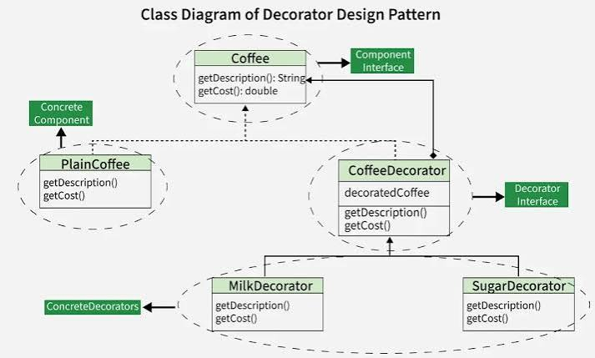

### Intent
Add new behavior to an object dynamically without changing its class.

### Real-time example
Coffee shop orders, where you can add milk, sugar, whipped cream, or caramel to a base coffee.

### When to use
- You need flexible feature combinations
- Avoid subclass explosion

### Java example
```java
interface Coffee {
double cost();
String description();
}

class SimpleCoffee implements Coffee {
public double cost() {
return 50;
}

public String description() {
return "Simple Coffee";
}
}

abstract class CoffeeDecorator implements Coffee {
protected Coffee coffee;

public CoffeeDecorator(Coffee coffee) {
this.coffee = coffee;
}
}

class MilkDecorator extends CoffeeDecorator {
public MilkDecorator(Coffee coffee) {
super(coffee);
}

public double cost() {
return coffee.cost() + 10;
}

public String description() {
return coffee.description() + ", Milk";
}
}
```

### Usage
```java
Coffee coffee = new MilkDecorator(new SimpleCoffee());
System.out.println(coffee.cost());
System.out.println(coffee.description());
```

---

## 8. Facade Pattern

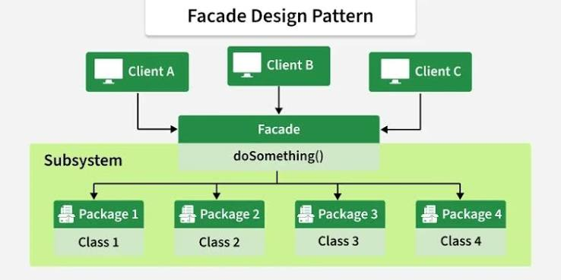

### Intent
Provide a simplified interface to a complex subsystem.

### Real-time example
A **hotel booking app** might internally call payment, room service, notification, and inventory systems. The facade exposes one simple booking API.

### When to use
- You want to hide subsystem complexity
- You need a cleaner entry point

### Java example
```java
class PaymentService {
void pay() {
System.out.println("Payment processed");
}
}

class InventoryService {
void reserveRoom() {
System.out.println("Room reserved");
}
}

class NotificationService {
void sendConfirmation() {
System.out.println("Confirmation sent");
}
}

class HotelBookingFacade {
private PaymentService paymentService = new PaymentService();
private InventoryService inventoryService = new InventoryService();
private NotificationService notificationService = new NotificationService();

public void bookRoom() {
inventoryService.reserveRoom();
paymentService.pay();
notificationService.sendConfirmation();
}
}
```

### Benefit
The client only interacts with one simple method instead of many subsystem classes.

---

## 9. Proxy Pattern

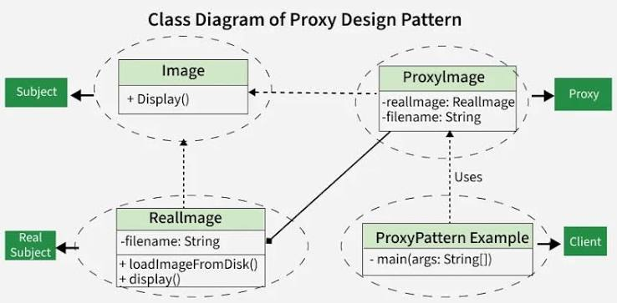

### Intent
Provide a placeholder or surrogate for another object to control access to it.

### Real-time example
A **lazy-loaded image** on a website, or access control for sensitive resources.

### When to use
- Lazy initialization
- Access control
- Logging
- Caching

### Java example
```java
interface Image {
void display();
}

class RealImage implements Image {
private String fileName;

public RealImage(String fileName) {
this.fileName = fileName;
loadFromDisk();
}

private void loadFromDisk() {
System.out.println("Loading " + fileName);
}

public void display() {
System.out.println("Displaying " + fileName);
}
}

class ProxyImage implements Image {
private RealImage realImage;
private String fileName;

public ProxyImage(String fileName) {
this.fileName = fileName;
}

public void display() {
if (realImage == null) {
realImage = new RealImage(fileName);
}
realImage.display();
}
}
```

---

# 3) Behavioral Design Patterns

Behavioral patterns focus on communication between objects and how responsibilities are distributed.

---

## 10. Strategy Pattern

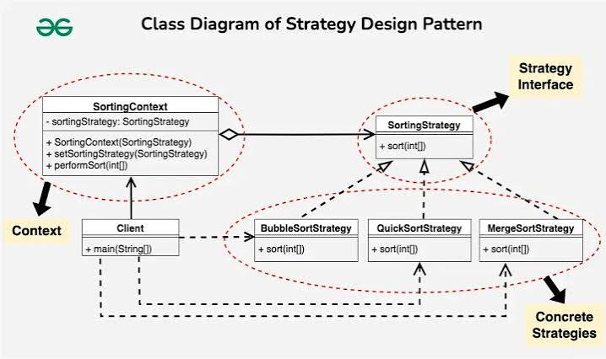

### Intent
Define a family of algorithms, encapsulate each one, and make them interchangeable.

### Real-time example
Different payment methods, routing strategies, or sorting algorithms.

### When to use
- Multiple ways to do the same task
- You want runtime flexibility

### Java example
```java
interface PaymentStrategy {
void pay(int amount);
}

class CreditCardPayment implements PaymentStrategy {
public void pay(int amount) {
System.out.println("Paid " + amount + " using credit card");
}
}

class UpiPayment implements PaymentStrategy {
public void pay(int amount) {
System.out.println("Paid " + amount + " using UPI");
}
}

class PaymentContext {
private PaymentStrategy strategy;

public PaymentContext(PaymentStrategy strategy) {
this.strategy = strategy;
}

public void executePayment(int amount) {
strategy.pay(amount);
}
}
```

### Usage
```java
PaymentContext context = new PaymentContext(new UpiPayment());
context.executePayment(500);
```

---

## 11. Observer Pattern

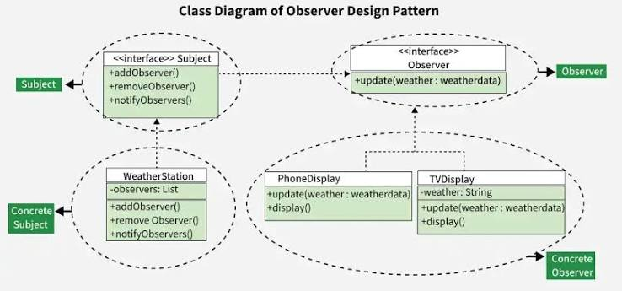

### Intent
Define a one-to-many dependency so that when one object changes state, all its dependents are notified.

### Real-time example
Stock market apps, YouTube subscriptions, weather updates, notification systems.

### When to use
- Event-driven systems
- One object changes and many must react

### Java example
```java
import java.util.ArrayList;
import java.util.List;

interface Observer {
void update(String message);
}

class Subscriber implements Observer {
private String name;

public Subscriber(String name) {
this.name = name;
}

public void update(String message) {
System.out.println(name + " received: " + message);
}
}

class YouTubeChannel {
private List<Observer> subscribers = new ArrayList<>();

public void subscribe(Observer observer) {
subscribers.add(observer);
}

public void unsubscribe(Observer observer) {
subscribers.remove(observer);
}

public void notifySubscribers(String message) {
for (Observer observer : subscribers) {
observer.update(message);
}
}
}
```

### Real benefit
A new subscriber can be added without changing the publisher logic.

---

## 12. Command Pattern

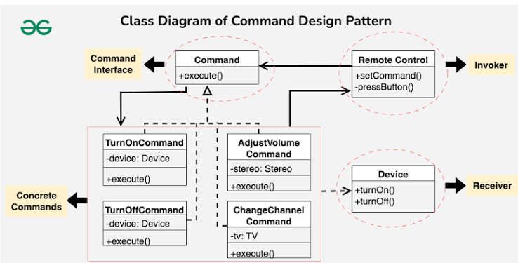

### Intent
Encapsulate a request as an object.

### Real-time example
Remote controls, undo/redo operations, task queues.

### When to use
- You want to queue, log, or retry actions
- You need undo functionality

### Java example
```java
interface Command {
void execute();
}

class Light {
void on() {
System.out.println("Light turned on");
}
}

class LightOnCommand implements Command {
private Light light;

public LightOnCommand(Light light) {
this.light = light;
}

public void execute() {
light.on();
}
}
```

---

## 13. State Pattern

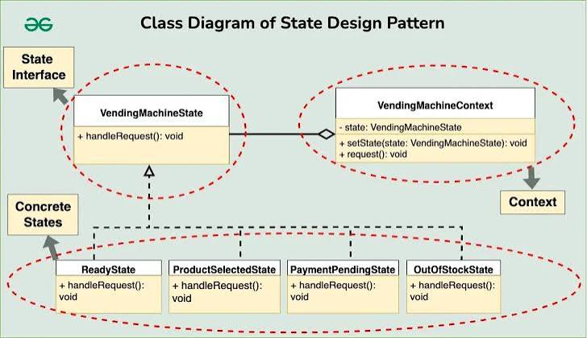

### Intent
Allow an object to change its behavior when its internal state changes.

### Real-time example
An **ATM machine** behaves differently when it has cash, when it is out of cash, or when a card is inserted.

### When to use
- Behavior depends on internal state
- You want to avoid large conditional statements

### Java example
```java
interface State {
void handle();
}

class ActiveState implements State {
public void handle() {
System.out.println("System is active");
}
}

class InactiveState implements State {
public void handle() {
System.out.println("System is inactive");
}
}
```

---

## 14. Template Method Pattern

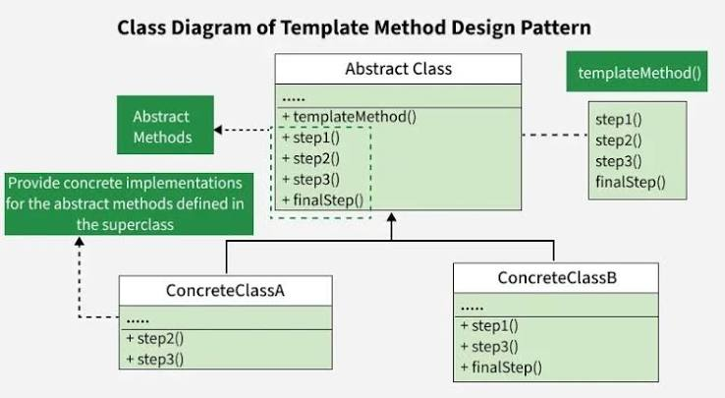

### Intent
Define the skeleton of an algorithm in a method, but let subclasses override certain steps.

### Real-time example
Cooking recipes, document generation, data processing pipelines.

### When to use
- Same workflow with some customizable steps

### Java example
```java
abstract class DataProcessor {
public final void process() {
loadData();
processData();
saveData();
}

protected abstract void loadData();
protected abstract void processData();
protected abstract void saveData();
}
```

### Benefit
Common workflow stays in one place, while steps can vary.

---

# Quick interview-friendly summary

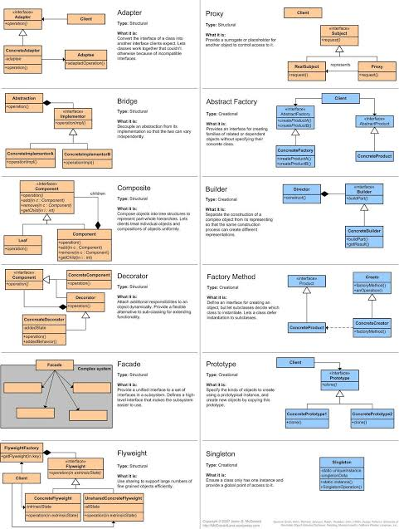

## Creational
- **Singleton**: one instance
- **Factory Method**: subclass decides object creation
- **Abstract Factory**: create related families of objects
- **Builder**: construct complex objects step by step
- **Prototype**: clone existing objects

## Structural
- **Adapter**: convert one interface to another
- **Decorator**: add behavior dynamically
- **Facade**: simplify a complex subsystem
- **Proxy**: control access to an object

## Behavioral
- **Strategy**: switch algorithms at runtime
- **Observer**: notify dependents on state change
- **Command**: turn requests into objects
- **State**: change behavior based on state
- **Template Method**: define algorithm skeleton

# How to remember them with real-life analogies

- **Singleton**: one central office
- **Factory**: car factory produces different car types
- **Builder**: assembling a custom PC
- **Adapter**: travel plug adapter
- **Decorator**: adding toppings to pizza
- **Facade**: hotel receptionist handling multiple services
- **Proxy**: security guard controlling access
- **Strategy**: choosing payment method
- **Observer**: YouTube channel subscribers
- **Command**: remote control buttons

# Best way to answer in interviews

If asked, “Explain design patterns in Java,” say:

> Design patterns are proven solutions to recurring design problems. In Java, they are usually grouped into creational, structural, and behavioral patterns. They help improve code reusability, flexibility, and maintainability. For example, Builder helps with complex object creation, Adapter helps integrate incompatible interfaces, and Strategy helps switch algorithms at runtime.

If you want, I can next provide:

1. **All Java design patterns in one diagram**
2. **A Java design patterns cheat sheet**
3. **Interview-focused answers for each pattern**
4. **Real-world project examples for each pattern**

