**PRADEEP MOTAPPA**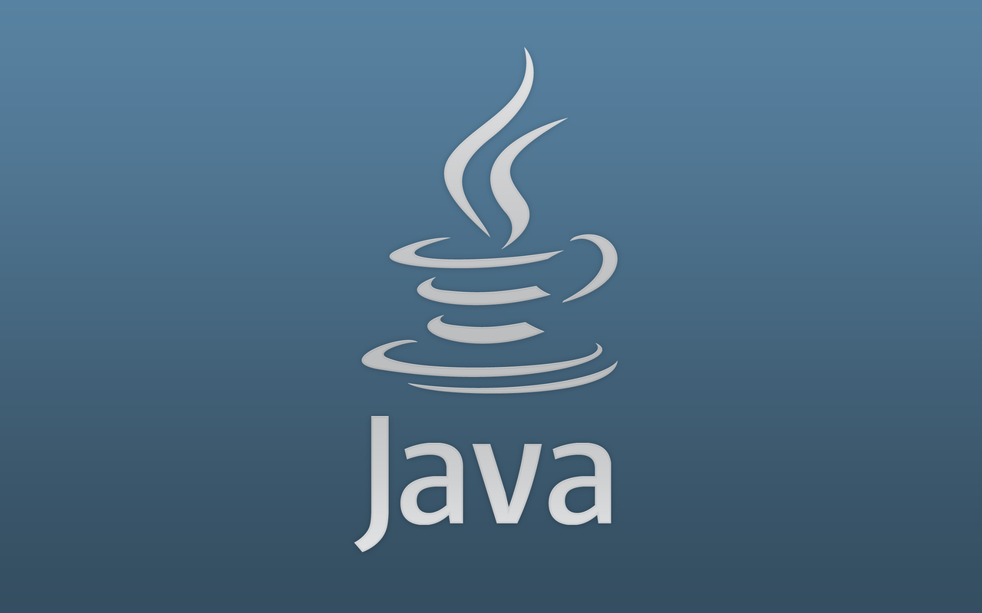

INSTALLATION OF JAVA - LINUX

[**INSTALLATION OF JAVA - LINUX**](http://www.wikihow.com/Install-Oracle-Java-on-Ubuntu-Linux)

This tutorial will cover the installation of **32-bit** and **64-bit** Oracle Java 7 (currently version number **1.7.0_51**) JDK/JRE on **32-bit** and **64-bit** LINUX operating systems.

These instructions will also work on **RedHat, Debian** and **LINUX Mint**.

If you already have Oracle Java 7 installed on your system but need to upgrade then use this method:

* [How to Upgrade Oracle Java on LINUX](http://www.wikihow.com/Upgrade-Oracle-Java-on-Ubuntu-Linux)

For those who **only** want to install Oracle Java JRE for running Java applications and not to develop Java programs use this method:

* [How to install Oracle Java JRE on LINUX](http://www.wikihow.com/Install-Oracle-Java-JRE-on-Ubuntu-Linux)

For those who want to install Oracle Java JDK to develop Java programs and applications (the Oracle Java JRE is also included in the Oracle JDK) use this method:

* [How to install Oracle Java JDK on LINUX](http://www.wikihow.com/Install-Oracle-Java-JDK-on-Ubuntu-Linux)

Also to enable/upgrade the Oracle Java in your web browsers:

* [How to Enable Oracle Java in your Web Browsers](http://www.wikihow.com/Enable-Oracle-Java-in-Your-Web-Browsers-on-Ubuntu-Linux)

**STEP – 1**

**Check to see if your LINUX Operating System Architecture is 32-bit or 64-bit.**

**Open up a Terminal & run the following command below.**

$file /sbin/init

**OUTPUT:**

/sbin/init: ELF 64-bit LSB shared object, x86-64, version 1 (SYSV),

dynamically linked (uses shared libs), for GNU/Linux 2.6.18, stripped

**STEP – 2**

**Check if you have Java installed on your system.**

$java -version

**OUTPUT:** (If you have OpenJDK installed on your system, it may look like this)

java version "1.7.0_15"

OpenJDK Runtime Environment (IcedTea6 1.10pre) (7b15~pre1-0lucid1)

OpenJDK 64-Bit Server VM (build 19.0-b09, mixed mode)

** **If you have OpenJDK installed on your system, you have the wrong vendor version of Java installed for this exercise.

**STEP – 3**

**Completely remove the OpenJDK/JRE from your Debian (Ubuntu, SUSE Linux) System.**

$sudo apt-get purge openjdk-\*

**Completely remove the OpenJDK/JRE from your Redhat & Fedora Systems.**

$sudo yum remove openjdk-\*

**** This command will completely remove OpenJDK/JRE from your system.

** **This will prevent system conflicts and confusion between different vendor versions of Java.

**STEP – 4**

**Create a Directory to hold your Oracle Java JDK/JRE binaries.**

$sudo mkdir -pv /opt/java

** **This command will create a directory to hold your Oracle Java JDK and JRE binaries.

[**Download the Oracle Java JDK/JRE for LINUX**](http://www.oracle.com/technetwork/java/javase/downloads/index.html).

Make sure you select the correctcompressed binaries for your System Architecture **32-bit** or **64-bit** (which has an extension “.tar.gz” or “.tar”)

* + For example, if you are on LINUX 32-bit operating system download 32-bit Oracle Java binaries.
  + For example, if you are on LINUX 64-bit operating system download 64-bit Oracle Java binaries.

**STEP – 5**

**Copy the Oracle Java binaries into the “/opt/java” directory.**

* **32-bit Oracle Java on 32-bit LINUX installation instructions:**

$cd ~/Downloads

$sudo cp -frv jdk-7u51-LINUX-i586.tar.gz /opt/java/

$cd /opt/java/

* **64-bit Oracle Java on 64-bit LINUX installation instructions:**

$cd ~/Downloads

$sudo cp -frv jdk-7u51-LINUX-x64.tar.gz /opt/java

$cd /opt/java

**STEP – 6**

**Unpack the compressed Java binaries in the directory “/opt/java”**

* + **32-bit Oracle Java on 32-bit LINUX installation instructions:**

$sudo tar -xvzf jdk-7u51-LINUX-i586.tar.gz # 🡪 **JDK**

$sudo tar -xvzf jre-7u51-LINUX-i586.tar.gz # 🡪 **JRE**

* + **64-bit Oracle Java on 64-bit LINUX installation instructions:**

$sudo tar -xvzf jdk-7u51-LINUX-x64.tar.gz # 🡪 **JDK**

$sudo tar -xvzf jre-7u51-LINUX-x64.tar.gz # 🡪 **JRE**

**STEP – 7**

**Edit the system PATH file “/etc/profile” & add the following System Variables to your System Path.**

Use “nano”, “gedit” or “any other text editor”, as root, open up “/etc/profile”

I am using “**vim**” editor.

$sudo vim /etc/profile

**STEP – 8**

**Scroll down to the end of the file using your arrow keys & add the following lines below to the end of your “/etc/profile” file:**

* **If you are installing the JRE:**

JRE_HOME=/opt/java/**jre1.7.0_51**  
PATH=$PATH:$HOME/bin:$JRE_HOME/bin

export JRE_HOME  
export PATH

* **If you are installing the JDK:**

JAVA_HOME=/opt/java/**jdk1.7.0_51**  
PATH=$PATH:$HOME/bin:$JAVA_HOME/bin

JRE_HOME=/opt/java/**jdk1.7.0_51**/jre  
PATH=$PATH:$HOME/bin:$JRE_HOME/bin

export JAVA_HOME  
export JRE_HOME  
export PATH

Save the “/etc/profile” file & exit (esc + :wq).

**STEP – 9**

**Inform your LINUX System where your Oracle Java JDK/JRE is located.**

This will tell the system that the new Oracle Java version is available for use.

* **If you are installing the JRE:**

$sudo update-alternatives --install "/usr/bin/java" "java"**<<space>>** "/opt/java/jre1.7.0_51/bin/java" 1

** **This command notifies the System that Oracle Java JRE is available for use

* **If you are installing the JDK:**

$sudo update-alternatives --install "/usr/bin/java" "java"**<<SPACE>>** "/opt/java/jdk1.7.0_51/bin/java" 1

** **This command notifies the System that Oracle Java JRE is available for use

$sudo update-alternatives --install "/usr/bin/javac" "javac"**<<SPACE>>** "/opt/java/jdk1.7.0_51/bin/javac" 1

** **This command notifies the system that Oracle Java JDK is available for use

$sudo update-alternatives --install "/usr/bin/javaws" "javaws"**<<SPACE>>** "/opt/java/jdk1.7.0_51/bin/javaws" 1

** **This command notifies the system that Oracle Java Web Start is available for use.

**STEP – 10**

**Inform your LINUX System that Oracle Java JDK/JRE must be the Default Java.**

* **If you are installing the JRE:**

$sudo update-alternatives --set java /opt/java/jre1.7.0_51/bin/java

** **This command will set the Java Runtime Environment for the System.

$sudo update-alternatives --set javaws /opt/java/jre1.7.0_51/bin/javaws

** **This command will set Java Web Start for the System.

* **If you are installing the JDK:**

$sudo update-alternatives --set java /opt/java/jdk1.7.0_51/bin/java

** **This command will set the Java Runtime Environment for the System.

$sudo update-alternatives --set javac /opt/java/jdk1.7.0_51/bin/javac

** **This command will set the Java Compiler for the System.

$sudo update-alternatives --set javaws /opt/java/jdk1.7.0_51/bin/javaws

** **This command will set Java Web Start for the System.

**STEP – 11**

**Reload your System Wide PATH “/etc/profile” by typing the following command:**

$. /etc/profile

** **Note your System-Wide PATH “**/etc/profile**”.

** **File will reload after reboot of your LINUX System.

**STEP – 12**

**Test to see if Oracle Java was installed correctly on your system.**

Run the following commands and note the version of Java:

* **A Successful Installation of 32-Bit Oracle Java will display:**

$java -version

**OUTPUT:**

Java Version "1.7.0_51"  
Java(TM) SE Runtime Environment (build 1.7.0_51-b18)  
Java HotSpot(TM) Server VM (build 24.51-b08, mixed mode)

** **This command lets you know that you are now able to compile Java programs from the terminal.

$javac -version

**OUTPUT:**

javac 1.7.0_51

** **This command lets you know that you are now able to compile Java programs from the terminal.

* **A Successful Installation of Oracle Java 64-bit will display:**

$java –version

**OUTPUT:**

Java Version "1.7.0_51"  
Java(TM) SE Runtime Environment (build 1.7.0_51-b18)  
Java HotSpot(TM) **64-Bit** Server VM (build 24.51-b08, mixed mode)

** **This command lets you know that you are now able to Compile Java Programs from the terminal.

$javac -version

**OUTPUT:**

javac 1.7.0_51

** **This command lets you know that you are now able to compile Java programs from the terminal.

**Congratulations, you just Installed Oracle Java on your LINUX System.**

Now reboot your LINUX system.

Afterwards, your system will be fully configured for running and developing Java programs. Later on you may want to try compiling and running your own Java programs by following this article [How to Create your First Java Program on LINUX](http://www.wikihow.com/Create-Your-First-Java-Program-on-Ubuntu-Linux)Top of FormBottom of Form