# **Case Stydy – Pixogram**

# **Pradeep Nayak (napradee@in.ibm.com)**

Spring boot Microservices for Pixogram:

1. netflix-eureka-server
2. usernamanagement
3. mediaservice

Angular8 – Pixogram User Interface

1. PixogramUI

Database – MySql

# **Screens**

## Eureka Server

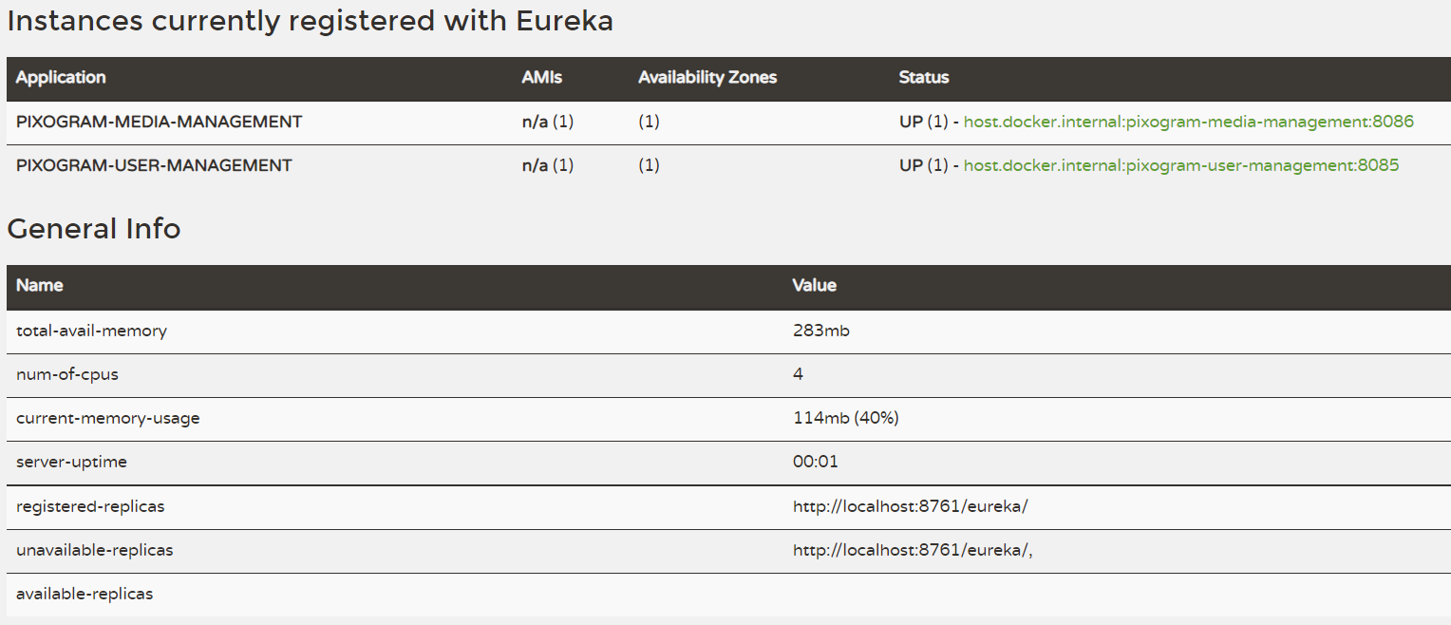

## **Database Schema Details**

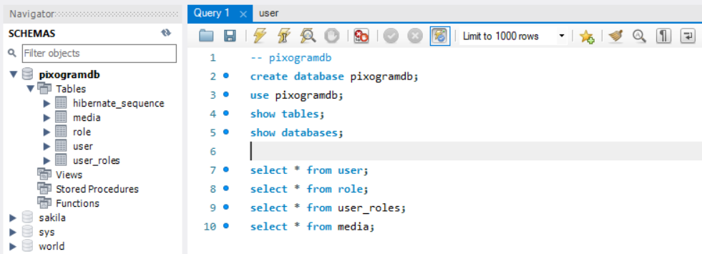

**describe user;**

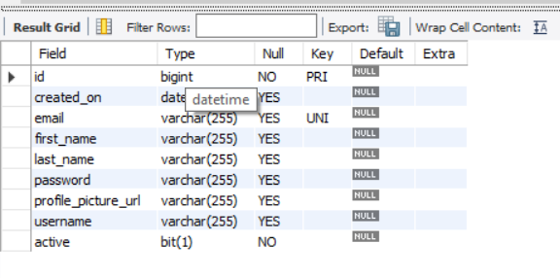

**describe role;**

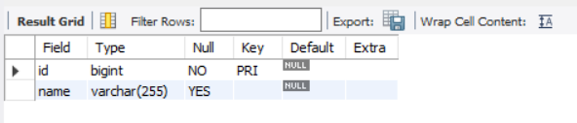

**describe user_roles;**

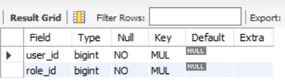

**describe media;**

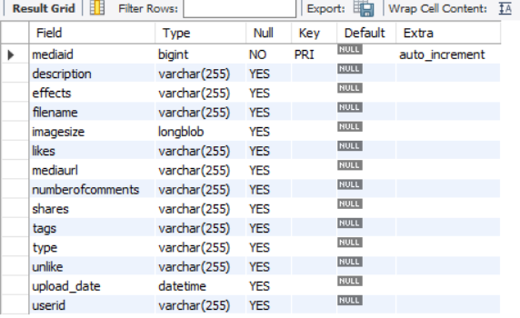

**select * from user;**

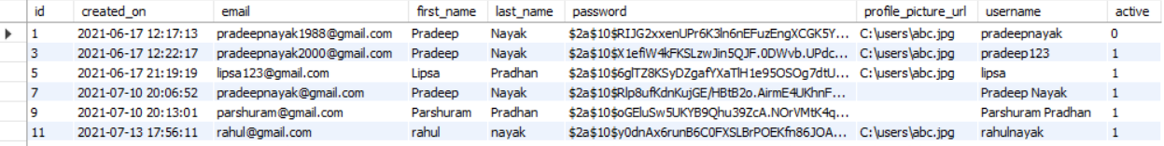

**select * from role;**

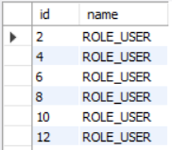

**select * from user_roles;**

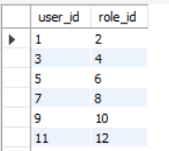

**select * from media;**

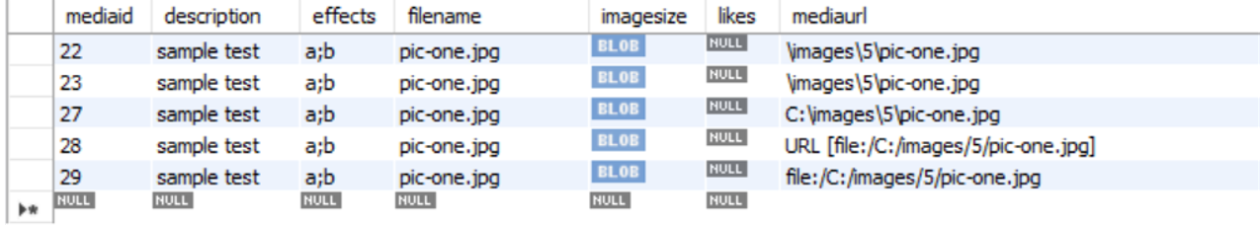

# **Usermanagement module screen shots**

**No Input or Invalid Login**

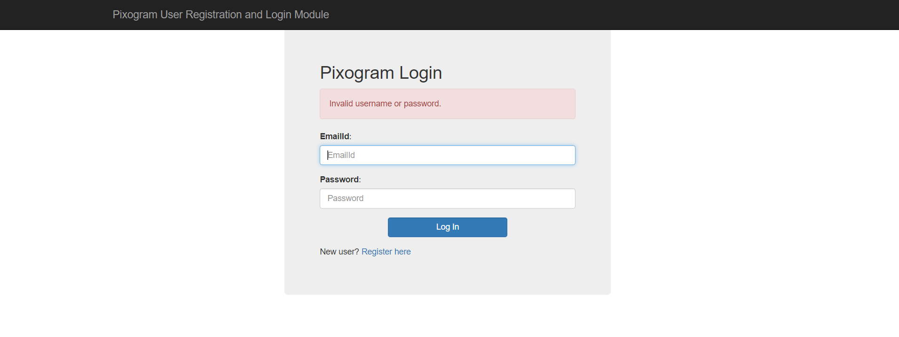

**Successful Login**

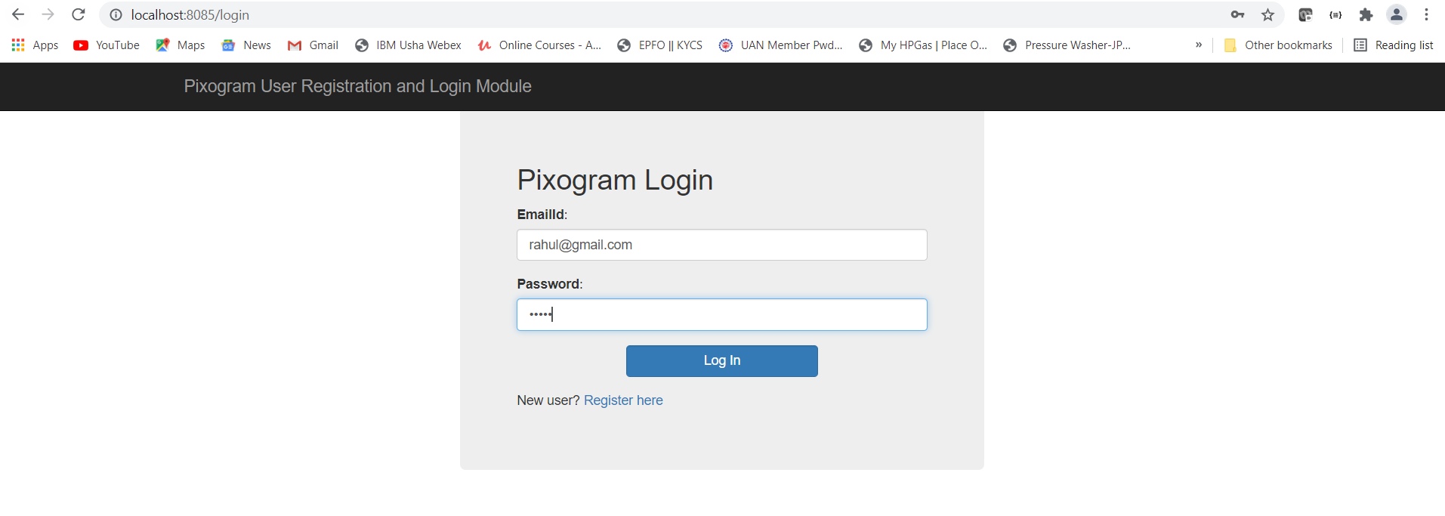

**Home Page**

**Logout Successful**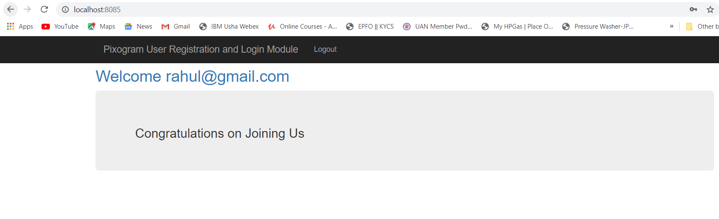

**Logout Successful Page**

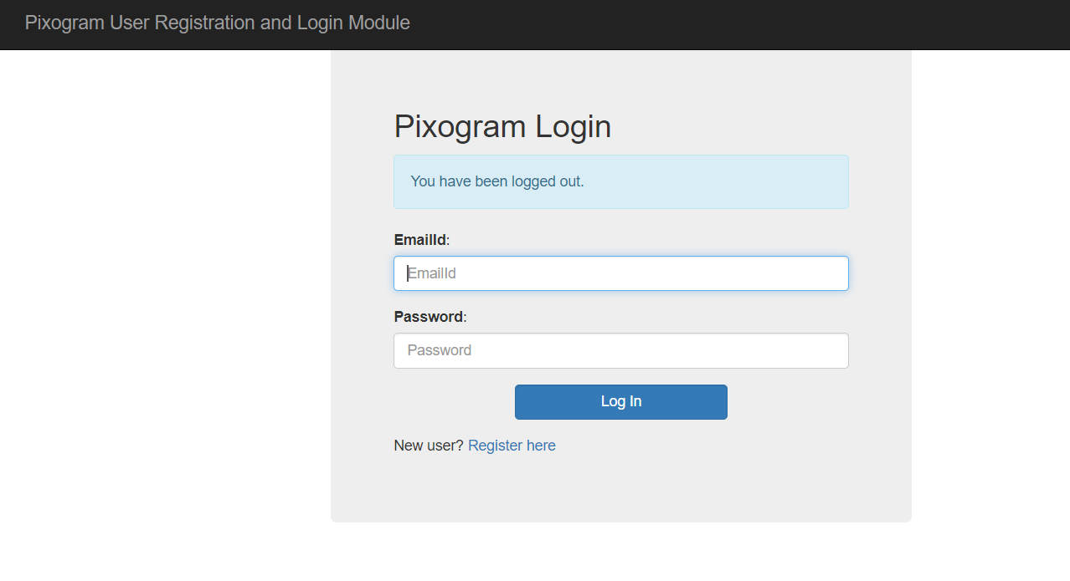

**User Registration Page**

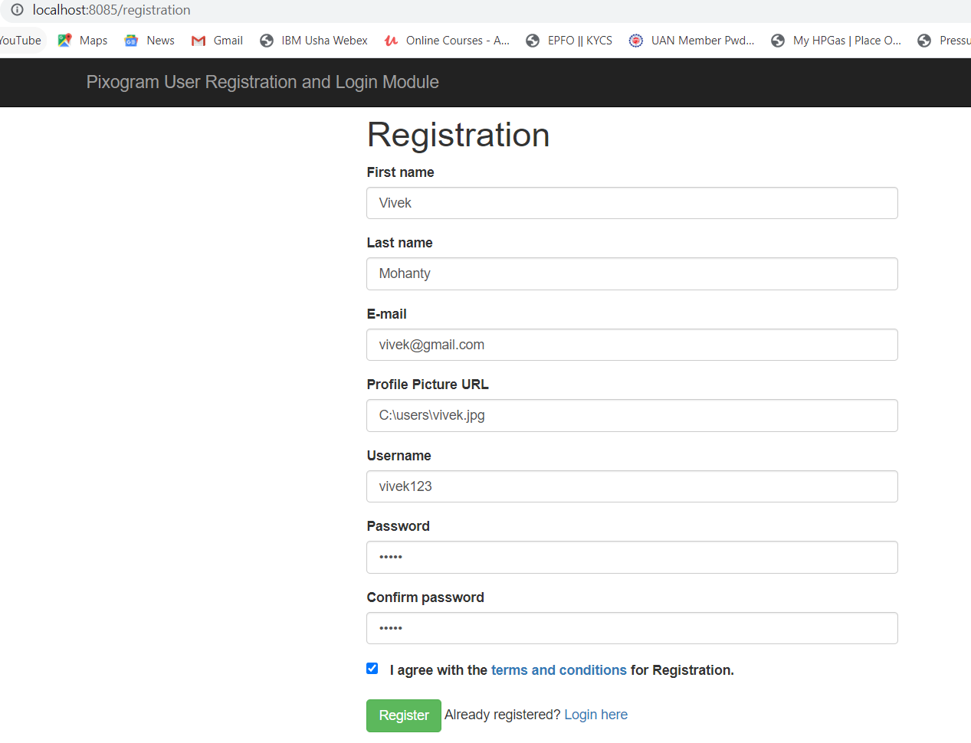

**Successful Registrarion**

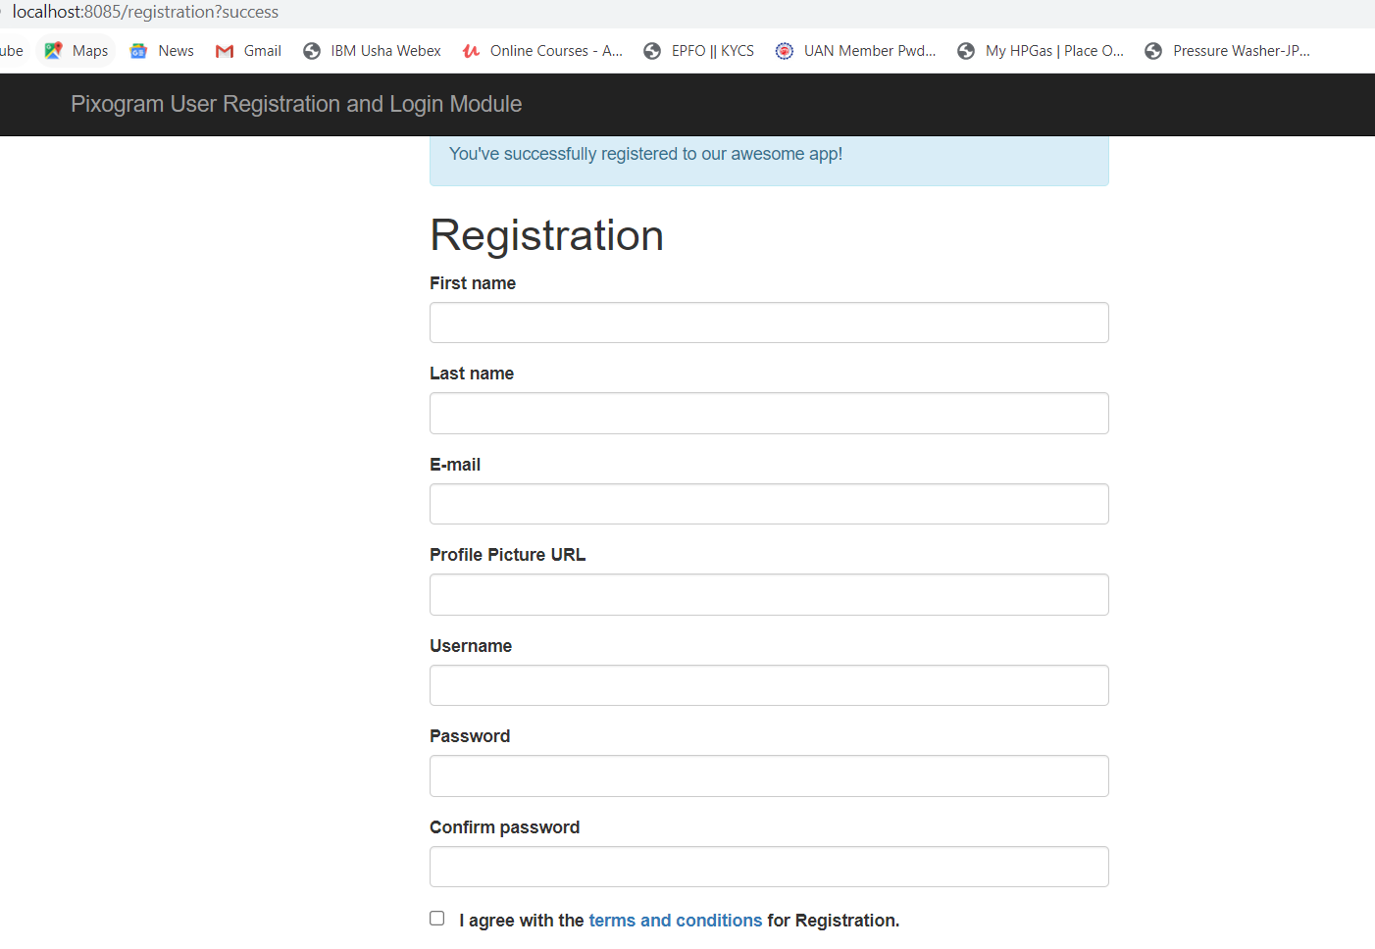

**JWT Authentication Token generation**

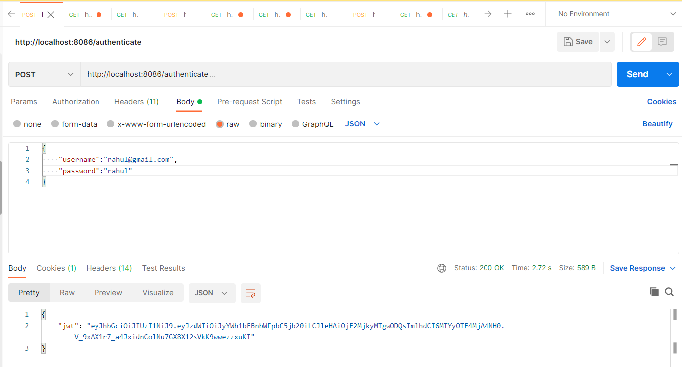

**Passing JWT Auth Token to access media service End Points**

**Invalid Authentication Token Forbidden Error**

