MedBox
Home Medicine Management App
App Design & Reference Document
Version 1.0 · April 2025
Built with Flutter + Firebase

1. App Overview
MedBox is a personal mobile application for managing home medicines and prescriptions for a family. It tracks what medicines are available, when they expire, who they belong to, and which hospital prescription they came from. The app sends alerts when medicines are nearing expiry or have been opened for too long.

App name | MedBox
Platform | iOS & Android (Flutter)
Backend | Firebase (Firestore + Storage + Cloud Functions)
State management | Riverpod (recommended)
Navigation | go_router
Primary users | Individual / family — personal use

1.1 Core objectives
- Track all medicines at home with patient, dates, expiry, and photo
- Record prescriptions from hospital visits with doctor and cause of illness
- Alert when medicines are expiring soon (1 / 7 / 30 day thresholds)
- Alert when opened medicines have been in use for more than 3 months
- Support multiple family members (patients) under one app

2. Screens
MedBox has 12 screens organised across 4 bottom navigation tabs.

# | Screen | Description
1 | Splash Screen | Entry point — initialises Firebase, routes to Dashboard.
2 | Dashboard | Home overview: stats, alerts, patients, recent medicines, prescriptions, quick actions.
3 | Medicine List | Full list with search, sort, filter. Grouped: Needs Attention first.
4 | Medicine Detail | Full view: photo, name, patient, form, dosage, dates, opened status, linked prescription.
5 | Add / Edit Medicine | Form with image capture, patient chips, dosage, dates, opened toggle, prescription link.
6 | Prescription List | All prescriptions grouped by year with search and patient filter.
7 | Prescription Detail | Image, patient, cause, visit date, doctor, hospital, linked medicines with status.
8 | Add / Edit Prescription | Form with photo capture, patient selector, visit info, inline medicine list.
9 | Alerts Screen | Tabs: Expiring (critical/warning), Opened (3+ months), Dismissed.
10 | Alert Settings | Expiry thresholds, opened threshold, push notification config, daily check time.
11 | Patient List | Manage family members — name, relationship, medicine count.
12 | Add / Edit Patient | Form: name, date of birth, relationship, optional photo.

3. Navigation Flow
The app uses a persistent bottom navigation bar with 4 tabs. All screens within a tab are pushed onto that tab's navigation stack. Cross-tab deep links are supported from Alerts and Dashboard.

Bottom navigation tabs
- Home → Dashboard Screen
- Medicines → Medicine List Screen
- Prescriptions (Rx) → Prescription List Screen
- Alerts → Alerts Screen

From | To | Trigger
Dashboard | Medicine Detail | Tap medicine card
Dashboard | Prescription Detail | Tap prescription card
Dashboard | Add Medicine / Add Prescription | Quick action buttons
Medicine List | Medicine Detail | Tap medicine card
Medicine Detail | Edit Medicine | Edit button (top right)
Medicine Detail | Prescription Detail | Tap linked prescription row
Medicine List | Add Medicine | FAB (+) button
Prescription List | Prescription Detail | Tap prescription card
Prescription Detail | Edit Prescription | Edit button (top right)
Prescription Detail | Medicine Detail | Tap medicine row
Prescription List | Add Prescription | FAB (+) button
Alerts | Alert Settings | Settings gear icon
Alerts | Medicine Detail | Tap 'View medicine' on alert card
Dashboard | Patient List | Tap patient section manage link

4. Data Model
MedBox uses Firebase Firestore. Four core collections: patients, prescriptions, medicines, and alerts.

4.1 Patient
Field | Type | Description
id | UUID (PK) | Auto-generated unique identifier
name | String | Full name of the patient
dob | String | Date of birth (DD/MM/YYYY)
relationship | String | self / spouse / parent / child / other
avatar_url | String? | Optional profile photo URL (Firebase Storage)
created_at | Timestamp | Record creation timestamp

4.2 Prescription
Field | Type | Description
id | UUID (PK) | Auto-generated unique identifier
patient_id | UUID (FK) | Reference to Patient
cause_of_sickness | String | Diagnosis or reason for visit
visit_date | Date | Date of hospital / clinic visit
doctor_name | String? | Name of the treating doctor
hospital_name | String? | Name of hospital or clinic
image_url | String? | URL of prescription photo
notes | String? | Follow-up instructions, remarks
created_at / updated_at | Timestamp | Created and last updated timestamps

4.3 Medicine
Field | Type | Description
id | UUID (PK) | Auto-generated unique identifier
prescription_id | UUID? (FK) | Optional link to Prescription
patient_id | UUID (FK) | Reference to Patient (required)
name | String | Medicine name and strength
form | String | Tablet / Capsule / Syrup / Drops / Cream / Other
dosage | String? | Dosage instructions
quantity | String? | Amount remaining
image_url | String? | URL of medicine photo
date_purchased | Date | Date received or purchased (required)
expiry_date | Date? | Expiry date — drives expiry alerts
is_opened | Boolean | Whether seal is broken (default: false)
date_opened | Date? | Date opened — drives opened alerts
is_available | Boolean | Still in stock (default: true)
notes | String? | Special instructions or warnings
created_at / updated_at | Timestamp | Created and last updated timestamps

4.4 Alert
Field | Type | Description
id | UUID (PK) | Auto-generated unique identifier
medicine_id | UUID (FK) | Medicine that triggered this alert
alert_type | String | EXPIRY_WARNING or OPENED_TOO_LONG
status | String | ACTIVE or DISMISSED
triggered_on | Date | Date alert was generated
is_dismissed | Boolean | Whether user dismissed this alert
created_at | Timestamp | Record creation timestamp

Entity relationships
- Patient 1 : many Prescription
- Patient 1 : many Medicine
- Prescription 1 : many Medicine (optional link — medicine can exist without a prescription)
- Medicine 1 : many Alert

5. Screen Designs
Each screen is shown with its design mockup alongside key details about what is displayed and how it works.

5.1. Dashboard  The home screen gives a complete snapshot of the family medicine cabinet. It is the first screen seen on app launch.  - Top bar: App name, greeting with user name, notification bell with red badge when alerts exist  - Overview stats (2×2 grid): Total medicines (green), Expiring soon (red), Opened 3+ months (amber), Total prescriptions this year  - Active alerts: Top 2–3 critical alerts inline — red for expiring, amber for opened  - Patients row: Horizontally scrollable avatar chips per family member with medicine count  - Recent medicines: Last 3–4 medicines with name, patient, status badge, expiry  - Recent prescriptions: Last 2 cards with cause, date, patient avatar, medicine count  - Quick actions: 'Add medicine' and 'Add prescription' shortcut buttons  - Bottom nav: Home, Medicines, Prescriptions, Alerts tabs | 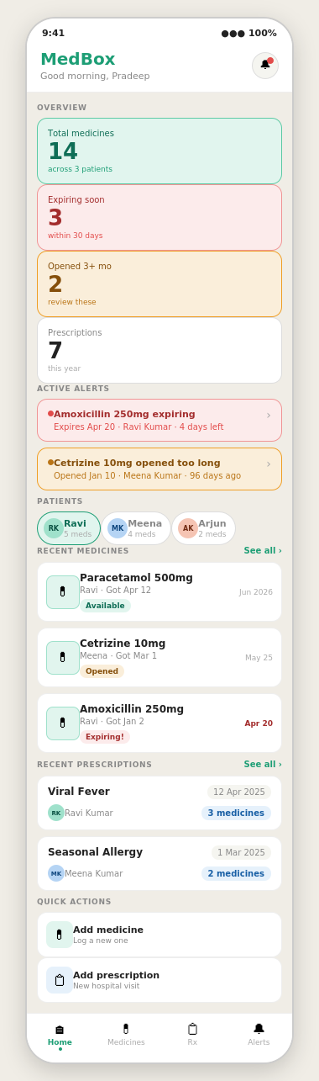

5.2. Medicine List  The full list of all medicines across all patients. Supports search, sort, and filter to help find medicines quickly.  - Search bar: searches medicine name, patient name, and prescription cause  - Sort chips: Date added (default), Expiry, Patient, Name A–Z  - Filter chips: All, Expiring, Opened, per patient — each shows count  - List grouped: 'Needs attention' (expiring + opened medicines with coloured borders) shown first, then 'Available'  - Each card: photo thumbnail, name, patient, date received, status tags (Available / Opened / Expiring), prescription tag, expiry date  - Red border on expiring medicines, amber border on opened-too-long medicines  - FAB (+): green button at bottom right to add a new medicine | 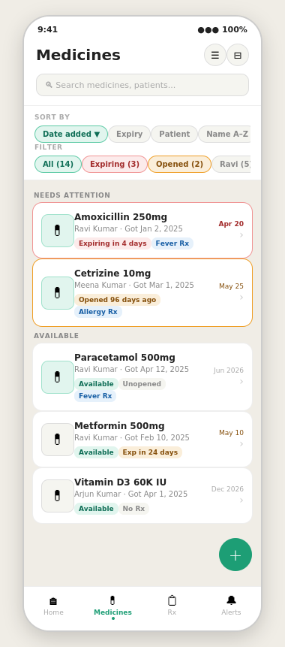

5.3. Medicine Detail  The full detail view of a single medicine. Opened by tapping any medicine card. Provides complete information and actions.  - Large medicine photo card — tap to view full screen. Shows placeholder if no photo added  - Medicine name with status badges: Available / Opened / Expiring + linked prescription tag  - Medicine info section: patient (with avatar), form, dosage instructions, quantity remaining, notes  - Dates section: date purchased, expiry date (colour-coded green/amber/red), date opened, opened toggle  - Linked prescription: tappable row that navigates to that prescription's detail screen  - Edit button (top right): opens the Edit Medicine form with all fields pre-filled  - Delete medicine button (red) at the bottom | 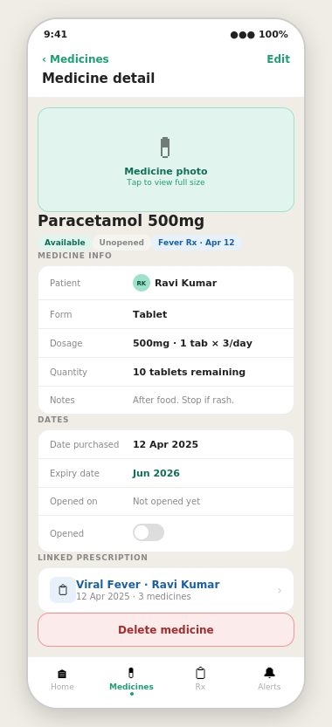

5.4. Add / Edit Medicine  The form for adding a new medicine or editing an existing one. Save button is greyed out until all required fields are filled.  - Image capture area: Camera and Gallery options. In edit mode shows existing photo with 'Change photo' overlay  - Patient selector: avatar chips for each family member, dashed 'New' chip to add a new patient inline  - Medicine name (required, free text), form as chip selector (Tablet / Capsule / Syrup / Drops / Cream / Other)  - Dosage instructions, quantity, notes (all free text)  - Date purchased (required, calendar picker), expiry date with colour-coded inline hint in edit mode  - Opened toggle: reveals Date Opened field when switched on. Drives the 3-month alert  - Available toggle: uncheck when medicine is finished or discarded  - Prescription link row: pick existing prescription or create a new one without leaving the form  - Save bar pinned at bottom with primary action button | 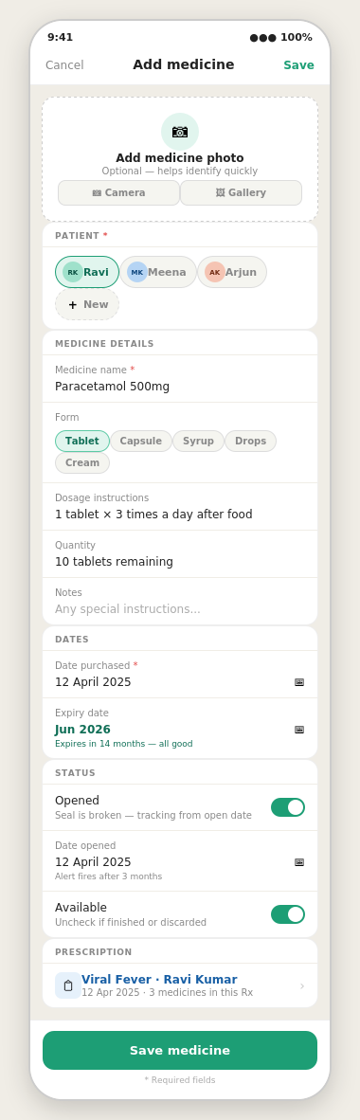

5.5–5.7. Prescription List, Detail & Add Prescription
Three screens form the Prescriptions workflow. The list groups by year for easy history browsing. Detail shows all visit and medicine info. Add/edit form captures a new hospital visit.
- Prescription List: search by cause / patient / doctor / hospital, sort by date or patient, filter by patient (with count). Cards show cause, date, doctor, hospital, patient avatar, image thumbnail, medicine count. Grouped by year
- Prescription Detail: prescription photo (large tappable card), visit details (patient, cause, visit date, doctor, hospital, notes), medicines list with live status badges. Tap any medicine row to open Medicine Detail. 'Add medicine' link to attach more medicines
- Add Prescription: prescription photo capture, patient chips, cause + visit date (required), doctor, hospital, notes. Medicines section with inline add / remove rows. Save button pinned at bottom
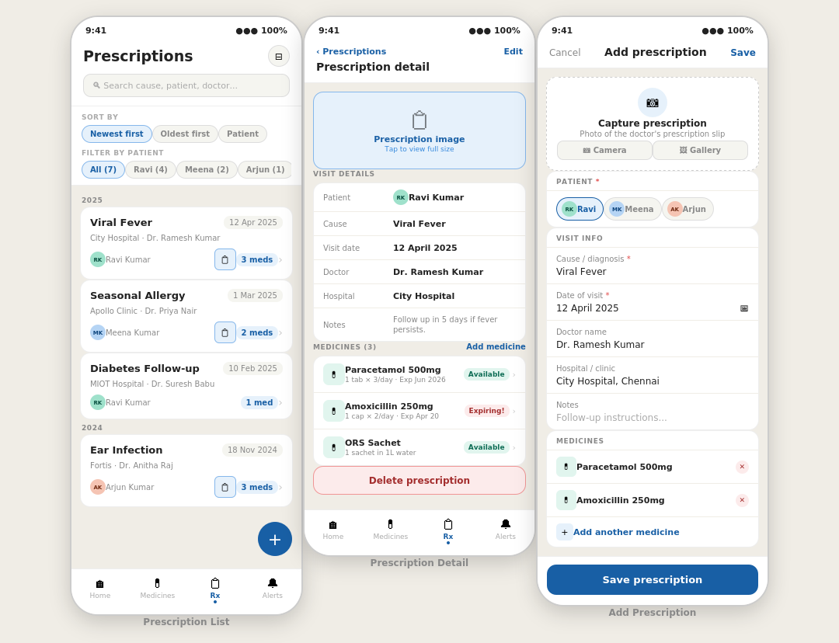

5.8–5.9. Alerts Screen & Alert Settings
The Alerts screen uses three tabs: Expiring, Opened, and Dismissed. Alert Settings lets the user configure thresholds and notification preferences.
- Alerts — Expiring tab: Critical group (red cards, expires ≤7 days) and Warning group (amber cards, ≤30 days). Each card shows medicine name, days-remaining pill, dismiss button, patient, and 'View medicine' deep link
- Alerts — Opened tab: amber cards for medicines opened beyond the configured threshold (default 3 months). Empty state shown when all medicines are within the window
- Alerts — Dismissed tab: grey muted cards with Undo option to restore accidentally dismissed alerts
- Alert Settings: expiry alert master toggle, day threshold chips (1 / 7 / 30 / 60 days, multi-select), opened alert toggle, month threshold chips (1 / 2 / 3 / 6, default 3), push notification toggle, daily check time picker (default 9:00 AM), in-app banner toggle, badge count toggle
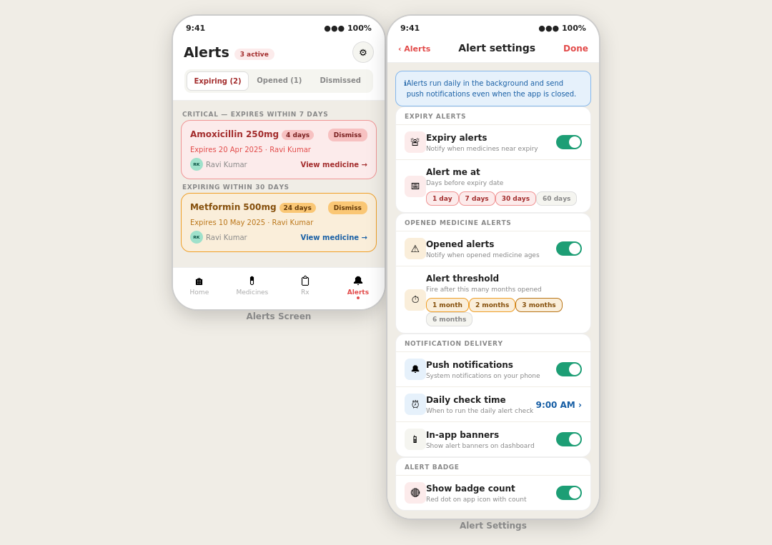

6. Alert Logic
Alerts are generated by a background service (workmanager package) that runs daily at the configured check time. Firebase Cloud Functions can also trigger on schedule for server-side reliability.

6.1 Expiry alert
- Condition: (expiry_date − today) ≤ threshold_days AND is_available = true
- Thresholds: 1, 7, 30 days (all active simultaneously if selected in settings)
- Colour: red for ≤7 days remaining, amber for ≤30 days

6.2 Opened alert
- Condition: is_opened = true AND (today − date_opened) ≥ threshold_months AND is_available = true
- Default threshold: 3 months (90 days). Configurable in Alert Settings
- Colour: always amber

6.3 Deduplication
- Before creating a new alert, check for an existing ACTIVE alert for that medicine + alert_type
- If found: skip — do not duplicate
- If dismissed: create a fresh alert so it reappears

6.4 Flutter packages
- flutter_local_notifications — local push notifications
- workmanager — background job scheduling (Android + iOS)
- firebase_messaging — optional for server-side push via Cloud Functions

7. Tech Stack

Layer | Technology | Purpose
UI framework | Flutter (Dart) | Cross-platform iOS + Android
State management | Riverpod | App-wide reactive state
Navigation | go_router | Declarative routing, deep links
Database | Cloud Firestore | NoSQL document store
File storage | Firebase Storage | Medicine + prescription photos
Background jobs | workmanager | Daily alert check
Notifications | flutter_local_notifications | Push alerts on device
Image capture | image_picker | Camera + gallery access
Server functions | Firebase Cloud Functions | Optional server-side alert job

8. Reusable Flutter Widgets
Build these once and reuse across screens for consistency and reduced duplication.

Widget | Usage
MedicineCard | Medicine list, dashboard recent medicines
PrescriptionCard | Prescription list, dashboard recent prescriptions
AlertBanner | Alerts screen, dashboard active alerts section
PatientAvatar | Avatar chip with initials/photo, used everywhere
ImagePickerWidget | Camera + gallery picker, medicines and prescriptions
DatePickerField | Styled date input, used across all forms
SortFilterBar | Scrollable chip row, medicine + prescription lists
StatusBadge | Coloured pill: Available / Opened / Expiring / No Rx
EmptyState | Illustrated empty state for empty lists and tabs
ConfirmDeleteDialog | Reusable confirmation modal for deletions

9. Colour System

Colour | Hex | Usage
Primary teal | #1D9E75 | Brand, FAB, active nav, save buttons, available badges
Light teal | #E1F5EE | Available badge backgrounds, patient chip active state
Alert red | #A32D2D | Expiring critical text, delete buttons, critical alert cards
Light red | #FCEBEB | Critical alert card backgrounds, danger badge fills
Caution amber | #854F0B | Opened alerts, expiring-soon warnings (text)
Light amber | #FAEEDA | Opened / warning card backgrounds
Info blue | #185FA5 | Prescriptions tab, linked prescription elements
Light blue | #E6F1FB | Prescription thumbnails, link icon backgrounds
Text primary | #2C2C2A | All primary body text and labels
Text secondary | #888780 | Muted labels, metadata, hints

10. Future Features (Phase 2)
- Smart task prediction — pre-suggest medicines based on time and history
- Barcode / QR scan — auto-fill name and expiry from medicine packaging
- Refill reminder — alert when medicine quantity is running low
- Export report — PDF summary of all medicines for a patient
- iCloud / Google Drive backup — periodic data backup
- Multi-device sync — share medicine data across family phones
- Dark mode — full dark theme support
- Biometric lock — Face ID / fingerprint to open the app

End of document · MedBox v1.0

