Project: **Tax Formalizer®**

**Summary**

**What is the Code Games Idea?**

Use mobile phone camera to capture the invoice and upload it using our application “**TaxFormalizer**”. TaxFormalizer will then smartly read the characters from the invoice and transform the invoice details into required format which can be processed thru WK’s TaxCalc Service to calculate the Tax Labiality and taxes.

In case of Tax Authority Officer, the TaxFormalizer will show the applicable tax as a result, which officer can use to determine if the buyer is eligible for refund.

In case of CPA user, their clients will use TaxFormalizer will save the tax details into database for calculating the taxes which can be further used for filing the tax returns for their clients.

**How is put together?**

* **REST Service**: S REST service build for reading invoices using Microsoft Office Document Imaging and transform the invoice details into tax details format which can be passed to the WK’s TaxCalc Service to calculate the Tax Labiality and taxes
* **WCF Service:** TaxCalcService - WK’s Sales Tax Calculation engine
* **Web:** Web client summarizes the invoices which are formalized and show tax details
* **Android:** Upload existing scanned document or use android phone’s camera to capture the picture of invoice and upload to see the formalized tax
* **Database**: SQL Server DB is used to maintain the uploaded documents and corresponding transactions tax data

**What tools technologies were used to create?**

|  |  |
| --- | --- |
| Microsoft Office Document Imaging | Microsoft Office Sharepoint Designer 2007 |
| TaxFormalizer API | ASP.NET Web API |
| TaxFormalizer Database | MS SQL Server |
| SignalR | ASP.NET SignalR |
| Xamarin. Android | Xamarin |
| Web Client | ASP.NET MVC |

**Source Code structure**

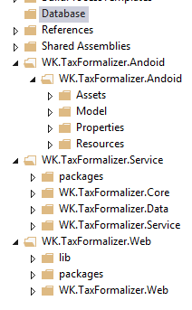

|  |  |
| --- | --- |
| Reference | Reference documents |
| WK.TaxFormalizer.Andoid | Android Client |
| WK.TaxFormalizer.Service | REST Service for processing invoices and transactions |
| WK.TaxFormalizer.Web | Web Client |
| Database / Scripts | DB Scripts |

**Other Notes**:

Install - Microsoft Office Sharepoint Designer 2007

**Deployment**

Special Setup Instructions (if any):

Host the API and Web application in IIS.

**How to execute**:

Web and Android client are used to formalize the Invoices