**PROJECT SNAPSHOTS**

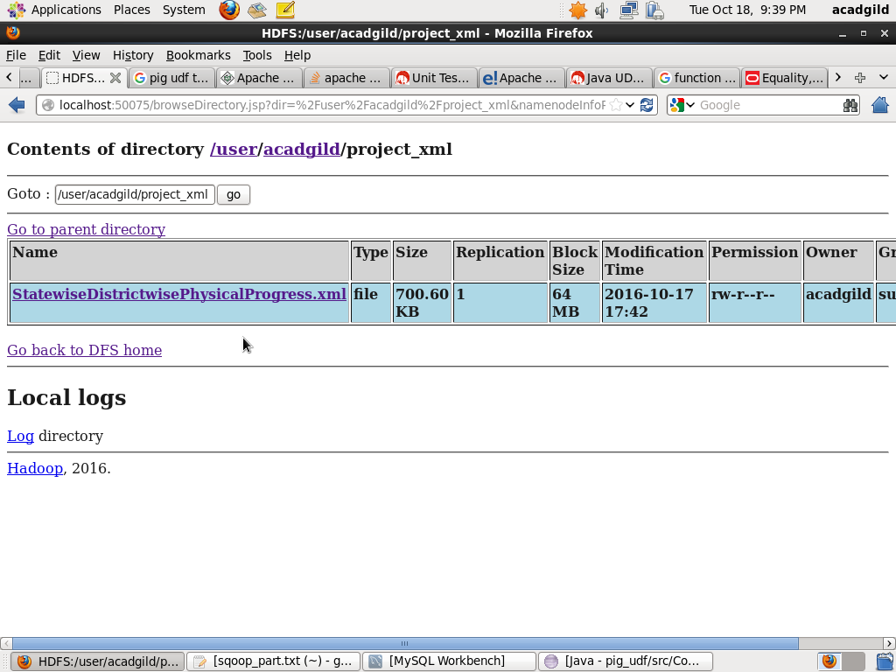

Copying file to hdfs using flume.

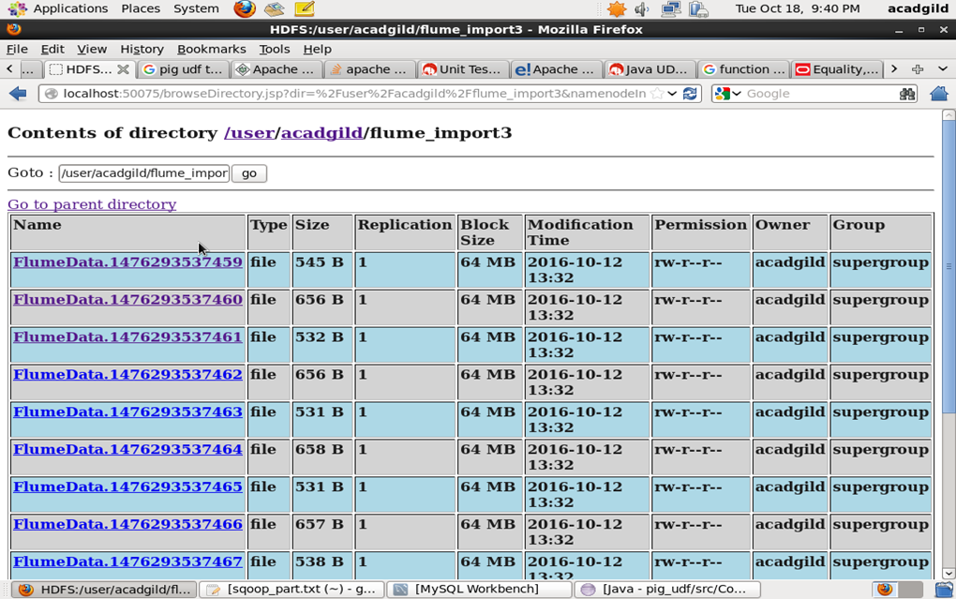

Pig script for parsing the xml data and storing it in hdfs and then solving the problem statement 1 that is getting the names of all districts who got 100 percent in BPL cards.

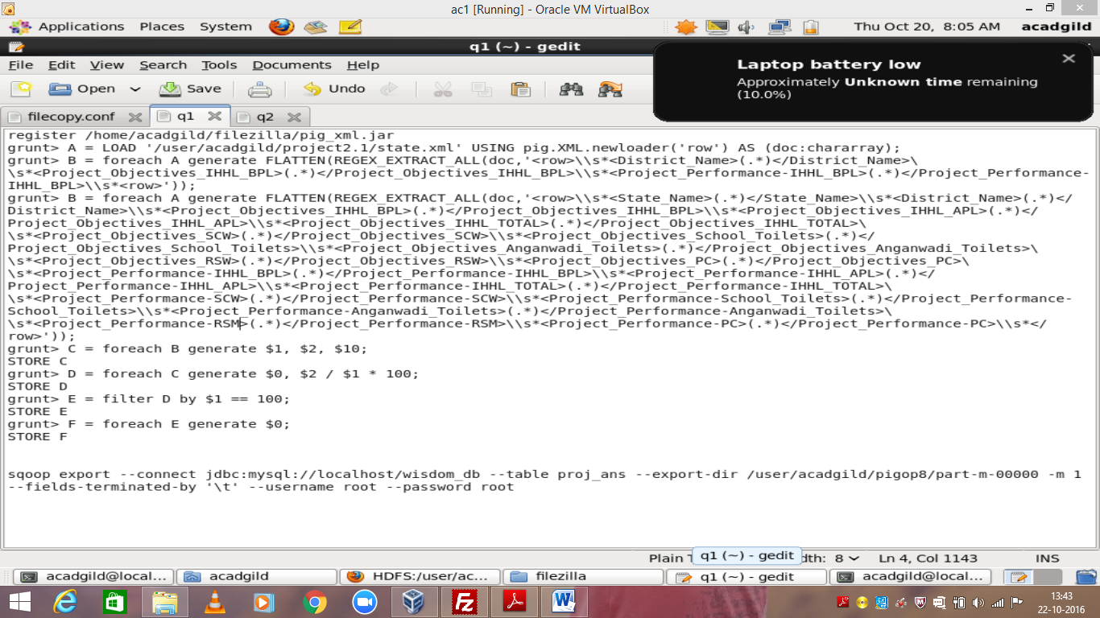

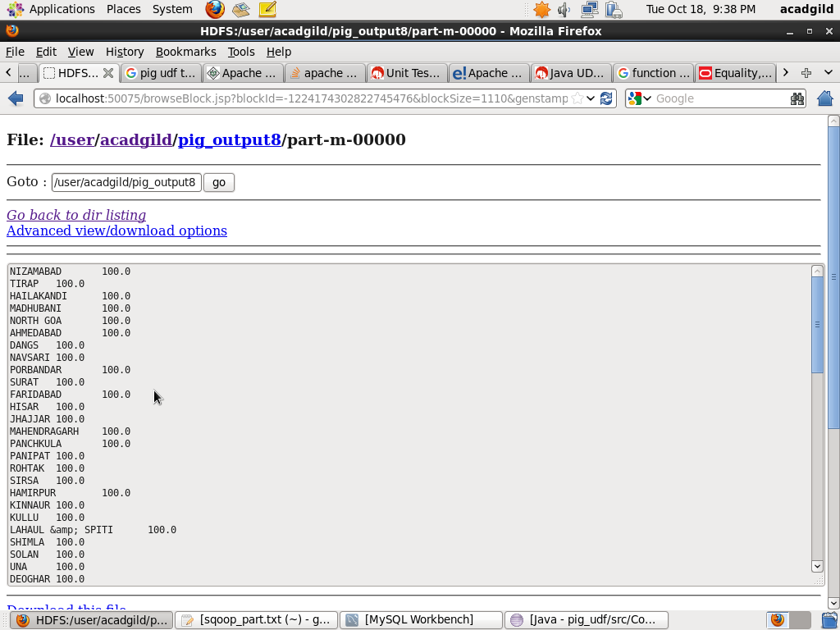

Exporting the result of 1st problem statement using sqoop.

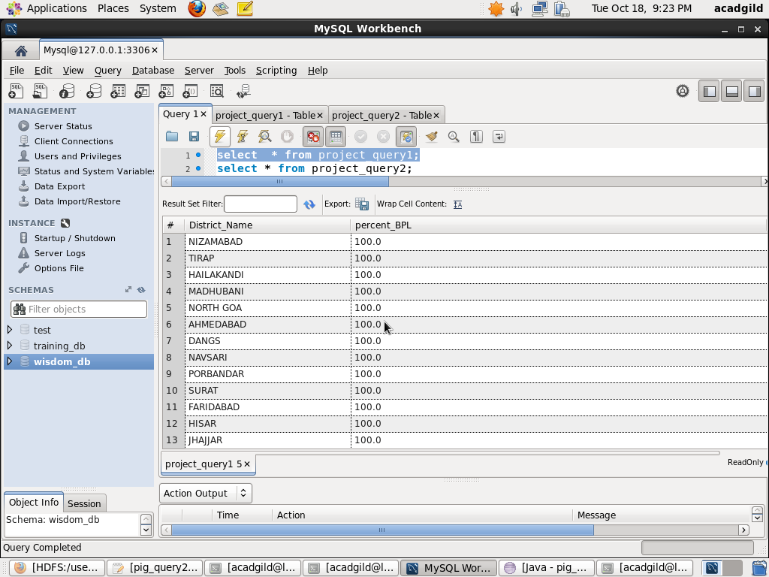

For solving problem statement 2 using pig udf.

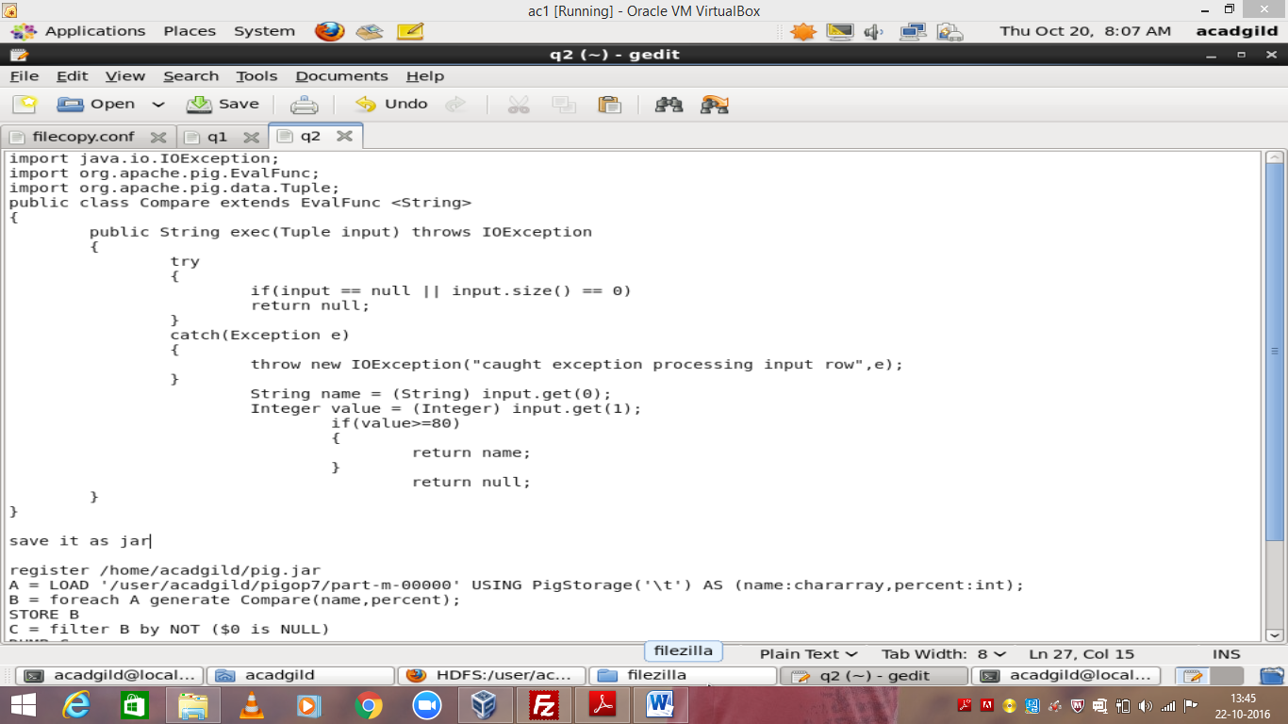

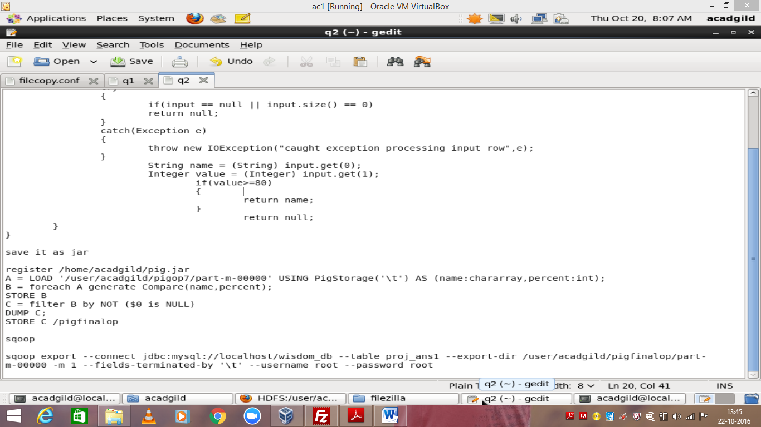

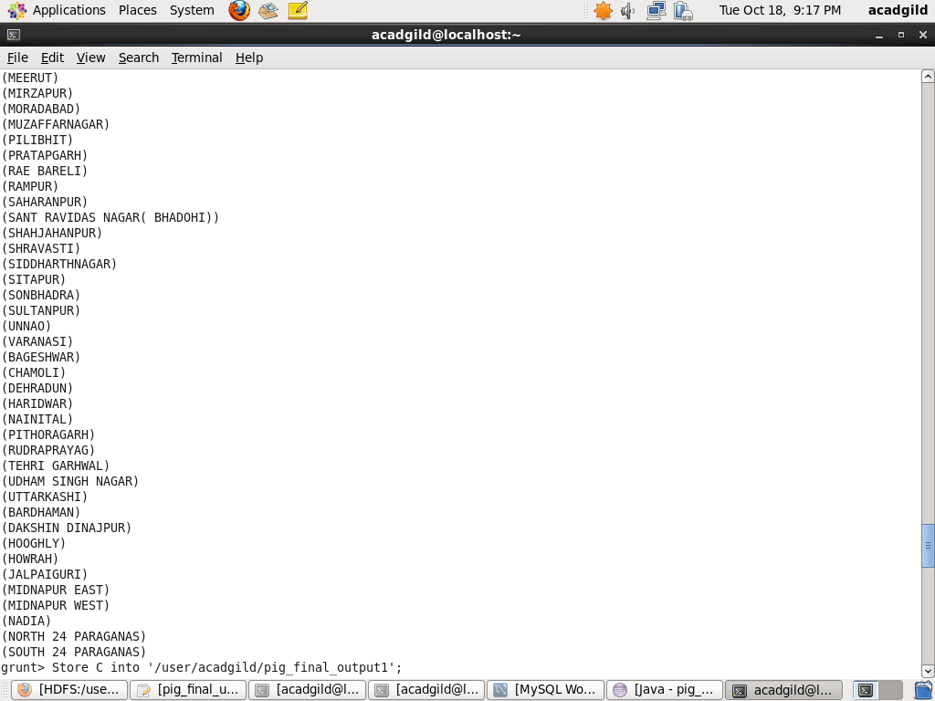

Exporting the result of pig udf using sqoop to SQL database.

