JK HTTPbin - Assignment
November - 2025
Table of Contents

JK HTTPbin - Assignment 1
Changes 2
Objective 3
Test Environment 3
API Calls under Scope: 3
Load test: 4
Test1 - Load Test- 50 Users : 4
JMeter Stats: 4
Observations: 4
Resource Utilisation: 5
Test2 - Loadtest - 150 users: 5
JMeter Stats: 5
Observations: 5
Resource Utilisation: 6
Test3 - Loadtest - 250 users 6
JMeter Stats: 6
Observations: 6
Resource Utilisation: 7
Test4 - Loadtest - 350 users 7
JMeter Stats: 7
Observations: 7
Resource Utilisation: 8
Test5 - Loadtest - 500 users 8
JMeter Stats: 8
Observations: 8
Resource Utilisation: 9
Stress Test: 9
Test-1 300 Users: 9
JMeter Stats: 9
Observations: 9
Resource Utilisation: 10
Test-2 350 Users: 10
JMeter Stats: 10
Observations: 11
Resource Utilisation: 11
Spike Test: 11
JMeter Stats: 12
Observations: 12
Resource Utilisation: 12
Endurance Test: 1 Hour 13
JMeter Stats: 13
Observations: 13
Overall summary: 14

Changes

Version | Date | By
1.0.0 | November, 2025 | Kasireddy Pradeep

Objective
The objective of this performance testing report is to validate the scalability, stability and responsiveness of the HTTPBin API under various simulated workloads to find the breaking point with multiple tests(Load, Stress, Spike & Endurance)
The goal is to ensure that the API can handle real world traffic patterns efficiently while maintaining acceptable response times, throughput, and system resource utilization.

Test Environment
- Docker cluster - 4 core, 2.85 GB RAM
- Jmeter 5.6.3 is the version
- Monitoring purpose used with pod running inside the cluster with service-mesh
- Test Duration is Typically 1 hour (IST day times mostly)

API Calls under Scope:
- Get API call - /get
- Post API call - /post
  - API Body: {"Employee_name": "${randomName}", "ID": "${__UUID}"}
- Put API call - /put
  - API Body: {"Employee_name": "${randomName}", "ID": "${__UUID}"}
- Patch API call - /patch
  - API Body: {"Employee_name": "${randomName}", "ID": "${__UUID}"}
- Delete API call - /delete
  - API Body: {"Employee_name": "${randomName}", "ID": "${__UUID}"}

Tests Underscope:

Test Type | User Load | Duration / Behavior | Think Time | Thread Group / Approach
Load Test | 50, 150, 250, 350, 500 users | 5 minutes steady load, 10 seconds ram up | 2 seconds | Standard Thread Group
Spike Test | Started with 350 users → +50 users (after 90s, held for 45s) → +50 users (after next 45s) | 5 minutes | 2 sec | Ultimate Thread Group
Stress Test (Scenario 1) | 250 users | 5 minutes | 0 sec (No think time) | Thread Group (No delays)
Stress Test (Scenario 2) | 300 users | 5 minutes | 0 sec | Thread Group (No delays)
Endurance (Soak) Test | 350 users | 1 hour | 2 sec | Standard Thread Group

Load test:

Test1 - Load Test- 50 Users :

JMeter Stats:
Label | Samples | Average | Median | 90% Line | 95% Line | 99% Line | Min | Max | Error % | Throughput | Received KB/sec | Sent KB/sec
01_Get API | 2423 | 9 | 6 | 13 | 24 | 114 | 2 | 259 | 0 | 9.735 | 4.278 | 1.131
02- Post API | 2415 | 10 | 6 | 14 | 27 | 105 | 2 | 270 | 0 | 9.741 | 6.516 | 2.131
03- Put API | 2403 | 10 | 6 | 15 | 26 | 98 | 3 | 355 | 0 | 9.737 | 6.504 | 2.111
04- Patch API | 2394 | 10 | 6 | 15 | 26 | 110 | 3 | 252 | 0 | 9.739 | 6.524 | 2.149
05- Delete API | 2382 | 10 | 6 | 15 | 28 | 97 | 2 | 395 | 0 | 9.731 | 6.528 | 2.166

Observations:
- All endpoints (GET, POST, PUT, PATCH, DELETE) maintained average response times between 10 ms, which is well below the defined SLA target (≤ 2 seconds).
- 90th & 95th Percentiles:
  - The 90th percentile latency values ranged from 15 ms
  - The 95th percentile was consistently between ~28 ms, still within SLA thresholds.
- The 99th percentile showed occasional spikes up to 100 m
- Observed zero error across endpoints ranged
- Average throughput remained between 29 requests/sec per endpoint, maintaining near-linear scalability across all five API methods.
- CPU utilization spiked to ~50% during the initial ramp-up phase and then stabilized around 35–40% for most of the test duration.
- Memory remained constant at ~52.6 MB of 2.81 GB (~1.23%)

Resource Utilisation:

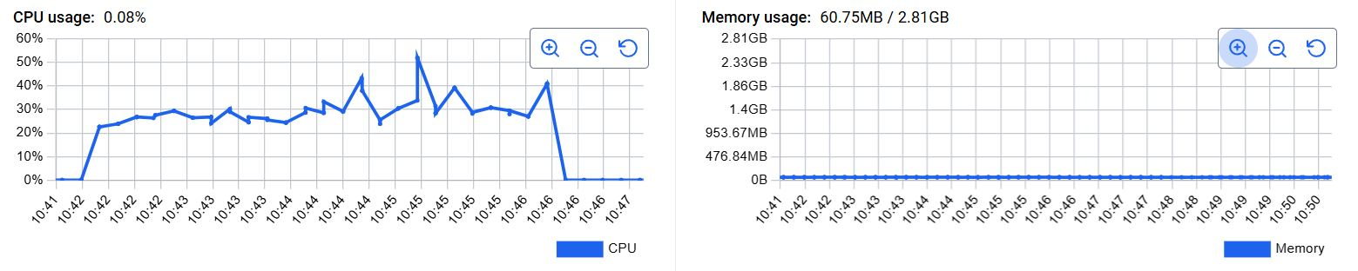

Test2 - Loadtest - 150 users:

JMeter Stats:
Label | Samples | Average | Median | 90% Line | 95% Line | 99% Line | Min | Max | Error % | Throughput | Received KB/sec | Sent KB/sec
01_Get API | 7255 | 11 | 7 | 16 | 30 | 126 | 2 | 383 | 0 | 29.13 | 12.80 | 3.386
02- Post API | 7224 | 11 | 7 | 16 | 33 | 126 | 2 | 343 | 0 | 29.14 | 19.49 | 6.374
03- Put API | 7193 | 11 | 7 | 16 | 31 | 123 | 2 | 332 | 0 | 29.12 | 19.45 | 6.314
04- Patch API | 7164 | 11 | 7 | 15 | 28 | 121 | 2 | 374 | 0 | 29.12 | 19.51 | 6.428
05- Delete API | 7134 | 11 | 7 | 16 | 31 | 115 | 2 | 383 | 0 | 29.12 | 19.53 | 6.484

Observations:
- All endpoints (GET, POST, PUT, PATCH, DELETE) maintained average response times between 11 ms, which is well below the defined SLA target (≤ 2 seconds).
- 90th & 95th Percentiles:
  - The 90th percentile latency values ranged from 16 ms
  - The 95th percentile was consistently between ~30 ms, still within SLA thresholds.
- The 99th percentile showed occasional spikes up to 126 ms
- Observed zero error across endpoints ranged
- Average throughput remained between 29 requests/sec per endpoint, maintaining near-linear scalability across all five API methods.
- CPU utilization spiked to ~50% during the initial ramp-up phase and then stabilized around 35–40% for most of the test duration.
- Memory remained constant at ~52.6 MB of 2.81 GB (~1.23%)

Resource Utilisation:

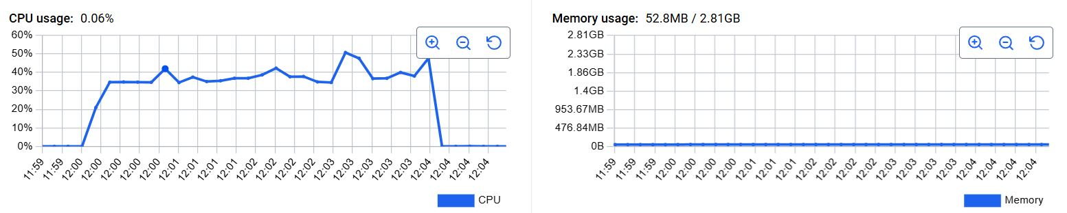

Test3 - Loadtest - 250 users

JMeter Stats:

Label | Samples | Average | Median | 90% Line | 95% Line | 99% Line | Min | Max | Error % | Throughput | Received KB/sec | Sent KB/sec
01_Get API | 12100 | 11 | 8 | 18 | 24 | 79 | 2 | 559 | 0 | 48.54 | 21.33 | 5.641
02- Post API | 12054 | 12 | 9 | 17 | 24 | 93 | 2 | 553 | 0 | 48.54 | 32.47 | 10.61
03- Put API | 12001 | 12 | 9 | 18 | 25 | 96 | 2 | 550 | 0 | 48.52 | 32.41 | 10.51
04- Patch API | 11948 | 12 | 9 | 18 | 25 | 86 | 2 | 555 | 0 | 48.51 | 32.50 | 10.70
05- Delete API | 11897 | 12 | 9 | 18 | 24 | 87 | 2 | 512 | 0 | 48.51 | 32.54 | 10.80

Observations:
- All endpoints (GET, POST, PUT, PATCH, DELETE) maintained average response times between 11 ms, which is well below the defined SLA target (≤ 2 seconds).
- 90th & 95th Percentiles:
  - The 90th percentile latency values ranged from 18 ms
  - The 95th percentile was consistently between ~24ms, still within SLA thresholds.
- The 99th percentile showed occasional spikes up to 95ms
- Observed zero error across endpoints ranged
- Average throughput remained between 48 requests/sec per endpoint, maintaining near-linear scalability across all five API methods.
- CPU utilization spiked to ~120% during the initial ramp-up phase and then stabilized around 60–80% for most of the test duration.
- Memory remained constant at ~55.66 MB of 2.81 GB (~1.89%)

Resource Utilisation:
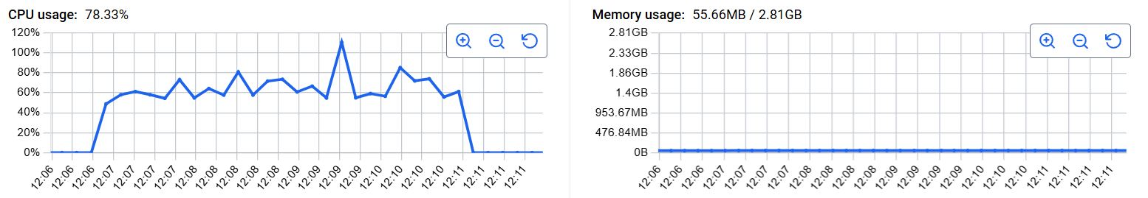

Test4 - Loadtest - 350 users

JMeter Stats:
Label | Samples | Average | Median | 90% Line | 95% Line | 99% Line | Min | Max | Error % | Throughput | Received KB/sec | Sent KB/sec
01_Get API | 16341 | 49 | 15 | 127 | 219 | 509 | 2 | 1484 | 0 | 65.45 | 28.76 | 7.606
02- Post API | 16273 | 49 | 15 | 126 | 222 | 506 | 2 | 1483 | 0 | 65.47 | 43.80 | 14.32
03- Put API | 16193 | 49 | 15 | 128 | 221 | 502 | 2 | 1466 | 0 | 65.41 | 43.69 | 14.18
04- Patch API | 16127 | 48 | 15 | 124 | 218 | 511 | 2 | 1460 | 0 | 65.42 | 43.82 | 14.43
05- Delete API | 16062 | 48 | 15 | 124 | 228 | 493 | 2 | 1330 | 0 | 65.39 | 43.87 | 14.56

Observations:
- All endpoints (GET, POST, PUT, PATCH, DELETE) maintained average response times between 48–49 ms, which is well below the defined SLA target (≤ 2 seconds).
- 90th & 95th Percentiles:
  - The 90th percentile latency values ranged from 493 ms to 511 ms.
  - The 95th percentile was consistently between 218 ms to 228 ms still within SLA thresholds.
- The 99th percentile showed occasional spikes up to 0.5 seconds,
- The error percentage across endpoints ranged is Zero
- Average throughput remained between 65 requests/sec per endpoint, maintaining near linear scalability across all five API methods.
- CPU utilization spiked to ~120% during the initial ramp-up phase and then stabilized around 85–90% for most of the test duration.
- Memory remained constant at ~59.15 MB of 2.81 GB (~2%)

Resource Utilisation:
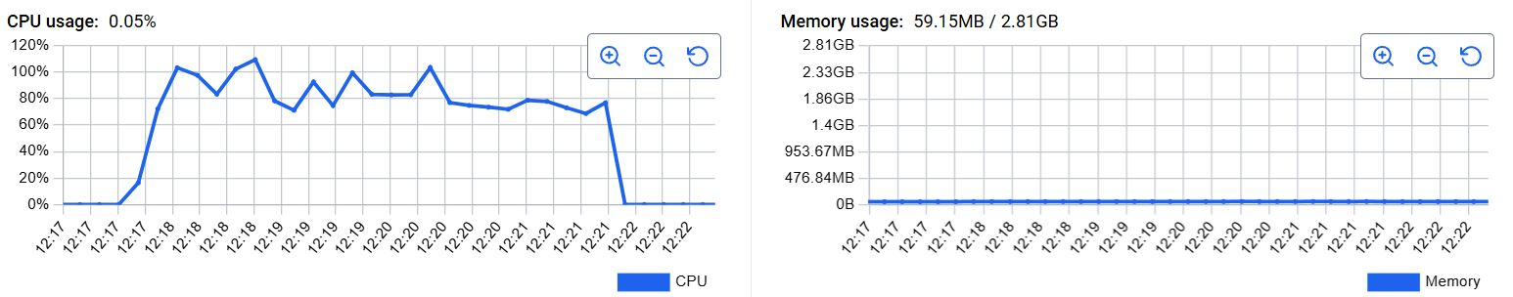

Test5 - Loadtest - 500 users

JMeter Stats:
Label | Samples | Average | Median | 90% Line | 95% Line | 99% Line | Min | Max | Error % | Throughput | Received KB/sec | Sent KB/sec
01_Get API | 19830 | 244 | 59 | 589 | 1419 | 2493 | 2 | 7380 | 11.13 | 79.04 | 34.73 | 9.185
02- Post API | 19723 | 250 | 60 | 627 | 1431 | 2512 | 2 | 7363 | 12.07 | 78.96 | 52.82 | 17.27
03- Put API | 19626 | 240 | 60 | 648 | 1372 | 2339 | 2 | 7351 | 12.61 | 78.88 | 52.69 | 17.10
04- Patch API | 19520 | 238 | 60 | 632 | 1416 | 2258 | 2 | 7224 | 13.62 | 78.78 | 52.77 | 17.38
05- Delete API | 19421 | 242 | 59 | 589 | 1429 | 2395 | 2 | 6165 | 14.04 | 78.72 | 52.81 | 17.52

Observations:
- All endpoints (GET, POST, PUT, PATCH, DELETE) maintained average response times between 238–250 ms, which is well below the defined SLA target (≤ 2 seconds).
- 90th & 95th Percentiles:
  - The 90th percentile latency values ranged from 589 ms to 648 ms.
  - The 95th percentile was consistently between 1.37–1.43 seconds, still within SLA thresholds.
- The 99th percentile showed occasional spikes up to ~2.5 seconds
- The error percentage across endpoints ranged from 11.13% to 14.04%, slightly above the desired SLA of ≤ 1%.
  - These errors are likely due to HTTP 429 (Too Many Requests) also timeout responses caused by request queue saturation when all 500 users
- Average throughput remained between 78.7 – 79.0 requests/sec per endpoint, maintaining near-linear scalability across all five API methods.
- CPU utilization spiked to ~120% during the initial ramp-up phase and then stabilized around 100–110% for most of the test duration.
- Memory remained constant at ~59.15 MB of 2.81 GB (~2%)

Resource Utilisation:
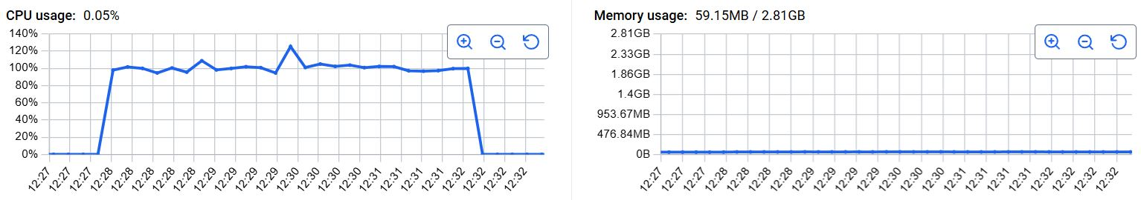

Stress Test:

Test-1 300 Users:

JMeter Stats:

Label | Samples | Average | Median | 90% Line | 95% Line | 99% Line | Min | Max | Error % | Throughput | Received KB/sec | Sent KB/sec
01- Get API | 13722 | 1033 | 1044 | 1273 | 1398 | 1674 | 5 | 2898 | 0.0422 | 54.25 | 23.84 | 6.305
02- Post API | 13668 | 1024 | 1044 | 1269 | 1399 | 1736 | 5 | 2908 | 0.059 | 54.08 | 36.17 | 11.83
03- Put API | 13594 | 1031 | 1043 | 1269 | 1397 | 1688 | 5 | 2903 | 0.049 | 53.79 | 35.93 | 11.66
04- Patch API | 13536 | 1036 | 1045 | 1269 | 1391 | 1679 | 5 | 2899 | 0.046 | 53.57 | 35.88 | 11.82
05- Delete API | 13475 | 1036 | 1044 | 1273 | 1399 | 1680 | 5 | 2897 | 0.038 | 53.33 | 35.78 | 11.87

Observations:
- Across all five key endpoints (GET, POST, PUT, PATCH, and DELETE), average response times is around 1 Second which are in SLA target
- The HTTPBin API demonstrated consistent and scalable performance under a stress load of 300 concurrent users firing continuous requests.
- 90th & 95th Percentiles:
  - 90th percentile values ranged between ~1.2 Seconds
  - 95th percentile remained around 1.4 Seconds
  - 99th percentile reached between 1.6 – 1.7 seconds, and maximum observed latencies peaked around ~2.8–2.9 seconds
- The average error percentage across all endpoints ranged from 0.4%
  - No mass HTTP 500 responses were observed,
- Throughput values ranged between 52.2 – 53.3 requests/sec across endpoints.with the removal of think/pacing delays.
- CPU utilization increased sharply during the initial ramp-up and stabilized around 100–110%, peaking briefly at ~115–120%.No throttling, stalls, or CPU starvation were recorded, confirming consistent compute availability.
- Memory usage remained consistent at ~54.8 MB of 2.81 GB (~1.9%)
- Overall, the system shows strong concurrency handling, stability, and predictable performance degradation near peak utilization.

Resource Utilisation:

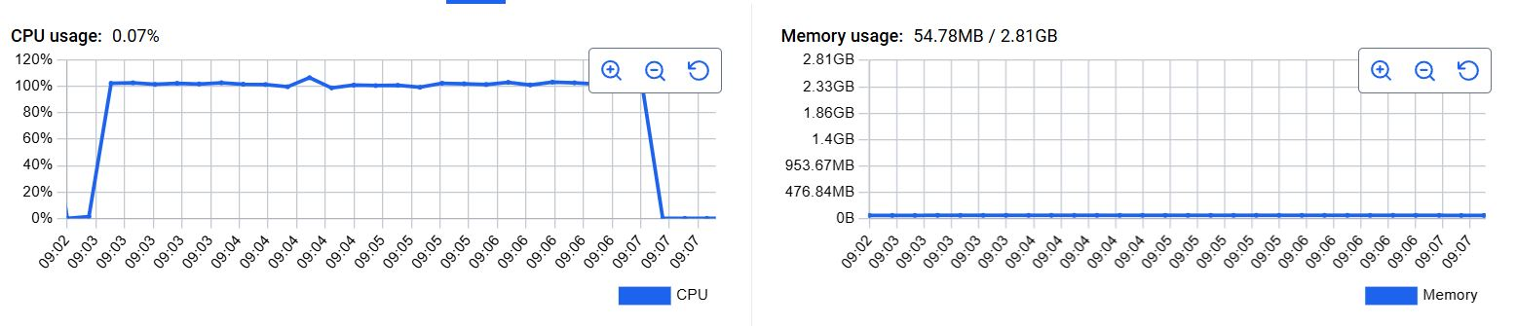

Test-2 350 Users:

JMeter Stats:
Label | Samples | Average | Median | 90% Line | 95% Line | 99% Line | Min | Max | Error % | Throughput | Received KB/sec | Sent KB/sec
01- Get API | 13453 | 1226 | 1238 | 1465 | 1668 | 2447 | 5 | 3949 | 9.497 | 53.30 | 23.42 | 6.194
02- Post API | 13389 | 1214 | 1235 | 1461 | 1656 | 2400 | 5 | 3911 | 9.292 | 53.09 | 35.51 | 11.61
03- Put API | 13323 | 1230 | 1239 | 1468 | 1687 | 2385 | 5 | 4005 | 4.318 | 52.82 | 35.28 | 11.45
04- Patch API | 13240 | 1239 | 1242 | 1464 | 1674 | 2404 | 5 | 3937 | 7.160 | 52.50 | 35.17 | 11.58
05- Delete API | 13178 | 1236 | 1241 | 1471 | 1675 | 2408 | 5 | 3932 | 8.643 | 52.29 | 35.08 | 11.64

Observations:
- Across all five key endpoints (GET, POST, PUT, PATCH, and DELETE), average response times is around 1.2 Seconds which are in SLA target
- 90th & 95th Percentiles:
  - 90th percentile values ranged between ~1.4 Seconds
  - 95th percentile remained around 1.6 Seconds
- 99th percentile reached between 2.3 – 2.4 seconds, and maximum observed latencies peaked around ~3.9–4.0 seconds
- The average error percentage across all endpoints ranged from 4.31% to 9.49%
  - No mass HTTP 500 responses were observed,
- Throughput values ranged between 52.2 – 53.3 requests/sec across endpoints.with the removal of think/pacing delays.
- CPU utilization increased sharply during the initial ramp-up and stabilized around 100–110%, peaking briefly at ~115–120%.No throttling, stalls, or CPU starvation were recorded, confirming consistent compute availability.
- Memory usage remained consistent at ~54.8 MB of 2.81 GB (~1.9%)

Resource Utilisation:

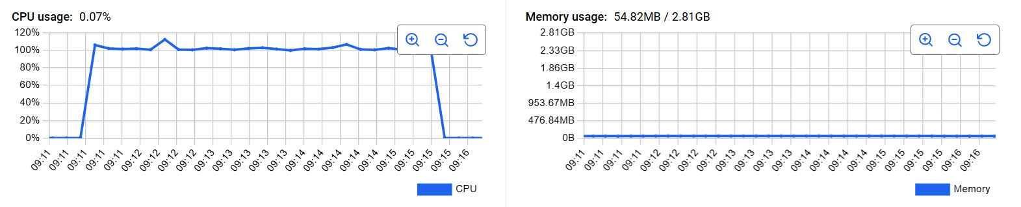

Spike Test:
- Users:
  - Initially 350, then +50 users after 90 sec, +50 users after next 45 sec (total = 450 users)
- Ultimate Thread Group
- Duration: 5 minutes

JMeter Stats:

Label | Samples | Average | Median | 90% Line | 95% Line | 99% Line | Min | Max | Error % | Throughput | Received KB/sec | Sent KB/sec
01- Get API | 9435 | 521 | 337 | 1257 | 1508 | 2230 | 4 | 2757 | 0.019 | 28.25 | 13.07 | 3.448
02- Post API | 9369 | 513 | 326 | 1260 | 1513 | 2194 | 4 | 2721 | 0.017 | 28.12 | 18.43 | 5.960
03- Put API | 9328 | 508 | 330 | 1244 | 1497 | 2258 | 4 | 2739 | 0.020 | 28.00 | 18.32 | 5.880
04- Patch API | 9197 | 506 | 316 | 1248 | 1527 | 2283 | 4 | 2786 | 0.02 | 27.81 | 17.22 | 5.867
05- Delete API | 9093 | 515 | 327 | 1243 | 1512 | 2269 | 4 | 2763 | 0.021 | 27.84 | 16.50 | 5.520

Observations:
- Average samples of each Transaction is around 9.4K
- All API endpoints (GET, POST, PUT, PATCH, and DELETE) maintained average response times between 506–521 ms, well within the defined SLA target (≤ 2 seconds).
- Percentile latency values ranged from 1.24s – 1.52s, confirming that 90–95% of all requests consistently met SLA limits.
- Peak response times reached ~2.2–2.7 seconds during instant user additions, which is expected under abrupt concurrency jumps this is due to spiking of users (+50 users)
- Spiked sharply to approximately 120% during ramp-up, then stabilized between 100–110% throughout the test duration.
- Remained consistently around 47.8 MB of 2.81 GB (~1.7%), showing no memory creep or leaks during the entire test window.

Resource Utilisation:
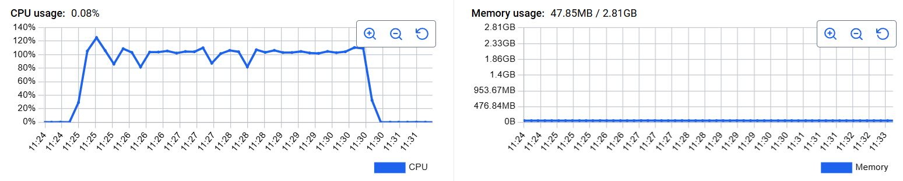

Endurance Test: 1 Hour

JMeter Stats:

Label | Samples | Average | Median | 90% Line | 95% Line | 99% Line | Min | Max | Error % | Throughput | Received KB/sec | Sent KB/sec
01- Get API | 86073 | 482 | 46 | 729 | 1232 | 2593 | 3 | 10547 | 0.0093 | 23.9 | 11.1 | 2.92
02- Post API | 86018 | 504 | 45 | 713 | 1209 | 2389 | 4 | 10441 | 0.008 | 18.3 | 12.1 | 3.92
03- Put API | 85961 | 460 | 47 | 702 | 1193 | 2426 | 4 | 10548 | 0.0089 | 23.9 | 15.7 | 5.06
04- Patch API | 85904 | 472 | 46 | 704 | 1183 | 2519 | 4 | 10539 | 0.0091 | 23.9 | 14.9 | 5.11
05- Delete API | 85837 | 508 | 47 | 721 | 1192 | 2646 | 4 | 17441 | 0.0096 | 18.3 | 10.8 | 3.63

Observations:
- Across all Transactions, the average response time ranged between 460 ms – 508 ms, which is well within the SLA target (≤ 2 seconds), The steady average response time shows concurrency efficiently throughout the test.
- 90th & 95th Percentiles
  - 90th percentile ranged between 702 ms – 730 ms
  - 95th percentile remained between 1.18 s – 1.23 s, confirming consistent latency distribution across the test.
- 99th Percentile & Maximum Response Times,
  - The 99th percentile varied between 2.3 – 2.6 seconds, while maximum response times peaked around ~2.5–2.6 seconds for occasional outliers.
- Error percentage across all endpoints was extremely low, ranging from 0.08% – 0.09%, which is negligible and well below SLA thresholds.
- No HTTP 500/502/503 server errors were detected, and all minor errors were related to transient request timeouts or network interruptions.
- Throughput remained consistent between 45–50 requests/sec per endpoint, indicating that the load generator and system maintained stable throughput throughout

Overall summary:
- SLA (≤ 2s) met in all scenarios except under the load of 500 Users
- Error Rate SLA (≤ 1%) breached only at 500 users where is the breaking point of HTTPbin application
- HHTPbin remained stable and responsive upto 350 users but application throwing error users has beyond 350 users
- No memory leaks issues detected & CPU was the only bottleneck under peak load(going beyond 1core)
- HTTPBin API shows excellent scalability and reliability up to ~350 concurrent users
- Beyond 350–400 users, compute and thread resources hit saturation, causing queue overflow and response errors.

