**MIRC Data Analysis with Radlex**

**Findings Category:**

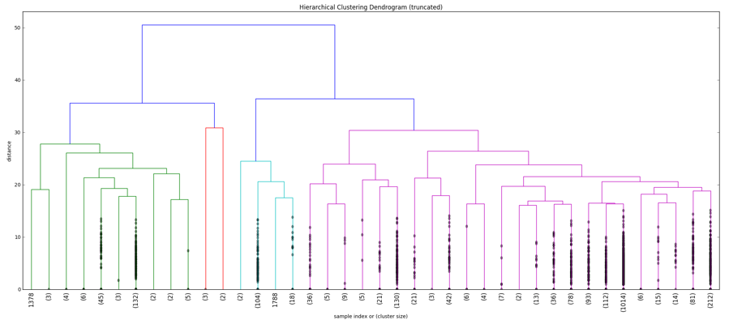

**Diagnosis Category:**

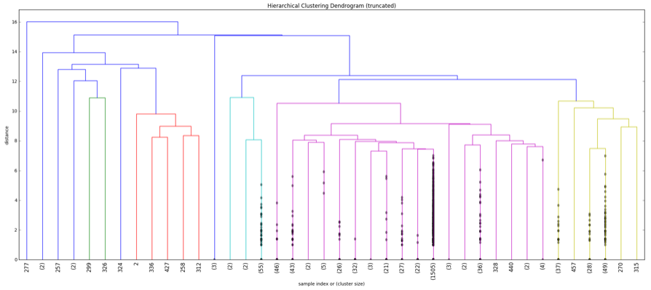

**Discussion/Comments:**

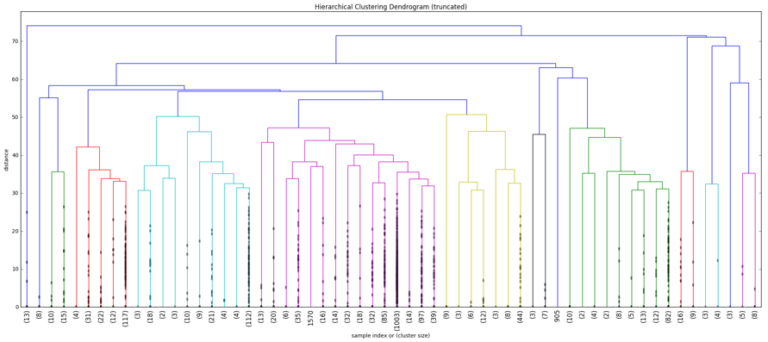

**DDX Category:**

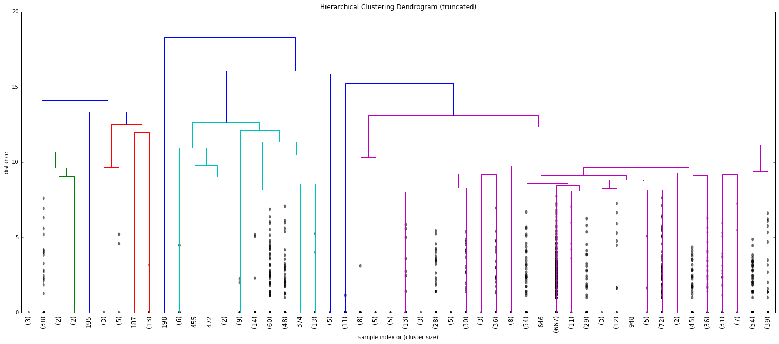

**Successfully Created the Coverage Tree for DDX Terms:**

**DDX_RSNA (All Radlex terms used in DDX Category):**

|  |  |  |  |  |  |
| --- | --- | --- | --- | --- | --- |
| Hemophilia of the knee | Leukemia (ALL) | Metastatic neuroblastoma | Asphyxiating Thoracic Dysplasia | Helium Contrast | Anoxic brain injury |

**Radlex Raw Tree Data [Sample from all Radlex Terms in Radlex Dictionary from Radlex.csv file]**

**[NodeName, NodeID, ParentID]**

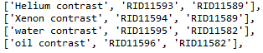

**Step-1:** We see if the nodeid is not in the list of all ParentID

**Step-2**: We create a function to generate the whole Raw Path

For e.g. ‘Helium Contrast’ > RID11593 > RID11589 > RID11582 > RID35973 > RID7479 > RID1

**Step-3:** We reverse this path

i.e. RID1 > RID7479 > RID35973 > RID11582 > RID11589 > RID11593 > ‘Helium Contrast’

**Step-4:** We see if the ‘Helium Contrast’ is **present** in DDX_RSNA, if present we are writing it to a file.

**Generated this for DDX:**

