**Assistive Chatbot – For DHL**

In the competitive businesses battleground, personalized customer experience would play a key differentiation in the fourth coming years particularly in freight business. Freight business is where individuals turn out to, when they need a package or a document that must reach its destination quickly. While regular mail services can also deliver packages rapidly, they cannot guarantee same day delivery or overnight delivery. To make a customer happy nowadays, not only quality of operations (i.e. delivery) matters, but also the service support plays a major role. *In the freight business, reliability, acting quickly, providing more personalized care to customers, ease of knowing details and having a knowledgeable staff have become equally important attributes for success*.

Based on User feedback statics and SERVQUAL method of market research, 40% of complaints are related to bad experience either from customer representative or delivery representative, 30% are related to customs clearance, 20% related to delivery and 10% are related to damage of delivered goods.

**Typical Customer Interaction and User Centric Issue’s**

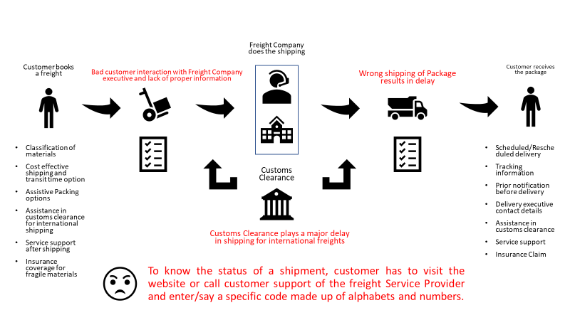

Customers want a different way to interact with the companies they do business with, and bots are one way to achieve this. Customers don’t want to call centres anymore to get information’s. At least not the way that exists today. And companies continue to digitize interactions to reduce costs. In this context, we put in place a Personal Assistant, fuelled by technology-driven, **@DHLBot**, to drive the necessary change to improve customer experience and ramp up loyalty.

**Customer Interaction with @DHLBot**

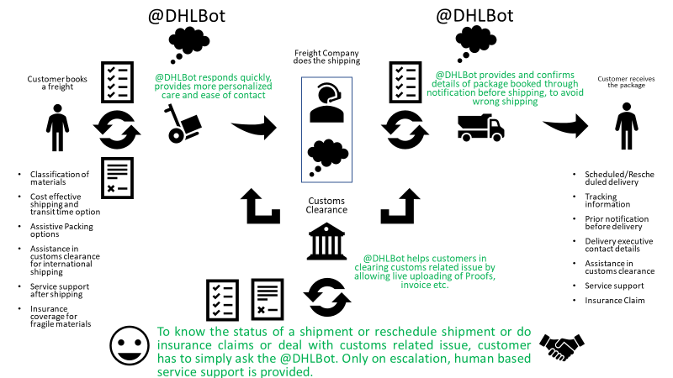

**@DHLBot** is integrated with *Google Personal Assistant* and leverage’s various Google API’s to respond quickly to customers and is fed with information about DHL products & services, which provides a real-time information for shipping, packing, transit time and cost for shipping. This Bot uses NLP (Natural Language Processing) so users can *directly speak with Bot* to get a quote or get status about their shipping. It can *recognize images* andallows users to gather visual information through their device's camera like invoice or document proof or address sign. Bot extracts the value for you and completes the order or upload the images for insurance claim or to clear issues related with customs clearance. *It also takes care of currency conversion and payment methods by using Google Payments or other Payment gateway options.*

Once order is placed, Bot sends a *push notification to package receiver* with information about the details on material being sent along with delivery address. Package receiver can confirm the details or provide changes in real time to the Freight systems. This avoid unnecessary interaction or delay during package transition. Further this Bot *uses google calendar notification* *to alert customers* about their package delivery so that customer can plan their schedule accordingly to avoid any conflict with delivery or reschedule the delivery later. Any changes in delivery schedule will be reflected in the calendar along with a notification to user. Also, Bot leverage’s *Google Maps* to show live transit details from the shipping vehicle using IOT’s or from the Freight database.

The Bot is further integrated with global courier charges database to provide clear insights about exact charges incurred to client and presents, in case if, any charges are to be collected from the recipient. This makes a transparent transaction in customs clearance so that customers exactly know what is being imposed on them when this transition is initiated. In an event of damage of the delivered package recipient may file a query for reverse pickup or initiate insurance claim by uploading a photograph of damaged package within a stipulated time frame.

**@DHLBot** could pave way for optimized resource management and lead to increase in customer engagement.

**Functional @DHLBot Architecture**

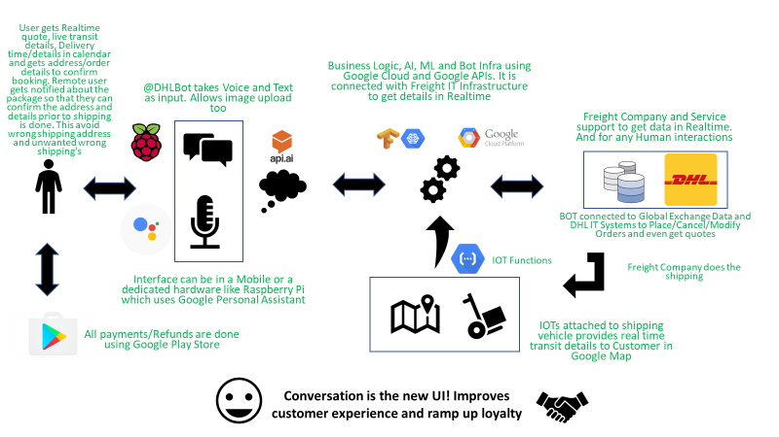

**Features of @DHLBot**

1. Provides Responsive and interactive engagement experience for Customers
2. Understands your natural language
3. Allows to gather visual information’s
4. Provides real time live tracking of shipped package using IOT’s
5. Supports Payment Gateways using Google Play store and others
6. Supports use of QR Code
7. Supports Raspberry PI implementation

**Tech-stack used**

1. Action on Google Personal Assistant as **@DHLBot**
2. API.AI for NLP and TensorFlow for ML
3. Google Maps and Calendar
4. Google Cloud Platform and Google API’s like Vision API, Speech API, Twilio, Cloud Storage etc
5. Programming Languages – Node.Js and Python
6. Database – MySQL or NoSQL
7. Hardware Bot using Raspberry PI

**Implementation Details**

Customer either uses their mobile or walks into DHL Store which has a Voice Activated Hardware Bot built using Raspberry PI, both powered by Google Personal Assistant, to avail DHL Services. @DHLBot supports both Voice and Text Chats in Mobile Version but supports only Voice Chats in Hardware Bot version. API.AI framework tries to understand the Natural Language of the Customer and provides native local language support to customers. This bot is further backed by Google’s Vision API, Speech API, Translate API and Natural Language API which provides Google’s Machine Learning/Tensor Flow Capabilities to interpret images, provide Text-to-Speech capability and respond to user query natively. Google Cloud Functions incorporates serverless micro services to connect with DHL IT Systems and with Global Exchange Data through Google Endpoints. Google Maps provide live tracking feature and Google Calendar provides delivery schedules in real time. If IOTs are attached to shipping vehicles, customers will get live feeds of package that is being in transit. Twilio platform provides SMS functionality which is used to send notification to customer about information’s or with any updates. The customer can confirm the details or provide changes in real time to the Freight systems. This avoid unnecessary delay during package transition and hence save’s cost by avoiding unnecessary shipping. This Bot is hosted in Google Cloud Platform which provides high availability without any downtime to customers.

**Technical @DHLBot Architecture**

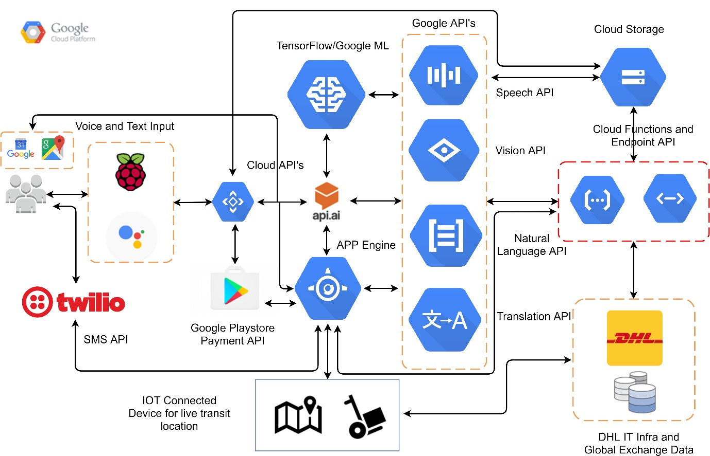

**Impact & feasibility**

Every Individual will have a personal assistant to decide on their freight and assist them when needed. This Bot can work on any platform like Google Assistant, Messenger, Skype, Slack, etc.