AJ Accountancy & Taxation Services Limited
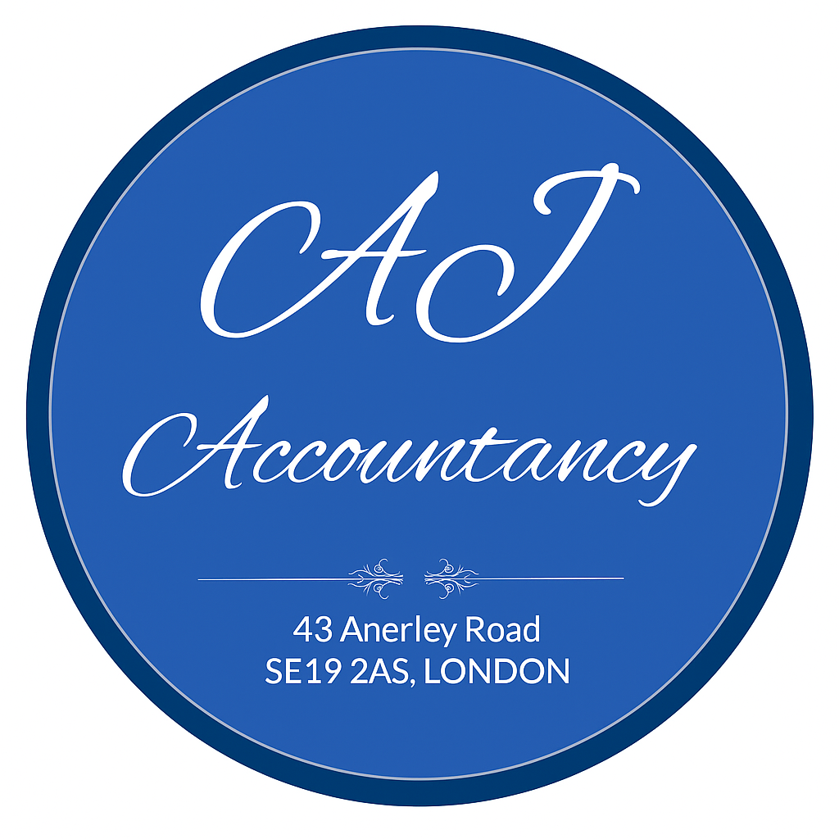
📍 43 Anerley Road, Crystal Palace, London, SE19 2AS
📞 020 8778 8666
📱 +44 7484 095669
📧 info@ajaccountancy.co.uk

🏢 Home
Trusted Accountants in Crystal Palace with Over 40 Years of Experience
Welcome to AJ Accountancy & Taxation Services Limited, a well-established accountancy firm based in Crystal Palace, London.
With over 40 years of professional experience, we provide reliable, accurate, and proactive accounting and taxation services to individuals, sole traders, contractors, startups, and limited companies across the UK.
We understand that managing finances can be complex. Our goal is to make accounting simple, stress-free, and efficient — while helping you stay compliant and grow your business with confidence.
✔ 40 Years of Professional Experience
✔ Personalised & Friendly Service
✔ Transparent & Competitive Pricing
✔ On-Time Filing & Full Compliance
✔ Year-Round Support & Advice

🎯 Our Mission
To deliver reliable, affordable, and proactive accounting and taxation services backed by over 40 years of professional expertise, ensuring financial clarity, regulatory compliance, and sustainable growth for individuals and businesses in Crystal Palace and across the UK.

🌍 Our Vision
To be recognised as one of the most trusted and respected accountancy firms in Crystal Palace and South London, known for professionalism, integrity, and long-term client relationships.
We combine decades of experience with modern cloud accounting technology to provide efficient, forward-thinking financial solutions.

💼 Our Services
For Individuals & Self-Employed
- Self-Assessment Tax Returns
- Tax Planning & Tax Saving Advice
- Bookkeeping & Record Keeping
- Payroll Services
- CIS Returns
- Capital Gains Tax Advice
- HMRC Correspondence & Support
- General Financial Advice
We ensure your tax returns are accurate, submitted on time, and fully compliant — helping you avoid penalties and maximise tax efficiency.

For Limited Companies
- Company Accounts Preparation
- Corporation Tax Returns
- VAT Registration & VAT Returns
- Payroll & Auto-Enrolment
- Confirmation Statements
- Company Secretarial Services
- Management Accounts
- Business Planning & Forecasting
- Director’s Tax & Dividend Planning
We support company directors with expert financial guidance, helping them make informed decisions and maintain full statutory compliance.

Additional Services
- Bookkeeping
- VAT Advisory
- Business Consultancy
- Company Formation
- Tax Investigation Support
- HMRC Enquiry Assistance

💻 Accounting Software Support
We have extensive experience working with leading accounting software and can help you choose, set up, and manage the right system for your business.
Supported Software:
- Sage
- Xero
- QuickBooks
- FreeAgent
- QuickFile
We also provide system setup, training, data migration, and ongoing support to improve efficiency and reporting.

⭐ Why Choose Us?
✔ 40 Years of Industry Experience
Four decades of knowledge across multiple industries and business sectors.
✔ Personalised Service
We take time to understand your business and provide tailored financial solutions.
✔ Local Expertise – Crystal Palace
As a local firm, we understand the needs of businesses in Crystal Palace and South London.
✔ Proactive Tax Planning
We actively identify tax-saving opportunities — not just prepare accounts.
✔ Transparent Pricing
Clear and honest fees with no hidden surprises.
✔ Modern & Efficient
Combining traditional experience with modern cloud accounting systems.
✔ Peace of Mind
We ensure deadlines are met, submissions are accurate, and your business remains compliant at all times.

👥 About Us
AJ Accountancy & Taxation Services Limited is a trusted London-based accountancy firm with over 40 years of professional experience.
We proudly support small businesses, startups, contractors, landlords, and individuals with tailored accounting and tax solutions.
Our firm is built on professionalism, integrity, confidentiality, and long-term client success. We believe strong client relationships are the foundation of successful financial management.

📞 Contact Us
Get in Touch Today
Whether you are starting a new business, switching accountants, or seeking expert tax advice, we are here to help.
📍 43 Anerley Road, Crystal Palace, London, SE19 2AS
📞 020 8778 8666
📱 +44 7484 095669
📧 info@ajaccountancy.co.uk
Book your free initial consultation today and benefit from over 40 years of trusted experience.

