Task1:
Instances Created:
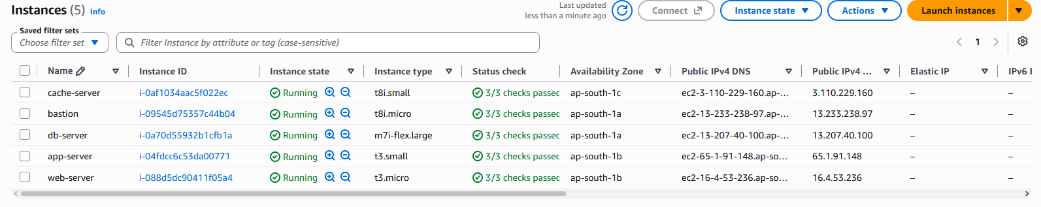
Destroy failed:
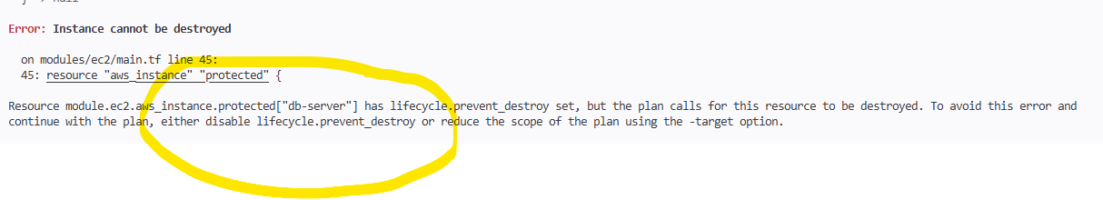

Volumes:
