Activity – 2 (30.09.2026)
1. Access Channels - Mobile Network Architecture - Mobile Station - Base Station Subsystems.

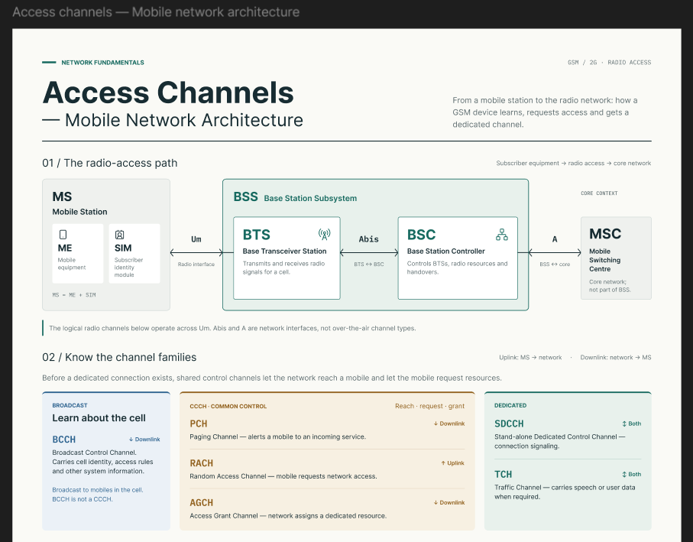
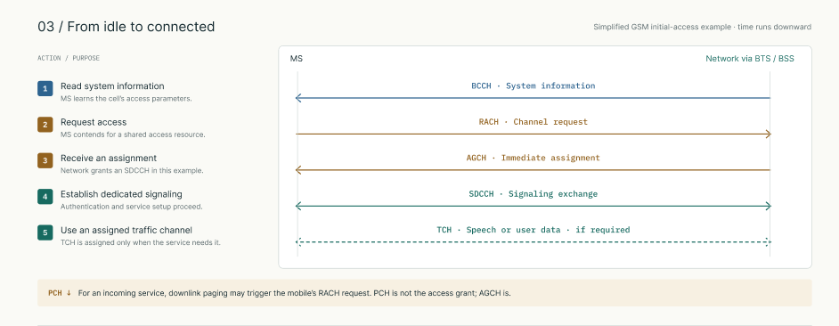
2.Use Figma to create an interactive diagram illustrating the components of a basic cellular system.
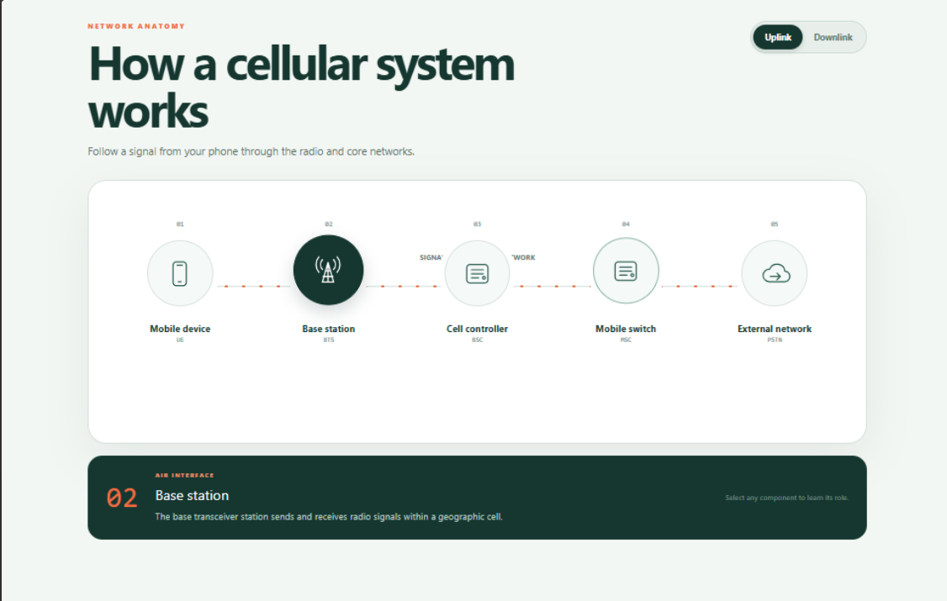
3. Network Switching Subsystems - Mobile Network Protocol Stacks - Core Networks

