# **Functionality**

Introduction

DPP Veg Mart is a vegetable delivery organization in India spread over many cities and states. They are actively conducting this business from the last 4-5 years. They are eminent in their field and have around 13 branches across India, including their head office in Nagpur. They purchase vegetables from farmers and other sources directly and deliver to the customers in wholesale. DPP Veg Mart has a varied clientele spread across the wholesale vendors, retail markets and end customers. To keep up with their ever-growing client base, and to run their business smoothly, they have decided to take their business online.

The Chairman and CEO is Mr. Dharmendra Pathak. All business units report to him. The first line of business units includes the Planning and Management, Marketing and Finance. The Human Resources and Production coordination departments are part of the Planning and Management unit. The Marketing Business Unit includes the departments of Sales, Distribution, Marketing Analysis and Planning. The Finance department takes care of all the Accounts for DPP. The hierarchy of the Business units, along with the names of the Heads of the department heads is illustrated in the following Figure 1 in Page 4.

Each business unit works as an individual entity with focused goals, deliverables, target markets and strives to achieve the business goals of DPP. Every unit reports to the CEO about their operational status, concerns, statistics and reports.

How DPP Veg Mart Works

DPP Veg Mart specializes in offering both seasonal and non-seasonal fruits/ vegetables. As there is no chain of middlemen between the producer (Farmer) and consumer, both the parties get good value for the products. Also, fruits and vegetables require special handling. To preserve quality and maintain marketability, each crop must be harvested, prepared for market, packaged, and shipped promptly. Transportation of the vegetables is managed according to the specific needs and priorities. Either farmers or other sources can transport them or DPP Veg Mart would send their own transport to get the vegetables at the client’s doorstep. The latter is the preferred method because of the challenge’s other sources face in transportation.

Upon arrival, the produce is stored in the company warehouses which operate in a hierarchy of 3 levels. The First level is the Central Hub (CH in the corporate office), then comes the Sub Center Hub (SCH) and then the clients (users, traders). Pictorial representation of the same could be found in Figure 2 in Page 5.

SCHs are usually bombarded with bulk orders. In case of shortage of supplies, the SCHs promptly order the CH on re-stocking. Based on the locations, in times of priority, the SCHs fetch their produce from other SCHs or directly from farmers too. In this way, the SCHs communicate with each other through CH or amongst themselves.

All the Legal, economic and management decisions are taken by the Corporate Hub head office. The success factors for DPP Veg Mart has been the elimination of middlemen, seamless delivery of the produce and management of the vendors. The farmers get good value for their products and the vendors and happy with the glitch-free work flow.

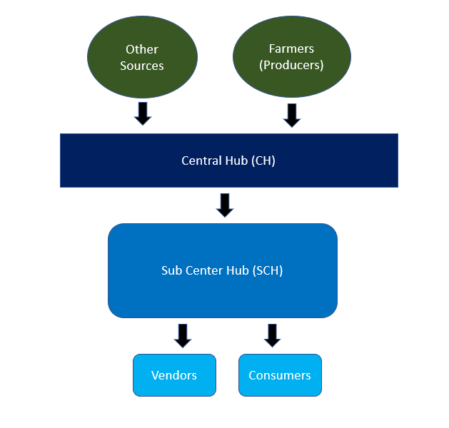

Figure 2: DPP Business Centers Hierarchy