Lesson 01 Demo 01

Creating CloudFormation Stack for Launching VM

Objective: To create CloudFormation stack for launching VM

Tools required: AWS CloudFormation

Prerequisites: None

Steps to be followed:
- Log in to the AWS Console
- Create a new CloudFormation template to launch a new VM

Step 1: Log in to the AWS Console

  - Click on the Practice Labs tab and log in to the AWS Console from the AWS Labs

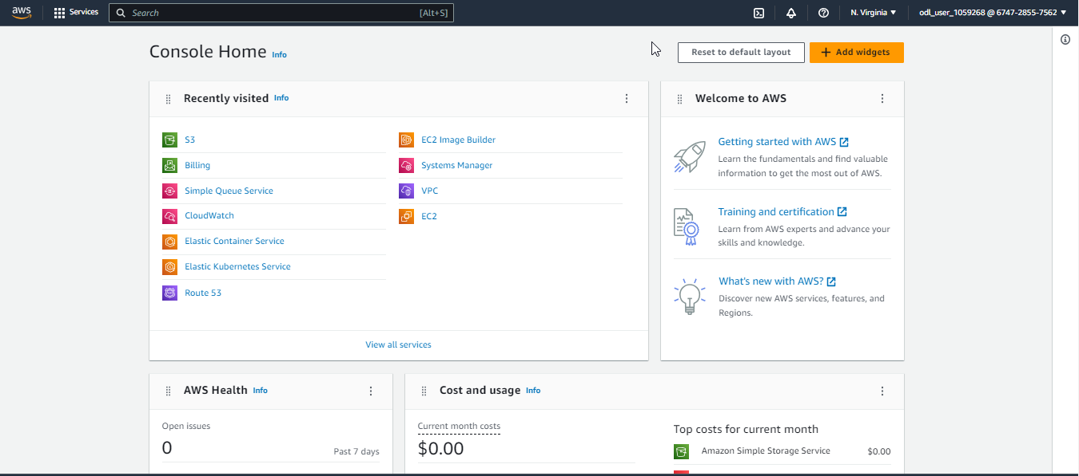

  - Search for and select CloudFormation in the AWS Console

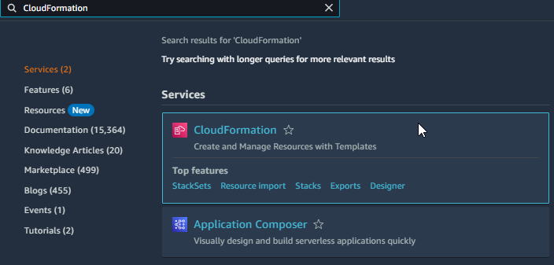

Step 2: Create a new CloudFormation template to launch a new VM

- Click on Create stack and select the With new resources (standard) option

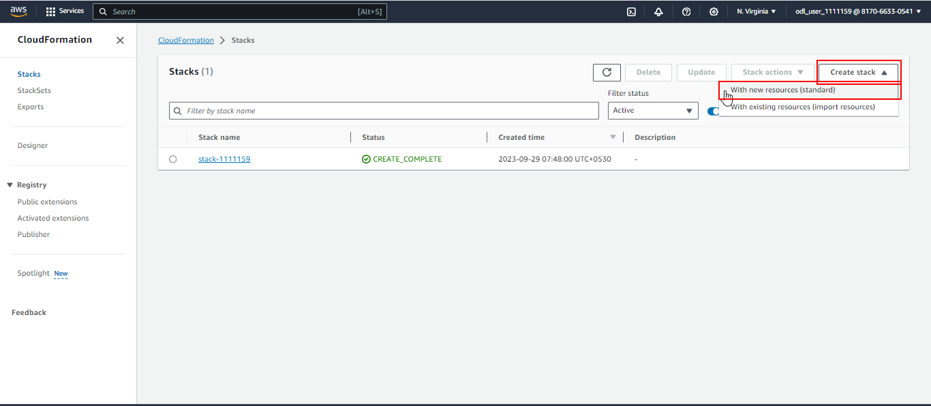

- In the Prerequisite - Prepare template section, select Create template in Designer and click on the Create template in designer button

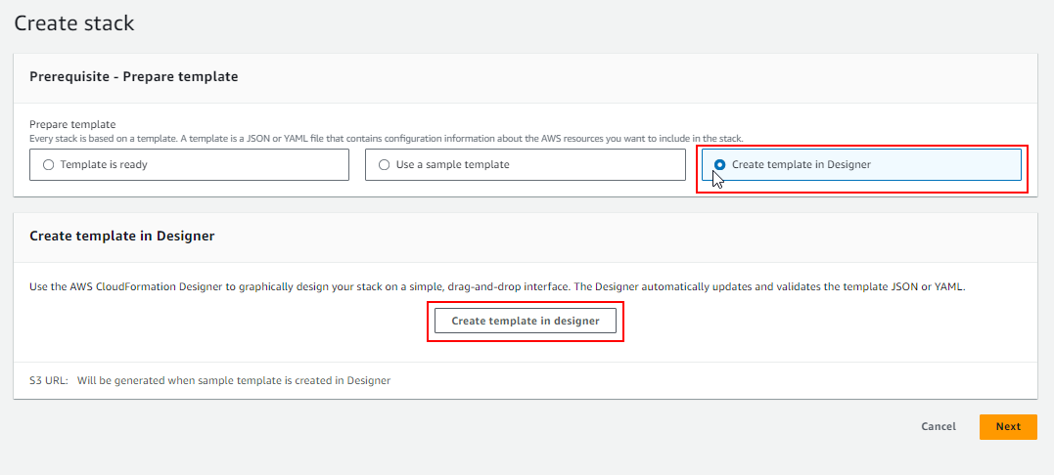

- Under the new template section, click on Template and add the Header, Parameters, and Resource components, which are shared below:

AWSTemplateFormatVersion: '2010-09-09'
Description: Launch a t2.micro EC2 instance without a key pair

Resources:
EC2InstanceSecurityGroup:
Type: AWS::EC2::SecurityGroup
Properties:
GroupDescription: Enable HTTP and ICMP (ping)
SecurityGroupIngress:
- IpProtocol: tcp
FromPort: 80
ToPort: 80
CidrIp: 0.0.0.0/0
- IpProtocol: icmp
FromPort: -1
ToPort: -1
CidrIp: 0.0.0.0/0

EC2Instance:
Type: AWS::EC2::Instance
Properties:
InstanceType: t2.micro
ImageId: ami-0c02fb55956c7d316 # Amazon Linux 2 (update if needed for your region)
SecurityGroups:
- !Ref EC2InstanceSecurityGroup
Tags:
- Key: Name
Value: CFN-EC2-NoKeyPair

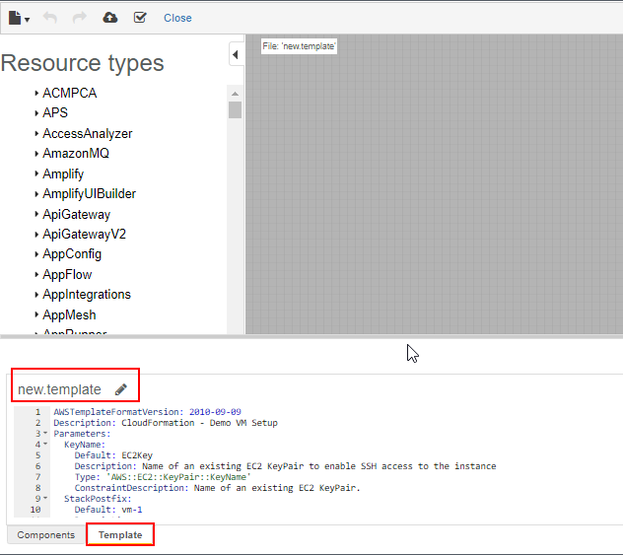

- Click on the Validate icon to validate the template, remove any errors, and click on the Create stack icon

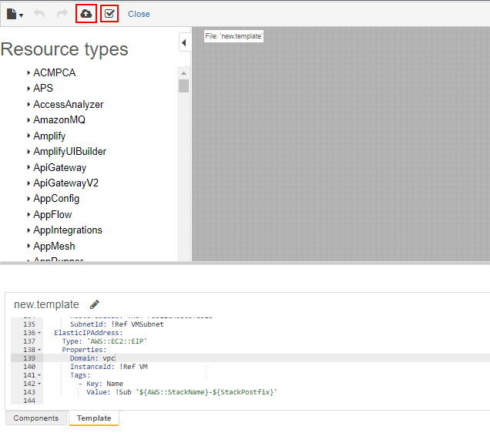

- Click on the Next button. Add the Name, specify other stack details, and click Next per the below screenshots:

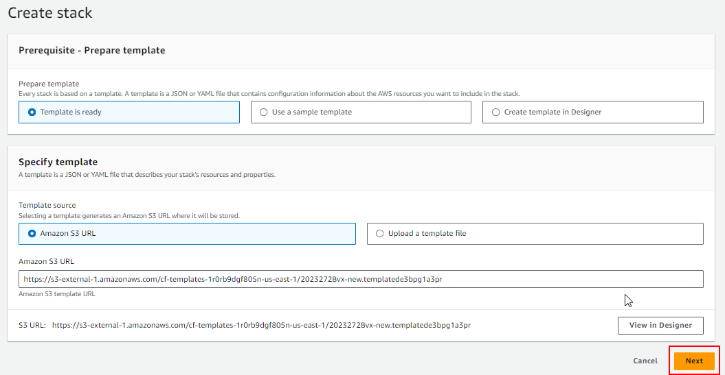

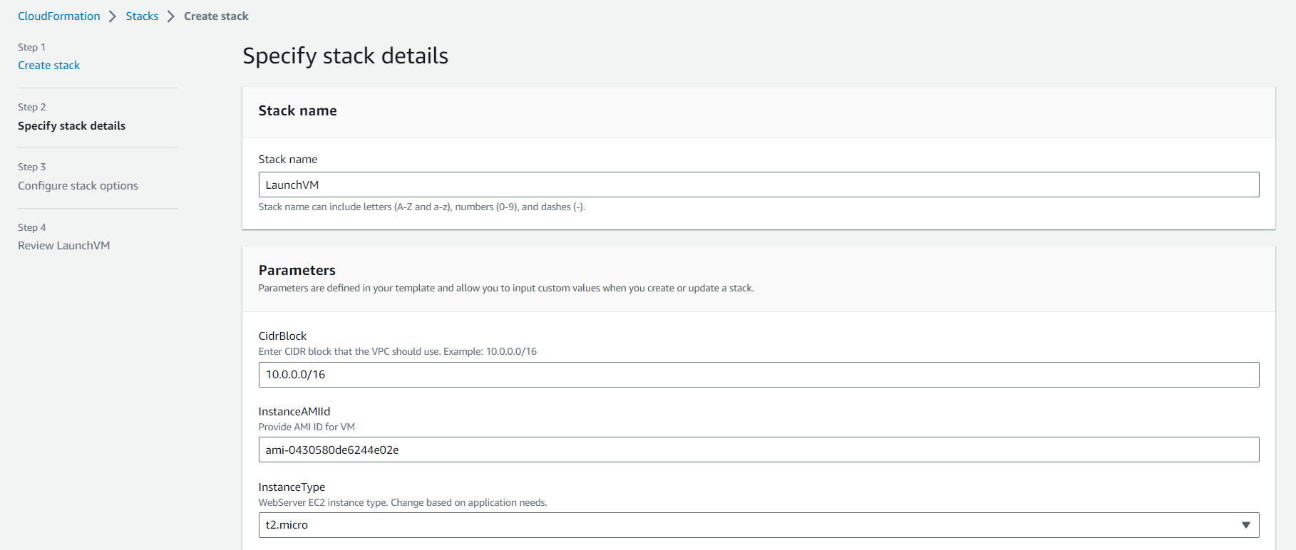

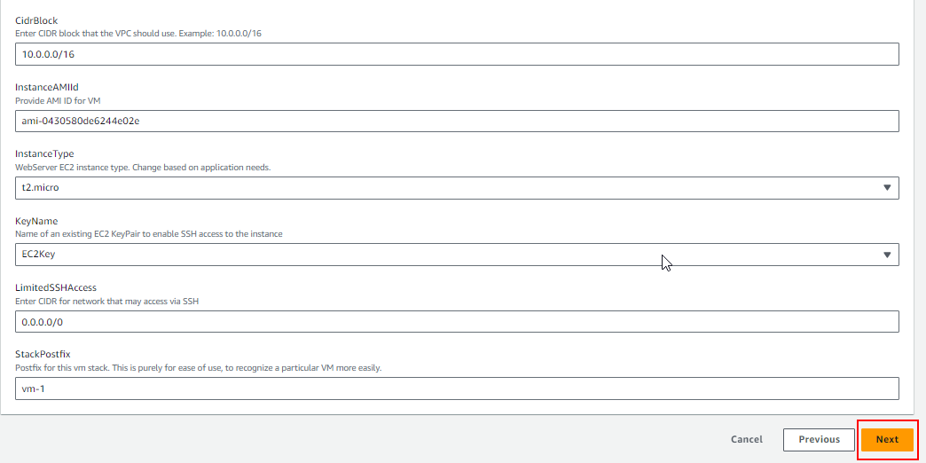

- Validate whether the stack is created per the screenshot:

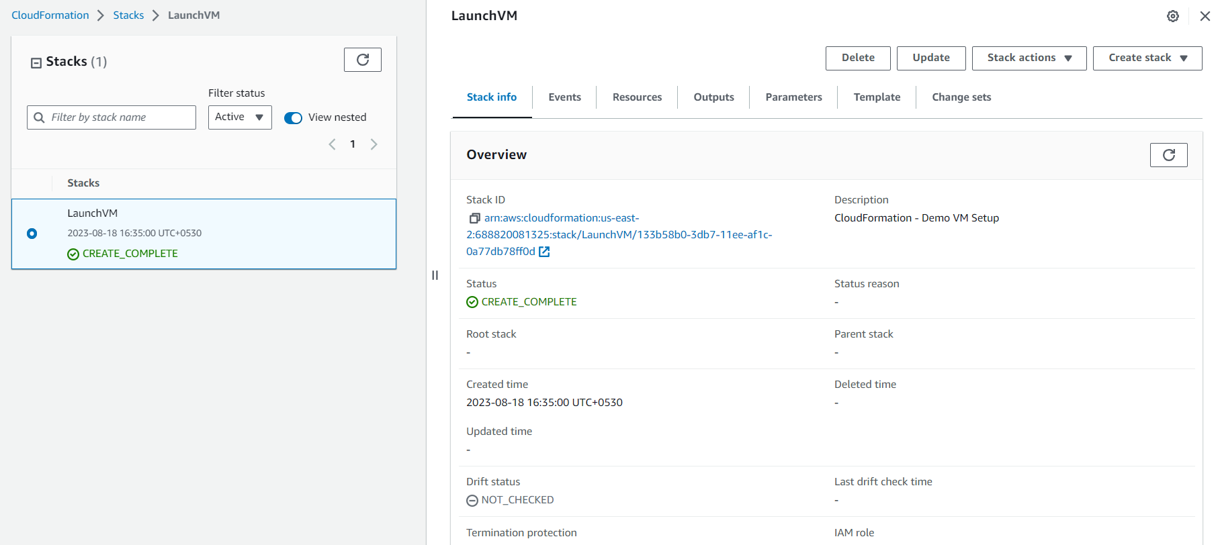

- Navigate to EC2 services to list all the available instance

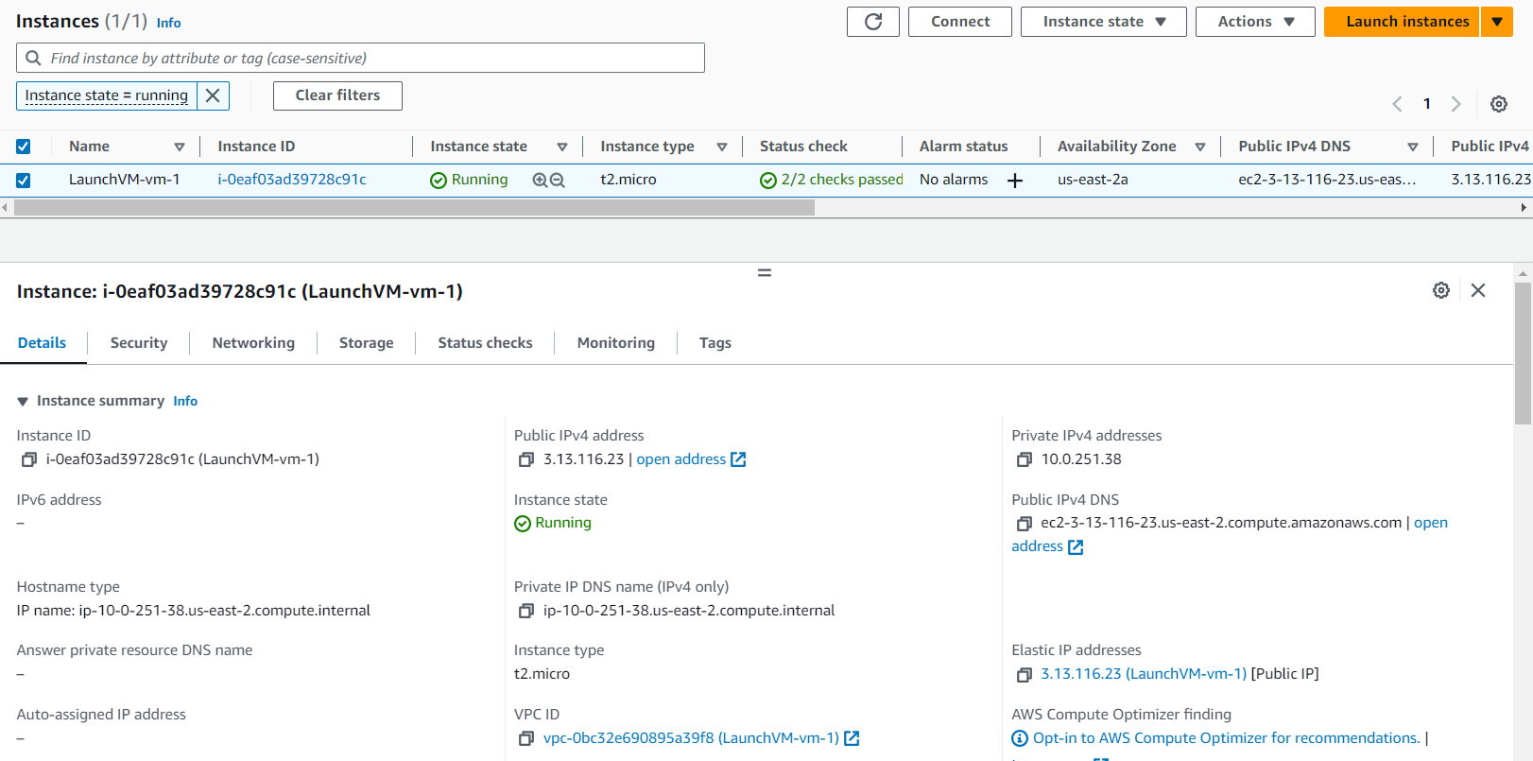

With this, we have successfully created a CloudFormation stack and launched a VM.

