PG DO DevSecOps - Principles and AWS
Cloud Security
Lab Guide



This section will guide you to:
- Use labs to execute all demos included in this course

Step 1: Starting practice labs on LMS
- Login to Simplilearn LMS
- Go to the respective course
- On the left, you will find the course ToC page
- To its left, you will find the PRACTICE LABS tab
- Click on it

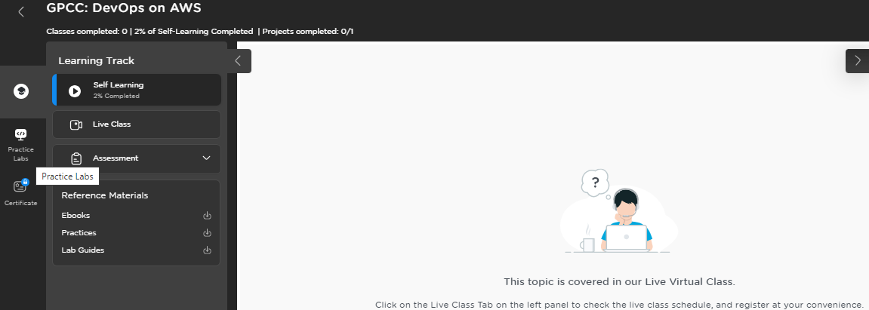

- As a new window opens, read the instructions, and click on LAUNCH LAB
- This will launch practice labs for this course

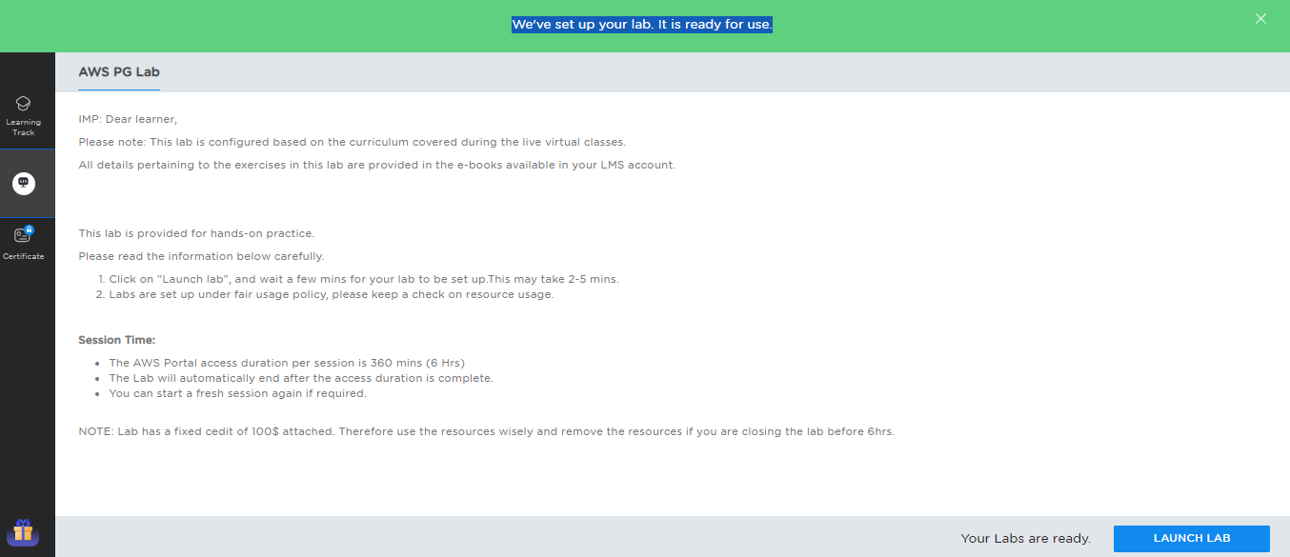

- Once the lab instance is started, copy the Sign-in link as shown below:
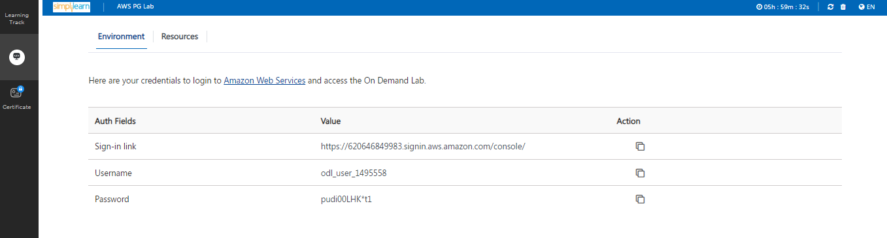
- Provide the credentials and the click on Sign in as shown in the screenshot below:
