Pradeep Vuyyuru
CMPE 272
September 8, 2026

Deploying Webservers with Ansible
For this assignment, I used VirtualBox to set up two Ubuntu VMs and Ansible to deploy a webserver on both of them. Each server listens on port 8080, but the page identifies which VM is responding. VM1 displays "Hello World from SJSU-1," while VM2 displays "Hello World from SJSU-2." I also included a separate play to remove the webserver resources and checked that I could deploy them again afterward.
The first issue came up before Ubuntu could even start. VirtualBox reported that AMD-V was disabled, so I enabled SVM Mode in the BIOS and restarted the PC. After that, both VMs could boot from the Ubuntu 26.04.1 desktop ISO. This was a useful reminder that the virtualization setting on the host matters before any of the configuration inside the VMs can work.

Setting up the two VMs
Both VMs have 4 GB of memory and two virtual CPUs. VM1 has a 25 GB virtual disk, and VM2 has a 30 GB disk. I used a NAT adapter so Ubuntu could download packages and a host-only adapter so the VMs and my Windows browser could communicate directly. VM1 uses 192.168.56.101, and VM2 uses 192.168.56.102.
I used VM1 as the Ansible controller as well as one of the webservers. This let me manage both machines without setting up a third VM. The inventory lists the two hosts and gives each one an instance_id value. The HTML template uses that value to put the correct number in the message.

Checking the connection
Before deploying anything, I checked that Ansible could reach both hosts over SSH. The ping module returned success for VM1 and VM2. This checked more than basic network connectivity because Ansible also needed to authenticate and run Python on each VM.
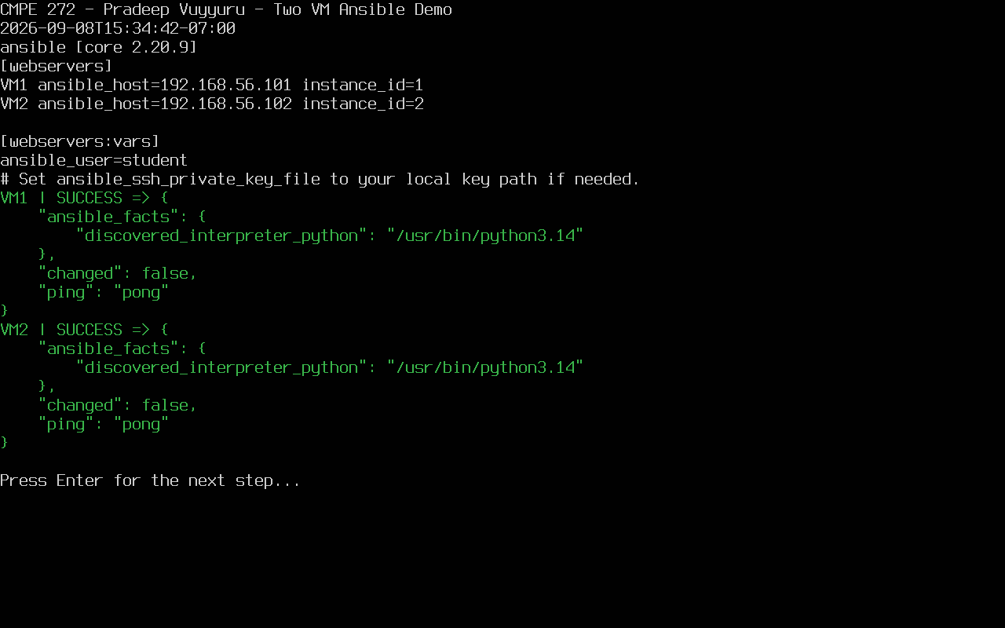
Figure 1. The inventory and Ansible connection checks for both VMs.

How the playbook works
The deploy play installs nginx, creates the page from a template, and starts a dedicated systemd service called sjsu-web. Its nginx configuration listens on port 8080. I kept the application configuration separate so the un-deploy play could remove the files that belong to this assignment.
I used explicit deploy and undeploy tags to choose which play runs. Both plays also have the never tag, so running the playbook without an action tag does not accidentally deploy the application and remove it in the same run. After deployment, the playbook requests the page on each VM and checks the message against that host's instance_id.

Deploying the webservers
The deployment completed on both hosts. I then ran the same deploy command again to check whether Ansible would make unnecessary changes. The repeat run reported changed=0 for both machines, which showed that the existing configuration already matched the playbook.
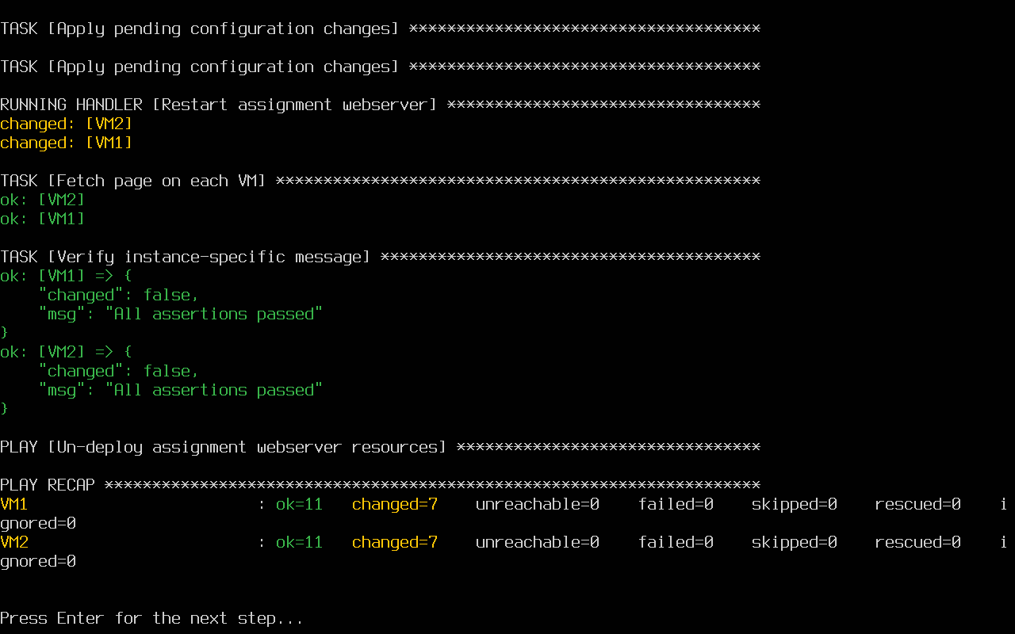
Figure 2. Deployment results for VM1 and VM2.
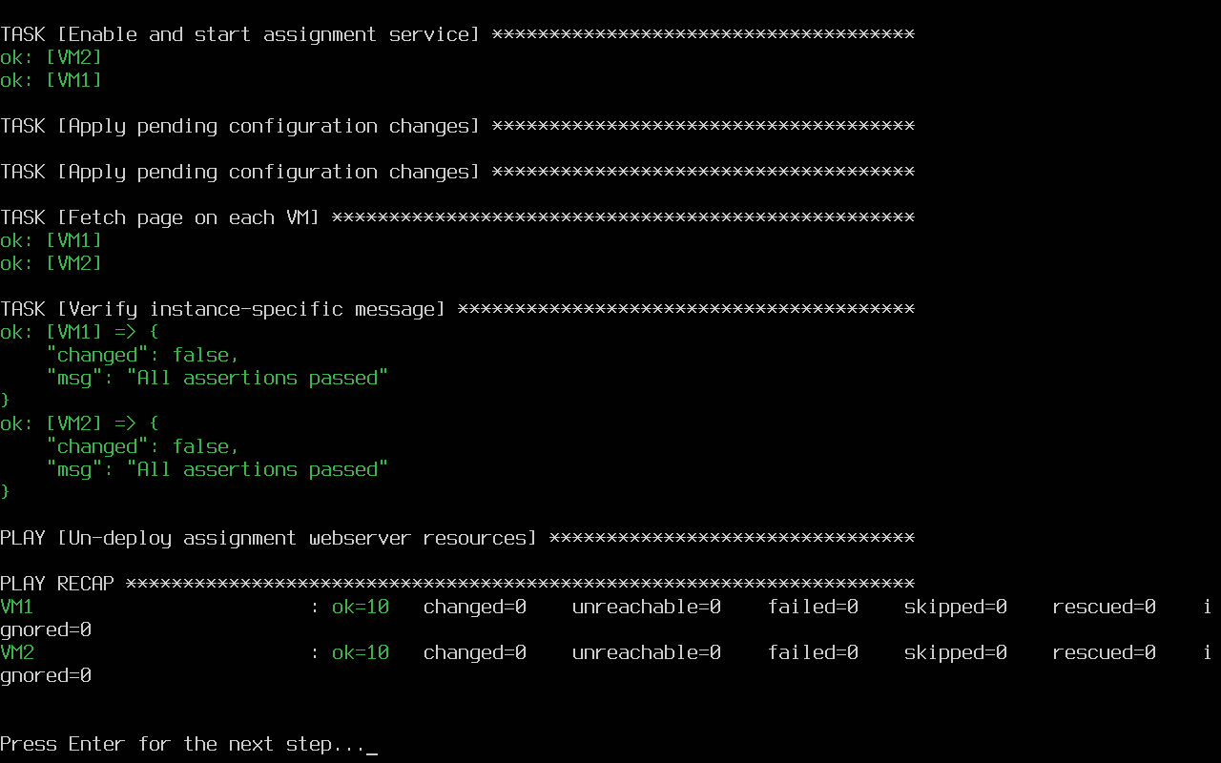
Figure 3. A second deployment leaves both hosts unchanged.

Opening the pages in a browser
I opened each VM's address with :8080 in the browser. Both pages loaded with the expected message. Seeing the two different numbers made it easy to confirm that the same template was being customized for each host.
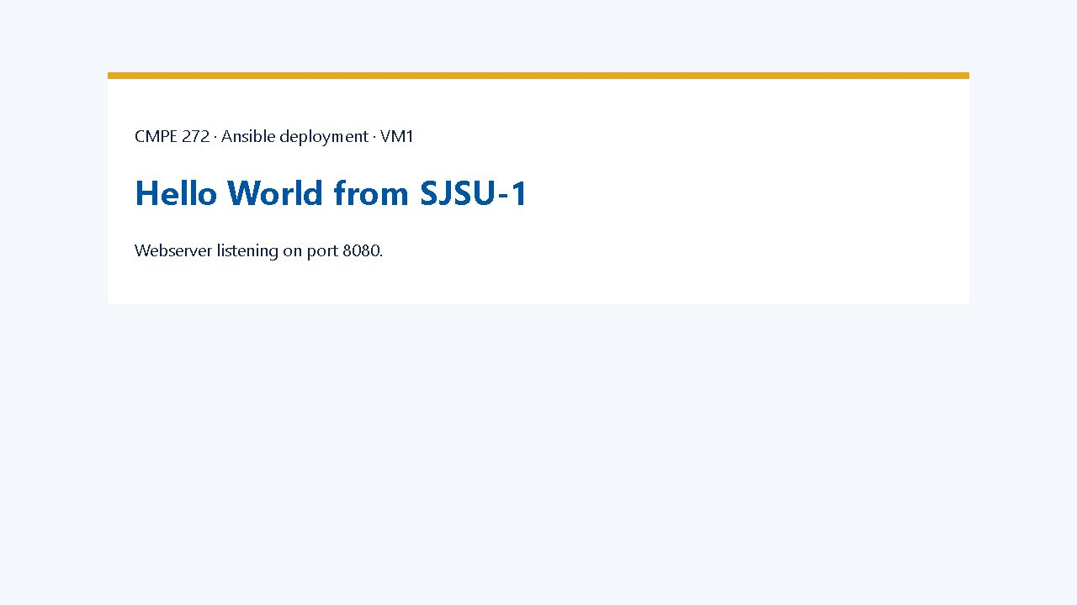
Figure 4. VM1 at http://192.168.56.101:8080 displays Hello World from SJSU-1.
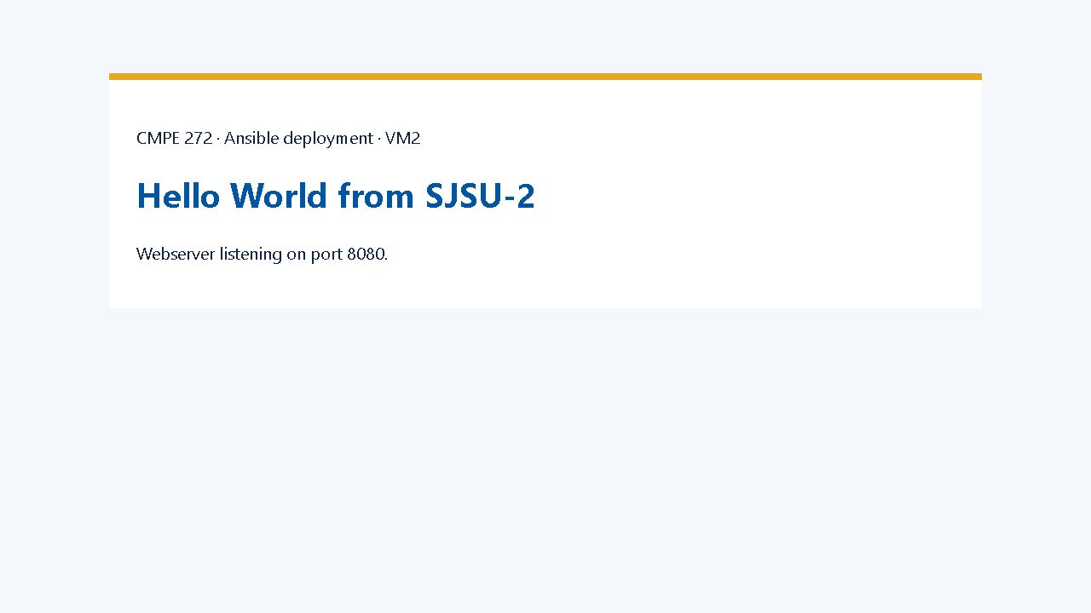
Figure 5. VM2 at http://192.168.56.102:8080 displays Hello World from SJSU-2.

Removing and restoring the application
The un-deploy play stops and disables sjsu-web, then removes its service file, nginx configuration, and page directory. It removes the nginx packages because these VMs are dedicated to the assignment, and checks that port 8080 is closed.
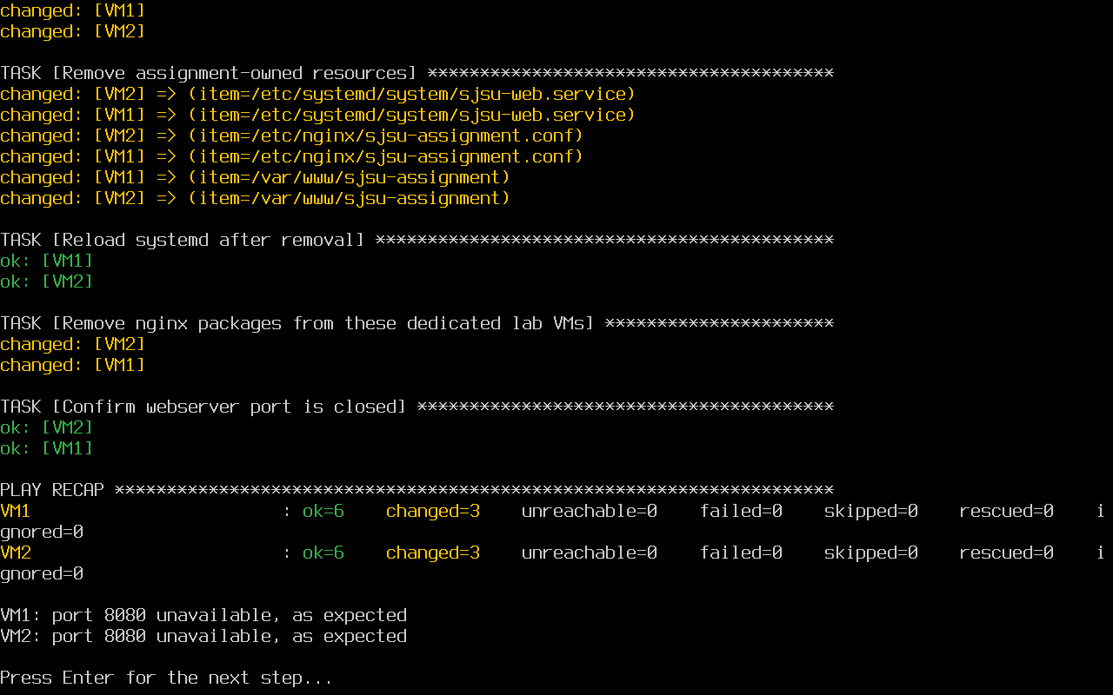
Figure 6. The un-deploy run removes the application from both hosts.
After removal, neither VM responded to an HTTP request on port 8080. I repeated the un-deploy command to check that it could run again safely, then deployed the webservers again. Both pages came back with their original messages.
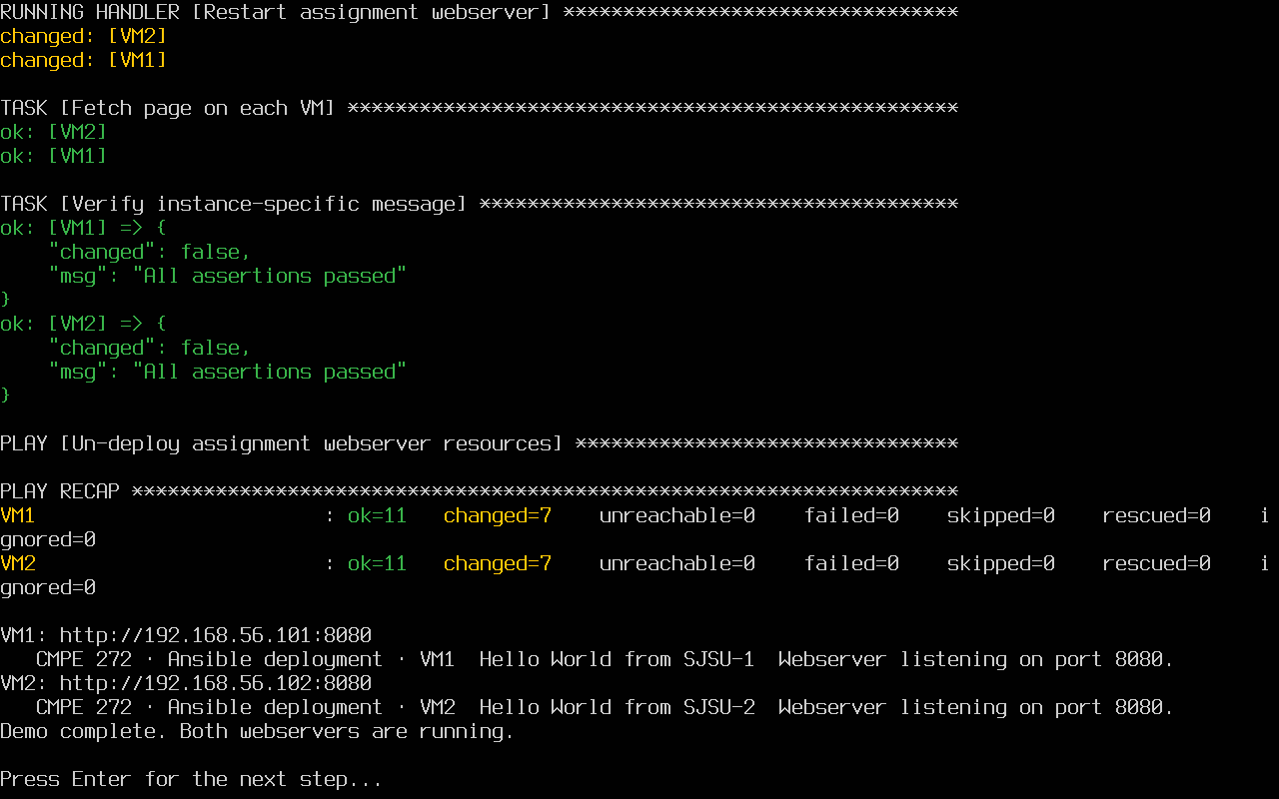
Figure 7. Both webservers respond again after redeployment.

Demo and source code
The repository includes the Ansible playbook, inventory, nginx and HTML templates, service file, controller setup script, and demo script. The evidence folder contains the screenshots and command output from the runs. The recorded demo shows the deployment cycle, and demo.sh repeats the command-line checks.
GitHub repository: https://github.com/pradeepvuyyuru/CMPE272AnsibleAssignment
Recorded demo: demo.webm in the repository.
To run the playbook from VM1, activate the Ansible environment and open the assignment directory. The main commands are:
source ~/ansible-venv/bin/activate
cd ~/ansible-assignment
ansible-playbook site.yml --tags deploy
ansible-playbook site.yml --tags undeploy
What stood out to me was that the same playbook handled both machines without needing two separate copies of the configuration. The inventory controlled the one detail that changed between them. Running the deployment a second time and then removing and restoring it made the result easier to check than just loading the pages once.

References
Ansible tags documentation: https://docs.ansible.com/projects/ansible/latest/playbook_guide/playbooks_tags.html
Ubuntu autoinstall reference: https://canonical-subiquity.readthedocs-hosted.com/en/latest/reference/autoinstall-reference.html

