Hotspot Identification

1. Background
Road safety is a critical issue worldwide, with traffic accidents causing loss of lives and economic damages. Certain locations, known as accident hotspots, record disproportionately higher numbers of crashes due to road geometry, traffic volume, or environmental conditions. Correct identification of these hotspots allows transport authorities to target safety measures effectively. It reduces accidents, improves traffic flow, and ensures optimal use of resources. Methods of hotspot identification integrate accident frequency, severity, and contributing factors such as human behavior, weather, and vehicle conditions. With growing traffic, hotspot identification is increasingly important for sustainable and safer transportation systems.

2. Need
Hotspot identification is essential for reducing accidents and improving road safety. It enables better allocation of safety budgets, supports data-driven planning, and ensures preventive measures are implemented at critical locations. By focusing on high-risk zones, it helps reduce fatalities, minimize congestion, and create safer transport networks for all users.

3. What Has Been Done in Past
Earlier studies mainly used statistical methods such as accident frequency, accident rate, severity index, and crash density for hotspot identification. Many countries applied threshold-based definitions, for example, Germany considers three accidents in 300 meters annually as a hotspot. Regression models like Poisson and Negative Binomial were widely used to address accident frequency and over-dispersion issues. GIS mapping improved spatial visualization of accident-prone areas. Recently, machine learning and Artificial Neural Networks (ANN) have been applied to integrate multiple factors like traffic volume, road design, and human behavior. These approaches provide more accurate and dynamic hotspot detection compared to older static methods.

4. What We Want to Do / Methodology
In this project, we plan to identify accident hotspots using a combination of accident, traffic, and geometric data. First, accident records will be collected from reliable sources and preprocessed to handle missing values and standardize parameters. The study area will be segmented, and hotspots will be identified using both statistical models (Poisson, Negative Binomial) and spatial mapping through GIS. Additionally, clustering techniques and Artificial Neural Networks (ANN) will be explored to improve prediction accuracy. The methodology emphasizes combining frequency, severity, and road characteristics, ensuring hotspots are identified with higher reliability for effective safety interventions.
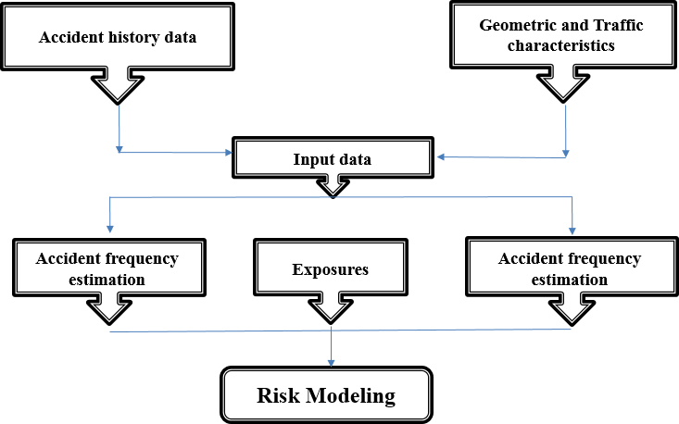
Fig. 1. Conceptual model of research (Identification process of the accident hotspots and segments).

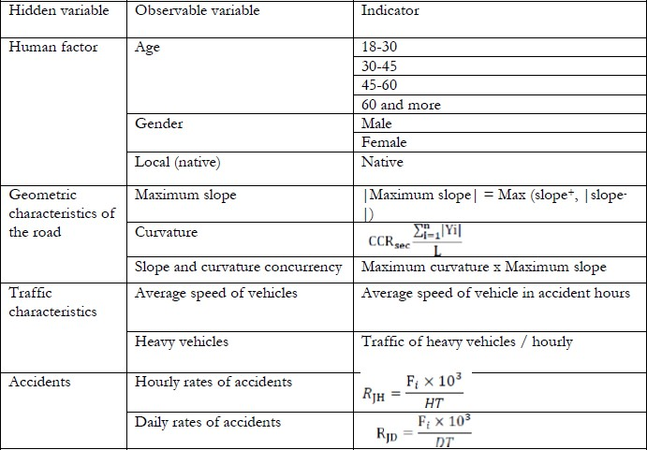

Table 6. Indicators used to define hidden variables (human, geometric, traffic, and accident parameters) for hotspot identification. These indicators represent measurable factors such as driver age, road geometry, traffic volume, and accident characteristics, which are essential inputs for modeling and analysis.
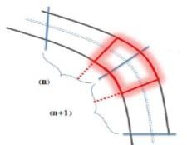
Failure to coordinate the accident-prone segment position with the defined segments.
5. Data
The dataset will include accident details (time, location, cause, severity), traffic parameters (volume, average speed, vehicle type), and road characteristics (geometry, slope, curvature). Data will be sourced from official transport authorities and police reports. GPS-based accident coordinates will enable accurate mapping and segmentation for spatial hotspot identification.
Variable  name | Specifications | Variable type/value/unit
A.S. | Dependent variable (with coefficient) | Fatal\injury\damage (equaled)
A.F. | Dependent variable (accident  frequency) | Number of accidents
S.C. | segment length | 1 or 2 km
Volume | Hourly traffic volume | Vehicle in hour
AADT | Annual average daily traffic | Vehicle in hour
P.C.H | Traffic volume of passenger cars | passenger cars in hour
N.P.C.H | Traffic volume of non- passenger cars | Vehicle in hour
Av. Speed | Average speed at the time of accident | Km/h
Weekend | Days of week | Weekend 1, rest 0
Lic | Native , Non-Native license plate | Native 0, Non-Native 1
Light | Lighting conditions | Day 1, night 0
C.T. | Collision Type | One or more vehicle-  overturning-with pedestrian- etc
WC | Weather conditions | Clear 1 etc 0
A.C. | Accident cause | Nine causes of accidents
GC | Geometric condition of accident location | P-straight\ P-intersection\ P-  Residential\P- Slope\ P- horizontal curve
GPS | - | Global Positioning Systems of  accident location
Table presents a sample of key variables used in hotspot identification.
6. Data Tools
Tools include Excel for preprocessing, GIS software (ArcGIS/QGIS) for spatial hotspot mapping, and STATA/MATLAB for statistical modeling (Poisson, Negative Binomial, ANN). Additionally, Python with libraries such as Pandas, Scikit-learn, and Matplotlib will support clustering and visualization. These tools will collectively enhance the analysis and validation of identified hotspots.
7. Deliverable
The final deliverable will be a report supported by GIS-based hotspot maps, statistical analysis results, and practical recommendations for improving safety and reducing accidents at identified critical road locations.

