7th of September 2011
eCivil Registration System
Progress Report

Note: Newly added features marked as bold and in progress tasks marked as italic

- Registration of Births

  - Live Births
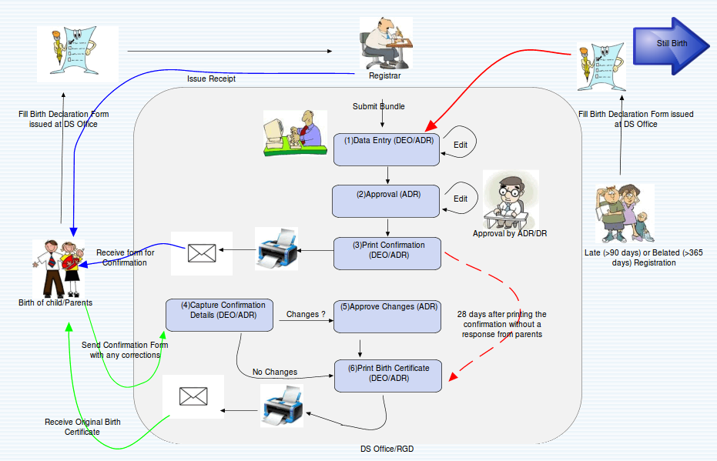Illustration 1: Live Birth Registration Process
    - Receiving and escalating of declaration registration of Births within 3 months and approval of declaration of registrations by ADR or higher ranked officer
    - Receiving declaration registration of Births after 3 months by ADR
    - Approval of declaration of registration of Births after 3 months and within 1 year by ADR or higher ranked officer
    - Receiving and escalating of declaration registration of Births after 1 year by ADR.
    - Approval of declaration of registration of Births after 1 year by ARG or higher ranked officer
    - Confirmation of Birth generated and post to the parents/guardian to verify entered declaration registration of Birth to assure accuracy of recorded data
    - Generation of the Birth Certificate and post it to the Informant of declaration of Birth
    - Generation of unique 12 digit Sri Lankan National Identity Number (SLIN)
    - Translation of Birth Certificates not necessary any more since certificates issued in any of applicant requested official language and English
    - Copies of Birth Certificates can be issued from any Divisional Secretariat in Sri Lanka

  - Still Births
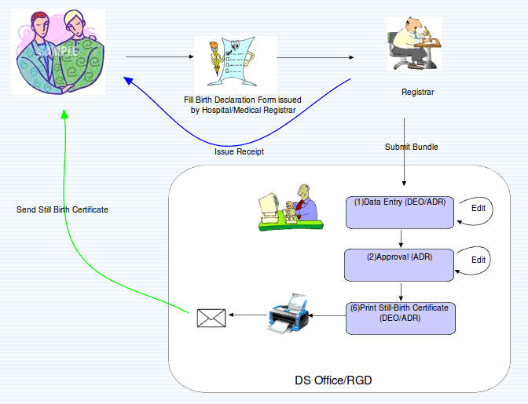Illustration 2: Still Birth Registration Process

    - Receiving declaration registrations of Still Births.
    - Approval of declaration of registration of Still Births by ADR
    - Generation of the Still Birth Certificate and post it to the Informant of declaration of Still Birth

  - Birth Alterations
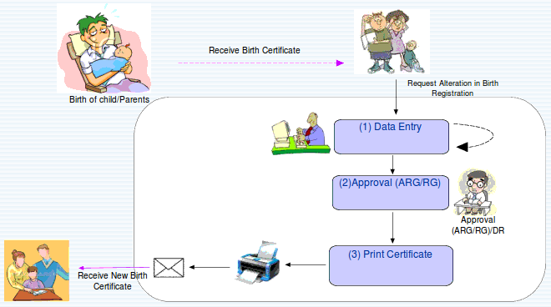Illustration 3: Birth Alteration Process

    - Section 27 – Alteration of names
      - Name in official language and English
    - Section 27 A - Amendments
      - Details of Father, Marriage, Grandfathers and Mothers name after marriage
    - Section 52 (1) – Corrections
      - Details of Child, Mother and Informant
    - Receiving and escalating of declaration of Birth Alteration of above mentioned types in any Divisional Secretariat Division Office in Sri Lanka
    - Approval of Section 27 declaration of Birth Alterations by ADR or higher ranked officer
    - Approval of Section 27A and Section 52(1) declaration of Birth Alterations by ARG or higher ranked officer
    - Approval of declaration of Birth Alterations can be done officers who only have access to declaration of Birth Alteration submitted location or original birth certificate issued location
    - After the approval of declaration of Birth Alteration of Section 27 or 27A or 52(1), Birth Certificate generated with mentioned alterations
    - Alter names of father and mother in English language for Section 27A and 52(1) – In Progress
    - Option to view full detailed history of birth alterations for a particular birth record – In Progress

  - Search of archive birth records and certificate issue
    - Search option to view the current status of specified birth record with full detailed view
    - Advance search option to search any archived birth declarations quickly
    - Birth certificate copies can be issued from any Divisional Secretariat

- Registration of Adoptions

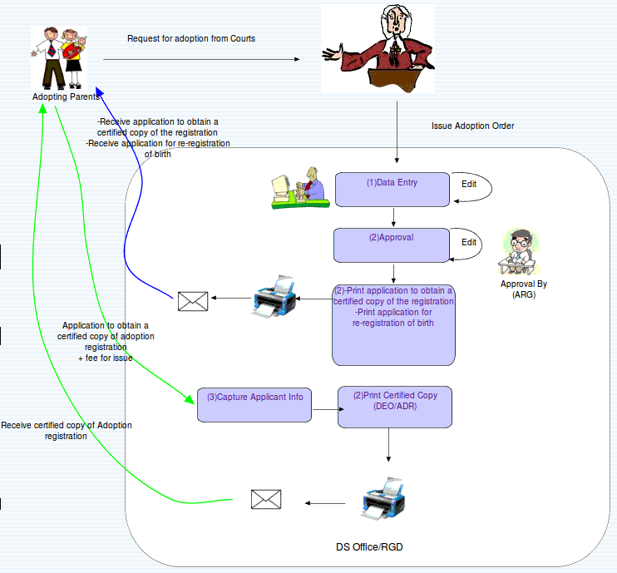Illustration 4: Child Adoption Registration Process
  - Receiving and escalating of declaration registration of Adoption Order issued by Court
  - Approval of declaration registration of Adoption Order by ARG or higher ranked officer
  - Generation of application to obtain a certified copy of the Adoption registration and re-registration of Birth and post it to the parents
  - Capture Adoption applicant information from application to obtain a certified copy of Adoption
  - Generation of Certificate of Adoption and post it to the applicant
  - Re-registration of birth after generation of Adoption Certificate, approval of ARG of higher officer needed
  - Follow the Live Birth Registration flow and generation of Birth Certificate

- Registration of Deaths

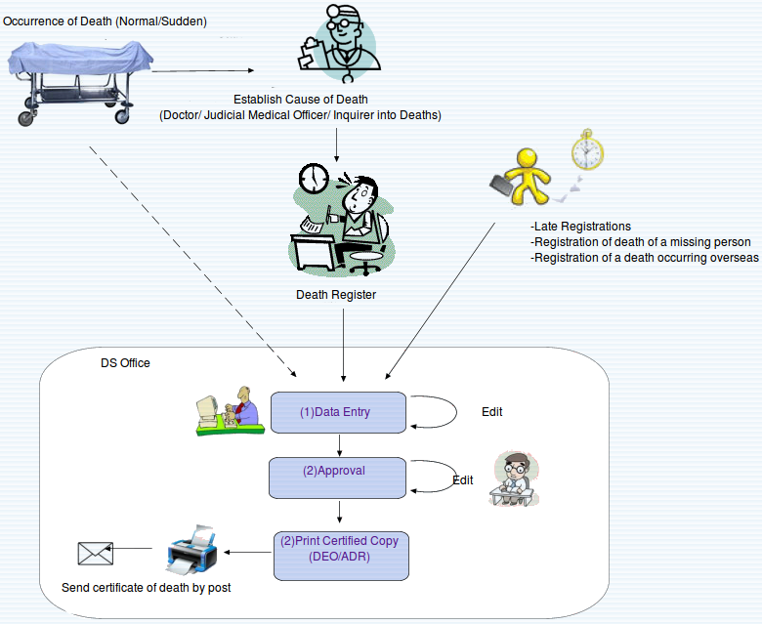Illustration 5: Death Registration Process

  - Receiving declaration registrations of Normal Deaths
  - Approval of declaration registration of Normal Deaths by ADR or higher ranked officer
  - Receiving declaration registrations of Sudden Deaths
  - Approval of declaration registration of Sudden Deaths by ADR or higher ranked officer
  - Receiving and escalating of declaration registration of Death of Missing Person
  - Approval of declaration registration of Death of Missing Person by ADR or higher
  - Receiving and escalating of declaration registration of Late Deaths
  - Approval of declaration registration of Late Deaths before 1 year by ADR or higher
  - Approval of declaration registration of Late Deaths after 1 year by ARG or higher
  - Generation of Certificate of Death

  - Death Alterations
    - Section 52 (1) – A, B, D, E are cancellations; H, I are amendments
    - Section 53 – alteration is amendment
    - Receiving and escalating of declaration of Death Alterations of above mentioned types in any Divisional Secretariat Division Office in Sri Lanka
    - Approval of declaration of Birth Alterations by ARG or higher ranked officer
    - Death Certificate generation for Death Alterations made under Section 52(1) – H, I and Section 53

  - Search of death records and issuance of copies
    - Search option to view the current status of specified death record with full detailed view
    - Death certificate copies can be issued from any Divisional Secretariat
- Registration of Marriages

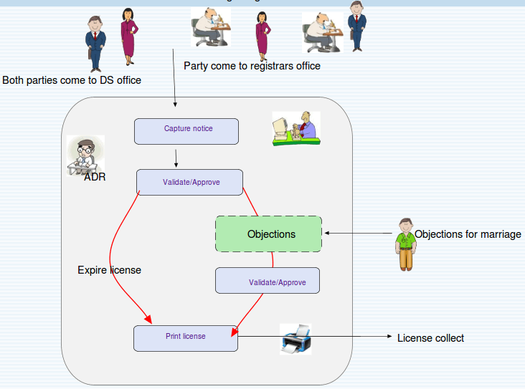Illustration 6: Marriage Registration – License of Marriage Issue Process

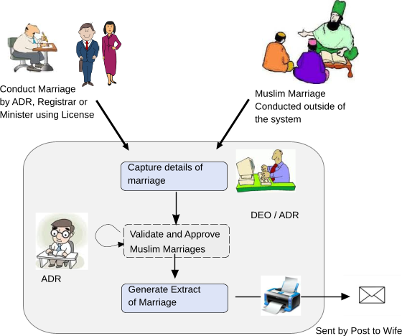Illustration 7: Marriage Registration - Extract of Marriage Issue Process

  - General and Kandyan Marriages
    - Receiving and escalating of Notice of Marriage by ADR. There can be single notice or notice per party
    - Capturing of Objections
    - Approval of Marriage Notice or Notices by ADR or higher authority
    - Generation of the License for Marriage, which can be used to process there Marriage in any Divisional Secretariat Division in Sri Lanka
    - After the marriage using License of Marriage Registrar/ Minister details and Marriage details registered in Marriage Register. Also scanned image of the Marriage Certificate is uploaded for that marriage
    - Approve and validate Marriage against prohibited relationships by ADR or higher authority
    - Generation of Extract of Marriage

  - Muslim Marriages
    - After the Marriage is solemnized Marriage details captured by the ADR or higher authority. Also scanned image of the Marriage Certificate is uploaded for that marriage
    - Approve and validate Marriage against prohibited relationships by ADR or higher authority
    - Generation of Extract of Marriage

  - Marriage registration can be done in any Divisional Secretariat Division if they already have their License for Marriage
  - Including a facility to upload scanned copies of the Register of Marriages
  - Capturing of Divorce details
  - Receiving of Divorce approved by ADR or higher authority
  - Issuance of a Certificate of Divorce for Kandyan Marriages
  - Search of marriage records and issuance of copies
  - Until finalizing this Marriage License issuing process system have support to record ongoing Marriage Registrations
- Administrator Tasks
  - Register users in the system (DEO, ADR, DR, ARG, RG)
  - Search already registered users and update their user information, location information and regenerate password
  - Registration of Divisions in the system – Districts, Divisional Secretariat Divisions, Birth Death Registration Divisions, Marriage Registration Divisions, Grama Niladhari Divisions, Locations and Courts
  - Above mentioned Division names can be updated
  - Registration of Registrars and assigning their assignments
  - Search and manage Registrars
  - Indexing option to re-index archived data with issues

- Population Registry System

  - Registration of Person in Population Registry by ADR or higher authority
  - Approval of Person registered or automatically added to the system
  - Advance search option to search Person quickly by many attributes and print Person details
  - Person full details view with the relationships to his/her parents, spouse, children etc.
  - Certificate generation with Bar Code for the registration of person in the PRS
  - Corrections in already registered person details in PRS – In Progress
  - Manage relationships of already registered persons in the PRS – In Progress

- Statistical Reports

Note: The system does not retain the “sector” of a registration division. The system will generate a complete data set which can be download into Excel Sheet /Open Office for further analysis, and following reports are generated.

  - Births
    - Live Births registered by District, Sector and Sex
    - Urban, Rural and Estate categorization to be performed
    - Live Births by District of Usual Residence of Mother and Sex of Child
    - Live Births by District of Usual Residence of Mother and Month
    - Live Births registered by Live Birth Order, Sex and District
    - Live Births registered by Ethnic Group of Mother and District
    - Live Births registered by Age of Mother and Race
    - Live Births registered by Month, Sex and District
    - Live Births registered by Age of Mother and District
    - Sex Ratio at Birth and Live Births Occurred in Hospital and Home by District
    - Percentage Distribution of Live Births registered by Sector and Age of Mother
    - Live Births registered by Age of Mother, Sex, Legitimacy and Sectors
    - Live Births registered by Month, Race and Sex
    - Live Births registered in each Month of the Year by District, Sex and Year of Occurrence

  - Deaths
    - Deaths registered by District, Sector and Sex
    - Deaths registered by Usual Resident District and Sex
    - Deaths registered by District, Age and Sex
    - Deaths registered by Race, Age and Sex
    - Deaths registered by District, Year of Occurrence, Month and Sex
    - Deaths registered by District, Race and Sex

  - Infant Deaths
    - Infant Deaths registered by District, Sector and Sex
    - Infant Deaths registered by District, Age and Sex
    - Infant Deaths registered by District, Race and Sex
    - Infant Deaths registered by District, Month and Sex
    - Infant Deaths registered by District, Race and age, Sex (Under One Month)
    - Infant Deaths registered by District, Race and Age, Sex (One Month To Under One Year)

  - Marriages (In Progress)
    - Marriages of Men by District and Civil Condition: All Marriages;
    - Marriages of Women by District and Civil Condition: All Marriages
    - Marriages registered by age of Bride and Bridegroom: All Marriages
    - Mean Age at Marriage of Men by District and Civil Condition: All Marriages
    - Mean Age at Marriage of Women by District and Civil Condition: All Marriages
    - Marriages of Men by Age and Civil Condition: All Marriages
    - Marriages of Women by Age and Civil Condition: All Marriages
    - Marriage Type by District: All Marriages

- Possible New Reports (Out of Original Scope of the Project)

  - Births
    - Weight of child by District
      - Identify malnutrition
    - Divisional Secretariat Division of registration
    - Divisional Secretariat Division of Mother's residence
    - Late declarations of birth by District and Age of child at declaration
      - Analyze districts (or Divisional Secretariat Divisions) where births are not duly registered
    - Alterations requested - Analyze errors or changes made by district
    - Based on Still birth statistics

  - Adoptions
    - Age of child at adoption
    - Adoptions by District
    - Re-registrations after adoption
    - Adoptions by Court
    - Adoptions by Foreigners
    - By Country of Adopting parents

  - Deaths
    - Number of Deaths according to cause by Age and Sex (List 1-ICD10)
      - Can be generated if the ICD codes are specified to the system
      - This maybe accomplished as performed now, and/or by improving the health sector to specify this at the time of death
    - Late declarations of death by District
      - Analyze delays noticed in certain districts
    - Alterations requested
      - Analyze corrections made on original declarations
      - Analyze by section 52(1) – a,b,d,e,h,i or 53
    - Sudden and Normal death reports
      - Analyze trends of sudden deaths
    - Report on deaths by establishment of cause
      - Open Verdict vs Other for Sudden deaths

  - Marriages
    - Reports on Divorces and Annulments
    - Reports on Objections filed, and cancellation of Licenses (current Pink forms) – for General and Kandyan marriages
    - Reports on marriages rejected due to
      - Under age
      - Prohibited relationships
      - Legal status
    - Reports on the number of marriages per person

