ACADEMIC INTERNSHIP REPORT
ATTENDEASE

Smart QR-Based Attendance Management System
with Geofencing & Real-Time Analytics
School of Computer Science and Engineering
IILM University, Greater Noida, U.P.

In partial fulfilment of the requirements for the degree of
BACHELOR OF TECHNOLOGY IN COMPUTER SCIENCE & ENGINEERING



Presented By -
Name: PRADEEP YADAV
Roll Number: CS-2341196
Section: 4CSE13
Batch: 2026–27

Industry / Organisation: DigiSamaksh Pvt. Ltd.
Internship Duration: 3 Months (June 01, 2026 – August 15, 2026)

Faculty Mentor: Ms. Surabhi Purwar
Industry Mentor: Mr. Raushan
Academic Session: 2026–27

1. CANDIDATE'S DECLARATION
I, Pradeep Yadav, student of B.Tech Computer Science & Engineering, Section 4CSE13, Roll Number CS-2341196, hereby declare that the internship report entitled “Attendease: Smart QR-Based Attendance Management System with Geofencing & Real-Time Analytics” is my original work completed during my three-month internship at DigiSamaksh Pvt. Ltd.
The project was developed as part of my academic internship and focuses on developing a smart attendance-management system using dynamic QR codes, GPS-based geofencing, role-based access control, real-time monitoring, leave management, and automated reporting.
The information presented in this report is based on the work carried out during the internship and the project documentation provided for the development of Attendease. All the references have been duly acknowledged, and no material has been reproduced from any other source without proper citation. I affirm that this report has not been submitted, in part or full, to any other institute for the award of any degree or diploma, and I shall be solely responsible for any copyright violation in this regard, if found otherwise.
Signature: ____________________________
Student Name: Pradeep Yadav
Roll No.: CS-2341196
Date: ____________________________

2. ACKNOWLEDGEMENT
I am using this opportunity to express my gratitude to IILM University, Greater Noida, and the School of Computer Science and Engineering for providing me with the opportunity to complete this internship and gain valuable practical experience in software development.
I am especially thankful to my faculty mentor, Ms. Surabhi Purwar, for her valuable guidance, aspiring suggestions, invaluably constructive criticism, and continuous support throughout the internship.
I would also like to sincerely thank my industry mentor, Mr. Raushan, at DigiSamaksh Pvt. Ltd., for providing technical guidance and sharing his truthful and illuminating views on a number of issues related to the development of the Attendease project.
This internship helped me gain practical knowledge of frontend and backend development, database management, REST APIs, authentication, QR-code systems, GPS geofencing, real-time communication, and automated report generation.
Finally, I would like to thank my parents, friends, faculty members, and everyone who supported me directly or indirectly during the successful completion of this internship.
Signature: ____________________________
Student Name: Pradeep Yadav
Roll No.: CS-2341196

3. INTERNSHIP COMPLETION CERTIFICATE
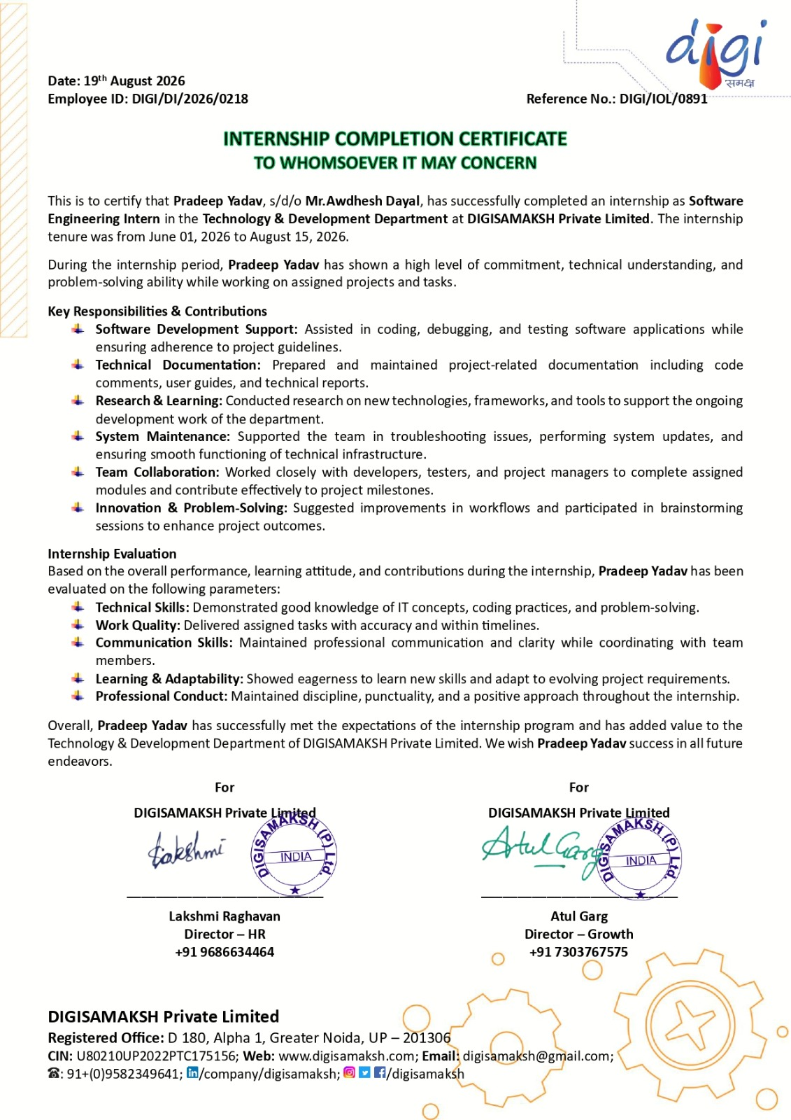

CONTENTS
1. Candidate's Declaration i
2. Acknowledgement ii
3. Internship Completion Certificate iii*
4. Project Description 1
4.1 Introduction 1
4.2 Organization Profile 1
4.3 Problem Statement 2
4.4 Project Objectives 2
4.5 Scope of the Project 3
4.6 Technologies and Tools Used 4
4.7 System Architecture 5
4.8 Methodology 6
4.8.1 Security Features 7
4.8.2 Testing 8
4.9 Expected Outcomes 8
4.9.1 Key Outcomes 8
4.9.2 Limitations 9
4.9.3 Future Enhancements 9
4.9.4 Conclusion 9
4.10 Certificates and Communication Proof 10
5. Bibliography / References 10
* No page number is displayed on this page as per the official format.

4. PROJECT DESCRIPTION
4.1 Introduction
Attendease is a web-based smart attendance-management system developed to make classroom attendance faster, more reliable, and resistant to proxy attendance.
Traditional attendance methods such as manual roll calls and paper registers are time-consuming and prone to human error. Static QR-code systems improve speed but can still be misused, since a QR screenshot can easily be shared with an absent student.
Attendease addresses these problems by combining dynamic QR-code validation with GPS-based geofencing. In the system, a teacher starts a live attendance session; the teacher’s location is captured and a dynamic QR code is generated. Students scan the QR code using their own devices and share their current location. The backend then verifies both the QR secret and the distance between the teacher and the student, using a 50-metre geofencing limit calculated with the Haversine formula.
The application also provides role-based access for administrators, teachers, and students, along with attendance analytics, real-time monitoring, leave management, and automated Excel-based reporting.
4.2 Organization Profile
DigiSamaksh Pvt. Ltd.
The internship was completed at DigiSamaksh Pvt. Ltd. over a duration of three months. The internship provided practical exposure to real-world software development and helped bridge the gap between academic concepts and industry practices.
During the internship, the following practical skills were acquired:
- Frontend development
- Backend development
- Database management
- REST API development
- Authentication
- QR-code integration
- GPS and geofencing
- Real-time communication
- Data analytics
- Excel report generation
- Software testing
The project was completed under the guidance of Mr. Raushan, Industry Mentor, and Ms. Surabhi Purwar, Faculty Mentor.
4.3 Problem Statement
Attendance is an important part of academic administration, but traditional methods have several limitations. Manual attendance requires teachers to call out student names individually, consuming approximately 10–15 minutes of every lecture.
Another major problem is proxy attendance, where a student marks attendance on behalf of an absent classmate. Static QR codes carry a similar weakness, since screenshots can be captured and shared freely.
Manual attendance records can also lead to data-entry errors, delayed reports, difficulty in maintaining historical records, and increased administrative workload. Attendease addresses these issues through dynamic QR codes, GPS geofencing, secure authentication, real-time monitoring, and automated reporting.
4.4 Project Objectives
The major objectives of Attendease are:
- To develop a digital attendance-management system.
- To reduce the time consumed by classroom attendance.
- To reduce proxy attendance using dynamic QR codes and GPS verification.
- To verify student location using a 50-metre geofencing radius.
- To implement secure authentication and role-based access control.
- To provide separate interfaces for administrators, teachers, and students.
- To provide real-time attendance monitoring.
- To allow students to view attendance history and percentages.
- To provide digital leave management.
- To generate automated Excel attendance reports.
- To prevent duplicate attendance records.
- To provide an efficient and user-friendly attendance platform.
4.5 Scope of the Project
The scope of Attendease covers the major activities required for digital classroom attendance management, organised around three user roles.
Administrator
- Manage users.
- Manage departments.
- Manage classes and sections.
- Manage academic information.
- View attendance information.
- Manage leave requests.
Teacher
- Start live attendance sessions.
- Generate dynamic QR codes.
- Refresh QR secrets.
- Monitor student check-ins.
- Manually mark attendance.
- View attendance analytics.
- Generate attendance reports.
Student
- Scan QR codes.
- Provide location information.
- Mark attendance.
- View attendance history.
- View attendance percentages.
- View attendance calendars.
- Apply for leave.
- Upload supporting documents.
4.6 Technologies and Tools Used
Attendease uses a modern full-stack technology stack, summarised in Table 4.1.
Table 4.1: Technologies and Tools Used
Category | Technology | Purpose
Frontend | React 18 | User interface
Build Tool | Vite 6 | Frontend development / build
Styling | TailwindCSS 3 | Responsive UI
Backend | Node.js | Server-side runtime
Framework | Express.js 4 | REST APIs
Database | PostgreSQL | Data storage
ORM | Prisma ORM 7 | Database access
Real-Time | Socket.io 4 | Live updates
Authentication | JWT + BCrypt | Secure authentication
QR Scanner | HTML5 QR Scanner | QR-code scanning
Reports | ExcelJS | Excel generation
File Upload | Multer | Document upload
Email | Nodemailer | Email functionality
Development | VS Code | Coding
API Testing | Postman | API testing
Version Control | Git / GitHub | Source-code management
Hardware Requirements
- Smartphone or laptop.
- Camera for QR scanning.
- GPS / location support.
- Internet connection.
- Modern web browser.
Software Requirements
- Windows, macOS, or Linux.
- Node.js runtime.
- PostgreSQL database.
- Modern web browser.
- VS Code editor.
- Git.
- Postman.
4.7 System Architecture
Attendease follows a client-server architecture consisting of frontend, backend, real-time communication, and database components, as illustrated in Figure 4.1.
The Client Layer consists of React 18 and TailwindCSS, with built-in QR-scanning and GPS support. It communicates via REST API and WebSocket with the Application Layer, built on Node.js and Express.js, which handles authentication, role-based access control, QR validation, GPS / Haversine validation, attendance management, leave management, Excel reporting, and Socket.io events. The Application Layer communicates through Prisma ORM with the Database Layer (PostgreSQL), which stores Users, Attendance, LiveSession, and LeaveRequest data.
The Attendance model uses a composite uniqueness constraint based on (studentId, subject, date) to prevent duplicate attendance records.
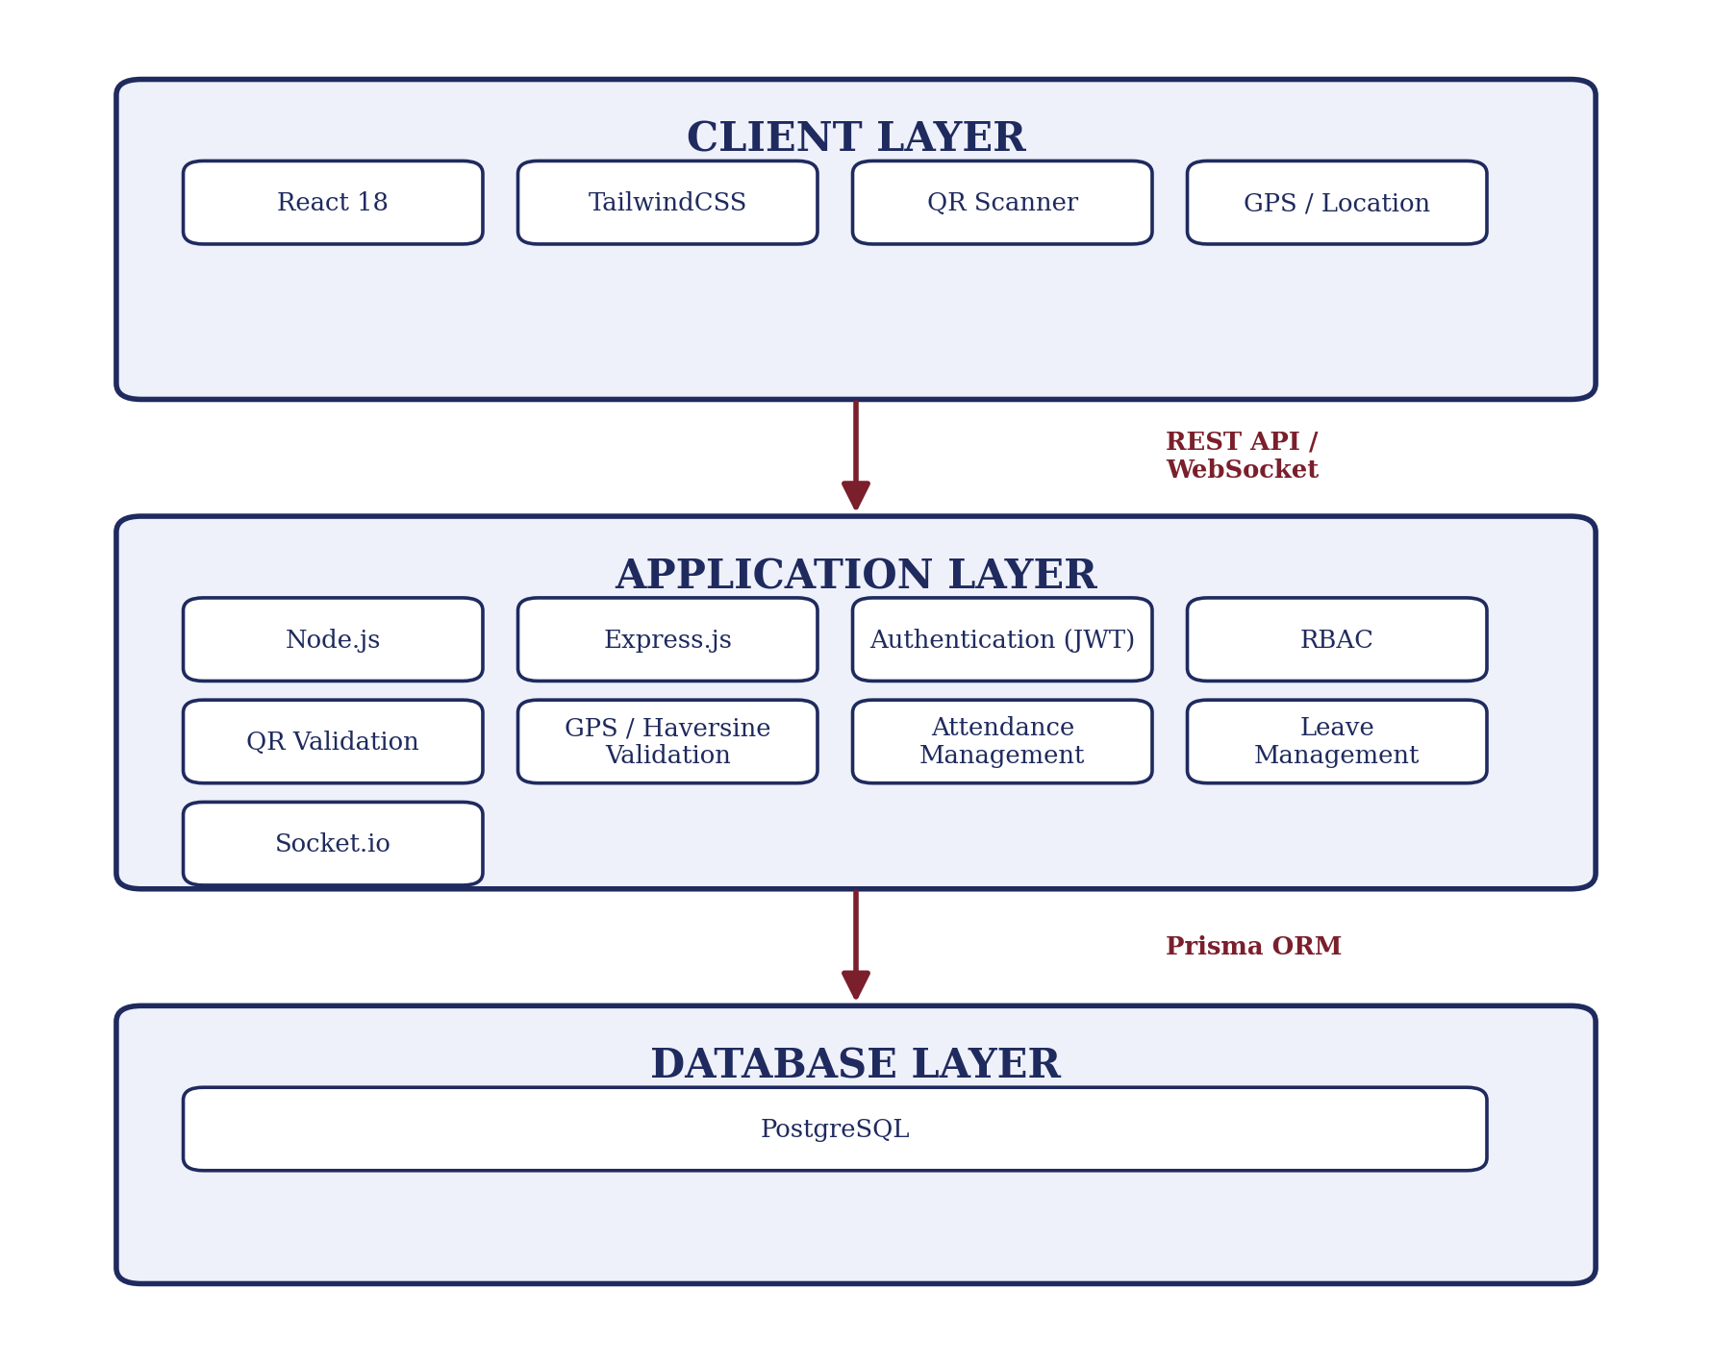
Figure 4.1: High-Level System Architecture
4.8 Methodology
The development of Attendease followed a structured, step-by-step software-development process, described below.
Step 1 — Requirement Analysis
The requirements were analysed to identify the major problems with existing attendance systems. The key requirements identified were secure login, role-based access, dynamic QR generation, GPS verification, attendance management, real-time monitoring, leave management, and reporting.
Step 2 — System Design
The system was divided into frontend, backend, and database layers. React was selected for the frontend, Express.js for the backend, and PostgreSQL for data storage.
Step 3 — Authentication
Authentication was implemented using JWT and BCrypt. The flow followed is: Login → Email + Password → Password Verification → JWT Authentication → Role Verification → Access Dashboard. Security is built around BCrypt password hashing, HTTP-only cookies, JWT tokens, and role-based access control (RBAC).
Step 4 — Live Attendance Session
The teacher starts a live session by selecting the required academic information. The system captures the teacher’s location and generates a dynamic QR secret, which is then displayed to students.
Step 5 — Student Check-In
The student scans the QR code and shares their GPS location. The backend validates student authentication, the active attendance session, the QR secret, the student’s location, and duplicate attendance before recording it. The overall workflow is: Teacher Starts Session → Teacher GPS Captured → Dynamic QR Generated → Student Scans QR → Student GPS Captured → Backend Validation → QR Secret Check → Haversine Distance Check → Duplicate Check → Attendance Recorded → Real-Time Dashboard Update.
Step 6 — GPS Geofencing
The Haversine formula calculates the distance between the teacher and the student. The rule applied is: distance ≤ 50 metres → attendance accepted; distance > 50 metres → attendance rejected. The implementation uses an Earth radius of approximately 6,371,000 metres.
Step 7 — Dynamic QR Validation
The QR code carries a dynamically generated six-character hexadecimal secret. Once refreshed, the previous secret becomes invalid: Generate Secret → Store Current Secret → Display QR → Refresh Secret → Old QR Invalid. This makes reuse of old screenshots significantly more difficult.
Step 8 — Real-Time Monitoring
Socket.io updates teacher dashboards the moment a student successfully checks in: Student Check-In → Attendance Saved → statsUpdated Event → Teacher Dashboard Updated — removing the need for repeated manual page refreshes.
Step 9 — Leave Management
Students submit leave requests with a start date, end date, reason, and supporting document. Requests begin in a Pending state and can later be approved or rejected by an administrator or teacher.
Step 10 — Report Generation
Teachers and administrators can generate attendance reports in Excel format containing student roll number, name, subject, date, attendance status, and distance, using the ExcelJS library.
4.8.1 Security Features
BCrypt: Used to securely hash user passwords.
JWT (JSON Web Token): Used for stateless, secure authentication.
Role-Based Access Control: Ensures users can access only the functions authorised for their role.
Dynamic QR Secret: Prevents simple reuse of old or screenshotted QR codes.
GPS Geofencing: Checks whether the student is within the permitted 50-metre radius.
Duplicate Prevention: Prevents multiple attendance records for the same student, subject, and date.
4.8.2 Testing
The major testing areas were GPS geofencing, dynamic QR validation, and duplicate-attendance prevention. A representative subset of test cases is summarised in Table 4.2.
Table 4.2: Representative Test Cases and Results
Test ID | Distance | QR Status | Expected Result | Status
TC-GEO-01 | 4.2 m | Valid | Attendance accepted | PASS
TC-GEO-02 | 28.5 m | Valid | Attendance accepted | PASS
TC-GEO-03 | 49.8 m | Valid | Attendance accepted | PASS
TC-GEO-04 | 52.1 m | Valid | Attendance rejected | PASS
TC-GEO-05 | 140 m | Valid | Attendance rejected | PASS
TC-SEC-01 | 12 m | Old / Expired | Rejected | PASS
TC-SEC-02 | 15 m | Duplicate | Rejected | PASS
4.9 Expected Outcomes
4.9.1 Key Outcomes
Faster Attendance: QR-based check-in reduces the time required for traditional manual attendance, from approximately 12 minutes to under 45 seconds per lecture.
Reduced Proxy Attendance: Dynamic QR validation combined with GPS verification provides much stronger protection against common proxy-attendance methods.
Real-Time Monitoring: Teachers can monitor attendance as students check in, without needing to refresh the page manually.
Better Data Management: Attendance is stored digitally in a structured PostgreSQL database, improving accuracy and retrievability.
Automated Reporting: Teachers and administrators can generate Excel reports without manually preparing spreadsheets.
Digital Leave Management: Students can submit and track leave requests electronically, with document upload support.
Improved Security: Authentication, RBAC, dynamic QR validation, geofencing, and duplicate prevention together provide multiple layers of system protection.
4.9.2 Limitations
- GPS Accuracy — GPS accuracy can vary depending on device hardware and indoor conditions.
- Internet Dependency — The system requires network connectivity for normal operation.
- Device Dependency — Students need a device with a working camera and location services.
- QR Dependency — Students must access the currently active QR code within its validity window.
- Privacy — Use of location data requires appropriate privacy and data-retention policies in a production environment.
4.9.3 Future Enhancements
- AI Facial Verification — Add facial verification as an additional identity check.
- Offline PWA Support — Allow temporary attendance queuing during network interruptions.
- SMS and Email Alerts — Automatically notify students or guardians about low attendance.
- Detailed Audit Logs — Maintain records of login attempts, failed attendance attempts, QR refreshes, and manual attendance changes.
4.9.4 Conclusion
The Attendease project provides a smart and efficient approach to classroom attendance management. It addresses the major problems associated with manual and static QR-based attendance systems by combining dynamic QR codes, GPS geofencing, authentication, role-based access control, real-time monitoring, and automated reporting.
The system enables teachers to create live attendance sessions and students to mark attendance through QR scanning, with the backend validating the QR secret and student location before recording attendance.
The use of the Haversine formula provides reliable geographical-distance verification, while dynamic QR secrets substantially reduce the possibility of reusing old QR screenshots.
The project also offers attendance analytics, digital leave management, and Excel report generation, making it useful for both academic and administrative purposes. The testing results summarised in this report demonstrate successful validation of the major geofencing, QR-secret, and duplicate-attendance scenarios.
Overall, the three-month internship at DigiSamaksh Pvt. Ltd. provided valuable practical experience in full-stack development, database management, API development, authentication, geospatial computing, real-time communication, testing, and technical documentation — demonstrating the practical application of modern web technologies to solve a real-world academic management problem.
4.10 Certificates and Communication Proof
The following supporting documents are attached to this internship report:
A. Internship Completion Certificate — attached as Chapter 3 of this report.
B. Internship Communication Proof — [Placeholder: insert relevant email / communication records from DigiSamaksh Pvt. Ltd. here.]
C. Project Proof — [Placeholder: insert screenshots of the Login page, Teacher dashboard, Dynamic QR screen, Student QR scanner, Attendance result, Attendance analytics, Leave application, and Excel report here.]
5. BIBLIOGRAPHY / REFERENCES
1. React Documentation. React Official Documentation. Retrieved from https://react.dev
2. Express.js Documentation. Express Official Documentation. Retrieved from https://expressjs.com
3. Prisma Documentation. Prisma ORM Documentation. Retrieved from https://www.prisma.io/docs
4. Socket.IO Documentation. Socket.IO Documentation. Retrieved from https://socket.io/docs
5. Sinnott, R. W. (1984). Virtues of the Haversine. Sky and Telescope, 68(2), 159.
6. PostgreSQL Documentation. PostgreSQL Official Documentation. Retrieved from https://www.postgresql.org/docs
7. Node.js Documentation. Node.js Official Documentation. Retrieved from https://nodejs.org/docs

