ASR (Architecturally Significant Requirements)

Any requirement that greatly influences our choice of structures for the architecture is referred to as an architecturally significant requirement, or ASR. It is the role of the software architect to identify requirements that are architecturally significant.

Types Of Requirements

* **Constraints:** Unchangeable design decisions, usually given, sometimes chosen.
* **Quality Attributes**: Externally visible properties that characterize how the system operates in a specific context.
* **Influential Functional Requirements:**  Features and functions that require special attention in the architecture.
* **Other Influencers**: Time, knowledge, experience, skills, office politics, Architect geeky biases, and all the other stuff that sways your decision making

Purpose and Scope

Risk analysts require a one-stop shop for market prices as a next-generation solution. The portal that we will create will include elements that will make it easier to search for market symbols and their prices utilizing attribute-based searches.

Limit Design Options with Constraints

|  |  |
| --- | --- |
| Technical Constraints | Business Constraints |
| Programming Language Choice | Legal Constraints |

Constraints, once decided, are 100 percent non-negotiable.

Capture Constraints

|  |  |  |  |
| --- | --- | --- | --- |
| Constraint | Origin | Type | Context |
| Must support  Chrome web browser | Stack Holder | Technical | Officially supported  browser. |

Non-Functional Requirements

1. Portal and API should not be accessible outside Organization domain freely
2. Platform should support 500 symbols with pricing update coming every 10 seconds
3. The 90-percentile page response time should be under 2 seconds
4. The API response time should be under 200ms
5. The site should be scalable to take a load 0 to 1000 parallel connections and site should be sustainable to the load
6. The platform should support 99.95% up time
7. The platform must be adhered to security compliance for the OWASP top 10 vulnerabilities
8. The site should be responsive to Chrome 85 & above, IOS and Android
9. The platform data backup should happen daily.
10. The pipeline should automate the code, quality checks, test automation, performance test and security test.
11. Planform much also follow CI/CD process and follow Blue/Green deployment strategy
12. Feature Toggle
13. Failure and Retry (should start from failover)
14. Automated test data creation & clean-up (should support million rows of data)
15. Use Oauth for Microsoft identity provider
16. The Delivered code should have
    1. 0 Blocker and critical Sonar Bugs vulnerability
    2. 0P1 &P2 defect
    3. 90%-unit test coverage
    4. 90% Test Automation

Scenarios

A quality attribute is just a word (Scalability, Performance, Availability). To offer an unambiguous description of a quality attribute, Architect employ a quality attribute scenario. Quality attribute scenarios describe how the software system is expected to operate within a certain environmental context. There is a functional component to each scenario—stimulus and response—just like any feature.

Example:-

|  |  |  |
| --- | --- | --- |
| Quality Attribute | Scenario | Priority |
| Performance | A user sees search results within 5 seconds when the system is at an average load of 2 searches per  second.  A user can sort, filter the search results within short time of period | High |
| Scalability | During a scheduled maintenance time, new servers can be added. | Low |

Functional Requirements

There are two sorts of users who will access the portal.

* **Admin**
* **Analyst**

**Admin Functionalities**

* Pricing Configuration
  + Third party api config manager (api url, endpoint, country, pricing symbols)

**Analyst Functionalities**

* View market data (sorting,filtering, searching, grouping)
* Analyst should be able to save view (personalization)
* Export to excel/csv
  + Third party api config manager (api url, endpoint, country, pricing symbols)

Identifying influential functional requirements

* Pricing Configuration
* View market data
* Personalization
* Export to excel/csv

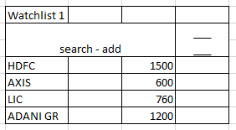

Risk analysts require a one-stop shop for market prices as a next-generation solution. The portal that we will create will include elements that will make it easier to search for market symbols and their prices utilizing attribute-based searches.

User will be able to view market data and can perform search, sort, filtering and grouping using our stock tracker app and also user will be able to personalize the dashboard. Also, data can be exported to an excel/csv file.

User will be able to add the searched stock to the watchlist also user can filter the existing watchlist and add multiple watchlist to group the stocks.

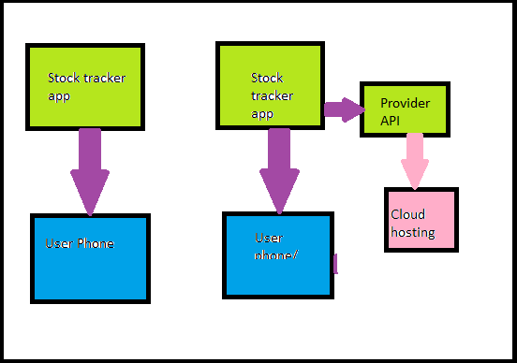

Find Out What Else Influences the Architecture

“When all you have is a hammer, you will find plenty of nails to hit.”

