Supplementary material

Influence of burn severity on avifaunal communities in southern tropical dry deciduous forest, Western Ghats

Figure S1: Rarefaction curves for species diversity across four habitats (H, L, M, UB) at three diversity orders (q = 0, 1, 2) with increasing sample size. Curves represent diversity accumulation for species richness (q = 0), Shannon diversity (q = 1), and Simpson diversity (q = 2) with shaded regions showing 95% confidence intervals.
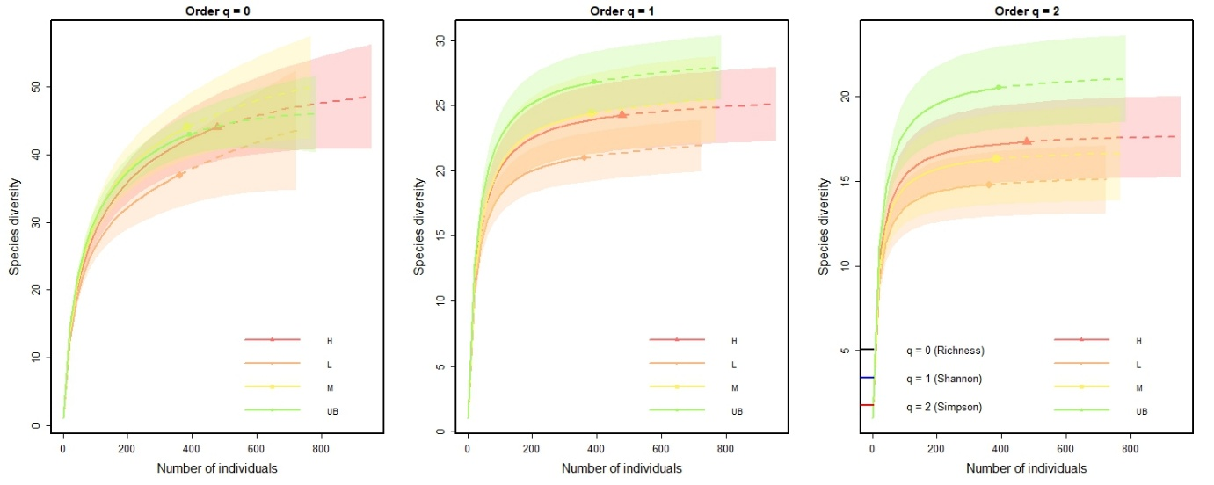

Figure S2. Pearson’s correlation matrix showing relationships between avian community metrics and environmental variables across 120 sampling sites. Colour intensity reflects correlation strength, with green for positive and orange for negative correlations.
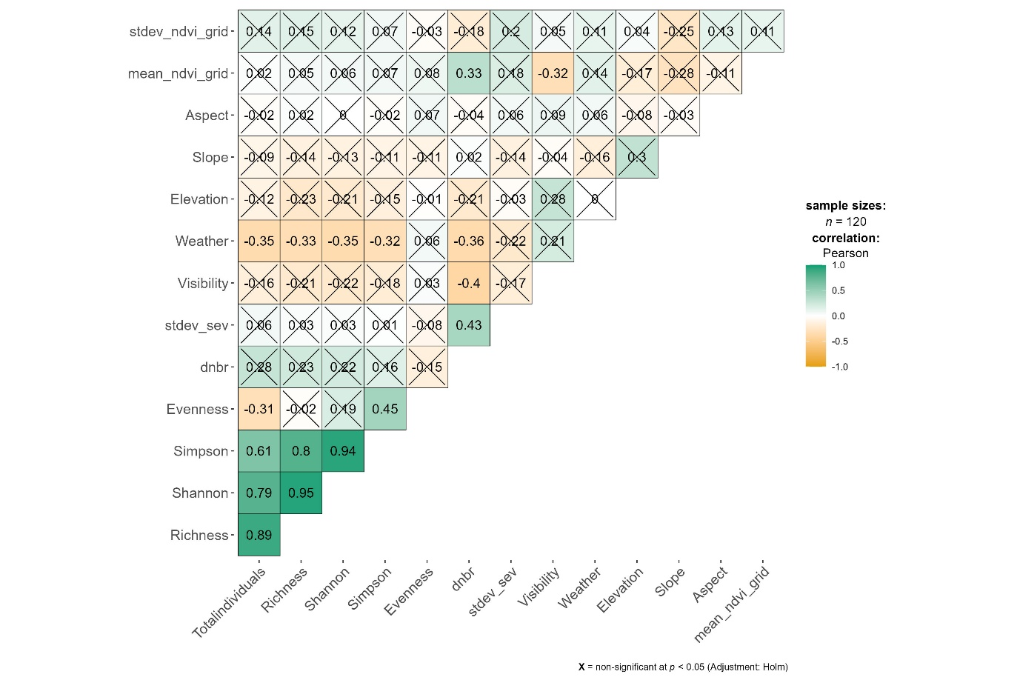

Figure S3: Percent composition of A) feeding substrate and B) foraging technique by burn severity (UB, L, M, and H) within the 2019 forest fire, five years post-fire.
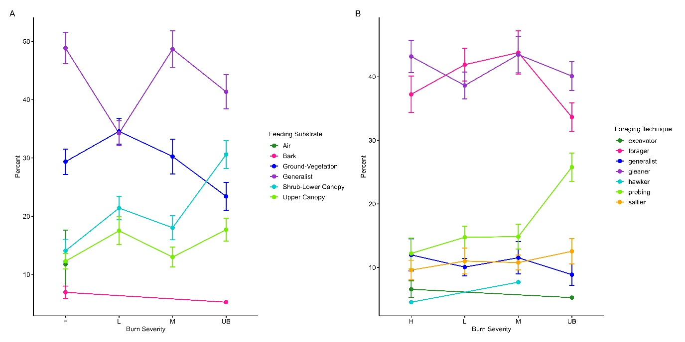

Table S1: dNBR value at the grid-level showing the mean and standard deviation
Point ID | Burn Severity | Mean | Stdev
H01 | High | 1.091396 | 0.020355
H02 | High | 1.069715 | 0.036478
H03 | High | 1.040812 | 0.073023
H04 | High | 0.784295 | 0.06237
H05 | High | 0.868288 | 0.075459
H06 | High | 0.942691 | 0.0596
H07 | High | 1.041515 | 0.033037
H08 | High | 0.98351 | 0.040234
H09 | High | 0.817599 | 0.100145
H10 | High | 0.872114 | 0.038299
H11 | High | 0.888189 | 0.033704
H12 | High | 0.971779 | 0.042056
H13 | High | 0.959568 | 0.049497
H14 | High | 0.780706 | 0.0564
H15 | High | 1.033621 | 0.032519
H16 | High | 1.101293 | 0.015249
H17 | High | 1.055398 | 0.030554
H18 | High | 1.054373 | 0.029796
H19 | High | 1.057402 | 0.032322
H20 | High | 1.080489 | 0.030897
H21 | High | 0.94888 | 0.069499
H22 | High | 0.834798 | 0.103159
H23 | High | 0.862029 | 0.083037
H24 | High | 0.799933 | 0.040402
H25 | High | 0.757489 | 0.050768
H26 | High | 0.770112 | 0.052592
H27 | High | 0.867408 | 0.065048
H28 | High | 0.765221 | 0.044075
H29 | High | 0.880955 | 0.06926
H30 | High | 0.799038 | 0.059888
L01 | High | 0.313303 | 0.028998
L02 | Low | 0.340364 | 0.039381
L03 | Low | 0.37429 | 0.036568
L04 | Low | 0.299256 | 0.017473
L05 | Low | 0.295596 | 0.016441
L06 | Low | 0.317281 | 0.027005
L07 | Low | 0.286917 | 0.009328
L08 | Low | 0.304886 | 0.015021
L09 | Low | 0.319582 | 0.015103
L10 | Low | 0.290118 | 0.021874
L11 | Low | 0.332038 | 0.042454
L12 | Low | 0.297747 | 0.026049
L13 | Low | 0.29259 | 0.011113
L14 | Low | 0.26367 | 0.033045
L15 | Low | 0.323407 | 0.039024
L16 | Low | 0.298027 | 0.02725
L17 | Low | 0.287657 | 0.029793
L18 | Low | 0.300242 | 0.029986
L19 | Low | 0.352098 | 0.044923
L20 | Low | 0.344592 | 0.017975
L21 | Low | 0.321433 | 0.019262
L22 | Low | 0.342821 | 0.025639
L23 | Low | 0.315568 | 0.03597
L24 | Low | 0.393331 | 0.021413
L25 | Low | 0.34423 | 0.017493
L26 | Low | 0.389711 | 0.028559
L27 | Low | 0.365417 | 0.039693
L28 | Low | 0.415528 | 0.013315
L29 | Low | 0.408836 | 0.012018
L30 | Low | 0.410235 | 0.030258
M01 | Moderate | 0.454833 | 0.057337
M02 | Moderate | 0.496998 | 0.03552
M03 | Moderate | 0.498294 | 0.038655
M04 | Moderate | 0.522475 | 0.03796
M05 | Moderate | 0.470054 | 0.0303
M06 | Moderate | 0.501549 | 0.043205
M07 | Moderate | 0.534832 | 0.021791
M08 | Moderate | 0.555238 | 0.040463
M09 | Moderate | 0.578766 | 0.035581
M10 | Moderate | 0.568558 | 0.028022
M11 | Moderate | 0.5326 | 0.029219
M12 | Moderate | 0.501901 | 0.040947
M13 | Moderate | 0.53871 | 0.02607
M14 | Moderate | 0.608632 | 0.07898
M15 | Moderate | 0.502448 | 0.026284
M16 | Moderate | 0.563002 | 0.025917
M17 | Moderate | 0.551116 | 0.032491
M18 | Moderate | 0.485884 | 0.045401
M19 | Moderate | 0.497164 | 0.019892
M20 | Moderate | 0.591107 | 0.073917
M21 | Moderate | 0.575321 | 0.034658
M22 | Moderate | 0.582171 | 0.028262
M23 | Moderate | 0.533248 | 0.036796
M24 | Moderate | 0.559898 | 0.044693
M25 | Moderate | 0.617266 | 0.039684
M26 | Moderate | 0.560046 | 0.025
M27 | Moderate | 0.560576 | 0.066603
M28 | Moderate | 0.528999 | 0.070797
M29 | Moderate | 0.518323 | 0.030659
M30 | Moderate | 0.541174 | 0.015865
U01 | Unburned | 0.235067 | 0.031582
U02 | Unburned | 0.201435 | 0.055679
U03 | Unburned | 0.235145 | 0.039758
U04 | Unburned | 0.20107 | 0.06679
U05 | Unburned | 0.209793 | 0.046428
U06 | Unburned | 0.19102 | 0.035791
U07 | Unburned | 0.166168 | 0.029823
U08 | Unburned | 0.211876 | 0.039628
U09 | Unburned | 0.194067 | 0.030037
U10 | Unburned | 0.203587 | 0.029999
U11 | Unburned | 0.157526 | 0.033307
U12 | Unburned | 0.13173 | 0.029994
U13 | Unburned | 0.128201 | 0.02105
U14 | Unburned | 0.195857 | 0.030967
U15 | Unburned | 0.20707 | 0.022271
U16 | Unburned | 0.161071 | 0.033632
U17 | Unburned | 0.217881 | 0.023814
U18 | Unburned | 0.225674 | 0.023363
U19 | Unburned | 0.21304 | 0.032904
U20 | Unburned | 0.153502 | 0.018383
U21 | Unburned | 0.144765 | 0.02464
U22 | Unburned | 0.163002 | 0.017655
U23 | Unburned | 0.205742 | 0.021482
U24 | Unburned | 0.224503 | 0.022042
U25 | Unburned | 0.214728 | 0.013282
U26 | Unburned | 0.219577 | 0.024209
U27 | Unburned | 0.25366 | 0.010327
U28 | Unburned | 0.224388 | 0.020059
U29 | Unburned | 0.197474 | 0.017308
U30 | Unburned | 0.204692 | 0.02421

Table S2A: List of bird species excluded from further analysis due to low detections
S. No. | Common name | Scientific name
1. | Asian koel | Eudynamys scolopaceus
2. | Ashy Woodswallow | Artamus fuscus
3. | Brown capped Pygmy Woodpecker | Yungipicus nanus
4. | Changeable Hawk Eagle | Nisaetus cirrhatus
5. | Indian Grey Hornbill | Ocyceros birostris
6. | Indian Golden Oriole | Oriolus kundoo
7. | Indian Cuckoo | Cuculus micropterus
8. | Indian Paradise Flycatcher | Terpsiphone paradisi
9. | Jungle Myna | Acridotheres fuscus
10. | Large Cuckooshrike | Coracina macei
11. | Malabar Whistling Thrush | Myophonus horsfieldii
12. | Red wattled Lapwing | Vanellus indicus

Table S2B: Total bird abundance of species across four burn severities within the 2019 forest fire, 5 years post-burn.
Abbr. | Common Name | Scientific Name | Unburned | Low | Moderate | High
AGBE | Asian Green Bee-eater | Merops orientalis |  |  |  | 4
ASPR | Ashy Prinia | Prinia socialis | 1 | 1 |  | 14
BHBA | Brown Headed Barbet | Psilopogon zeylanicus |  |  | 3
BHCU | Black headed cuckooshrike | Lalage melanoptera | 6 | 2 | 7 | 17
BHOR | Black hooded Oriole | Oriolus xanthornus | 8 | 4 | 2
BRST | Brahminy Starling | Sturnia pagodarum |  |  |  | 14
CBSU | Crimson backed Sunbird | Leptocoma minima | 13 | 19 | 3 | 1
CHCU | Common Hawk Cuckoo | Hierococcyx varius | 2 |  | 1
CITI | Cinerous Tit | Parus cinereus |  | 1 | 2 | 1
COIO | Common Iora | Aegithina tiphia | 10 | 15 | 5 | 5
COMY | Common Myna | Acridotheres tristis | 2 | 5
COTA | Common Tailorbird | Orthotomus sutorius | 33 | 37 | 41 | 38
COWO | Common Woodshrike | Tephrodornis pondicerianus | 7 | 1 | 4 | 1
CSBA | Coppersmith Barbet | Psilopogon haemacephalus |  |  |  | 3
ECDO | Eurasian Collared Dove | Streptopelia decaocto |  | 5 | 6 | 15
FTDC | Fork tailed Drongo-Cuckoo | Surniculus dicruroides | 2 | 1 | 3
GBCU | Grey bellied Cuckoo | Cacomantis passerinus | 4 | 1 | 9 | 16
GBPR | Grey breasted Prinia | Prinia hodgsonii | 34 | 18 | 31 | 61
GRJU | Grey Junglefowl | Gallus sonneratii | 8 | 1 | 7 | 3
INPE | Indian Peafowl | Pavo cristatus | 3 | 1 | 5 | 1
INRO | Indian Robin | Copsychus fulicatus | 1 |  |  | 2
INWH | Indian White-eye | Zosterops palpebrosus | 32 | 5 | 17 | 11
ISBA | Indian Scimitar Babbler | Pomatorhinus horsfieldii | 3 | 8 | 3 | 1
JBQU | Jungle Bushquail | Perdicula asiatica |  |  | 3
JUBA | Jungle Babbler | Argya striata | 7 |  | 11 | 15
JUPR | Jungle Prinia | Prinia sylvatica | 28 | 21 | 28 | 28
LADO | Laughing Dove | Spilopelia senegalensis |  | 1 | 3 | 10
LECO | Lesser Coucal | Centropus bengalensis |  |  |  | 2
LOSU | Loten's Sunbird | Cinnyris lotenius | 7
LTSH | Long tailed Shrike | Lanius schach |  |  | 1 | 3
MAPA | Malabar Parakeet | Psittacula columboides | 5
OMRO | Oriental Magpie Robin | Copsychus saularis | 1 |  | 1 | 1
PBFL | Pale billed Flowerpecker | Dicaeum erythrorhynchos | 7 | 7 | 10 | 2
PHPA | Plum headed Parakeet | Psittacula cyanocephala |  |  | 2 | 3
PRSU | Purple rumped Sunbird | Leptocoma zeylonica | 22 | 7 | 9 | 5
PTBA | Puff throated Babbler | Pellorneum ruficeps | 9 | 12 | 12 | 4
PUSU | Purple Sunbird | Cinnyris asiaticus | 13 | 8 | 6 | 17
RRPA | Rose ringed Parakeet | Psittacula krameri | 1 | 3 | 4 | 3
RUTR | Rufous Treepie | Dendrocitta vagabunda | 2 | 7 | 5 | 2
RVBU | Red vented Bulbul | Pycnonotus cafer | 25 | 24 | 23 | 41
RWBU | Red whiskered Bulbul | Pycnonotus jocosus | 20 | 39 | 18 | 33
SBFA | Spot breasted Fantail | Rhipidura albogularis | 1 | 4 | 1 | 1
SHIK | Shikra | Tachyspiza badia |  |  | 1 | 1
SMMI | Small Minivet | Pericrocotus cinnamomeus | 7 | 7 | 1 | 2
SPDO | Spotted Dove | Spilopelia chinensis | 5 | 8 | 4 | 13
STWO | Streak throated Woodpecker | Picus xanthopygaeus | 1 |  |  | 3
TBBA | Tawny bellied Babbler | Dumetia hyperythra | 2 | 2 | 6
TBFL | Tickell's blue Flycatcher | Cyornis tickelliae | 7 | 12 | 13 | 8
VHPA | Vernal Hanging Parrot | Loriculus vernalis | 4 | 11
WBBU | White browed Bulbul | Pycnonotus luteolus | 24 | 55 | 57 | 44
WBDR | White bellied Drongo | Dicrurus caerulescens | 5 | 1 | 1 | 4
WBFA | White browed Fantail | Rhipidura aureola | 2
WCBA | White cheeked Barbet | Psilopogon viridis | 1 | 2 | 2 | 10
WTKI | White-throated Kingfisher | Halcyon smyrnensis | 2 |  | 1
YBBA | Yellow billed Babbler | Argya affinis | 16 | 5 | 11 | 10
YEBA | Yellow eyed Babbler | Chrysomma sinense |  |  | 1 | 5
 |  | Abundance | 393 | 361 | 384 | 478
 |  | Richness | 43 | 37 | 44 | 44
 |  | Mean Abundance (±SD) | 11.6  (± 6) | 11.1 (±4.5) | 12.1  (±4.5) | 15.2 (±4.7)

Table S3: Model selection results for candidate models assessing the effects of fire and environmental variables on the total bird abundance.
 | (Intercept) | Aspect | dnbr | Elevation | Slope | stdev_ndvi_grid | stdev_sev | Visibility | Weather | df | logLik | AICc | delta | weight
model13 | 16.161 | NA | 1.536 | NA | NA | 1.369 | -0.980 | NA | -1.104 | 6 | -350.625 | 713.994 | 0.000 | 0.652
model11 | 16.022 | NA | 1.093 | NA | NA | 1.082 | NA | NA | -1.045 | 5 | -352.652 | 715.831 | 1.836 | 0.260
model10 | 15.921 | NA | 0.920 | NA | NA | NA | NA | NA | -1.002 | 4 | -355.787 | 719.921 | 5.927 | 0.034
model12 | 15.979 | NA | 1.124 | NA | NA | NA | -0.504 | NA | -1.027 | 5 | -355.227 | 720.981 | 6.986 | 0.020
Global | 21.558 | -0.094 | 1.419 | -0.005 | -0.505 | 1.265 | -1.017 | -0.101 | -1.170 | 10 | -349.484 | 720.987 | 6.993 | 0.020
model3 | 16.462 | NA | NA | NA | NA | NA | NA | NA | -1.233 | 3 | -357.746 | 721.700 | 7.705 | 0.014
model1 | 13.575 | NA | 1.434 | NA | NA | NA | NA | NA | NA | 3 | -360.426 | 727.059 | 13.065 | 0.001
model2 | 15.447 | NA | NA | NA | NA | NA | NA | -0.977 | NA | 3 | -363.803 | 733.813 | 19.818 | 0.000
model8 | 13.575 | NA | NA | NA | NA | 0.715 | NA | NA | NA | 3 | -364.170 | 734.548 | 20.553 | 0.000
model4 | 26.220 | NA | NA | -0.013 | NA | NA | NA | NA | NA | 3 | -364.451 | 735.109 | 21.114 | 0.000
model5 | 13.575 | NA | NA | NA | -0.464 | NA | NA | NA | NA | 3 | -364.862 | 735.931 | 21.936 | 0.000
model7 | 13.575 | NA | NA | NA | NA | NA | 0.296 | NA | NA | 3 | -365.158 | 736.523 | 22.528 | 0.000
model6 | 13.575 | -0.127 | NA | NA | NA | NA | NA | NA | NA | 3 | -365.322 | 736.851 | 22.857 | 0.000

Table S4: Model selection results for candidate models assessing the effects of fire and environmental variables on the abundance of shrub-lower canopy foraging species.
 | (Intercept) | Aspect | dnbr | Elevation | Slope | stdev_ndvi_grid | stdev_sev | Visibility | Weather | df | logLik | AICc | delta | weight
model14 | -6.66904 | NA | -0.66214 | 0.010132 | NA | NA | NA | NA | -0.2951 | 5 | -223.653 | 457.8889 | 0 | 0.649749
model13 | -7.94073 | NA | -0.51344 | 0.010715 | NA | NA | NA | NA | NA | 4 | -225.929 | 460.2426 | 2.353741 | 0.20028
model11 | 3.565747 | NA | -0.71559 | NA | NA | 0.286695 | NA | NA | -0.33835 | 5 | -226.276 | 463.1342 | 5.245364 | 0.047177
model10 | 3.542032 | NA | -0.77032 | NA | NA | NA | NA | NA | -0.32336 | 4 | -227.39 | 463.1647 | 5.27584 | 0.046463
model12 | 3.534461 | NA | -0.79653 | NA | NA | NA | 0.076911 | NA | -0.31855 | 5 | -227.331 | 465.2439 | 7.355021 | 0.016429
model4 | -9.84169 | NA | NA | 0.012621 | NA | NA | NA | NA | NA | 3 | -229.616 | 465.4615 | 7.57263 | 0.014736
Global | -8.2107 | 0.152707 | -0.59967 | 0.012103 | -0.09582 | 0.280361 | -0.15195 | -0.21451 | -0.31643 | 10 | -221.685 | 465.6149 | 7.726001 | 0.013648
model1 | 2.788119 | NA | -0.61334 | NA | NA | NA | NA | NA | NA | 3 | -229.949 | 466.1264 | 8.237525 | 0.010568
model8 | 2.782001 | NA | NA | NA | NA | 0.378237 | NA | NA | NA | 3 | -233.157 | 472.5425 | 14.65362 | 0.000427
model2 | 2.279081 | NA | NA | NA | NA | NA | NA | 0.276001 | NA | 3 | -234.27 | 474.7692 | 16.88033 | 0.00014
model3 | 3.106562 | NA | NA | NA | NA | NA | NA | NA | -0.13182 | 3 | -234.518 | 475.2644 | 17.37554 | 0.00011
model7 | 2.789159 | NA | NA | NA | NA | NA | -0.16836 | NA | NA | 3 | -234.65 | 475.5293 | 17.64045 | 9.60E-05
model6 | 2.797364 | 0.147726 | NA | NA | NA | NA | NA | NA | NA | 3 | -234.685 | 475.5991 | 17.71024 | 9.27E-05
model5 | 2.799293 | NA | NA | NA | 0.121141 | NA | NA | NA | NA | 3 | -234.784 | 475.7959 | 17.90705 | 8.40E-05

Table S5: Model selection results for candidate models assessing the effects of fire and environmental variables on the abundance of ground foraging species.
 | (Intercept) | Aspect | dnbr | Elevation | Slope | stdev_ndvi_grid | stdev_sev | Visibility | Weather | df | logLik | AICc | delta | weight
model1 | 5.794096 | NA | 1.274376 | NA | NA | NA | NA | NA | NA | 3 | -285.103 | 576.4144 | 0 | 0.399201
model10 | 6.337781 | NA | 1.153472 | NA | NA | NA | NA | NA | -0.23138 | 4 | -284.298 | 576.9464 | 0.531953 | 0.305971
model11 | 6.378567 | NA | 1.284002 | NA | NA | NA | -0.32732 | NA | -0.2482 | 5 | -283.553 | 577.6364 | 1.221944 | 0.216696
model12 | 6.386064 | NA | 1.305464 | NA | NA | 0.068556 | -0.35073 | NA | -0.2517 | 6 | -283.518 | 579.7859 | 3.371437 | 0.073976
Global | 7.47697 | -0.13488 | 1.387319 | -0.00166 | -0.32281 | 0.024029 | -0.38001 | 0.358445 | -0.30487 | 10 | -281.785 | 585.6065 | 9.192066 | 0.004029
model3 | 7.033423 | NA | NA | NA | NA | NA | NA | NA | -0.52322 | 3 | -293.33 | 592.8685 | 16.45402 | 0.000107
model4 | 12.97726 | NA | NA | -0.00717 | NA | NA | NA | NA | NA | 3 | -296.428 | 599.0644 | 22.64994 | 4.82E-06
model7 | 5.804334 | NA | NA | NA | NA | NA | 0.294783 | NA | NA | 3 | -296.703 | 599.6142 | 23.19978 | 3.66E-06
model8 | 5.809667 | NA | NA | NA | NA | -0.29389 | NA | NA | NA | 3 | -296.709 | 599.6265 | 23.21204 | 3.64E-06
model2 | 6.461152 | NA | NA | NA | NA | NA | NA | -0.34307 | NA | 3 | -296.738 | 599.6853 | 23.27091 | 3.53E-06
model5 | 5.804208 | NA | NA | NA | -0.20082 | NA | NA | NA | NA | 3 | -297.026 | 600.2598 | 23.84541 | 2.65E-06
model6 | 5.805573 | -0.18686 | NA | NA | NA | NA | NA | NA | NA | 3 | -297.059 | 600.3262 | 23.91177 | 2.56E-06

Table S6: Model selection results for candidate models assessing the effects of fire and environmental variables on the abundance of upper canopy foraging species.
 | (Intercept) | Aspect | dnbr | Elevation | Slope | stdev_ndvi_grid | stdev_sev | Visibility | Weather | df | logLik | AICc | delta | weight
model8 | 1.97124 | NA | NA | NA | NA | 0.275326 | NA | NA | NA | 3 | -126.442 | 259.1923 | 0 | 0.29267
model10 | 1.979845 | NA | -0.13413 | NA | NA | 0.243714 | NA | NA | NA | 4 | -125.88 | 260.2792 | 1.086859 | 0.169969
model11 | 2.297291 | NA | -0.19884 | NA | NA | 0.253296 | NA | NA | -0.14029 | 5 | -124.775 | 260.3404 | 1.148112 | 0.164842
model1 | 1.997265 | NA | -0.18931 | NA | NA | NA | NA | NA | NA | 3 | -127.638 | 261.583 | 2.390659 | 0.088563
model12 | 0.146029 | NA | -0.16447 | 0.002131 | NA | 0.2634 | NA | NA | -0.13128 | 6 | -124.433 | 261.9852 | 2.792836 | 0.072431
model4 | -0.91005 | NA | NA | 0.002901 | NA | NA | NA | NA | NA | 3 | -128.127 | 262.5607 | 3.368421 | 0.054317
model3 | 2.139485 | NA | NA | NA | NA | NA | NA | NA | -0.0676 | 3 | -128.494 | 263.2962 | 4.103841 | 0.037605
model6 | 1.990327 | 0.059105 | NA | NA | NA | NA | NA | NA | NA | 3 | -128.659 | 263.6249 | 4.432591 | 0.031905
model5 | 1.986884 | NA | NA | NA | -0.02199 | NA | NA | NA | NA | 3 | -128.751 | 263.8089 | 4.616568 | 0.029101
model2 | 2.017348 | NA | NA | NA | NA | NA | NA | -0.01505 | NA | 3 | -128.758 | 263.8236 | 4.631261 | 0.028888
model7 | 1.987672 | NA | NA | NA | NA | NA | 0.004853 | NA | NA | 3 | -128.763 | 263.8338 | 4.641514 | 0.02874
Global | -0.7631 | 0.045569 | -0.21404 | 0.00337 | -0.05081 | 0.248701 | -0.00659 | -0.1691 | -0.12832 | 10 | -123.756 | 270.6106 | 11.41824 | 0.00097

Table S7: Model selection results for candidate models assessing the effects of fire and environmental variables on the abundance of foraging substrate generalist species.
 | (Intercept) | Aspect | dnbr | Elevation | Slope | stdev_ndvi_grid | stdev_sev | Visibility | Weather | df | logLik | AICc | delta | weight
model15 | 23.11767 | NA | 0.443577 | -0.01796 | NA | 0.364394 | -0.36568 | NA | -0.49438 | 7 | -233.651 | 482.3885 | 0 | 0.295243
model12 | 23.46119 | NA | 0.236124 | -0.01837 | NA | NA | NA | NA | -0.46743 | 5 | -235.973 | 482.5176 | 0.129028 | 0.276798
model13 | 23.37241 | NA | 0.275914 | -0.01827 | NA | 0.262606 | NA | NA | -0.47034 | 6 | -235.062 | 482.9316 | 0.543056 | 0.225039
model14 | 23.31194 | NA | 0.339253 | -0.01818 | NA | NA | -0.24771 | NA | -0.48295 | 6 | -235.277 | 483.3624 | 0.973873 | 0.181429
Global | 23.19725 | -0.13812 | 0.397995 | -0.0178 | -0.00871 | 0.370206 | -0.35639 | -0.13694 | -0.48611 | 10 | -233.19 | 488.5806 | 6.192105 | 0.013353
model11 | 20.7428 | NA | 0.474275 | -0.01675 | NA | NA | NA | NA | NA | 4 | -240.802 | 489.9816 | 7.593085 | 0.006628
model4 | 22.14209 | NA | NA | -0.01813 | NA | NA | NA | NA | NA | 3 | -243.451 | 493.126 | 10.73749 | 0.001376
model10 | 4.927266 | NA | 0.400924 | NA | NA | NA | NA | NA | -0.3845 | 4 | -245.317 | 499.0118 | 16.62325 | 7.25E-05
model3 | 5.175745 | NA | NA | NA | NA | NA | NA | NA | -0.48272 | 3 | -246.9 | 500.0252 | 17.63672 | 4.37E-05
model1 | 4.018064 | NA | 0.587812 | NA | NA | NA | NA | NA | NA | 3 | -248.173 | 502.5704 | 20.18185 | 1.22E-05
model2 | 5.196334 | NA | NA | NA | NA | NA | NA | -0.60854 | NA | 3 | -249.186 | 504.5966 | 22.20811 | 4.44E-06
model5 | 4.052179 | NA | NA | NA | -0.26541 | NA | NA | NA | NA | 3 | -251.058 | 508.3402 | 25.95168 | 6.84E-07
model8 | 4.047005 | NA | NA | NA | NA | 0.172164 | NA | NA | NA | 3 | -251.476 | 509.1757 | 26.7872 | 4.50E-07
model6 | 4.046886 | -0.0984 | NA | NA | NA | NA | NA | NA | NA | 3 | -251.674 | 509.573 | 27.1845 | 3.69E-07
model7 | 4.044754 | NA | NA | NA | NA | NA | 0.062941 | NA | NA | 3 | -251.734 | 509.6928 | 27.30427 | 3.48E-07

