Supplementary material:
Birds in the Pyrocene: Influence of burn severity on avifaunal communities in southern tropical dry deciduous forest, Western Ghats
Pradeeshwar Rajagopal James^{1,2}, Ramesh Kumar Parthasarathy³, Ramesh Tharmalingam^{4,6}, Riddhika Kalle^{5,6*}
¹Master’s Program in Wildlife Science (Ornithology), Sálim Ali Centre for Ornithology and Natural History, Anaikatty, Coimbatore, 641108, Tamil Nadu, India
²Central University of Tamil Nadu, Thiruvarur, 610 005, Tamil Nadu, India.
³The Conservator of Forests (Project Tiger), Karnataka Forest Department, Aranya Bhawan, Ashok puram, Mysuru, Karnataka 580008, India
⁴Division of Conservation Ecology, Sálim Ali Centre for Ornithology and Natural History, Anaikatty (POST), Coimbatore, 641108, Tamil Nadu, India
⁵Division of Environmental Impact Assessment, Sálim Ali Centre for Ornithology and Natural History, Anaikatty (POST), Coimbatore, 641108, Tamil Nadu, India
⁶Centre for Functional Biodiversity, School of Life Sciences, University of KwaZulu Natal, Pietermaritzburg, South Africa
*Corresponding author: riddhikalle@gmail.com

Figure S1: Rarefaction curves for species diversity across four habitats (H, L, M, UB) at three diversity orders (q = 0, 1, 2) with increasing sample size. Curves represent diversity accumulation for species richness (q = 0), Shannon diversity (q = 1), and Simpson diversity (q = 2) with shaded regions showing 95% confidence intervals.
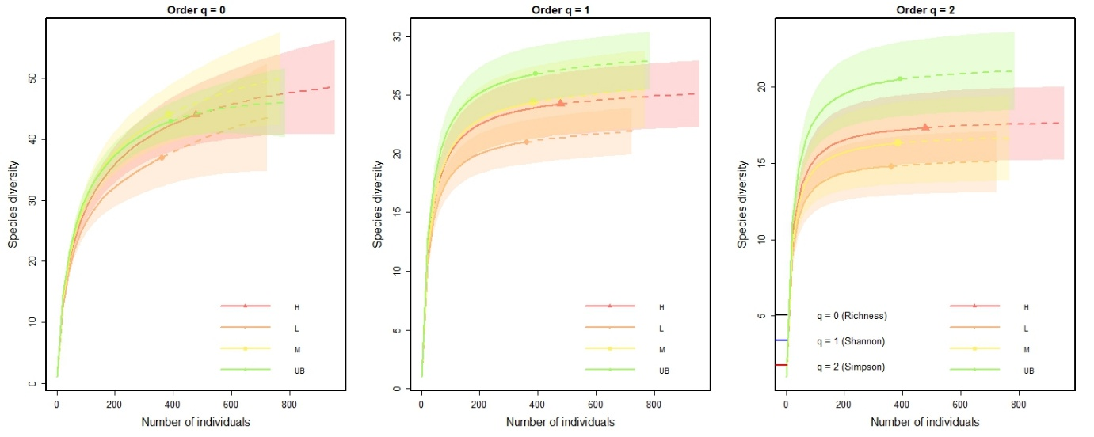

Figure S2. Pearson’s correlation matrix showing relationships between avian community metrics and environmental variables across 120 sampling sites. Color intensity reflects correlation strength, with green for positive and orange for negative correlations.
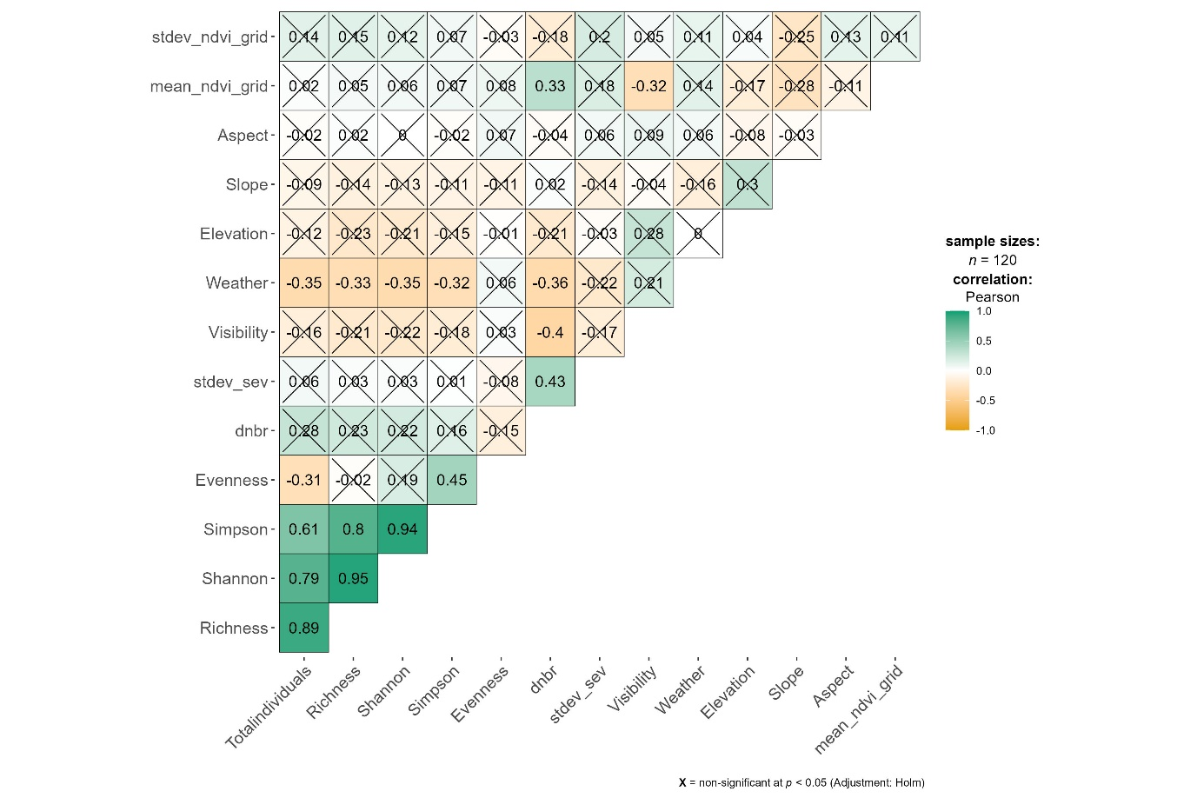

Figure S3: Percent composition of A) feeding substrate and B) foraging technique by burn severity (UB, L, M, and H) within the 2019 forest fire, five years post-fire.
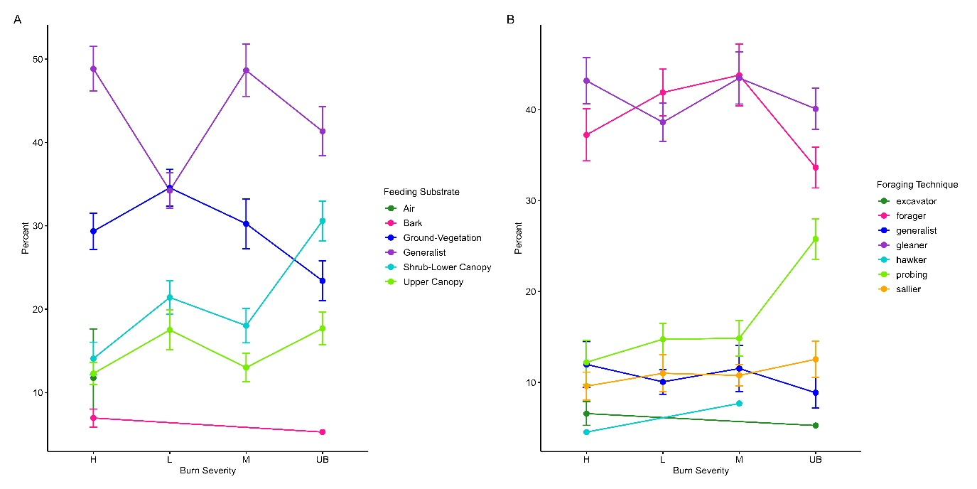

Table S1: Total bird abundance by species across four burn severities within the 2019 forest fire, 5 years post-burn.
Abbr. | Common Name | Scientific Name | Unburned | Low | Moderate | High
AGBE | Asian Green Bee-eater | Merops orientalis |  |  |  | 4
ASPR | Ashy Prinia | Prinia socialis | 1 | 1 |  | 14
BHBA | Brown Headed Barbet | Psilopogon zeylanicus |  |  | 3
BHCU | Black headed cuckooshrike | Lalage melanoptera | 6 | 2 | 7 | 17
BHOR | Black hooded Oriole | Oriolus xanthornus | 8 | 4 | 2
BRST | Brahminy Starling | Sturnia pagodarum |  |  |  | 14
CBSU | Crimson backed Sunbird | Leptocoma minima | 13 | 19 | 3 | 1
CHCU | Common Hawk Cuckoo | Hierococcyx varius | 2 |  | 1
CITI | Cinerous Tit | Parus cinereus |  | 1 | 2 | 1
COIO | Common Iora | Aegithina tiphia | 10 | 15 | 5 | 5
COMY | Common Myna | Acridotheres tristis | 2 | 5
COTA | Common Tailorbird | Orthotomus sutorius | 33 | 37 | 41 | 38
COWO | Common Woodshrike | Tephrodornis pondicerianus | 7 | 1 | 4 | 1
CSBA | Coppersmith Barbet | Psilopogon haemacephalus |  |  |  | 3
ECDO | Eurasian Collared Dove | Streptopelia decaocto |  | 5 | 6 | 15
FTDC | Fork tailed Drongo-Cuckoo | Surniculus dicruroides | 2 | 1 | 3
GBCU | Grey bellied Cuckoo | Cacomantis passerinus | 4 | 1 | 9 | 16
GBPR | Grey breasted Prinia | Prinia hodgsonii | 34 | 18 | 31 | 61
GRJU | Grey Junglefowl | Gallus sonneratii | 8 | 1 | 7 | 3
INPE | Indian Peafowl | Pavo cristatus | 3 | 1 | 5 | 1
INRO | Indian Robin | Copsychus fulicatus | 1 |  |  | 2
INWH | Indian White-eye | Zosterops palpebrosus | 32 | 5 | 17 | 11
ISBA | Indian Scimitar Babbler | Pomatorhinus horsfieldii | 3 | 8 | 3 | 1
JBQU | Jungle Bushquail | Perdicula asiatica |  |  | 3
JUBA | Jungle Babbler | Argya striata | 7 |  | 11 | 15
JUPR | Jungle Prinia | Prinia sylvatica | 28 | 21 | 28 | 28
LADO | Laughing Dove | Spilopelia senegalensis |  | 1 | 3 | 10
LECO | Lesser Coucal | Centropus bengalensis |  |  |  | 2
LOSU | Loten's Sunbird | Cinnyris lotenius | 7
LTSH | Long tailed Shrike | Lanius schach |  |  | 1 | 3
MAPA | Malabar Parakeet | Psittacula columboides | 5
OMRO | Oriental Magpie Robin | Copsychus saularis | 1 |  | 1 | 1
PBFL | Pale billed Flowerpecker | Dicaeum erythrorhynchos | 7 | 7 | 10 | 2
PHPA | Plum headed Parakeet | Psittacula cyanocephala |  |  | 2 | 3
PRSU | Purple rumped Sunbird | Leptocoma zeylonica | 22 | 7 | 9 | 5
PTBA | Puff throated Babbler | Pellorneum ruficeps | 9 | 12 | 12 | 4
PUSU | Purple Sunbird | Cinnyris asiaticus | 13 | 8 | 6 | 17
RRPA | Rose ringed Parakeet | Psittacula krameri | 1 | 3 | 4 | 3
RUTR | Rufous Treepie | Dendrocitta vagabunda | 2 | 7 | 5 | 2
RVBU | Red vented Bulbul | Pycnonotus cafer | 25 | 24 | 23 | 41
RWBU | Red whiskered Bulbul | Pycnonotus jocosus | 20 | 39 | 18 | 33
SBFA | Spot breasted Fantail | Rhipidura albogularis | 1 | 4 | 1 | 1
SHIK | Shikra | Tachyspiza badia |  |  | 1 | 1
SMMI | Small Minivet | Pericrocotus cinnamomeus | 7 | 7 | 1 | 2
SPDO | Spotted Dove | Spilopelia chinensis | 5 | 8 | 4 | 13
STWO | Streak throated Woodpecker | Picus xanthopygaeus | 1 |  |  | 3
TBBA | Tawny bellied Babbler | Dumetia hyperythra | 2 | 2 | 6
TBFL | Tickell's blue Flycatcher | Cyornis tickelliae | 7 | 12 | 13 | 8
VHPA | Vernal Hanging Parrot | Loriculus vernalis | 4 | 11
WBBU | White browed Bulbul | Pycnonotus luteolus | 24 | 55 | 57 | 44
WBDR | White bellied Drongo | Dicrurus caerulescens | 5 | 1 | 1 | 4
WBFA | White browed Fantail | Rhipidura aureola | 2
WCBA | White cheeked Barbet | Psilopogon viridis | 1 | 2 | 2 | 10
WTKI | White-throated Kingfisher | Halcyon smyrnensis | 2 |  | 1
YBBA | Yellow billed Babbler | Argya affinis | 16 | 5 | 11 | 10
YEBA | Yellow eyed Babbler | Chrysomma sinense |  |  | 1 | 5
 |  | Abundance | 393 | 361 | 384 | 478
 |  | Richness | 43 | 37 | 44 | 44

Table S2: Model selection results for candidate models assessing the effects of fire and environmental variables on the total bird abundance.
 | (Intercept) | Aspect | dnbr | Elevation | Slope | stdev_ndvi_grid | stdev_sev | Visibility | Weather | df | logLik | AICc | delta | weight
model13 | 16.161 | NA | 1.536 | NA | NA | 1.369 | -0.980 | NA | -1.104 | 6 | -350.625 | 713.994 | 0.000 | 0.652
model11 | 16.022 | NA | 1.093 | NA | NA | 1.082 | NA | NA | -1.045 | 5 | -352.652 | 715.831 | 1.836 | 0.260
model10 | 15.921 | NA | 0.920 | NA | NA | NA | NA | NA | -1.002 | 4 | -355.787 | 719.921 | 5.927 | 0.034
model12 | 15.979 | NA | 1.124 | NA | NA | NA | -0.504 | NA | -1.027 | 5 | -355.227 | 720.981 | 6.986 | 0.020
Global | 21.558 | -0.094 | 1.419 | -0.005 | -0.505 | 1.265 | -1.017 | -0.101 | -1.170 | 10 | -349.484 | 720.987 | 6.993 | 0.020
model3 | 16.462 | NA | NA | NA | NA | NA | NA | NA | -1.233 | 3 | -357.746 | 721.700 | 7.705 | 0.014
model1 | 13.575 | NA | 1.434 | NA | NA | NA | NA | NA | NA | 3 | -360.426 | 727.059 | 13.065 | 0.001
model2 | 15.447 | NA | NA | NA | NA | NA | NA | -0.977 | NA | 3 | -363.803 | 733.813 | 19.818 | 0.000
model8 | 13.575 | NA | NA | NA | NA | 0.715 | NA | NA | NA | 3 | -364.170 | 734.548 | 20.553 | 0.000
model4 | 26.220 | NA | NA | -0.013 | NA | NA | NA | NA | NA | 3 | -364.451 | 735.109 | 21.114 | 0.000
model5 | 13.575 | NA | NA | NA | -0.464 | NA | NA | NA | NA | 3 | -364.862 | 735.931 | 21.936 | 0.000
model7 | 13.575 | NA | NA | NA | NA | NA | 0.296 | NA | NA | 3 | -365.158 | 736.523 | 22.528 | 0.000
model6 | 13.575 | -0.127 | NA | NA | NA | NA | NA | NA | NA | 3 | -365.322 | 736.851 | 22.857 | 0.000

Table S3: Model selection results for candidate models assessing the effects of fire and environmental variables on the abundance of shrub-lower canopy foraging species.
 | (Intercept) | Aspect | dnbr | Elevation | Slope | stdev_ndvi_grid | stdev_sev | Visibility | Weather | df | logLik | AICc | delta | weight
model14 | -6.66904 | NA | -0.66214 | 0.010132 | NA | NA | NA | NA | -0.2951 | 5 | -223.653 | 457.8889 | 0 | 0.649749
model13 | -7.94073 | NA | -0.51344 | 0.010715 | NA | NA | NA | NA | NA | 4 | -225.929 | 460.2426 | 2.353741 | 0.20028
model11 | 3.565747 | NA | -0.71559 | NA | NA | 0.286695 | NA | NA | -0.33835 | 5 | -226.276 | 463.1342 | 5.245364 | 0.047177
model10 | 3.542032 | NA | -0.77032 | NA | NA | NA | NA | NA | -0.32336 | 4 | -227.39 | 463.1647 | 5.27584 | 0.046463
model12 | 3.534461 | NA | -0.79653 | NA | NA | NA | 0.076911 | NA | -0.31855 | 5 | -227.331 | 465.2439 | 7.355021 | 0.016429
model4 | -9.84169 | NA | NA | 0.012621 | NA | NA | NA | NA | NA | 3 | -229.616 | 465.4615 | 7.57263 | 0.014736
Global | -8.2107 | 0.152707 | -0.59967 | 0.012103 | -0.09582 | 0.280361 | -0.15195 | -0.21451 | -0.31643 | 10 | -221.685 | 465.6149 | 7.726001 | 0.013648
model1 | 2.788119 | NA | -0.61334 | NA | NA | NA | NA | NA | NA | 3 | -229.949 | 466.1264 | 8.237525 | 0.010568
model8 | 2.782001 | NA | NA | NA | NA | 0.378237 | NA | NA | NA | 3 | -233.157 | 472.5425 | 14.65362 | 0.000427
model2 | 2.279081 | NA | NA | NA | NA | NA | NA | 0.276001 | NA | 3 | -234.27 | 474.7692 | 16.88033 | 0.00014
model3 | 3.106562 | NA | NA | NA | NA | NA | NA | NA | -0.13182 | 3 | -234.518 | 475.2644 | 17.37554 | 0.00011
model7 | 2.789159 | NA | NA | NA | NA | NA | -0.16836 | NA | NA | 3 | -234.65 | 475.5293 | 17.64045 | 9.60E-05
model6 | 2.797364 | 0.147726 | NA | NA | NA | NA | NA | NA | NA | 3 | -234.685 | 475.5991 | 17.71024 | 9.27E-05
model5 | 2.799293 | NA | NA | NA | 0.121141 | NA | NA | NA | NA | 3 | -234.784 | 475.7959 | 17.90705 | 8.40E-05

Table S4: Model selection results for candidate models assessing the effects of fire and environmental variables on the abundance of ground foraging species.
 | (Intercept) | Aspect | dnbr | Elevation | Slope | stdev_ndvi_grid | stdev_sev | Visibility | Weather | df | logLik | AICc | delta | weight
model1 | 5.794096 | NA | 1.274376 | NA | NA | NA | NA | NA | NA | 3 | -285.103 | 576.4144 | 0 | 0.399201
model10 | 6.337781 | NA | 1.153472 | NA | NA | NA | NA | NA | -0.23138 | 4 | -284.298 | 576.9464 | 0.531953 | 0.305971
model11 | 6.378567 | NA | 1.284002 | NA | NA | NA | -0.32732 | NA | -0.2482 | 5 | -283.553 | 577.6364 | 1.221944 | 0.216696
model12 | 6.386064 | NA | 1.305464 | NA | NA | 0.068556 | -0.35073 | NA | -0.2517 | 6 | -283.518 | 579.7859 | 3.371437 | 0.073976
Global | 7.47697 | -0.13488 | 1.387319 | -0.00166 | -0.32281 | 0.024029 | -0.38001 | 0.358445 | -0.30487 | 10 | -281.785 | 585.6065 | 9.192066 | 0.004029
model3 | 7.033423 | NA | NA | NA | NA | NA | NA | NA | -0.52322 | 3 | -293.33 | 592.8685 | 16.45402 | 0.000107
model4 | 12.97726 | NA | NA | -0.00717 | NA | NA | NA | NA | NA | 3 | -296.428 | 599.0644 | 22.64994 | 4.82E-06
model7 | 5.804334 | NA | NA | NA | NA | NA | 0.294783 | NA | NA | 3 | -296.703 | 599.6142 | 23.19978 | 3.66E-06
model8 | 5.809667 | NA | NA | NA | NA | -0.29389 | NA | NA | NA | 3 | -296.709 | 599.6265 | 23.21204 | 3.64E-06
model2 | 6.461152 | NA | NA | NA | NA | NA | NA | -0.34307 | NA | 3 | -296.738 | 599.6853 | 23.27091 | 3.53E-06
model5 | 5.804208 | NA | NA | NA | -0.20082 | NA | NA | NA | NA | 3 | -297.026 | 600.2598 | 23.84541 | 2.65E-06
model6 | 5.805573 | -0.18686 | NA | NA | NA | NA | NA | NA | NA | 3 | -297.059 | 600.3262 | 23.91177 | 2.56E-06

Table S5: Model selection results for candidate models assessing the effects of fire and environmental variables on the abundance of upper canopy foraging species.
 | (Intercept) | Aspect | dnbr | Elevation | Slope | stdev_ndvi_grid | stdev_sev | Visibility | Weather | df | logLik | AICc | delta | weight
model8 | 1.97124 | NA | NA | NA | NA | 0.275326 | NA | NA | NA | 3 | -126.442 | 259.1923 | 0 | 0.29267
model10 | 1.979845 | NA | -0.13413 | NA | NA | 0.243714 | NA | NA | NA | 4 | -125.88 | 260.2792 | 1.086859 | 0.169969
model11 | 2.297291 | NA | -0.19884 | NA | NA | 0.253296 | NA | NA | -0.14029 | 5 | -124.775 | 260.3404 | 1.148112 | 0.164842
model1 | 1.997265 | NA | -0.18931 | NA | NA | NA | NA | NA | NA | 3 | -127.638 | 261.583 | 2.390659 | 0.088563
model12 | 0.146029 | NA | -0.16447 | 0.002131 | NA | 0.2634 | NA | NA | -0.13128 | 6 | -124.433 | 261.9852 | 2.792836 | 0.072431
model4 | -0.91005 | NA | NA | 0.002901 | NA | NA | NA | NA | NA | 3 | -128.127 | 262.5607 | 3.368421 | 0.054317
model3 | 2.139485 | NA | NA | NA | NA | NA | NA | NA | -0.0676 | 3 | -128.494 | 263.2962 | 4.103841 | 0.037605
model6 | 1.990327 | 0.059105 | NA | NA | NA | NA | NA | NA | NA | 3 | -128.659 | 263.6249 | 4.432591 | 0.031905
model5 | 1.986884 | NA | NA | NA | -0.02199 | NA | NA | NA | NA | 3 | -128.751 | 263.8089 | 4.616568 | 0.029101
model2 | 2.017348 | NA | NA | NA | NA | NA | NA | -0.01505 | NA | 3 | -128.758 | 263.8236 | 4.631261 | 0.028888
model7 | 1.987672 | NA | NA | NA | NA | NA | 0.004853 | NA | NA | 3 | -128.763 | 263.8338 | 4.641514 | 0.02874
Global | -0.7631 | 0.045569 | -0.21404 | 0.00337 | -0.05081 | 0.248701 | -0.00659 | -0.1691 | -0.12832 | 10 | -123.756 | 270.6106 | 11.41824 | 0.00097

Table S6: Model selection results for candidate models assessing the effects of fire and environmental variables on the abundance of foraging substrate generalist species.
 | (Intercept) | Aspect | dnbr | Elevation | Slope | stdev_ndvi_grid | stdev_sev | Visibility | Weather | df | logLik | AICc | delta | weight
model15 | 23.11767 | NA | 0.443577 | -0.01796 | NA | 0.364394 | -0.36568 | NA | -0.49438 | 7 | -233.651 | 482.3885 | 0 | 0.295243
model12 | 23.46119 | NA | 0.236124 | -0.01837 | NA | NA | NA | NA | -0.46743 | 5 | -235.973 | 482.5176 | 0.129028 | 0.276798
model13 | 23.37241 | NA | 0.275914 | -0.01827 | NA | 0.262606 | NA | NA | -0.47034 | 6 | -235.062 | 482.9316 | 0.543056 | 0.225039
model14 | 23.31194 | NA | 0.339253 | -0.01818 | NA | NA | -0.24771 | NA | -0.48295 | 6 | -235.277 | 483.3624 | 0.973873 | 0.181429
Global | 23.19725 | -0.13812 | 0.397995 | -0.0178 | -0.00871 | 0.370206 | -0.35639 | -0.13694 | -0.48611 | 10 | -233.19 | 488.5806 | 6.192105 | 0.013353
model11 | 20.7428 | NA | 0.474275 | -0.01675 | NA | NA | NA | NA | NA | 4 | -240.802 | 489.9816 | 7.593085 | 0.006628
model4 | 22.14209 | NA | NA | -0.01813 | NA | NA | NA | NA | NA | 3 | -243.451 | 493.126 | 10.73749 | 0.001376
model10 | 4.927266 | NA | 0.400924 | NA | NA | NA | NA | NA | -0.3845 | 4 | -245.317 | 499.0118 | 16.62325 | 7.25E-05
model3 | 5.175745 | NA | NA | NA | NA | NA | NA | NA | -0.48272 | 3 | -246.9 | 500.0252 | 17.63672 | 4.37E-05
model1 | 4.018064 | NA | 0.587812 | NA | NA | NA | NA | NA | NA | 3 | -248.173 | 502.5704 | 20.18185 | 1.22E-05
model2 | 5.196334 | NA | NA | NA | NA | NA | NA | -0.60854 | NA | 3 | -249.186 | 504.5966 | 22.20811 | 4.44E-06
model5 | 4.052179 | NA | NA | NA | -0.26541 | NA | NA | NA | NA | 3 | -251.058 | 508.3402 | 25.95168 | 6.84E-07
model8 | 4.047005 | NA | NA | NA | NA | 0.172164 | NA | NA | NA | 3 | -251.476 | 509.1757 | 26.7872 | 4.50E-07
model6 | 4.046886 | -0.0984 | NA | NA | NA | NA | NA | NA | NA | 3 | -251.674 | 509.573 | 27.1845 | 3.69E-07
model7 | 4.044754 | NA | NA | NA | NA | NA | 0.062941 | NA | NA | 3 | -251.734 | 509.6928 | 27.30427 | 3.48E-07

