Ans 1.

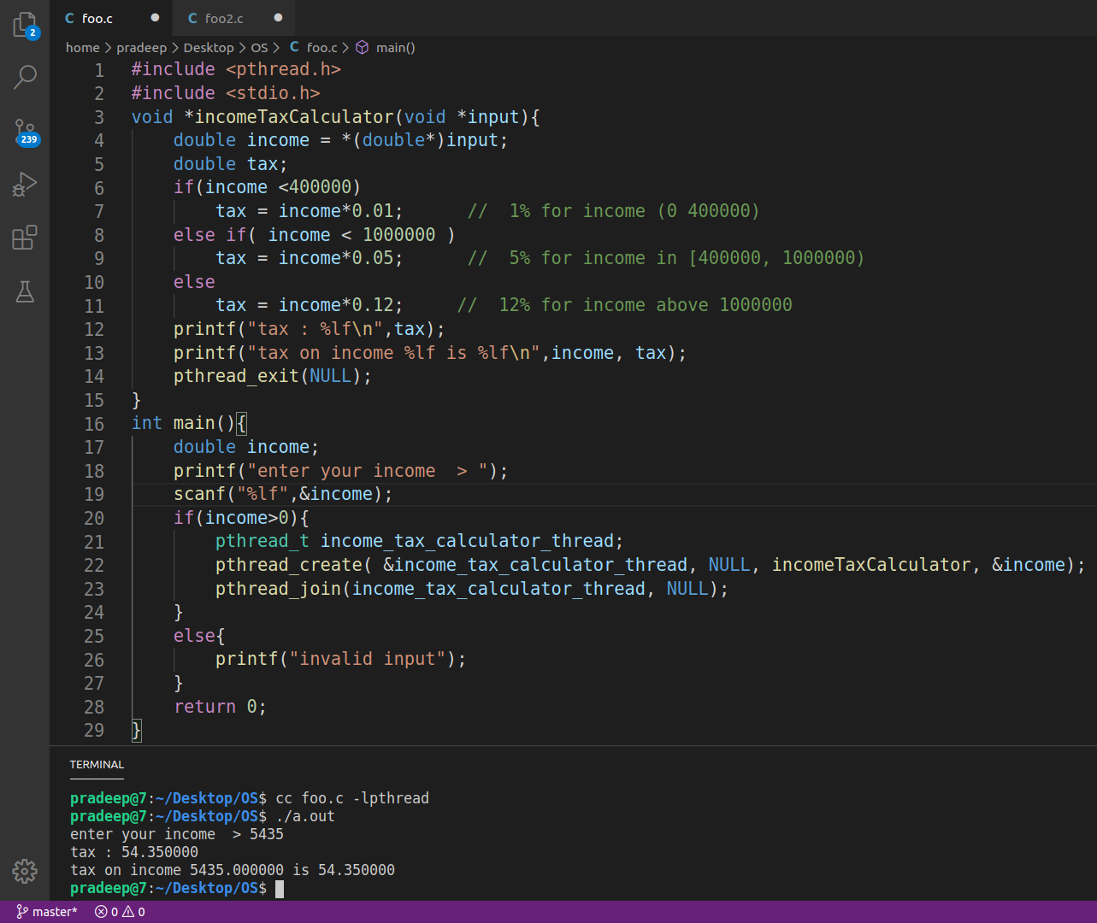
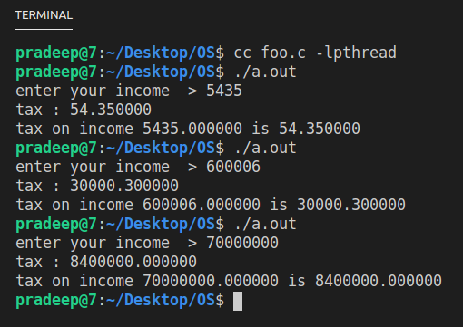

#include <pthread.h>
#include <stdio.h>
void *incomeTaxCalculator(void *input){
double income = *(double*)input;
double tax;
if(income <400000)
tax = income*0.01; // 1% for income (0 400000)
else if( income < 1000000 )
tax = income*0.05; // 5% for income in [400000, 1000000)
else
tax = income*0.12; // 12% for income above 1000000
printf("tax : %lf\n",tax);
printf("tax on income %lf is %lf\n",income, tax);
pthread_exit(NULL);
}
int main(){
double income;
printf("enter your income > ");
scanf("%lf",&income);
if(income>0){
pthread_t income_tax_calculator_thread;
pthread_create( &income_tax_calculator_thread, NULL,
incomeTaxCalculator, &income);
pthread_join(income_tax_calculator_thread, NULL);
}
else{
printf("invalid input");
}
return 0;
}

Ans 2
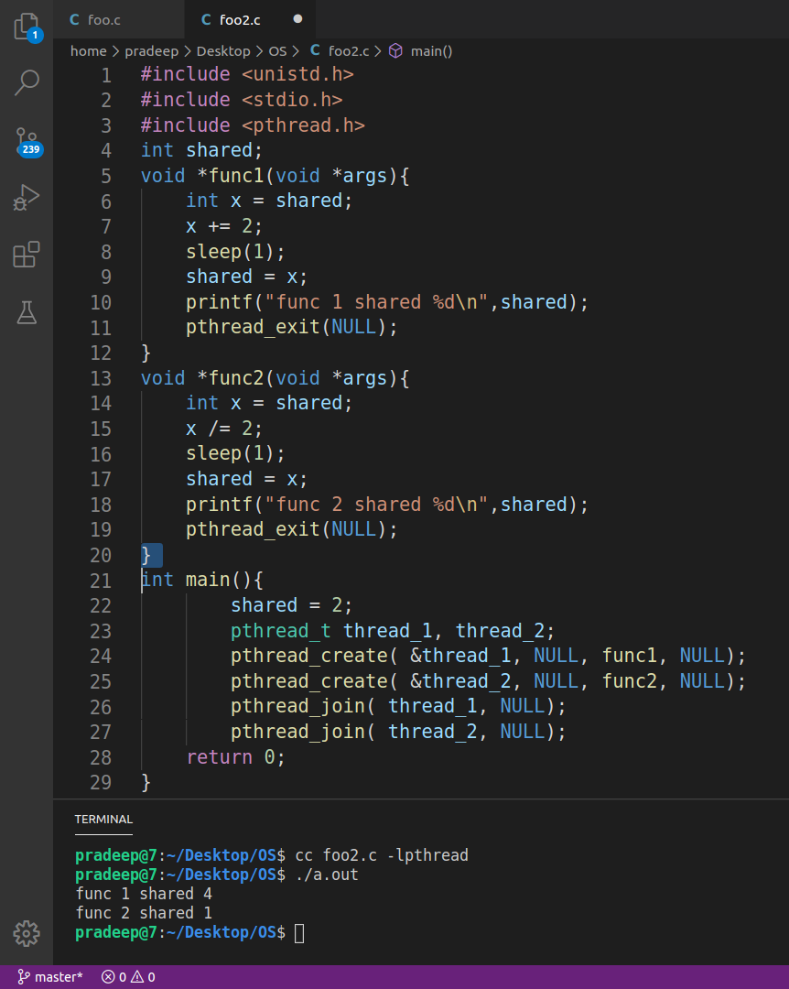

// code Ans2
#include <unistd.h>
#include <stdio.h>
#include <pthread.h>
int shared;
void *func1(void *args){
int x = shared;
x += 2;
sleep(1);
shared = x;
printf("func 1 shared %d\n",shared);
pthread_exit(NULL);
}
void *func2(void *args){
int x = shared;
x /= 2;
sleep(1);
shared = x;
printf("func 2 shared %d\n",shared);
pthread_exit(NULL);
}
int main(){
shared = 2;
pthread_t thread_1, thread_2;
pthread_create( &thread_1, NULL, func1, NULL);
pthread_create( &thread_2, NULL, func2, NULL);
pthread_join( thread_1, NULL);
pthread_join( thread_2, NULL);
return 0;
}

Ans 3
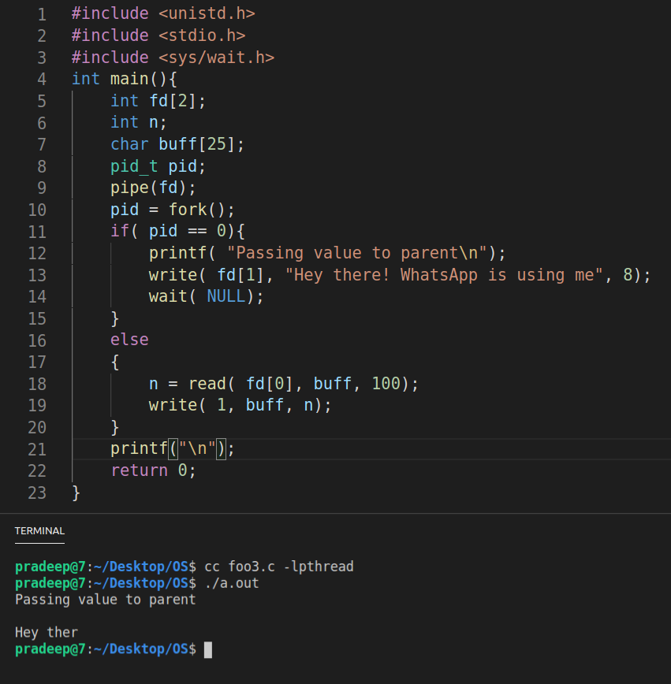

// Code 3

#include <unistd.h>
#include <stdio.h>
#include <sys/wait.h>
int main(){
int fd[2];
int n;
char buff[25];
pid_t pid;
pipe(fd);
pid = fork();
if( pid == 0){
printf( "Passing value to parent\n");
write( fd[1], "Hey there! WhatsApp is using me", 8);
wait( NULL);
}
else
{
n = read( fd[0], buff, 100);
write( 1, buff, n);
}
printf("\n");
return 0;
}

Ans 4 (first program file)
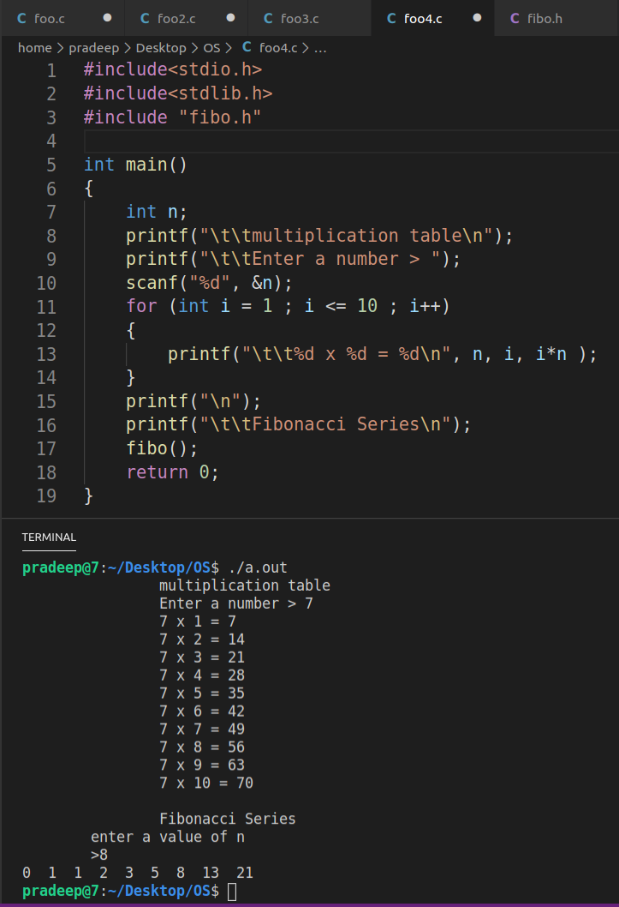

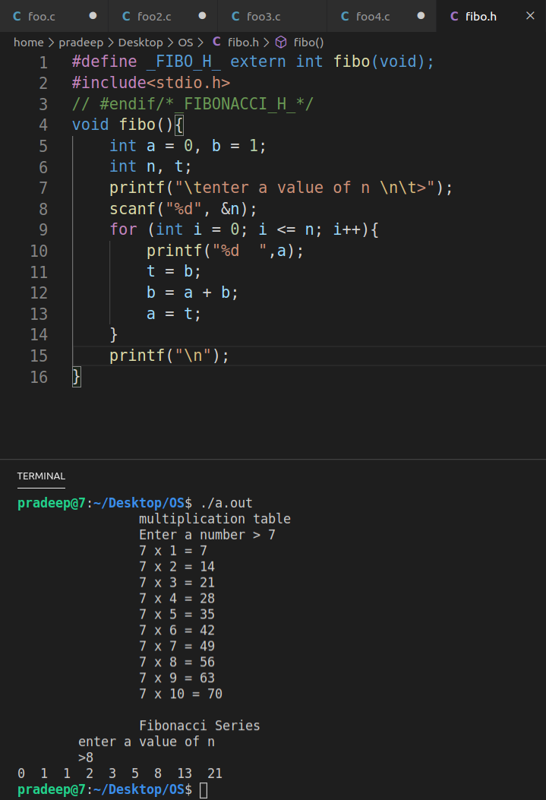
second header file code..
// Code of file 1
#include<stdio.h>
#include<stdlib.h>
#include "fibo.h"

int main()
{
int n;
printf("\t\tmultiplication table\n");
printf("\t\tEnter a number > ");
scanf("%d", &n);
for (int i = 1 ; i <= 10 ; i++)
{
printf("\t\t%d x %d = %d\n", n, i, i*n );
}
printf("\n");
printf("\t\tFibonacci Series\n");
fibo();
return 0;
}

// code for file2 > save as fibo.h

#define _FIBO_H_ extern int fibo(void);
#include<stdio.h>
// #endif/*_FIBONACCI_H_*/
void fibo(){
int a = 0, b = 1;
int n, t;
printf("\tenter a value of n \n\t>");
scanf("%d", &n);
for (int i = 0; i <= n; i++){
printf("%d ",a);
t = b;
b = a + b;
a = t;
}
printf("\n");
}

