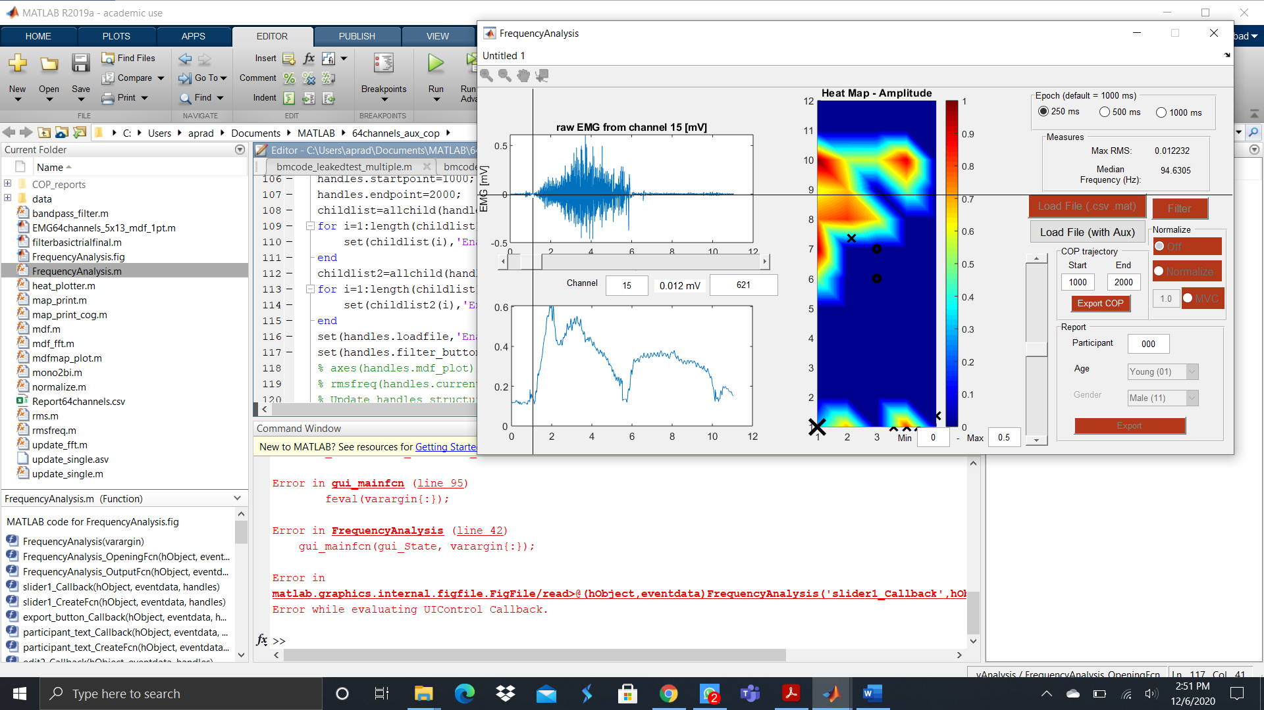

6

7

5

4

3

2

1

1. Load a file using the “Load File (with Aux). Make sure you place all data files in the data folder inside the main folder. The data is in the format of 66 columns with the first column for time and the last for the aux signal.
2. Use the “get point tool on the menu to select a point on the contraction.
3. The time value is updated in this box automatically.
4. Select the start of the contraction using steps 2 and 3 and enter the start point in the start box
5. Similarly for the end point get the value using step 2 and 3 and enter the endpoint in the end box
6. Adjust the slider (0.5 for 50% mask and 0% for global coordinates)
7. Click the export COP button to get the plots and excel files for a particular file, check in the reports folder. The export button can be clicked multiple times. One advice is to adjust start and end points and click export COP to update the plots to suit your requirement