Project Report: Diabetes Classification using Machine Learning

1. Project Overview

This project involves building a predictive model to determine whether a patient has diabetes based on specific diagnostic measurements. The analysis uses the Diabetes Dataset and implements a Machine Learning pipeline including data preprocessing, Exploratory Data Analysis (EDA), and model optimization.

2. Data Description

The dataset contains several medical predictor variables and one target variable (Outcome). Key features include:

Pregnancies: Number of times pregnant.

Glucose: Plasma glucose concentration.

Blood Pressure: Diastolic blood pressure (mm Hg).

Skin Thickness: Triceps skin fold thickness (mm).

Insulin: 2-Hour serum insulin (mu U/ml).

BMI: Body mass index.

Diabetes Pedigree Function: A function which scores likelihood of diabetes based on family history.

Age: Age in years.

3.How the Top Features Were Chosen

By looking at the "Outcome" row/column in the heatmap, we can identify which factors are the strongest predictors of diabetes:

Glucose (0.47): This has the strongest positive correlation.

BMI (0.29): The second strongest predictor.

Age (0.24): A moderate positive correlation
The correlation analysis confirms that Glucose, BMI, and Age are the most statistically significant variables in the dataset for predicting diabetes

4.Explanation of Custom Logistic Regression (my_LR)

Step 1: Initialization (__init__)

We define the starting parameters:

Learning Rate (lr): Controls how big a step we take during optimization.

Epochs: The number of times the model will see the entire dataset to learn.

Weights and Bias: Initialized as None; these will be defined once we know the shape of the data.

Step 2: The Sigmoid Function
Logistic Regression needs to predict probabilities between 0 and

1. The sigmoid function (1 / (1 + e^(-z))) takes any linear output

and "squashes" it into this 0-1 range.
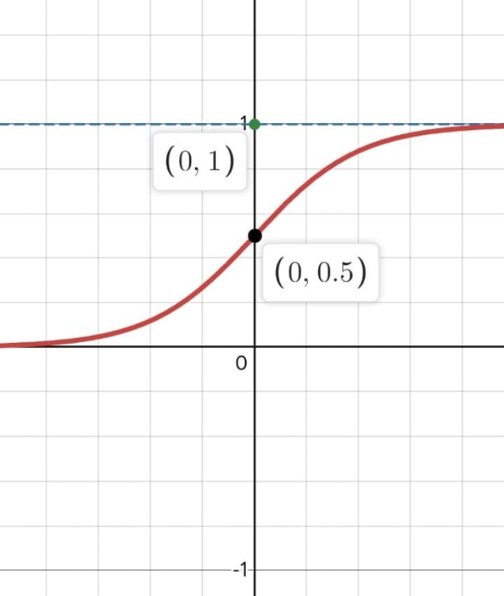

Step 3: The Loss Function (Log Loss)

Since we are dealing with probabilities, we use Binary Cross-Entropy (Log Loss).

It penalizes the model more heavily when it is confident about a wrong prediction.

The epsilon (1e-9) is a tiny number added to prevent "log(0)" errors, which would crash the code.

Step 4: Training the Model (fit method)

This is where the learning happens through these sub-steps:

Initialization: We set weights to zero based on the number of features in our data.

Linear Formula: We calculate z = (X.W) + b.

Activation: We pass z through the sigmoid function to get the prediction y_pred.

Gradient Calculation: We calculate the derivatives (dw and db). This tells us the direction and magnitude of the error.

Updating Parameters: We subtract the gradient (multiplied by the learning rate) from our weights and bias. This is the Gradient Descent step that minimizes the error.
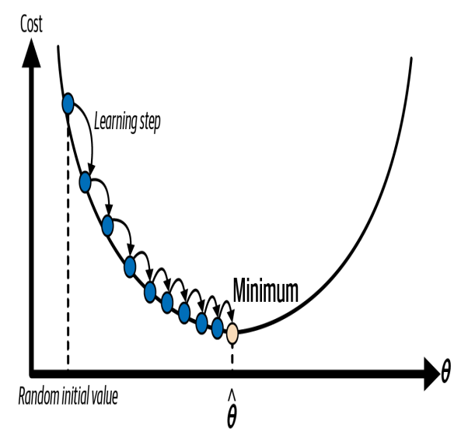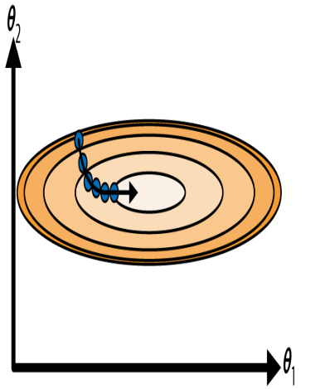

Step 5: Making Predictions (predict & predict_proba)

predict_proba: Returns the raw probability (e.g., 0.82).

predict: Converts the probability into a class. By default, if the probability is equal to 0.5, it returns 1 (Diabetic); otherwise, it returns 0 (Non-Diabetic).

Step 6: Evaluation (accuracy)

This simple function compares the predicted labels with the actual labels and calculates the percentage of correct guesses.

Comparison of Machine Learning Models:

While the final project utilized a Random Forest Classifier, it is important to understand why other models are often used for diabetes classification and how they function.

- Logistic Regression

Why use it: It is the baseline model for binary classification (Diabetes vs.
No Diabetes). It is highly interpretable, meaning you can easily see how much each factor (like Glucose or BMI) increases the probability of having diabetes.

How it works: It uses a mathematical function called the Sigmoid Function to map any real-valued number into a probability value between 0 and 1. If the probability is greater than 0.5, the patient is classified as having diabetes.
“draws a decision boundary in feature space. It computes a weighted sum of features (Glucose × w₁ + BMI × w₂ + Age × w₃) and passes it through a sigmoid function to get a probability between 0–1. If P ≥ 0.5, the patient is classified as diabetic.”

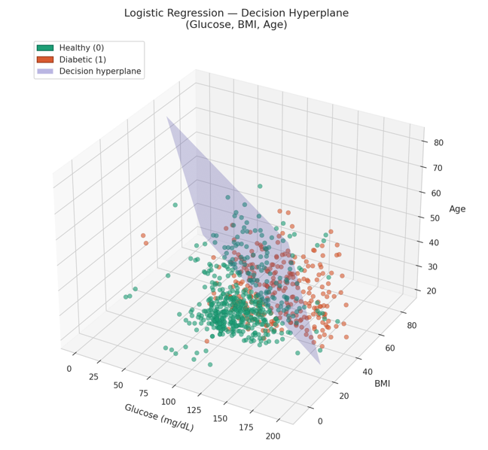

2. Decision Trees

Why use it: Decision Trees mimic human decision-making. They are excellent for identifying the most important "split points" in data, such as "Is Glucose > 125?".

How it works: The model splits the data into branches based on feature values. It continues splitting until it reaches a "leaf," which provides the final classification. While easy to visualize, a single tree can sometimes "overfit" (memorize) the data too closely.
greedily splits the data at each node by the feature and threshold that gives the best information gain (e.g. "Glucose > 127?"). It keeps splitting until leaves are mostly pure, then assigns a class to each leaf.

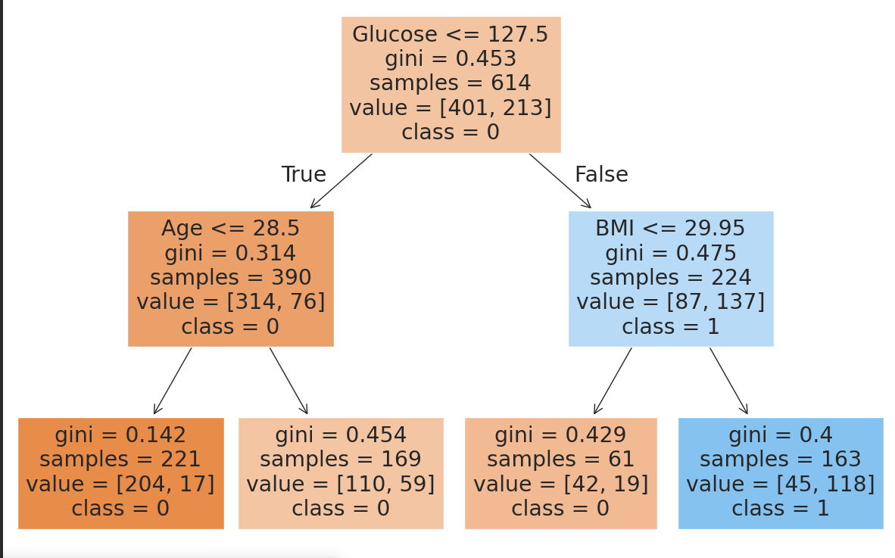

3.Why Random Forest?

While Logistic Regression is a great baseline, I chose Random Forest because it is an "Ensemble" method. It combines multiple decision trees to reduce errors and handle complex patterns better than a single model.

5. Hyperparameter Tuning

To get the best performance, I tuned the model using Grid Search.

Key Settings: max_depth=8, n_estimators=20, and max_samples=0.75.

Result: Tuning prevented the model from memorizing (overfitting) the data and pushed the accuracy to its peak of 78.67%.
