PROJECT REPORT
Autonomous Vehicle Decision Module
A MATLAB simulation of stop, yield, and turn behavior
Module 2 | Project 4: Decision Making and Actuator Handling | 2026

1. Introduction
Autonomous vehicles need to choose a response when road conditions change. This project implements a small decision module from the Module 2 assignment. It simulates an approaching vehicle, a pedestrian crossing, and a stop sign, then shows how the vehicle changes from driving to yielding, stopping, turning, and driving again. The work is intended as a MATLAB classroom demonstration of decision logic and actuator handling.

2. Objective
The objective is to create a simple, understandable decision controller that responds to two road events and simulates the vehicle’s motion and controls.
- Yield while a pedestrian occupies the crossing.
- Stop at the stop sign and wait for a fixed dwell time.
- Turn right after stopping, then resume driving.
- Display the decision timeline, route, and run summary.

3. Dataset Description
This project does not use a recorded or external dataset. It generates one fixed scenario from values set in the MATLAB script. The scenario contains a pedestrian crossing at 45 m, a stop sign at 105 m, and a pedestrian presence window from 4 to 8 seconds. Vehicle state is simulated in 0.05-second time steps for 30 seconds. These values are scenario inputs, not observations from a real road.
Input | Value | Purpose
Pedestrian crossing | 45 m; active from 4 to 8 s | Triggers YIELD when the vehicle is within 18 m.
Stop sign | 105 m | Triggers STOP when the sign is within 22 m.
Target speed | 8 m/s (28.8 km/h) | Sets the maximum cruising speed.
Stop dwell | 2.5 s | Sets the wait after the vehicle comes to a stop.
Turn command | 12 degrees for 3 s | Simulates a right turn after the stop.

4. Data Preprocessing
Because the project has no imported dataset, it does not perform missing-value removal, filtering, scaling, or train/test splitting. Instead, the script initializes the vehicle position, heading, speed, decision state, and event timers. At each 0.05-second step, it updates whether the pedestrian is present, calculates distance to the crossing and stop sign, applies the decision rules, and records the vehicle and actuator values for plotting.

5. Feature Selection
Statistical or machine-learning feature selection is not used. The controller reads only the scenario variables needed for its rules:
Controller input | Why it is used
Pedestrian present | Determines whether yielding is required.
Distance to crossing | Checks whether the pedestrian is close enough to trigger YIELD.
Distance to stop sign | Checks whether the vehicle should begin stopping.
Speed | Determines whether the vehicle has stopped and can begin its dwell.
Elapsed stop and turn time | Determines when to leave STOP and TURN RIGHT.
Vehicle position and heading | Updates the simulated route.

6. Machine Learning Model
No machine-learning model is used in this project. The assignment option is a decision-making module, so the implementation uses a finite-state controller with hand-written rules. This distinction is important: the simulation does not learn from training data or predict events from sensor measurements.
State | Rule and action
DRIVE | When no active event requires a yield or stop, accelerate toward 8 m/s.
YIELD | When the pedestrian is present and within 18 m, apply braking until the crossing is clear.
STOP | When the stop sign is within 22 m, brake; after stopping, hold for 2.5 seconds.
TURN RIGHT | After the stop dwell, steer right at a reduced target speed for 3 seconds.

The pedestrian condition is checked first. The actuator layer maps each state to throttle, brake, and steering values. A basic kinematic bicycle model estimates speed, heading, and position from these commands.

7. Results
The supplied MATLAB run shows the sequence DRIVE, YIELD, DRIVE, STOP, TURN RIGHT, and DRIVE. It reports a maximum speed of 28.8 km/h, 2.4 seconds in the YIELD state, 4.8 seconds in the STOP state, and 3.0 seconds in the TURN state.
The 4.8 seconds is total time in the STOP state, including the approach and braking. The programmed stationary wait after stopping is 2.5 seconds.
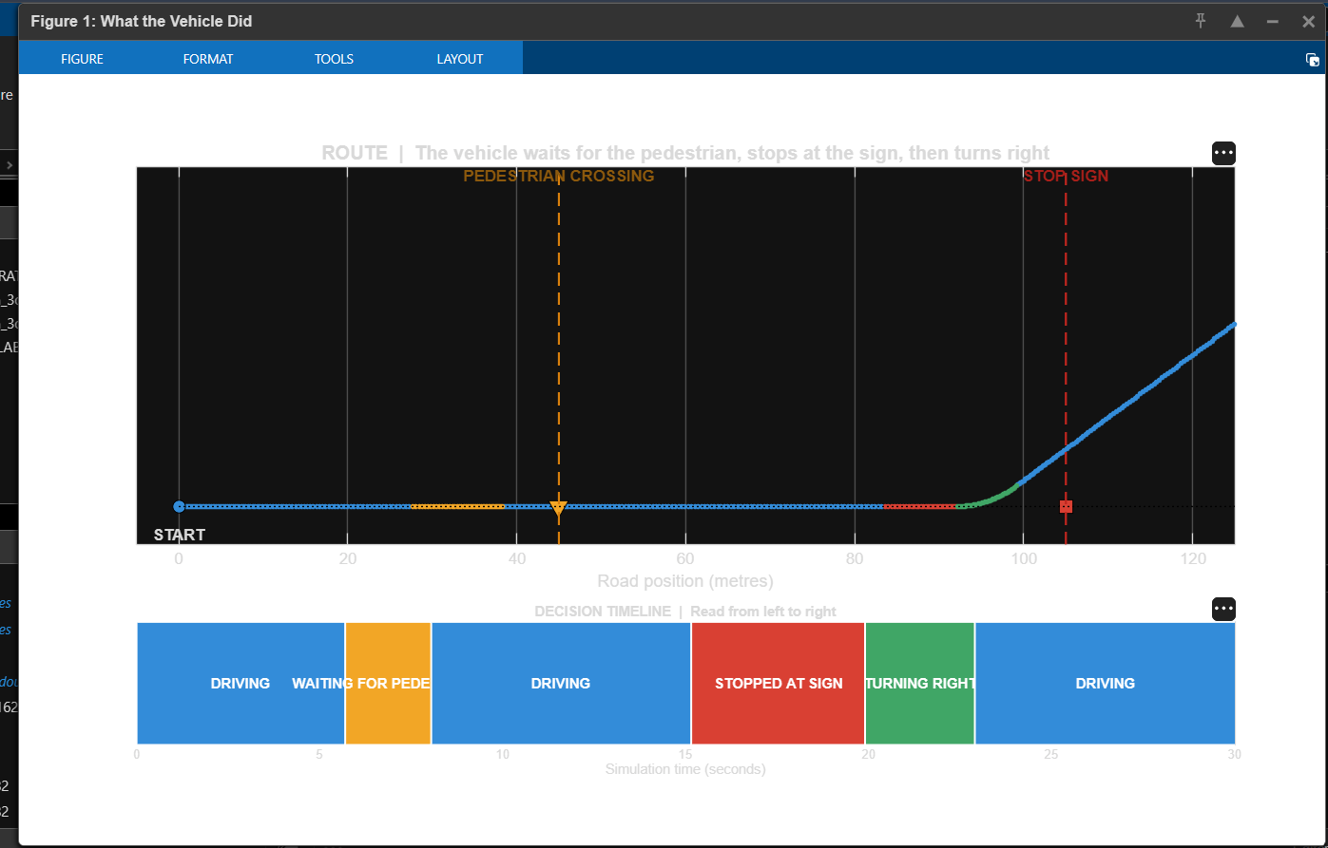
Figure 1. Route view and colored decision timeline from the MATLAB run.
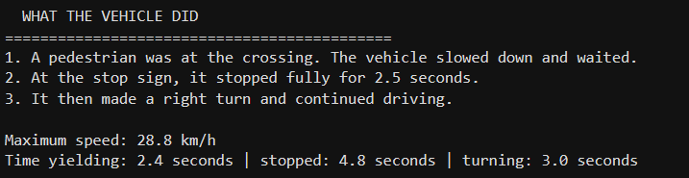
Figure 2. Plain-language run summary.

8. Discussion
The run demonstrates that the controller changes its action when scenario conditions change, and that the selected states produce different simulated actuator commands. The route and timeline make the behavior visible. The values describe one preset simulation and should not be interpreted as measured vehicle performance.
The model uses known event timing and positions, simple braking and steering behavior, and no noisy sensors. It does not detect pedestrians or signs, model traffic, or test safety on real roads. Future work could add traffic lights, uncertain sensor inputs, more scenarios, and a Simulink version. A real vehicle would require a validated perception system, vehicle model, hardware integration, and safety testing.

9. Conclusion
This project presents a compact MATLAB example of autonomous-vehicle decision making and actuator handling. A finite-state controller handles a pedestrian crossing and stop sign, then simulates a right turn and continued driving. It meets the educational goal of making the decision sequence easy to understand. It is a simplified prototype and must not be used to control a real vehicle.

