

Agile Development Process and Devops Lab – ISWE406P

Digital Assessment – 4

Faculty: Dr. Bala Ganesh N
Slot: L3 + L4

Name: Pradheep.R
Register Number: 23MIS0518

Step 1:
Install Docket Desktop
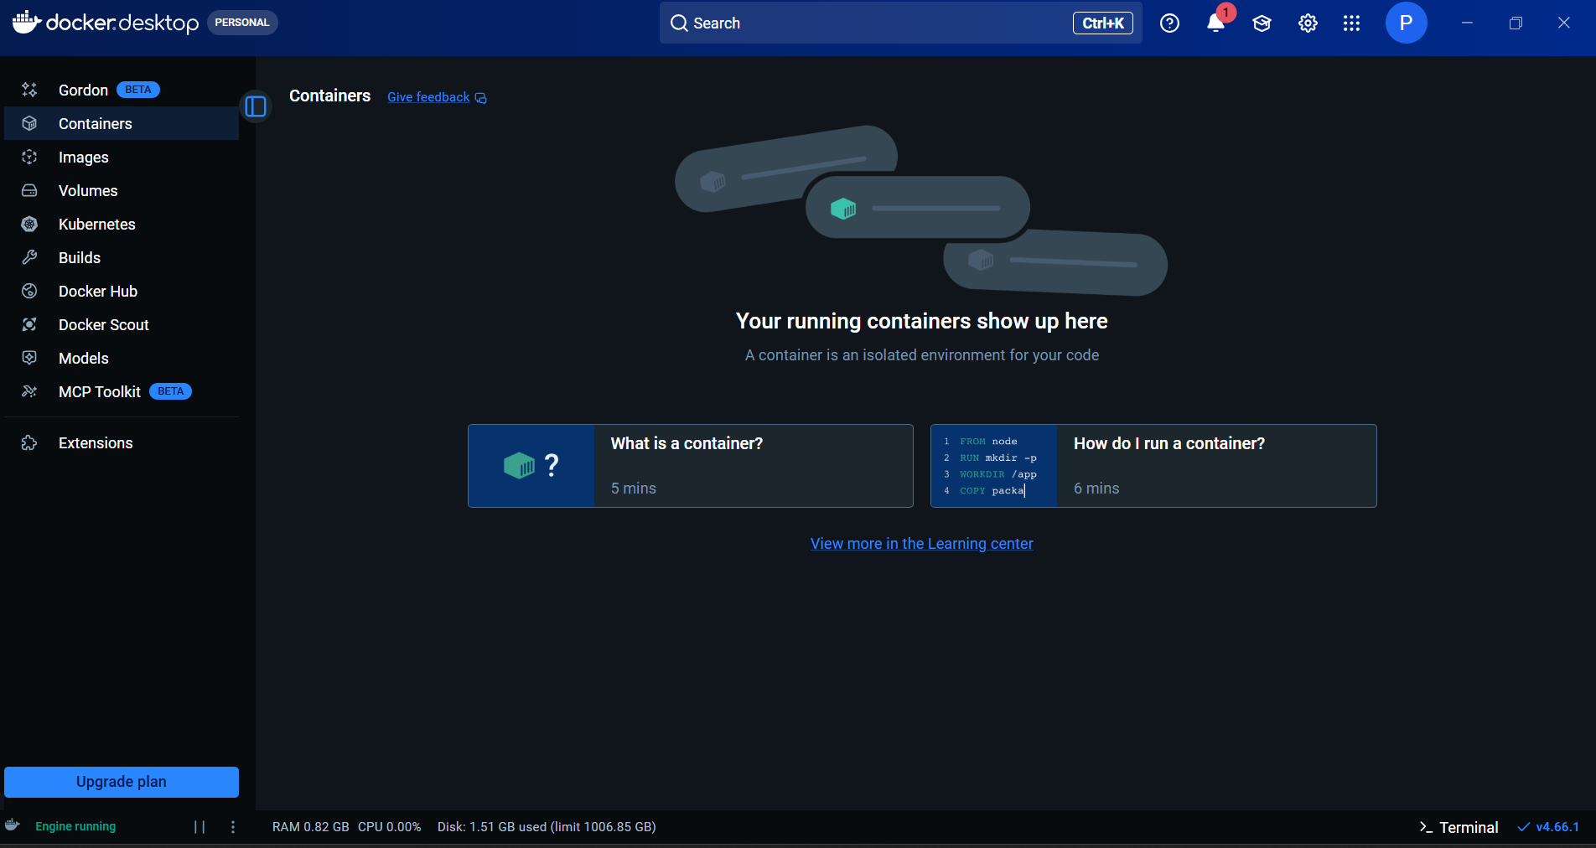

Enable Kubernets
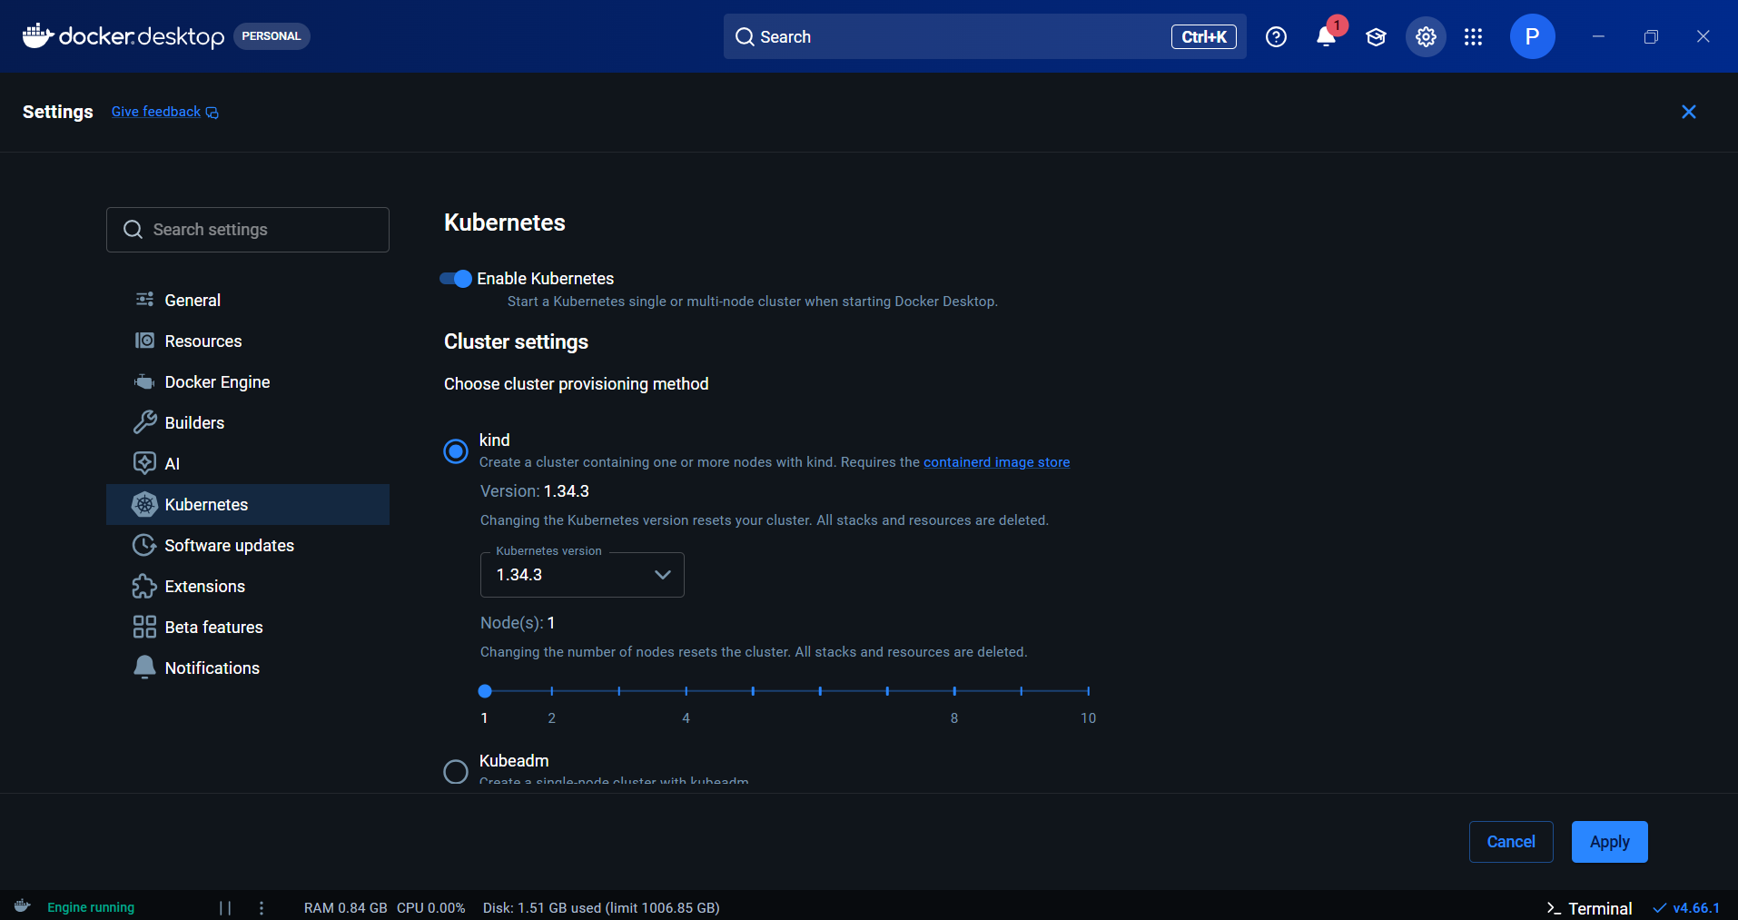

Enable three plugins (Docker, Docker Pipeline, Kubernetes CLI) and install them:

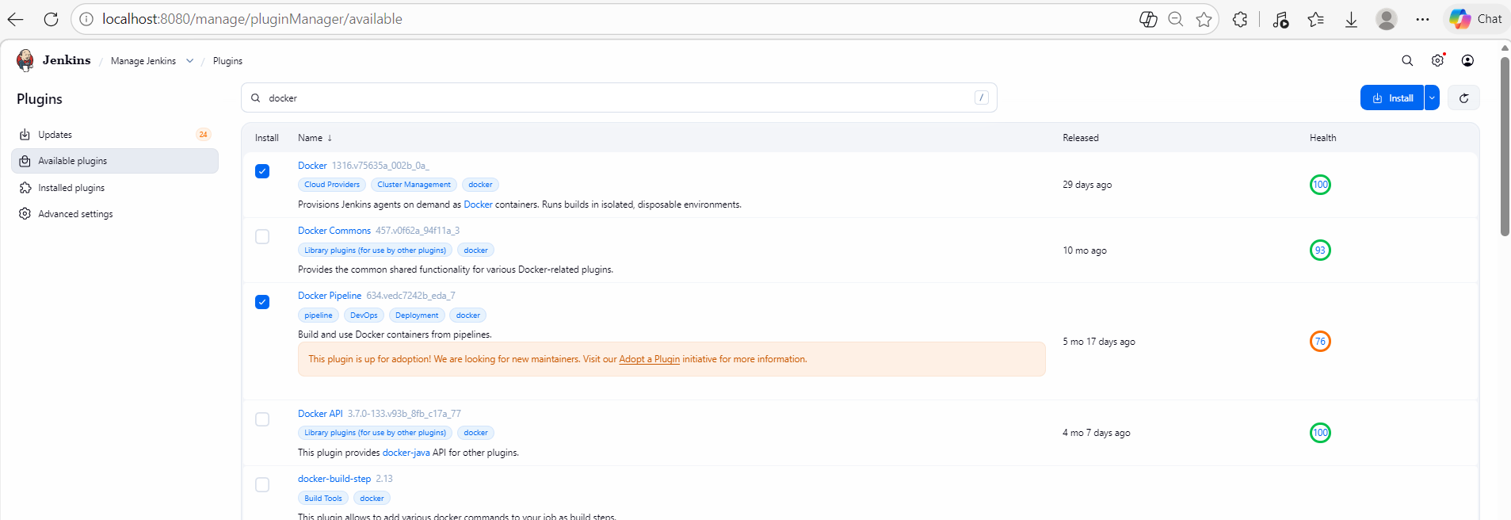
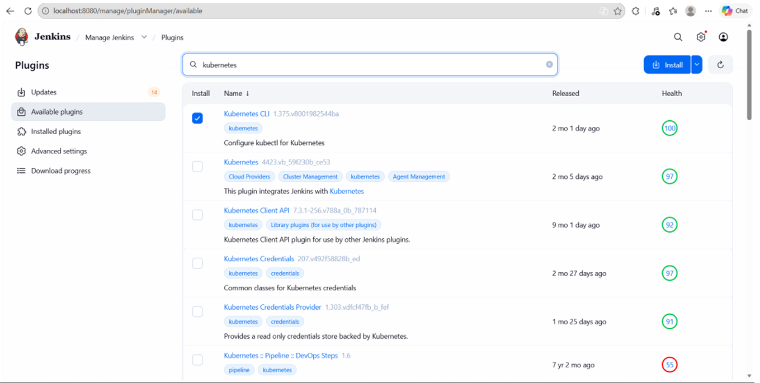
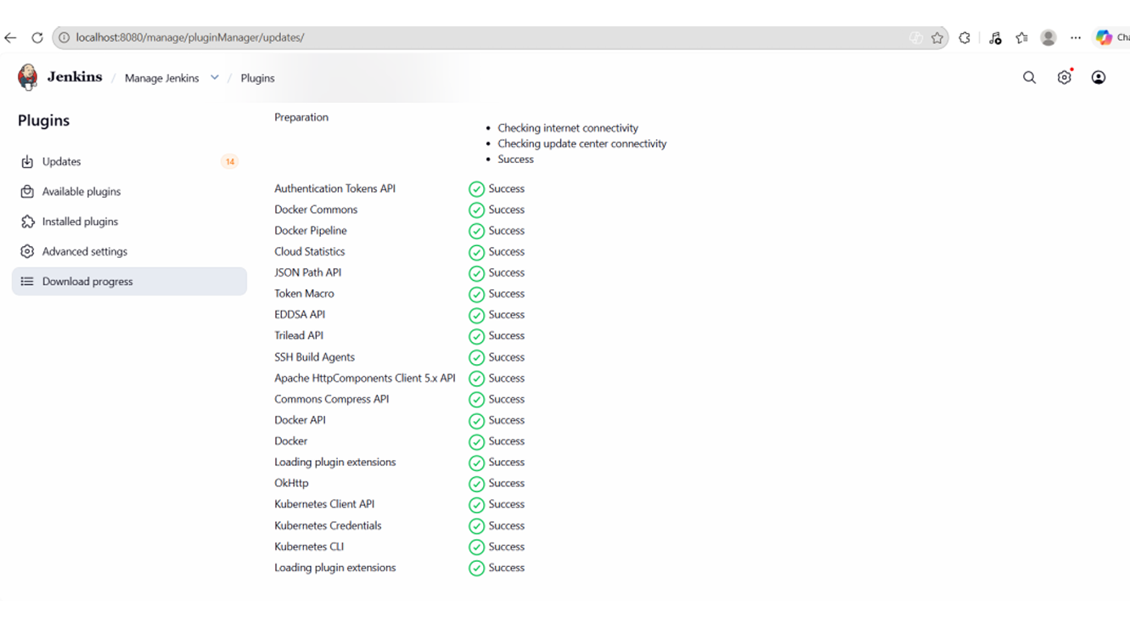

Step 2 - Create Simple Java Application (in local machine)
Create App.java
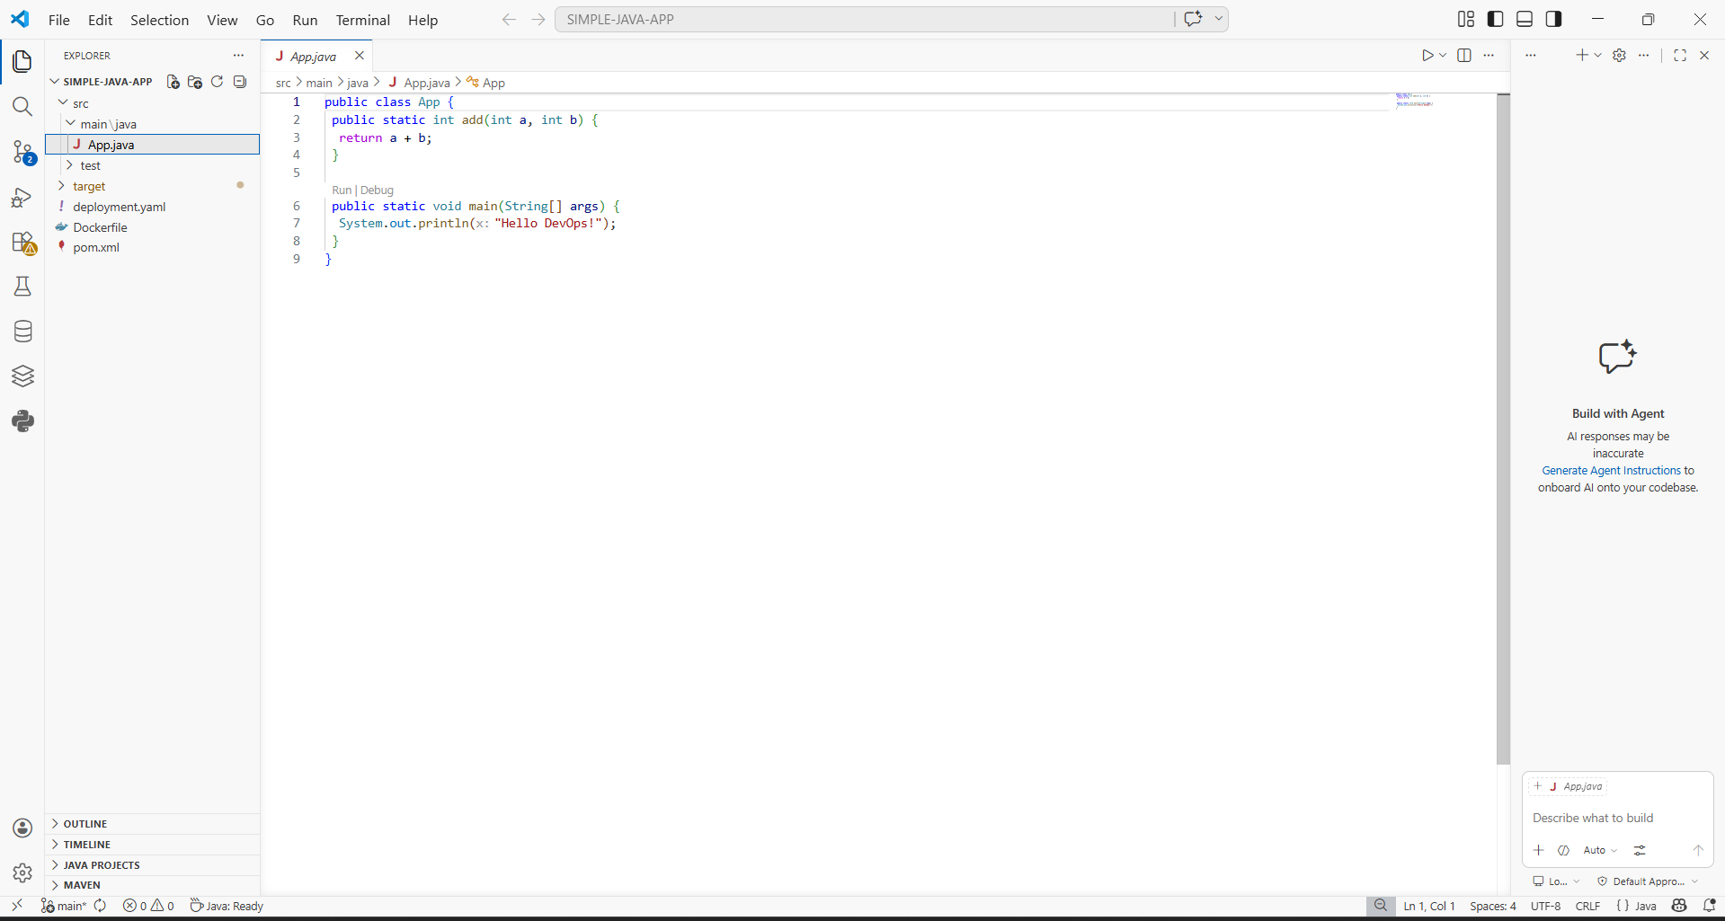

Create AppTest.java

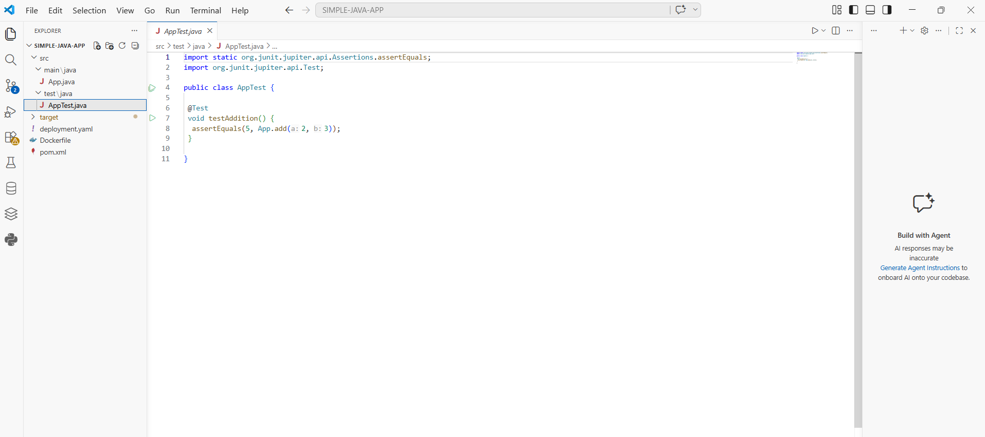

Create pom.xml
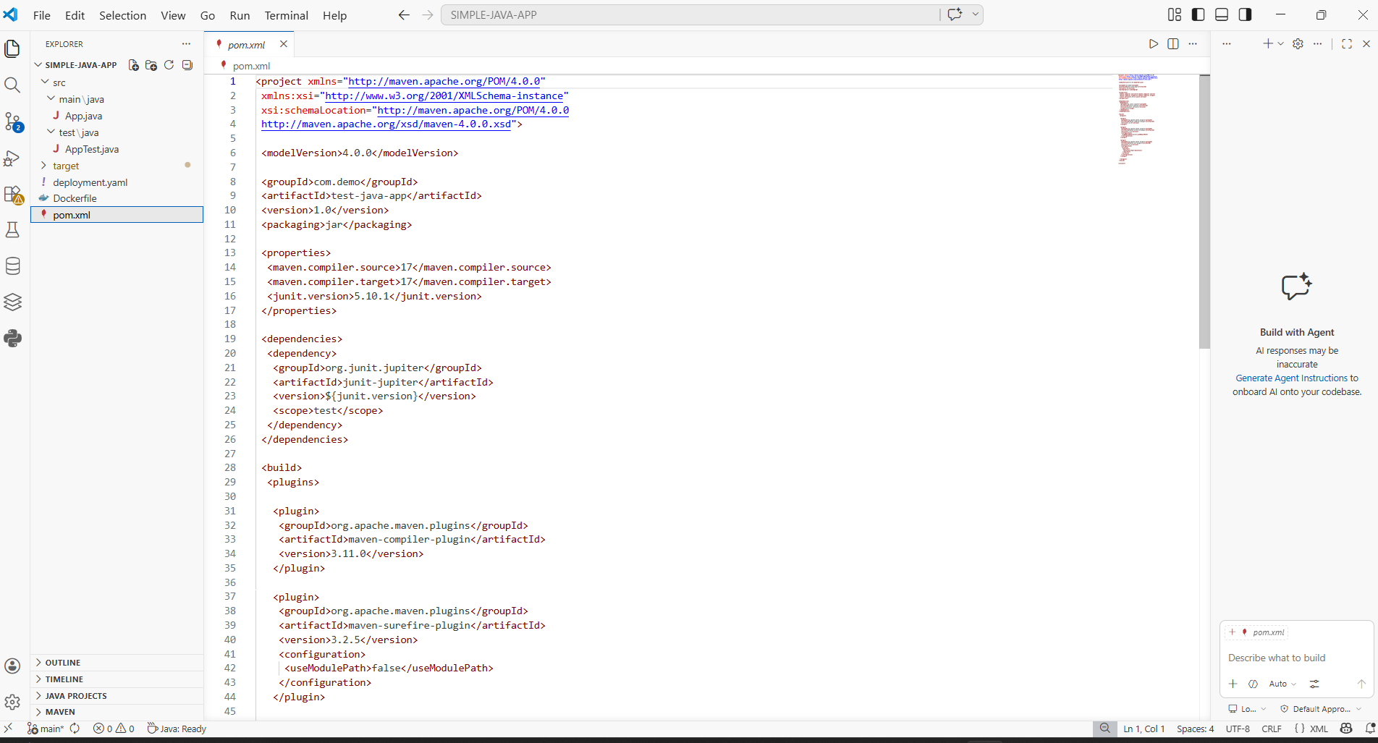
Step 3 - Build Locally using Maven (Test)
Inside project folder:
mvn clean test:
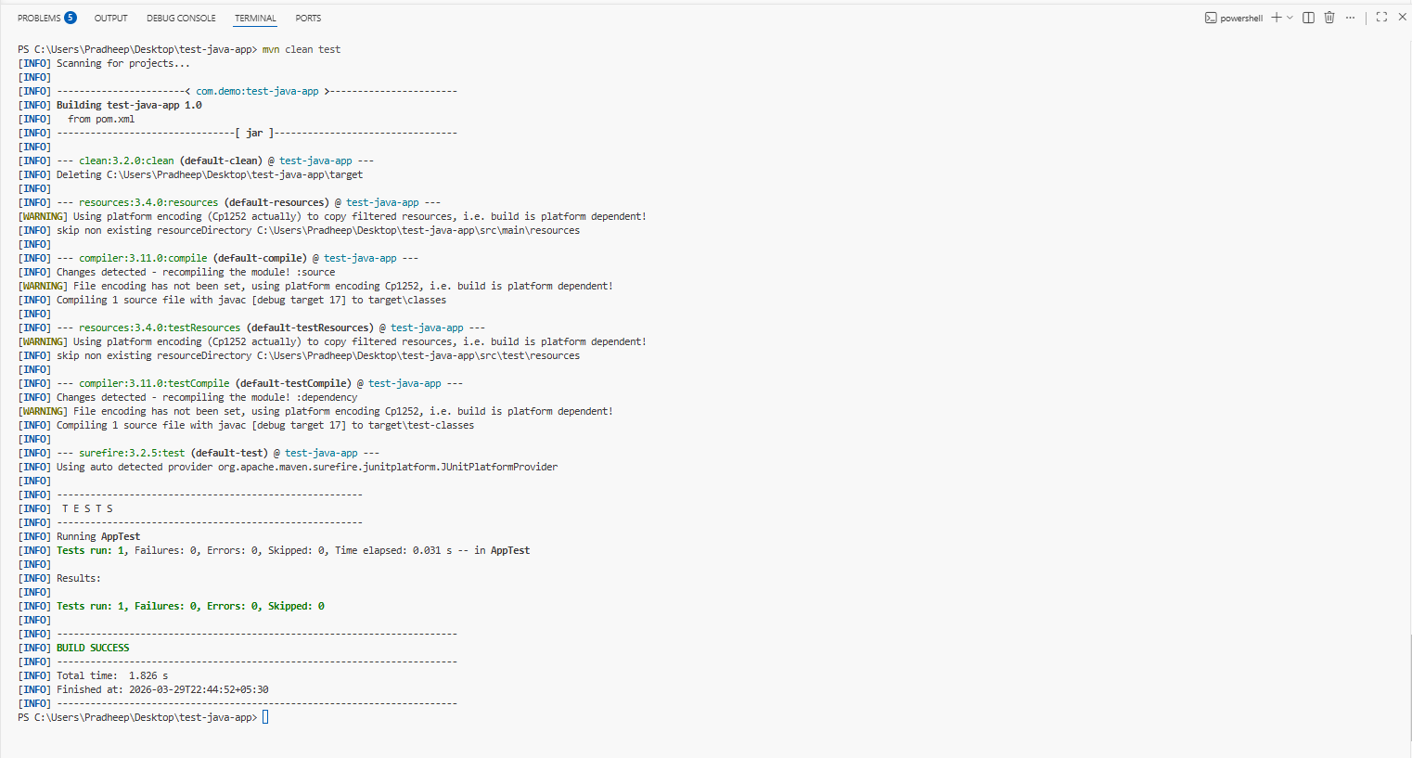
mvn clean package
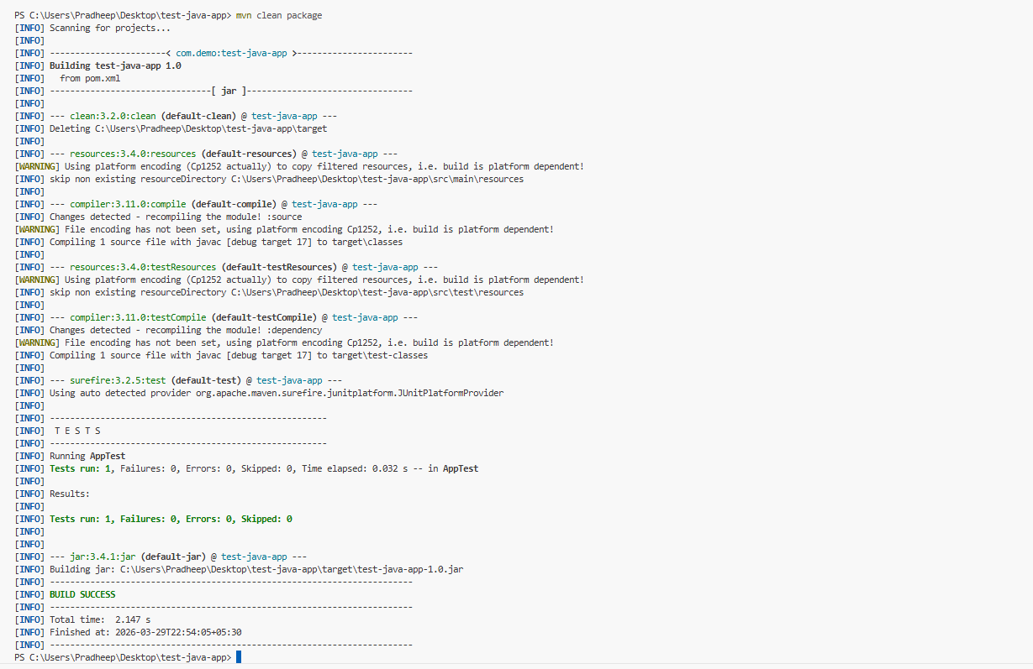
It generates: target/ test-java-app-1.0.jar
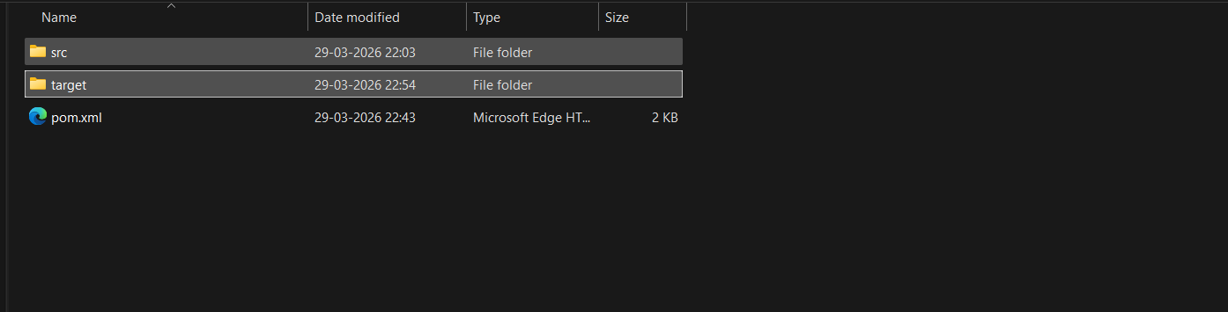
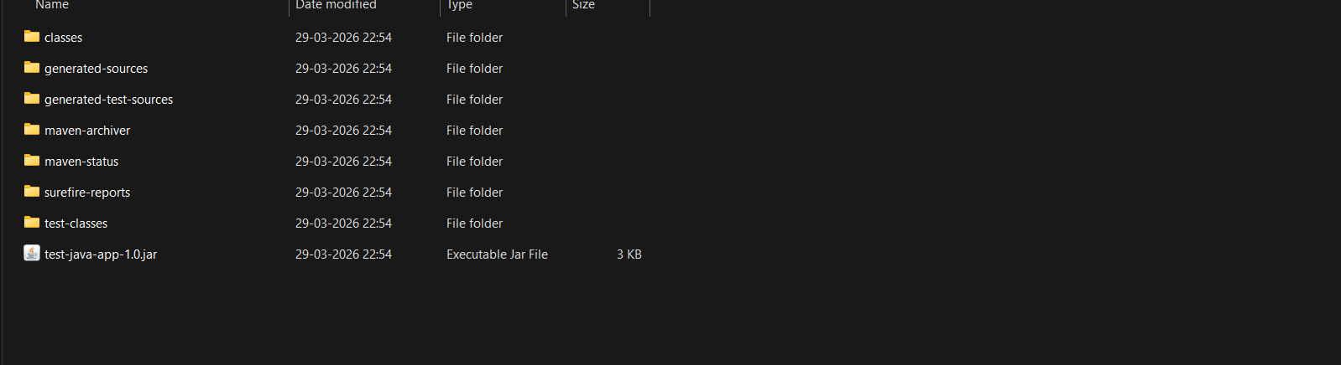

Step 4 - Create Dockerfile
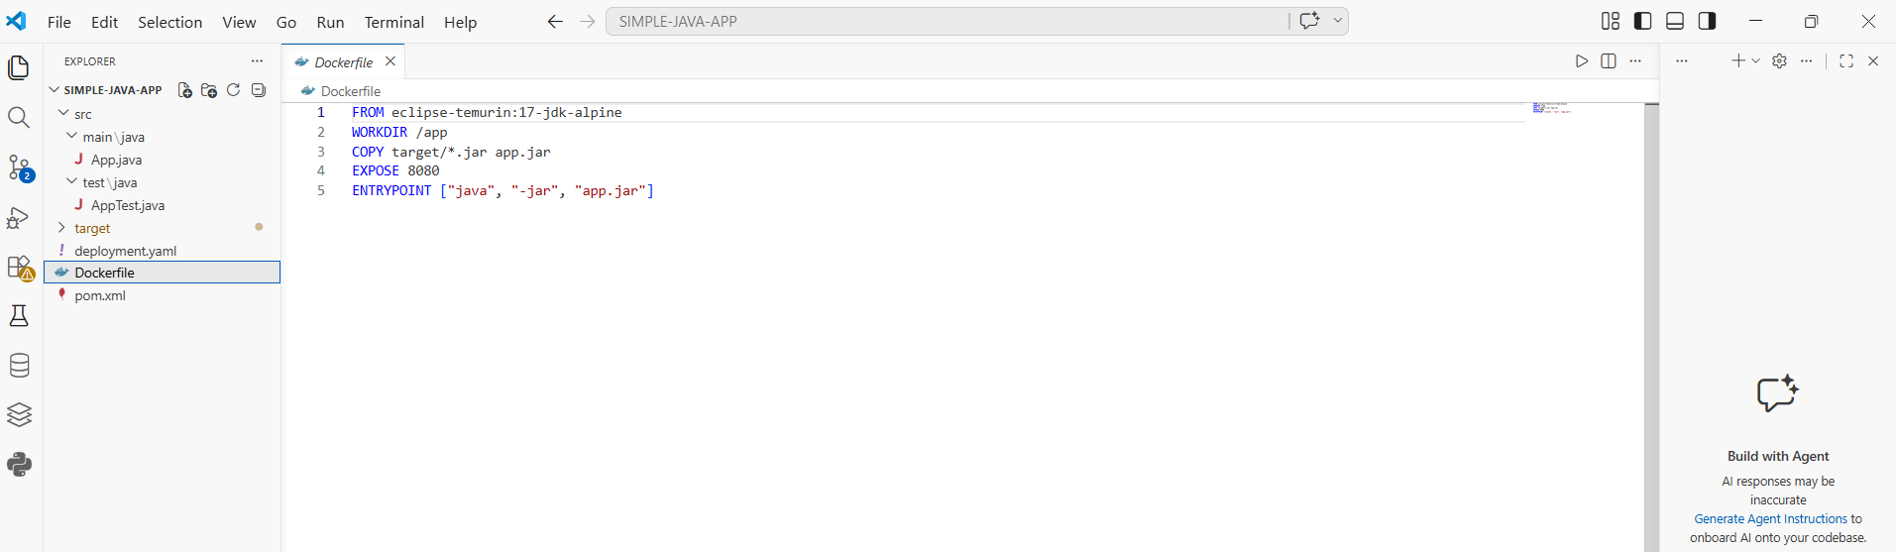
Step 5 - Create Kubernetes Deployment File
deployment.yaml
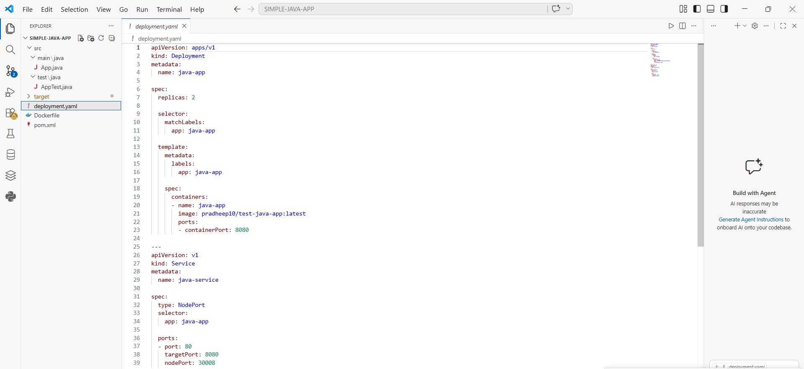
Step 6 - Push Code to GitHub
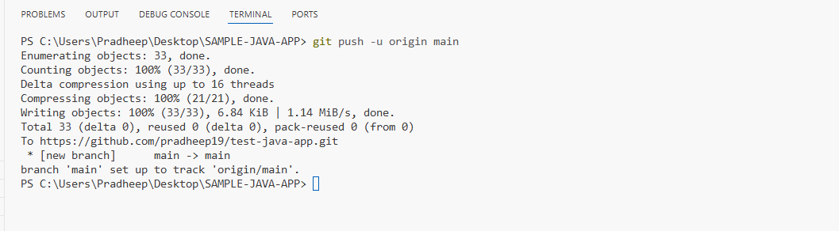
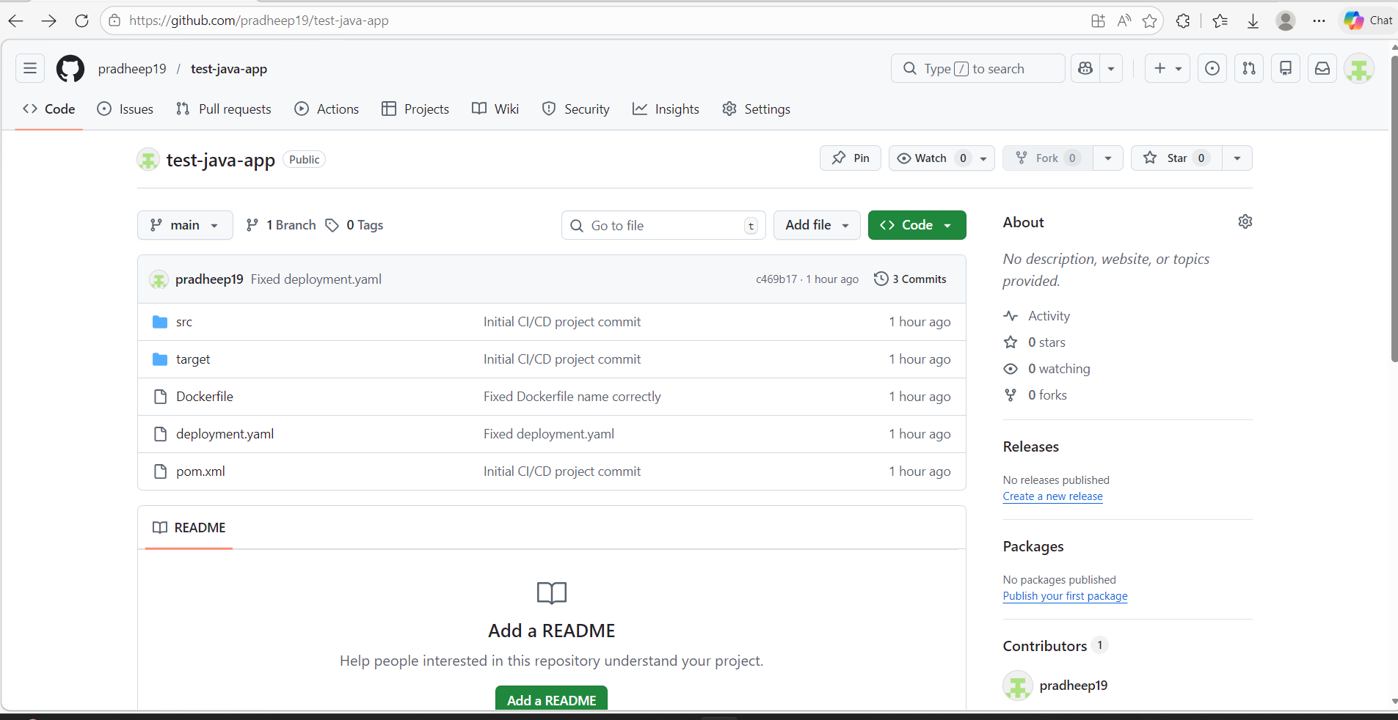

Step 7 - Create Jenkins Pipeline Job

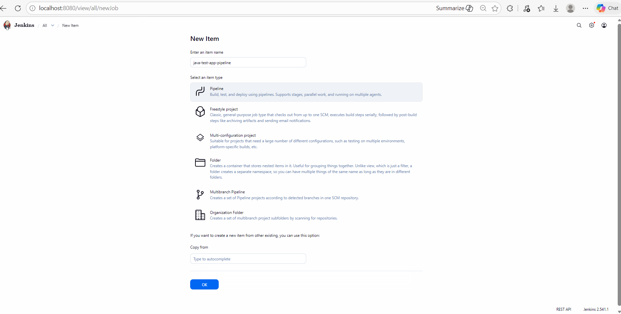

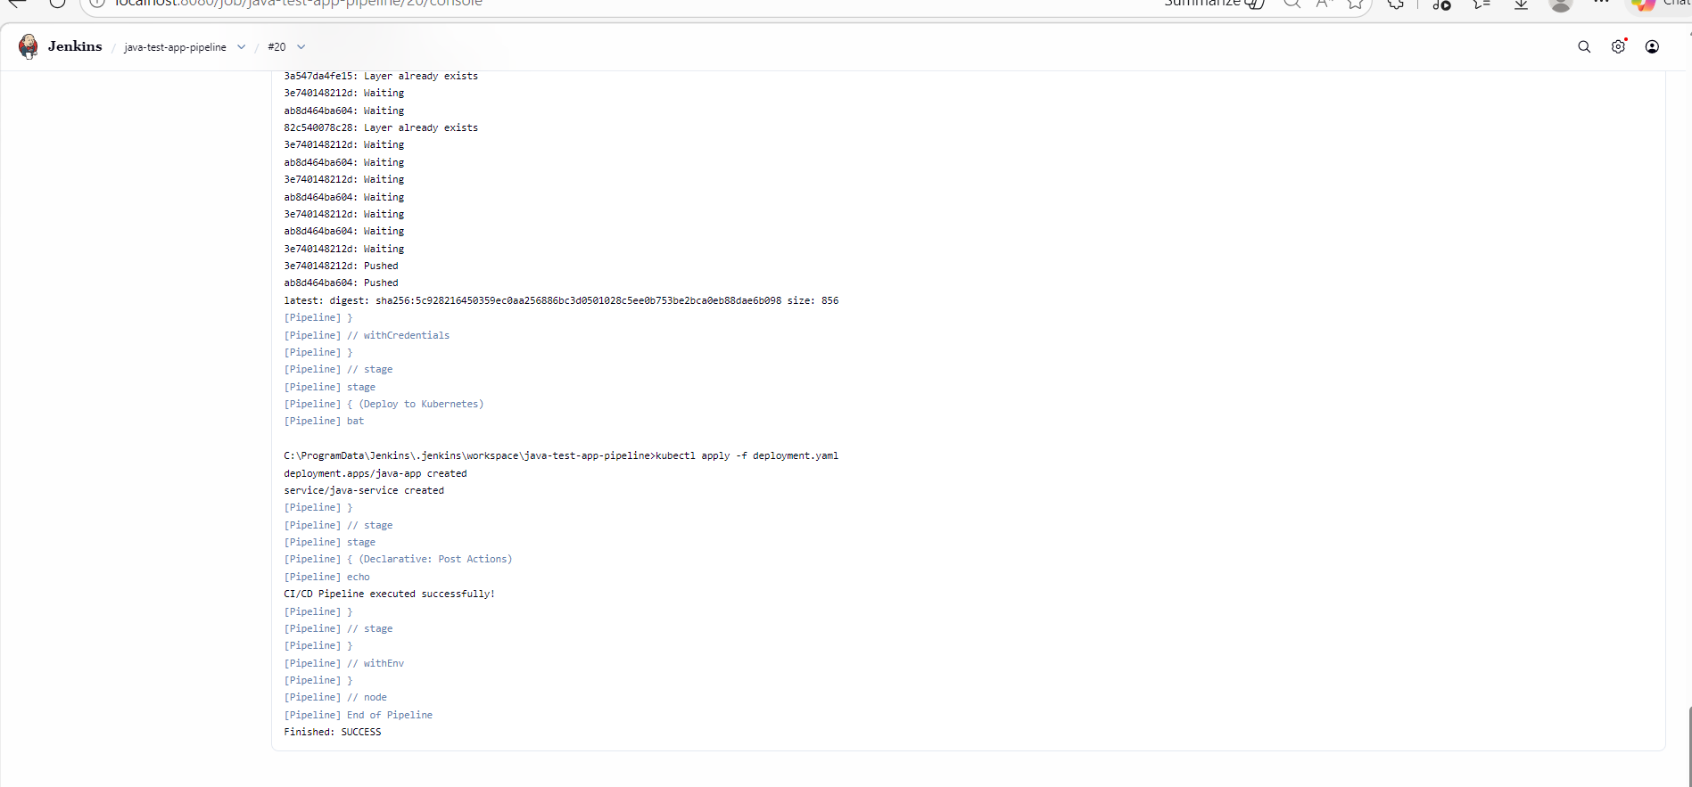

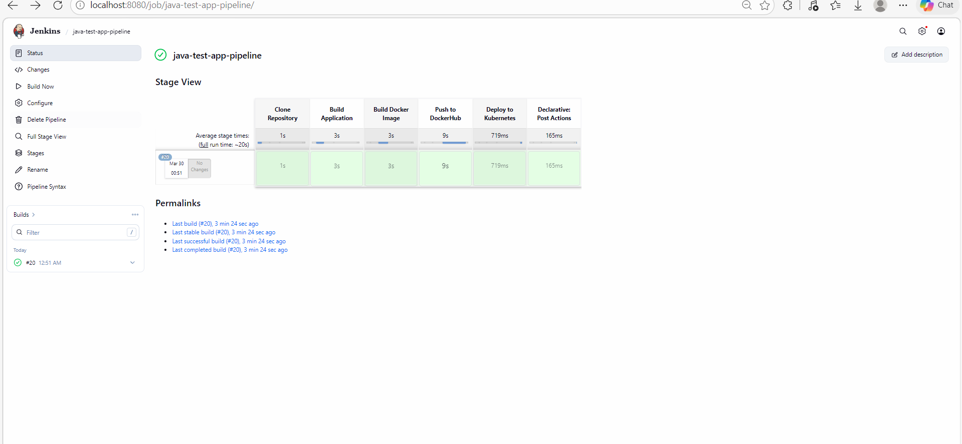

Step 12 - Verify Docker and Kubernetes Deployment

Docker Image
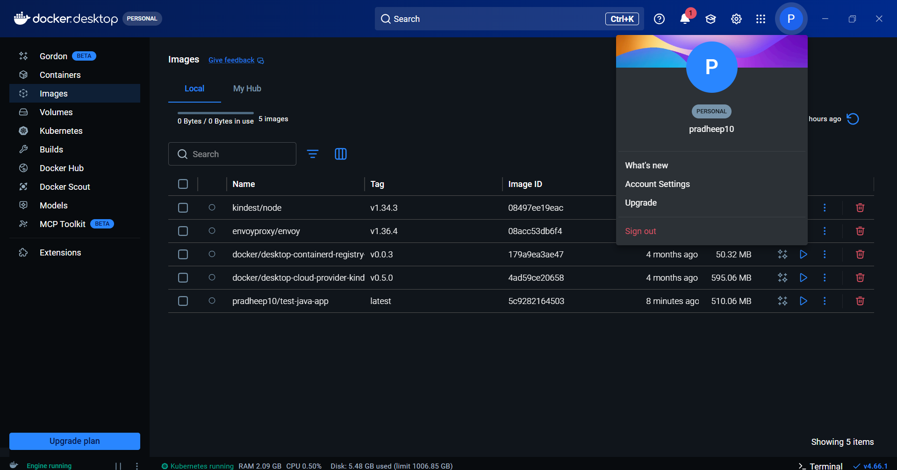

Kubernetes
