**Backend**

This Task is a **User and Admin Management Backend**.  
It provides:

* User authentication & profile management
* Admin authentication with a separate collection
* Role-based JWT authentication (user/admin)
* Full CRUD for user profiles (create, read, update, delete)
* Admin access to user data

Folder Structure

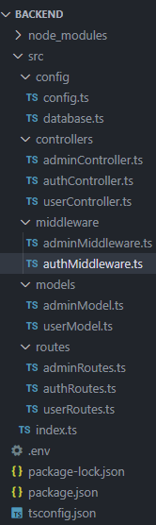

## Features

### 1. **User Authentication**

* POST /api/auth/signup → Register new user.

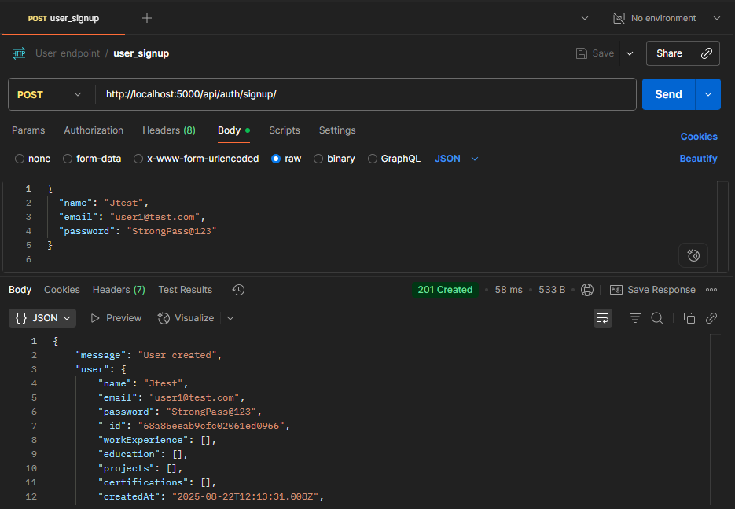

* POST /api/auth/login → Login user and get JWT token.

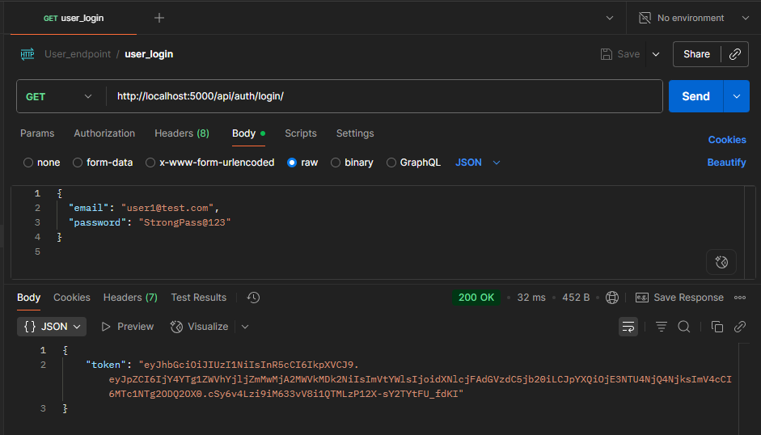

### 2. **User Profile Management**

Endpoints under /api/user/profile:

* POST → Create profile

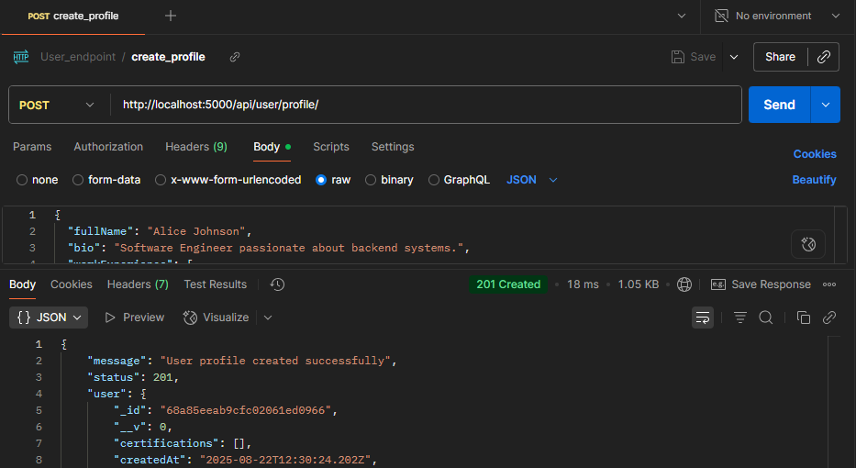

* 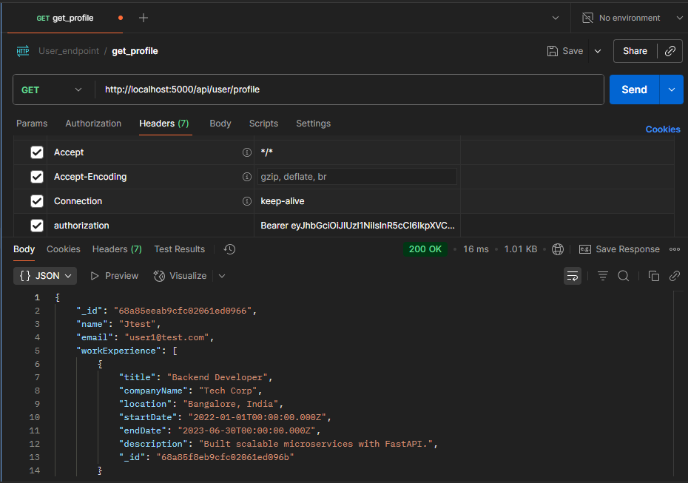GET → Get profile
* PUT → Update profile

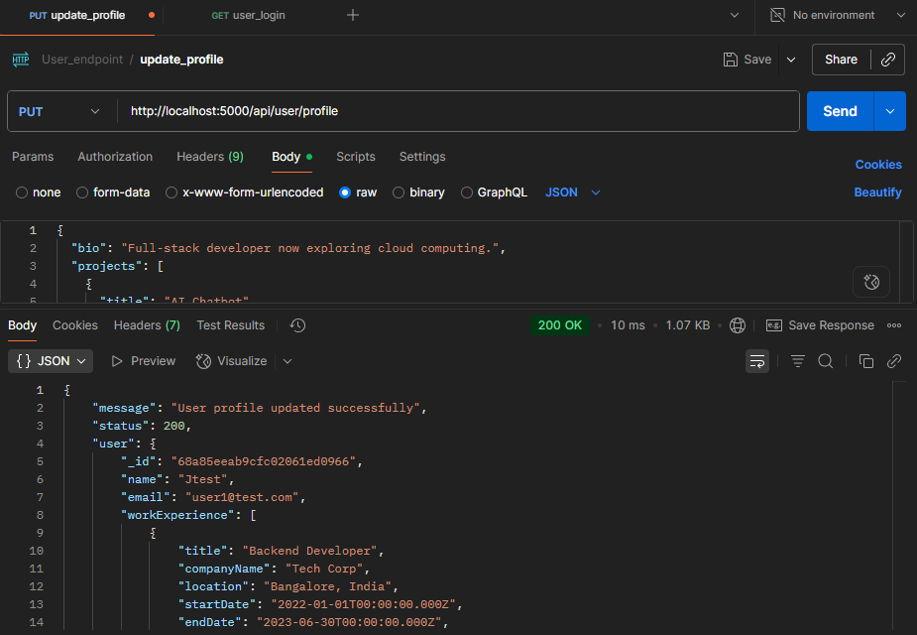

* DELETE → Delete profile

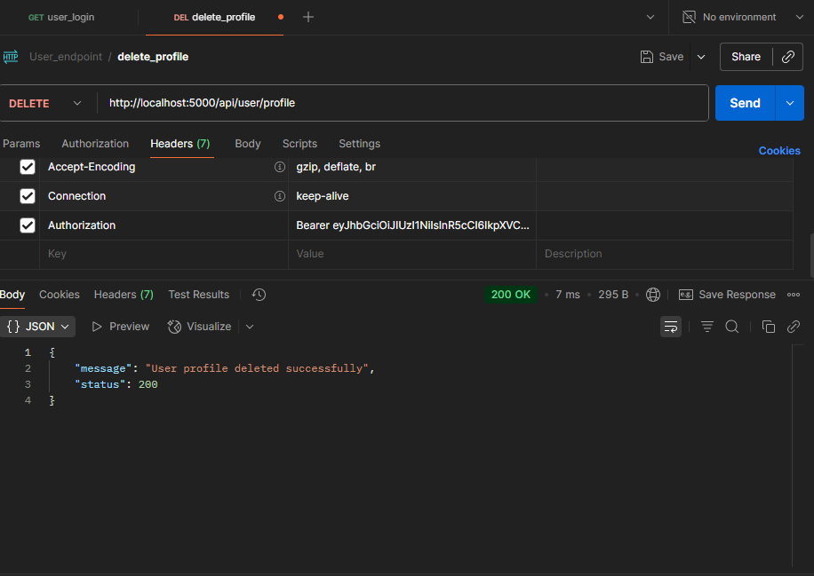

Validations (example: workExperience requires title, companyName, location, startDate).

### 3. **Admin Authentication**

* POST /api/admin/signup → Register admin.

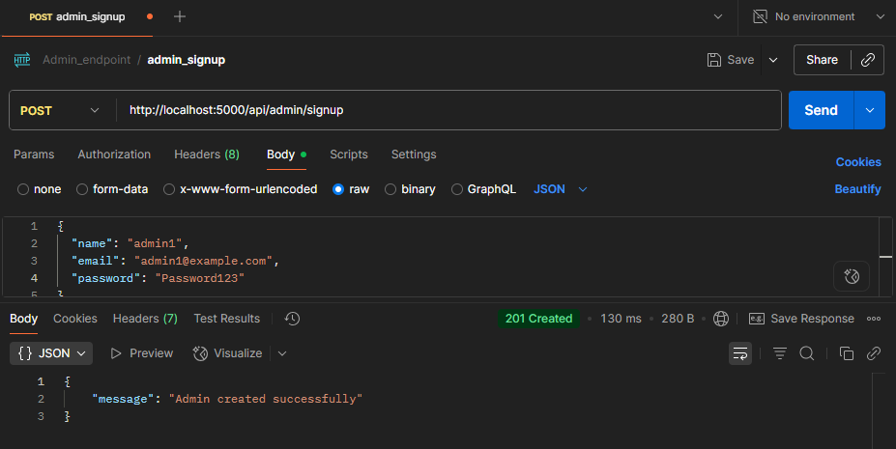

* POST /api/admin/login → Login admin and get Admin JWT.

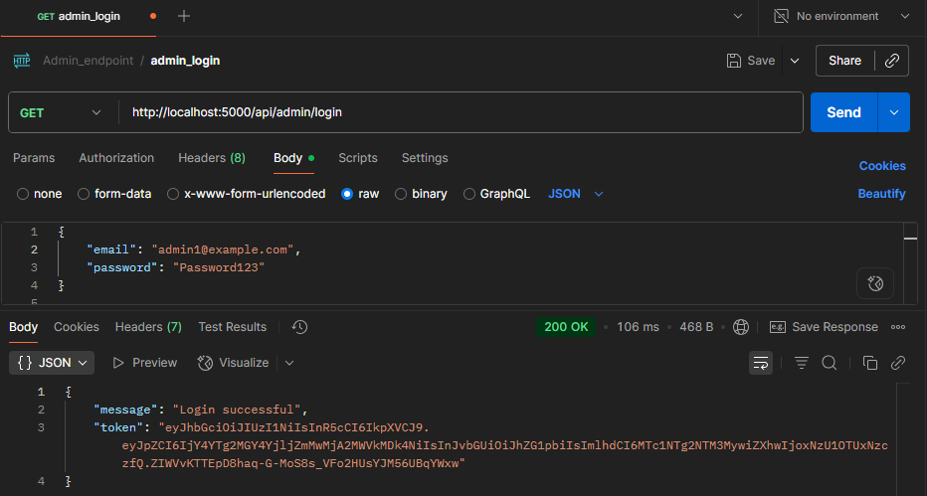

### 4. **Admin Privileges**

* GET /api/admin/users → Get all users.

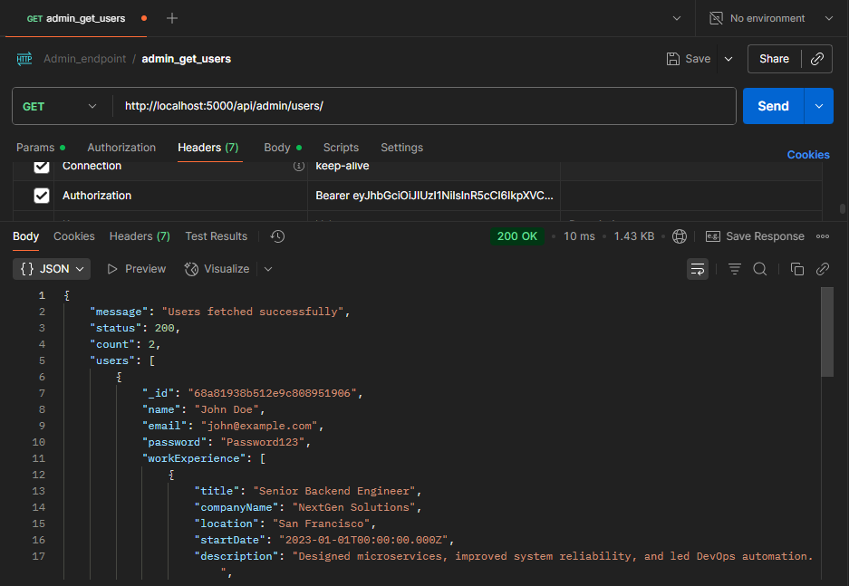

* GET /api/admin/users/:id → Get specific user by ID.

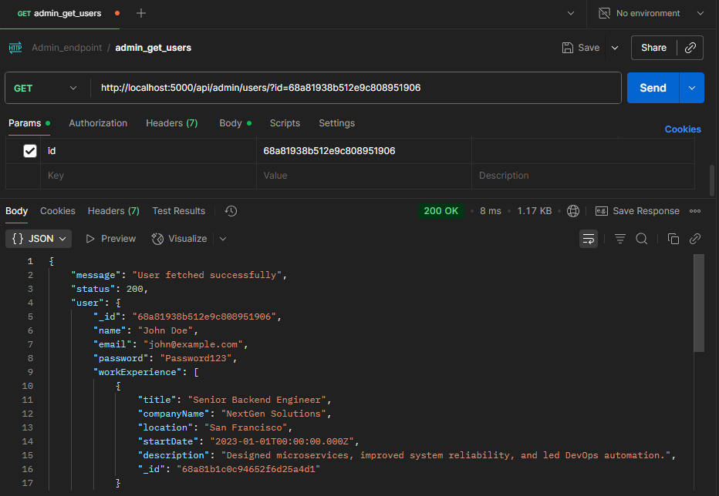

### 5. **Middleware**

* **authMiddleware.ts** → Verifies **User JWT**.
* **adminMiddleware.ts** → Verifies **Admin JWT**.

## Workflow

1. **User Flow**
   * Signup → Login → Get JWT → Use JWT for profile operations.
2. **Admin Flow**
   * Signup → Login → Get Admin JWT → Use Admin JWT to fetch users.